

NEST WP4: Global slice availability

Version 0.1

[Publication Date]

This is a Non-binding Permanent Reference Document of the GSMA

Security Classification: Confidential

Access to and distribution of this document is restricted to the persons permitted by the security classification. This document is confidential to the Association and is subject to copyright protection. This document is to be used only for the purposes for which it has been supplied and information contained in it must not be disclosed or in any other way made available, in whole or in part, to persons other than those permitted under the security classification without the prior written approval of the Association.

Copyright Notice

Copyright © 2019 GSM Association

Disclaimer

The GSM Association (“Association”) makes no representation, warranty or undertaking (express or implied) with respect to and does not accept any responsibility for, and hereby disclaims liability for the accuracy or completeness or timeliness of the information contained in this document. The information contained in this document may be subject to change without prior notice.

Antitrust Notice

The information contain herein is in full compliance with the GSM Association’s antitrust compliance policy.

Revision History

|  |  |  |
| --- | --- | --- |
| Date | Revision | Comments |
| August 15, 2019 |  | TOC proposal |
|  |  |  |
|  |  |  |

Table of Contents

1 Introduction 5

2 The evolution of roaming 5

2.1 Roaming in today’s networks 5

2.2 Global availability of network slices 6

3 Customer requirements on global slice availability 6

4 How to achieve global slice availability 7

4.1 Standardised slice types 7

4.1.1 Overview 7

4.1.2 Details 8

4.1.3 Summary 9

4.2 Network slice type export 10

4.2.1 Overview 10

4.2.2 Details 10

4.2.3 Summary 11

4.3 Network slice export 12

4.3.1 Overview 12

4.3.2 Details 12

4.3.3 Summary 12

5 User plane treatment, e.g. LBO vs. HR 13

6 Implications on the GST 13

7 Summary & conclusions 13

Appendix 13

Table of Figures

Figure 1: S-NESTs are associated to standardised SST values in order to make them globally available and to identify them uniquely 8

Figure 3: Global reach based on standardized slice types 9

Figure 4: Global reach based on network slice type export 11

Figure 5: Global reach based on virtual home slice 12

# Introduction

This document discusses the global reach of customer’s mobile network services. Focus will be on a review how this is done in today’s networks called roaming and how this can be achieved in a future 5G network supporting network slicing.

The introduction of network slicing along with the promised flexibility due to automation and virtualization technology will change the way global reach can be implemented and also changes the roles and value chains. This document aims to identify these changes.

Therefore, first a review of roaming in today’s networks and the need for new ways in times of network slicing is provided followed by an overview about customer’s requirements in terms of global slice availability. Afterwards three scenarios on how to achieve global slice availability are discussed together with open issues related to these scenarios. Also the handling of user plane traffic (home routed vs. local break out) is briefly analysed. Finally the implication on the Generic Slice Template (GST) are handled and the document is concluded.

# The evolution of roaming

## Roaming in today’s networks

Roaming services enable mobile subscribers to use services in countries or areas outside of their home networks. Roaming is allowed among networks that have the same network standards and only usable in areas or countries where operators have signed a roaming agreement.

For operators, roaming services can be classified into inbound and outbound roaming. The inbound roaming service allows subscribers from other operators to access the local network and services. The outbound roaming service allows subscribers from the local network to access another operator's network and services.

Roaming can be classified into national and international roaming based on the physical locations accessed by subscribers. National roaming indicates that mobile subscribers can access other operator networks and services in the home country. International roaming indicates that mobile subscribers can access operator networks and services abroad.

To ensure service continuity while roaming, connections must be established and roaming agreements must be signed between operator networks. Roaming agreements allow operators to set policies to control network access for roaming subscribers and manage roaming services.

Based on the roaming service access policies used by mobile terminals, two roaming types are supported: Home-routed and LocalBreakOut (LBO).

* Home-routed roaming enables subscribers to access the visited network through the home PDN gateway (H-PGW) and obtain services provided by their home networks.
* LBO roaming enables subscribers to access the visited network through the visited PGW (V-PGW) and obtain services, which can be provided by the home or visited network.

Home-routed roaming is widely used in today’s networks.

LBO can relatively reduce user plane loops and transmission resources required, thereby reducing the roaming service delay and providing better user experience. However, service control, policy control, and charging are complex. Home route is the preferred mode of network operators simply due to the fact that billing is much simpler and can be done by the home operator itself.

To ensure service continuity while roaming, connections must be established and roaming agreements must be signed between operator networks. Roaming agreements allow operators to set policies to control network access for roaming subscribers and manage roaming services.

## Global availability of network slices

5G networks, in combination with network slicing, permit business customers to enjoy connectivity and data processing tailored to the specific business requirements that adhere to a Service Level Agreement (SLA) agreed with the mobile operator. The customisable network capabilities include data speed, quality, latency, reliability, security, and services.

From a mobile operator’s point of view, a network slice is an independent end-to-end logical network that runs on a shared physical infrastructure, capable of providing a negotiated service quality. The technology enabling network slicing is transparent to business customers.

As the network slice is presented to the user as a normal mobile network, there is no impediment in providing a network slice type to devices that roam outside the home network thus delivering levels of service continuity required for a seamless experience.

There are at least three ways to ensure the availability of a suitable slice in an international roaming scenario: usage of standardized slice types, network slice template export and network slice export. These options are explained in more detail in Chapter 4.

# Customer requirements on global slice availability

In this chapter the customer requirements in terms of global slice availability are analysed. In principle the following requirements can be identified:

* National slice availability indicates that a slice customer can access the slice type in other operator networks in the home country
* International slice availability indicates that a slice customer can access the slice type in operator networks abroad.
* Local break out
  + Might be relevant for use cases with low latency and high reliability requirements
* Home routing
  + Might be relevant for all other use cases. However, maybe network slicing might solve the charging issue and might enable LBO for other use cases as well

tbd

# How to achieve global slice availability

This chapter discuss three potential solutions on how to achieve global slice availability.

## Standardised slice types

### Overview

The visited network could provide to the international roaming user a network slice with equivalent functionality of the slice used in the home network. For example, the international roaming partners may agree to support a set of Network Slice Types (NESTs) with industry accepted slice characteristics (S-NESTs), which will be shared between all network operators.

A set of industry wide S-NESTs are beneficial in order to replicate slice behaviour across network boundaries, to unlock “basic” roaming models and to simplify network slicing rollout.

In 3GPP TS 23.501, the Slice/Service Type (SST) is used to refer to an expected network slice behaviour in terms of features and services. Standardized SSTs assigned by the 3GPP are used in order to identify slices uniquely around the world. The following SSTs and their respective values are defined for now:

1. Enhanced Mobile Broadband – eMBB
2. Ultra reliable low latency communication – URLLC
3. Massive Internet of Things – MIoT

Other SSTs are currently under discussion as like V2X and Mission critical.

However, 3GPP does not specify the characteristics of these SSTs. These characteristics are to be specified in the S-NESTs by the GSMA. Therefore, an S-NEST is associated to one or multiple standardized SST values in order to identify it uniquely around the world (Figure 5).



Figure 1: S-NESTs are associated to standardised SST values in order to make them globally available and to identify them uniquely

### Details

An example of a globally agreed slice type (NEST) allocated to the international roaming device in the visited network is shown in Figure 6 and comprises the following steps:

1. HPLMN and VPLMN have a roaming agreement for standardized slice types.
2. The device roams into the visited network and requests access to a standardized slice type. More details about the registration process can be found in ….
3. The visited network validates the request and assigns a standardised slice type (NEST) to the roaming device.

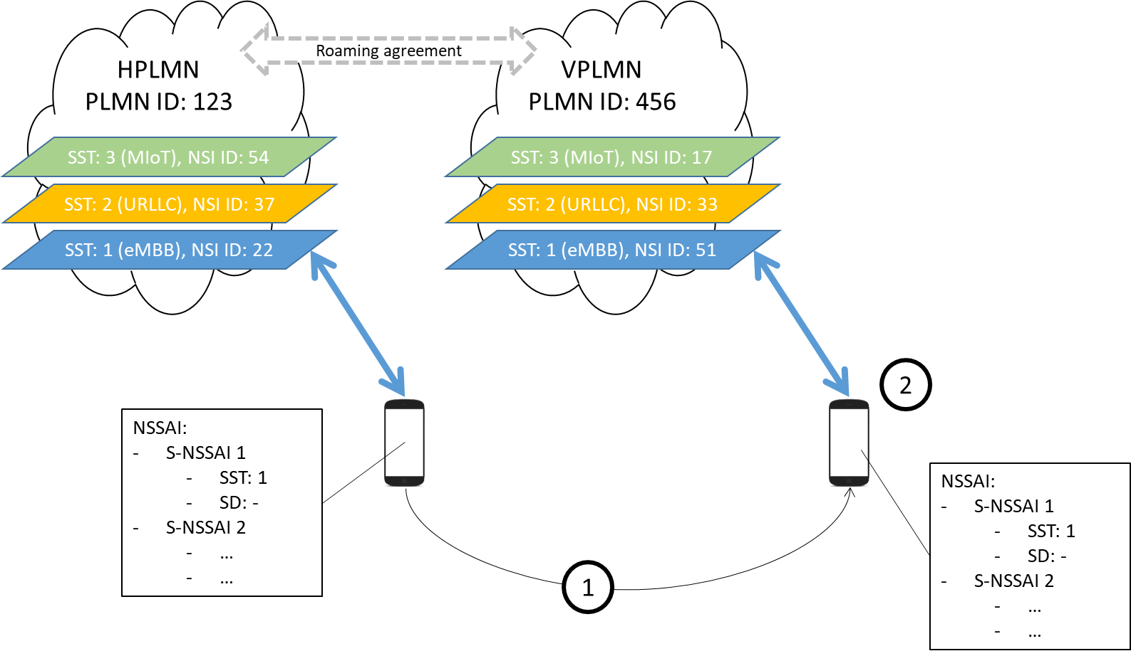

Figure 3: Global reach based on standardized slice types

If the UE uses standard S-NSSAI values, then the same S-NSSAI values can be used in VPLMN as in the HPLMN [23.501].

This type of global slice availability is very similar to roaming in today’s networks and can be considered as an evolution of it. The home operator (HPLMN) does have a “roaming” agreement with the visited network operator (VPLM) allowing customers of HPLMN to continue service usage while being located in VPLMN. Initial thoughts about roaming agreements in this type of roaming are discussed in….

### Summary

Roaming based on standardized slice types does have the following advantages:

* Serves early slicing demands
* Solves global slice availability for standard slice types
* Evolution of the well established and well known roaming model in today’s networks
* …

In the following the disadvantages of this approach are listed:

* Only available for standard slice types, custom slice types require different solutions
* Availability of standard slice types depends on willingness of the network operator to deploy those slices
* Increased complexity of roaming agreements as the agreements have to be extended in order to consider KPIs and service guarantees.
* How to make sure that the visiting operator is really able to meet the requirements? Certification?
* …

## Network slice type export

### Overview

There could be cases in which a slice customer does have an agreement with its home network operator about the usage of a non-standard but individual slice type. In addition to that the slice customer might also want to access the slice while being outside of the coverage of the home network operator. In this case of course the slice customer could have individual contracts (as like the contract with the home network operators) with the different network operators to make sure that the individual slice is also available outside the coverage of the home network operator. However, it is obvious, that this requires big efforts on the customer side. Therefore, the slice customer might ask the home network operator to take care about that and to make sure that the slice is available also outside its own coverage.

This requires roaming agreements between the home network operator and visiting network operators in which the description of the individual slice is exchanged. In other words, the home network may export the template of an individual network slice (P-NEST) of a network slice customer so that it can be instantiated and administered by the visited mobile network operator.

### Details

An example for a home operator providing the P-NEST to the visited network who instantiates it for the roaming device is shown in Figure 8 and comprises the following steps:

1. The home network does have a roaming agreement with the visiting network and the home operator provided the P-NEST of the network slice to the visited operator.
2. The visiting network operator instantiates the slice based on the P-NEST. The instantiation could be done on demand or in advance. This depends on the degree of automation available in the visited network.
3. The device roams into the visited network and aim to connect to its individual slice.
4. Mapping of the Subscribed S-NSSAIs values to the S-NSSAI values used in the VPLMN.
5. Device will be connected to the network slice instance.

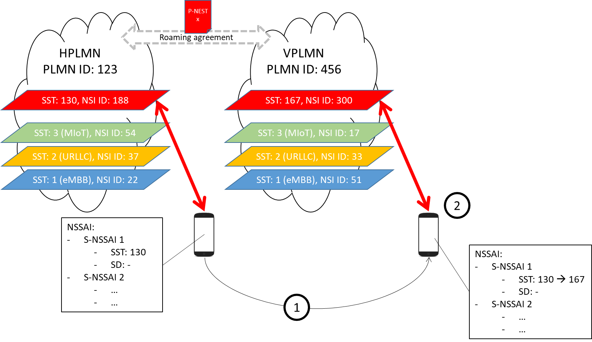

Figure 4: Global reach based on network slice type export

If the VPLMN and HPLMN have an SLA to support non-standard S-NSSAI values in the VPLMN, the Network Slice Selection Function (NSSF) of the VPLMN maps the Subscribed S-NSSAIs values to the respective S-NSSAI values to be used in the VPLMN. The S-NSSAI values to be used in the VPLMN are determined by the NSSF of the VPLMN based on the SLA. The NSSF of the VPLMN need not inform the HPLMN of which values are used in the VPLMN.

Depending on operator's policy and the configuration in the AMF, the AMF may decide the S-NSSAI values to be used in the VPLMN and the mapping to the Subscribed S-NSSAIs.

### Summary

This approach does have the following advantages:

* Provides global slice availability also for custom slice types
* Slice customers are able to access their regular communication services while being outside of the home network.
* …

In the following the disadvantages are listed:

* Requires individual negotiations between network operators which might become very complex as there will be many dependencies.
* New approach, different to what is known from today’s networks – requires changes in the internal processes of network operators.
* How to prize this type of roaming is not clear.
* The number of individual slices to be offered by a single network operator (for own customers and roaming customers) might become very high and might cause a lot of management overhead. It is not clear how many slices are required and how many slices can be supported by a single network.
* Liability might be an issue as well as monitoring of the “slice quality” offered by the visiting network.
* …

## Network slice export

### Overview

The home network may extend the slice into the visited network, provided it has authorisation from the visited network to control the resources.

### Details

An example in which the home network operator, with permission from the visited operator takes control of the network resources in the visited network is shown in Figure 8 and comprises the following steps:

1. The device roams into the visited network
2. The home network requests permission to control the visited network and to instantiate the network slice requested by the roaming device
3. The device uses the same slice as when at home

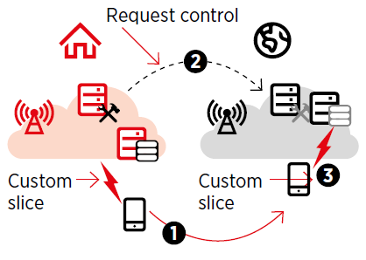

Figure 5: Global reach based on virtual home slice

### Summary

This approach does have the following advantages:

* Provides global slice availability also for custom slice types
* …

In the following the disadvantages are listed:

* New approach, different to what is known from today’s networks – requires changes in the internal processes of network operators
* How to prize this type of roaming is not clear
* Requires availability of APIs
* Network resources might be controlled by external parties – operators might not be willing to do that. Eventually this might be an option with trusted network operators. However, in any case the capabilities should be restricted.

# User plane treatment, e.g. LBO vs. HR

tbd

# Implications on the GST

tbd

# Summary & conclusions

tbd

# Appendix