Specialised Enterprise Networks

June 2019



|  |  |  |
| --- | --- | --- |
| About the GSMA  The GSMA represents the interests of mobile operators worldwide, uniting nearly 750 operators with almost 300 companies in the broader mobile ecosystem, including handset and device makers, software companies, equipment providers and internet companies, as well as organisations in adjacent industry sectors. The GSMA also produces industry-leading events such as Mobile World Congress (Barcelona, Shanghai and Los Angeles) and the Mobile 360 Series of conferences.  For more information, please visit the GSMA corporate website at [www.gsma.com](http://www.gsma.com). Follow the GSMA on Twitter: @GSMA. |  | Future Networks Programme  The GSMA’s Future Networks is designed to help operators and the wider mobile industry to deliver All-IP networks so that everyone benefits regardless of where their starting point might be on the journey.  The programme has three key work-streams focused on: The development and deployment of IP services, The evolution of the 4G networks in widespread use today, The 5G Journey developing the next generation of mobile technologies and service.  For more information, please visit the Future Networks website at: [www.gsma.com/futurenetworks](http://www.gsma.com/futurenetworks)  Document Editor  Name, company |

Contents

Contents 3

A Flexible Network for the 5G Era 4

5G design principles 4

Specialised Enterprise Networks 4

Relationship between Specialised Enterprise Networks and Network Slicing 5

The Value Proposition of Specialised Enterprise Networks 5

Service Level Agreement 6

Business models examples 6

Specialised Enterprise Networks as Private Networks 7

Creation of a Specialized Enterprise Network 8

Glossary of Terms 8

References 10

**1** Business Aspects

# A Flexible Network for the 5G Era

## 5G design principles

Unlike previous mobile generations that followed a somewhat monolithic architecture aimed at fulfilling a primary use case (e.g. 4G was engineered around the concept of “always on, always connected”), the design of 5G has had flexibility and adaptability at its heart.

This has manifested itself in the access network in the shape of the so called “flexible numerology”, that is, the ability of parametrising fundamental elements of the radio connectivity layer. This flexibility will allow 5G not only to use frequency bands where the 4G technology would not be suitable such as “above 6GHz” spectrum, but also to achieve incredibly low latency and improved reliability, two key requirements of 5G.

Figure 1: CSC – CSP relationship

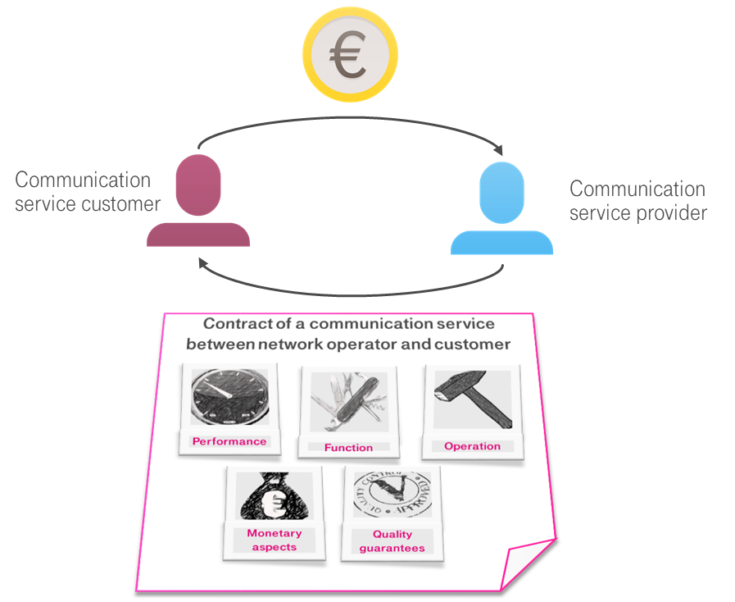

The core network design is equally revolutionary. Borrowing from the software engineering best practices, the new 5G core architecture will be service based, modular, as far as possible access agnostic and built for deployment in virtual environments. The combination of these factors will allow mobile operators to create network configurations that are specialised towards meeting specific performance criteria.

We refer to the capability of creating a set of logically independent networks that run on a common physical architecture with the term *Network Slicing*.

## Specialised Enterprise Networks

Communication Service Providers (CSP) will leverage network slicing to create a communications network with characteristics and quality guarantees that best match the Communication Service Customer (CSC) use cases, requirements and expectations.

We will refer to this communication network offered by the CSP to the CSC as *Specialised Enterprise Network* (SEN) and it will be characterized by:

* Slice characteristics in terms of performance, functionality and operation
* Service level agreements to stipulate a specified level of service, support option, a guaranteed level of system performance as relates to downtime or uptime
* Monetary aspects in terms of pricing models, fees, etc.

This transforms the business of mobile network operators from static “one size fits all” paradigm, to a new paradigm where logical networks are created which are tailored to the specific requirements of the CSC, which may not be satisfied with ‘vanilla mobile broadband’.

In other words, whereas the in a traditional mobile network, the CSP has focused on providing a set of well defined, highly standardized services to consumers, such as voice, messaging, mobile internet, in the 5G Era the CSP will expand its reach to encompass B2B (business to business) and B2B2C (business to business to consumer) models producing a corresponding shift from delivery of services to fulfiment of a very diverse family of use cases.

As the CSP gears to configure the network to serve a myriad of use cases with diverse requirements, one of the main challenges CSPs face is the ability of offering quickly a suitable product to the new, and often more demanding, enterprise customers.

## Relationship between Specialised Enterprise Networks and Network Slicing

Network slicing is the starting point for addressing the above mentioned challenge. The capability of configuring the same physical network in such a way as to provide a fitting response to the CSC demands is the key to address the enterprise market. The CSC need not be concerned with the complexity of preparing and instantiating the network slice (or network slices) needed to fulfil its use cases requirements: as far as the device is concerned the concept of network slice is immaterial and all they can see is a network optimized to them. Hence the concept of specialized enterprise network.

# The Value Proposition of Specialised Enterprise Networks

A Specialised Enterprise Network creates a tight fit between the CSC’s use case and the CSP offering. This relationship can be analysed through the framework devised by Dr Alexander Osterwalder [ref5] in Figure 2.

Figure 2: The value proposition canvas

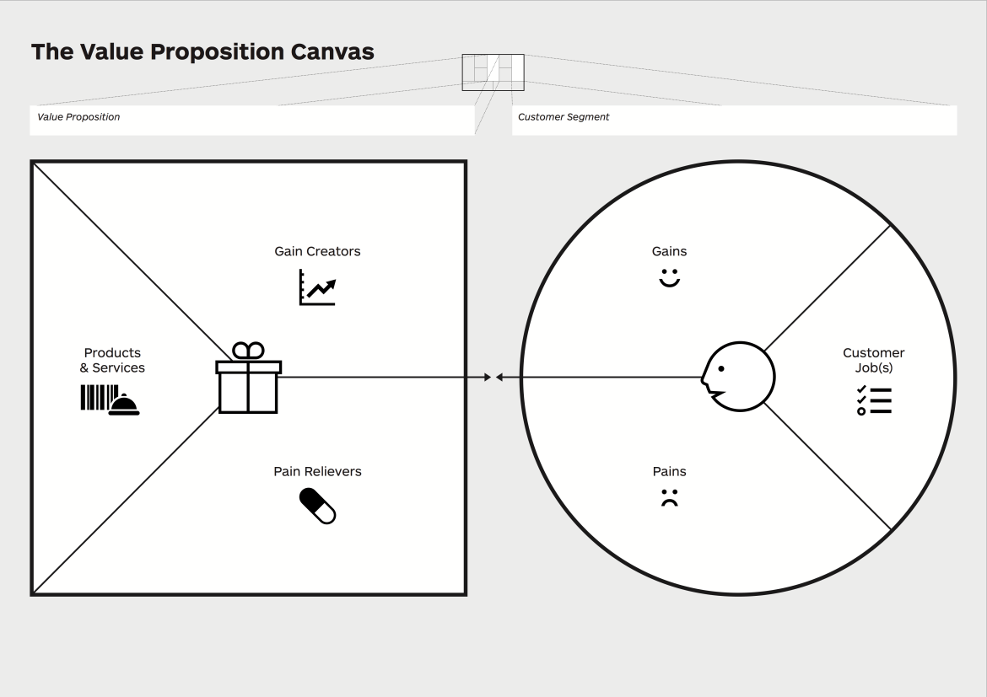

By a careful analysis of the jobs (use cases) that the CSC performs regularly, the CSP can identify how the CSC can improve the processes and productivity (that is, the gains that can be made) as well as the main problems that the CSC experiences while carrying out the required jobs (the pains).

The task of the CSP is then to design a network that can address the issues faced by the CSC in the current setup (pain relievers) and improve the value to the customer (gain creators).

CSPs will be in the position to address a very large variety of jobs across many industry segments: automotive industries, healthcare providers, smart cities administrators and so on. Each of them will be characterized by different potential gains and pain points that will require creative solutions.

In mapping the CSC requirements into slice attributes CSPs will build up a portfolio of Specialised Enterprise Networks that can then be adapted to serve similar types of businesses. Some of the most prominent attributes that are likely to be needed by many SENs are:

* Isolation. This attribute describes the capability of a slice to make use of dedicated hardware resources for business critical communication and data. Isolation can be confined to databases holding confidential information (e.g. patient records for a hospital, financial records for a bank and so on) to dedicated radio access facilities (e.g. a factory floor or campus);
* Monitoring capability. This attribute allows the CSP to expose the SEN key performance indicators to the CSC and is essential to enforce Service Level agreements.
* Quality of Service provision. This is a family of attributes that include throughput, latency, jitter, reliability that the CSP can commit to provide with a certain level of confidence. Not all the QoS attributes are relevant for each use case;
* Geographic scope. This attribute represents the agreed service area that the CSP agrees to offer to the CSC.

.

## Service Level Agreement

Unlike previous mobile generations where services were provided on a best effort basis, with SENs it will be possible for the CSP and CSC to enter into commercial relationship where the CSP commits to deliver certain KPIs. Having a service level agreement will provide reassurance to the CSC that the Specialised Enterprise Network will deliver the expected performance.

The importance of being able to offer SLAs as well as to provide interfaces to monitor the agreed KPIs should not be underestimated as it opens up a raft of opportunities for several enterprise segments to make use of mobile technology in their processes.

Whether SLAs remain enforceable in a roaming scenario is still under investigation.

.

## Business models examples

The offering of specialized service networks will also spur the definition of new types of business models. Given the large variations in use cases, resource utilization, service level agreements, a one size fits all business model will not be sufficient. Operators may draw inspiration from well-established cloud service providers models such as Infrastructure as a Service (IaaS) or Platform as a Service (PaaS), modulating the charging based on the role of the operator in the overall value chain and other aspects.

For a SEN operating according to the IaaS model, the CSP responsibility will be limited to providing compute, storage and networking features to a business application that is hosted outside the CSP domain. On the other hand a SEN using a PaaS model will also include hosting part (or all) of the service logic in the CSP premises.

# Specialised Enterprise Networks as Private Networks

As SENs are optimally built to address a specific set of use cases, it is natural to consider whether it would be more efficient for an enterprise to create and operate a fully private network. GSMA has examined the main drivers for a customer to own a private network and the preliminary observations point to the fact that, with some exceptions, it is more beneficial to leverage the CSP public network rather than owning and operating the the infrastructure. Here are the 5 drivers:

**Coverage everywhere**: while in a factory or campus network there is no major difference between a public and private network, in cases where the customer’s use case needs wide geographical coverage (e.g. public safety, smart city) then leveraging the existing infrastructure of the operator is potentially orders of magnitude more efficient.

**Capacity on demand**: strong Service level agreements combined with the capability of the operator of reserving resources and prioritising traffic creates a situation where there is really not a great advantage for the customer to deploy its own private network.

Figure 3: Specialised Enterprise Networks vs Private Networks

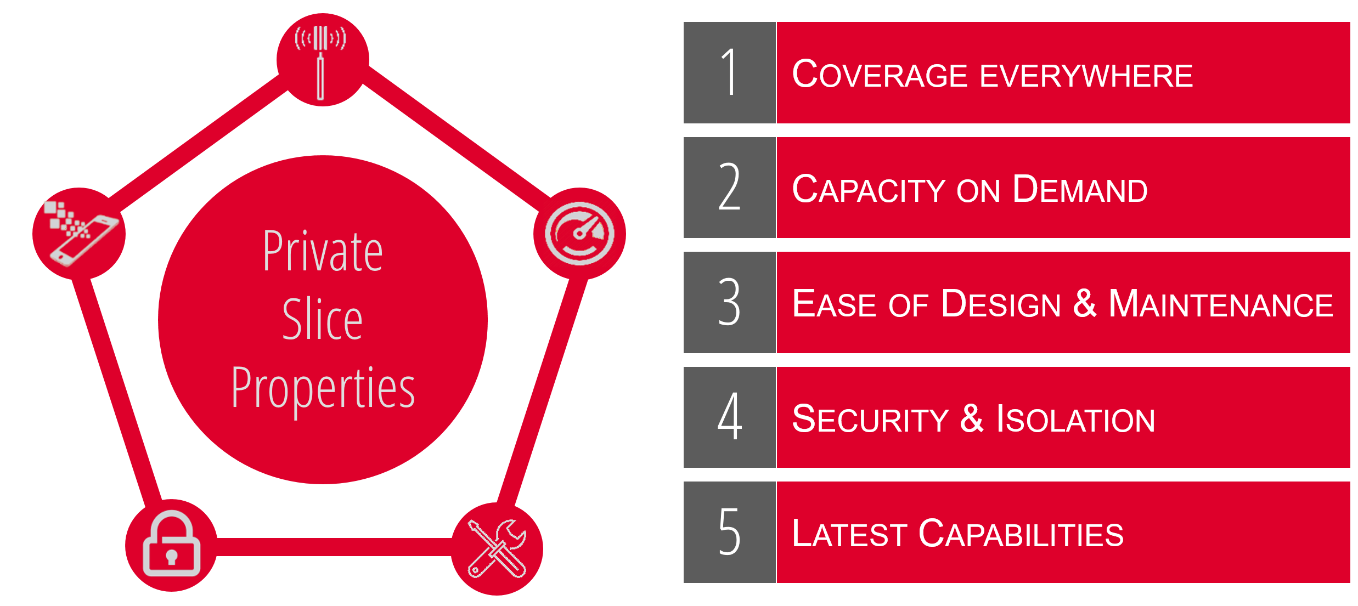

**Design, ease of maintenance**: many mobile operators have spent the last 30+ years learning how to deploy networks and how to maintain them. Part of this know-how is independent of the size of the network and will have to be built from ground up in many instances. As a comparison, very few companies providing WiFi connectivity in their premises perform the design and maintenance of the WiFi Access points.

**Security and Isolation**: in the course of the interviews with vertical industries, security has often been mentioned as a primary concern when considering moving to wireless solutions. More specifically, it is critical in certain use cases that the company data is at all times on machines fully owned by the business (isolation). In some cases customers require that an entire portion of the network is fully dedicated. Though providing isolation reduces the efficiency of network slicing and increases the costs, this is certainly possible to be provided by operators. Customers can of course overlay their own security mechanisms at application level if so desired

**Latest Capabilities**: as it has been the case for 4G, the expected speed of evolution of 5G in the course of the next 10 years will be such as to greatly improve the system KPIs. While it is natural for public network operators to track the progress of standards and update their systems accordingly, it could be a lot harder for a private network to avoid obsolescence.

The allocation in some jurisdictions of spectrum reserved for private use has reignited a debate on the prospect of CSCs to create their own private networks rather than relying on operators public networks.

# Creation of a Specialized Enterprise Network

While the SEN provided to each individual user is highly customized, the conceptual process followed to create it is illustrated in Figure 3. The starting point is always the analysis of the use case requirements that need to be fulfilled. It is important for the CSC to ensure the formulation is sufficiently accurate to guide the CSP to provide adequate resources. Overprovisioning of capabilities or use of dedicated hardware will have an impact on the cost. For each use case, the CSP will populate a GST with the required values (e.g. latency <120ms, precise positioning, …) and will create a NEST. As each CSC may need the mobile network to address several different use cases, the operator will create an adequate number of NESTs. All the NESTs that are needed by the customer are then aggregated in a signel Specialised Enterprise Network that is offered to the customer.

Figure 3: SEN creation process



# Glossary of Terms

Many organisations are engaged in the definition and commercialisation of network slicing and each of them has created its own terminology. This section provides a summary of the terminology used in this booklet as well as, where appropriate whether the same term is used in other organisations with a different meaning.

| Acronym | Term | Description/alternative term |
| --- | --- | --- |
| CSC | Communication Service Customer | The consumer of communication services. Often referred to as “vertical”. |
| CSP | Communication Service Provider | The provider of communication services. Equivalent to Mobile Network Operator |
| SEN | Specialised Enterprise Network | A network slice or a combination of several network slices that form a |
| NS | Network Slice |  |
| NEST | Network Slice Template | a GST filled with values. The attributes and their values are assigned to fulfil a given set of requirements derived from a network slice customer use case |
| GST | Generic Slice/Service Template | a set of attributes that can characterise a type of network slice/service. GST is generic and is not tied to any specific network deployment. |

References

| Ref | Title |
| --- | --- |
|  | GSMA, Network Slicing Taskforce (NEST), “From Vertical Industry Requirements to Network Slice Characteristics”, August 2018. |
|  | GSMA, “Generic Network Slice Template”, April 2019 |
|  | GSMA, Network Slicing Taskforce, “An Introduction to Network Slicing”, 2017. |
|  | 3GPP TS 28.530 V15.1.0 (2018-12) Concepts, use cases and requirements (Release 15) |
|  | “Value Proposition Design: How to Create Products and Services Customers Want”, A. Osterwalder, 2014 |
|  |  |
|  |  |
|  |  |
|  |  |
|  |  |