

Operator Acceptance Values for Device Antenna Performance

Version 7.0

20 October 2025
Security Classification: Non-confidential
Access to and distribution of this document is restricted to the persons permitted by the security classification. This document is subject to copyright protection. This document is to be used only for the purposes for which it has been supplied and information contained in it must not be disclosed or in any other way made available, in whole or in part, to persons other than those permitted under the security classification without the prior written approval of the Association.
Copyright Notice
Copyright © 2025 GSM Association
Disclaimer
The GSM Association (“Association”) makes no representation, warranty or undertaking (express or implied) with respect to and does not accept any responsibility for, and hereby disclaims liability for the accuracy or completeness or timeliness of the information contained in this document. The information contained in this document may be subject to change without prior notice.
Compliance Notice
The information contain herein is in full compliance with the GSM Association’s antitrust compliance policy.
This Permanent Reference Document is classified by GSMA as an Industry Specification, as such it has been developed and is maintained by GSMA in accordance with the provisions set out in GSMA AA.35 - Procedures for Industry Specifications.

Table of Contents
1 Introduction 4
1.1 Overview 4
1.2 Scope 4
1.3 Definition of Terms 5
1.4 Document Cross-References 6
2 Antenna Performance Requirements 7
2.1 Antenna Performance Calculation Formula 8
2.2 Operator Antenna Performance Acceptance Values for 2G and 3G Bands 8
2.3 Operator Antenna Performance Acceptance Values for LTE Bands 9
2.4 Operator Antenna Performance Acceptance Values for 5G NR FR1 12
2.5 Operator Antenna Performance Acceptance Values for FWA devices 16
2.6 Operator Antenna Performance Acceptance Values for Wrist-Worn Devices 21
3 Moving Forward 24
Annex A Measured Values 25
A.1 RAG Status Tables 25
A.1.1 Test Methodology 25
A.1.2 Interpretation 25
A.1.3 Measured Results Tables 26
A.1.4 Further Analysis 28
A.2 Study on Wide Grip Hand 28
A.3 Data Collection Campaign on 5G NR FR1 Bands 29
A.4 Test Campaign on 5G NR FR1 Bands 31
A.5 Survey on EN-DC Combinations 31
A.6 Study on Wrist-Worn Devices 32
A.6.1 TRP & TIS Measurement Data for Low Bands 32
A.6.2 TRP & TIS Measurement Data for Mid/High Bands 33
Annex B Document Management 34
B.1 Document History 34
Other Information 34

Introduction

Overview
Mobile handset design has changed significantly over the past few years. Antennas, which were external in many cases, moved inside the terminal and evolved to be light-weight and low-volume.
The increasing focus on design conflicts with radio performance of the antenna systems can lead to service disruption and increased dropped call rates impacting customer experience. Increasing network density is not an option as it may not be viable in many cases.
Whilst the 3GPP standards define the absolute global minimum OTA performance requirements to be met by devices, numerous operators are already requesting higher values in their own procurement activities to serve customer needs and network rollout plans.
However, the test methods used, and antenna performance values requested by the various operators differ widely, leaving vendors with a fragmented requirements landscape.
To facilitate this alignment and agreement, the antenna experts of operators within the GSMA Terminal Steering Group have reviewed results of antenna performance tests (conducted within their own organisations as well as by the GSMA) and have aligned test methods and agreed on performance values to be used as guidelines for acceptable and achievable performance of antennas in Mobile devices. The values are supported by global operators.
Following the publication of version four in February 2019 [TS.24], the TSG operators have now aligned performance - in addition to 2G/3G/LTE - also for 5G NR FR1 bands.

Scope
This document defines the Operator Acceptance Values for Device Antenna Performance. The values are determined taking into consideration.
- devices being held close to the head with left and right hand (BHHL & BHHR)
- devices being held with one hand only for the purpose of Browsing (HL & HR).
- devices being measured with the Free Space (FS) method.
- device being measured with the wrist phantom left or right (WL or WR)
The requirements (which include measurement uncertainty) are relevant for mobile devices, including feature phones, smart phones, tablets, and dongles. More details can be found in the relevant sections.
These GSMA Operator Acceptance Values for Device Antenna Performance are non-binding, and operators are free to request alternative values as required. It will be up to each individual operator to adopt and enforce the GSMA Operator OTA requirements.
These values serve to align, enhance and promote antenna performance requirements across the industry while seeking to improve device antenna performance and network interoperability.

Note 1: The alignment of the GSMA Operator Acceptance Values for Device Antenna Performance does not impact the test process; this will continue as it is the case today in Operator-Manufacturer bilateral agreements.
Each phase of the work carried out in updating TS.24 has also involved independent tests on commercially available smart phones. The purpose of these tests was to benchmark the Acceptance Values defined in TS.24. For 5G NR FR1 bands, network operators voluntarily provided antenna performance data for devices used in their device portfolio pool. Test campaign has been done in across 8 different labs.
In this version of TS.24 the results of these tests and data collection campaign are published in the appendix.

Definition of Terms
Term | Description
3GPP | 3rd Generation Partnership Project
BHH | Beside Head and Hand
AoA | Angle of Arrival
BHHL | Beside Head and Hand Left
BHHR | Beside Head and Hand Right
BS | Base Station
BW | Bandwidth
CBW | Channel bandwidth
CC | Component Carrier
CCSA | China Communications Standards Association
CPE | Consumer Premises Equipment
CS | Circuit Switched (voice mode)
CTIA | CTIA Certification™
EN-DC | E-UTRA New Radio-Dual Connectivity
DUT | Device Under Test
EPS | Equal Power Sharing. In EN-DC mode Tx power is equally shared between NR and LTE bands (Option B)
FDD | Frequency Division Duplex
E-UTRA | Evolved Universal Terrestrial Radio Access
FS | Free Space
FR1 | 5G Frequency Range 1 (410 MHz – 7125 MHz)
FR2 | 5G Frequency Range 2 (24250 MHz – 52600 MHz)
FWA | Fixed Wireless Access
GSM / E-GSM | Global System for Mobile Communication/ Extended-GSM
GSMA | GSM Association
HL | Browsing mode with Hand Left Only
HR | Browsing mode with Hand Right Only
LTE | Long Term Evolution
MIMO | Multiple Input Multiple Output
MS | Mobile Station
NR | New Radio
NHPRP | Near-Horizon Partial Radiated Power
NHPIS | Near-Horizon Partial Isotropic Sensitivity
NR FR1 | New Radio in frequency range 1 bands
NR FR2 | New Radio in frequency range 2 bands
NSA | Non-Standalone
OEM | Original Equipment Manufacturer
Option A/B | Power sharing. Option A: max power on NR and min power on LTE. Option B: power is shared equally between NR and LTE
OTA | Over The Air (without cable)
RAG | Red, Amber, Green
RedCap | Reduced Capability
PC | Power class. PC3=23 dBm; PC2=26 dBm conducted Tx power
RB | Resource Block
RMC | Reference Measurement Channel
TDD | Time Division Duplex
SA | 5G Standalone
TRP | Total Radiated Power
TRS (TIS) | Total Radiated (Isotropic) Sensitivity
TSG | Terminal Steering Group
TSGFM | Terminal Steering Group Full Members
UE | User Equipment
VoLTE | Voice over LTE
VoNR | Voice over NR
VoIP | Voice over Internet Protocol
WCDMA | Wideband Code Division Multiple Access
WL | Wrist-worn left
WR | Wrist-worn right

Document Cross-References
Ref | Document  Number | Title
CTIA | Latest Active version | The latest active version of the Test Plan, as identified at https://ctiacertification.org/test-plans/.  © CTIA Certification. Referenced with permission. All testing referencing this test plan must be conducted in a CTIA Certification Authorized Test Lab by submitting an OTA  Test Plan Use Request at https://certify.ctiacertification.org/.
3GPP | TS 25.144 | User Equipment (UE) and Mobile Station (MS) over the air performance requirements
3GPP | TS 38.101 | User Equipment (UE) transmission and reception for NR

Antenna Performance Requirements
The following table serves as an internal guideline for mobile operators, who are encouraged to apply the required values in their bilateral agreements with their vendors.
Req ID | Requirement
TS.24_2.0_REQ_001 | For the scenario “Head and Hand” (BHH) and in line with CTIA, the terminal SHALL support an average value of the low, medium and high frequency channels, on both, the left (BHHL) and right (BHHR) hand-side, a performance equal to or above the GSMA performance requirements for that frequency band listed in table 1 and 2 in section 2.2 for 2G/3G and table 3 and 4 in section 2.3 for LTE bands.
TS.24_2.0_REQ_002 | For the scenario “Browsing” (HL or HR) and in line with CTIA, the terminal SHALL support an average value of the low, medium and high frequency channels, on both the left and right hand-side, a performance equal to or above the GSMA performance requirements for that frequency band listed in table 1 and 2 in section 2.2 for 2G/3G and table 3 and 4 in section 2.3 for LTE bands.
TS.24_2.0_REQ_003 | For the scenario “Free Space” (FS) and in line with CTIA, the terminal SHALL support an average value of the low, medium and high frequency channels a performance equal to or above the GSMA performance requirements for that frequency band listed in table 1 and 2 in section 2.2 for 2G/3G and table 3 and 4 in section 2.3 for LTE bands.
TS.24_2.0_REQ_004 | No measured channel SHALL be 1 dB worse than the performance values defined for that frequency band.
TS.24_2.0_REQ_005 | The CTIA/3GPP PDA hand SHALL be used for testing a device which is between 56 mm and 72 mm (inclusive) wide.
TS.24_2.0_REQ_006 | The CTIA Wide Grip hand SHALL be used for testing a device which exceeds 72 mm but does not exceed 92 mm in width.
TS.24_2.0_REQ_007 | TRP and TRS values agreed for 5G NR FR1 bands in EN-DC and SA modes
TS.24_2.0_REQ_008 | Requirements for FWA devices added
TS.24_2.0_REQ_009 | The CTIA Forearm phantom (0.3 – 3 GHz) shall be used for wrist-worn devices (WL or WR)
TS.24_2.0_REQ_010 | Requirements for wrist-worn devices added for LTE bands

Antenna Performance Calculation Formula
Note 2:
  - The values include measurement uncertainty.
  - Operators may accept alternative values for bands outside of their home market.
  - BHH and Browsing acceptance values are the same for devices tested using the PDA and Wide Grip hand phantom.

Operator Antenna Performance Acceptance Values for 2G and 3G Bands
The following tables list the Operator Antenna Performance Values per test scenario and frequency band (2G and 3G).
Test scenario:
Head and Hand (BHH):
Relevant for devices that support voice and do not exceed the maximum dimensions specified for hand phantom (92 mm) [CTIA]. The values are defined considering head and hand and are relevant for left or right hand.
PDA hand is used for testing devices with widths 56 – 72 mm.
Wide Grip hand is used for testing devices with widths >72 - 92 mm.

Browsing (HL or HR):
Relevant for devices where the display is visible to the end user for data usage and where width ranges are between 56 mm and 92 mm [CTIA]. The values are defined considering one-hand only and are relevant for left or right hand. The 3G frequencies are measured, using a 12.2 Kbps reference measurement channel (RMC).
PDA hand is used for testing devices with widths 56 – 72 mm.
Wide Grip hand is used for testing devices with widths >72 - 92 mm.

Free Space:
Relevant for any device that embeds an antenna and that supports voice and/or data. The applicable measurement method is voice (CS) mode. The 3G frequencies are measured, using a 12.2 Kbps reference measurement channel (RMC).
These acceptance values include measurement uncertainty.
Frequency Band 2G/3G | GSMA Operator Acceptance Values for TRP [dBm]
Frequency Band 2G/3G | BHH (Note 3) | Browsing | Free Space
GSM 850 | 20.0 | 24.0 | 27.0
EGSM 900 | 20.0 | 25.0 | 28.0
GSM 1800 | 21.0 | 23.0 | 26.0
GSM 1900 | 21.0 | 23.0 | 26.0
WCDMA Band 1 | 15.0 | 17.0 | 20.0
WCDMA Band 2 | 16.5 | 17.0 | 20.0
WCDMA Band 3 | 13.5 | 14.7 | 17.7
WCDMA Band 5 | 11.0 | 14.7 | 17.7
WCDMA Band 8 | 11.0 | 15.0 | 18.0
WCDMA Band 19 | 11.0 | 15.5 | 18.0
- : GSMA Operator Acceptance Values for TRP for 2G and 3G bands

Frequency Band 2G/3G | GSMA Operator Acceptance Values for TRS [dBm]
Frequency Band 2G/3G | BHH (Note 3) | Browsing | Free Space
GSM 850 | -97.0 | -99.0 | -103.0
EGSM 900 | -95.0 | -99.0 | -103.0
GSM 1800 | -99.0 | -100.0 | -104.0
GSM 1900 | -99.5 | -100.0 | -103.0
WCDMA Band 1 | -101.0 | -103.0 | -106.0
WCDMA Band 2 | -98.5 | -101.0 | -104.0
WCDMA Band 3 | -98.5 | -99.0 | -102.0
WCDMA Band 5 | -94.5 | -100.0 | -103.0
WCDMA Band 8 | -96.0 | -101.0 | -104.0
WCDMA Band 19 | -96.0 | -102.0 | -104.5
- : GSMA Operator Acceptance Values for TRS for 2G and 3G bands

Operator Antenna Performance Acceptance Values for LTE Bands
The following tables list the Operator Antenna Performance Values per test scenario and frequency band (LTE).
Test scenario:
Head and Hand (BHH):
Relevant for devices that support voice (e.g., VoLTE, VoIP). The relevant hand phantom is to be used according to the device’s width:
PDA hand is used for testing devices with widths 56 – 72 mm.
Wide Grip hand is used for testing devices with widths >72 - 92 mm.
The values are relevant for left or right hand.
Browsing (HL or HR):
Relevant for devices where the display is visible to the end user for data usage and relevant hand phantom to be used according to the device’s width:
PDA hand is used for testing devices with widths 56 – 72 mm.
Wide Grip hand is used for testing devices with widths >72 - 92 mm.
The values are defined considering one-hand only and are relevant for left or right hand.
Free Space:
Relevant for any device that embeds an antenna and supports voice (e.g., VoLTE, VoIP) and /or data.
These acceptance values include measurement uncertainty.
Settings during testing
TRP:
Single antenna transmitting
Uplink RB Allocation: 12
TRS:
All receivers/antennas active
Downlink RB Allocation: 50
Bandwidth: 10 MHz

Frequency Band LTE | GSMA Operator Acceptance Values for TRP [dBm]
Frequency Band LTE | BHH (Note 3) | Browsing | Free Space
FDD Band 1 | 13.5 | 15.5 | 18.5
FDD Band 2 | 13.5 | 15.5 | 18.5
FDD Band 3 | 13.5 | 15.5 | 18.5
FDD Band 4 | 13.5 | 15.5 | 18.5
FDD Band 5 | 9.8 | 14.3 | 18.0
FDD Band 7 | 13.5 | 15.5 | 18.5
FDD Band 8 | 9.8 | 14.3 | 18.0
FDD Band 11 | 11.5 | 14.5 | 18.0
FDD Band 12 | 9.8 | 14.3 | 18.0
FDD Band 13 | 9.8 | 14.3 | 18.0
FDD Band 17 | 9.8 | 14.3 | 18.0
FDD Band 18 | 9.8 | 14.3 | 18.0
FDD Band 19 | 9.8 | 14.3 | 18.0
FDD Band 20 | 9.8 | 14.3 | 18.0
FDD Band 21 | 11.5 | 14.5 | 18.0
FDD Band 25 | 13.5 | 15.5 | 18.5
FDD Band 26 | 9.8 | 14.3 | 18.0
FDD Band 28 | 9.8 | 14.3 | 18.0
TDD Band 38 | 13.5 | 15.5 | 18.5
TDD Band 39 | 13.5 | 15.5 | 18.5
TDD Band 40 | 13.5 | 15.5 | 18.5
TDD Band 41 | 13.5 | 15.5 | 18.5
TDD Band 42 | 13.5 | 15.5 | 18.5
TDD Band 43 | 13.5 | 15.5 | 18.5
- : GSMA Operator Acceptance Values for TRP for the LTE Bands

Frequency Band LTE | GSMA Operator Acceptance Values for TRS [dBm]
Frequency Band LTE | BHH (Note 3) | Browsing | Free Space
FDD Band 1 | -89.0 | -91.0 | -94.0
FDD Band 2 | -89.0 | -91.0 | -94.0
FDD Band 3 | -89.0 | -91.0 | -94.0
FDD Band 4 | -89.0 | -91.0 | -94.0
FDD Band 5 | -85.0 | -89.5 | -93.5
FDD Band 7 | -89.0 | -91.0 | -94.0
FDD Band 8 | -85.0 | -89.5 | -93.5
FDD Band 11 | -87.0 | -90.0 | -93.5
FDD Band 12 | -85.0 | -89.5 | -93.5
FDD Band 13 | -85.0 | -89.5 | -93.5
FDD Band 17 | -85.0 | -89.5 | -93.5
FDD Band 18 | -85.0 | -89.5 | -93.5
FDD Band 19 | -85.0 | -89.5 | -93.5
FDD Band 20 | -85.0 | -89.5 | -93.5
FDD Band 21 | -87.0 | -90.0 | -93.5
FDD Band 25 | -89.0 | -91.0 | -94.0
FDD Band 26 | -85.0 | -89.5 | -93.5
FDD Band 28 | -85.0 | -89.5 | -93.5
TDD Band 38 | -89.0 | -91.0 | -94.0
TDD Band 39 | -89.0 | -91.0 | -94.0
TDD Band 40 | -89.0 | -91.0 | -94.0
TDD Band 41 | -89.0 | -91.0 | -94.0
TDD Band 42 | -89.0 | -91.0 | -94.0
TDD Band 43 | -89.0 | -91.0 | -94.0
- GSMA Operator Acceptance Values for TRS for the LTE Bands
Note 3: BHH and Browsing acceptance values are the same for PDA and Wide Grip hand phantom.

Operator Antenna Performance Acceptance Values for 5G NR FR1
The following tables list the Operator Antenna Performance Values per test scenario and frequency band for 5G NR FR1.
Requirements are defined for EN-DC (NSA) and 5G SA.
If a device supports both NSA and SA it’s up to the MNO to request which configuration they would like to test the device.
However, it is recommended for test optimization perspective to perform the full OTA test (TRP and TRS) in SA mode and in addition to test TRP at a mid-channel in EN-DC mode.
TRP requirements for PC3 are defined for all NR bands listed in this document.
Although 3GPP has not yet defined PC2 conducted values for the FDD bands, TRP requirements have been defined for PC2 in all FDD bands listed in this document.

Test scenario:
Head and Hand (BHH):
Relevant for devices that support voice (e.g., VoIP, VoNR). The relevant hand phantom is to be used according to the device’s width:
PDA hand is used for testing devices with widths 56 – 72 mm.
Wide Grip hand is used for testing devices with widths >72 - 92 mm.
The values are relevant for left or right hand.
Browsing (HL or HR):

Relevant for devices where the display is visible to the end user for data usage and relevant hand phantom to be used according to the device’s width:
PDA hand is used for testing devices with widths 56 – 72 mm.
Wide Grip hand is used for testing devices with widths >72 - 92 mm.
The values are defined considering one-hand only and are relevant for left or right hand.
Note 4: Head and hand phantoms used for 2G/3G/LTE bands can also be used for the defined NR bands in this document.
Free Space:
Relevant for any device that embeds an antenna and supports voice (e.g., VoIP, VoNR) and /or data.
These acceptance values include measurement uncertainty.
Settings during testing
TRP:
Single antenna transmitting.
Option A: Max Tx power on NR, min Tx power on LTE (10 dBm regardless of device’s PC for NR band).
Option B: Tx Power equally shared between LTE and NR (EPS).
TRS:
All receivers/antennas active.
Bandwidth: see table
Converting a measured TRS value with BW1 to a TRS value with BW2 is possible:
Δ= 10*log(BW2/BW1)
Example: BW1= 100 MHz; BW2 = 20 MHz
Δ = 10*log(20/100) = -7 dB
-86 dBm @ (100 MHz) -93 dBm @ (20 MHz)

NR FR1 Frequency Band | GSMA Operator Acceptance Values for TRP [dBm] in EN-DC Mode for PC3
NR FR1 Frequency Band | BHH (Note 4) |  | Browsing (Note 4) |  | Free Space
Option | A | B | A | B | A | B
N1 | 14 | 12 | 16 | 14 | 18.5 | 16.5
N3 | 14 | 12 | 16 | 14 | 18.5 | 16.5
N5 | 10.5 | 8.5 | 14.5 | 12.5 | 18.5 | 16.5
N7 | 14 | 12 | 16 | 14 | 18.5 | 16.5
N8 | 10.5 | 8.5 | 14.5 | 12.5 | 18.5 | 16.5
N20 | 10.5 | 8.5 | 14.5 | 12.5 | 18.5 | 16.5
N26 | 10.5 | 8.5 | 14.5 | 12.5 | 18.5 | 16.5
N28 | 10.5 | 8.5 | 14.5 | 12.5 | 18.5 | 16.5
N40 | 14 | 12 | 16 | 14 | 18.5 | 16.5
N77 | 14 | 12 | 16 | 14 | 18.5 | 16.5
N78 | 14 | 12 | 16 | 14 | 18.5 | 16.5
- : GSMA Operator Acceptance Values for TRP for the NR FR1 Bands in EN-DC mode

NR FR1 Frequency Band (BW) | GSMA Operator Acceptance Values for TRS [dBm] in EN-DC Mode
NR FR1 Frequency Band (BW) | BHH (Note 4) |  | Browsing (Note 4) |  | Free Space
Option | A | B | A | B | A | B
N1 (20 MHz) | -90 | -90 | -92 | -92 | -94 | -94
N3 (20 MHz) | -90 | -90 | -92 | -92 | -94 | -94
N5 (10 MHz) | -86 | -86 | -90 | -90 | -94 | -94
N7 (20 MHz) | -90 | -90 | -92 | -92 | -94 | -94
N8 (10 MHz) | -86 | -86 | -90 | -90 | -94 | -94
N20 (10 MHz) | -86 | -86 | -90 | -90 | -94 | -94
N26 (10 MHz) | -86 | -86 | -90 | -90 | -94 | -94
N28 (10 MHz) | -86 | -86 | -90 | -90 | -94 | -94
N40 (20 MHz) | -90 | -90 | -92 | -92 | -94 | -94
N77 (20 MHz) | -90 | -90 | -92 | -92 | -94 | -94
N78 (20 MHz) | -90 | -90 | -92 | -92 | -94 | -94
- : GSMA Operator Acceptance Values for TRS for the NR FR1 Bands in EN-DC mode

NR FR1 Frequency Band | GSMA Operator Acceptance Values for TRP [dBm] in SA Mode for PC3
NR FR1 Frequency Band | BHH (Note 4) | Browsing (Note 4) | Free Space
N1 | 14 | 16 | 19
N3 | 14 | 16 | 19
N5 | 10.5 | 15 | 18.5
N7 | 14 | 16 | 19
N8 | 10.5 | 15 | 18.5
N20 | 10.5 | 15 | 18.5
N26 | 10.5 | 15 | 18.5
N28 | 10.5 | 15 | 18.5
N40 | 14 | 16 | 19
N77 | 14 | 16 | 19
N78 | 14 | 16 | 19
- : GSMA Operator Acceptance Values for TRP for the NR FR1 Bands in SA mode for PC3 (23 dBm)

NR FR1 Frequency Band | GSMA Operator Acceptance Values for TRP [dBm] in SA Mode for PC2
NR FR1 Frequency Band | BHH (Note 4) | Browsing (Note 4) | Free Space
N1 | 17 | 19 | 22
N3 | 17 | 19 | 22
N5 | 13 | 17.5 | 21
N7 | 17 | 19 | 22
N8 | 13 | 17.5 | 21
N20 | 13 | 17.5 | 21
N26 | 13 | 17.5 | 21
N28 | 13 | 17.5 | 21
N40 | 17 | 19 | 22
N77 | 17 | 19 | 22
N78 | 17 | 19 | 22
- : GSMA Operator Acceptance Values for TRP for the NR FR1 Bands in SA mode for PC2 (26 dBm)

NR FR1 Frequency Band (BW) | GSMA Operator Acceptance Values for TRS [dBm] in SA Mode
NR FR1 Frequency Band (BW) | BHH (Note 4) | Browsing (Note 4) | Free Space
N1 (20 MHz) | -90 | -92 | -94
N3 (20 MHz) | -90 | -92 | -94
N5 (10 MHz) | -86 | -90 | -94
N7 (20 MHz) | -90 | -92 | -94
N8 (10 MHz) | -86 | -90 | -94
N20 (10 MHz) | -86 | -90 | -94
N26 (10 MHz) | -86 | -90 | -94
N28 (10 MHz) | -86 | -90 | -94
N40 (20 MHz) | -90 | -92 | -94
N77 (20 MHz) | -90 | -92 | -94
N78 (20 MHz) | -90 | -92 | -94
- : GSMA Operator Acceptance Values for TRS for the NR FR1 Bands

Operator Antenna Performance Acceptance Values for FWA devices

In this section antenna performance acceptance values are defined for products with integrated cellular modules which are mostly used as data access points. These are products like FWA (Fixed Wireless Access) devices, CPEs (Consumer Premises Equipment). In this section, only LTE and 5G NR (FR1 and FR2) frequency bands are considered. This kind of devices are normally not used close to human body like a mobile phone and thus used only for data transfer between device and base station (BS) via cellular network. However, there are different environments possible during operation, such as:
- Device mounted on a pole (e.g., an outdoor FWA device)
- Device mounted on a wall (e.g., an outdoor router, FWA device)
- Device on a desk (e.g., an indoor FWA device)
It’s also important to distinguish between indoor and outdoor use cases.
For indoor use case (e.g. device on a desk) an omnidirectional antenna pattern for the device is recommended since the Angle of Arrival (AoA) is not defined due to multiple arbitrary reflections of the Rx and Tx signals from the walls and obstacles.
Devices can also be installed outdoors by mounting on a pole or a wall. However, in this document DUTs utilizing an external antenna are not considered, because the external antenna is not part of the device and thus it’s designed independently from the device.
For indoor use case it is appropriate to measure TRP and TRS in all spherical directions (3D).
For outdoor use case with integrated directional antennas, it is more appropriate to consider only a part of the space above the horizon (e.g., +/- 30°). For this scenario the CTIA certification near horizon metric could be used. Regardless which material the wall or pole consist of, the CTIA defined near horizon parameters are recommended:
For radiated power:
- NHPRP=Near-Horizon Partial Radiated Power
For radiated sensitivity:
- NHPIS=Near-Horizon Partial Isotropic Sensitivity
As these devices are not used close to human body, the acceptance values are defined for Free Space (FS) use case.
It is recommended to test device with near horizon metric when device’s antenna is considered as directive one (based on manufacturer declaration estimated antenna gain of more than 6 dBi is considered as directive antenna). Otherwise, device’s antenna is considered as non-directive one and therefore it is recommended to test the device in conventional way (3D).
Frequency Band LTE | GSMA Operator Acceptance Values for TRP [dBm] for FWA devices
Frequency Band LTE | Non-Directional integrated antenna - Free Space - 3D | Directional integrated antenna - Free Space – NHPRP+/-30°
FDD Band 1 | 19.5 | 17.5
FDD Band 2 | 19.5 | 17.5
FDD Band 3 | 19.5 | 17.5
FDD Band 4 | 19.5 | 17.5
FDD Band 5 | 19.0 | 17.0
FDD Band 7 | 19.5 | 17.5
FDD Band 8 | 19.0 | 17.0
FDD Band 11 | 19.0 | 17.0
FDD Band 12 | 19.0 | 17.0
FDD Band 13 | 19.0 | 17.0
FDD Band 17 | 19.0 | 17.0
FDD Band 18 | 19.0 | 17.0
FDD Band 19 | 19.0 | 17.0
FDD Band 20 | 19.0 | 17.0
FDD Band 21 | 19.0 | 17.0
FDD Band 25 | 19.5 | 17.5
FDD Band 26 | 19.0 | 17.0
FDD Band 28 | 19.0 | 17.0
TDD Band 38 | 19.5 | 17.5
TDD Band 39 | 19.5 | 17.5
TDD Band 40 | 19.5 | 17.5
TDD Band 41 | 19.5 | 17.5
TDD Band 42 | 19.5 | 17.5
TDD Band 43 | 19.5 | 17.5
- : GSMA Operator Acceptance Values for TRP for the LTE bands in Free Space for PC3

Frequency Band LTE | GSMA Operator Acceptance Values for TRS [dBm] for FWA devices
Frequency Band LTE | Non-Directional integrated antenna - Free Space - 3D | Directional integrated antenna - Free Space – NHPIS+/-30°
FDD Band 1 | -95.5 | -93.5
FDD Band 2 | -95.5 | -93.5
FDD Band 3 | -95.5 | -93.5
FDD Band 4 | -95.5 | -93.5
FDD Band 5 | -95.0 | -93.0
FDD Band 7 | -95.5 | -93.5
FDD Band 8 | -95.0 | -93.0
FDD Band 11 | -95.0 | -93.0
FDD Band 12 | -95.0 | -93.0
FDD Band 13 | -95.0 | -93.0
FDD Band 17 | -95.0 | -93.0
FDD Band 18 | -95.0 | -93.0
FDD Band 19 | -95.0 | -93.0
FDD Band 20 | -95.0 | -93.0
FDD Band 21 | -95.0 | -93.0
FDD Band 25 | -95.5 | -93.5
FDD Band 26 | -95.0 | -93.0
FDD Band 28 | -95.0 | -93.0
TDD Band 38 | -95.5 | -93.5
TDD Band 39 | -95.5 | -93.5
TDD Band 40 | -95.5 | -93.5
TDD Band 41 | -95.5 | -93.5
TDD Band 42 | -95.5 | -93.5
TDD Band 43 | -95.5 | -93.5
- : GSMA Operator Acceptance Values for TRS for the LTE bands in Free Space with 10 MHz Bandwidth for all bands
Frequency Band NR | GSMA Operator Acceptance Values for TRP [dBm] for FWA devices
Frequency Band NR | Non-Directional integrated antenna - Free Space - 3D | Directional integrated antenna - Free Space – NHPRP+/-30°
N1 | 19.5 | 17.5
N3 | 19.5 | 17.5
N5 | 19.5 | 17.5
N7 | 19.5 | 17.5
N8 | 19.5 | 17.5
N20 | 19.5 | 17.5
N26 | 19.5 | 17.5
N28 | 19.5 | 17.5
N40 | 19.5 | 17.5
N77 | 19.5 | 17.5
N78 | 19.5 | 17.5
- : GSMA Operator Acceptance Values for TRP for the NR bands in Free Space in EN-DC for PC3
Note: Only mode A to be consider (Max Power on NR)
Frequency Band NR | GSMA Operator Acceptance Values for TRS [dBm] for FWA devices
Frequency Band NR | Non-Directional integrated antenna - Free Space - 3D | Directional integrated antenna - Free Space – NHPIS+/-30°
N1 (20 MHz) | -95.5 | -93.5
N3 (20 MHz) | -95.5 | -93.5
N5 (10 MHz) | -95.5 | -93.5
N7 (20 MHz) | -95.5 | -93.5
N8 (10 MHz) | -95.5 | -93.5
N20 (10 MHz) | -95.5 | -93.5
N26 (10 MHz) | -95.5 | -93.5
N28 (10 MHz) | -95.5 | -93.5
N40 (20 MHz) | -95.5 | -93.5
N77 (20 MHz) | -95.5 | -93.5
N78 (20 MHz) | -95.5 | -93.5
- : GSMA Operator Acceptance Values for TRS for the NR bands in Free Space in EN-DC
Frequency Band NR | GSMA Operator Acceptance Values for TRP [dBm] for FWA devices
Frequency Band NR | Non-Directional integrated antenna - Free Space - 3D | Directional integrated antenna - Free Space – NHPRP+/-30°
N1 | 20 | 18.0
N3 | 20 | 18.0
N5 | 19.5 | 17.5
N7 | 20 | 18.0
N8 | 19.5 | 17.5
N20 | 19.5 | 17.5
N26 | 19.5 | 17.5
N28 | 19.5 | 17.5
N40 | 20 | 18.0
N77 | 20 | 18.0
N78 | 20 | 18.0
- : GSMA Operator Acceptance Values for TRP for the NR bands in Free Space in SA for PC3
Note: Only mode A to be consider (Max Power on NR)
Frequency Band NR | GSMA Operator Acceptance Values for TRP [dBm] for FWA devices
Frequency Band NR | Non-Directional integrated antenna - Free Space - 3D | Directional integrated antenna - Free Space – NHPRP+/-30°
N1 | 23 | 21
N3 | 23 | 21
N5 | 22 | 20
N7 | 23 | 21
N8 | 22 | 20
N20 | 22 | 20
N26 | 22 | 20
N28 | 22 | 20
N40 | 23 | 21
N77 | 23 | 21
N78 | 23 | 21
- : GSMA Operator Acceptance Values for TRP for the NR bands in Free Space in SA for PC2
Note: Only mode A to be consider (Max Power on NR)

Frequency Band NR | GSMA Operator Acceptance Values for TRS [dBm] for FWA devices
Frequency Band NR | Non-Directional integrated antenna - Free Space - 3D | Directional integrated antenna - Free Space – NHPIS+/-30°
N1 (20 MHz) | -95.5 | -93.5
N3 (20 MHz) | -95.5 | -93.5
N5 (10 MHz) | -95.5 | -93.5
N7 (20 MHz) | -95.5 | -93.5
N8 (10 MHz) | -95.5 | -93.5
N20 (10 MHz) | -95.5 | -93.5
N26 (10 MHz) | -95.5 | -93.5
N28 (10 MHz) | -95.5 | -93.5
N40 (20 MHz) | -95.5 | -93.5
N77 (20 MHz) | -95.5 | -93.5
N78 (20 MHz) | -95.5 | -93.5
- : GSMA Operator Acceptance Values for TRS for the NR bands in Free Space in SA

Operator Antenna Performance Acceptance Values for Wrist-Worn Devices

In this section, antenna performance acceptance values are defined for products worn on the human wrist. Examples of such wrist-worn devices include smartwatches, kids' watches, medical wrist-worn devices, SOS bracelets, and ID bracelets. The values are defined considering the device worn on left or right wrist (WL or WR).
In this version, only the LTE bands tested with the CTIA forearm phantom, defined for the frequency range 0.3 – 3 GHz, are considered. 5G NR bands will be considered in a later version. To define realistic values for TRP and TRS, measurement data from 20 smartwatches tested in independent antenna labs, were analysed (see details in the appendix). In all cases, the tested devices contained a single antenna for both Tx and Rx.
The recommended limits in the tables below are defined for wrist-worn devices with at least one antenna with PC3 (Tx) and 10 MHz bandwidth (Rx). Devices with PC2 are expected to have higher TRP values (not considered in this version). Devices with more than two antennas for Rx could achieve better downlink (TRS) performance.
Frequency Band LTE | GSMA Operator Acceptance Values for TRP [dBm] for Wrist-Worn Devices
Frequency Band LTE | Wrist-Mode, right (WR) or left (WL)
FDD Band 1 | 11.5
FDD Band 2 | 11.5
FDD Band 3 | 11.5
FDD Band 4 | 11.5
FDD Band 5 | 8.0
FDD Band 7 | 11.5
FDD Band 8 | 8.0
FDD Band 11 | 10.5
FDD Band 12 | 8.0
FDD Band 13 | 8.0
FDD Band 17 | 8.0
FDD Band 18 | 8.0
FDD Band 19 | 8.0
FDD Band 20 | 8.0
FDD Band 21 | 10.5
FDD Band 25 | 11.5
FDD Band 26 | 8.0
FDD Band 28 | 8.0
TDD Band 38 | 11.5
TDD Band 39 | 11.5
TDD Band 40 | 11.5
TDD Band 41 | 11.5
- : GSMA Operator Acceptance Values for TRP for the LTE bands in Wrist-Mode (WL or WR) with PC3

Frequency Band LTE | GSMA Operator Acceptance Values for TRS [dBm] for Wrist-Worn Devices
Frequency Band LTE | Wrist-Mode, right (WR) or left (WL)
FDD Band 1 | -86.0
FDD Band 2 | -86.0
FDD Band 3 | -86.0
FDD Band 4 | -86.0
FDD Band 5 | -83.0
FDD Band 7 | -86.0
FDD Band 8 | -83.0
FDD Band 11 | -85.5
FDD Band 12 | -83.0
FDD Band 13 | -83.0
FDD Band 17 | -83.0
FDD Band 18 | -83.0
FDD Band 19 | -83.0
FDD Band 20 | -83.0
FDD Band 21 | -85.5
FDD Band 25 | -86.0
FDD Band 26 | -83.0
FDD Band 28 | -83.0
TDD Band 38 | -86.0
TDD Band 39 | -86.0
TDD Band 40 | -86.0
TDD Band 41 | -86.0
- : GSMA Operator Acceptance Values for TRS for the LTE bands in Wrist-Mode (WL or WR) with 10 MHz bandwidth

Moving Forward
The GSMA operators will progress:
- To run tests with wrist-worn devices in 5G NR bands in RedCap mode
- To run tests with PC2 in EN-DC mode. Add acceptance limits for PC2 in EN-DC mode.
- Define acceptance limits for 5G NR FR2
In addition, operators will continue to test antenna performance of market devices and actively monitor and/or engage in work driven in relevant industry bodies.
- Measured Values
As part of the process to derive the harmonised Operator Acceptance Values published in this document the GSMA has, for each phase of the work, carried out independent tests on commercially available Smartphones. These devices are taken from consumer stock, and are not prototype or engineering samples provided by the OEMs.
In this appendix, the results from these tests have been published.
The purpose of the tests was to benchmark the acceptance values defined in TS.24 and to ensure that they represent a realistic achievable target that manufacturers of devices can readily achieve.
All device results have been anonymised.
  - RAG Status Tables
The tables published in this appendix include a RAG (Red Amber Green) colour coding. This RAG status can be interpreted as follows:
Red = fails to meet the GSMA TS.24 acceptance value by a value greater than 2 dB
Amber = within 2 dB of the GSMA TS.24 acceptance value
Green = meets or surpasses the GSMA TS.24 acceptance value
The 2 dB margin used to define the Amber category reflects that the acceptance values published in this document are a harmonised average of the values contributed by operators who took part in this work.
It also recognises that some operators have a small tolerance in their acceptance values so that they do not block the launch of a device that marginally fails to meet their requirements. These tolerances are usually defined on a bilateral basis and are reviewed per device.
Because of the above the tables below try to reflect this reality through use of the 2 dB margin which defines values in Amber.

A.1.1 Test Methodology
Device selection was based on a random selection of commercially available devices at the time of measurement, typically these devices are from Tier 1 OEMs and are their Flagship or high-volume selling products.
The tests were carried out in an independent antenna lab, accredited by both CTIA (e.g., a CTIA Certification Authorized Test Lab) and GCF (Global Certification Forum).
The specific test methodologies used, followed the recommendations issued by CTIA.

A.1.2 Interpretation
For the purpose of this work these tables were used to assess the values defined in TS.24, and to ensure that when the 2 dB margin is taken into account, the significant majority of devices are able to meet or surpass the acceptance values published in TS.24.

A.1.3 Measured Results Tables
- : TRP and TRS RAG status of tested devices in 2G/3G bands for the use cases Browsing and Free Space (status: 2013)
- : TRP and TRS RAG status of tested devices in 2G/3G bands for head & hand use case (status: 2013)
- : TRP RAG status of tested devices in LTE bands for head & hand use case (status: 2015)

- : TRS RAG status of tested devices in LTE bands for head & hand use case (status: 2015)

A.1.4 Further Analysis
As part of the analysis, it was noticed that there could be a perceived trend that demonstrates a difference between left hand and right hand performance. Further analysis of this trend is required to establish if this is a genuine trend or just an anomaly in the results. The TSGFM Group would like to draw attention to this as it was noted that accreditation in some regions is still limited to testing with the right hand, and therefore there could be a correlation between this and some products being optimized for performance in the right hand.
The sample of measured product is too small to establish if this trend is real, but it has been noted for further study during future measurement and test campaigns carried out by GSMA.
  - Study on Wide Grip Hand
More and more devices with big screens (including many flagship models) are introduced to the market and there are still no requirements on devices wider than 72 mm. Therefore CCSA (China Communications Standards Association) made a big study with many devices with widths between 72 – 92 mm using the CTIA Wide Grip hand phantom. TRP and TIS values in BHHR (“Talk” right) and HR (“Browsing” right) modes have been measured in 2G/3G/LTE bands used in China.
The study has shown an excellent correlation between GSMA BHH requirements for PDA hand phantom and results of devices tested with Wide Grip hand phantom. The values are selected so that 80% of the devices could pass the CCSA limit. The results show that there are no obvious differences for test results between devices with widths between 72 mm and 92 mm under CTIA Wide Grip hand phantom and devices with widths below 72 mm under PDA hand phantom. So, the limit values can stay unchanged with the test of the PDA hand phantom.

Band (Test Scenario) | TRP (80%) | TRP (TS.24) | TIS (80%) | TIS (TS.24)
GSM 900 (BHHR) | 17 | 20 | -93 | -95
GSM1800 (BHHR) | 19 | 21 | -97 | -99
WCDMA Band 1 (BHHR) | 13.5 | 15 | -100 | -101
LTE Band 3（HR） | 15.5 | 15.5 | -91 | -91
LTE Band 38（HR） | 15 | 15.5 | -86 | -91
LTE Band 39（HR） | 16 | 15.5 | -88 | -91
LTE Band 40（HR） | 15 | 15.5 | -86 | -91
LTE Band 41（HR） | 14.5 | 15.5 | -85 | -91
- : Test results of devices with widths between 72 mm and 92 mm under CTIA Wide Grip hand phantom in comparison to TS.24 limits from the CCSA (status: 2017)

  - Data Collection Campaign on 5G NR FR1 Bands
At first, a data collection campaign was run, and the MNOs were asked to provide TRP and TRS data of devices from their device pool. In total, 313 TRP and 282 TRS values for more than 100 devices were received. Below is an extract with values for N78 band:
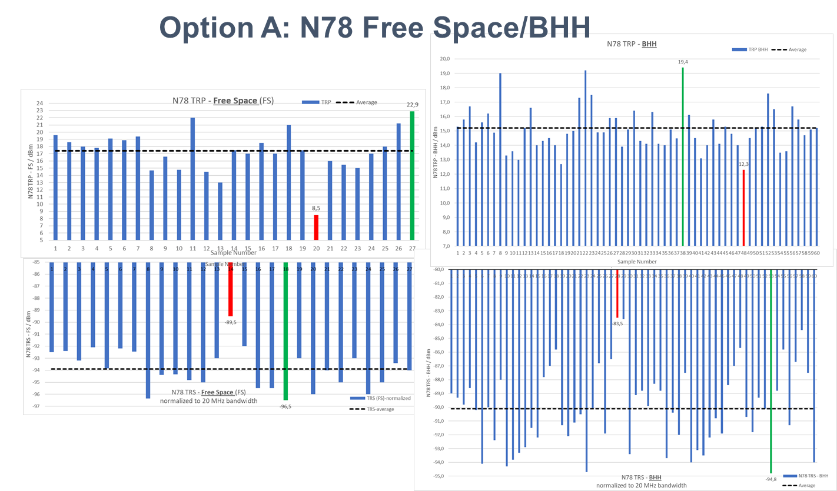
- : TRP and TRS data from MNOs for N78 band (Free Space, Option A). Green: best performing device; Red: worst performing device

Then, the average of all received data was calculated (see below overview):

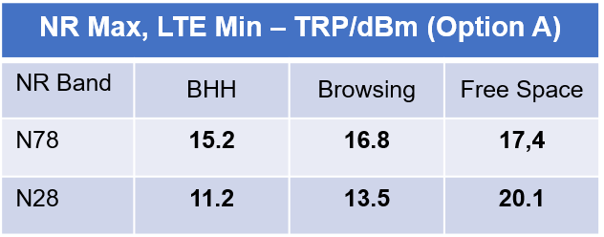
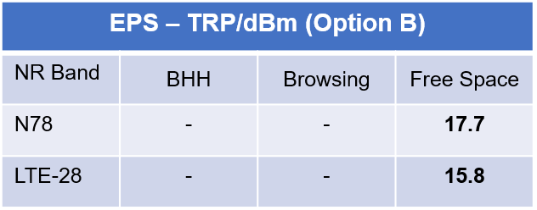
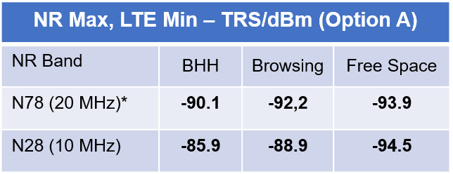
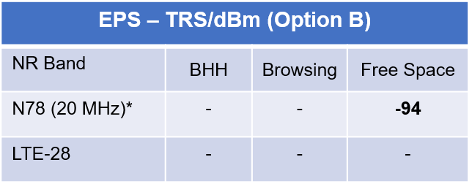

- : Average of all data from MNOs (313 TRP and 282 TRS values). TRS values for N78 are normalized to 20 MHz bandwidth.

* TRS for N78 normalized to 20 MHz bandwidth
  - Test Campaign on 5G NR FR1 Bands
A small test campaign was performed with 6 devices, tested in 8 different labs.
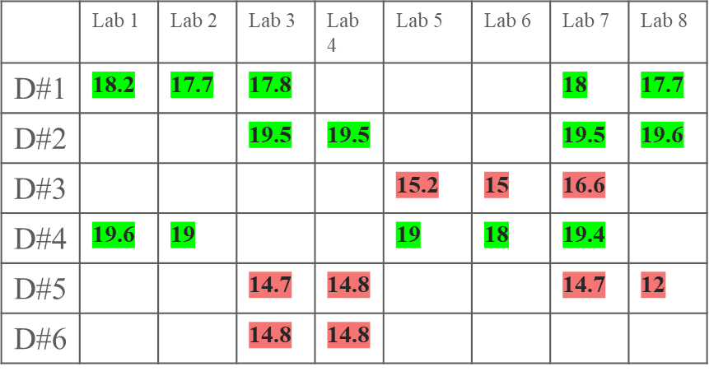
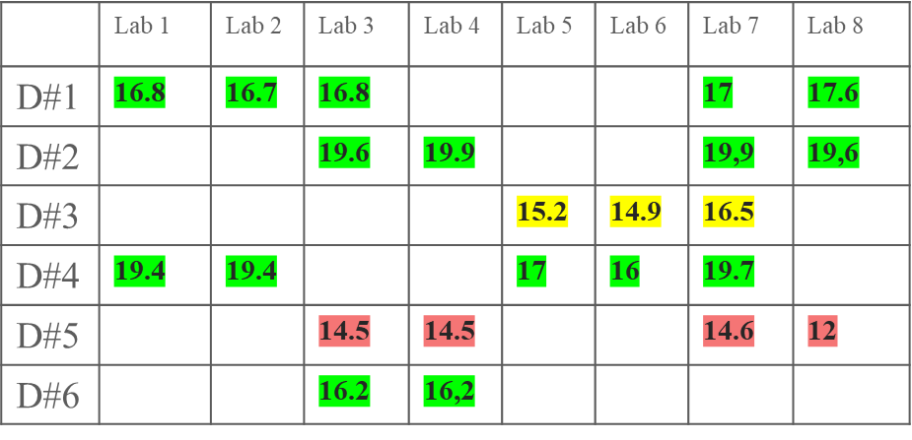

- : TRP results of test campaign with 6 devices tested in 8 different labs. Left: Option A; Right: Option B.
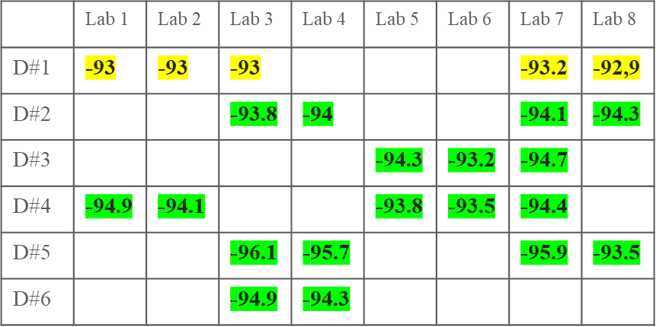
- : TRS results of test campaign with 6 devices tested in 8 different labs
  - Survey on EN-DC Combinations
MNOs have been asked to provide their prioritized EN-DC combinations. The table below shows the most used EN-DC-combinations.
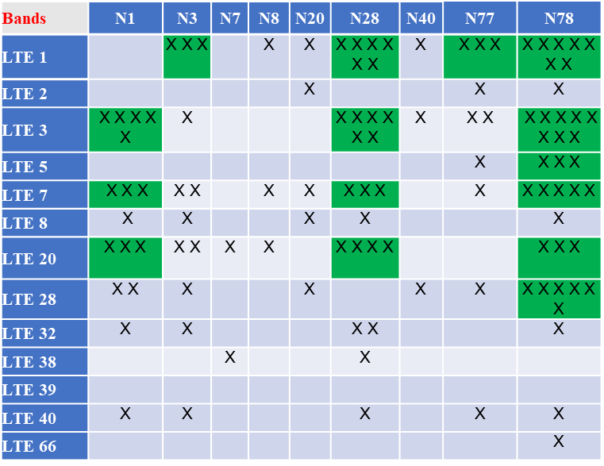
- : Most used EN-DC combinations from survey among MNOs

  - Study on Wrist-Worn Devices
MNOs have been asked to provide test data for wrist-worn devices from their device pool. Data for the LTE bands for 20 smartwatches tested with CTIA forearm phantom, defined for the frequency range 0.3 – 3 GHz, has been received. All tests have been carried out in independent 3rd party antenna labs. The table below shows the collected data for TRP and TIS.
    - TRP & TIS Measurement Data for Low Bands

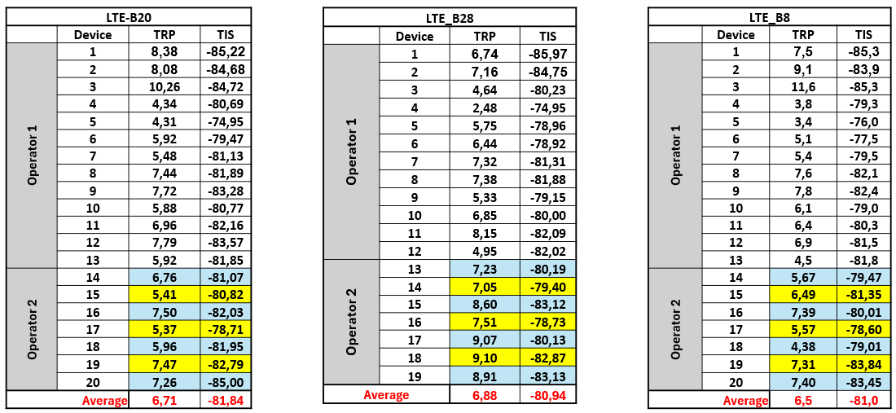
- : Received measurement data in dBm for smartwatches tested for the LTE bands B20, B28 and B8 with CTIA forearm phantom, defined for the frequency range 0.3 – 3 GHz

After applying the CDF function, the following values in dBm for the LTE bands B20, B28 and B8 have been aligned on:
LTE-B20 TRP: 8.0
TIS: -83.0
LTE-B28 TRP: 8.0
TIS: -83.0
LTE-B8 TRP: 8.0
TIS: -83.0

    - TRP & TIS Measurement Data for Mid/High Bands

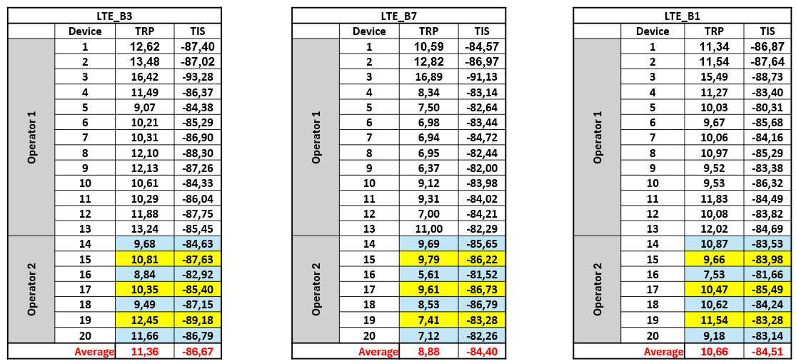
- : Received measurement data in dBm for smartwatches tested for the LTE bands B3, B7 and B1 with CTIA forearm phantom, defined for the frequency range 0.3 – 3 GHz

After applying the CDF function, the following values in dBm for the LTE bands B3, B7 and B1 have been aligned on:
LTE-B3 TRP: 11.5
TIS: -86.0
LTE-B7 TRP: 11.5
TIS: -86.0
LTE-B1 TRP: 11.5
TIS: -86.0

The values for the bands that were not measured are derived from the values of the measured bands (see Table 17 and Table 18 ).

- Document Management
  - Document History
Version | Date | Brief Description of Change | Approval Authority | Editor / Company
V1.0 | 14 May 2013 | Published on GSM world | TSG | Katrin Jordan, DT
V2.0 | Feb 2014 | Updated scope, references, requirements and added performance values for Free Space and Browsing. | TSG | Katrin Jordan, DT
V3.0 | Sept. 2015 | Performance values for LTE and Annex A added | TSG | Xiaolong Zhou, China Unicom  Abbas Alpaslan,  Vodafone
V4.0 | February 2019 | Clarifying the requirements for devices wider than 72 mm | TSG | Xiaolong Zhou,  China Unicom  Abbas Alpaslan,  Vodafone  Momar Goumballe,  Orange
V4.1 | June 2021 | Updated in line with CTIA licence agreement | TSG | Paul Gosden GSMA
V5.0 | October 2022 | Antenna performance limits for 5G NR FR1 bands added | TSG#49 | Abbas Alpaslan,  Vodafone  Momar Goumballe,  Orange
V5.1 | December 2022 | Updated CTIA reference for new licence agreement | TSG#50 | Paul Gosden GSMA
V6.0 | Oct 2023 | Updated with FWA section | TSG#53  ISAG#34 | Abbas Alpaslan,  Vodafone  Momar Goumballe,  Orange
V7.0 | Oct. 2025 | Update with wrist-worn devices | TSG#61  ISAG#56 | Abbas Alpaslan,  Vodafone  Momar Goumballe,  Orange

Other Information
Type | Description
Document Owner | This document is owned and approved by TSG Full Members
Document Editor | Abbas Alpaslan, Vodafone and Momar Goumballe, Orange

It is our intention to provide a quality product for your use. If you find any errors or omissions, please contact us with your comments. You may notify us at prd@gsma.com.

Your comments or suggestions & questions are always welcome.

