

Mobile Network Codes and Names Guidelines and Application Form

Version 6.0

25 March 2024
Security Classification: Non-confidential
Access to and distribution of this document is restricted to the persons permitted by the security classification. This document is confidential to the Association and is subject to copyright protection. This document is to be used only for the purposes for which it has been supplied and information contained in it must not be disclosed or in any other way made available, in whole or in part, to persons other than those permitted under the security classification without the prior written approval of the Association.
Copyright Notice
Copyright © 2024 GSM Association
Disclaimer
The GSMA makes no representation, warranty or undertaking (express or implied) with respect to and does not accept any responsibility for, and hereby disclaims liability for the accuracy or completeness or timeliness of the information contained in this document. The information contained in this document may be subject to change without prior notice.
Compliance Notice
The information contain herein is in full compliance with the GSMA Antitrust Compliance Policy.
This Permanent Reference Document is classified by GSMA as an Industry Specification, as such it has been developed and is maintained by GSMA in accordance with the provisions set out GSMA AA.35 - Procedures for Industry Specifications.

Table of Contents
1 Scope 3
2 Disclaimer 3
3 Registration Process 4
3.1 Input Form 4
4 Application Form Guidance 4
4.1 Country Initials 5
4.2 GSM Association Organisation Name 5
4.3 TADIG Code 5
4.4 Mobile Network Name (Network) 5
4.5 Presentation of Country Initials and Mobile Network Name (PPCI&N) 5
4.6 Abbreviated Network Name 6
4.7 Type of Network (Net Type) 6
4.8 Mobile Country Code (MCC) 6
4.9 Mobile Network Code (MNC) 6
4.10 (U)SIM Header 6
4.10.1 Syntax of the (U)SIM Header 7
5 Data Syntax Rules 7
5.1 Character Encoding 7
5.2 Rules for the creation of the data in all fields 7
5.2.1 Mandatory Syntax Checks 8
6 ITU Reference Documents & Contact Information 8
Annex A Document Management 10
A.1 Document History 10
Other Information 10

Scope
During network selection, GSM mobile equipment (such as mobile devices, tablets, etc.) displays information regarding the network, or networks, available and the country in which the network/s are operating.
This permanent reference document (PRD), details the nature, structure and handling of the “Mobile (Network) Codes and Names” (TS.25 formerly SE13), how it can be submitted by Mobile Network Operators and how it is presented and made available to those wishing to receive the data. The primary purpose of collating and making available the network codes and names is to provide terminal vendors with network details to be displayed to users on mobile devices on the display or within the network selection menu.
In addition, entries for (U)SIM headers (part of the ICCID) are collected and presented to aid SIM Card identification.
Note: Satellite compatible mobile stations are handled in accordance with GSMA SSC Network Selection Documents and hence the display requirements may differ from terrestrial-only mobile stations.
Any mobile equipment manufacturer unable to accommodate a specific network operator’s country initials and name should contact that network operator in the first instance.
The data presented includes the following information:

- GSM Association Organisation Name
- Mobile Network Name: Name of the Mobile Network as chosen by the GSM Association Member Organisation
- Country Initials
- Presentation of Country Initials and Mobile Network Names used for network selection (PPCI&N)
- Abbreviated Mobile Network Name (maximum of 8 characters, including hyphen, space, slash etc.)
- Void
- Mobile Country Code (MCC): Code as specified in ITU T E.212
- Mobile Network Code (MNC) as allocated by the National Administration and specified in ITU T E.212
- (U)SIM Header (ICCID) as registered with ITU E.118 as agreed and provided by the National Administration
- TADIG Code as allocated by IDS (Interoperability Data Specifications and Settlement Group)

Disclaimer
Important: All information submitted to GSM Association is registered as it is made available. The GSM Association assumes no responsibility for the correctness of this information. The submitting member organisation is responsible for complying with the rules and procedures described and mentioned in this document.

Registration Process
The GSMA hosts the “mobile network codes and names” data and when a member wishes to provide and register new or updated information, they should complete the Input Form Template in Section 3.1, using the guidance provided in this document (see section 4) and submit this information to the email address networkcodesandnames@gsma.com
The information received, will be processed within two weeks and updates will be provided to members that have subscribed to the mailing list to which updates are sent. To receive the latest updated TS.25 database please contact networkcodesandnames@gsma.com or view it under the tab, Roaming > Mobile Network Codes and Names or click here to view.

Input Form

CONTACT INFORMATION
Send to | networkcodesandnames@gsma.com
Name
Company
Email
Phone
Date sent

Country  Initials | Organisation | TADIG Code | Network | PPCI&N | Abrev. Net. Name | Void | MCC | MNC | (U)SIM Header
AAA | Ex Operator | NLDKW | Ex Operator | Example | Example |  | 123 | 456 | 89XXXX

Application Form Guidance
Important: All information submitted to GSM Association is registered as it is made available. The GSM Association assumes no responsibility for the correctness of this information. The submitting member organisation is responsible for complying with the rules and procedures described and mentioned in this document.
This data is available from the GSM Association. However, it is not guaranteed that device manufacturers will always use the most current data registered with GSMA.

Country Initials
Please use the internationally recognised ISO three digit country initials for unambiguous identification of each country in the table: http://www.nationsonline.org/oneworld/country_code_list.htm
Note: This information is not required for GSM-Satellite Operators.

GSM Association Organisation Name
Please use the company name as registered with the GSM Association.

TADIG Code
A new recent addition to the TS.25 database is the TADIG Code (allocated by IDS (Interoperability Data Specifications and Settlement Group), formerly known as the TADIG (Transferred Account Data Interchange Group).
The TADIG Code consists of two fields, with a total length of five characters consisting of a three-character country code and a two-character operator/company identifier for example NLDKW
See GSMA PRD TD.13 TADIG Code Naming Conventions for further information contact td13@gsma.com.

Mobile Network Name (Network)
Please provide the official name of the network.
Note: This name may be identical to the GSM Association Organisation Name or may complement the official company name, e.g. when a licence is acquired. This name will not appear on the mobile station’s display. Instead, the mobile station will display either the Presentation of Country Initials and Mobile Network Name or the Abbreviated Name.

Presentation of Country Initials and Mobile Network Name (PPCI&N)
Please provide the complete network name with country initials (country initials optional) as it should appear on the mobile device’s display (“alpha tag”) or network selection menu.
The display space on some mobile devices and within network selection menus may be limited, therefore, operators are advised to use a short name. This name may or may not be the same name as the full official Mobile Network Name. The full Mobile Network Name should be displayed on all devices, but due to the limitation of the screen size of some devices, there may not be enough room to display the full Mobile Network Name. In these devices the Abbreviated Mobile Network Name will be used which has an eight character limit, see section Abbreviated Mobile Network Name below for more details.
It is recommended to use the Presentation of Country Initials and Mobile Network Name in cases where more network information is relevant and should be presented to the user, e.g. network selection and to use the Abbreviated Mobile Network Name where the display space is limited e.g. on small home screens.

Abbreviated Network Name
Please provide the Abbreviated Mobile Network Name to be displayed on the mobile device’s display (as an alternative to the Presentation of Country Initials and Mobile Network Name defined in 4.4) when the device is registered to a mobile network.
The Abbreviated Mobile Network Name SHOULD be the same for all Network Type entries for an operator.
Note: The Abbreviated Mobile Network Name SHALL NOT exceed the maximum length of eight (8) characters (including hyphen, space, slash etc.) otherwise mobile manufacturers may create their own short name, which will inevitably lead to inconsistency in the presentation of the network details. Capital characters SHALL be indicated as such.

Type of Network (Net Type)
This field is deprecated from v6.0 onwards.

Mobile Country Code (MCC)
Please provide the Mobile Country Code (MCC) as assigned by the ITU in E.212. The Mobile Country Code is used in combination with the Mobile Network Code to uniquely identify the country of domicile of the mobile station.
Note: A MCC consists of three digits.

Mobile Network Code (MNC)
Please provide a Mobile Network Code (MNC) as allocated by the national regulator and notified to the ITU and listed in E.212. The Mobile Network code is used to uniquely identify the home public land mobile network to the user on the mobile device display when it is connected to the network.
Note: Mobile Network Codes consist of two or three digits.
Note: Please ensure the Mobile Network Code is registered with the ITU.

(U)SIM Header
The (U)SIM Header is part of the (U)SIM Serial Number (ICCID (Integrated Circuit Card IDentification)), typically printed on the (U)SIM and stored in its memory.
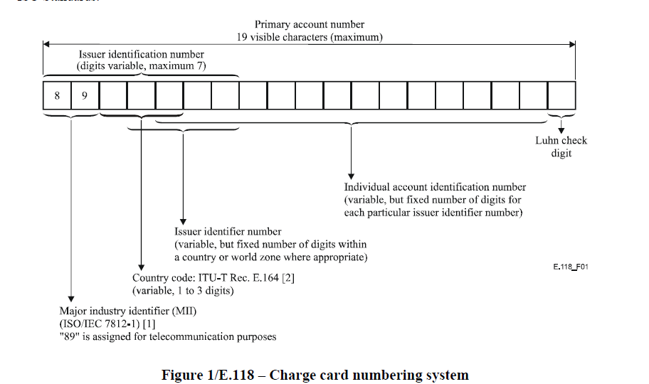
- : Charge card numbering system (Source: E.118 ITU (05/2006))
As indicated in above Figure, the ICCID specifies a maximum of 19 digits, the first six or seven digits comprises of the SIM header. The remaining digits of the ICCID are the individual serial number, ending in a check digit.

Syntax of the (U)SIM Header

The SIM Header should consist of six or no more than seven digits, comprised as follows:
  - Always 89
  - An Assigned Country Code (one to three digits) ITU-T E.164
  - An Issuer Identifier Number (two or three digits) ITU-T E118
Generally, the Issuer Identifier Number is allocated by the national administration in an operator’s country. The issuer identifier numbers are normally used to distinguish between multiple issuers within a country. However, these numbers may also be used to distinguish individual countries sharing the same country code (as defined in E.164) or, if appropriate, to distinguish both countries and issuers.
Note: Please ensure that the (U)SIM Header is registered with the ITU and strictly complies with the procedure indicated in E.118. Otherwise, network operators could experience financial and operational damage including regulatory demands for withdrawal of issued (U)SIMs.

Data Syntax Rules

Character Encoding
All fields in the database are stored in UTF-8, subject to any further limitations/exclusions below.

Rules for the creation of the data in all fields
In order to improve the data with the TS.25 Database the following rules are implemented. These rules must be followed by all users of the TS.25 Database when completing their entries.

Mandatory Syntax Checks
The TS.25 Database will check for syntax errors in new entries, this will be applied to all new entries or updates to existing entries.
Blank / White space
- No entry SHALL contain leading or trailing spaces.
- No entry SHALL contain 2 (or more) consecutive spaces.
Forbidden Symbols
- No entry SHALL contain any of the following symbols:
` | ¬ | ¦ | £ | $ | € | % | ^ | & | * | @ | ~ | # | < | > | ? | = | |

- The following is a list of symbols that can be used as a single entry which is then followed by a letter Aa to Zz, or number 0 to 9. Two or more consecutive symbols as listed below are not allowed. Combinations of symbols from the list below are also not allowed.
( | ) | + | - | _ | , | . | ; | : | ‘ | ’ | [ | ] | { | } | / | \ | ‘ | ’

- No entry SHALL end with any of the following symbols:
( | ‘ | [ | { | / | \

- No entry SHALL start with any of the following symbols:
) | ’ | ] | } | / | \

ITU Reference Documents & Contact Information

Document Number | Title and Reference
E.212 | Mobile network codes (MNC) for the international Identification plan for public networks and subscriptions(according to recommendation ITU-T E.212 (05/2008))
E.118 | List of Issuer Identifier Number (IIN) for the International Telecommunication Charge Card (in accordance with ITU-T recommendation ITU-T E.118 (05/2006))
E.164 | List of recommendation ITU-T E.164 Assigned Country Codes

Address: International Télécommunication Union
Télécommunication Standardisation Bureau
Place Des Nations
CH - 1211 Genève 20
Switzerland
Tel: +41 22 730 5211

Please contact the ITU offices for the relevant application form(s) http://www.itu.int/en/about/Pages/contact.aspx

- Document Management
  - Document History

Version | Date | Brief Description of Change | Approval Authority | Editor / Company
0.1 | March 2013 | Document changed from an AD.25 to TS.25 and major editorial review and re-write, with new owning group TSG. | TSG/PSMC | Paul Gosden GSMA, Donna Mackay GSMA;  Katrin Jordan DTAG
0.2 | June 2013 | Draft Version presented to TSG#12 for approval | TSG/PSMC | Paul Gosden GSMA, Donna Mackay GSMA;  Katrin Jordan DTAG
0.3 | July 2013 | Draft Version marked with CB to original version | TSG/PSMC | Katrin Jordan DTAG
0.4 | July 2013 | Sent to TSG for final approval after process and editorial updates | TSG/PSMC | Katrin Jordan DTAG
0.5 | July 2013 | Minor editorial updates | TSG/PSMC | Donna Mackay, GSMA
1.0 | July 2013 | Sent to DAG#107 and PSMC for approval | TSG/PSMC | Paul Gosden, GSMA
2.0 | June 2014 | Removal of all text relating to the Network Colour Code removed from PRD which will lead to the removal of the NCC from the TS25 database | TSG/PSMC | Paul Gosden GSMA
3.0 | Oct 2017 | Updated with CR1006 adding TADIG Codes, and clearer definition of using the PPCI&N and a new form to submit changes | TSG | Paul Gosden GSMA
4.0 | May 2018 | Adding the Disclaimer Section 2.0 | TSG | Paul Gosden GSMA
5.0 | Dec  2018 | Update with changes approved in CR1010 | TSG#34 | Geoff Hart  BELL Canada
6.0 | March 2024 | Update with changes approved in CR1011 | TSG55  ISAG#40 | Paul Gosden GSMA

Other Information
Type | Description
Document Owner | TSG
Editor / Company | Paul Gosden, GSMA

It is our intention to provide a quality product for your use. If you find any errors or omissions, please contact us with your comments. You may notify us at prd@gsma.com
Your comments or suggestions & questions are always welcome.

