

NFC Handset Requirements

Version 15.0

19 June 2019
This is a Non-binding Permanent Reference Document of the GSMA
Security Classification: Non-confidential
Access to and distribution of this document is restricted to the persons permitted by the security classification. This document is confidential to the Association and is subject to copyright protection. This document is to be used only for the purposes for which it has been supplied and information contained in it must not be disclosed or in any other way made available, in whole or in part, to persons other than those permitted under the security classification without the prior written approval of the Association.
Copyright Notice
Copyright © 2019 GSM Association
Disclaimer
The GSM Association (“Association”) makes no representation, warranty or undertaking (express or implied) with respect to and does not accept any responsibility for, and hereby disclaims liability for the accuracy or completeness or timeliness of the information contained in this document. The information contained in this document may be subject to change without prior notice.
Antitrust Notice
The information contain herein is in full compliance with the GSM Association’s antitrust compliance policy.

Table of Contents
1 Introduction 4
1.1 Purpose 4
1.2 Scope and Objective 4
1.2.1 Android Versions Applicability 5
1.3 Use Cases/Services 5
1.4 Abbreviations 6
1.5 Definition of Terms 7
2 References 9
3 Terminology 10
4 VOID 10
5 Generic Device Architecture 10
5.1 Dual Application architecture 10
5.2 Security 12
5.3 Mobile Wallet 12
6 Generic Device Requirements 13
6.1 NFC Device Architecture 13
6.2 Core Required NFC Features 14
6.2.1 NFC Controller Management 16
6.2.2 Card Emulation Mode Requirements 16
6.2.3 Reader/writer mode & TAG management requirements 17
6.3 Secure Element Access & Multiple Secure Elements Management 18
6.3.1 Mobile Device Modem Requirements 18
6.3.2 Secure Element Access API requirements 19
6.3.3 Multiple CEE support 20
6.4 UI Application triggering requirements 23
6.5 Remote Management of NFC services 24
6.5.1 Mobile Device APN Management Requirements 24
6.5.2 UICC Remote Management (Access to UICC in connected mode) requirements 24
6.6 Security 24
6.6.1 NFC Event & Access Control requirements 25
6.6.2 VOID 25
6.7 SCWS support 26
6.8 Card Application Toolkit Support 26
6.9 VOID 27
6.10 Personalization of the eSE 27
7 Android Operating System 28
7.1 NFC Device Architecture 28
7.2 VOID 28
7.2.1 VOID 28
7.2.2 Card Emulation mode requirements 28
7.2.3 Reader/writer & TAG management requirements 29
7.3 Secure Element Access & Multiple Secure Elements Management 29
7.3.1 Mobile Device Modem requirements 29
7.3.2 Secure Element Access API requirements 29
7.3.3 Multiple CEE support 29
7.4 UI Application triggering requirements 34
7.4.1 VOID 35
7.4.2 VOID 35
7.5 Remote Management of NFC Services 35
7.6 Security 35
7.6.1 Access API & Secure Element Access Control requirements 36
7.6.2 NFC Event & Access Control requirements 36
7.6.3 VOID 36
7.7 SCWS support 36
7.8 Card Application Toolkit Support 37
7.9 VOID 37
8 VOID 37
9 VOID 37
10 VOID 37
11 Android Wear Operating System 37
Annex A Implementation/usage help of REQ 94.1 for multi eSE on Android 38
Annex B Implementation/usage hint of REQ 94.3 for multi SE from Android 10 39
Annex C Document Management 40
C.1 Document History 40
Other Information 43

Introduction

Purpose
With the increasing activity to deploy commercial Near Field Communication (NFC) services in a number of markets around the world, it is important to align implementation requirements and embrace common standards to support the global interoperability of services, while maintaining the momentum to meet time-to-market requirements in certain markets.
This document lists requirements for devices to support NFC services primarily focused on NFC services based on the UICC and eSE. It sets out a common framework of requirements, identifying and referencing relevant standards (or elements thereof), selecting options from among those allowed by existing standards to ensure interoperability. A list of relevant standards is captured in section 2 and further detailed by explicit requirements.
This document is delivered by the GSMA Terminal Steering Group (TSG), taking forward work driven by the GSMA TSG NFC Handset Requirements group. It is an update to and replaces all previous versions of TS.26, “NFC Handset Requirements” Specification.
Given the complexity of some of the underlying technology components and the variances across OS implementations, not all requirements could be finalised at this time. Where requirements are still work in progress, these are marked *yellow. Work is ongoing to finalise these as soon as possible as well as to further enhance requirements and details/applicability for the various OS and to publish updates with the next document versions.
This document applies to devices supporting a UICC, an eUICC and an eSE. As indicated in the definition of eUICC in section 1.5, an eUICC is a particular type of UICC. Therefore, when this document uses the term “UICC”, this incorporates both the standard UICC and the eUICC.
Basic Devices are also in the scope of this document and some requirements are specific to this category of devices.
The eUICC related specifications are being developed by the GSMA and ETSI. The latest version of the GSMA RSP specifications includes NFC support.
In case of any feedback or questions, you may notify us at prd@gsma.com.

Scope and Objective
The body of this document sets out requirements to be supported by mobile devices needed to support NFC services that are agreed globally, according to the GSMA’ s processes for consulting its members.
It should be noted that this document is expected to evolve by:
- Embracing new standards as and when they are published by the relevant industry organisations;
- Adding further requirements or further evolving current requirements as needed
The GSMA is defining the requirements’ for NFC based services within Operating Systems (OS) and the device hardware which leverage the incumbent features of the OSs. Overall, the aim is to:
- Align members’ terminal requirements for SE based NFC services
- Provide transferable solutions between different mobile device OSs and mobile devices;
- Provide the ecosystem with a quicker and simpler method for service deployment.
These ambitions will be fulfilled by adoption of the key NFC enablers, thereby facilitating a quicker time-to-market by providing clear and unambiguous device requirements.
This document defines at a high level the application architecture and lower layer enablers, required to fulfil NFC use cases. It further expands upon this, by detailing the particular mobile device Application Programming Interfaces (APIs) per OS (as applicable/ available) to enable a secured service use case and the requirements necessary to fulfil the NFC enabler software architecture.
Other specific OS requirements will be considered when contributions are received.
Note: this Permanent Reference Document (PRD) does not exclude the possibility for support of additional NFC capabilities not mentioned in this document.

Android Versions Applicability
To comply with requirements in this document, devices with Android OS shall implement Android 9 or later version.

Use Cases/Services
The intended use cases for NFC can be grouped into secured and non-secured services. This document primarily targets the SE based NFC secured service use cases, and can provide for the following propositions, but is not limited to:
- Plastic credit/debit card replacement
- Travel vouchers
- Business to Business transactions
- Secure access
- Mobile health
- IT system, e.g. RSA
- Touch and Pay
- Event ticketing
It is required that the device and the SE provide a secured environment, i.e. an environment which satisfies the security needs of Service Providers’ (Mobile Network Operators’ (MNOs)) and consumers.

Abbreviations
Term | Description
AC | Access Control
AID | Application ID
API | Application Programming Interface
APDU | Application Protocol Data Unit
APN | Access Point Name
BIP | Bearer Independent Protocol
CE | Card Emulation
CEE | Card Emulation Environment
CLF | Contactless Frontend
DUT | Device Under Test
eSE | Embedded SE
eUICC | A removable or non-removable UICC which enables the remote and/or local management of Profiles in a secure way.  NOTE: The term originates from "embedded UICC".
JVM | Java Virtual Machine
HCE | Host Card Emulation
HCI | Host Controller Interface
MIDP | Mobile Information Device Profile
MNO | Mobile Network Operator
NFC | Near Field Communication
OS | Operating System
ODM | Original Device Manufacturer
OEM | Original Equipment Manufacturer
PoS | Point of Sale
PRD | Permanent Reference Document
RIL | Radio Interface Layer
SCWS | Smart Card Web Server
SDO | Standards Organisations
SE | Secure Element
SIM | Subscriber Identity Module
SP | Service Provider
SWP | Single Wire Protocol
TSG | Terminal Steering Group
UI | User Interface
UICC | Universal Integrated Circuit Card
UID | User Identification

Definition of Terms
Term | Description
Active CEE | An Active CEE is a CE environment that can receive data based on routing mechanisms (e.g. AID, Protocol and Technology).
Active UICC Profile | When the physical UICC is a standard UICC: the UICC itself.  When the physical UICC is an eUICC: the combination of the Enabled Profile and the eUICC onto which the Profile has been provisioned.
AID Conflict | When two or more applications register with the same Application Identifier
AID Conflict Detection | Conflict Detection is the procedure to check for AID Conflict. Conflict Detection can be done  1. During registration of Application Identifiers  2. When an Application selection is being received from a contactless reader.
APDU | An Application Protocol Data Unit (APDU) is the communication unit between a smart card reader and a smart card.
Application Identifier | AID, as defined in ISO/IEC 7816-4, used to address a card emulation service or application
Basic Device | A Device with no screen or with a small basic display (i.e. not able to display menus)
Battery Operational Mode | The battery of the DUT has sufficient power to support all functions in the mobile devices.
Battery Low Mode | The battery of DUT has reached “Battery Low Threshold” at which the display and most functionalities of the DUT are automatically switched off, except the clock and a few remaining functions. The battery of the DUT only has sufficient power to support NFC controller to function in card emulation mode.
Battery Power-off Mode | The battery of the DUT has reached “Battery Power-off threshold” at which there is no residual power to support NFC controller to function. No functions are available in the DUT. The NFC controller can function if power is provided via the contactless interface (i.e. power by the field).
Card Emulation Environment | A Card Emulation Environment is an execution environment used together with a NFC controller to manage a Card Emulation transaction. It can be a Secure Element (e.g. UICC, embedded Secure Element or micro-SD) or an application running in a device host.
Default AID Route | The Default AID route is the route used by the NFC Controller when a NFC reader explicitly selects a NFC Service by its AID but the AID is not defined in the NFC Controller’s routing table.  Note: this definition is only relevant for devices which support the Multiple Active CEEs model.
Device | In the context of this specification, the term Devices is used to represent any electronic equipment supporting NFC functionality into which a NFC Secure Element can be inserted, and that provides a capability for a server to reach the UICC through an Over The Air (OTA) channel. E.g. smartphones, wearables.
Embedded UICC | A removable or non-removable UICC which enables the remote and/or local management of Profiles in a secure way.  NOTE: The term originates from "embedded UICC".
Embedded SE | Secure Element which is a separated chipset and integrated into the devices, owned by the device manufacturer and cannot be removed.
Multiple Active CEEs model | A model where the device can activate several CEE at the same time. RF traffic can be provided to a CEE based on routing mechanisms.  Note: an implementation may support Multiple Active CEEs model in Battery Operational Mode and Single Active CEE model in Battery Low or Power-Off Mode.
Operator | Refers to a Mobile Network Operator who provides the technical capability to access the mobile environment using an Over The Air (OTA) communication channel. The OPERATOR is also the UICC Issuer. An OPERATOR provides a UICC OTA Management System, which is also called the OTA Platform.
Prefix of AIDs | An AID prefix will match all AIDs that are starting with the same N bytes of the mentioned AID prefix.
Screen Lock | The device functionality can only be accessed via a user intervention.
Screen ON | The battery of the device is in Battery Operational Mode and the screen of the device was turned on by the end-user (i.e. the screen is active).
Screen OFF | The battery of the device is in Battery Operational Mode and the screen of the device was turned off either by the end-user or automatically by the device after a timeout.
Switched OFF | The device was turned OFF by the end-user or the device is in battery low mode or the device is in battery power-off mode.
Secure Element | A SE is a tamper-resistant hardware component which is used to provide security, confidentiality, and multiple application environments required to support various business models. In TS.26, the term SE includes UICC, eUICC and eSE.
Sensitive API | An API which shall be protected from malicious use.
Single Active CEE model | A model where the device only activates one CEE at a time. Other CEEs, if available, are not active.

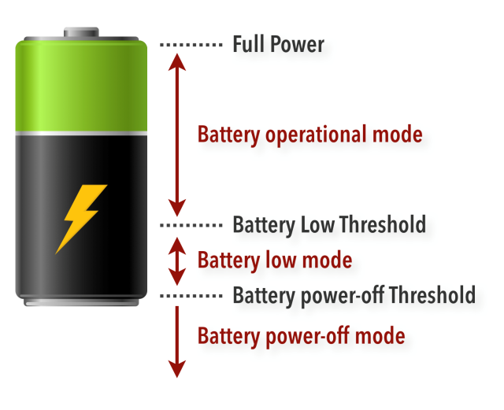
- :Battery power levels within the NFC mobile devices

References
Note: Testing shall be based on the exact versions as indicated below. However if the manufacturers use a later release and/or version this should be indicated. TSG will take efforts to continually align with other SDOs for timely information about release plans.
3GPP Specifications | 3GPP TS 31.111 V15.6.0 or later: Universal Subscriber Identity Module (USIM) Application Toolkit (USAT)  3GPP TS 31.116 V15.0.0 or later: Remote APDU (Application Protocol Data Unit) Structure for (Universal) Subscriber Identity Module (U)SIM Toolkit applications  Later releases of 3GPP specifications shall be backward compatible  The manufacturer can use Release 9 or a later release of the specifications
EMVCo Specifications | EMV Contactless Communication Protocol Specification, Book D, Version 2.6 (or later)
ETSI SCP Specifications | ETSI TS 102 221 V15.1.0 or later: Smart Cards; UICC- Terminal interface; Physical and logical characteristics  ETSI TS 102 613 V15.0.0 or later: UICC – Contactless Front End (Physical and data link layer characteristic)  ETSI TS 102 622 V15.0.0 or later: UICC – Contactless Front End, HCI (Host Controller Interface)  ETSI TS 102 223 V15.1.0 or later: Card Application Toolkit  ETSI TS 102 226 V13.1.0 or later: Remote APDU structure for UICC based applications  Later releases of ETSI-SCP specifications shall be backward compatible The manufacturer can use Release 9 or a later release of the specifications
NFC Forum Specifications | NFCForum-TS-T2T  NFCForum-TS-T3T  NFCForum-TS-T4T  NFCForum-TS-T5T  NFCForum-TS-RTD_SP  NFCForum-TS-RTD  NFCForum-TS-RTD_TEXT  NFCForum-TS-Analog  NFCForum-TS-Digital  NFCForum-TS-Activity  NFCForum-TS-NDEF  NFCForum-TS-NCI  The versions of each referenced Specification above, are defined in NFC Forum Technical Specification Release 2017 (or later)
GlobalPlatform | Open Mobile API Specification v3.3 or later
GSMA Requirements | SGP.03 NFC UICC Requirement Specification, Version 7.0  SGP.12 NFC Multi Protocol for Interoperability, Version 2.0
GlobalPlatform | Secure Element Access Control Version 1.0
GlobalPlatform | GlobalPlatform Secure Element Configuration Version 1.0
GlobalPlatform | GlobalPlatform Card Specification Version 2.3
RSA Laboratory | PKCS #15 v 1.1: Cryptographic Token Information Syntax

Terminology
As per IETF Requirements terminology, reference RFC 2119, the following terms have the following meaning.

Term | Description
SHALL | Denotes a mandatory requirement
SHOULD | Denotes a recommendation
MAY | Denotes Optional

VOID
TS26_NFC_REQ_001 | VOID
TS26_NFC_REQ_002 | VOID
TS26_NFC_REQ_003 | VOID
TS26_NFC_REQ_004 | VOID
TS26_NFC_REQ_005 | VOID

Generic Device Architecture

Dual Application architecture
GSMA Operators promote the following application architecture (below) to pragmatically support the key use case of secured NFC services.
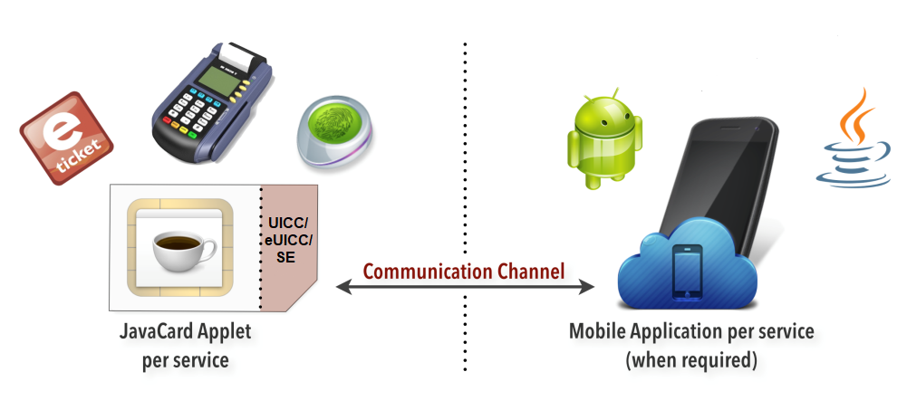
- : Dual application architecture
The mobile device User Interface (UI) application executing on the device OS is the consumer facing component. In this example, the UI application interacting with the application on an SE, communicating with the NFC reader, allows the customer to interact with the service functionalities, e.g. with a PoS (point of sale) for a financial service use case or a physical ticketing barrier in the case of an e-ticketing application. However the UI Application component is not seen as mandatory for all use cases, where the Service Provider (SP) could decide to have a UI-less service, including when the service is intended to be deployed on Basic Devices. It could be also the case that device applications without UI are deployed and finally a User Interface does not necessarily require the presence of a display, but it could be achieved by sounds, LEDs or vibrates. In the rest of the document the term “UI” designates all kind of interfaces allowing an interaction with or a simple notification to the user.
The applet component resides within the SE, and works in tandem with the UI application when applicable. It holds the logic of the application and performs actions such as holding secure authentication keys or time-stamped transaction data for transaction resolution, history and fraud prevention etc.
Within this dual-application architecture for secured services, there is need for a consistent communication channel between these two applications. This communication channel could be used to transmit status information passed from the application in the SE to the UI for notifying the user on NFC events. It could also be used for more information exchanges between the SE and the device UI like user authentication toward a SE applet (e.g. PIN code verification).
As the communication channel accesses a secured storage space on the SE, the communication channel itself must have attributes which allow it to be accessed only by authorised UI applications.
The following illustration gives an overview of the device software components required to satisfy the dual application architecture, which delivers key use cases for NFC, in case of a NFC handset with a UICC.

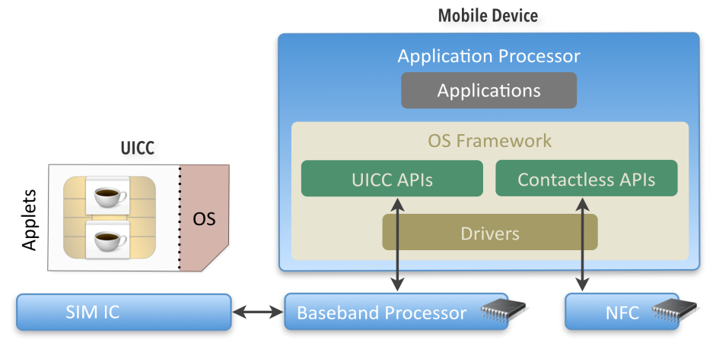
- : Mobile Device API generic software stack
The mandated method of communication between these two applications is APDU (Application Protocol Data Unit).
The following figure depicts the typical data flow for a NFC transaction, between a PoS and a UICC, including the routing that the event will need to follow. The event is the trigger from the PoS to the user which indicates an activity in the NFC service. From this activity the nature of the event between the various components can be determined, for example where the event needs to be protected and has attributes which will allow for, or not allow for, any modification. The same flow will take place between a PoS and an eSE
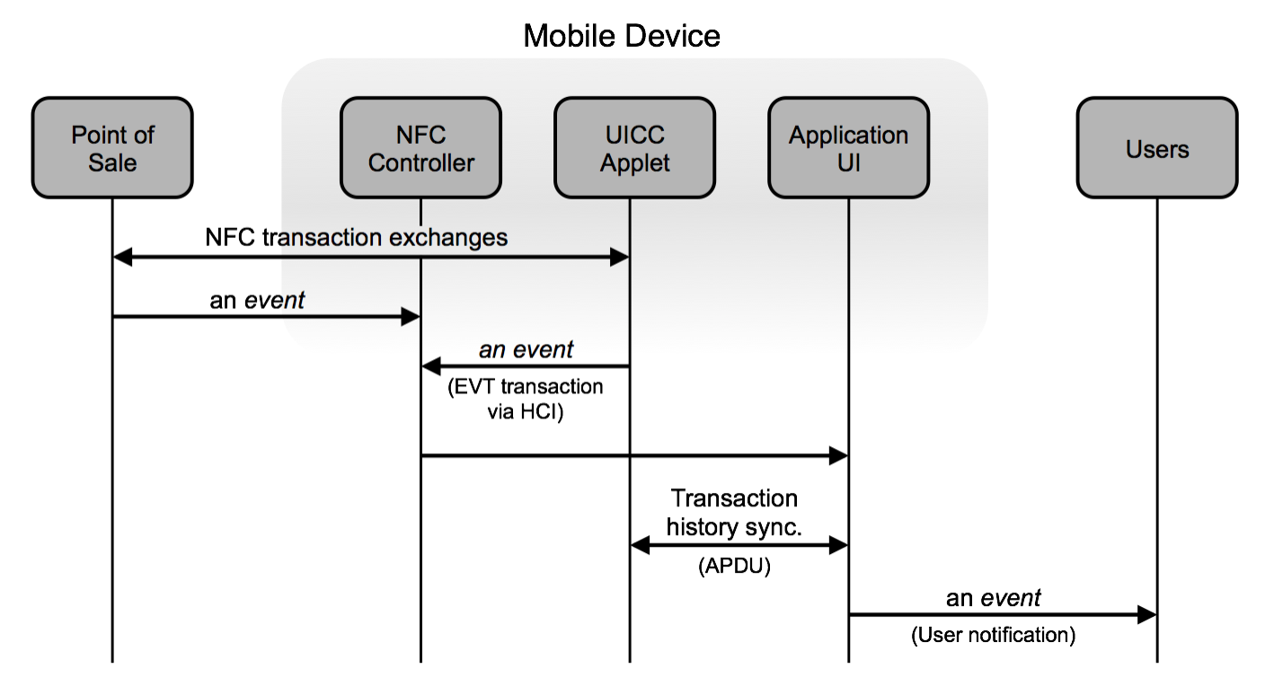
- : Typical data flow for card-emulation mode

Security
For the secured services use case it is imperative for MNOs and SPs to continuously strive to provide best possible secured and trusted communication along the end-to-end chain of the various components necessary.
- Two key areas where security is important are the Secure Element and the privileges available to communicate with the NFC service applet in the SE. The SE will securely hold protected information, and provide a controlled access path to relevant parts of its internal memory.
- Access to services inside a SE is requesting a specific care as a high level of security is required by some Service Providers. It is necessary to manage which device applications communicate with applets in the SE. In addition to existing protection mechanisms provided by the mobile OS, a dedicated Access Control mechanism based on rules/rights provided by the SE is needed. The main purpose of this Access Control is typically to prevent service attacks from malware applications.

Mobile Wallet
The Mobile Wallet is intended to facilitate the user experience, and allow the MNO or SP to optionally differentiate by providing targeted and convenient access to the NFC Services within the mobile device and SEs. The wallet application, for example, can typically list all SP services loaded into the mobile device or SE and display their current status. Additionally, this application may also allow the users to manage the NFC settings of their mobile device. This type of application is not relevant for Basic Devices. Users could manage their NFC services installed on such Basic Devices from a Mobile Wallet installed on a paired smartphone. The way this is achieved is out of scope of this document.

Generic Device Requirements

NFC Device Architecture
The following figure provides an overview of a typical Mobile NFC architecture:
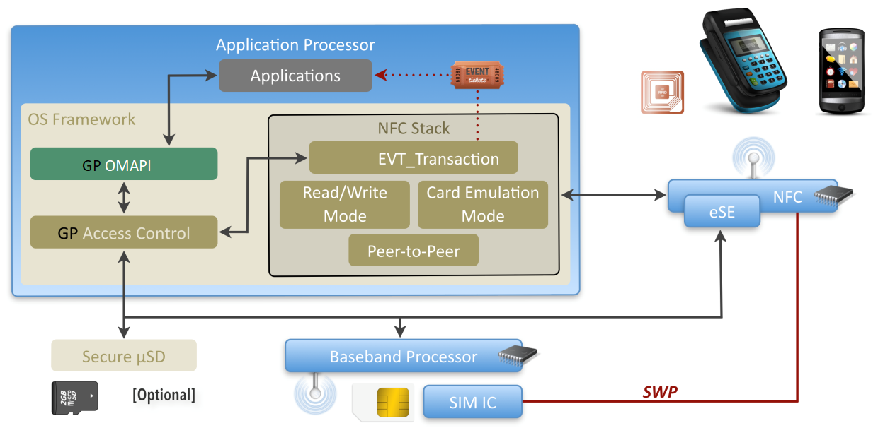
- : Mobile NFC Architecture
The device provides, as standard component, a NFC controller and one or more SEs.
The NFC Stack is driving the NFC Controller and is typically providing software APIs enabling:
- Management of Multiple Secure Element (activation, deactivation, routing, etc.)
- Management of the NFC events
- An external API available for 3rd party applications to manage reader/writer mode, Peer to Peer mode and Card Emulation mode from Device
- An internal API to provide a communication channel with an embedded Secure Element for APDU exchanges
The Secure Element Access API provides a communication channel (using APDU commands) allowing 3rd party applications running on the Mobile OS to exchange data with Secure Element Applets. This API provides an abstraction level common for all Secure Elements and could rely on different low level APIs for the physical access:
- RIL extension for accessing the UICC
- Specific libraries for communicating with other embedded secure elements
In order to implement security mechanisms (e.g. Secure Element Access Control), the Secure Element Access API shall use Mobile OS mechanisms such as UIDs or application certificates to identify the calling application.

Core Required NFC Features
TS26_NFC_REQ_006 | The NFC controller SHALL support SWP (Single Wire Protocol) interface with the UICC as per ETSI TS 102 613.
TS26_NFC_REQ_173 | A device MAY be shipped with an eSE for NFC services.
TS26_NFC_REQ_173.1 | The NFC controller SHALL support an interface with the eSE.  Note: The interface can be SWP or any other interface.
TS26_NFC_REQ_007 | The NFC controller SHALL support HCI with the UICC as per ETSI TS 102 622.
TS26_NFC_REQ_164 | For devices with more than one UICC slot, the NFC controller SHALL support SWP and HCI interface with at least one UICC slot of the device as per ETSI TS 102 613 and ETSI TS 102 622.
TS26_NFC_REQ_164.1 | For devices with more than one NFC capable UICC slot, there SHALL only be one NFC capable UICC slot active at any one time.
TS26_NFC_REQ_164.2 | Each NFC capable UICC slot SHALL be indicated to the user.
TS26_NFC_REQ_164.3 | For devices with more than one NFC capable UICC slot, a menu SHALL give the option to the user to select on which NFC capable UICC slot, NFC is active.
*TS26_NFC_REQ_165 | If the device has both an eUICC and a UICC slot the device SHALL implement the NFC card emulation on both.
TS26_NFC_REQ_166 | The device SHALL send the Terminal Capability command to the UICC indicating that the UICC-CLF interface (SWP) is supported as per ETSI TS 102 221.
TS26_NFC_REQ_008 | Contactless tunnelling (CLT=A) mode SHALL be supported for SWP (per ETSI TS 102 613).
TS26_NFC_REQ_009 | VOID
TS26_NFC_REQ_009.1 | Contactless tunnelling (CLT=F) mode SHALL be supported for SWP (per  ETSI TS 102 613).
TS26_NFC_REQ_010 | The device interface with UICC SHOULD support Class B.
TS26_NFC_REQ_011 | The device interface with UICC SHALL support Class C.
TS26_NFC_REQ_012 | VOID
TS26_NFC_REQ_137 | The NFC controller interface with UICC SHALL use ETSI TS 102 613 full power mode when the device is in battery operational mode.
TS26_NFC_REQ_013 | VOID
TS26_NFC_REQ_154 | The NFC controller interface with UICC MAY use ETSI TS 102 613 full power mode when the device is in battery low mode.
TS26_NFC_REQ_138 | The NFC controller interface with UICC MAY use ETSI TS 102 613 full power mode in battery power-off mode.
TS26_NFC_REQ_139 | If the NFC controller interface with UICC is not supporting ETSI TS 102 613 full power mode in battery low mode, then the NFC Controller SHALL support ETSI TS 102 613 low power mode when the device is in battery power-low mode.
TS26_NFC_REQ_140 | If the NFC controller interface with UICC is not supporting ETSI TS 102 613 full power mode in battery power-off mode, then the NFC Controller SHALL support ETSI TS 102 613 low power mode when the device is in battery power-off mode.
TS26_NFC_REQ_107 | The device manufacturer SHALL provide information to the user about the position of the NFC antenna reference point.  Examples: a marker on the device, a removable sticker, a device user manual or a tutorial that is started when activating NFC for the first time.
TS26_NFC_REQ_014 | The device interface with UICC SHALL support DEACTIVATED followed by subsequent SWP interface activation in full power mode.
TS26_NFC_REQ_015 | The NFC controller SHOULD support both windows size set to 3 and set to 4.
TS26_NFC_REQ_016 | VOID
TS26_NFC_REQ_017 | The NFC controller SHALL ensure that the UICC SWP/HCI initialization is finished before deactivating the SWP without full power down UICC.  Note: The SWP/HCI specification is not integrating a recovery mechanism so in case of SWP line deactivation in the middle of the activation, it may lead to blocking situation, with SWP-UICC interface not usable until the next device boot.
TS26_NFC_REQ_018 | VOID
TS26_NFC_REQ_019 | The NFC Controller SHALL support configuration of the listen mode routing for Card Emulation, by the device manufacturer or operator, for at least ISO DEP, NFCA, NFCB & NFCF.
TS26_NFC_REQ_020 | If NFC was enabled, when the mobile device is automatically switched off, and enters battery low mode, the mobile device SHALL be able to perform 15 transactions in card emulation within the following 24 hours.
TS26_NFC_REQ_174 | If NFC was enabled when the device is switched off by the user, the device SHALL be able to perform card emulation transactions.
TS26_NFC_REQ_021 | If NFC is enabled, NFC transactions SHALL be possible in battery low mode.  Note: This is important for public transport services.
TS26_NFC_REQ_167 | The NFC controller SHALL support at least 16 AIDs of 16 bytes in the routing table.
TS26_NFC_REQ_167.1 | The NFC controller SHOULD support at least 40 AIDs of 16 bytes in the routing table.
TS26_NFC_REQ_175 | In case the NFC Controller receives a RF parameters configuration request from a CEE enabling a Mifare Classic service with either UID 4 or 7 bytes, the corresponding RF parameters profile “Profile 2 ” as defined in chapter 3.1.2.2 of GSMA SGP.12 SHALL apply
TS26_NFC_REQ_176 | In case the NFC Controller receives a RF parameters configuration request from a CEE enabling a Mifare DESFire service, the RF parameters profile “Profile 3” as defined in chapter 3.1.2.2 of GSMA SGP.12 SHALL apply
TS26_NFC_REQ_177 | In other cases, the RF parameters profile “Profile 1” as defined in chapter 3.1.2.2 of GSMA SGP.12 SHALL apply

NFC Controller Management
The following features are needed:
Management of the NFC Controller state
- Check if the NFC Controller is enabled
- Activate the NFC Controller
- Check if Card Emulation mode is activated
TS26_NFC_REQ_022 | There SHOULD be an API to ask the system to enable the NFC functionality. User input SHALL be required to enable NFC. This UI dialogue SHALL be generated by the OS and not by the calling application.
TS26_NFC_REQ_023 | Devices SHALL provide an API which allows the query of the NFC controller’s state.
TS26_NFC_REQ_024 | VOID
TS26_NFC_REQ_108 | VOID
TS26_NFC_REQ_109 | In non Basic Devices the OS SHALL allow the user to turn NFC on and off when the device is in Radio Off Mode.
TS26_NFC_REQ_178 | In Basic Devices the OS SHOULD allow the user to turn NFC on and off when the device is in Radio Off Mode.  If not the NFC function SHALL always be enabled.

Card Emulation Mode Requirements
TS26_NFC_REQ_025 | The mobile device SHALL support Card Emulation as per: TS-Analog, TS-Digital and TS-Activity [NFC Forum Specifications].
TS26_NFC_REQ_025.1 | VOID
TS26_NFC_REQ_026 | Card Emulation mode SHALL be enabled when the NFC is turned on.
TS26_NFC_REQ_027 | For Card emulation mode the read distance SHALL be in the 0cm – 2cms range for battery operational mode, battery low mode.
TS26_NFC_REQ_028 | In Single Active CEE model the Active UICC Profile SHALL be the default CEE, that is the active CEE at first start up or after a factory reset.
TS26_NFC_REQ_029 | Manufacturers SHALL provide to operators the capability to customise settings for defining if the UICC card emulation is enabled / disabled when the device is powered off, screen is off or locked.  Note: this will not be via a UI.
TS26_NFC_REQ_030 | In the case of a factory reset, the operator customised settings (as per TSG26_NFC_REQ_029) SHALL remain.
TS26_NFC_REQ_031 | Operator settings as stated in TS26_NFC_REQ_029 above SHALL only be valid if NFC is enabled.
TS26_NFC_REQ_157 | The device SHALL implement the requirements of the EMV Contactless Communication Protocol Specification, Book D.
TS26_NFC_REQ_158 | Card emulation mode SHALL support APDU transmission case 1, 2, 3 & 4 as defined in ISO/IEC 7816-4 including Extended Length Field support. Command and response data field size minimum of 2048 bytes SHALL be supported.  Note 1: Currently, the support for extended length APDU is not a common feature of NFC-UICC. At this point in time, NFC-UICC in the field typically don’t support extended length APDU. Both handset architecture and NFC-UICC have to be compliant in order for the device to support the extended length APDU feature.  Note 2: The implementation of the protocol and the mechanisms leading to the use of the extended length APDU option according to ISO/IEC 7816-4 have to be ensured by a negotiation between the contactless reader and the selected application in the NFC-UICC.

Reader/writer mode & TAG management requirements
All requirements in this chapter are optional for Basic Devices.
TS26_NFC_REQ_032 | VOID
TS26_NFC_REQ_033 | The mobile device SHALL support Reader/Writer Mode as per: TS-Analog, TS-Digital and TS-Activity [NFC Forum Specifications].
TS26_NFC_REQ_034 | VOID
TS26_NFC_REQ_035 | The mobile device SHALL support NFC Forum Type 2 Tag, as specified in [NFC Forum Specifications]. Requirement applies to both protocol and application level.
TS26_NFC_REQ_036 | The mobile device SHALL support NFC Forum Type 3 Tag, as specified in [NFC Forum Specifications]. Requirement applies to both protocol and application level.
TS26_NFC_REQ_037 | The mobile device SHALL support NFC Forum Type 4 Tag, as specified in [NFC Forum Specifications]. Requirement applies to both protocol and application level.
TS26_NFC_REQ_192 | The mobile device SHALL support NFC Forum Type 5 Tag, as specified in [NFC Forum Specifications]. Requirement applies to both protocol and application level.
TS26_NFC_REQ_038 | Reader mode events SHALL be routed exclusively to the UICC or the Application processor.
TS26_NFC_REQ_039 | The default routing for the reader mode events SHALL be via the Application processor.
TS26_NFC_REQ_040 | The NFC Controller SHOULD support Reader Mode as per ETSI TS 102 622.
TS26_NFC_REQ_041 | The device SHALL support automatic and continuous switching between card emulation and reader mode.
TS26_NFC_REQ_159 | VOID
TS26_NFC_REQ_160 | The mobile device SHALL support APDU transmission case 1, 2, 3 & 4 including Extended Length Field support as defined in ISO/IEC 7816-4 with 32767 bytes command and response data field size for the Reader/Writer mode.

Note: Default mode Card emulation mode, with a poll for Reader mode, the frequency for the Reader mode poll shall be such that the battery power consumption is kept to a minimum. This implementation will require on-going optimisation; however, the aim is to provide good responsiveness to the consumer.
TS26_NFC_REQ_042 | A transaction time SHALL take 500ms or less for TAG message length not exceeding 100 bytes. The transaction time is defined from the start of the frame of the first RF command receiving an answer, to the end of the frame of the response to the last received RF command by a device, where the RF command is used to read the content in a tag.
TS26_NFC_REQ_043 | The mobile device SHALL be able to read/write the NFC Forum Smart Poster RTD.
TS26_NFC_REQ_044 | The TAG SHALL be read at a distance of 1 cm and at distances between 0 to 1 cm.  Note: This requirement will be tested with a TAG Test Reference system agreed in the Test Book group.
TS26_NFC_REQ_110 | The TAG SHOULD be read at a distance from 1 cm to 4 cm.  Note: This requirement will be tested with a TAG Test Reference system agreed in the Test Book group.

Secure Element Access & Multiple Secure Elements Management
This section details functionality which the GSMA requires to be implemented within the NFC Framework, in order to support requirements in this document related to handling of the NFC Controller, Card Emulation mode and multiple Secure Elements.

Mobile Device Modem Requirements
TS26_NFC_REQ_045 | For handling logical channel Baseband SHALL provide interfaces based on either the following AT commands or equivalent functionality:  - AT+CCHO  - AT+CCHC  - AT+CGLA
TS26_NFC_REQ_045.1 | Modem SHALL support all lengths of AID from 5 bytes to 16 bytes as defined in ISO/IEC 7816-4.
TS26_NFC_REQ_141 | The modem SHALL provide a way for the application processor to retrieve the answer from the UICC after the selection of an AID.
TS26_NFC_REQ_111 | Modem SHALL provide an interface based on AT+CRSM (Restricted SIM Access) or equivalent functionality for internal communication on basic channel.
TS26_NFC_REQ_112 | The Modem SHALL prevent the usage of the AT+CSIM or equivalent functionality.
TS26_NFC_REQ_113 | Modem SHALL support APDU transmission case 1, 2, 3 & 4 as defined in ISO/IEC 7816-4.
TS26_NFC_REQ_161 | Modem SHALL support Extended Length APDU as defined in ISO/IEC 7816-4 with at least 2048 bytes command and response data field size.  Note: This requirement will become effective from the 1st January 2018.
TS26_NFC_REQ_114 | For all APDU exchanges originating from the Secure Element Access API the Modem driver SHALL forward warning status codes (SW=62XX or 63XX) directly to the application level without any change.
TS26_NFC_REQ_155 | For all APDU exchanges originating from the Secure Element Access API the Modem driver SHALL allow the mobile application to perform a GET RESPONSE after any warning status code (SW=62XX or 63XX) is sent back by the UICC.
TS26_NFC_REQ_115 | VOID
TS26_NFC_REQ_046 | Access to the UICC (logical channel) SHALL be allowed even when the mobile device is in a Radio OFF state, i.e. flight mode, airplane mode etc.
TS26_NFC_REQ_142 | The modem SHALL support 19 logical channels in addition to the basic channel.

Secure Element Access API requirements
The SIMalliance group has published the “Open Mobile API” specification until version 3.2. The specification has thereafter moved to GlobalPlatform Device committee. From this document, any mobile device manufacturer will be able to provide a standardised API for access to the different Secure Elements such as the UICC SE. This feature is not specific to NFC and has much broader use cases, it is also used in the context of NFC services.
TS26_NFC_REQ_047 | OS implementations SHALL provide an API for communicating with all SE inside the device (UICC, eUICC, eSE, …).
TS26_NFC_REQ_047.1 | Communication with SEs SHALL be done through the logical channels.
TS26_NFC_REQ_047.2 | Communication with the Active UICC Profile SHALL prevent access to basic channel (channel 0).
TS26_NFC_REQ_047.3 | The API SHALL implement the GlobalPlatform Open Mobile API transport layer or provide an equivalent set of features.
TS26_NFC_REQ_048 | VOID
TS26_NFC_REQ_049 | VOID
TS26_NFC_REQ_050 | VOID
TS26_NFC_REQ_183 | The API SHALL be able to send the Select by AID command with zero length AID (as defined in GlobalPlatform card specification) to the eSE.  Note: In order to select the Issuer Security Domain without knowing the AID.

Multiple CEE support

VOID

VOID
TS26_NFC_REQ_051 | VOID
TS26_NFC_REQ_051.1 | VOID
TS26_NFC_REQ_051.2 | VOID
TS26_NFC_REQ_052 | VOID

VOID
TS26_NFC_REQ_053 | VOID
TS26_NFC_REQ_054 | VOID
TS26_NFC_REQ_116 | VOID

Multiple Active CEE model
The following requirements only apply where a device supports the Multiple Active CEEs model.
TS26_NFC_REQ_117 | In Multiple Active CEE model, the UICC SHALL be one of the active CEEs if the inserted UICC supports SWP.
TS26_NFC_REQ_179 | In Multiple Active CEE model, the eSE MAY be one of the active CEEs if an eSE is part of the device.

NFC Controller Management API
TS26_NFC_REQ_055 | The device SHALL support an API that allows applications to dynamically register and un-register NFC application by list of AIDs.
TS26_NFC_REQ_055.1 | All the AIDs registered dynamically SHALL stay persistent (still available after a power off/on of the device).
TS26_NFC_REQ_056 | VOID
TS26_NFC_REQ_057 | The device SHOULD support an API that allows applications to dynamically register and un-register NFC application by pattern (e.g. DESFIRE).
TS26_NFC_REQ_058 | An API SHALL be offered by the OS to provide a way for the applications to specify which card emulation environment their AIDs are to be routed to.  Note: To allow applications to register AIDs belonging to UICC CEE and/or eSE CEE
TS26_NFC_REQ_059 | VOID
TS26_NFC_REQ_060 | VOID
TS26_NFC_REQ_061 | The device MAY support an OS mechanism that allows applications to statically register NFC application by list of AIDs.
TS26_NFC_REQ_062 | The device SHOULD support an OS mechanism that allows applications to statically register NFC application by pattern (e.g. DESFIRE).
TS26_NFC_REQ_168 | The device SHALL support an OS mechanism for the registration of prefix AIDs and offer a way for applications to use it.
TS26_NFC_REQ_168.1 | The device SHALL only allow prefixes longer than or equal to 5 bytes and less than 16 bytes.  In the case of an AID registered matching a prefix also registered, the rule is to route according to the longest match.

Card Emulation Mode Requirements
TS26_NFC_REQ_095 | The device SHALL support routing to active CEEs.
TS26_NFC_REQ_118.1 | At first power up or factory reset the device SHALL set the route for NFCA and NFCB technologies (as defined in NFC Forum specification) to the UICC.
TS26_NFC_REQ_118.2 | At first power up or factory reset the device SHALL set the route for ISO_DEP protocol (as defined in NFC Forum specification) to the UICC.
TS26_NFC_REQ_118.3 | At first power up or factory reset the device SHOULD set the Default AID route to the UICC.
TS26_NFC_REQ_162 | When a NFC Reader explicitly selects a NFC Service by its AID but the AID is not defined in the NFC Controller’s routing table, the NFC Controller SHALL route the transaction to the Card Emulation Environment identified as Default AID route.
TS26_NFC_REQ_162.1 | The default AID route SHALL be independent of any other routes configured in the NFC controller (such as those for RF Protocol (for example: ISO_DEP, T2T, T3T, T4T, T5T) or RF Technology (for example: NFC_A, NFC_B, NFC_F, NFC_V)).
TS26_NFC_REQ_119 | VOID
TS26_NFC_REQ_063 | When a NFC application is uninstalled, the device SHALL remove all information related to this application from the routing table.
TS26_NFC_REQ_063.1 | When a NFC application is disabled, the device SHALL remove all information related to this application from the NFC routing table.  Note: this also applies for preinstalled applications that cannot be uninstalled but that can only be disabled.
TS26_NFC_REQ_064 | When a NFC application is updated or re-enabled, the device SHALL update the routing table according to the new registration information (removing/adding elements).  Note: Static elements from the previous version will be removed and static elements from the new version will be added.
TS26_NFC_REQ_143 | When the device needs to update the routing table because of new AID registration; AND  - there is not enough space in the routing table for all required AIDs while maintaining the current default route; AND  - there would be enough space in the routing table for all required AIDs if the default AID route was changed to one of the other card emulation environments,  THEN the device SHALL change the default AID route automatically to one of those other card emulation environments and SHALL update the routing table accordingly.  In such situation, there SHALL be no user interaction at all.  Note: This mechanism needs to be totally transparent for end users as this is a solution resolving the chipset routing table size shortage.
TS26_NFC_REQ_065 | The device SHALL provide a routing mechanism using the following priority: AID, then default AID route, then RF protocol and then RF technology.
TS26_NFC_REQ_065.1 | When the device is powered off and a NFC reader is trying to select by AID a NFC service relying on the HCE technology, the NFC Controller SHALL return an ISO error code (‘6A82’) indicating this service is not available.
  Routing Table | NFC Controller action when device is powered off
  - Contains AID based on HCE  - Default AID route set to “Off-Host” | - Return an ISO error code (‘6A82’) for AID stored in the routing table and related to HCE.  - Forward others request to the “Off-Host”
  - Contains “Off-Host” AIDs  - Default AID route set to HCE | - Forward the request for all the AID stored in the routing table to OFF-Host  - - Return an ISO error code (‘6A82’) for all the other AID select requests
TS26_NFC_REQ_066 | VOID
TS26_NFC_REQ_067 | When manual mechanism is used to register the new NFC service, the device SHOULD provide high level information to the user (i.e. NFC service name and not AID, etc.).

AID Conflict Resolution
TS26_NFC_REQ_068 | The device SHALL provide a mechanism to handle AID Conflict.
TS26_NFC_REQ_068.01 | AID Conflict resolution SHOULD follow the same mechanisms whether NFC services registration is dynamic or static.
TS26_NFC_REQ_068.02 | When managing AID conflict resolution, the device SHALL follow the end-user preferences.  Note: In case of a Basic Device, end-user preference may have been set via a paired device or from a connected PC. The way this is achieved is out of scope of this document.
TS26_NFC_REQ_068.03 | For non Basic Devices, when AID conflict resolution implies user choice at transaction time the user SHOULD be able to make their decision persistent, until the terms of the AID conflict change (another application is installed or removed, which claims the same AID), or the user goes into the menus to revisit their decision.  Note: For Basic Devices the end-user is not able to make such choice at transaction time. It is the responsibility of the device manufacturer to implement mechanisms that will detect such conflict at installation time and ask for end-user preferences.

UI Application triggering requirements
When a transaction has been executed by an applet on a Secure Element, it may need to inform the application layer. To do this, an applet may trigger an event known as “EVT_TRANSACTION”. This HCI event will be sent to the NFC Controller over SWP line. The NFC Controller will then forward this event to the device application processor where the event may trigger an authorized registered mobile application.
How to register a mobile application including the exact mechanism depends on the mobile OS used. This section intends to define the content of this event message and the main principles for its management.
The event message holds the following information:
- SEName (mandatory) reflecting the originating SE. It must be compliant with GlobalPlatform Open Mobile API naming convention and below complementary requirement in case of UICC, using types which are appropriate to the OS programming environment.
- AID (mandatory) reflecting the originating SE (UICC) applet identifier if available
- Parameters (mandatory) holding the payload conveyed by the HCI event EVT_TRANSACTION if available
- When AID is omitted from the URI, application component are registered to any “EVT_TRANSACTION” events sent from the specified Secure Element.
TS26_NFC_REQ_069 | For UICC, Secure Element Name SHALL be SIM[smartcard slot] (e.g. SIM/SIM1, SIM2… SIMn).
TS26_NFC_REQ_070 | For embedded SE, Secure Element Name SHALL be eSE[number] (e.g. eSE/eSE1, eSE2, etc.).
TS26_NFC_REQ_071 | The device SHALL support HCI event EVT_TRANSACTION as per ETSI TS 102 622.
TS26_NFC_REQ_072 | The OS implementation SHALL provide a mechanism to inform authorised OS applications of Transaction Events and this SHALL include the Secure Element name and the AID of the applet which triggered the transaction and PARAMETERS holding the payload conveyed by the HCI EVT_TRANSACTION event.
TS26_NFC_REQ_073 | VOID
TS26_NFC_REQ_074 | VOID
TS26_NFC_REQ_144 | Across all the different system components and the APIs exposed to the developers, the OS/Framework SHALL make available only existing Secure Elements and SHALL name them in a coherent way (i.e. using the same Secure Element names for OMAPI and Transaction events).

Remote Management of NFC services

Mobile Device APN Management Requirements
TS26_NFC_REQ_075 | For mobile devices supporting multiple APNs, the device SHALL be able to set-up an OTA channel with the Active UICC Profile using the APN information that is provided in the OPEN CHANNEL command.
TS26_NFC_REQ_076 | For devices which are configured as "Always-ON" and only support a single APN, the APN information provided in the OPEN CHANNEL command SHALL be ignored and the device SHALL use the device default APN.
TS26_NFC_REQ_077 | If the APN information provided by the network in the OPEN CHANNEL command is empty the device SHALL always use the device default APN.

UICC Remote Management (Access to UICC in connected mode) requirements
TS26_NFC_REQ_078 | The mobile device SHALL support BIP in UICC client mode for UDP.
TS26_NFC_REQ_079 | The mobile device SHALL support BIP in UICC client mode for TCP.
TS26_NFC_REQ_080 | The mobile device SHALL support two concurrent channels, BIP in UICC client mode.
TS26_NFC_REQ_081 | The mobile device SHALL support the SMS push (per ETSI TS 102 226 and 3GPP TS 31.116) to establish an open BIP channel as per ETSI TS 102 223 Open Channel Command.
TS26_NFC_REQ_120 | The device SHALL support the BIP session regardless of incoming or outgoing calls, incoming or outgoing MMS, SMS.  Note: This is not applicable if the device is on a 2G network.

Security
Access API & Secure Element Access Control Requirements
The main objective of the Access Control mechanism is to protect communication with the Secure elements.
From this cache, the Access Control can determine if the relationship between the UI application and the SE applet (application signature/AID) is valid, and then authorise a communication or send an exception.
TS26_NFC_REQ_082 | Open OS devices SHALL provide access control as per GlobalPlatform, Secure Element Access Control specification for each available SE.
TS26_NFC_REQ_082.1 | The access rules & associate caching mechanism, a.k.a Access Control Enforcer, SHALL be specific to each SE.
TS26_NFC_REQ_083 | When no access control data (files or applets) is found on a SE the OS SHALL deny access to this SE.
TS26_NFC_REQ_121 | Access Control Enforcer SHALL check if Access Rules has been updated only when a new logical channel is open. All rules SHALL stay valid until the channel is closed.
TS26_NFC_REQ_122 | Access Control Enforcer SHALL cache the rules from the Secure Element  (ARF mechanism or ARA with GET DATA[ALL]).
TS26_NFC_REQ_122.1 | Access Control Enforcer cache SHALL be rebuilt when the device is switched on or the Secure Element is powered on.
TS26_NFC_REQ_122.2 | When the Access Control Enforcer checks if the Access Rules have been updated, the cache SHALL only be refreshed if the “Refresh Tag” is updated.
TS26_NFC_REQ_163 | The device SHALL not log any APDU or AID exchanged in a communication with an applet located in an SE (UICC, eSE, …).
TS26_NFC_REQ_169 | The Access Control Enforcer SHALL be able to parse rules with unknown or missing tags.
TS26_NFC_REQ_169.1 | The Access Control Enforcer SHALL ignore rules with unknown or missing tags and SHALL process the rest of the ruleset.

NFC Event & Access Control requirements
“EVT_TRANSACTION” messages are sensitive data. Intercepting these events might help a malicious application to lure a user into entering sensitive information into a fake UI.
The NFC stack shall therefore implement GlobalPlatform Secure Element Access Control specification to check that the recipient activity has been signed with an authorised certificate. This check is performed at the time the event is being forwarded from the lower layers to the target application using, when already populated, the cached SEAC rules for performance reasons. If no application is authorised as per “Access Control” check, then the event is discarded.

TS26_NFC_REQ_084 | The OS implementation SHALL support the use of the GlobalPlatform Secure Element Access Control enforcer to manage Transaction Events originating from a Secure Element and SHALL ensure that this event is made available only to authorised OS applications.
TS26_NFC_REQ_084.1 | The OS SHALL re-use the caching mechanism as described in TS26_NFC_REQ_122  Note: As per TS26_NFC_REQ_121 Refresh tag is not used in this scenario as no open logical channel is performed by the Transaction Event itself.
TS26_NFC_REQ_085 | The device SHALL prevent the case that an application UI is triggered from an applet when the access conditions would not allow the application UI to exchange APDUs with this applet and there is no rule explicitly granting the NFC event permission.

VOID
TS26_NFC_REQ_145 | VOID
TS26_NFC_REQ_145.1 | VOID
TS26_NFC_REQ_145.2 | VOID
TS26_NFC_REQ_145.3 | VOID

SCWS support
TS26_NFC_REQ_086 | VOID

Card Application Toolkit Support
The following requirements list the minimum letter classes’ support for NFC device.
TS26_NFC_REQ_087 | A device which implements Rel-11 or earlier of ETSI TS 102 223 SHOULD support the letter class “c” with the following command and events:  - Proactive command: LAUNCH BROWSER  - Event download: Browser termination event  - Event download: Browsing status event
TS26_NFC_REQ_087.1 | A device which implements Rel-12 or later of ETSI TS 102 223 SHOULD support the letter class “ab” with the following command:  - Proactive command: LAUNCH BROWSER
TS26_NFC_REQ_088 | The device SHALL support the letter class “e” with the following commands and events:  - Proactive command: OPEN CHANNEL (UICC in client mode and with the support of UDP/TCP bearer)  - Proactive command: CLOSE CHANNEL  - Proactive command: RECEIVE DATA  - Proactive command: SEND DATA  - Proactive command: GET CHANNEL STATUS  - Event download: Data available  - Event download: Channel status
TS26_NFC_REQ_088.1 | For OPEN CHANNEL related to Default (network) Bearer, the device SHALL also support an optional Network access name (APN) occurring after the Buffer size.  If supplied, the Network Access Name provides information to the device necessary to identify the Gateway entity which provides interworking with an external packet data network.
TS26_NFC_REQ_089 | The device SHALL support the letter class “l” with the following command:  - Proactive command: ACTIVATE
TS26_NFC_REQ_090 | The device SHOULD support the letter class “m” with the following command and event:  - Event download: HCI connectivity event
TS26_NFC_REQ_091 | The device SHOULD support the letter class “r” with the following commands and events:  - Proactive command: CONTACTLESS STATE CHANGED  - Event download: Contactless state request

VOID
TS26_NFC_REQ_092 | VOID
TS26_NFC_REQ_092.01 | VOID
TS26_NFC_REQ_092.02 | VOID
TS26_NFC_REQ_092.03 | VOID
TS26_NFC_REQ_092.04 | VOID
TS26_NFC_REQ_092.05 | VOID
TS26_NFC_REQ_092.06 | VOID
TS26_NFC_REQ_092.07 | VOID
TS26_NFC_REQ_092.08 | VOID
TS26_NFC_REQ_092.09 | VOID
TS26_NFC_REQ_092.10 | VOID
TS26_NFC_REQ_092.11 | VOID

6.10 Personalization of the eSE
TS26_NFC_REQ_184 | The eSE SHOULD comply with GlobalPlatform Secure Element Configuration.
TS26_NFC_REQ_185 | The Issuer Security Domain on the eSE SHALL be personalized with CIN (Card Image Number) and IIN (Issuer Identification Number) as defined in GlobalPlatform Secure Element Configuration.

Android Operating System

NFC Device Architecture
Android is providing, software components, to use the NFC controller and to access one or more Secure Elements (SEs).
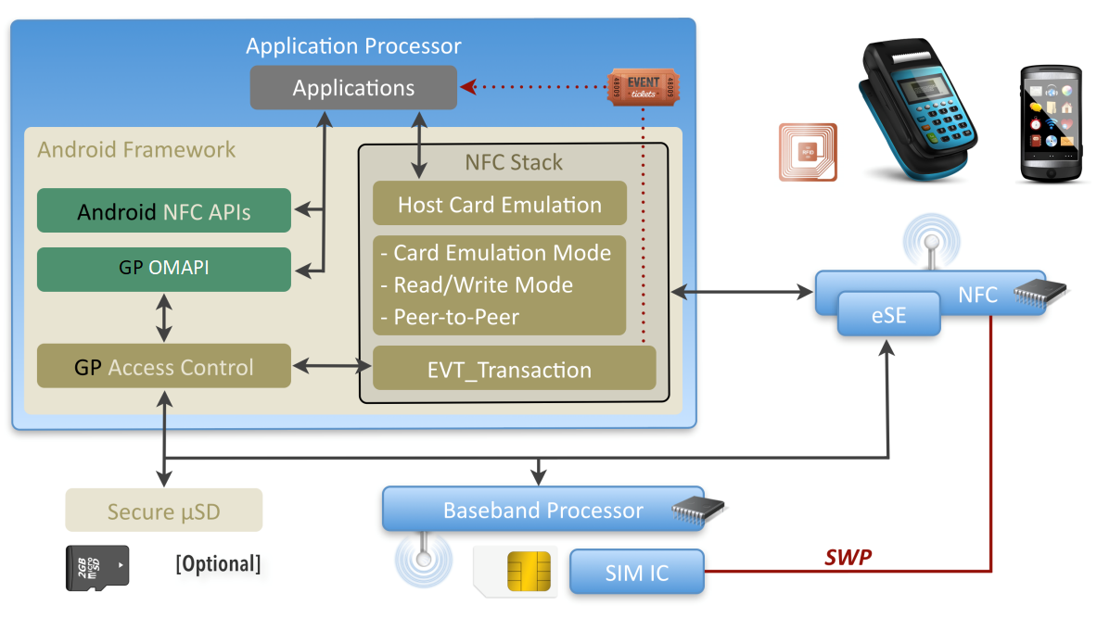
- : Android NFC software stack
The previous figure gives an overview of a possible Android implementation as an example showing how this requirement can be mapped to an OS.
On Android the architecture could be encapsulated in an Android Service. Having a single service ensures that security checks (who is accessing the service) and resource management (freeing up a logical channel) can be guaranteed.
On Android, such a background component might rely on a RIL extension for accessing the UICC and on some specific libraries, for communicating with any embedded secure elements.

VOID
TS26_NFC_REQ_181 | VOID
TS26_NFC_REQ_123 | VOID

VOID
TS26_NFC_REQ_093 | VOID
TS26_NFC_REQ_146 | VOID

Card Emulation mode requirements
All generic device requirements are applicable in addition to below specific requirements for Android.
TS26_NFC_REQ_193 | This requirement is applicable from Android 10 onwards.  The device SHALL declare FEATURE_NFC_OFF_HOST_CARD_EMULATION_UICC
TS26_NFC_REQ_194 | This requirement is applicable from Android 10 onwards.  The device MAY declare FEATURE_NFC_OFF_HOST_CARD_EMULATION_ESE

Reader/writer & TAG management requirements
No specific requirement, see Generic Device Requirements.

Secure Element Access & Multiple Secure Elements Management

Mobile Device Modem requirements
No specific requirement, see Generic Device Requirements.

Secure Element Access API requirements
TS26_NFC_REQ_124 | VOID
TS26_NFC_REQ_186 | The device SHALL implement GlobalPlatform Open Mobile API using the “android.se.omapi” namespace.  Note: this requirement fulfils the generic requirements TS26_NFC_REQ_047, TS26_NFC_REQ_047.1, TS26_NFC_REQ_047.2 TS26_NFC_REQ_047.3 and TS26_NFC_REQ_183.
TS26_NFC_REQ_125 | GlobalPlatform Open Mobile API and GlobalPlatform Access Control SHALL be initialized and ready to use when the BOOT_COMPLETED intent is sent.
TS26_NFC_REQ_125.1 | As system components, GlobalPlatform Open Mobile API and GlobalPlatform Access Control SHALL be independent of the state of the SIM and initialization SHALL be completed even when the SIM is locked by a PIN code.

Multiple CEE support
All generic device requirements are applicable in addition to below specific requirements for Android.

VOID
TS26_NFC_REQ_126 | VOID

Multiple Active CEE model
The following requirements only apply where a device supports Multiple Active CEEs model.
TS26_NFC_REQ_094 | When a mobile application is registering an AID-based or non AID-based service (statically or dynamically) it SHALL be able to state the target CEE using an OS mechanism (manifest, API, …).
TS26_NFC_REQ_094.1 | Before Android 10, the following extension SHALL be supported in the manifest  <extensions xmlns:android="http://www.gsma.com" android:description="@string/servicedesc">  <se-ext-group>  <se-id name="XXX" />  </se-ext-group>  <AID-based>boolean</AID-based>  </extensions>  Where:  - se-id name SHALL be set as described in TS26_NFC_REQ_069 and TS26_NFC_REQ_070 ; the uniqueness of the naming SHALL be ensured by the OS as described in TS26_NFC_REQ_144.  - For se-id name field, following values SHALL be accepted by the device:  - “SIM” and “SIM1” for SIM slot 1  - “eSE” and “eSE1” for embedded Secure Element 1  - AID-based SHALL be set to true in case a SE application is compliant with ISO 7816-4 and false in all other cases  Note: When a mobile application is declaring a se-id name that is not existing on the device the registration shall be ignored.
TS26_NFC_REQ_094.2 | Before Android 10, if the extension is not declared in the manifest of the application, then the following default values SHALL apply (for backward compatibility):  - <se-id name=”SIM1”/>  - <AID-based>true</AID-based>
TS26_NFC_REQ_094.3 | From Android 10 onwards, it SHALL support the definition of the target Offhost CEE from the manifest of the application  Note: In Android 10 this is achieved using the following tag in the OffHostApduService description  <attr name="secureElementName"/>  Note: See Annex B for documented usage the feature name may change in any future release of Android, please check Android developer documentation for updates.
TS26_NFC_REQ_094.4 | From Android 10 onwards, if the tag is not declared in the service declaration of the manifest of the application, then it SHALL be interpreted as SIM1 (for backward compatibility)
TS26_NFC_REQ_094.5 | From Android 10 onwards, it SHALL be possible to define (set & unset) the target Offhost CEE using APIs defined by Android  Note: In Android 10 the APIs are named like stated below but the naming may change in any future release of Android, please check Android developer documentation for updates.  - CardEmulation.setOffHostForService(serviceName, offhostName)  - CardEmulation.unsetOffHostForService (serviceName)
TS26_NFC_REQ_133 | The device SHALL support an OS mechanism that allows applications to statically register NFC application by list of AIDs.  Note: this requirement fulfils the generic requirement TS26_NFC_REQ_061.
TS26_NFC_REQ_127 | VOID
TS26_NFC_REQ_127.1 | VOID
TS26_NFC_REQ_127.2 | VOID
TS26_NFC_REQ_128 | VOID
TS26_NFC_REQ_128.1 | VOID
TS26_NFC_REQ_128.2 | VOID
TS26_NFC_REQ_128.3 | VOID
TS26_NFC_REQ_134 | The device SHALL provide an additional menu entry in “Settings” in order to enable/disable group of AIDs (as defined by Android) belonging to the category “Other”.  A group of AIDs SHALL only be enabled/disabled as a single unit.  This requirement is optional if TS.26_NFC_REQ_167.1 is supported.
TS26_NFC_REQ_134.1 | When there is an overflow in the NFC router table, the menu entry SHOULD display:  - A banner representing the groups of AIDs belonging to the category “Other” (and optionally the group description) with its current status (enabled/disabled) and a way for disabling/enabling it  - A visual indication representing the NFC Controller capacity and showing  - The space used by the selected group  - If enablement of the selected group can fit with the remaining space of the NFC Controller routing table
TS26_NFC_REQ_134.2 | The menu entry SHOULD be hidden to the end user until the first time a NFC Service cannot be added in the NFC Controller routing table
TS26_NFC_REQ_134.3 | When the menu entry is opened, the status of NFC services group displayed by the menu entry SHALL reflect the actual status of the current NFC Controller routing table.
TS26_NFC_REQ_134.4 | When there is no overflow in the NFC routing table and if the menu entry is available to the end user, the menu SHOULD not allow the end user to disable the AID groups.
TS26_NFC_REQ_172 | The device SHALL consider that non-AID based services are conflicting as soon as they are associated to different Off-Host entities.
TS26_NFC_REQ_170 | In case the device detects a conflict between non-AID based contactless services (see TS26_NFC_REQ_172), the device SHALL display a menu entry in “Settings” in order to list impacted contactless services and the user SHALL be directed to the menu.
TS26_NFC_REQ_170.1 | The menu entry SHALL present the conflicting services to the end user with an option to select which service(s) to be active. Only one set of service(s) (which are not conflicting with each other) SHALL be active at any one time.
TS26_NFC_REQ_170.2 | The menu entry SHOULD be hidden to the end user in case there is no conflicting services.
TS26_NFC_REQ_170.3 | VOID
TS26_NFC_REQ_171 | VOID
TS26_NFC_REQ_180 | If the end user changes the default non-AID based contactless service via the menu described in TS26_NFC_REQ_170, the device SHALL reconfigure the NFC Controller with the contactless parameters configured in the Off-Host linked to the newly activated service.
TS26_NFC_REQ_135 | When an application is trying to register new AIDs belonging to the category “Other” and there is no automatic solution to solve any routing table overflow (as defined in REQ_143), the device SHALL:  - Inform the end user that some NFC Services proposed by the application cannot be used. A message SHALL provide the description of the group(s) of AIDs (android:description) which cannot be activated  - Propose the end user should disable some previously installed NFC services using the feature described in TS26_NFC_REQ_134 in order to free some NFC Controller routing table space to be able to register all AIDs needed by the current application  When one AID from a group of AIDs cannot be added in the NFC Controller routing table, the entire group of AIDs SHALL not be enabled.
TS26_NFC_REQ_136 | When a customer is selecting a service from the “Tap&Pay” menu and there is no automatic solution to solve any routing table overflow (as defined in REQ_143), the device SHALL:  - Inform the end user that activation of the selected NFC services cannot be performed  - Propose the end user should disable some previously installed NFC services using the feature described in TS26_NFC_REQ_134 in order to free some NFC Controller routing table space  If the end user doesn’t disable enough NFC services to allow activation of the selected “Tap&Pay” menu, previous “Tap&Pay” entry SHALL stay active and the end users selection is cancelled.  This requirement is optional if TS.26_NFC_REQ_167.1 is supported.
TS26_NFC_REQ_147 | In the “Tap&Pay” menu, the user selection has precedence and the behaviour of the device is consistent across different handset states.  The following scenarios SHALL be applied.  Note 1: If Android is changing the behaviour then this requirement will change accordingly.  Note 2: GSMA strongly recommend that service providers register the Off-Host AIDs in the Android OS as defined by Android.
  Scenario | Screen ON (Screen Lock/Unlock) | Screen OFF | Switched Off
  Default AID route is set to HCE.  No App in the Payment category has been installed. | For any AID which is not registered in the "Other" category, contactless selection fails with error code '6A82'. | For any AID which is not registered in the "Other" category, contactless selection fails with error code '6A82'. | For any AID which is not registered in the "Other" category, contactless selection fails with error code '6A82'.
  Default AID route is set to Off-Host  No App in the Payment category has been Installed. | For any AID which is not registered in the "Other" category, APDUs go to Off-Host. | For any AID which is not registered in the "Other" category, APDUs go to Off-Host. | For any AID which is not registered in the "Other" category, APDUs go to Off-Host.
  Default AID route is set to Off-Host  The user selected an Off-Host-based service in Tap&Pay menu. | APDUs intended for the selected Off-Host service go to Off-Host. | APDUs intended for the selected Off-Host service go to Off-Host. | APDUs intended for the selected Off-Host service go to Off-Host.
  Default AID route is set to Off-Host  The user selected a HCE-based service in Tap&Pay menu. | APDUs intended for the selected HCE service go to HCE. | For APDUs intended for the selected HCE service, contactless selection fails with error code '6A82' OR APDUs go to HCE. | For APDUs intended for the selected HCE service, contactless selection fails with error code '6A82'.
  Default AID route is set to HCE  The user selected a HCE-based service in Tap&Pay menu. | APDUs intended for the selected HCE service go to HCE. | For APDUs intended for the selected HCE service, contactless selection fails with error code '6A82 OR APDUs go to HCE'. | For APDUs intended for the selected HCE service, contactless selection fails with error code '6A82'.
  Default AID route is set to HCE  The user selected an Off-Host-based service in Tap&Pay menu. | APDUs intended for the selected Off-Host service go to Off-Host. | APDUs intended for the selected Off-Host service go to Off-Host. | APDUs intended for the selected Off-Host service go to Off-Host.
TS26_NFC_REQ_148 | The device SHALL not change the default AID route in response to changes in device state (such as screen off, power off).
TS26_NFC_REQ_148.1 | The same behaviour SHALL be implemented when the mobile device is set in Flight Mode with NFC ON.
TS26_NFC_REQ_149 | AID Conflict resolution mechanism defined by Android SHALL be applied to both HCE applications and Off-Host applications (UICC, eSE).

UI Application triggering requirements
The same generic requirements are applicable to Android platform with the following requested implementation:
TS26_NFC_REQ_129 | VOID
- : VOID
TS26_NFC_REQ_096 | VOID
- : VOID
TS26_NFC_REQ_187 | Transaction Event is provided natively by Android.  A Transaction Event (EVT_TRANSACTION) SHALL be triggered based on the following information:

Action | android.nfc.action.TRANSACTION_DETECTED
Mime type | -
URI | nfc://secure:0/<SEName>/<AID>  - SEName reflects the originating SE  It must be compliant with GlobalPlatform Open Mobile API  - AID reflects the originating UICC applet identifier, in upper case hexadecimal format
- : Table: Intent Details for TRANSACTION_DETECTED
TS26_NFC_REQ_188 | Transaction event data SHALL be set in the following extended field:

android.nfc.extra.AID  ByteArray | Contains the card “Application Identifier”
android.nfc.extra.DATA  ByteArray | Payload conveyed by the HCI event  “EVT_TRANSACTION” [optional]
android.nfc.extra.SECURE _ELEMENT_NAME  String | Indicates the Secure Element on which the transaction occurred.  eSE1...eSEn for Embedded Secure Elements, SIM1...SIMn for UICC, etc.
- : Table: TRANSACTION_DETECTED data
TS26_NFC_REQ_098 | VOID
TS26_NFC_REQ_182 | VOID
TS26_NFC_REQ_097 | VOID
TS26_NFC_REQ_099 | VOID
TS26_NFC_REQ_189 | The framework SHALL generate a send broadcast intent toward application signed with an allowed hash in access rules.
6 Note: Refer to the Javadoc linked to this document for more details.

VOID
TS26_NFC_REQ_150 | VOID
TS26_NFC_REQ_150.1 | VOID
TS26_NFC_REQ_150.2 | VOID

VOID
TS26_NFC_REQ_151 | VOID

Remote Management of NFC Services
No specific requirement, see Generic Device Requirements.

Security
TS26_NFC_REQ_130 | VOID
TS26_NFC_REQ_130.1 | VOID
TS26_NFC_REQ_130.2 | VOID
TS26_NFC_REQ_190 | The permission SHALL be set as following:  - OMAPI does not require any specific permissions  - TRANSACTION_EVENT SHALL be  - android.permission.NFC_TRANSACTION_EVENT

Access API & Secure Element Access Control requirements
No specific requirement, see Generic Device Requirements.

NFC Event & Access Control requirements
The same generic requirements are applicable to Android platform with the following requested implementation:
Android permissions
TS26_NFC_REQ_131 | VOID
- :VOID
TS26_NFC_REQ_191 | The device SHALL ensure that the application has the following permission before forwarding a Transaction event to the application:

Transaction Event | android.permission.NFC_TRANSACTION_EVENT
- : Table EVT_TRANSACTION Permissions
Access control
Transaction intents link an Android application and an applet installed on a Secure Element. For this reason, securing them shall be done with the same rules that restrict applet access by the Android application through the GlobalPlatform Open Mobile API.
TS26_NFC_REQ_152 | The NFC stack SHALL therefore use internal “Access Control” API to check that the recipient activity has been signed with an authorised certificate. This check is performed at the time the event is being forwarded from the lower layers to the target application. See TS26_NFC_REQ_084.1
TS26_NFC_REQ_152.1 | If an application is registered to any “EVT_TRANSACTION”, by omitting the AID in the Intent, it SHALL receive the events of any applets to those accessible using the “Access Control”.
TS26_NFC_REQ_152.2 | If no application is authorised as per “Access Control” check, then the event SHALL be discarded by the framework.

VOID
TS26_NFC_REQ_156 | VOID
TS26_NFC_REQ_153 | VOID
TS26_NFC_REQ_153.1 | VOID

SCWS support
No specific requirement, see Generic Device Requirements.

Card Application Toolkit Support
No specific requirement, see Generic Device Requirements.

VOID
TS26_NFC_REQ_132 | VOID

VOID
TS26_NFC_REQ_100 | VOID
TS26_NFC_REQ_101 | VOID
TS26_NFC_REQ_102 | VOID
TS26_NFC_REQ_103 | VOID
TS26_NFC_REQ_104 | VOID
TS26_NFC_REQ_105 | VOID
TS26_NFC_REQ_106 | VOID

VOID

VOID

Android Wear Operating System
Requirements for Android Wear will be added in a later version of this document.

- Implementation/usage help of REQ 94.1 for multi eSE on Android
OffHost Service definition in Android Manifest
<service android:name=".MyserviceOffHost"
android:exported="true"
android:permission="android.permission.BIND_NFC_SERVICE" >
<intent-filter>
<action android:name="android.nfc.cardemulation.action.OFF_HOST_APDU_SERVICE"/>
<category android:name="android.intent.category.DEFAULT"/>
</intent-filter>
<meta-data android:name="android.nfc.cardemulation.off_host_apdu_service" android:resource="@xml/offhost_aid"/>
<meta-data android:name="com.gsma.services.nfc.extensions" android:resource="@xml/nfc_se"/>
</service>
Note: the bold line is a GSMA extension.

com.gsma.services.nfc.extensions = see REQ 094.1
nfc_se XML file content example

<extensions xmlns:android="http://www.gsma.com" android:description="@string/servicedesc">
<se-ext-group>
<se-id name="XXX"/>
</se-ext-group>
<AID-based>boolean</AID-based>

</extensions>

XXX can be : SIM/SIM1, SIM2, eSE/eSE1, eSE2, … (as per requirements TS26_NFC_REQ_070 and 071)
AID-based is set to:
- true for Application defining service using AID based (compliant with ISO 7816-4)
- false for Application defining service using non AID based (i.e. Mifare, Felica, …)

- Implementation/usage hint of REQ 94.3 for multi SE from Android 10
<service android:name=".MyserviceOffHost"
android:exported="true"
android:permission="android.permission.BIND_NFC_SERVICE" >
<intent-filter>
<action android:name="android.nfc.cardemulation.action.OFF_HOST_APDU_SERVICE"/>
<category android:name="android.intent.category.DEFAULT"/>
</intent-filter>
<meta-data android:name="android.nfc.cardemulation.off_host_apdu_service" android:resource="@xml/ apduservice"/>
</service>

XML apduservice content:
<offhost-apdu-service android:description="@string/servicedesc" android: android:secureElementName ="SIM1” xmlns:android="http://schemas.android.com/apk/res/android" />
Note: the bold line is the way to specify the target CEE

- Document Management
  - Document History
Ver. | Date | Brief Description of Change | Approval Authority | Editor / Company
1.0 | July 2011 | First draft submitted to DAG and PSMC for approval | PSMC and NFC (Rejected at PSMC level) | Sameer Tiku, Vodafone
2.0 | November 2011 | Second draft incorporating PSMC feedback submitted to DAG and PSMC for approval | PSMC and NFC (V2.0 Approved and published) | Sameer Tiku, Vodafone
3.0 | 03 October 2012 | Submitted to DAG and PSMC for 7 day Committee Email approval | PSMC and NFC | Sameer Tiku, Vodafone
4.0 | 17 September 2013 | Re-Submitted to DAG and PSMC for approval following comments received from PSMC | PSMC and NFC | Sameer Tiku, Vodafone
4.1 | 6 November 2013 | Corrected and updated namespace to <com.gsma.services.nfc>.  Impacted sections: 4.9, 4.10 | Terminal Steering Group | Katrin Jordan,  DT / TSG
5.0 | 12th March 2014 | Implemented updates to: Title, Introduction, Abbreviations, Terms of Definitions, References, Doc. structure, Figures, Requirements across the document and API specifications. Added a new numbering scheme and provided editorial updates. Marked requirements still work in progress. Removed Annexes and requirements/references as applicable. | Terminal Steering Group | K.Jordan (DT)
6.0 | 21 July 2014 | Implemented updates to: Introduction, Abbreviations, Definitions of Terms, References, Figures, Core Required NFC Features, Secure Element Access & Multiple Secure Elements Management, UI Application triggering requirements, UICC Remote Management, Security, SCWS support, Card Application Toolkit Support, Platform Dependent Properties, Android and Blackberry OS specific sections.  Removed majority of yellow markings where req. could be confirmed.  Removed Android API details and provided updated API details as separate Javadoc with Readme file.  Implemented further formatting and quality updates. | Terminal Steering  Group | K.Jordan, G.Printemps, DT
7.0 | 23 March 2015 | Extra document release to address 2 critical issues: 1) ambiguity of the requirement 114 and 2) full AID routing table issue when installing new application on Android devices. | Terminal Steering Group | Radomír Věncek, DT
8.0 | 13 October 2015 | General update based mainly on feedback from the NFC Handset Test Book, changes across the whole document. Includes also initial changes related to transport industry – accepted NFC Forum specifications as a baseline for device testing. Added new requirements as well as modified existing ones. | Terminal Steering Group | Radomír Věncek, DT
9.0 | 01 April 2016 | General update fixing some known issues, removing empty OS sections (Blackberry, Windows Phone), adding few new requirements. | Terminal Steering Group | Radomír Věncek, DT
10.0 | 05 December 2016 | General update amending some existing requirements and adding few new requirements. | Terminal Steering Group | Ruben Rico, Vodafone
11.0 | 12 June 2017 | General update, adding eSE and Wearables as part of the document. GSMA API is marked as deprecated from this version. | Terminal Steering Group – TSG#28 | Anders Olsson, Sony Mobile
12.0 | 05 December 2017 | General update, next step in deprecating GSMA APIs. Adding clarifying requirements for Dual SIM and eSE. | Terminal Steering Group – TSG#30 | Anders Olsson, Sony Mobile
13.0 | 04 June 2018 | This version includes the following changes:  - Android 9 impacted requirements have been updated and some new requirements have been introduced to support the Android 9 implementation.  - Single CEE (Card Emulation Environment) requirements have been Voided as this is not relevant anymore.  - Multiple UICC “slots” – 1 updated requirement on NFC capability for multiple UICC/eUICC slots.  - GSMA APIs: Requirements updated to reflect deprecated GSMA APIs have been made optional and changed from SHOULD to MAY. | Terminal Steering Group | Anders Olsson, Sony Mobile
14.0 | 4th December 2018 | This version is implementing the following changes:  - NFC Forum Type 5 Tag requirement is introduced.  - NFC Forum Type 1 Tag requirement is removed.  - NFC transaction in Battery Power-Off Mode is removed.  - AID Routing Table Overflow support in device menu made optional if more than 40 AIDs are supported.  - Requirements for GSMA API are removed (Void). (Previously they were MAY and deprecated). The property to return version numbering removed.  - Document Cross Reference updated with reference to newer specifications.  - Including reference to NFC Forum Technical Specification Release which identifies the version of specific NFC Forum specifications.  References to SIMalliance specifications in relation to OMAPI are changed to GlobalPlatform. | Terminal Steering Group | Anders Olsson, Sony Mobile
15.0 | 19 June 2019 | This version is implementing the following changes:  - 6 new requirements  - 2 updated requirements  - 12 removed requirements.  Summary of changes:  - Android 10 supported by TS.26.  - 5 new Android 10 related requirements introduced:  1. New Android 10 related requirements for registering NFC services to a specific SE for AID based services (REQ_094.3, REQ_094.4, REQ_094.5).  2. New Android 10 related requirements for the Device to declare support of Card Emulation for UICC and eSE (REQ_193, REQ_194). Supporting new Android 10 API.  - Requirements for devices implementing Android versions before Android 9 have been removed. Devices shall implement Android 9 or later version of Android.  - Transaction Event: Clarification of expected behaviour for Transaction Event (New REQ_084.1).  - AID naming: Clarification how the AID in NFC transaction events is specified in relation to lower/upper case hexadecimal usage (Section 7.4).  - Document Cross References updated with reference to newer specifications including. | TSG | Anders Olsson, Sony Mobile

Other Information
Type | Description
Document Owner | GSMA TSG
Editor / Company | Anders Olsson (Sony Mobile), Paul Gosden (GSMA)

It is our intention to provide a quality product for your use. If you find any errors or omissions, please contact us with your comments. You may notify us at prd@gsma.com
Your comments or suggestions

Note: This requirement will be updated to also reference pattern, as soon as relevant specifications from NFC Forum or GlobalPlatform are available.
Refers to NCI specification [NFC Forum specifications] for details of routing based on AID, RF protocol and RF technology.
Note: Letter class e (BIP commands and events set) is related to the requirement of section 6.5.2. (UICC Remote Management (Access to UICC in connected mode) requirements).

