

TS.71 IDL to Modem Specification

28th April 2026

Version 1.0

Security Classification: Non-Confidential
Access to and distribution of this document is restricted to the persons permitted by the security classification. This document is subject to copyright protection. This document is to be used only for the purposes for which it has been supplied and information contained in it must not be disclosed or in any other way made available, in whole or in part, to persons other than those permitted under the security classification without the prior written approval of the Association.
Copyright Notice
Copyright © 2026 GSM Association
Disclaimer
The GSMA makes no representation, warranty or undertaking (express or implied) with respect to and does not accept any responsibility for, and hereby disclaims liability for the accuracy or completeness or timeliness of the information contained in this document. The information contained in this document may be subject to change without prior notice.
Compliance Notice
The information contain herein is in full compliance with the GSMA Antitrust Compliance Policy.
This Permanent Reference Document is classified by GSMA as an Industry Specification, as such it has been developed and is maintained by GSMA in accordance with the provisions set out GSMA AA.35 - Procedures for Industry Specifications.

Table of Contents
1 Introduction 4
1.1 Overview 4
1.2 Scope 4
1.3 Definitions 5
1.4 Abbreviations 5
1.5 References 5
1.6 Conventions 6
2 Interfaces, UE Architecture, and Functional Requirements 6
2.1 Interface Overview 6
2.2 UE Architecture 7
3 ImsDataChannelServiceController Interface 9
3.1 Requirements 9
3.2 ImsDataChannelServiceController Interface Definition 9
3.3 Creating a Data Channel 9
3.3.1 AppInfoXml Schema 10
3.3.2 AppInfoXml Example 13
4 ImsDataChannelCallback Interface 14
4.1 Requirements 14
4.2 ImsDataChannelCallback Interface Definition 14
4.3 Get Result of Creating a Data Channel 14
4.4 Call Flow for UE Creating an Application Data Channel 16
5 ImsDataChannel Interface 18
5.1 Requirements 18
5.2 ImsDataChannel Interface Definition 18
5.3 Sending Message on a Data Channel 19
5.3.1 Mapping to TS.66 send() method 19
5.4 Closing a Data Channel 19
5.4.1 Mapping to TS.66 close() method 19
6 DCSendDataCallback Interface 20
6.1 Requirements 20
6.2 DCSendDataCallback Interface Definition 20
6.3 Get Result of Sending Data 20
6.3.1 Transmission Status Code Definition 21
6.4 Call Flow Showing Transmission Result Handling 21
7 ImsDCObserver Interface 22
7.1 Requirements 22
7.2 ImsDCObserver Interface Definition 22
7.3 Data Channel State 23
7.3.1 Mapping to TS.66 RTCDataChannelState 23
7.4 Receiving Message 23
7.4.1 Mapping to TS.66 onMessage method 23
Annex A Document Management 24
A.1 Document History 24
A.2 Other Information 24

Introduction

Overview
The present document specifies the interface to 3GPP TS 26.114 [5] defined IMS Data Channel Service implemented by UE, e.g. as part of modem providing DCMTSI client in terminal functionality. The interface is defined by the means of the Interface Definition Language (IDL) [9] and exists between two UE functional blocks:
- JavaScript run-time environment exposing GSMA PRD TS.66 [4] API for application consumption.
- IMS Data Channel Service implementing the data channel procedures across IMS User-to-Network Interface (UNI) as part of DCMTSI client in terminal.
The terminal and the modem suppliers that wish to implement a standardized, and interoperable IMS Data Channel capability set should refer to this document, i.e. GSMA PRD TS.71. The document can be also used by SDK and Operating System suppliers that wish to access IMS Data Channel Services in the modem and/or expose those capabilities to the JavaScript application developers.
The IMS Data Channel Application Programming Interface (API) is defined in GSMA PRD TS.66 [4] and exposes the IMS Data Channel Service to JavaScript Applications referred as IMS Data Channel Applications. GSMA PRD TS.66 [4] API supports, but is not limited to, the establishment and termination of IMS Data Channels, SIP Offer/Answer, data transmission and reception, etc. The interfaces defined in this document are consumed by IMS Data Channel Applications through GSMA PRD TS.66 [4] defined API which invoke the IMS Data Channel Services required for peer-to-peer data transfer.

Scope
The document provides the minimal set of requirements to access IMS Data Channel Service and specifies the interface for such access expressed in IDL [9] .The interface specification applies equally to the Native Implementations and SDK based implementations of IMS Data Channel run-time, i.e. this specification does not differentiate those two cases and makes the same capabilities available to both. GSMA PRD TS.71 requires that UE supports 3GPP TS 26.114 [5] defined DCMTSI client in terminal and the compliance to GSMA PRD NG.134 [3] and GSMA PRD TS.66 [4]. And in essence this minimal compliance baseline guarantees that DCMTSI client in terminal capabilities can be exposed to JavaScript Applications through the OEM, Operating System or operators provided run-time environments. Therefore, enabling peer to peer data transfers.

NOTE: The interfaces specified in this document that is GSMA PRD TS.71 have been implemented by the IMS Data Channel SDK open-source project and made available from GitHub at the following link: https://github.com/GSMATerminals/IMS-DC-SDK-Open-Source.

Definitions
Term | Description
DCMTSI client | An IMS Data Channel capable MTSI client supporting data channel media as defined in section 6.2.10 of 3GPP TS 26.114 [5].
IMS Data Channel Service Development Kit | UE software component implementing IMS Data Channel run-time environment.
IMS Data Channel Service | UE functional block implementing 3GPP TS 26.114 defined procedures required for establishing, maintaining, managing and terminating IMS Data Channel sessions. It is part of DCMTSI client in terminal.
Native Implementation | UE capability that is made available as a part of standard OS distribution and does not require any add-ons or extra components for making it available to applications.
Dialler | The mobile device human to machine interface function allowing users to enter telephone numbers in E.164 format, initiate call and initiates the data channel interactivity sequence.
Data Channel Application | The Data Channel Application is an application used in IMS audio or video calls that allows to transmit data, including text data, control commands, etc., through the IMS Data Channel and enable enhanced telephony service.

Abbreviations
Term | Description
API | Application Programming Interface
APN | Access Point Name
IDL | Interface Definition Language
IMS | IP Multimedia Subsystem
PRD | Permanent Reference Document
BDC | Bootstrap Data Channel
ADC | Application Data Channel
UE | User Equipment
MNO | Mobile Network Operator

References
Ref | Doc Number | Title
[1] | RFC 2119 | “Key words for use in RFCs to Indicate Requirement Levels”, S. Bradner, March 1997. Available at http://www.ietf.org/rfc/rfc2119.txt
[2] | RFC 8174 | Ambiguity of Uppercase vs Lowercase in RFC 2119 Key Words  https://www.rfc-editor.org/info/rfc8174
[3] | GSMA PRD NG.134 | IMS Data Channel
[4] | GSMA PRD TS.66 | IMS Data Channel API
[5] | 3GPP TS 26.114 | IP Multimedia Subsystem (IMS); Multimedia telephony; Media handling and interaction
[6] | GSMA PRD IR.92 | IMS Profile for Voice and SMS
[7] | GSMA PRD IR.94 | IMS Profile for Conversational Video Service
[8] | GSMA PRD NG.114 | IMS Profile for Voice, Video and Messaging over 5GS
[9] | IDL | Interface Definition Language  https://www.omg.org/spec/IDL

Conventions
The key words “SHALL”, “SHALL NOT”, “SHOULD”, “SHOULD NOT”, and “MAY in this document is to be interpreted as described in RFC 2119 [1] and clarified by RFC8174 [2], when, and only when, they appear in all capitals, as shown here.

Interfaces, UE Architecture, and Functional Requirements

Interface Overview
The interfaces defined in this document are used to access IMS Data Channel Service implemented by 3GPP TS 26.114 [5] defined DCMTSI client in terminal without limitation how it is technically realized. The interface can be called by IMS Data Channel SDK developed by Operator, or by OEM from within JavaScript run-time environment or be used by Operating System to offer native implementation. All those scenarios are the same from the access perspective but might differ otherwise due to different implementations, i.e. non-functional differences between those environments might exist. In all cases the objective is to make the IMS data Channel Service available to the application layer in a transparent and operating system independent manner. Therefore, the interfaces address the following requirements
- Enable Standardized Access to IMS Data Channel Service
  - Normalize and allow standardized functional access to IMS Data Channel Service to authorized entities, e.g. OS, JavaScript API, SDK, therefore enabling the same method across devices and modems to access the data channel procedures such as establishment, termination, data transmission, etc.
- Expose IMS Data Channel Service to JavaScript Applications
  - Makes IMS Data Channel Service available for consumption to the application layer through the GSMA PRD TS.66 [4] defined API.
- Ensure Standard Compliance
  - Complies with GSMA PRD NG.134 [3], 3GPP TS 26.114 [5], and GSMA PRD TS.66 [4] therefore standardizing the end-to-end service flows and the interactions across the UE stack, i.e., from the Application across JavaScript run-time to IMS Data Channel Service and the IMS network over UNI. Therefore, providing integrated and consistent implementation architecture for UE.
- Provide real-time constructs similar to W3C WebAPIs
  - Make available events and callbacks to support asynchronous nature of IMS Data Channel Applications and that of data transfers so the code is non-blocking and asynchronous
The document introduces the following interfaces:
- ImsDataChannel Interface providing access to IMS Data Channel Service for entities that require such access and are authorized to do so,
- ImsDataChannelServiceController Interface that supports the creation and deletion of IMS Data Channels,
- DCSendDataCallback Interface supporting the callback registration linked to the anynchronous data transmission events, e.g. reception notification,
- ImsDataChannelCallback Interface supporting the callback registration related to the asynchrous establishement of IMS Application Data Channels,
- ImsDCObserver Interface used to observe the IMS Data Channel state transition notification.

UE Architecture
UE internal architecture showing the relation between different IMS Data Channel functional blocks defined by GSMA PRD TS.66 [4], GSMA PRD NG.134 [3], 3GPP TS 26.114 [5] and the interface defined in this document is shown on Figure 2.2-1.
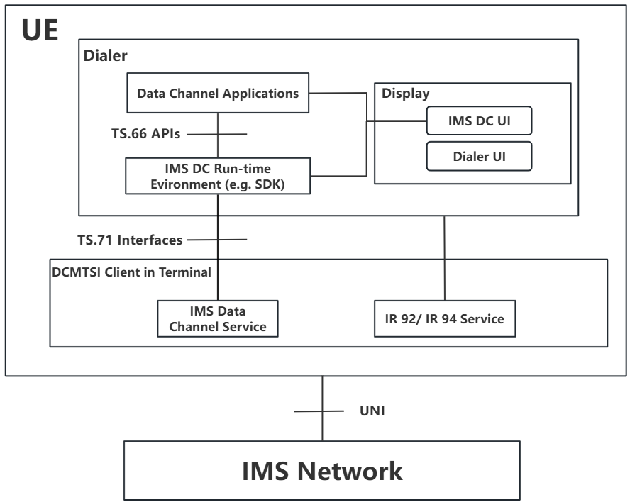
Figure 2.2-1: The UE Architecture illustrating relationship between GSMA PRD TS.66, 3GPP TS 26.114 and GSMA PRD TS.71 functional blocks
The IMS Data Channel run-time environment such as the SDK provides the execution environment for IMS Data Channel applications, and IMS Data Channel applications invoke the required Data Channel capabilities by using the API defined in GSMA PRD TS.66[4]. The DCMTSI Client deployed on the terminal is a multimedia telephony service client equipped with IMS Data Channel Service capabilities. Specifically, it supports IMS Data Channel Service as well as IMS audio and video services, both of which are defined in IR.92 [6] and IR.94 [7]. The IMS Data Channel Service provides Data Channel capabilities via the GSMA PRD TS.71 defined interfaces.

NOTE 1: The IMS Data Channel SDK is optional component. The Communication Service Provider might use such SDK subject to its discretion but might also choose to use the Native Implementation if such are available. In all cases regardless of the solution chosen, the above architecture applies.
NOTE 2: The IDL implementation mechanism to access the IMS Data Channel Service is left to OEM discretion as it represents internal realization and is the local system support function. It suffices that the access mechanism complies to GSMA PRD TS.71 but the Service Access Points defined in section 4.1 of GSMA PRD TS.66 [4] can be implemented differently by different UEs.

ImsDataChannelServiceController Interface
The ImsDataChannelServiceController Interface is used to create and establish an Application Data Channel connectivity layer using the procedures defined in section 4.2.4 of NG.134 [3]. The Application Data Channel created by this procedure meets the characteristics specified by the IMS Data Channel applications.

Requirements
TS71_3.1_REQ_001 | IMS Data Channel capable UE SHALL support ImsDataChannelServiceController Interface.
TS71_3.1_REQ_002 | The IMS Data Channel service SHALL support the creation of IMS Application Data Channels using ImsDataChannelServiceController interface.

ImsDataChannelServiceController Interface Definition
interface ImsDataChannelServiceController
{
void createImsDataChannel(in sequence<string> dcLabels, in string appInfoXml, in long slotId, in string telecomCallId);
};

The createImsDataChannel() method used to create Data Channel provides no return value.

Parameters
- dcLabels: used to create Data Channel with unique label
- slotId: identifies SIM slot ID.
- telecomCallId: identifies current call.
- appInfoXml: provides information about Data Channels that are to be created.

Creating a Data Channel
The ImsDataChannelServiceController interface createImsDataChannel() creates a specified IMS Data Channel and establishes the IMS Data Channel connectivity layer over the IMS UNI using the procedures specified in section 4.2.4 of GSMA PRD NG.134 [3].

TS71_3.3_REQ_001 | The createImsDataChannel() method SHALL implement void createImsDataChannel including parameters: dcLabels of string array type, appInfoXml of string type, slotId of 32-bit signed integer type, and telecomCallId of string type.
TS71_3.3_REQ_002 | The parameter dcLabels SHALL identify in unique way the IMS Application Data Channel that is being created.
TS71_3.3_REQ_003 | The parameter appInfoXml SHALL contain the information about all Application Data Channels, i.e. 1+, potentially required by the IMS Data Channel Application. It is recommended that the number of configured Application Data Channel does not exceed the UE’s own capability.
TS71_3.3_REQ_004 | The parameter slotId SHALL denote which SIM card slot is currently being used. “0” is sim card 1, “1” is sim card 2.
TS71_3.3_REQ_005 | The parameter telecomCallId SHALL uniquely identify the current call.  NOTE: This is typically provided by device upon device power on. It is used to distinguish IMS Data Channels in multiple calls scenario.When the device is first powered on, this parameter is “TC@0”. After one call is made, the parameter becomes “TC@1”, and so on.
TS71_3.3_REQ_006 | When createDataChannel() defined in section 6.4.3 of GSMA PRD TS.66 [4] i.e. createDataChannel(USVString label,  optional RTCDataChannelInit dataChannelDict = {});  is called with string label type , e.g. ‘channel1’ without appInfoXml data structure then single Data Channel SHALL be created with that label value used as dcLabel, i.e. dcLabel=label with type conversion.
TS71_3.3_REQ_007 | When createDataChannel() defined in section 6.4.3 of GSMA PRD TS.66 [4] i.e. createDataChannel(USVString label,  optional RTCDataChannelInit dataChannelDict = {});  is called with optional dataChannelDict describing Data Channel transport characteristics to be used then a such Data Channel described SHALL be created, e.g., dataChannelDict to appInfoXml mapping might be required at the lower level of stack.

AppInfoXml Schema
<?xml version="1.0" encoding="UTF-8"?>
<xs:schema
xmlns:xs="http://www.w3.org/2001/XMLSchema">
<xs:element name="DataChannelAppInfo">
<xs:annotation>
<xs:documentation>
The standard core root element of AppInfoXML, used to encapsulate the basic information, attribute configuration, and service capability definition of single or multiple IMS Data Channel Applications.
</xs:documentation>
</xs:annotation>
<xs:complexType>
<xs:sequence>
<xs:element name="DataChannelApp">
<xs:annotation>
<xs:documentation>
The main node of the IMS Data Channel Application, which contains the unique identifier of a single application and the corresponding data channels.
</xs:documentation>
</xs:annotation>
<xs:complexType>
<xs:sequence>
<xs:element name="DataChannel" maxOccurs="unbounded">
<xs:annotation>
<xs:documentation>
IMS Data Channel detail node, which defines the unique identifier. One application can correspond to multiple data channels.
</xs:documentation>
</xs:annotation>
<xs:complexType>
<xs:sequence>
<xs:element name="StreamID" type="xs:string">
<xs:annotation>
<xs:documentation>
IMS Data Channel stream unique ID.
</xs:documentation>
</xs:annotation>
</xs:element>
<xs:element name="DcLabel" type="xs:string">
<xs:annotation>
<xs:documentation>
IMS Data Channel label.
</xs:documentation>
</xs:annotation>
</xs:element>
<xs:element name="UseCase" type="xs:integer">
<xs:annotation>
<xs:documentation>
IMS Data Channel scenario code. 0: P2A, 1: P2P, 2: A2P
</xs:documentation>
</xs:annotation>
</xs:element>
</xs:sequence>
<xs:attribute name="dcId" type="xs:string" use="required">
<xs:annotation>
<xs:documentation>
IMS Data Channel globally unique identifier attribute.
</xs:documentation>
</xs:annotation>
</xs:attribute>
</xs:complexType>
</xs:element>
</xs:sequence>
<xs:attribute name="appId" type="xs:string" use="required">
<xs:annotation>
<xs:documentation>
IMS Data Channel application globally unique identifier attribute.
</xs:documentation>
</xs:annotation>
</xs:attribute>
</xs:complexType>
</xs:element>
</xs:sequence>
</xs:complexType>
</xs:element>
</xs:schema>

AppInfoXml Example
<DataChannelAppInfo>
<DataChannelApp appId="DcCall"> <!-- Mandatory --->
<DataChannel dcId="dcID1"> <!-- Mandatory --->
<StreamId></StreamId> <!-- Mandatory, Recommended value: empty --->
<DcLabel>local_DcCall_1_dcID1</DcLabel> <!-- Mandatory --->
<UseCase>1</UseCase> <!-- Mandatory, 0:P2A; 1: P2P, 2:A2P --->
</DataChannel>
<DataChannel dcId="dcID2">
<StreamId></StreamId>
<DcLabel>local_DcCall_1_dcID2</DcLabel>
<UseCase>0</UseCase>
</DataChannel>
</DataChannelApp>
</DataChannelAppInfo>

NOTE 1: AppInfoXml is not directly compatible with GSMA PRD TS.66 [4] since it uses different parameters for Data Channel creation. When the application invokes GSMA PRD TS.66 createDataChannel(), it should fill the label parameter(of type string) with the content of AppInfoXml; otherwise, the Application Data Channel cannot be created correctly.
NOTE 2: The requirement for creations simultaneously multiple Application Data Channels needs to be further verified with 3GPP to confirm the need to AppInfoXML semantics
NOTE 3: The optional configuration parameters used to configure underlying Data Channel reliability and used in createDataChannel(), i.e. RTCDataChannelInit, need to be supported when provided by the Application.

ImsDataChannelCallback Interface
The ImsDataChannelCallback Interface is used to return the instance of the successfully created IMS Data Channel, e.g., IMS Bootstrap Data Channel and/or IMS Application Data Channel based on method invoked.

Requirements
TS71_4.1_REQ_001 | IMS Data Channel capable UE SHALL implement ImsDataChannelCallback Interface.
TS71_4.1_REQ_002 | The IMS Data Channel service SHALL provide the capability to return the instance of the created IMS Data Channel through ImsDataChannelCallback interface.

ImsDataChannelCallback Interface Definition
interface ImsDataChannelCallback
{
void onBootstrapDataChannelResponse(in ImsDataChannel dc);
void onApplicationDataChannelResponse(in ImsDataChannel dc);
}

The onBootstrapDataChannelRespons() and onApplicationDataChannelResponse() methods used to create the Data Channel type returns no value.
Parameters
- dc: the type of Data Channel created, e.g. Application or Bootstrap

TS71_4.2_REQ_001 | The ImsDataChannelCallback Interface SHALL be invoked to return the Bootstrap Data Channel to the caller when Bootstrap Data Channel needs to be created by the UE. The Bootstrap Data Channel is used to retrieve the IMS Data Channel applications, as referred to in section 4.2.2 and 4.2.3 of GSMA PRD NG.134[3].
TS71_4.2_REQ_002 | When the IMS Data Channel Application invokes the createDataChannel() method defined in TS.66 [4], the modem SHALL return the successfully created Application Data Channel to the IMS Data Channel SDK via the ImsDataChannelCallback Interface, which then passes it to the application for use.

Get Result of Creating a Data Channel

The ImsDataChannelCallback onBootstrapDataChannelResponse() method returns the instance of the successfully created Bootstrap Data Channel using the procedures specified in section 4.2.2 of GSMA PRD NG.134 [3].

The ImsDataChannelCallback onApplicationDataChannelResponse() method returns the instance of the successfully created Application Data Channel using the procedures specified in section 4.2.4 of GSMA PRD NG.134 [3].

TS71_4.3_REQ_001 | The ImsDataChannelCallback Interface SHALL support onBootstrapDataChannelResponse method.
TS71_4.3_REQ_002 | The ImsDataChannelCallback Interface SHALL support onApplicationDataChannelResponse method.
TS71_4.3_REQ_003 | The onBootstrapDataChannelResponse() method SHALL implement method with signature void onBootstrapDataChannelResponse(in ImsDataChannel dc) with dc parameter containing the returned Bootstrap Data Channel to the calling context.
TS71_4.3_REQ_004 | The onApplicationDataChannelResponse() method SHALL implement method with signature void onApplicationDataChannelResponse(in ImsDataChannel dc) with dc the parameter containing the returned: Application Data Channel to the calling context.

NOTE: The Bootstrap Data Channel related requirements are not documented in GSMA PRD TS.66 [4]. However, they are required in this document since while the IMS Data Channel Applications does not require this functionality, the 3GPP TS 26.114 [5] defined DCMTSI client in terminal system functionality require Bootstrap Data Channels for the Application delivery. The Bootstrap Data Channels are UE level and not Application-level functionality.

Call Flow for UE Creating an Application Data Channel
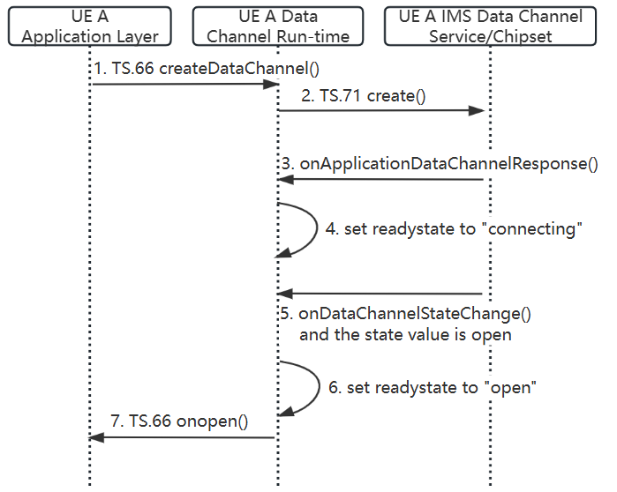
Figure 4.4-1: The call flow for UE creating an Application Data Channel
(1). The active application on UE A invokes TS.66[4] createDataChannel() method to create an Application Data Channel.
(2). After receiving the request for creating an Application Data Channel from the application, the Data Channel Run-time invoke TS.71 create() method to send a request for Application Data Channel creation to the IMS Data Channel Service/Chipset based on the received information about the data channel.
(3). The IMS Data Channel Service/Chipset initiates negotiation of the Application Data Channel with the network and invokes TS.71 onApplicationDataChannelResponse() method to return the instance of the Application Data Channel to the Data Channel Run-time.
(4). The Data Channel Run-time sets the status of the Application Data Channel to “connecting”.
(5). After the Application Data Channel is successfully created, the IMS Data Channel Service/Chipset invokes TS.71 onDataChannelStateChange() method to notify the Data Channel Run-time of the “open” state of the data channel.
(6). The Data Channel Run-time sets the status of the Application Data Channel to “open”.
(7). The Data Channel Run-time invokes TS.66[4] onopen() method to return the state value “open” of the data channel to the application.

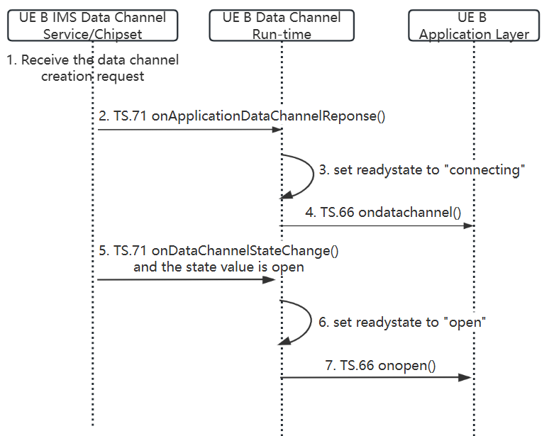
Figure 4.4-2: The call flow for UE creating an Application Data Channel from the network request.
(1). The UE B IMS Data Channel Service/Chipset receives a request from the network to create an Application Data Channel.
(2).The IMS Data Channel Service/Chipset invokes TS.71 onApplicationDataChannelResponse() method to return the instance of the Application Data Channel to the Data Channel Run-time.
(3). The Data Channel Run-time sets the status of the Application Data Channel to “connecting”.
(4). The Data Channel Run-time invokes TS.66[4] ondatachannel() method to return the Application Data Channel instance with “connecting” status to the application.
(5). After the Application Data Channel is successfully created, the IMS Data Channel Service/Chipset invokes TS.71 onDataChannelStateChange() method to notify the Data Channel Run-time of the “open” state of the data channel.
(6). The Data Channel Run-time sets the status of the Application Data Channel to “open”.
(7). The Data Channel Run-time invokes TS.66[4] onopen() method to return the state value “open” of the data channel to the application.

ImsDataChannel Interface
The ImsDataChannel is the signature for interface specification allowing for interacting with IMS Data Channels. It manages the data channel life cycle, e.g. establishment, data transfer, termination.
NOTE: ImsDataChannel interface does not define the implementation but only the contract specification for managing IMS Data Channels. IDL needs to be implemented in an appropriate technology for a given modem and UE model. Then the local UE implementation can be called by the higher-level entities.

Requirements
TS71_5.1_REQ_001 | IMS Data Channel capable UE SHALL support and implement ImsDataChannel Interface.
TS71_5.1_REQ_002 | The IMS Data Channel Service SHALL provide the Data Channel capability through ImsDataChannel interface.

ImsDataChannel Interface Definition

interface ImsDataChannel
{
boolean send(in sequence<octet> data, in long length, in DCSendDataCallback callback);
void close();
};

The send() method is used to transmit data and returns a boolean value:
- true if the send request has been accepted by the IMS Data Channel Service.,
- false when the send request is rejected by the IMS Data Channel Service.
Parameters
- data: array populated with the data to be transmitted over IMS Application Data Channel.
- length: 32-bit signed integer indicating the length of the data to be transmitted.
- callback: DCSendDataCallback (defined in section 6 of GSMA PRD TS.71) used to return the transmission result.
The close() method is used to close the Application Data Channel and returns no value.
Parameters: None.

Sending Message on a Data Channel
The ImsDataChannel interface send() method transmits the data over the IMS UNI using the procedures specified in GSMA PRD NG.134 [3].
TS71_5.3_REQ_001 | The ImsDataChannel Interface SHALL support a method for transmiting data over IMS Data Channels
TS71_5.3_REQ_002 | The method signature send() defined in section 5.2 of GSMA PRD TS.71 SHALL be supported.

Mapping to TS.66 send() method
IMS Data Channel applications use GSMA PRD TS.66 send() method to transfer data between peers over the IMS Data Channel on which the method was called, i.e. IMS Data Channel is open, its reference exists and data channel state is correct.
TS71_5.3.1_REQ_001 | GSMA PRD TS.66 [4] send() method defined in section 6.4.6 of GSMA PRD TS.66 [4] SHALL bind to ImsDataChannel send() interface.
TS71_5.3.1_REQ_002 | The failute of GSMA PRD TS.71 boolean send(in sequence<octet> data, in long length, in DCSendDataCallback callback) method SHALL result on GSMA PRD TS.66 [4] RTCDataChannel.error event

Closing a Data Channel
The ImsDataChannel close() terminates a specified IMS Data Channel over the IMS UNI using the procedures specified in GSMA PRD NG.134 [3].

TS71_5.4_REQ_001 | The ImsDataChannel Interface SHALL include a method for closing the IMS Data Channel.

Mapping to TS.66 close() method
IMS Data Channel applications use GSMA PRD TS.66 [4] close() method to terminate IMS Data Channel on which the method is called, i.e. reference exists and IMS Data Channel is open
TS71_5.4.1_REQ_001 | GSMA PRD TS.66 [4] close() method defined in section 6.4.5 of GSMA PRD TS.66 [4] SHALL bind to ImsDataChannel close() Interface.
TS71_5.4.1_REQ_002 | When Data Channel closes, the modem SHALL invoke transit from DC_STATE_CLOSING to DC_STATE_CLOSED defined in section 7.3 and correspondingly fire closing and close events defined in GSMA PRD TS.66 [4]

NOTE: GSMA PRD TS.66 [4] specifies onclosing, onclose and onerror events but GSMA PRD TS.71 only defines single method to report the state. Therefore, the mapping is required.

DCSendDataCallback Interface
The DCSendDataCallback Interface is used to inform the sender whether the data transmission was successful. The send() method of the ImsDataChannel interface accepts as the parameter DCSendDataCallback. The call back returns the transmission status code.

Requirements
TS71_6.1_REQ_001 | IMS Data Channel capable UE SHALL support DCSendDataCalback Interface.
TS71_6.1_REQ_002 | The IMS Data Channel Service SHALL return transmission status code using DCSendDataCallback interface.

DCSendDataCallback Interface Definition
interface DCSendDataCallback
{
void onSendDataResult(in long status);
}

The onSendDataResult() method used to retrieve the data transmission result returns no value.
Parameters
- status: 32-bit signed integer providing the chipset operation status, e.g., success or failure

TS71_6.2_REQ_001 | The DCSendDataCallback Interface SHALL be invoked each time data is transmitted to return the transmission status code to the caller.

Get Result of Sending Data
TS71_6.3_REQ_001 | The DCSendDataCallback Interface SHALL include a method for returning the sending result.

Transmission Status Code Definition
status | Explanation
20000 | Transmission success
20001 | The sender buffer is full
20002 | The data channel is unavailable
20003 | The parameter passed into  send (in sequence<octet> data, in long length, in DCSendDataCallback callback) function is incorrect
20004 | Other error, reserved for future use

NOTE: GSMA PRD TS.66 [4] signals errors via error event described in section 9.3 of GSMA PRD TS.66 [4]. And the transmission failure codes should be mapped accordingly to this interface by OEM.

Call Flow Showing Transmission Result Handling
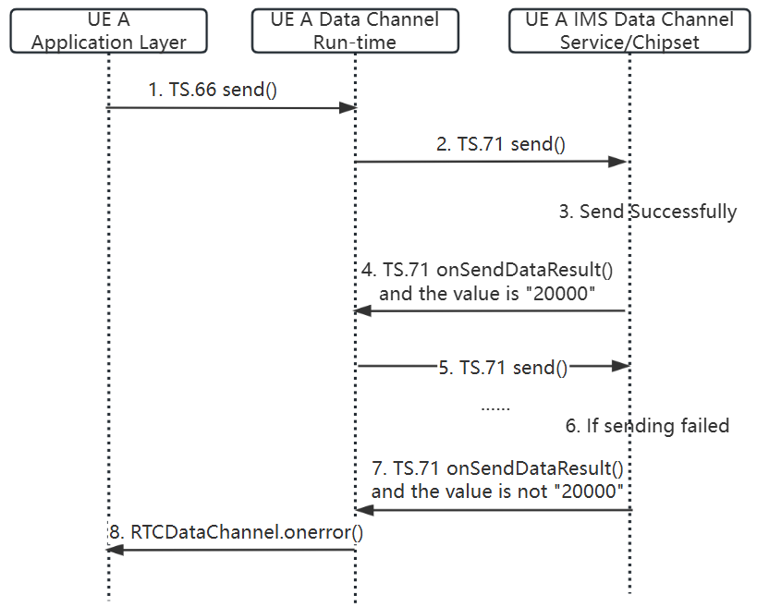
Figure 6.4-1: The send call flow and transmission result handling.
(1). The active application on UE A invokes TS.66[4] send() method to send data.
(2). After the Data Channel Run-time retrieves data from the application, it sends the data via the TS.71 send() method, with the other parameters populated by the Data Channel Run-time.
(3)~(4). The UE A IMS Data Channel Service/Chipset sends the data to the network over UNI after receiving the data from the Data Channel Run-time. Upon successful transmission, it invokes TS.71 onSendDataResult() to return the value “20000” to the Data Channel Run-time.
(5). After receiving the value “20000”, the Data Channel Run-timeinvokes TS.71 send() again to initiate the next data transmission. This method is asynchronous.
(6)~(7). If the IMS Data Channel Service/Chipset fails to send the data, it will invoke TS.71 onSendDataResult() to return a value other than "20000", such as "20001", to the Data Channel Run-time.
(8). The Data Channel Run-time invokes RTCDataChannel.onerror() to notify the application after receiving a value other than "20000"

ImsDCObserver Interface
The ImsDCObserver Interface reports the status of IMS Data Channel and delivers the message send by peer using the IMS Data Channel.

Requirements
TS71_7.1_REQ_001 | IMS Data Channel capable UE SHALL support ImsDCObserver Interface.
TS71_7.1_REQ_002 | The IMS Data Channel service SHALL deliver the messages send by peer using IMS Data Channel through ImsDCObserver interface.
TS71_7.1_REQ_003 | The IMS Data Channel service SHALL report the IMS Data Channel status through ImsDCObserver interface.

ImsDCObserver Interface Definition
interface ImsDCObserver
{
void onDataChannelStateChange(in ImsDCStatus state);
void onMessage(in sequence<octet> data, in long length);
}

The onDataChannelStateChange() method provides the current state of the IMS Data Channel and returns no value. And onMessage() delivers peer data but returns no value.
Parameters
- status: provides the current state of the IMS Data Channel, with a type of ImsDCstatus with valuesdefined in GSMA PRD TS.71 Section 7.3 REQ_002.
- data: the raw byte array of data received from the peer.
- length: 32-bit signed integer indicating the length of data.

TS71_7.2_REQ_001 | The ImsDCObserver onDataChannelStateChange method SHALL be invoked to return the state value of IMS Data Channel to the caller.
TS71_7.2_REQ_002 | The ImsDCObserver onMessage method SHALL be invoked each time data is received and return the data to the caller.

Data Channel State
TS71_7.3_REQ_001 | The onDataChannelStateChange() method SHALL implement void onDataChannelStateChange(in ImsDCStatus state); signature
TS71_7.3_REQ_002 | The IMS Data Channel SHALL only be in one of the following states:  "DC_STATE_CONNECTING",  "DC_STATE_OPEN",  "DC_STATE_CLOSING",  "DC_STATE_CLOSED".

NOTE: GSMA PRD TS.71 “DC_STATE_OPEN” corresponds to GSMA PRD TS.66 [4] ‘open’ state. And in general the upper state DC_STATE_”state name” needs to be mapped to lowercase string “state name” when delivered to the Application.

Mapping to TS.66 RTCDataChannelState
TS71_7.3.1_REQ_001 | RTCDataChannelState defined in section 6.4.2 of GSMA PRD TS.66 [4] SHALL bind to the status value of onDataChannelStateChange.
TS71_7.3.1_REQ_002 | When the system enters the "DC_STATE_OPEN" state then the GSMA PRD TS.66 [4] RTCDataChannel.readyState SHALL be set to “open” with open event generated.

Receiving Message
TS71_7.4_REQ_001 | The ImsDataChannelCallback Interface SHALL implement void onMessage(in sequence<octet> data, in long length); signature.

Mapping to TS.66 onMessage method
TS71_7.4.1_REQ_001 | onmessage event handler in section 6.4.7 of GSMA PRD TS.66[4] SHALL bind to the onMessage() method in ImsDCObserver Interface.

- Document Management
  - Document History
Version | Date | Brief Description of Change | Approval Authority | Editor / Company
1.0 | April 2026 | First version | TSG#63  ISAG#61 | Qi Xu & Jin Gao & Peng Cao / China Telecom
  - Other Information
Type | Description
Document Owner | GSMA Terminal Steering Group
Editor / Company | Qi Xu / China Telecom

It is our intention to provide a quality product for your use. If you find any errors or omissions, please contact us with your comments. You may notify us at prd@gsma.com
Your comments or suggestions & questions are always welcome.

