SIM Toolkit Device Requirements to improve Mobile Connect Customer Experience

Version 1.1

22 February 2022
This is a Non-binding Permanent Reference Document of the GSMA
Security Classification: Non-confidential
Access to and distribution of this document is restricted to the persons permitted by the security classification. This document is confidential to the Association and is subject to copyright protection. This document is to be used only for the purposes for which it has been supplied and information contained in it must not be disclosed or in any other way made available, in whole or in part, to persons other than those permitted under the security classification without the prior written approval of the Association.
Copyright Notice
Copyright © 2022 GSM Association
Disclaimer
The GSM Association (“Association”) makes no representation, warranty or undertaking (express or implied) with respect to and does not accept any responsibility for, and hereby disclaims liability for the accuracy or completeness or timeliness of the information contained in this document. The information contained in this document may be subject to change without prior notice.
Antitrust Notice
The information contain herein is in full compliance with the GSM Association’s antitrust compliance policy.

Table of Contents
1 Introduction 3
1.1 Overview 3
1.2 Scope 3
1.3 Abbreviations 4
1.4 References 4
1.5 Conventions 5
1.5.1 Buttons: physical vs virtual 5
1.5.2 User’s action description and MMI 5
2 Requirements 7
2.1 STK Proactive Commands Used, Events and TERMINAL PROFILE 7
2.2 Expected Device Behaviour 7
2.2.1 DISPLAY TEXT 7
2.2.2 GET INPUT 12
2.2.3 Logs 17
Annex A Document Management 18
A.1 Document History 18
A.2 Other Information 18

Introduction

Overview
This document presents the requirements for the device to improve the user experience of the Mobile Connect SIM applet authenticator.
The ETSI TS 102 223 [1] describes the interface between the UICC and the terminal within detailed information on SIM Toolkit commands and events. In addition to this specification, the following requirements insist not only on protocol but also on user interface expected.

Scope
This document covers the device requirements for the SIM Toolkit proactive commands used for the Mobile Connect service and does not affect other SIM Toolkit applications.
This document aims to improve the user experience by providing device manufacturer recommendations for SIM Toolkit handling and should directly improve the user experience of the Mobile Connect.
A table with an overview of the different requirements outlined in this document can be found below, along with a clarification to whether they are:
- compliant with the ETSI TS 102 223 [1] technical specification,
- they expand existing requirement ETSI TS 102 223 [1] technical specification
- or they represent a new requirement not covered by this specification.
Command Used for Mobile Connect Service | Behaviour Proposed for: | Relationship with ETSI TS 102 223
DISPLAY TEXT | Basic functionality | Compliant in terms of parameters and the text format.
 | Button Handling and TERMINAL RESPONSE result value | Recommends expansion to not display “Back” button on the screen but to allow the user to retrieve it through the contextual menu
 | Timeout Handling | Compliant in terms of the value in the “Duration” tag.
 | Immediate Response Parameter | Recommends expansion for the device to only display the “OK” button if the Immediate Response parameter is present in this command.
 | Idle Mode | New requirement, not covered by specification
 | Locked Screen – Manual Unlocking with Notification | New requirement, not covered by specification
 | External Interactions | New requirement, not covered by specification
GET INPUT | Basic functionality | Compliant in terms of the parameters and the text format.  Recommends expansion for the device to display only the message, input field and buttons
 | Button Handling | Recommends expansion to clarify TERMINAL RESPONSE result value and terminal behaviour according to user MMI action
 | Timeout Handling | New requirement, not covered by specification
 | Idle Mode | New requirement, not covered by specification
 | Locked Screen – Manual Unlocking with Notification | New requirement, not covered by specification
 | External Interactions | New requirement, not covered by specification
 | Logs | New requirement, not covered by specification

Abbreviations
Term | Description
STK | SIM Toolkit
MSSP | Managed Security Service Provider

References
Ref | Doc Number | Title
 | ETSI TS 102 223 | Smart Cards; Card Application Toolkit (CAT) Available at http://www.etsi.org/deliver/etsi_ts/102200_102299/102223/12.01.00_60/ts_102223v120100p.pdf
 | RFC 2119 | “Key words for use in RFCs to Indicate Requirement Levels”, S. Bradner, March 1997. Available at http://www.ietf.org/rfc/rfc2119.txt
 | ETSI TS 102 225 | Smart Cards; Secured packet structure for UICC based applications  (Release 9)  http://www.etsi.org/deliver/etsi_ts/102200_102299/102225/09.00.00_60/ts_102225v090000p.pdf

Conventions
“The key words “must”, “must not”, “required”, “shall”, “shall not”, “should”, “should not”, “recommended”, “may”, and “optional” in this document are to be interpreted as described in RFC2119 [2].”

Buttons: physical vs virtual
The terminals may have one or more physical or virtual buttons. In the tests described in this document, the user will interact with the following functions.
- Home: Get the user to the terminal home screen
- Back: Get the user to the previous function in the module
- Multitasking: Displays the list of running processes and lets the user choose a process to get it back at screen
NOTE: Some buttons presented in the above list may be not implemented depending on the device’s OS, manufacturer.

User’s action description and MMI
User’s action number | user’s action description | MMI representation
1 | user’s action description | User presses the “OK” button in a window displayed after a STK command was sent, either DISPLAY TEXT or GET INPUT
2 | User presses the Ok button | User presses the “Cancel” button in a window displayed after a STK command was sent, either DISPLAY TEXT or GET INPUT
3 | User presses the Cancel button | 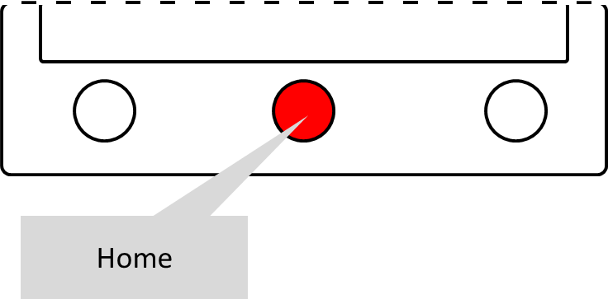  If available, the Home button returns the user to the terminal home screen
4 | User presses the Home button | 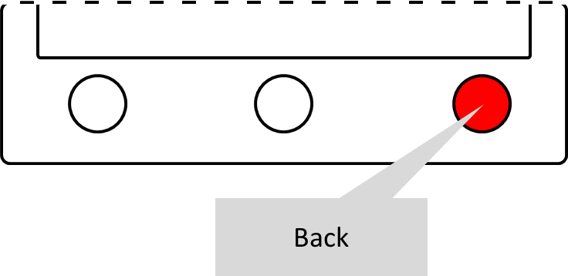  If available, the “Back” button returns the previous terminal screen
5 | User presses the Back button | 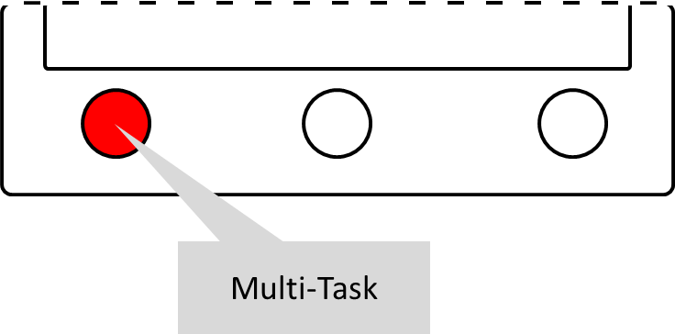  If available, the Multitasking button shows the list of the running processes
6 | User presses the Multitasking button | 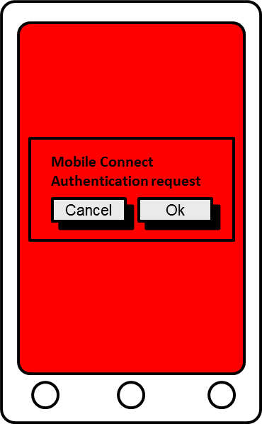 or 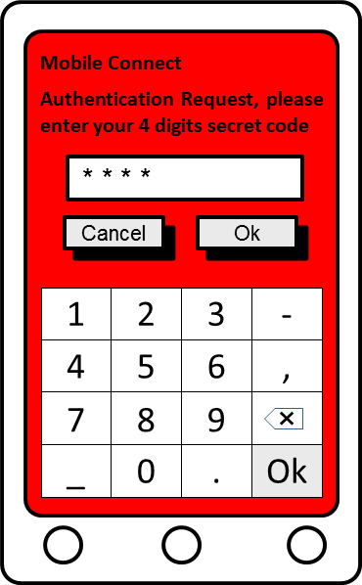
7 | User clicks in the red area
8 | no user action | User unlock the terminal using the appropriate method: PIN code, password, swipe, facial recognition, voice recognition, pattern, fingerprint, etc…

- : User’s action description / MMI

Requirements

STK Proactive Commands Used, Events and TERMINAL PROFILE
In order to support the 3 STK commands “DISPLAY TEXT”, “GET INPUT” and “SEND SHORT MESSAGE” and the event “EVENT_FORMATTED_SMS_PP_ENV”, the TERMINAL PROFILE shall return a convenient TERMINAL PROFILE.
Mobile Connect requires a TERMINAL PROFILE who matches with these binary masks:
- Byte 1 AND 0x12 == 0x12
  - Bit 2: SMS-PP data download
  - Bit 5: SMS-PP data download
- Byte 2 AND 0xE0 == 0xE0
  - Bit 6: UCS2 Entry supported
  - Bit 7: UCS2 Display supported
  - Bit 8: DISPLAY TEXT
- Byte 3 AND 0x05 == 0x05
  - Bit 1: DISPLAY TEXT
  - Bit 3: GET INPUT
- Byte 4 AND 0X02 == 0X02
  - Bit 2: SEND SHORT MESSAGE
- Byte 9 AND 0X01 == 0X01
  - Bit 1: DISPLAY TEXT

Expected Device Behaviour

DISPLAY TEXT
The device shall be compliant with the DISPLAY TEXT proactive command as described in ETSI TS 102 223 [1] regarding the parameters and the text format.
The device must handle the 3 text encoding:
- Data Coding Scheme 00 GSM default alphabet 7 bits packed
- Data Coding Scheme 04 GSM default alphabet 8 bits
- Data Coding Scheme 08 16 bits UCS2 alphabet
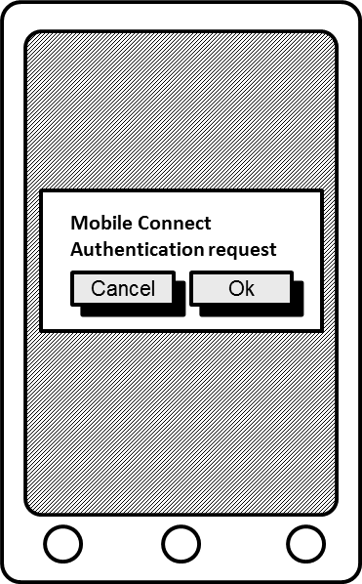

- : DISPLAY TEXT: User Interface expected
The following specification expands the DISPLAY TEXT command specification described in ETSI TS 102 223 [1]: it is recommended not to display any “Back” button on the screen but to allow the user to retrieve it due to the contextual menu.

Buttons Handling
The following specification is a clarification of what is described in ETSI TS 102 223 [1] with details on user’s action and device behaviour expected accordingly.
On reception of the DISPLAY TEXT SIM Toolkit proactive command, the device must display on its screen the text contained and the two options which are “OK” and “Cancel”. In addition to the text and the OK/Cancel buttons, most of the devices offers users the option to do different actions with other buttons (virtual, tactile or physical). The following paragraph describes the device behaviour expected and the return code associated in the TERMINAL RESPONSE.
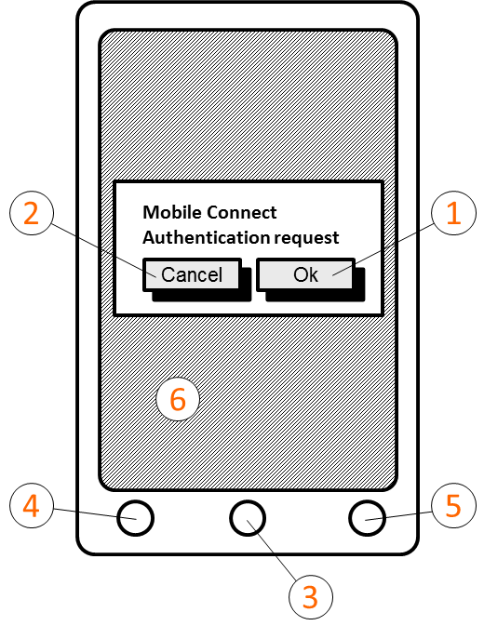

- : DISPLAY TEXT User’s action Overview
The device must return the result of the user’s action to the applet in the TERMINAL RESPONSE.
The returned code and the device behaviour must follow the principles detailed below:
User’s action | Mobile Connect Result | STK Result | Returned code (hex) | Device behaviour
OK pressed (1) | Validation | Command performed successfully | 00 | Window closing
Cancel pressed (2) | Cancellation | Proactive UICC session terminated by the user | 10 | Window closing
Home pressed (if present) (3) | Cancellation | Proactive UICC session terminated by the user | 10 | Window closing
Back pressed (if present) (4) | Cancellation | Backward move in the proactive UICC session requested by the user | 11 | Window closing
Multi task button (if present) (5) | None | None | None | No action, The user is able to reactivate the window using the Multi-task button (if no action is completed by the user before the timeout the device must close the STK channel including in the TERMINAL RESPONSE the returned code 12)
User clicks beside the displayed window (if possible) (6) | None | None | None | No action (window still displayed)
No user action (timeout) | Cancellation | No response from user | 12 | Window closing after the timeout
- : DISPLAY TEXT result code according to user’s action
NOTE: Certain buttons presented in the above table may be not implemented depending on the device’s OS, manufacturer, etc.

Timeout Handling
The DISPLAY TEXT STK command could contain a value in the “Duration” tag. The Device shall be compliant with duration parameter as defined in ETSI TS 102 223 [1].

Immediate Response Parameter
Some DISPLAY TEXT commands could be sent to the device including the tag “Immediate response”. In this case, the device must directly send back to the SIM card a TERMINAL RESPONSE containing the “Command performed successfully” information. Nevertheless, the device must continue to display the window on the device until the timeout has been reached or the user selects the “Ok” button.
The following specification completes the Immediate Response Parameter specification described in ETSI TS 102 223 [1]: If the “immediate response” parameter is present in the DISPLAY TEXT STK proactive command, the device must only display the “Ok” button.

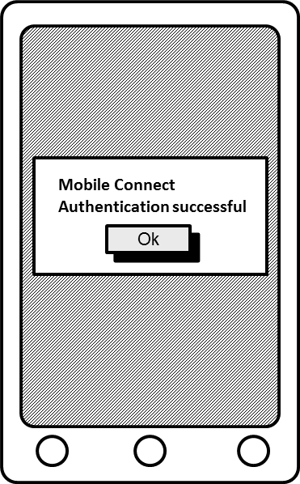

- : DISPLAY TEXT with immediate response tag: User Interface expected

Idle Mode
The following specification is not described in ETSI TS 102 223 [1] and is therefore a new requirement.
If the device is in idle mode, it must get out of standby mode when receiving a DISPLAY TEXT STK proactive command to display the associated window.
Once the STK command handling is done (e.g. the user has selected the “OK” button), the device must return to its initial state.

Locked Screen – Manual Unlocking with Notification
The following specification is not described in ETSI TS 102 223 [1] and is therefore a new requirement: if the device is in idle mode and locked when receiving a DISPLAY TEXT STK proactive command, it must get out of standby mode, display a message on the screen and allow the user to manually unlock their device. Once unlocked, the device must display the window associated to this DISPLAY TEXT command.
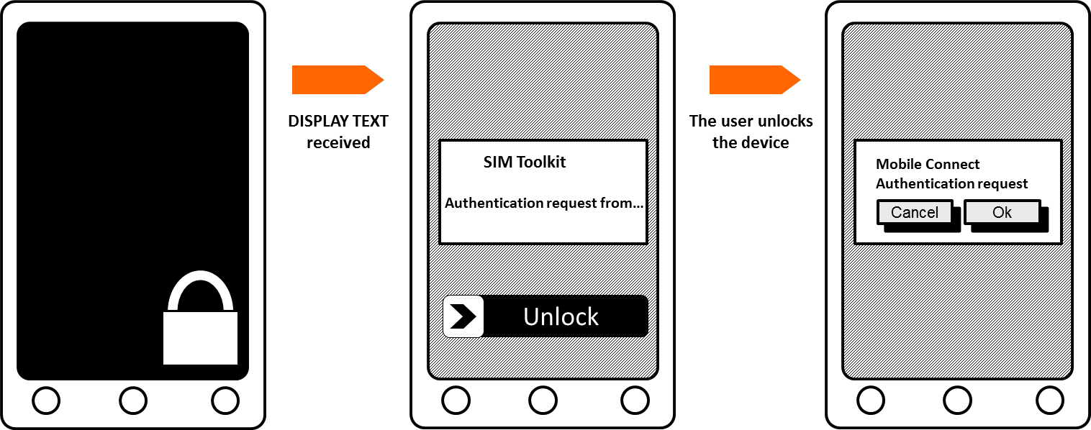

- : DISPLAY TEXT arriving on a device in locked screen: Steps expected

External Interactions
The following specification is not described in ETSI TS 102 223 [1] and is therefore a new requirement.
The device must implement the following behaviour to avoid conflicts between call/SMS and the DISPLAY TEXT STK proactive command:
- An incoming phone call arrives during the DISPLAY TEXT process The user must be able to accept, to reject this call or to stay on the DISPLAY TEXT window. If the user rejects the call, the DISPLAY TEXT window is still displayed on the device screen. As long as the timeout of the DISPLAY TEXT command is not reached, the DISPLAY TEXT will always be displayed on the device screen regardless of the call being accepted or rejected.
- An incoming text SMS arrives during the DISPLAY TEXT process The DISPLAY TEXT window is still displayed on the device screen
- A DISPLAY TEXT command is sent during an established phone call The DISPLAY TEXT window must be displayed on the device screen. Once the STK command handling (i.e. user select OK, Cancel, timeout, …), the DISPLAY TEXT window is closed but the phone call must stay connected during this process
- A DISPLAY TEXT command is sent at the same time as an incoming call establishment or an incoming text SMS The device must handle the DISPLAY TEXT STK command without any issues with the incoming call or the incoming text SMS

GET INPUT
The device must be compliant with the GET INPUT SIM Toolkit proactive command as described in the ETSI TS 102 223 [1] specification regarding the parameters and the text format.
As specified in the ETSI TS 102 223 [1], the device must handle the three text encoding:
- Data Coding Scheme 00 GSM default alphabet 7 bits packed
- Data Coding Scheme 04 GSM default alphabet 8 bits
- Data Coding Scheme 08 16 bits UCS2 alphabet
The device must also support the command qualifier describing the user entry:
- bit 1:
  - 0 = digits (0 to 9, *, #, and +) only;
  - 1 = alphabet set.
- bit 2:
  - 0 = SMS default alphabet;
  - 1 = UCS2 alphabet.
- bit 3:
  - 0 = terminal may echo user input on the display;
  - 1 = user input shall not be revealed in any way (see note).
- bit 4:
  - 0 = user input to be in unpacked format;
  - 1 = user input to be in SMS packed format.

In the Get Input command, Mobile Connect uses only the digits. When the bit 1 of the command qualifier is equal to 0, and if the device integrates a virtual keyboard, it must directly display the digits keyboard.
The following specification completes the Immediate Response Parameter specification described in ETSI TS 102 223 [1]: The device shall only display the message, the input field and the buttons and no other information, nor the allowed characters or the expected length (e.g. “Digits (0-9,*,#,+) 1-9”) or any title on the top of the window.
If the command qualifier indicates that the user input shall not be revealed in any way (which should be the case for Mobile Connect), the terminal shall prevent, as mentioned in the ETSI TS 102223, the text string from being identified by any means (e.g. stars could be displayed instead of characters).
The device should not display on the screen the “Back” button. This should be accessible through the contextual menu.
Moreover, the device must handle the min-max characters that are required in the STK command due to the “Response length” value.
It is recommended to use the wording “OK” instead of “Send”.
The picture below represents the expected display:

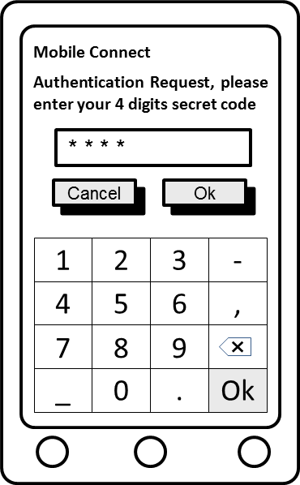

- : GET INPUT: User Interface expected

Buttons Handling
The following specification is a clarification of what is described in ETSI TS 102 223 [1] with details on user’s action and device behaviour expected accordingly. On reception of the GET INPUT SIM Toolkit proactive command, the device must display on its screen the text contained, a field allowing the user to enter numeric characters and the two options which are “OK” and “Cancel” (if not displayed on the screen, the “Cancel” option must be found in a contextual menu). It is highly recommended to display on the screen the “Cancel” button in addition to the “OK”.
The device must return the result code of the user’s action including the characters entered to the applet in the TERMINAL RESPONSE.
User’s action number | User’s action | Mobile Connect Result | STK Result | Returned code (hex) | Device behaviour
1 | OK pressed | Validation | Command performed successfully | 00 | Window closing
2 | Cancel pressed | Cancellation | Proactive UICC session terminated by the user | 10 | Window closing
3 | Home pressed (if present) | Cancellation | Proactive UICC session terminated by the user | 10 | Window closing
4 | Back pressed (if present) | Cancellation | Backward move in the proactive UICC session requested by the user | 11 | Window closing
5 | Multi task button (if present) | None | None | None | No action, The user is able to reactivate the window using the Multi-task button (if no action is completed by the user before the timeout the device must close the STK channel including in the TERMINAL RESPONSE the returned code 12)
6 | User clicks beside the displayed window (if possible) | None | None | None | No action (window still displayed)
7 | No user action (timeout) | Cancellation | No response from user | 12 | Window closing after the timeout
- : GET INPUT result code according to user’s action
NOTE: Certain buttons present in the above array may be not implemented depending on the device’s OS, manufacturer, etc.

Timeout handling
The GET INPUT command could contain a value in a “Duration” tag. This is a new requirement and is not described in ETSI TS 102 223 [1]: An ETSI change request is ongoing, its validation being expected in December 2016. Even if this requirement is not yet specified in the ETSI TS 102 223 [1], this feature which is already implemented in most devices, is required for the Mobile Connect service.
The duration parameter is encoded in 2 Bytes. The first one indicates the time unit used and the second one contains the time interval.
- The time unit is encoded as below:
  - 00 Minutes
  - 01 Seconds
  - 02 Tenths of seconds
- The time interval contains a value between 1 and 255.
If during a GET INPUT command the user does not perform any actions on their device, the window must be closed when the duration value is reached. The device must also send to the SIM card the status code 12 in the TERMINAL RESPONSE.

Idle Mode
The following specification is not described in ETSI TS 102 223 [1] and is therefore a new requirement: If the device is in the idle mode, it must get out of standby mode when receiving a GET INPUT STK proactive command to display the associated window.
Once the STK command handling is completed (e.g. the user has entered characters and selected the “OK” button), the device must return to its initial state.

Locked Screen – Manual Unlocking with Notification:
The following specification is not described in ETSI TS 102 223 [1] and is therefore a new requirement: if the device is in idle mode and locked when receiving a GET INPUT STK proactive command, it must get out of standby mode, display a message on the screen (notification) and allow the user to manually unlock the device. Once unlocked, the device must display the window associated to this GET INPUT command.

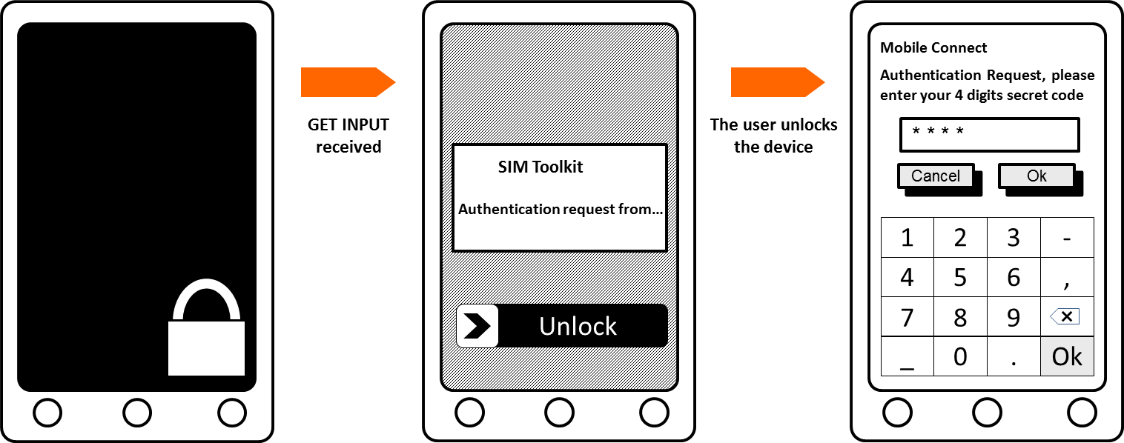

- : GET INPUT arriving on a device in locked screen: Steps expected

External Interactions
The following specification is not described in ETSI TS 102 223 [1] and is therefore a new requirement. The device must implement the following behaviour to avoid conflicts between call/SMS and the GET INPUT STK proactive command:
- An incoming phone call arrives during the GET INPUT process The user must be able to accept this call, to reject this call or to stay on the GET INPUT window. If the user rejects the call, the GET INPUT window is still displayed on the device screen. As long as the timeout of the DISPLAY TEXT command is not reached, the DISPLAY TEXT will always be displayed on the device screen regardless of the call being accepted or rejected.
- An incoming text SMS arrives during the GET INPUT process The GET INPUT window is still displayed on the device screen
- A GET INPUT command is sent during an established phone call The GET INPUT window must be displayed on the device screen. Once the STK command handling (i.e. user select OK, Cancel, timeout, …), the GET INPUT window is closed but the phone call must stay connected during this process
- A GET INPUT command is sent at the same time as an incoming call establishment or an incoming text SMS The device must handle the GET INPUT STK command without any issues with the incoming call or the incoming text SMS

Logs
The following specification is not described in ETSI TS 102 223 [1] and is therefore a new requirement. In order to avoid security issues, the device must not log the STK exchanges. Specifically, the exchanges of the DISPLAY TEXT, the GET INPUT and the SEND SHORT MESSAGE commands.

- Document Management
  - Document History
Version | Date | Brief Description of Change | Approval Authority | Editor / Company
1.0 | July 2016 | New document, in collaboration with Orange | PDATA/PSMC | Olivier Gruson and Anne-Claire Laval/ ORANGE
1.1 | June 2017 | Transfer of PRD from Personal Data | TG | Nick Cheung / GSMA
  - Other Information
Type | Description
Document Owner | IDG
Editor / Company | Olivier Gruson and Anne-Claire Laval/ ORANGE

It is our intention to provide a quality product for your use. If you find any errors or omissions, please contact us with your comments. You may notify us at prd@gsma.com
Your comments or suggestions & questions are always welcome.

