ISIFUNDO SAKUQALA;
ISINGENISO
YINI OKUTHWA YI INTERNET
I Internet yi nethiwekhi esetshenziswa ngamakhompiyutha labomakhalekhukhwini ikakhulu kulezi insuku zanamuhla ukudinga ulwazi emabangeni atshiyatshiyeneyo.Singaphinde njalo sithi I internet ngumgodi wolwazi othalakala ebulenjini.
INTERNET ISIPHATHISA NGANI/NJANI EMPILWENI ZETHU ZANAMUHLA
- Ku internet silakho ukuthola amabhuku okubala ikakhulu nxa sikhangele abantwana besikolo kubalula
- Ukukhuluma lezihlobo labangane abakhatshana sisebenzisa I WatsApp , Facebook , Google
- Iyasincedisa njalo kwabalamabhizimusi ukuthi abaelula ukubonakala lokutholakala kuwo wonke umuntu kungakhathalakile ukuthi ungaphi kwendawo
- Internet inhle ngoba silakho ukubona ama vidiyo, imipikitsha kuYouTube lokhu njalo kuphathisa abantu ukuthi bafunde okunengi okufana lokupheka , ukulima , ukuhlanyela, ukulungisa okungabe kufile etc
- Silakho njalo ukudinga imisebenzi ,izikolo sisebenzisa I Google

Umhlobo wabomakhalekhukhwini abasetshenziswayo ukungena ku Internet
Umhlobo wencingo ezisatshenziswayo ukuthi umuntu angene ku internet kuthiwa ngama Smart Phones. Incingo lezi yizo ezisetshenziswayo ngensuku zalamuhla . Zisetshenziswa lihlabahlaba kuscreen yo cingo lwakhona.
Ngena Ku Internet
Ebulenjini uyenelisa ukuvhula loba yini oyifunayo ngesikhathi ofuna ngaso , ukuze usebenzise internet kumele wenelise ukuvula esithi thina li browse (Bhurawuza ). Omakhalekhukhwini baba lama browser atshiyeneyo kusiya ngomhlobo wocingo olala. Bona umpikitsha ongaphansi otshengisa omunye umhlobo we bhurawuza ongenelisa ukulisebenzisa.

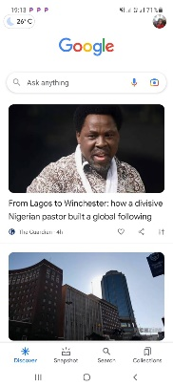

ISIFUNDO SESIBILI: GOOGLE
YISIBUNGU BANI I GOOGLE
I Google ngelinye lama bhurawuza asetshenziswa ngabantu ukudinga abakufunayo ku internet.
AMANYATHELO OKULANDELA EKUSEBENZISENI I GOOGLE
- “Ukudingisisa usebenzisa iGoogle kuyakuphathisa ukuthi uthole ulwazi olufunayo, Uyatshela iGoogle lololwazi ofuna ukuluthola, isibonelo, ‘Abantu bangaki emhlabeni wonke jikelele?’ ngokunjalo izakudingela kulo lonke ulwazi oselufakwe ngabantu kuyinthanethi, ukuze ithole lololwazi olufunayo.”
- “Ungathola ulwazi ngezindawo, ngemisebenzi, indlela zokupheka, amabhayisikopo, izingoma, ulwazi ngomsebenzi wesikolo, wekolitshi, wemihloliso lokunye”
UKUSEBENZISA I GOOGLE
Hlaba umfanekiso ofana lalo ongaphansi
- Ngemva kwalokho bhala lokho ofuna ukubakwazi ngakho (Njengesibonelo) “izaga lengcazelo”
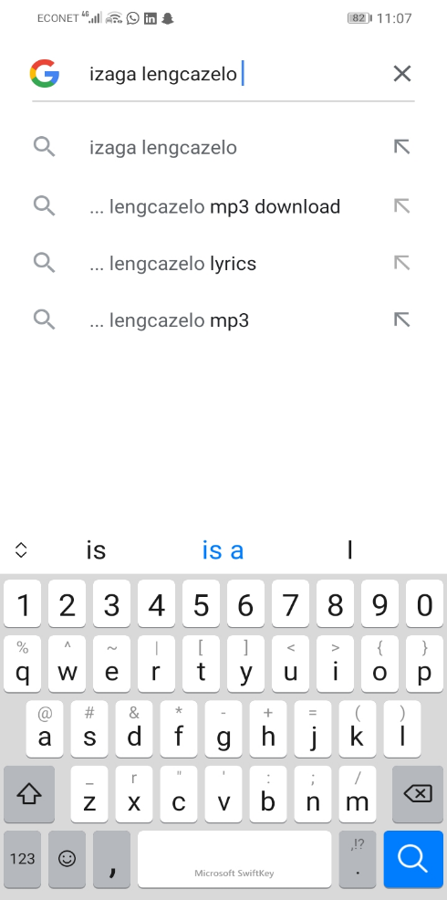

Elikudingayo kuyahle kuphume njengalokhu

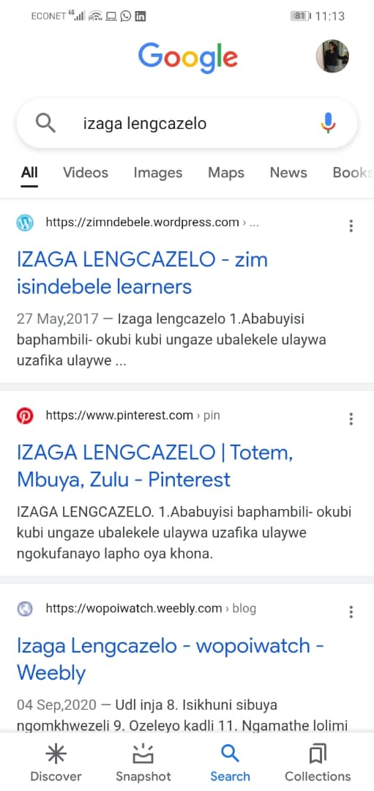

UKUKHALIPHA OKUKHULU
- Singavula kukhasi le Google sithola ukuthi I google isipha ukuthi sikhethe ukuthi impendulo zethu ukuthi sizifuna zinjani njengalokhu
impendulo zika “konke” (‘konke’, ‘imifanekiso’, ‘amavidiyo’ ‘lamamephu’ ‘izingwalo’
Ngokunjalo ungahlaba imifanekiso uyaphiwa impendulo yakho iyimifanekiso , ungahlaba amavidiyo uyithola ikumavidiyo
UKUZENQABELA NXA SISEBENZISA I GOOGLE
- Kuqakathekile ukubalolwazi ukuthi I inthanethi yindawo kazulu wonke jikelele ngakhoke kubalulekike ukuyithatha ngaleyo ndlela ukuthi lihlale livikelekile
- Zivikele ngokungakhulumi labantu ongabaziyo kumbe ukukhuluma labantu abahluphayo.
- Izinto eziphathelane lawe kakhulu mazihlale ezindaweni ezivikelekileyo okufana lemipikitsha , okuphathelane lemali lokunye okunjalo.
- Hlonipha abanye abantu abasebenzisa I internet/Google

ISIFUNDO SESITHATHU

Yini I WhatsApp

I WhatsApp yi apulikhesheni esetshenziswa ngabantu ekukhulumeni ,ukuhambisa lokuyamukela indaba zivela endaweni ezitshiyeneyo ngezikhathi zonke.

UKUCHASISA NGOKUGCWELEYO KWEZE WhatsApp
- I WhatsApp iyenza kubelula ukuthi abantu abelokuthintana labangane , izihlobo , abadla bonke.Kubalula ukukhuluma kungaba yikusebenzisa ama vidiyo
- I Whatsapp iyenza impilo ibelula ngoba iyenelisa ukuthumela imibiko kubantu abanengi ngesikhathi esifananayo njalo ulakho ukuthumela umbiko ngelizwi or usebenzisa I vidiyo.
- I WhatsApp isebenzisa idata ayabe iyi bundle yikho okwenza ukuthi ibelula ukusebenzisa kungakhathalekile ukuthi ukhuluma lobani njalo lowo muntu ungaphi kwendawo.
UKWENZA
Hlaba umfanekiso ofana lalo ongaphansi

Ukuthumele umbiko usebenzisa I whatsapp
- Liyavula I whatsaap yenu ngokuhlaba unfanekiso enjengalowo ophezulu , beselisiya ebizweni lomuntu elifuna ukumthumela lowo mlayezo / umbiko beselibhala elifuna ukumtshela khona
- Phezu kwalokho wenelisa ukuthumela umlayezo wakho ulilizwi ,hlaba I mikhoro phoni esesandleni sokudla kwebhokisi lokubhalela ,ukhulume ofuna ukukutsho bese uthumela kulowo muntu.
Bona umfanekiso ongaphansi

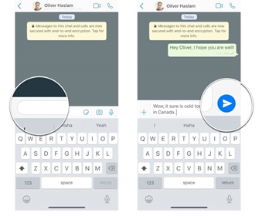

- Liyenelis njalo ukuba semaqenjini ayekhukeneyo lawo maqembu angaba ngawesikolo , awemisebenzini, awezinkonzweni, loba awamabhizimusi afana lokuthenga lokuthengiselana kubalula nxa ufuna ukuthumela imibiko.
- I whatsapp inhle kakhulu ngoba uyenelisa ukuthumela imifanekiso , vidiyo , izingwalo, njalo iyasincedisa ukuthumela I location indawo lapho oyabe ukhona kunceda njalo nxa uthe walahleka
- Iwhatsap itshipile ,wenelisa ukufona ngayo usebenzisa I vidiyo
Ukuzenqabela nxa usuthe wasebenzisa I WhatsApp
- Khangelisisa inkulumo othumelana lazo labanye ku Whatsapp
- Hlonipha abanye abantu ku Whatsapp
- Nxa ulabanye ongakhulumisani labo kuhle , yekela ukuphendulana labo ezinye inkulumo ezingayenziyo ku Whatsapp
- Liyenelisa ukuquma ubungane lalabo elingazwisisani labo hlaba u block
- Yonke into emayelana lempilo yakho yigcine kuhle endaweni ezibucayi.
ULWAZI; Iwhatsapp isebenza nge data le whatsaap elitholakala kuma service providers atshiyeneyo ngentengo etshiyeneyo kusinga ngokuthi ufuna elinganani

Ukusebenzisa amabhandulu lokubona ukuthi asebenza njani
- Yiba lolwazi lokuthi usebenzisa I bundle lemalimi njalo elinganani kusiya ngokuthi ufuna ukuvulani ku internet.
- Kuqakathekile njalo ukuthi ubekwazi ukuthi ususale lama bundles anganani njengoba likwanisa ukukhangela ukuthi ususele lamaminutes amangaki okufona lokhu kuya ngo service provider wakho eg Econet netone or telecel.
- Nxa usuthe wathola lapho okulamagagasi e WI-FI kutsho ukuthi akula mali oyisebenzisayo ekungeneni ku Internet. I WI-FI iyenelisa ukuthi ungene loba ngaphi.
ULWAZI
Nxa ufuna ukubona ukuthi ususele lemalini / bundles okungena ku internet ungaxhumana labameli benkampani ekupha ubulembu be internet abaseduze lawe ngoba inkampani lezi zitshiyene ngendawo ngendawo.

ISIFUNDO SESINE
YOUTUBE
YINI I YOUTUBE
I YOUTUBE yi apulikhesheni esetshenziswa ngabantu ukubona ama vidiyo ku internet
Isichazamazwi se YOUTUBE
- Ku Youtube silama vidiyo amanengi ehlukeneyo abalisela izingoma, ukufundela ukupheka , ukufundela ezinye indimi zakwamanye amazwe .
- I youtube iyasivumela ukuthi siyenze awethu ama vidiyo sithumele nxa ulamalungela eneleyo.
Sebenzisa I Youtube
Hlaba umfanekiso onje
Indlela zokungena ngazo ku Youtube
- Hlaba okusemfananisweni ophezulu , hamba kubhokisi lokubhalela bhala umazwi alokho okudingayo nxa kuyingoma bhala ibizo lengoma yakhon , khethake koziphiweyo eyiyo oyifunayo
- Senelisa njalo ukudinga amavidiyo sisebenzisa I mikhorofoni uphawu lwe miyikhorofoni lusesandleni sokudla kwe bhokisi lokubhala hlaba lolophawu khuluma ibizo le vidiyo oyidingayo khethatha kowaphiweyo.
Umgodi wolwazi
Nanzelela okuvulawo ngazo zonke izikhathi , nguwe olamandla okukhetha Phakathi kokubi lokuhle.
Amandla wonke aphiwe wena!!!!!!!!!

UNGASALELI KU INTERNET

