Connected Society
Mobile Internet Skills Training Toolkit
A guide for training people in basic mobile internet skills

Copyright © 2017 GSM Association

Bitesize Training

BITESIZE - INTRODUCTION TO THE INTERNET

This page is designed to help trainers answer more general questions that trainees may have about the mobile internet. It gives simple explanations to some questions that people often ask about the internet. It might be helpful to print this sheet off. You will also find these examples embedded within the modules of this toolkit.
What is it?
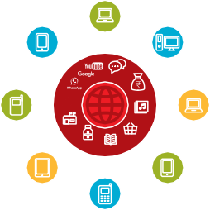
Show the ‘Internet Poster’ (p.185) “The Internet is a network of millions of computers around the world connected to each other with phone lines, satellites and cables. It gives you access to a huge range of information and services and it is growing all the time. The internet is for everybody. There are no restrictions on who can use it. You just need a computer, mobile phone or tablet and a data connection.”

Introduction to the Internet

Communication

Banking
Travel Internet
Entertainment

Government Services

Online
Health Shopping
Information
Education

What can you use it for?
“The internet will help you to do many things. For example, you will be able to send messages or speak with friends and family, send photos, watch videos, listen to music, buy and sell things and transfer money. It will also help you find information on nearly any subject, including news, weather, entertainment, transport timetables, religion, or sport. It can also help you if you are looking for a job, need health advice, or want to learn a new skill.”

The trainer can include their own personal examples of how the Internet has helped them.
BITESIZE – INTRODUCTION

Make it relevant to the trainee: discuss how it can be beneficial in the trainee’s own life.

BITESIZE - INTRODUCTION TO THE INTERNET

How does it work?
There are two kinds of mobile phone which you

can use to access the internet:
- A smartphone: These phones are like mini computers. Normally you control them by touching the screen rather than using buttons. They can take photos, play music and videos and have ‘apps’ that can quickly take you to an internet service.
2. A feature phone: These have less features than a smartphone. They don’t have a screen you can touch but you can play music and take photos. You can access the internet on a browser to use the online services you want.

$ Data Costs

“To access the internet via your mobile phone, you can either use a mobile data connection or a Wi-Fi connection.” Show the ‘Data Poster’
Data Costs

“Normally, when you use the internet on your phone, you are using mobile data. You will need to buy this from your local mobile network agent or a shop that sells phone credit.
Some things you do on the internet, like watching videos or listening to music, use more data, so will cost you more money.”
BITESIZE – INTRODUCTION

Posters, Cut-outs and
Info-sheets

Session Ground Rules

This space is:

Safe
Keep all information in this training confidential. We suggest you don’t share personal numbers with the other members of group.

Positive & open
Please be respectful and positive in your opinions and discussions. There are no right or wrong answers and we are not here to test you.

A shared community
There are people with different backgrounds, knowledge and opinions. This is our shared space, so respect and support everyone.

Fair
We will work in small groups and we will provide you with shared phones. We would like to give everyone an equal chance to be heard and to take turns using a phone

Easy tips for internet safety

‘Block’ or ignore people you don’t know, or who are bothering you

Tell someone you know and trust, if you feel uncomfortable about anything you see
or experience
Keep your personal information private

Be polite and respectful to people

Definitions
Trainers can add to this section to include local relevant information on the mobile internet

2G / 3G / 4G

App Address bar
www.india.in
Advert or Ad
Buy Now!

Browser
The internet can run at different speeds when you use it. 2G internet is the slowest, 3G internet is faster and 4G internet is the fastest.

An app gives you a shortcut to a service on your phone. For internet services e.g. WhatsApp, Facebook, Google, apps provide a quick and easy way to get onto the internet to use that service.

The address bar shows you what website you are on.
In the address bar there will always be the address of the website
e.g. www.google.in

An ad is a piece of information that is trying to sell you something. It is good practice to avoid clicking on ads.
- Ads can be videos or images that pop up on your screen
- Ads can also be the links at the top of Google results and on the right side of the screen

A web browser, or simply “browser”, is an application used to access and view websites. Common web browsers include;

Data
Google Chrome Mozilla Firefox Opera Microsoft Internet
Explorer

Whenever you use the internet on your phone, you are using data. You can buy data from your mobile network provider, just like you do with phone credit.

Feature phone

A mobile phone that has the ability to access the internet and store and play music but lacks the advanced functionality of a smartphone
Google is an internet service that makes it easy to find any information

Definitions
Trainers can add to this section to include local relevant information on the mobile internet

Internet

Link
The Internet is a network of millions of computers around the world connected to each other with phone lines, satellites and cables. It gives you access to a huge range of information and services and
it is growing all the time. The internet is for everybody. There are no restrictions on who can use it. You just need a computer, mobile phone or tablet and a data connection.

A link connects you from one website to another. To go to the other website, you can touch the link and this will connect you and take you to that other website.

Megabytes & Gigabytes

Megabytes (MB) and Gigabytes (GB) are units of data that you use when using the mobile internet. GB are 1000 x bigger than MB. If you download or stream a song, that will use approximately 5MB (1MB per minute).

Search
The search function helps you find what you are looking for. You type the words to what you are looking for into a search box and then you will see a list of links to potential answers.

SmartphoneA mobile phone that has the ability to access the internet, store and play music and videos, and run ‘apps’. These phones typically also have a touchscreen.

YouTube is an internet service that makes it easy to find, watch and listen to videos on the internet (and only videos).

Website
Information on the internet is kept on different websites. There are lots of separate and different websites on the internet e.g. Google is a website, YouTube is a website.

WhatsApp is an internet service that makes it easy to connect and communicate with people that you know; family, friends and colleagues.

WiFi
A WiFi zone is an area where you do not have to use your own data to access the internet on your phone; you can connect to the
internet for free. WiFi zones are available in some public places such as coffee shops and cafes
Introduction to
the Internet

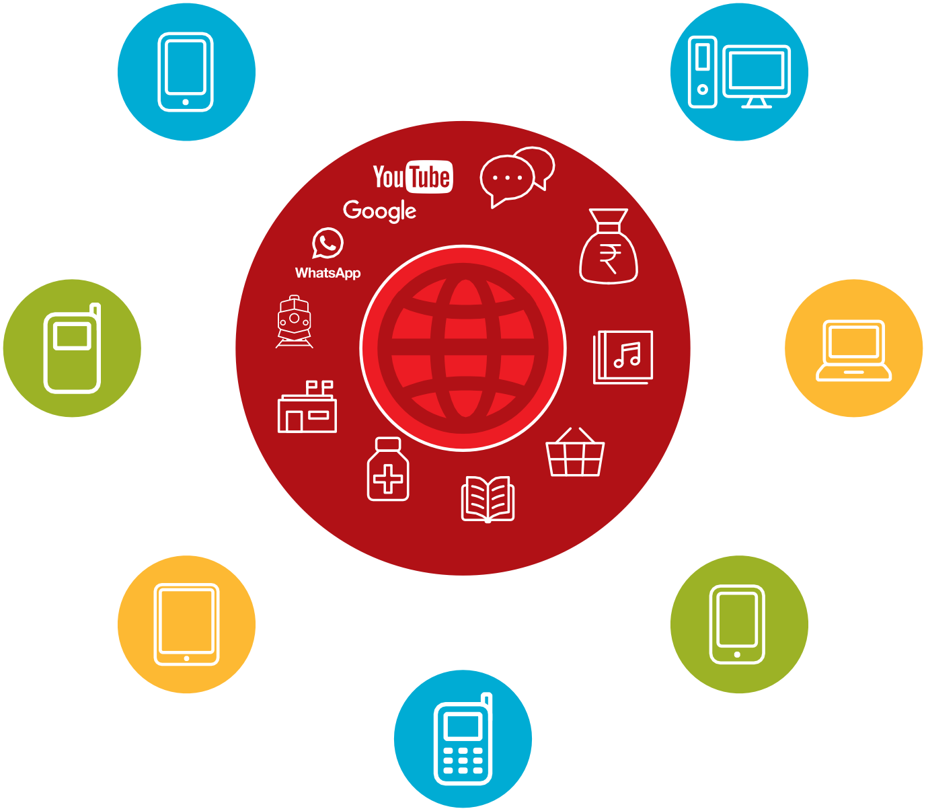

Communication

Travel
Internet
Banking
Entertainment

Government Services

Health
Information
Educatio2n

Online Shopping

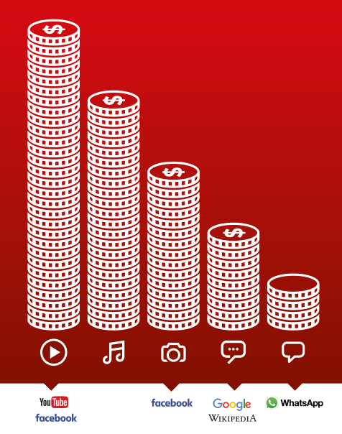
Data costs
Icon Cutouts - Apps

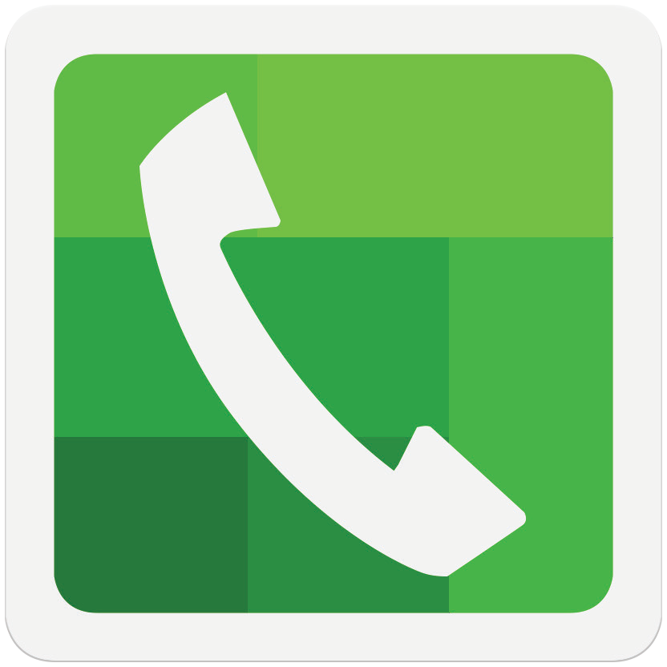

Icon Cutouts - Apps

Icon Cutouts - Phone Functions

CERTIFICATE

has completed
BASIC MOBILE INTERNET SKILLS
training

Date Signed

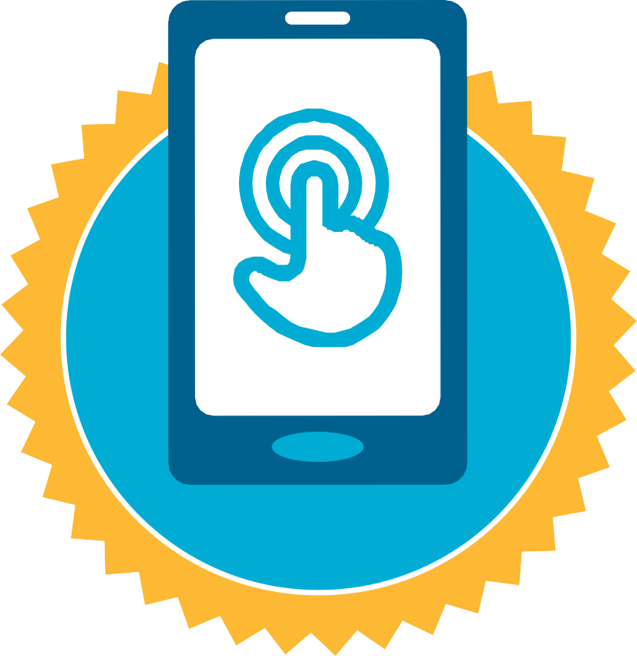

CERTIFICATE

has completed
BASIC MOBILE INTERNET SKILLS
training

Date Signed

