CHIDZIDZO 3: WHATSAPP
Chii chinonzi WhatsApp
WhatsApp iapurikesheni inoshandiswa kufambisa mashoko pakati pevanhu.
Tsananguro yeWhatsApp
- WhatsApp inoita kuti zvive nyore kubatana nekutaurirana nevanhu; mhuri, shamwari nevadyidzani.
- WhatsApp inoita mabasa ebetsero ekufambisa mashoko, inoda kufanana neSMS, asi WhatsApp inogoneka kutuma mazwi okutaura, mifanaidzo uyewo kutumira mashoko kumapoka evanhu vakawanda nguva imwe.
- WhatsApp inoshandisa bhanduro redhata reindaneti pachinhambo chebhanduro remari. Izvi zvinoreva kuti inogona kusadhura pakutuma mashoko uyewo kuva pedo kana kure nemunhu waunotumira mashoko hakunei nechekuita nemutengo.
Zviitwa:
Dzvanya pamureza weWhatsApp wakaita seuyu:
Kutumira mashoko akanyorwa kuchiitwa nevanhu vaviri
- Munovhura WhatsApp yenyu nekudzvanya pane chimureza cheWhatsApp chakafanana nechiri pamusoro apo
- Motsvaga zita remunhu wamurikuda kutumira meseji mobaya pazita iroro
- Dvanyai muchibhokisi chinonyogwa mavara monyora zvamunoda mobva matumira sezvakataridzwa pasi:
- Munokwanisa kutumira mashoko muchitaura kuburikidza nemaikirofoni inowanikwa padivi pechibhokisi chekunyorera mashoko.
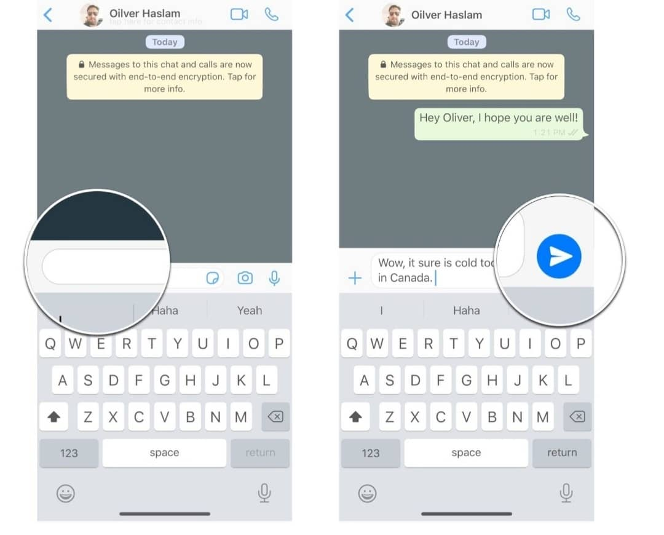
- Munokwanisa kupinda muzvikwata zvakasiyana siyana kuburikidza ne WhatsApp. Vamwe vane zvikwata zvemumakereke, zvikoro kana mabhizimusi chaiwo.Munokwanisa kutumira mashoko muzvikwata umu sematumiriro amunoita munhu mumwechete.
- WhatsApp inoshanda zvakawanda zvinosanganisira kutumira mifananidzo, mavideo, madocuments ne location.
Chenjedzo: WhatsApp inoshanda senzira yakachipa nekufona nayo. NeWhatsApp unogona kufona uchishandisa video uchiona munhu wauri kufonera zvisinei nekuti arikure sei.
Kuzvichengetedza paWhatsaApp
- Ngwarirai mashoko amunotumirana nevamwe paWhatsApp
- Remekedzai vamwe venyu varipaWhatsaApp
- Kana paine wamusiri kuwirirana naye musatambidzana mashoko akaipa
- Munokanisa kuisa mukaha pakati penyu nearikukunetsai nekudzvanya pakanzi block
- Zvinhu zvine chekuita nehupenyu hwenyu ngazvigare pakavanzika
Chenjedzo: Kuti mukwanise kupinda paWhatsApp munofanira kuva neWhatsApp bhanduru mufoni menyu. Mabhanduru eWhatsApp anemitengo yakasiyana siyana.
Kushandisa mabhanduru nekuona kuti ashanda zvakadii.
- Zivai mashandisa mari yakawanda sei huye kuti zvamunoita zvakasiyana-siyana paindaneti zvingada marii.
- Munogona kuona kuti wasara nemarii sekungoona kwamunoita kuti wasara nemamineti mangani ekuchaya runhare kana kuti masara nemashoko akawanda sei amungakwanisa kutumira. Izvi munozviita nekubaya kodhi panharembozha yenyu inoenderana neinoshandiswa nekambani iri kukupai masaisai.
- Munogona kuisa mari dzakasiyana-siyana dzedandemutande muzvikwama zvenyu zveindaneti zvichienderana nekuti paindaneti pacho muri kuda kuzoitei. Pihwai mazano kubva kumumiririri wevanopa masaisai amunoshandisa kuti mari ingakukwanira pane zvamunoda kushandisa ingaita marii.
- Kana muchikwanisa kuenda paindaneti munzvimbo ine WI-FI zvinoreva kuti hamuna mari yekuenda paindaneti yamuchashandisa. Mumiririri wevanopa masaisai munzvimbo yamuri anogona kukubatsirai kutsvaga nzvimbo dzinowanikwa WI-FI. Asi nedzimwewo nguva kunowanikwa WI-FI kunogona kunge kuri kure.
Chenjedzo: Nzira dzekuona nadzo mari yasara yekuenda paindaneti dzinosiyana zvichienderana nenyika yamuri huye mhando yemasaisai amuri kushandisa. Kana muchida rubatsiro nekuona kuti masara nemarii yekuenda paindaneti, munokwanisa kubvunza mumiririri wevanopa masaisai ari pedyo nemi.

