Connected Society
Mobile Internet Skills Training Toolkit
A guide for training people in basic mobile internet skills

Copyright © 2017 GSM Association

case.

6

MODULE 6 - FACEBOOK

Module 6 - Facebook

In-
Depth Training

MODULE 6 -

MODULE 6 - FACEBOOK

45-60

Time Duration:
Learning Objectives
- The trainees have registered for Facebook
- The trainees have added friends, followed Pages, and made a post
- The trainees are excited to use Facebook and connect with friends
45-60mins

Materials you will need:
MODULE 6 – FACEBOOK
Data Costs
Smartphone
Handsets
Facebook
Posters x 5
Glossary Handouts
Cost Poster
Safety Tips
Icon Cut-outs

Be polite and respectful to people

Tell someone you know and trust, if you feel uncomfortable about anything you see
or experience

Keep your personal information private

‘Block’ or ignore people you don’t know, or who are bothering you.

Easy tips for internet safety

Google is an internet service that makes it easy to find any information that you want to find on the internet
phone smartphone
Feature A mobile phone that has the ability to access the internet and
store and play music but lacks the advanced functionality of a
do with phone credit
Whenever you use the internet on your phone, you are using data.
Data You can buy data from your mobile network provider, just like you
Google Chrome Mozilla Firefox Opera Microsoft Internet
Explorer
A web browser, or simply “browser,” is an application used to
Browser access and view websites. Common web browsers include;
the right side of the screen.
- Ads can be videos or images that pop up on your screen
or Ad
- Ads can also be the links at the top of Google results and on
An ad is a piece of information that is trying to sell you something. It
Advert is good practice to avoid clicking on ads
www.india.in e.g. www.google.in
In the address bar there will always be the address of the website
Address bar The address bar shows you what website you are on.
An app gives you a shortcut to a service on your phone. For internet services e.g. WhatsApp, Facebook, Google, apps provide a quick and easy way to get onto the internet to use that service
App
The internet can run at different speeds when you use it. 2G internet
2G / 3G / 4G is the slowest, 3G internet is faster and 4G internet is the fastest
Definitions
Trainers can add to this section to include local relevant information on the mobile internet
Buy Now!
How to use
How to Create an Account
Facebook
1 2 3 4 5 6 7
How to use
Facebook
How to Add Friends
1
2
3
How to use
How to Download the Facebook App
on a Smartphone or Access on the Web
Web
App
Facebook
1 2
3
4

INTRO / ACCESS & REGISTER / ADDING FRIENDS & ‘LIKES’ / MAKE A POST / SAFETY / RECAP

MODULE 6 - FACEBOOK

Introduce Facebook

 | Show trainees the Facebook icon cut-out and ask them to find this on their phone
Give a short explanation of Facebook  - “Facebook connects you with your community, whether they live close to you or far away. You can use it to correspond with business contacts, receive news, stay in touch with family and friends or get updates on your favourite celebrities and sports teams.”  - “Using words, photos and videos, you can communicate with one person, a specific group of people or millions of people on Facebook.” |  | Bring the benefits to life!  - Tell your own story about how you use Facebook and the way it helps you, your friends and family. Some examples include:  - Communicate with friends, family and business contacts  - Share and get advice  - Advertise your business/products  - Read news from the world, celebrities and sports
Make the service relevant
Discuss with the trainees how Facebook can be beneficial in their own lives:
- Ask “What would you like to use Facebook for?” Give them some suggestions based on their interests.
MODULE 6 – FACEBOOK
INTRO / ACCESS & REGISTER / ADDING FRIENDS & ‘LIKES’ / MAKE A POST / SAFETY / RECAP

MODULE 6 - FACEBOOK
Activity: Access Facebook on your phone

Get practical!
Explain “You can get to Facebook through an app or a web browser.”
Tip: “It is best to download and use the Facebook app if you have a smart- phone and access Facebook on a web browser if you are using a feature phone.”
1 2 3 4
Web App
How to Download the Facebook App
How to use
Facebook on a Smartphone or Access on the Web
Show the “How to Download the Facebook App on a Smartphone” poster
- Go to free.facebook.com/lite OR go to facebook.com/lite if free isn’t available.
- Tap Download Now.
- Open the Facebook Lite app.
- Explain “This poster shows the steps for downloading accessing and registering for Facebook.”
- Take your trainees through the steps on their phones and explain you can add friends, share text and photos and get the latest news from celebrities, sports teams, news and more.

Show user how to access Facebook on the Web Explain “If you have a feature phone, then you can access Facebook on a web browser.”
- Go to free.facebook.com OR go to facebook.com if free isn’t available.
- Bookmark the website so the trainee can find it again.
MODULE 6 – FACEBOOK

INTRO / ACCESS & REGISTER / ADDING FRIENDS & ‘LIKES’ / MAKE A POST / SAFETY / RECAP

MODULE 6 - FACEBOOK
Activity: Create a Facebook Account
Explain “You need to create an account so your friends can find you on Facebook.” Ask If you can help the trainee create an account and walk them through the steps on the poster:
- Enter real name
How to use
Facebook How to Create an Account
1 2 3 4 5 6 7
- Select birthday
- Enter mobile number
- Select gender
- Choose a secure password that is easy to remember
- Receive and type in confirmation code via SMS or WhatsApp
- Click “Ok” to login

Activity: Add Friends

Explain “You must add people as friends on Facebook to see the pictures and information they post and share your pictures and thoughts.”

Show the “How to Add Friends” poster
Add friends:
How to use
Facebook How to Add Friends
1 2 3
- Hold up the Friends icon for Facebook and explain where to find it.
- Have the trainees connect with at least 5 friends using “Suggestions” of People You May Know.
- Have the trainees search for at least 2 specific friends and add them.
- Send trainees a friend request to show them how to accept (or decline).
- Explain that now when they use Facebook, they will see whatever their friends share.
MODULE 6 – FACEBOOK

INTRO / ACCESS & REGISTER / ADDING FRIENDS & ‘LIKES’ / MAKE A POST / SAFETY / RECAP

MODULE 6 - FACEBOOK

Activity: Like Celebrities, Sports and News Pages

Show the “How to “Like” Pages” poster
How to use
Facebook How to Follow Pages
1 2 3 3
- Explain “You can also get the latest news from your favorite celebrities, sports teams and news by liking their page. When you “like” a page, the information they post will show up when you log into Facebook.”

Like pages:
- Hold up the search icon and explain where to find it.
- Ask trainees what celebrities, sports or news they like and have them type it into the search and go to the page.
- Show them the like icon and show them where to click it on the page.
- Show them the News Feed icon, have them click it and see how their view has changed.

MODULE 6 – FACEBOOK
Tip: Give the trainees time to explore. Let them add as many friends and Pages as they want. The more they add, the better Facebook will be for them. You can also share what Pages are most popular in the local area.

INTRO / ACCESS & REGISTER / ADDING FRIENDS & ‘LIKES’ / MAKE A POST / SAFETY / RECAP

MODULE 6 - FACEBOOK

Activity: Make a Post

Explain “Now let’s learn how you can share personal or business information on Facebook.”

Show the “How to make a Post” poster

  - Show the photo/video icon and have trainees click it.
How to use
Facebook How to Make a Post
1 2 3 4
  - Explain that you can also select the camera icon to add a photo/video.
  - Explain that photos or videos can be added from the phone or new ones can be taken.
  - Explain that they can add text to the image/video or just post it alone.
  - Explain they can also just make a post from words if they don’t want to include a photo or video.

Personal Uses

Discuss with your trainees what they might like to share on Facebook.
Share what you post to Facebook. Show them some of the posts you’ve made and tell them why you shared them.
- Ask “What would you like to share with your friends and family?”
- Ask “What could you post to help your business?”
MODULE 6 – FACEBOOK

INTRO / ACCESS & REGISTER / ADDING FRIENDS & ‘LIKES’ / MAKE A POST / SAFETY / RECAP

MODULE 6 - FACEBOOK

Safety

Explain “Just like in the world, you can make choices on Facebook about whom you do and do not want to interact with.”
Explain “The photo you chose as a profile picture will be visible to all Facebook users. This helps people find you and add you as a friend on Facebook.”
Ask “Do you want to choose who sees your posts?”
Demonstrate how to select the audience when making a post and how to change the privacy setting later.
Explain “You can have a post appear to the public (everyone using Facebook) or only to your friends.”
Explain to trainees that they can access additional privacy controls. Show them Privacy Shortcuts where they can see who can view their profile, who can contact them with friend requests, and how to block someone who is bothering them.
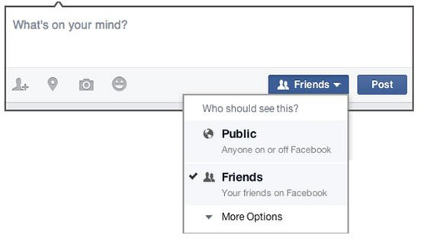
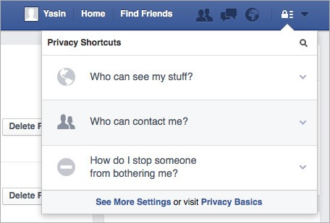

MODULE 6 – FACEBOOK
INTRO / ACCESS & REGISTER / ADDING FRIENDS & ‘LIKES’ / MAKE A POST / SAFETY / RECAP

MODULE 6 - FACEBOOK
MODULE 6 – FACEBOOK

Recap

Play the Facebook icon game
- Hold up each Facebook icon, one at a time.
- Ask “Where is this on the phone and what is it?”
- Explain to your trainees what each icon is, if they need support.
- Give small rewards (e.g. sweets) for correct answers and stick the icons on the wall afterwards to help remind your trainees what they are.
Tip: Let trainees play with Facebook on their own, make posts, share pictures, search Pages and add friends. Encourage them to ask questions as they explore Facebook.

Recap of Key Learnings
Discuss with your trainees what they have learned about using Facebook.
- “What have you learned about using Facebook?”
- “What do you want to use Facebook for in your own life? What are you most interested in and excited about using it for?”
- “What will your next post be?
MODULE 6 – FACEBOOK
BITESIZE – FACEBOOK

Posters, Cut-outs and
Info-sheets

Icon Cutouts - Facebook

Icon Cutouts - Facebook

Icon Cutouts - Facebook
How to use

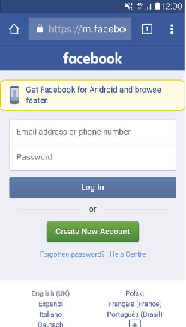
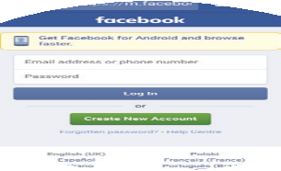

How to use
Facebook
How to Download the Facebook App on a Smartphone or Access on the Web
Facebook

1 2 3 4

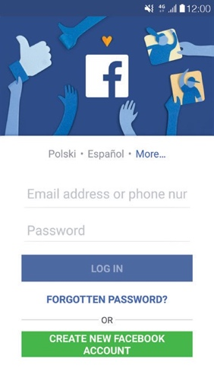
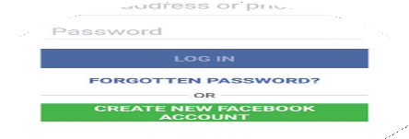
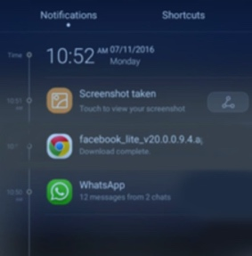
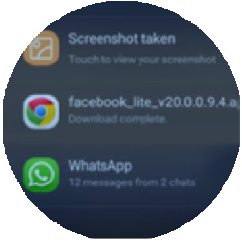
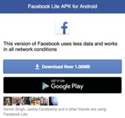

How to Create an Ac
Facebook
How to Create an Account
How to use
How to Add Friends

1 2 3 4 5 6 7
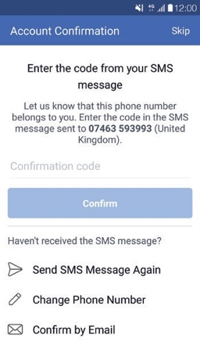
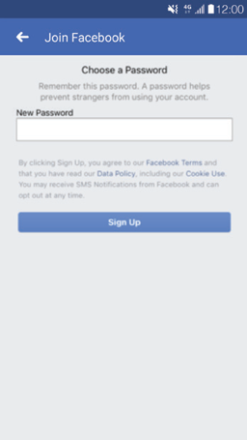
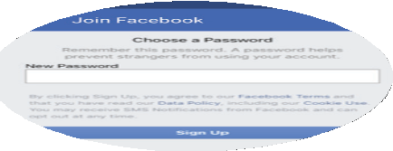
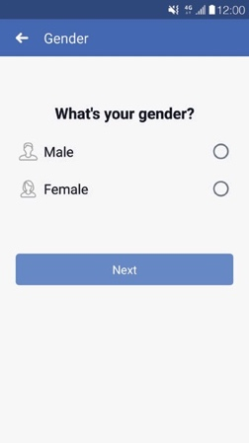
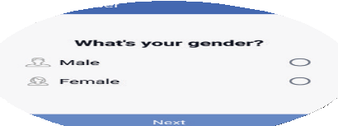
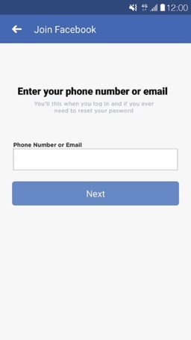
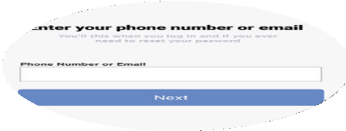
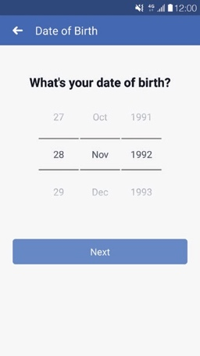
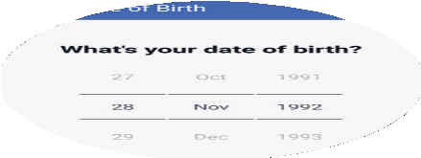
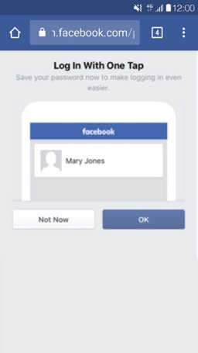
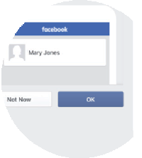
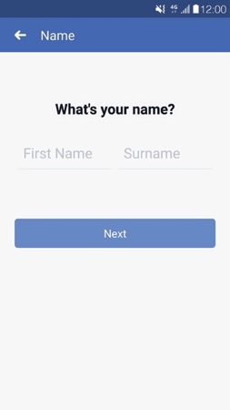
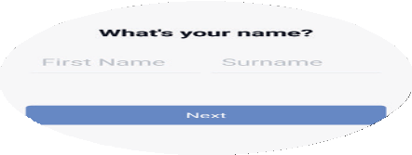

Facebook
How to use
How to Add Friends

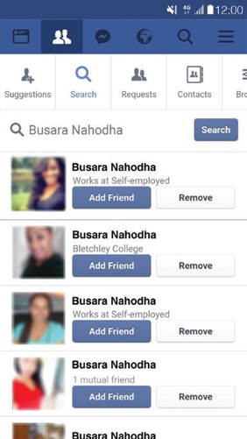
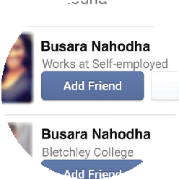
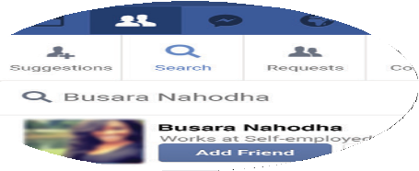
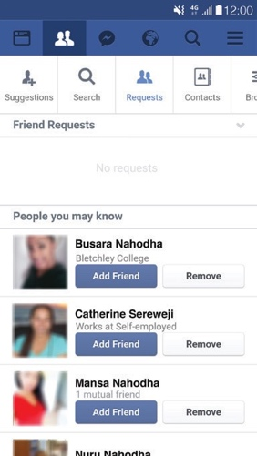
1 2 3
F Facebook
How to use
How to Follow Pages
How to use

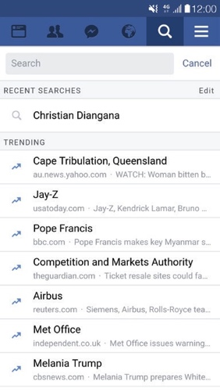
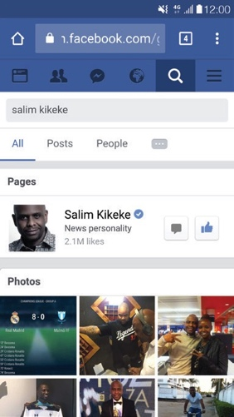
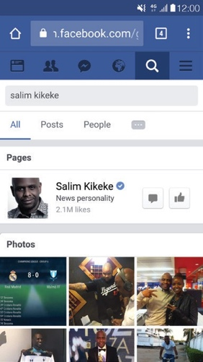
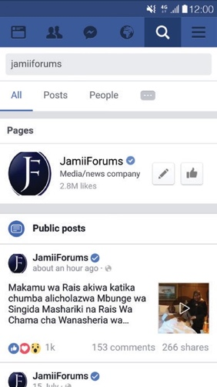
1 2 3 3

Facebook How to Make a Post
How to use

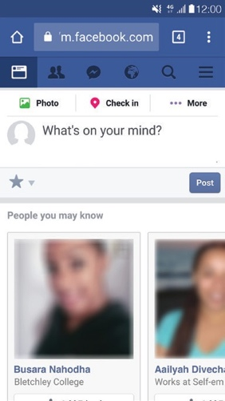

1 2 3 4
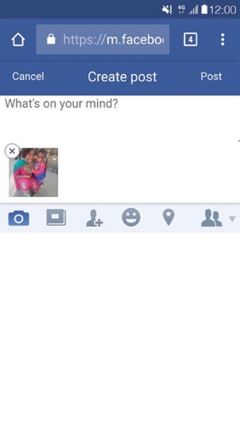
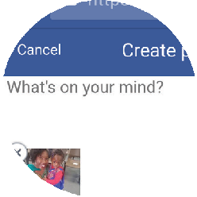
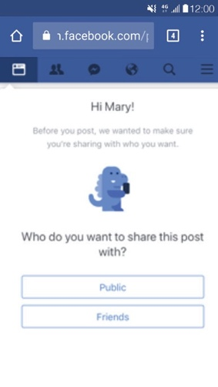

CERTIFICATE

has completed
BASIC MOBILE INTERNET SKILLS
training

Date Signed

CERTIFICATE

has completed
BASIC MOBILE INTERNET SKILLS
training

Date Signed

