

Connected Society

Mobile Internet Skills Training Toolkit

A guide for training people in basic mobile internet skills

Copyright © 2017 GSM Association

case.

**8**

**MODULE 8 – MOBILE MONEY**

**Module 8 – Mobile Money**

# Bitesize Training

**BITESIZE - MOBILE MONEY**

**BITESIZE – MOBILE MONEY**

What is it?



**Show a basic mobile phone with a mobile money service, ensuring the menu is open showing key functions.**

|  |  |
| --- | --- |
| **What**  **you’ll need**    Mobile Phone  Diagram  Description automatically generated  Mobile Money  Posters | **What can you use it for?**  **Explain:**  “A mobile money account is like having a wallet on your phone. With mobile money you can send and receive money from people, and make payments just using your phone - without having a bank account! Depending on your mobile operator, you can also do lots of other things like pay your bills, and save or borrow money.”  **Share** examples from your own (the trainer’s) life about how mobile money has been useful.  **Make it relevant** to the trainee by discussing how it can be beneficial in the trainee’s own life. |

BITESIZE – MOBILE MONEY

**one in the trainees’ hands (or use**

**BITESIZE - MOBILE MONEY**

**BITESIZE – MOBILE MONEY**

BITESIZE – MOBILE MONEY

How Does It Work?

**Place the phone in the trainees’ hands (or use   
the trainees’ phones) and help them follow   
the below steps**

**Demonstrate** how the trainee can send money to a friend using the steps on the

Poster.

**Tip:** At the beginning of the training session check who already has a mobile money account. If there are trainees without a mobile money account take them through the registration process (see ‘In Depth’ section for details).

**Show the “Sending money to friend using   
your phone” poster.**

**Explain**: “I will now show you how you can send money to a friend using your phone.”

**Ask:** “If you want to send money using your account for real, we can do this! Or if you don’t have money in your mobile money account or don’t want to send it right now, I can demonstrate how it is done so that you know for the future.”

**BITESIZE - MOBILE MONEY**

**BITESIZE – MOBILE MONEY**

How Does It Work?

* Your mobile operator wil

  
How Does It Work?

* Your mobile operator will have a short number to use their mobile money service. It will look something like *123#. Type it in and press the ‘call’ button.
* You will get a list of options on screen (e.g. 1,2,3,4,5…). You need to choose ‘transfer’ / ‘send’ money. This is normally number 1 (at the top). Press 1 on your phone keypad and move then ‘select / ok’.
* Type in the phone number of your friend or family member that you want to send the money to. Press ‘select / ok’.
* Now type in the amount of money you want to send to your friend or family member (e.g. 100). Press ‘select / ok’.
* Type in your personal PIN number. This is a special number that you choose and only you will know. This helps protect your account. Choose a hard to guess PIN! Press ‘select / ok’.
* Finally, you need to press 1 to ‘confirm’ that you want to send this money. Press ‘select / ok’. Congratulations! You have sent money to your friend or family member!

**Tip:** If the trainee does not want to send any money, then show them they can do it without sending money for real.

BITESIZE – MOBILE MONEY

**BITESIZE - MOBILE MONEY**

**BITESIZE – MOBILE MONEY**

Practise

**“Now that we have seen how to send**

**Practise **

**“Now that we have seen how to send money using mobile money, who could you send money to?”**

**Trainer:** Allow the trainee to run through the process of sending money to

someone on their own. If they need help at any stage, then assist them.

**Tip:** Remember that your ‘PIN number’ is your own personal number. It is really important that you keep this safe as it is how you access your account. Be careful about sharing this number with anyone, even mobile money agents or customer care staff, whether in person, via SMS or the internet!

BITESIZE – MOBILE MONEY

**Posters, Cut-outs and Info-sheets**



### Diagram Description automatically generatedDiagram Description automatically generatedSending money to friend

### using your phone

Select

Select

Select

Select

Select

### Diagram Description automatically generatedDiagram Description automatically generatedPaying a bill

### using your phone

Select

Select

Select

Select

Select

Select

Select

**What is mobile money**

**You can send money**

**To other people, pay**

**bills, pay for goods.**

**Cash can be deposited and withdrawn from your   
mobile money account  
with your agent.**

**Your PIN number is the way you can use**

**your account.**

**It’s like having a wallet on your phone.**

**To register for mobile**

**money, you need proof of**

**Identity.**

**Once these steps have been completed you can start using your mobile money account!**

**Go to your agent every time**

**you need to deposit or  
withdraw money from your**

**account.**

**You need a SIM card from your mobile operator. Your  
money agent will register**

**you for mobile money**

**Registering for mobile money account**

**What can you do with mobile money**

**Get a loan**

**Earn interest on your**

**savings**

**Pay for goods and   
services**

**Send /receive money to  
and from friends and  
family in other countries**

**Buy airtime for you**

**or other people**

**Pay bills or school   
fees**

**Receive money from  
friends or family**

**Send money to**

**friends or family**

**Staying safe using mobile**

**Agents**

**Phone**

**PIN**

**Message**

**5 key things to know about mobile money**

**PIN number**

**Mobile number**

**Mobile money**

**agent**

**Mobile money  
account**

**Account  
registration**

### Diagram Description automatically generatedTimeline Description automatically generated with medium confidence5 key things to know about mobile money

**Account  
registration**

To use mobile money you will need to register at a mobile money agent

who will help you create an account. To do this you will need a SIM card  
and some ID documents (like a passport, driving license or voters card)

A mobile money account is like having a wallet on your phone. With  
mobile money you can send and receive money from people and make  
payments just using your phone – all without having a bank account.

A mobile money agent is who you go to when you need to deposit or

withdraw money from your account. They can help you if you have a  
problem with your account.

A mobile phone number – the one you use to call and SMS people – are   
important for mobile money. When you want to send money to  
someone using mobile money you use their mobile number. This is the   
same if they want to send money to you.

This is your personal number which helps you protect your mobile  
money account. You will need to type this into your phone when using  
mobile money. Keep it safe and don’t share it with anyone!

**PIN number**

**Mobile number**

**Mobile money**

**agent**

**Mobile money  
account**



**CERTIFICATE**

has completed

**BASIC MOBILE INTERNET SKILLS**

training

Date Signed

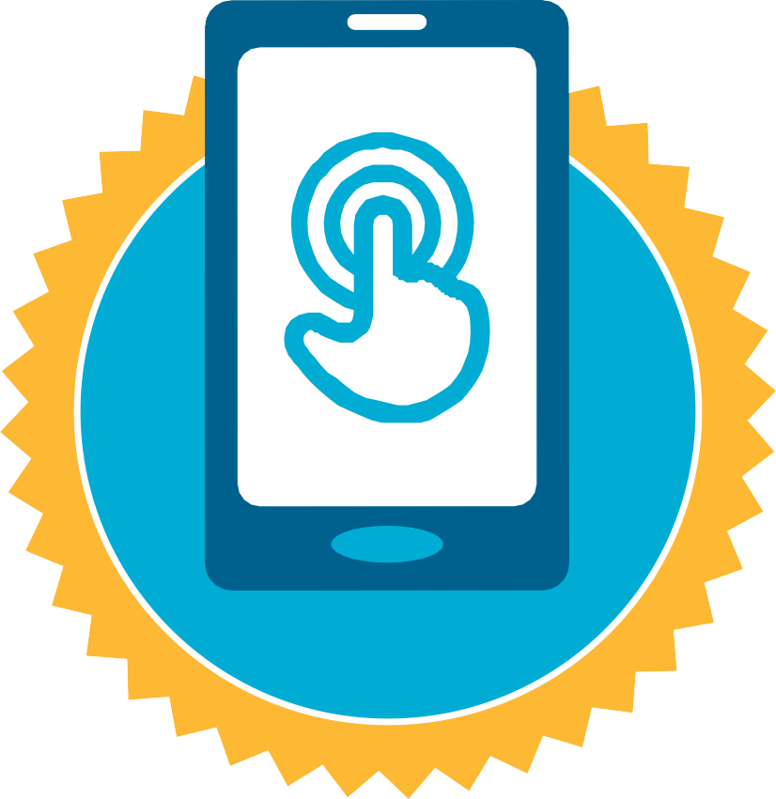

**CERTIFICATE**

has completed

**BASIC MOBILE INTERNET SKILLS**

training

Date Signed