

Connected Society

Mobile Internet Skills Training Toolkit

A guide for training people in basic mobile internet skills

Copyright © 2017 GSM Association

case.

**8**

**MODULE 8 – MOBILE MONEY**

**Module 8 – Mobile Money**

# In- Depth Training

**MODULE 8 - MOBILE MONEY**

|  |  |
| --- | --- |
| Learning Objectives  • Trainees understand what mobile money is  • They feel excited and motivated about mobile money and understand that there are a number of ways it can be used to improve their lives  • Trainees are able to: understand the registration process for mobile money; how to send money to a friend or family member and pay a bill and understand basic safety implications of using mobile money | **Time Duration:** 45-60 minutes  45-60 |

|  |  |  |  |
| --- | --- | --- | --- |
| **Materials you will need:** | Introduce Mobile Money | | |
| Mobile Phone |  | **Give a short**  **explanation of**  **mobile money** |
| Diagram  Description automatically generated  Mobile Money Posters | **Explain:**  • “A mobile money account is like having a wallet on your phone. With mobile money you can send and receive money from people, and make payments just using your phone – without having a bank account! You can also do lots of other things like pay your bills, and save or borrow money”.  • “Unlike with cash you do not have to carry money around if you want to pay for things. This means that it is safer and easier.”  • “Depending on your mobile operator, with mobile money you can do many things like: send and receive money from people, pay.” | | |

MODULE 8 – MOBILE MONEY

**MODULE 8 - MOBILE MONEY**

INTRO / REGISTRATION / SENDING A TRANSFER / PAYING A BILL / SAFETY

**MODULE 8 - MOBILE MONEY**

**Make mobile money relevant for your trainees**

Discuss with the trainees how mobile money can be beneficial in their own lives:

**Ask:**

• “What would you like to use mobile money for in your own life?” Give them some suggestions if they are unsure.

• “What are you most interested in and excited to learn about doing with mobile money?”

Introducing Mobile Money

**Bring the benefits to life!**

• Tell your own story of how mobile money has been beneficial to you (the trainer), your   
friends and family. Depending on your mobile operator, some examples might include:

• Sending money to family that live a long distance away

• Using mobile money to pay businesses or traders in the local market (so not having to   
carry cash)

• Paying a utility bill or school fees immediately

• Sending and receiving money from people outside of the country

• Pay for goods and services from a range of businesses

• Earning an interest on your savings

• Getting a loan

**Show the “What is mobile money” poster**

1. A mobile money account is like having a wallet on your phone.
2. You can give cash to a mobile money agent and it will be deposited in   
   your mobile money. account. You can also withdraw cash from your mobile money account at this agent.
3. You can send money to other people, pay bills, pay for goods.
4. Your PIN number is your special number and is the way you can use   
   your account.

MODULE 8 – MOBILE MONEY

MODULE 8 – MOBILE MONEY

INTRO / REGISTRATION / SENDING A TRANSFER / PAYING A BILL / SAFETY

**MODULE 8 - MOBILE MONEY**

Registration

**Explain:** “In order t



**Registration**

**Explain:** “In order to make use of mobile money you will need to have a mobile money ‘account’   
with your mobile operator. Every adult with a SIM card can register for a mobile money account.   
It is similar to how you open an account to make calls or send SMS. To register for a mobile   
money account you will need to visit a mobile money agent.”

**Explain:** “Your mobile money agent is a very important person. They help you deposit cash   
into your account, as well as withdraw cash from your account when you need it. Sometimes,   
you can buy airtime and data from them but you can also set up your mobile money account   
with them. They will also be able to help you if you have questions.”

**Show the “Registering for mobile money account” poster**

* + 1. If you don’t already have one, you will first need a SIM card from your mobile operator. Once you have a SIM card, your mobile money agent will be able to help you register for mobile money. You may need to complete a form with some personal information.
    2. In order to register for mobile money, you will need to have an ID document (like a passport, driving license or voters’ card).
    3. To start using/paying with mobile money you will need to deposit money in your account at your operator agent (or at some ATMs - depending on your country). You will go to your agent every time you need to deposit or withdraw money from your account.
    4. Once you have completed these steps you will have a mobile money account and you can start using mobile money!

MODULE 8 – MOBILE MONEY

INTRO / REGISTRATION / SENDING A TRANSFER / PAYING A BILL / SAFETY

**MODULE 8 - MOBILE MONEY**

Activity: Sending a trans

Activity: Sending a transfer or remittance using   
mobile money

|  |  |
| --- | --- |
|  | • **Trainer** At the beginning of the training session check who has a  mobile money account and who has not. If there are trainees without a  mobile money account take them through the registration process.  • **Explain:** “You are now going to learn how to send some money to a  friend or family member using mobile money!”  • **Ask:** “If you want to send money using your account for real, we can  do this! Or if you don’t have money in your mobile money account or  don’t want to send it, I can demonstrate how it is done so that you  know for the future.” |

**Tip:** If the trainee does not want to send any money, then show them how they can do, without sending the money for real.

**Demonstrate how the trainee can send money to a friend or family member   
using the steps on the poster**

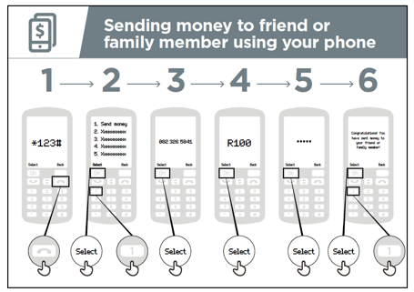**Show the “Sending money to friend or family**

**member using your phone” poster**

**Explain:** “We will now see how to send money to friend using your phone”:

• Your mobile operator will have a short number to use their

mobile money service. It will look something like *123#.

Type it in and press the ‘call’ button.

• You will get a list of options on screen (e.g. 1,2,3,4,5…). You

need to choose ‘transfer / send’ money. This is normally

number 1 (at the top). Press 1 on your phone keypad and

move then ‘select / ok’.

• Type in the phone number of your friend or family

member that you want to send the money to. Press ‘select / ok’.

MODULE 8 – MOBILE MONEY

INTRO / REGISTRATION / SENDING A TRANSFER / PAYING A BILL / SAFETY

**MODULE 8 - MOBILE MONEY**

• Now type in the amount of money you want to

• Now type in the amount of money you want to send to your friend or family member   
(e.g. 100). Press ‘select / ok’.

• Type in your personal PIN number. This is a special number that you choose and only you   
will know. This helps protect your account. Choose a hard to guess PIN! Press ‘select / ok’.

• Finally, you need to press 1 to ‘confirm’ that you want send this money. Press ‘select / ok’. Congratulations! You have sent money to your friend or family member!

**Explain:** “If you realise that you have sent the money to the wrong person, your mobile   
operator might be able to help! Call your mobile operator customer service as soon as   
possible, or ask your mobile money agent for help.”

Tip: Remember that your ‘PIN number’ is your own personal number. It is really important that you keep this safe as it is how you access your account.

Be careful about sharing this number with anyone, even mobile money agents or customer care staff, whether in person, via SMS or on the internet!

Activity: Paying a bill

**Explain:** “With mobile money you can do far more than just send money to other people!   
For example, other people can send money to you; you can pay bills, or you can save or   
borrow money.”

**Explain:** “Your mobile money agent is a very important person. You can buy airtime and   
data from them but you can also set up your mobile money account with them. They also   
help you deposit cash into your account, as well as withdraw cash from your account when   
you need it. They will also be able to help you if you have questions.”

MODULE 8 – MOBILE MONEY

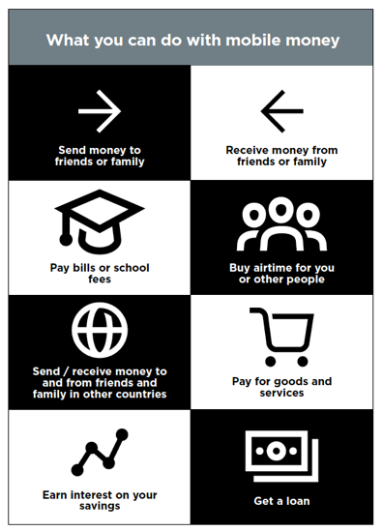  
**Show the “What you can do with mobil**

INTRO / REGISTRATION / SENDING A TRANSFER / PAYING A BILL / SAFETY

**MODULE 8 - MOBILE MONEY**

**Show the “What you can do with mobile money”   
poster**

1. Send money to friends or family

2. Receive money from friends or family

3. Pay bills or school fees

4. Buy airtime for you or other people

5. Send / receive money to and from friends and family in

other countries

6. Pay for goods and services

7. Earn interest on your savings

8. Get a loan

**Explain:** “Once you know how to send a payment to someone using mobile money on your   
phone, you can also learn how to do other things! For example, you could pay a bill.”

**Demonstrate** how the trainee can send money to a friend or family member using the steps   
on the poster.

**Show the “Paying a bill using your phone” poster**

1. Your mobile operator will have a short number to call for using their mobile money service. It will look something like *123#. Type it in and press the ‘call’ button.

2. You will get a list of options (1,2,3,4,5…). You need to choose the option for ‘pay a bill or payments’. Press ‘select / ok’.

3. Then you need to find the type of bill you would like to pay and/or enter your payee’s number. For example, this could be school fees or utilities. Press ‘select / ok’.

4. Enter your ‘account number’ for this service. Press ‘select / ok’.

5. Now type in the amount of money you want to pay (e.g. 100). Press ‘select / ok’.

6. Type in your personal PIN number. This is so that your mobile operator knows that it is you! Press ‘select / ok’.

7. Finally, you need press 1 to ‘confirm’ that you want send this money. Press ‘select / ok’. Congratulations! You have paid your bill!

MODULE 8 – MOBILE MONEY

INTRO / REGISTRATION / SENDING A TRANSFER / PAYING A BILL / SAFETY

**MODULE 8 - MOBILE MONEY**

**Ask:** “Now that have paid a bill using mobil

**Ask:** “Now that have paid a bill using mobile money, what else would you like to do?”

**Trainer:** Allow the trainee to run through menu to find the other use cases for mobile money   
(e.g. buying airtime). Explain that the menu works in the same way as for bill payment or   
sending money to someone. If they need help at any stage, then assist them.

**Tip:** You can also use mobile money on a smartphone. This will let you do many of the same things but are also easier to use and let you do other things such as let you find out where mobile money agents are on a map. You will need mobile data to use mobile money via a smartphone app.

Safety

**Explain:** “Mobile money is safer than carrying cash with you. But you need to remember that   
it is important that you stay safe!”

**Ask** your trainees to imagine they are in a typical public place, e.g. the market. Ask them   
to discuss what they would do to keep their money safe in this place.

If necessary, prompt them with the following questions and answers:

|  |  |
| --- | --- |
| **Prompts** | **Suggested answers** |
| What do you do if someone you  don’t know bothers you for money? | You avoid or ignore them. Remember  that people are not always who they  say they are. |
| What do you do if you feel unsure  or uncomfortable about something  someone asks you? | Tell someone you know and trust  about what happened and ask their  advice. |
| What do you do if someone you  don’t know or trust asks you for your  personal information (including via  SMS or WhatsApp)? | You don’t give out personal  information to someone you don’t  know or trust because they may  misuse it. |

MODULE 8 – MOBILE MONEY

INTRO / REGISTRATION / SENDING A TRANSFER / PAYING A BILL / SAFETY

**Explain:** “You can stay safe using mobile money by acting like you do in a public place.   
If someone sends you an SMS saying that they need your PIN number or asks you for money,   
they may not be who they say they are.”

**MODULE 8 - MOBILE MONEY**

|  |  |
| --- | --- |
|  | **Show the “Staying safe using mobile” poster**  **1.** **Message:** If someone sends you an SMS or message on  the internet asking for money or your PIN, they might not  be who they say they are.  **2.** **PIN:** Your ‘PIN number’ a personal number for you! You  need to keep this safe and be careful about sharing  this number with anyone, even mobile money agents or  customer care staff. It is better to hide your screen and  keep your fingers covered when entering your PIN. If you  think somebody else might have discovered your PIN,  contact your mobile money agent to learn how to change it.  **3. Phone:** If you lose your phone it doesn’t mean that  people can steal money from your mobile money account.  If the thieves don’t know your mobile money PIN they will  not be able to use your money. If your phone gets stolen,  visit your mobile money agent.  **4. Agents:** Remember that you can only withdraw cash  from and deposit cash in your mobile money account at  authorised agents of your mobile operator or at certain  ATMs. Make sure you know if the person you are talking to  about your mobile money account is an agent. |

**Explain:** “It is very important to remember your ‘PIN number’. If you forget it, your mobile   
operator will be able to help you. Ask your mobile money agent how to get a new PIN but   
remember to keep it a secret! If you insert the wrong PIN for a number of times your account   
might be locked. Visit your mobile money agent to get a new PIN and unlock your account.”

**Discuss** with your trainees what these tips mean for using mobile money.

Bring the tips to life by using examples from your life that are relevant for your trainees.

MODULE 8 – MOBILE MONEY

INTRO / REGISTRATION / SENDING A TRANSFER / PAYING A BILL / SAFETY

**MODULE 8 - MOBILE MONEY**

|  |  |
| --- | --- |
|  | **Show the “5 key things to know about mobile money” poster**  **1. Account registration:** To use mobile money you will need  to register at a mobile money agent who will help you  create an account. To do this you will need a SIM card and  some ID documents (like a passport, driving license or  voters card).  **2. Mobile money account:** A mobile money account is like  having a wallet on your phone. With mobile money you  can send and receive money from people, and make  payments just using your phone – all without having a  bank account.  **3. Mobile money agent:** A mobile money agent is who you  go to when you need to deposit or withdraw money from  your account. They can help you if you have a problem  with your account.  **4. Mobile number:** A mobile phone number – the one you  use to call and SMS people -are important for mobile  money. When you want to send money to someone using  mobile money you use their mobile number. This is the  same if they want to send money to you.  **5. PIN number:** This is your personal number which helps  you protect your mobile money account. You will need to  type this into your phone when using mobile money. Keep  it safe and don’t share it with anyone! |

MODULE 8 – MOBILE MONEY

MODULE 8 – MOBILE MONEY

**Posters, Cut-outs and Info-sheets**



### Diagram Description automatically generatedDiagram Description automatically generatedSending money to friend

### using your phone

Select

Select

Select

Select

Select

### Diagram Description automatically generatedDiagram Description automatically generatedPaying a bill

### using your phone

Select

Select

Select

Select

Select

Select

Select

**What is mobile money**

**You can send money**

**To other people, pay**

**bills, pay for goods.**

**Cash can be deposited and withdrawn from your   
mobile money account  
with your agent.**

**Your PIN number is the way you can use**

**your account.**

**It’s like having a wallet on your phone.**

**To register for mobile**

**money, you need proof of**

**Identity.**

**Once these steps have been completed you can start using your mobile money account!**

**Go to your agent every time**

**you need to deposit or  
withdraw money from your**

**account.**

**You need a SIM card from your mobile operator. Your  
money agent will register**

**you for mobile money**

**Registering for mobile money account**

**What can you do with mobile money**

**Get a loan**

**Earn interest on your**

**savings**

**Pay for goods and   
services**

**Send /receive money to  
and from friends and  
family in other countries**

**Buy airtime for you**

**or other people**

**Pay bills or school   
fees**

**Receive money from  
friends or family**

**Send money to**

**friends or family**

**Staying safe using mobile**

**Agents**

**Phone**

**PIN**

**Message**

**5 key things to know about mobile money**

**PIN number**

**Mobile number**

**Mobile money**

**agent**

**Mobile money  
account**

**Account  
registration**

### Diagram Description automatically generatedTimeline Description automatically generated with medium confidence5 key things to know about mobile money

**Account  
registration**

To use mobile money you will need to register at a mobile money agent

who will help you create an account. To do this you will need a SIM card  
and some ID documents (like a passport, driving license or voters card)

A mobile money account is like having a wallet on your phone. With  
mobile money you can send and receive money from people and make  
payments just using your phone – all without having a bank account.

A mobile money agent is who you go to when you need to deposit or

withdraw money from your account. They can help you if you have a  
problem with your account.

A mobile phone number – the one you use to call and SMS people – are   
important for mobile money. When you want to send money to  
someone using mobile money you use their mobile number. This is the   
same if they want to send money to you.

This is your personal number which helps you protect your mobile  
money account. You will need to type this into your phone when using  
mobile money. Keep it safe and don’t share it with anyone!

**PIN number**

**Mobile number**

**Mobile money**

**agent**

**Mobile money  
account**



**CERTIFICATE**

has completed

**BASIC MOBILE INTERNET SKILLS**

training

Date Signed

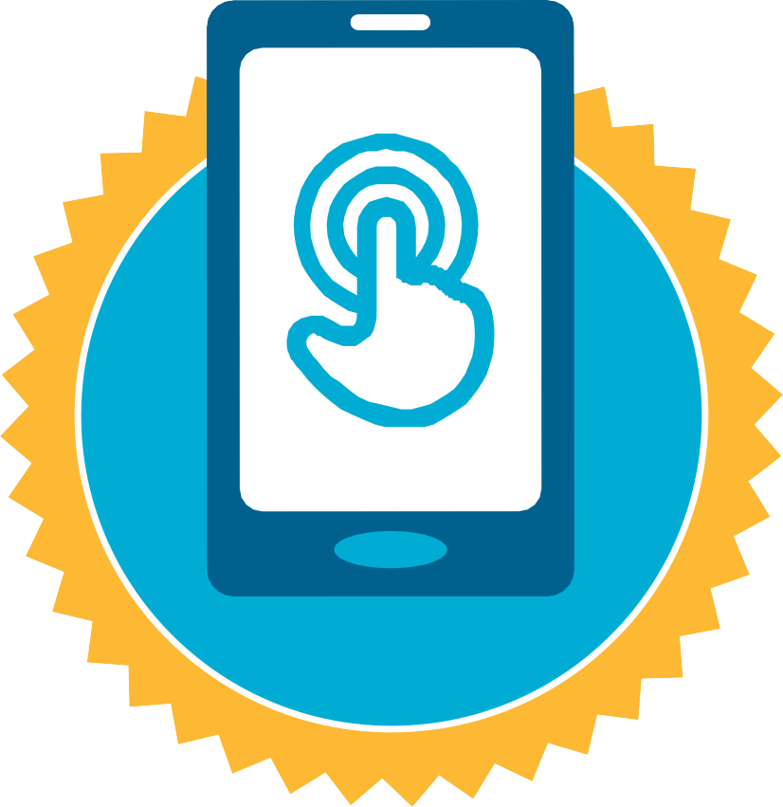

**CERTIFICATE**

has completed

**BASIC MOBILE INTERNET SKILLS**

training

Date Signed