

Connected Society

Mobile Internet Skills Training Toolkit

A guide for training people in basic mobile internet skills

Copyright © 2017 GSM Association

case.

**7**

**MODULE 7 – ONLINE SAFETY**

**Module 7 – Online   
Safety**

# Bitesize Training

**BITESIZE - SAFETY**

What is it?

“There are many great things that you can use the internet for, but it is important to remember the internet is open to everyone around the world and so it is essential to treat it like a real-life public place (e.g. a market place) and stay safe.”



Materials you will need

**Keep your personal information private**

**‘Block’ or ignore people you don’t know, or who are bothering you.**

**Easy tips for internet safety**

Smartphone Handsets

**Tell someone you know and trust, if you feel uncomfortable about anything you see**

**or experience**

Safety Poster

What can you use it for?

**Give out the ‘Easy tips for internet safety’ sheet**

“Just like in a public space, you should:

1. ‘Block’ or ignore people you don’t know or who are bothering you
2. Keep your personal information private (e.g. who you are, where you live, passwords)
3. Tell someone you know and trust if you feel uncomfortable about anything you see or experience on the internet
4. Be polite and respectful to people and do not bother them”

**Trainer:** Give your own examples for each tip if you have time

BITESIZE – SAFETY

**BITESIZE - SAFETY**

How do you stay safe?

**Ask** trainee which service they want to learn to stay safe on (WhatsApp,

YouTube, Wikipedia, Facebook, KaiOS, Android or mobile money).

**Demonstrate following the below:**

|  |  |
| --- | --- |
|  | **WhatsApp:** “If someone you do not know messages you or bothers you on WhatsApp and you do not want them to, you can ‘block’ them so that they cannot contact you again.”  Show the **‘How To Block’** poster and demonstrate the steps. |
|  | **YouTube:** “If you are looking at videos on YouTube and you see one that you think is bad or offensive, you can go back to the previous page, refine your search and continue looking at other videos.”  **Demonstrate this on YouTube:** Press the back button, delete the keywords in your search box and change your search by using different keywords. |
|  | **Wikipedia:** “If you are on Wikipedia, all the information is from people all over the world! Remember that you should check what the source of this is to make sure it is correct.”  **Demonstrate this on Wikipedia:** Show trainees the list of sources and references at the bottom of a Wikipedia page. |
|  | **Facebook:** “If you are on Facebook you can change who sees your profile and who can contact you.”  **Demonstrate this on Facebook:** Show them Privacy Shortcuts where they can adjust who can see their profile and who can contact them with Friend requests. |

BITESIZE – SAFETY

**BITESIZE - SAFETY**

**BITESIZE - SAFETY**

|  |  |
| --- | --- |
|  | **KaiOS:** “If you are using a KaiOS phone, there are a number of ways you can change your phone so that you stay safe. You can find them in the ‘privacy and security’ on your phone.  **Demonstrate this on KaiOS:** Show trainee how to find the ‘privacy and security’ via the main KaiOS menu. |
|  | **Android:** “If you don’t use your Android phone for some time it will turn the screen off to save the battery. It is important to create a password so that other people can’t use your phone if they find it.”  **Demonstrate this on Android:** Show trainee how they can set up a PIN / passcode on their device to keep it secure. |
|  | **Mobile money:** “Remember that your ‘PIN number’ is your own personal number. It is really important that you keep this safe as it is how you access your account. Be careful about sharing this number with anyone, even mobile money agents or customer care staff, whether in person, via SMS or the mobile internet!”  **Demonstrate this on mobile money service:** Show trainee when a PIN is needed in a normal mobile money transaction (e.g. when sending money to a friend or family member). |

BITESIZE – SAFETY

BITESIZE – FACEBOOK

**BITESIZE - COST**

What is it?

“Whenever you use the internet on your phone, you are using ‘data’. This means you need to buy data from your mobile network. Some activities on the internet use more data, so cost more to do.”

$

“You can buy data for the internet; it is like buying phone credit for calls and messages. Data for the internet can be bought from your local mobile network agent or phone credit seller who will top it up for you.”

“Sometimes internet data can also be bought in ‘data vouchers’ or ‘data cards’ that you can use to top up your mobile internet yourself.”



Materials you will need

Smartphone Handsets

**Data Costs**

Cost Poster

What uses data?

**Show the cost poster**

“Different activities use different amounts of data. Looking at text uses the least data, looking at images uses more, playing and downloading music, stickers and ringtones also uses more and downloading and playing videos

uses the most. Videos tend to use more data than other internet uses.”

“Some internet services are linked to activities that use more data:

* e.g. watching videos on YouTube tends to use a lot of data
* e.g. Google costs less for looking at text and images, but will cost more if you watch videos

**Explain** that “software updates also use data and so will cost money”.

BITESIZE – COST

$

**BITESIZE - COST**

$

How do you check your data costs?

**Put the   
phone in   
the trainee’s**

“It is useful to check your data to understand how much you   
have used, and how much different activities cost”

“You can check how much data you have, just like when you check how many minutes or texts you have by typing in a   
code on your phone from your mobile network

**hands and   
help them to   
follow the   
steps**

BITESIZE – COST

**Tip:** “You can buy data in different amounts depending on what you are going to use the internet for. Ask for advice from your local mobile agent on which amount is best suited to you.”

**Posters, Cut-outs and**

**Info-sheets**

‘Block’ or ignore people you don’t know, or who are bothering you



**Block’ or ignore people you don’t know, or who are bothering you**

**Keep your personal information private**

**Be polite and respectful to people**

**Tell someone you know and trust, if you feel uncomfortable about anything you see or experience**

Icon Cutouts – Online Safety



Icon Cutouts - Online Safety



**How to ‘block’ on Gmail**

**1 2 3**

**Accessing Search History in Chrome**

History

### Icon Description automatically generatedDiagram, schematic Description automatically generatedSetting up Parental Controls on Play Store

History

Type PIN

Parental controls

Off

### Icon Description automatically generatedDiagram, text, whiteboard Description automatically generatedReporting a page on Facebook

### Icon Description automatically generatedDiagram Description automatically generatedHow to ‘block’ on Facebook

Privacy shortcuts

Blocking

ADD TO BLOCKED LIST

Type a name or email address

### Icon Description automatically generatedDiagram, schematic Description automatically generatedReporting a video on YouTube

Sexual content

Report

**False information**

**Be careful!**

**Report it**

**Check**

**Other sites**

**Don’t share**

**something**

**with other**

**people without**

**thinking first!**

**If you are unsure,**

**Ask someone**

**You trust!**



**CERTIFICATE**

has completed

**BASIC MOBILE INTERNET SKILLS**

training

Date Signed

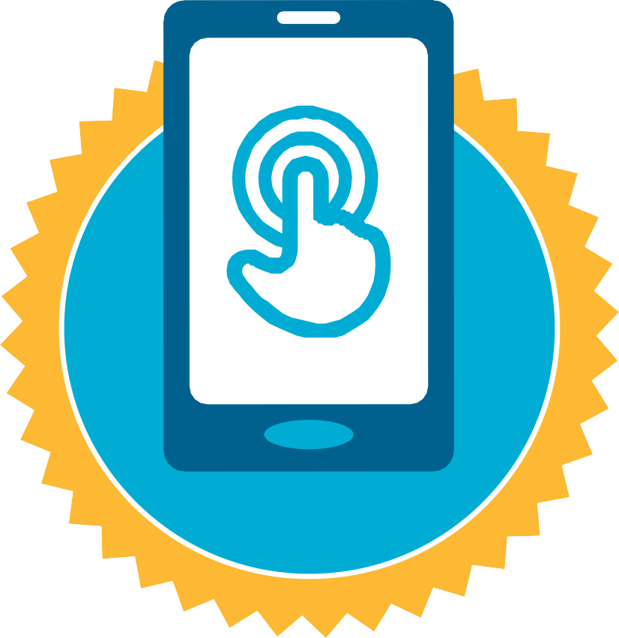

**CERTIFICATE**

has completed

**BASIC MOBILE INTERNET SKILLS**

training

Date Signed