

Connected Society

Mobile Internet Skills Training Toolkit

A guide for training people in basic mobile internet skills

Copyright © 2017 GSM Association

case.

**7**

**MODULE 7 – ONLINE SAFETY**

**Module 7 – Online   
Safety**

# In- Depth Training

**MODULE 7 - ONLINE SAFETY**

|  |  |
| --- | --- |
| Learning Objectives   * Trainees have a basic understanding of online safety * Trainees understand that online safety has important implications for children | 45-60  45-60 minutes |

**Materials you**

will need:

|  |  |  |
| --- | --- | --- |
| Smartphone or KaiOS  Handset | Graphical user interface, application  Description automatically generated  Safety Tips | Diagram  Description automatically generated  Safety Posters |
| Active Airtime Access  (mobile SIM or Wi-Fi) |
| Small Rewards |

**MODULE 7 – ONLINE SAFETY**

MODULE 7 – ONLINE SAFETY

**MODULE 7 - ONLINE SAFETY**

INTRO / DEALING WITH UNSOLICITED CONTACT / INAPPROPRIATE CONTENT

PARENTAL CONTROLS / RELIABLE INFORMATION / REPORTING CONTENT / RECAP

 Introduce Safety

**Give a short explanation of what safety is and why   
it matters**

**Explain:**

“There are many great things that you can use the internet

for, but it is important to remember that anyone can use the

internet around the world. It is important to treat it like a

real-life public place (e.g. a market place) and stay safe.”

“There are lots of ways that you can stay safe when using

the internet. All phones and apps have ‘settings’ which you

can change to make sure that you are safe!”.

|  |  |
| --- | --- |
| **Bring the benefits to life!**   * Tell your own story of how you (the trainer) have stayed safe when using the internet. This could also include examples from your friends and family.   **Some examples might include:**   * Blocking unknown numbers on WhatsApp if they seem dangerous or malicious. * Using the ‘back’ button when finding an unsuitable video on YouTube. * Changing the privacy settings in Facebook so that your profile is only accessible by ‘Friends’. * Setting up a PIN / passcode on your device so that people cannot access your phone if it is stolen. Changing the privacy settings in the phone operating system (e.g. Android or KaiOS). * Keeping your mobile money PIN safe to prevent fraud. | **Make safety relevant**  **Discuss with the trainees how** staying safe when using the internet is important:  **Ask:**  • “What are the main  things you like (or want)  to do on the internet?”  Give them some  suggestions based on  their interests.  • “Are there things that  worry you when you  are using the internet?”  Trainer to help the trainee understand how they can  be safe in these areas. |

MODULE 7 – ONLINE SAFETY

**MODULE 7 - ONLINE SAFETY**

INTRO / DEALING WITH UNSOLICITED CONTACT / INAPPROPRIATE CONTENT

PARENTAL CONTROLS / RELIABLE INFORMATION / REPORTING CONTENT / RECAP



Dealing with unsolicited contact

**Explain:**

* “The internet helps you to send messages to your friends and family. You can even send messages to people on the other side of the world that you haven’t met before! However, this means sometimes that people may send you messages that you don’t want to receive.”
* “It is really important to teach children how to keep themselves safe when using messaging services (e.g. WhatsApp). If children are using the internet then people can send them bad messages. You can help to protect them by teaching them how to keep their information private and block unwanted contact.”
* “On your phone or on the internet you are able to stop any unwanted messages   
  you receive.”

**Ask** the trainee what is the main way they send messages to other people when using the internet.

**Demonstrate** on how to block unwanted messages in following programmes steps on poster/ their phone: **WhatsApp, Gmail** and **Facebook**.

**Show posters for blocking**

**on WhatsApp, Gmail and**

**Facebook**

**MODULE 7 - ONLINE SAFETY**

MODULE 7 – ONLINE SAFETY

INTRO / DEALING WITH UNSOLICITED CONTACT / INAPPROPRIATE CONTENT

PARENTAL CONTROLS / RELIABLE INFORMATION / REPORTING CONTENT / RECAP

**Explain:**

* “You can also take steps to manage who sees your ‘posts’ on social media. If you only want your close friends or family to see something you limit other people seeing what you have put there.”
* “Remember that the internet is a public place and you cannot always control what happens to content once you have shared it. You should only post things that you are happy for other people to see.”
* “Remind your children that if they wouldn’t want their head teacher or grandmother to see something, they should not risk posting it!”

**Tip:** You can help trainees to change privacy settings on Facebook by looking

at the Facebook module on p.106.

 Inappropriate Content

**Explain:** “The internet is very useful and interesting and can help you in many ways. You must be careful - because anyone can write anything or add pictures or videos, it means that sometimes bad things are on the internet.”

“There are ways to help keep you and your family are safe when you are using the internet. You can control what you see on your phone and make sure other people who use your phone – including any children – are safe.”

**Explain:** “We are now going to learn how you can see the different websites that you have looked at in the past on Google Chrome.”

“Every time you visit a website Google Chrome will keep a record of it – it is like the phone is writing everything down in a big book. If anyone uses your phone – for example your children – it will record which webpages they look at as well.”

**Show poster accessing browsing history on Chrome**

**Demonstrate** how trainees can look at their ‘browsing history’ of all   
the websites that have been visited on their phone on Chrome using   
the poster / the trainees’ phone(s). Show them how they can ‘search’   
the history if they want to or ‘clear browsing history’.

**Explain:** “If you are sharing a phone with your family you might want to turn on SafeSearch. This means that Google Chrome will show you websites that are suitable for the whole family.”

**MODULE 7 – ONLINE SAFETY**

**MODULE 7 - ONLINE SAFETY**

INTRO / DEALING WITH UNSOLICITED CONTACT / INAPPROPRIATE CONTENT

PARENTAL CONTROLS / RELIABLE INFORMATION / REPORTING CONTENT / RECAP

  
 Parental Controls on Play

**Explain:**

• “The internet has things that are not suitable for children. Like in normal life, some things are not good for children on the internet.”

• “If there are children that use your phone, you can do some simple things so that they   
see good things.”

**Demonstrate** how to turn on ‘Parental Controls’ on the Google Play Store.

**  
  
  
Show poster explaining parental controls in play store**

Explain that ‘Parental Controls’ means that children will  
not be able to download apps or games that are for adults.  
They will also only find videos and music in the Play Store  
that are good for children.”

Tip: It is possible to set up Android so that parents are able to control what

is on their children’s phone. Explain to trainees that this is possible if they are

interested.

MODULE 7 – ONLINE SAFETY

**MODULE 7 - ONLINE SAFETY**

INTRO / DEALING WITH UNSOLICITED CONTACT / INAPPROPRIATE CONTENT

PARENTAL CONTROLS / RELIABLE INFORMATION / REPORTING CONTENT / RECAP

  
  
 Reliable Information

**Explain:** “The internet has so many pieces of news, photos, videos and of music – you will never run out! However, it is important to remember that not everything that is on the internet can be trusted.”

“The internet is a public place – like a market - and it is important to act in the same way. You cannot trust everything that people tell you or that you see.”

“If you have children remember that they will need your help to understand what is good or bad. You can help them understand.”

**  
  
Give your trainees the poster explaining the 5 key tips for spotting false information online.**

Not everything on the internet is what it says it is. Be careful!

People can make fake versions of a website or an app to make it look like a good company (e.g. your phone company) or organization (e.g. your government). If you are unsure, ask someone you trust!

People sometimes put false information on the internet   
(e.g. WhatsApp or Facebook). Don’t share something with   
other people without thinking first!

If you hear some news on from the internet, you might   
want check this by checking on other sites (e.g. trusted   
news sites like BBC).

If you think something you see is dangerous or bad, you   
can ‘report’ it so the company (e.g. YouTube) knows there   
is a problem.

**Discuss** with your trainees what these tips mean for using the internet.

Bring the tips to life by using examples that are relevant for your trainees based on your experience. For example, parents may be more concerned about how to help their children avoid incorrect information.

MODULE 7 – ONLINE SAFETY

**MODULE 7 - ONLINE SAFETY**

INTRO / DEALING WITH UNSOLICITED CONTACT / INAPPROPRIATE CONTENT

PARENTAL CONTROLS / RELIABLE INFORMATION / REPORTING CONTENT / RECAP

  
  
 Reporting Content on YouTube or Facebook

**Explain:** “If you think that something on the internet is dangerous to you or your

family, you can ‘report’ it to Facebook or YouTube or other internet services. This

means that you are telling them something is bad and they need to look at it.”

**Explain:** “You might want to report something because it is violent, it involves

terrorism, it might put someone in danger – especially children – or because it is

too sexual.”

**Ask:** If they want to learn how to ‘report’ something on YouTube or Facebook.

**Demonstrate** how to report content on YouTube or Facebook using the steps on

the posters.

**Show posters for reporting**

**content on YouTube or**

**Facebook**

MODULE 7 – ONLINE SAFETY

**MODULE 7 - ONLINE SAFETY**

INTRO / DEALING WITH UNSOLICITED CONTACT / INAPPROPRIATE CONTENT

PARENTAL CONTROLS / RELIABLE INFORMATION / REPORTING CONTENT / RECAP

Recap on Safety

**Discuss** with your trainees what they have learned about safety during this session.

“What have you learned about safety when using the internet?”

• Prompt if required: ‘blocking’ people on messaging platform, dealing with

inappropriate content, knowing what to trust on the internet.

• What do you want to use Google Search for in your own life? What are you most interested   
in and excited about using it for?

• Key lessons are recapped.

• **Ask:** “Do you still have any concerns about staying safe when using the internet?”

• More advanced ideas are suggested for those that are particularly interested.

Tip: If appropriate, run the recap as a quiz and give rewards (e.g. sweets) to

trainees for playing.

**Going to the next level**If you reach the end of the session and have extra time:

**Ask:** “Do you have any further questions about safety?”

**Ask:** “What else would you like to know about staying safe on the mobile

internet?”

Potential areas to discuss, depending on what you or the trainee are interested in,

include:

• Common financial scams in your local area

• Learning to understand if a website is trustworthy (e.g. the ‘padlock’ icon)

• Why downloading apps, music or videos from a computer or memory stick can be dangerous.

• How to delete your Google Account from a computer or another phone if it is stolen

• What is a ‘virus’? Using antivirus software to remove a ‘virus’ from your phone or computer.

MODULE 7 – ONLINE SAFETY

**Posters, Cut-outs and**

**Info-sheets**

Icon Cutouts – Online Safety



Icon Cutouts - Online Safety



**How to ‘block’ on Gmail**

**1 2 3**

**Accessing Search History in Chrome**

History

### Icon Description automatically generatedDiagram, schematic Description automatically generatedSetting up Parental Controls on Play Store

History

Type PIN

Parental controls

Off

### Icon Description automatically generatedDiagram, text, whiteboard Description automatically generatedReporting a page on Facebook

### Icon Description automatically generatedDiagram Description automatically generatedHow to ‘block’ on Facebook

Privacy shortcuts

Blocking

ADD TO BLOCKED LIST

Type a name or email address

### Icon Description automatically generatedDiagram, schematic Description automatically generatedReporting a video on YouTube

Sexual content

Report

**False information**

**Be careful!**

**Report it**

**Check**

**Other sites**

**Don’t share**

**something**

**with other**

**people without**

**thinking first!**

**If you are unsure,**

**Ask someone**

**You trust!**



**CERTIFICATE**

has completed

**BASIC MOBILE INTERNET SKILLS**

training

Date Signed

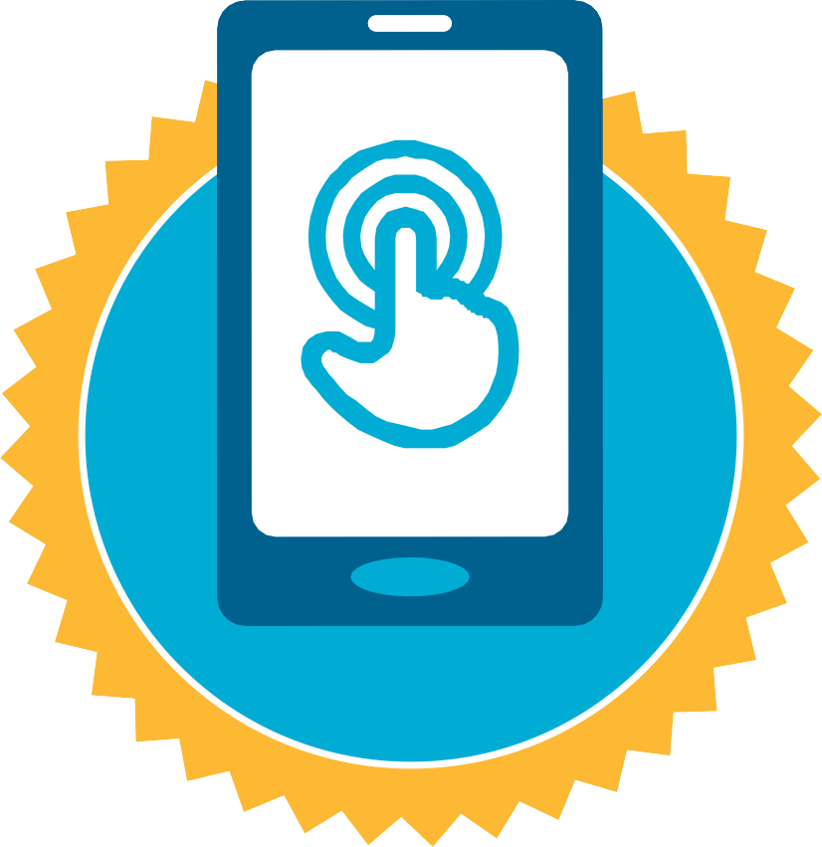

**CERTIFICATE**

has completed

**BASIC MOBILE INTERNET SKILLS**

training

Date Signed