Connected Society
Mobile Internet Skills Training Toolkit
A guide for training people in basic mobile internet skills

Copyright © 2017 GSM Association

case.

5

MODULE 5 - WIKIPEDIA

Module 5 - Wikipedia

Bitesize Training

BITESIZE - WIKIPEDIA

What is it?

Show Wikipedia on the phone

“Wikipedia is a free internet reference (or encyclopaedia), which provides neutral, factual information about educational topics. It is often the first site to appear when you do a Google search, or you can type the word “wiki” along with the words you are searching for.”

“Wikipedia is written by ordinary people, all over the world. People make changes to the site every hour. You can make sure the information you find is reliable by looking at the bottom of every page, where the sources of information are listed.”

Materials you will need

Smartphone Handsets

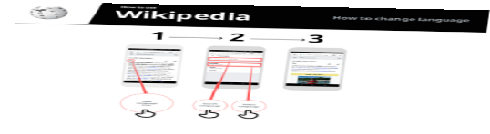
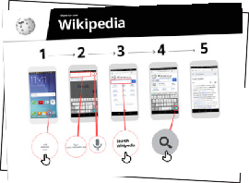
WhatsApp Posters

What can you use it for?

“You can use Wikipedia to search many different subjects. For example, you can search for information about sports, music, history, other countries or science.”

“Wikipedia is available in almost 300 languages. Each
is written by people who speak that language, so some Wikipedias have more articles than others. For example, the Kinyarwanda Wikipedia 2,000 articles, but there are more than 5 million articles on the English Wikipedia.”

Explain: Trainer to include their own personal examples of the benefits of Wikipedia and what they use it for.

Make it relevant to the trainee: discuss how it can be beneficial in the trainee’s own life.
BITESIZE – WIKIPEDIA

BITESIZE - WIKIPEDIA

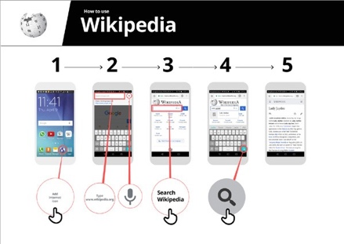
How does it work?
Put the phone in the trainee’s hands and help them

follow the steps
How to use Wikipedia
Show the poster and go through the steps for searching for a Wikipedia article
(e.g. Rwanda, music or World Cup).
BITESIZE – WIKIPEDIA

BITESIZE - WIKIPEDIA

Practise!

“Now you know how to use Wikipedia, what do you want to use it for?”

Trainer: Provide support for the trainee to search for a Wikipedia article on their phone.

Explain: You may find that Wikipedia appears when you use another service, like Google or Yahoo, to search the internet. Often Wikipedia is the first result of a search. You can often look at Wikipedia first to get an overview of a topic, and then explore through the references to find more reliable information.”
Tip: “Wikipedia is available in almost 300 languages. Each is written by people who speak that language, so some Wikipedias have more articles than others. For example, the Swahili language Wikipedia has around 35,000 articles. There are more than 5 million articles on the English Wikipedia.”

BITESIZE – WIKIPEDIA

Posters, Cut-outs and
Info-sheets

Icon Cutouts - Wikipedia

Icon Cutouts - Wikipedia

Icon Cutouts - Wikipedia
Google
How to use

.,/
•

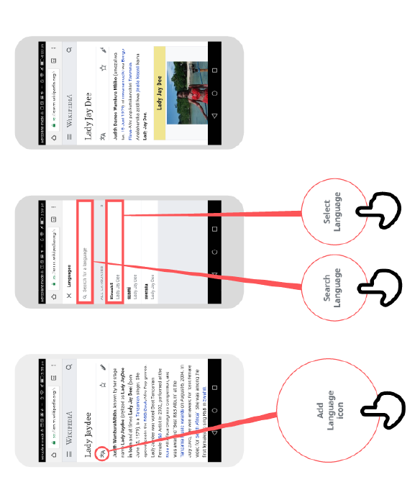
1 2 3

Add
Language
Icon
Select
Language
Search
Language

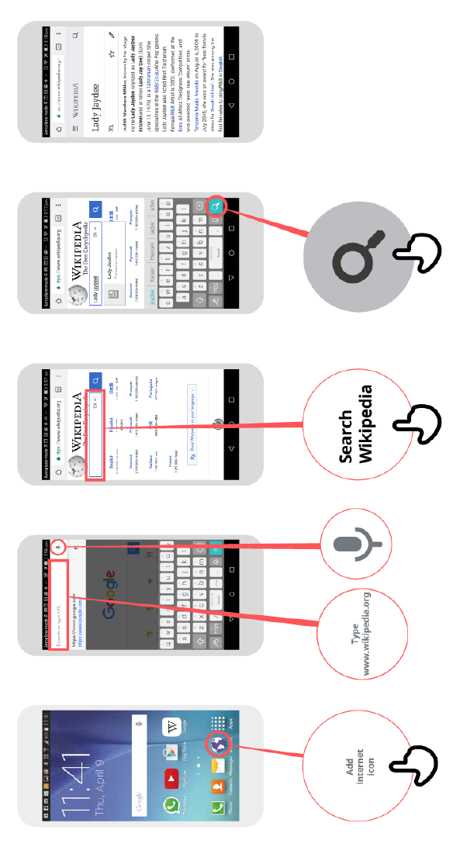
.,/
•

CERTIFICATE

has completed
BASIC MOBILE INTERNET SKILLS
training

Date Signed

CERTIFICATE

has completed
BASIC MOBILE INTERNET SKILLS
training

Date Signed

