Connected Society
Mobile Internet Skills Training Toolkit
A guide for training people in basic mobile internet skills

Copyright © 2017 GSM Association

case.

5

MODULE 5 - WIKIPEDIA

Module 5 - Wikipedia

In-
Depth Training

MODULE 5 - WIKIPEDIA

45-60

Time Duration:
Learning Objectives
- The trainees know how to use Wikipedia to access free knowledge and information
- The trainees understand that Wikipedia is created by people all over the world, and feel excited about using it to learn new things
45-60mins

Materials you will need:
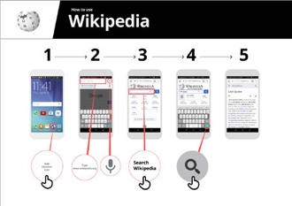
MODULE 5 – WIKIPEDIA
Pens, Paper and
Masking Tape
Smartphone
Handsets
Small Rewards
Wikipedia
Poster x 1
Data Costs
Glossary Handouts
Cost Poster
Safety Tips
Icon Cut-outs

Be polite and respectful to people

Tell someone you know and trust, if you feel uncomfortable about anything you see
or experience

Keep your personal information private

‘Block’ or ignore people you don’t know, or who are bothering you.

Easy tips for internet safety

Google is an internet service that makes it easy to find any information that you want to find on the internet
phone smartphone
Feature A mobile phone that has the ability to access the internet and
store and play music but lacks the advanced functionality of a
do with phone credit
Whenever you use the internet on your phone, you are using data.
Data You can buy data from your mobile network provider, just like you
Google Chrome Mozilla Firefox Opera Microsoft Internet
Explorer
A web browser, or simply “browser,” is an application used to
Browser access and view websites. Common web browsers include;
- Ads can be videos or images that pop up on your screen
- Ads can also be the links at the top of Google results and on
the right side of the screen.
or Ad
An ad is a piece of information that is trying to sell you something. It
Advert is good practice to avoid clicking on ads
www.india.in e.g. www.google.in
In the address bar there will always be the address of the website
Address bar The address bar shows you what website you are on.
services e.g. WhatsApp, Facebook, Google, apps provide a quick
An app gives you a shortcut to a service on your phone. For internet
App and easy way to get onto the internet to use that service
The internet can run at different speeds when you use it. 2G internet
2G / 3G / 4G is the slowest, 3G internet is faster and 4G internet is the fastest
Definitions
Trainers can add to this section to include local relevant information on the mobile internet
Buy Now!

INTRO / BASE USE / EVALUATING INFORMATION / SAFETY / COST / RECAP

MODULE 5 - WIKIPEDIA
Introduce Wikipedia
Show the trainees the Wikipedia logo cut-out
Ask Does anyone know what Wikipedia is?” “What is it used for?”
Explain that trainees can access Wikipedia by searching through Google. Ask them to open Google and search for ‘Wikipedia’
Give a short explanation of Wikipedia  - “Wikipedia is a free internet reference (or encyclopedia), which provides neutral, factual information about educational topics.”  - “Wikipedia is a website. It is often the first site to appear when you do a Google search, or you can type the word “wiki” along with the words you are searching for.  - “Wikipedia is written by ordinary people, all over the world. People make changes to the site every hour. You can make sure the information you find is reliable by looking at the bottom of every page, where the sources of information are listed.” |  | Bring the benefits to life!  - Tell your own story of how Wikipedia is beneficial to you (the trainer), your friends and family. For example, you may use it to help a child with his or her homework, to find the answer  to a question about geography or science. Offer specific examples.  - Ask trainees to share topics they are most interested in. The answers  could be a sports team or game, pop culture interests, or current events.
Remember: Link discussions and activities in the training back to how the internet can be helpful in your trainees lives. This will help to keep the training relevant and interesting for them.

Make Wikipedia relevant for your trainees
  - Discuss with the trainees how Wikipedia might benefit their own lives.
- Ask “What questions would you like to answer using Wikipedia?” Give them some suggestions based on their interests.
  - Sports (e.g. the Olympic Games, the World Cup)
  - Pop culture (e.g. Urban Boyz)
  - History (e.g. Rwanda)
  - Learn about other countries (e.g. U.S.A)
  - Science (e.g. Solar Eclipse)
MODULE 5 – WIKIPEDIA
INTRO / BASE USE / EVALUATING INFORMATION / SAFETY / COST / RECAP

MODULE 5 - WIKIPEDIA
Activity: Basic use of Wikipedia

Get practical!
Explain “Now, we are going to try using Wikipedia on the phone!”

Show the ‘How to use Wikipedia’ poster
- Explain “This poster shows the steps for using Wikipedia to search for information.”
- Take your trainees through the steps on their shared phones and do a simple search for their favourite musician (e.g. Urban Boyz).

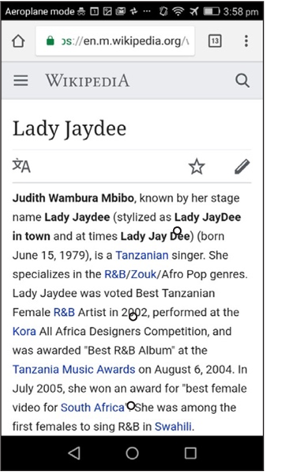
  - Explain what your trainees are looking at:
- Each page begins with a summary of the thing you have searched for.
- As you read further down the page, you will discover more details, including history, politics, or other people connected.
- Each fact has a number at the end. This matches the number of a “Reference” at the bottom of the page, which is where the information came from.
Ask “Have you got any questions about what you are looking at here?”

Show trainees how to learn more about topics.
- Explain “Wikipedia is organised by topic. This page is about Urban Boyz, but
there is a different page for Rwandan music, and another page about Afropop music.”
- “From any Wikipedia page, you can go directly to other pages because all of the blue words are links.”
- “Clicking on a blue word will take you to another Wikipedia page, with more information about the word.”
- Ask your trainees to click on any of the words in the page about Afropop and then share what they find.
MODULE 5 – WIKIPEDIA
INTRO / BASE USE / EVALUATING INFORMATION / SAFETY / COST / RECAP

MODULE 5 - WIKIPEDIA
Activity: Checking Information

- Discuss with your trainees how Wikipedia can help them in their lives.
Explain “Wikipedia is written by people all over the world. Anyone can add to an article, or update information. Anyone who edits Wikipedia has to explain where the information came from. So you can check for yourself to see whether what you read is true.”
Ask your trainees to search for the Wikipedia page ‘Tanzania’ and then scroll down to the references on the bottom of the page.

Activity: Personal searches
- Ask your trainees to practise searching for information about the following topics within Wikipedia:
- Type ‘Rwanda’ into the search bar.
- Type the name of the nearest large city into the search bar.
- Invite your trainees to type a topic into the search box that is relevant to their interests (e.g., sports players, hobbies, professions).
Tip: Encourage your trainees to click through the blue words on each article to find more information that is interesting to them.

- Wikipedia is available in multiple languages.
Explain “Wikipedia is available in almost 300 languages. Each is written by people who speak that language, so some Wikipedias have more articles than others. For example, the Kinyarwanda Wikipedia 2,000 articles, but there are more than 5 million articles on the English Wikipedia.”
Show your trainees the “Read in another language” button at the top of the page.
MODULE 5 – WIKIPEDIA
INTRO / BASE USE / EVALUATING INFORMATION / SAFETY / COST / RECAP

MODULE 5 - WIKIPEDIA

Safety

Ask “What does safety mean to you?”
Ask your trainees to imagine they are in a typical public place, like the market. Ask them to discuss what they would do to keep safe in this place. Prompt them with the following questions and answers:

Prompts | Potential Answers
What do you do if someone you don’t know bothers you? | You avoid or ignore them  Be careful – they are not always who they say they are.
What do you do if someone you don’t know or trust asks you for your personal information? | You don’t give out personal information to someone you don’t know or trust because they may misuse it.
What do you do if you feel unsure or uncomfortable about something you see or experience? | Tell someone you know and trust about what happened.
How do you treat people you interact with? | You are polite and respectful to people.

Explain “It is important to remember the internet is also public place, and it is important to treat it like a public place and stay safe.”

Safety on Wikipedia
Ask “Is there anything that you are concerned about when using Wikipedia?”
Ask “If you click on something in Wikipedia and you see or open something you think is bad or offensive, what can you do next?”
Explain and demonstrate for your trainees “You can press the back button, and click on other links within Wikipedia.”
MODULE 5 – WIKIPEDIA

$ Cost
INTRO / BASE USE / EVALUATING INFORMATION / SAFETY / COST / RECAP

MODULE 5 - WIKIPEDIA

If you have already covered cost in the previous modules, only use this as a recap.

Explain “Now you know how to use Wikipedia, and what it can be used for, let us talk about how much it costs to use! To use the internet on your mobile, you have to buy data from your mobile network provider, just like you do with phone credit”.

Checking Data
Show the ‘Cost’ poster
- Explain “Different activities use different amounts of data. Looking at text uses the least amount of data, looking at images uses more, playing and downloading music uses a bit more and playing videos uses the most.”
Data Costs
- Explain “Some internet services are linked to activities that use more data.”
- Ask ““Where is Wikipedia on the poster? What does that mean for how much it tends to cost?”

  - Ask “Why is it useful to check how much data you have used?”
Tip: The data checking process varies depending on which country you are in
and which network the phone is on. Ask a mobile agent if you need support with how to check data.
  - Answer: “To understand how much of your data you have used up and how much different activities cost to do.”
  - Explain “You can check how much data you have, just like you check how many minutes or texts you have by typing in a code on your phone from your mobile network.”
  - Explain “You can buy data in different amounts depending on what you are going to use the internet for. Ask advice from your local mobile agent on which amount is best suited to you.
  - Explain “if you access the internet in a Wi-Fi zone, you will not use your data package. Your local mobile agent may be able to help you find your local Wi-Fi zones. However, the nearest zone may be too far to travel to.
  - Demonstrate to your trainees how to check their data.
MODULE 5 – WIKIPEDIA

INTRO / BASE USE / EVALUATING INFORMATION / SAFETY / COST / RECAP

MODULE 5 - WIKIPEDIA

Recap

Play the Wikipedia icon game
    - Hold up each Wikipedia icon, one at a time.
    - Ask “What does this do on Wikipedia?”
    - Explain to your trainees what each icon is, if they need support.
    - Give small rewards small rewards (e.g. sweets) for correct answers and stick the icons on the wall afterwards to help remind your trainees what they are.

Explain: You may find that Wikipedia appears when you use another service, like Google or Yahoo, to search the internet. Often Wikipedia is the first result of a search. You can often look at Wikipedia first to get an overview of a topic, and then explore through the references to find more reliable information.”

Recap on Wikipedia
Discuss with your trainees what they have learned about using Wikipedia
- “How would you describe Wikipedia to a friend or family member?”
- “Do you still have any concerns about using Wikipedia?”
- “What personal or professional use could you have for Wikipedia?”
- “What are you most excited to explore on Wikipedia?”

MODULE 5 – WIKIPEDIA
Tip: If trainees would like to explore Wikipedia on their own phones, give them some time here to practise what they have learned and offer support and encouragement.

MODULE 5 - WIKIPEDIA
INTRO / BASE USE / EVALUATING INFORMATION / SAFETY / COST / RECAP

Recap

Going to the next level
If you reach the end of the session and have extra time:
- Ask “Do you have any further questions about anything we have covered in the session?”
- Ask “What else would they like to know about the mobile internet?” Some more advanced features you can discuss with your trainees include:
- Download the Wikipedia App. Explain, “You can search directly in Wikipedia by going to the app.”
- To discuss: Are there additional features/questions we want to cover?
MODULE 5 – WIKIPEDIA

Posters, Cut-outs and
Info-sheets

Icon Cutouts - Wikipedia

Icon Cutouts - Wikipedia

Icon Cutouts - Wikipedia
Google
How to use

.,/
•

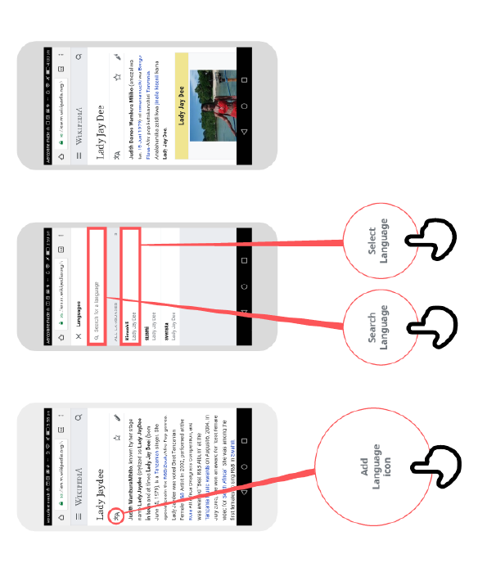
1 2 3

Add
Language
Icon
Select
Language
Search
Language

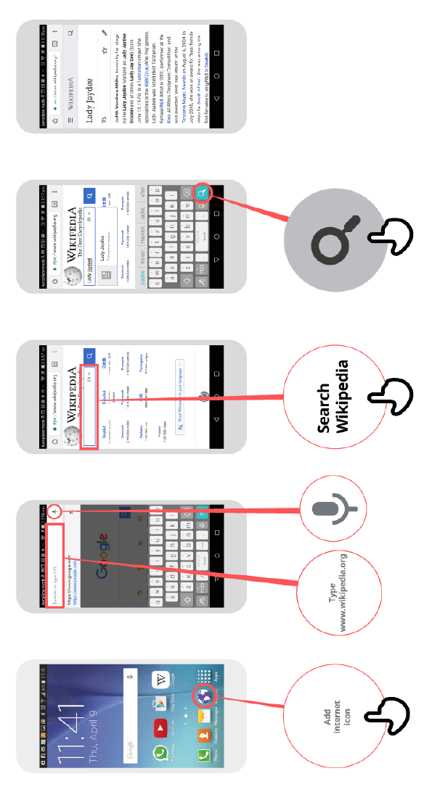
.,/
•

CERTIFICATE

has completed
BASIC MOBILE INTERNET SKILLS
training

Date Signed

CERTIFICATE

has completed
BASIC MOBILE INTERNET SKILLS
training

Date Signed

