Connected Society
Mobile Internet Skills Training Toolkit
A guide for training people in basic mobile internet skills

Copyright © 2017 GSM Association

case.

3

MODULE 3 - YOUTUBE

Module 3 - YouTube

In-
Depth Training

MODULE 3 - YOUTUBE

45-60

Time Duration:
Learning Objectives
- Trainees know how to use YouTube to access videos and music
- Trainees understand the range of content available and feel excited and motivated about accessing relevant content on YouTube
45-60mins

Remember: YouTube may not be available to use in all locations due to connectivity issues. In these instances, we suggest either not doing the YouTube module, or using another audio/visual application that requires less data to run.
Alternatively, you can change the YouTube account settings on the phone so that it plays videos using a lower bandwidth. Additionally, you can download YouTube videos to play offline, by clicking on the icon under the video.

Materials you will need:
Pens, Paper and
Masking Tape
Smartphone
Handsets
Small Rewards
YouTube
Poster x 1
Glossary Handouts
Icon Cut-outs
MODULE 3 - YOUTUBE
Safety Tips
Cost Poster
Data Costs

Be polite and respectful to people

Tell someone you know and trust, if you feel uncomfortable about anything you see
or experience

Keep your personal information private

‘Block’ or ignore people you don’t know, or who are bothering you.

Easy tips for internet safety

Google is an internet service that makes it easy to find any information that you want to find on the internet
store and play music but lacks the advanced functionality of a
phone smartphone
A mobile phone that has the ability to access the internet and
Feature
do with phone credit
Whenever you use the internet on your phone, you are using data.
Data You can buy data from your mobile network provider, just like you
Google Chrome Mozilla Firefox Opera Microsoft Internet
Explorer
A web browser, or simply “browser,” is an application used to
Browser access and view websites. Common web browsers include;
- Ads can be videos or images that pop up on your screen
- Ads can also be the links at the top of Google results and on
the right side of the screen.
or Ad
Now!
An ad is a piece of information that is trying to sell you something. It
Advert Buy is good practice to avoid clicking on ads
Address bar The address bar shows you what website you are on.
In the address bar there will always be the address of the website
www.india.in e.g. www.google.in
An app gives you a shortcut to a service on your phone. For internet services e.g. WhatsApp, Facebook, Google, apps provide a quick and easy way to get onto the internet to use that service
App
The internet can run at different speeds when you use it. 2G internet
2G / 3G / 4G is the slowest, 3G internet is faster and 4G internet is the fastest
Definitions
Trainers can add to this section to include local relevant information on the mobile internet
Search YouTube
5
4
How to use
YouTube
1 2 3

INTRO / BASE USE / MULTIPAL WORD SEARCH / PERSONAL SEARCHES / SAFETY / COST / RECAP

MODULE 3 - YOUTUBE

Introduce YouTube

Show the trainees the YouTube icon and ask them to find this on the phone
Ask “Does anyone know what this is?” “What is it for?”
Give a short explanation of YouTube  - “YouTube lets you watch videos, like TV, but you have more videos to choose from, and you can also choose what videos to watch and when to watch them.”  - “You tell YouTube what kind of videos you want to find, and it will search through all the videos that people have put on YouTube, to find the kinds of videos that you want.”  - “You can watch lots of different videos; movies, songs, news, sports, recipes, and educational ones. There are also lots of ‘how to’ videos e.g. how to learn a language, how to do a dance, how to cook a recipe, how to fix a tyre on a bicycle and others.”  - “You can also create your own videos and share them on YouTube.” |  | Bring the benefits to life!  Tell your own story of how YouTube has helped you (the trainer), your friends and family. Some examples might include:  - Watching music, songs, learning a new skill, improving a skill, creating your own video  - Give specific examples or stories of how YouTube can be used
Make YouTube relevant for your trainees
Discuss with your trainees how YouTube can be beneficial in their own lives:
- Ask What could you learn to use YouTube for in your own life?” Give them some suggestions based on their interests.
- Ask “What are you most interested in and excited to learn about?”
MODULE 3 – YOUTUBE
Remember: Link discussions and activities in the training back to how the internet can be helpful or useful in your trainees own lives. This will help to keep the training relevant and interesting for them.

MODULE 3 - YOUTUBE
INTRO / BASE USE / MULTIPAL WORD SEARCH / PERSONAL SEARCHES / SAFETY / COST / RECAP

Activity: Basic use of YouTube

Get practical!
Explain “You are now going to try using YouTube on the phone.”

Show the ‘How to use YouTube’ poster

  - Explain “This poster shows the steps for using YouTube to search for videos.”

How to use
YouTube
1 2 3 4 5

Search YouTube
- Take your trainees through the steps on their shared phones for a simple YouTube search.

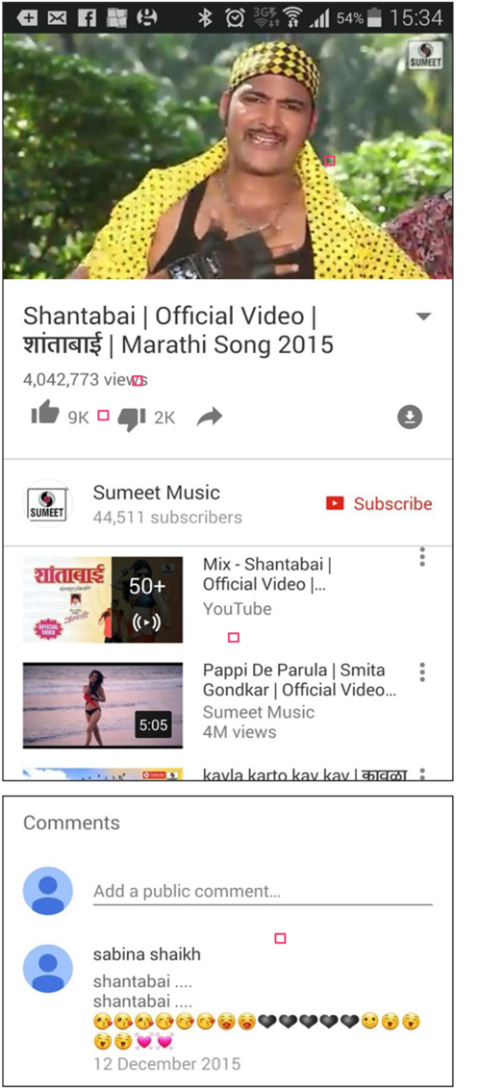
Show the result page for a popular video
  - Explain what your trainees are looking at:
- “The image at the top is the video – you can tap on it to make it play or pause.”
- “This is the number of times the video has been viewed by people on YouTube and can give you an indication of how popular it is.”
- “You can ‘like’ or ‘dislike’ the video by clicking on the thumb icons. The number next to each shows how many people have liked and disliked it.”
- “These are links to other videos you can play that are similar.”
- “When you scroll down to the bottom, you see a ‘comments’ box, where people have written
comments about the video. You can add your own comment here about the video!”
Ask “Have you got any questions about what you are looking at here?”
MODULE 3 – YOUTUBE

MODULE 3 - YOUTUBE
INTRO / BASE USE / MULTIPAL WORD SEARCH / PERSONAL SEARCHES / SAFETY / COST / RECAP

Activity: Basic use of YouTube

Hold up the microphone icon for YouTube
- Explain “The microphone can be used so that you do not have to type any text. When you can’t spell or write the words you want to search, you can just tell YouTube the words you want to search for.”
- Demonstrate where to find it: “Click in the search box and the microphone will appear on the right.”
- Demonstrate how to use it: “Press the microphone icon and speak loudly, clearly and slowly.”
- Ask your trainees to search for ‘Shantabai’ using the microphone.
Ask your trainees to practise searching for videos with the following exercises:
MODULE 3 – YOUTUBE
- Type the name of a popular local song into the YouTube search box and play it.
- Type a local famous location into the search box and play it.
- Give your trainees one word to type into the search box that is relevant to them e.g. ‘recipes’, ‘jobs’, ‘farming’, and play the results.

INTRO / BASE USE / MULTIPAL WORD SEARCH / PERSONAL SEARCHES / SAFETY / COST / RECAP

MODULE 3 - YOUTUBE

Activity: Multiple word search

Explain “We are now going to try a more detailed search by using more search words – this can be helpful to find the videos you want.”
Ask your trainees to practise searching for videos by putting different combinations of two to three words into the YouTube search box. They can do this using the microphone or by typing in text. Give your trainees different words to combine, based on what they searched for earlier. For example:
  - “Indian”, “Recipes”, “Marathi”
  - “Jobs”, “Pune”, “Marathi”
Tip: Give your trainees plenty of time to explore different results and different word combinations.
Activity: Personal Searches

Discuss with your trainees how YouTube can help them in their own lives
- Ask “Now you know how to use YouTube, what do you want to use it for in your own life?” Give them some suggestions based on their interests.
- Discuss with your trainees what words they can use to search according to their interest (keep your search word suggestions simple, and use only 1-2 words).
- Ask each trainee to take turns using the phone to search for videos they are interested in and ask the other trainees to support them with this.
- Ask “What videos do you want to search for next?”

MODULE 3 – YOUTUBE
Tip: “There is a lot of great information on the internet, but also some which is not so great, and some that is not completely truthful. It is always best to look at 2-3 results to get the best answer to what you are looking for.”

INTRO / BASE USE / MULTIPAL WORD SEARCH / PERSONAL SEARCHES / SAFETY / COST / RECAP

MODULE 3 - YOUTUBE

Safety

Ask “What does safety mean to you?”
Ask your trainees to imagine they are in a typical public place, like the market. Ask them to discuss what they would do to keep safe in this place. Prompt them with the following questions and answers:

Prompts | Potential Answers
What do you do if someone you don’t know bothers you? | You avoid or ignore them  Be careful – they are not always who they say they are.
What do you do if someone you don’t know or trust asks you for your personal information? | You don’t give out personal information to someone you don’t know or trust because they may misuse it.
What do you do if you feel unsure or uncomfortable about something you see or experience? | Tell someone you know and trust about what happened.
How do you treat people you interact with? | You are polite and respectful to people.

Explain “It is important to remember the internet is a public place, and it is important to treat it like a public place and stay safe.”
MODULE 3 – YOUTUBE

INTRO / BASE USE / MULTIPAL WORD SEARCH / PERSONAL SEARCHES / SAFETY / COST / RECAP

MODULE 3 - YOUTUBE

Safety

Give your trainees the ‘Safety tips’ handout
Easy tips for internet safety
‘Block’ or ignore people you don’t know, or who are bothering you. | Keep your personal information private
Tell someone you know and trust, if you feel uncomfortable about anything you see  or experience | Be polite and respectful to people

  - Discuss with your trainees what these tips mean for using the internet.
  - Bring the tips to life by using examples that are relevant for your trainees. For example, women may be more concerned about how to prevent harassment.

YouTube Safety
  - Ask “Is there anything that you are concerned about when using YouTube?”
  - Ask “If you are looking at videos on YouTube and you see one that you think is bad or offensive, what can you do next?”
  - Explain and demonstrate for your trainees “You can press the back button, delete the words in your search box and refine your search by using different words.”
MODULE 3 – YOUTUBE
Tip: “You are in control of what you search for – you can search for good things or you can search for bad things. It is your responsibility to search for good things.”

$ Cost
INTRO / BASE USE / MULTIPAL WORD SEARCH / PERSONAL SEARCHES / SAFETY / COST / RECAP

MODULE 3 - YOUTUBE

Explain “Now you know how to use YouTube, and what it can be used for, let us talk about how much it costs to use! To use the internet on your mobile, you
have to buy data from your mobile network provider, just like you do with phone credit.”

Show the ‘Cost’ poster
Data Costs
  - Explain “Different activities use different amounts of data. Looking at text uses the least data, looking at images uses more, playing and downloading music uses a bit more and playing videos uses the most.”
  - Explain “Some internet services are linked to activities that use more data.”
  - Ask “Which service tends to cost more to use?”
Answer YouTube. Watching videos on YouTube tends to use a lot of data.”

Checking Data
- Ask “Why is it useful to check how much data you have used?” Answer “To understand how much of your data you have used up and how much different activities cost to do.”
Tip: The data checking process varies depending on which country you are in
and which network the phone is on. Ask a mobile agent if you need support with how to check data.
- Explain “You can check how much data you have, just like you check how many minutes or texts you have, by typing in a code on your phone from your mobile network.”
- Explain “You can buy data in different amounts depending on what you are going to use the internet for. Ask advice from your local mobile agent on which amount is best suited to you.”
- Explain “if you access the internet in a Wi-Fi zone, you will not use your data package. Your local mobile agent may be able to help you find your local Wi-Fi zones. However, the nearest zone may be too far to travel to.”
- Demonstrate to your trainees how to check their data.
MODULE 3 – YOUTUBE

INTRO / BASE USE / MULTIPAL WORD SEARCH / PERSONAL SEARCHES / SAFETY / COST / RECAP

MODULE 3 - YOUTUBE

Recap

Play the YouTube icon game
  - Hold up each YouTube icon, one at a time.
  - Ask “Where is this on the phone and what is it?”
  - Explain to your trainees what each icon is, if they need support.
  - Give small rewards (e.g. sweets) for correct answers and stick the icons on the wall afterwards to help remind your trainees what they are.

Explain: that there are other similar services to YouTube, which allow people to upload and watch videos. Some examples of this are Daily Motion and Vimeo.
Tip: “Many applications and services on the internet use similar icons and words. When you are using the internet look out for these icons, so next time you see them, you can remember what they mean.”

Recap on YouTube
Tip: Run the recap as a quiz and give rewards (e.g. sweets) to trainees for playing.
Discuss with your trainees what they have learned about using YouTube:
- What have you learned about using YouTube?”
- “How is it different from watching TV?”, “What can you do with YouTube that you can’t do with TV?”
- “Do you still have any concerns about using YouTube?”
- “What personal uses could you have for it?”, “What professional uses could you have for it?”
- “What do you want to use YouTube for in your own life? What are you most interested in and excited about using it for?”
MODULE 3 – YOUTUBE

MODULE 3 - YOUTUBE
INTRO / BASE USE / MULTIPAL WORD SEARCH / PERSONAL SEARCHES / SAFETY / COST / RECAP

Recap

Tip: “YouTube is a great place to find videos, but there is a lot more information on the internet that is not video and that will not be accessible through YouTube. The internet is much bigger than only YouTube! One way to find other information can be through Google Search.”
Tip: If trainees would like to access the internet and YouTube on their own phones, give them some time here to practise what they’ve learned and offer support and encouragement.

Going to the next level
If you reach the end of the session and still have additional time:
- Ask “Do you have any further questions about anything we have covered in the session?”
- Ask “What else would they like to know about the mobile internet?”

Some more advanced features you can discuss with your trainees include:
- Evaluating results: “How do you decide which video to select on the search results page? How do you know if one option is better than another?”
- Creating videos: “You can also create your own videos and share them on YouTube.”
- Sharing videos: “If you were able to share your own YouTube videos, what would you share?”
- Downloading apps from the app store (you will need to cover email also, as having email is necessary to download apps).
MODULE 3 – YOUTUBE

Posters, Cut-outs and
Info-sheets

Icon Cutouts - YouTube

Icon Cutouts - YouTube

How to use

YouTube
How to use

YouTube

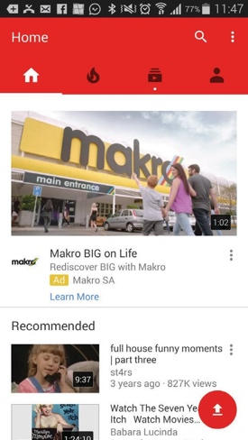
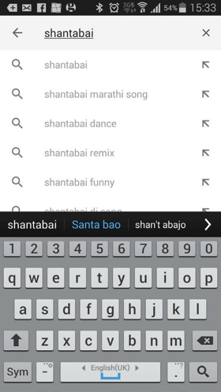
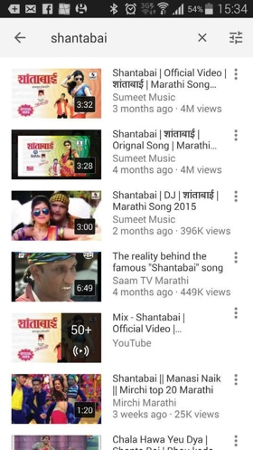
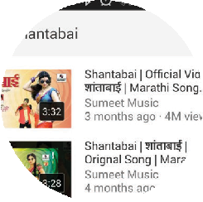
1 2 3 4 5
Search YouTube

CERTIFICATE

has completed
BASIC MOBILE INTERNET SKILLS
training

Date Signed

CERTIFICATE

has completed
BASIC MOBILE INTERNET SKILLS
training

Date Signed

