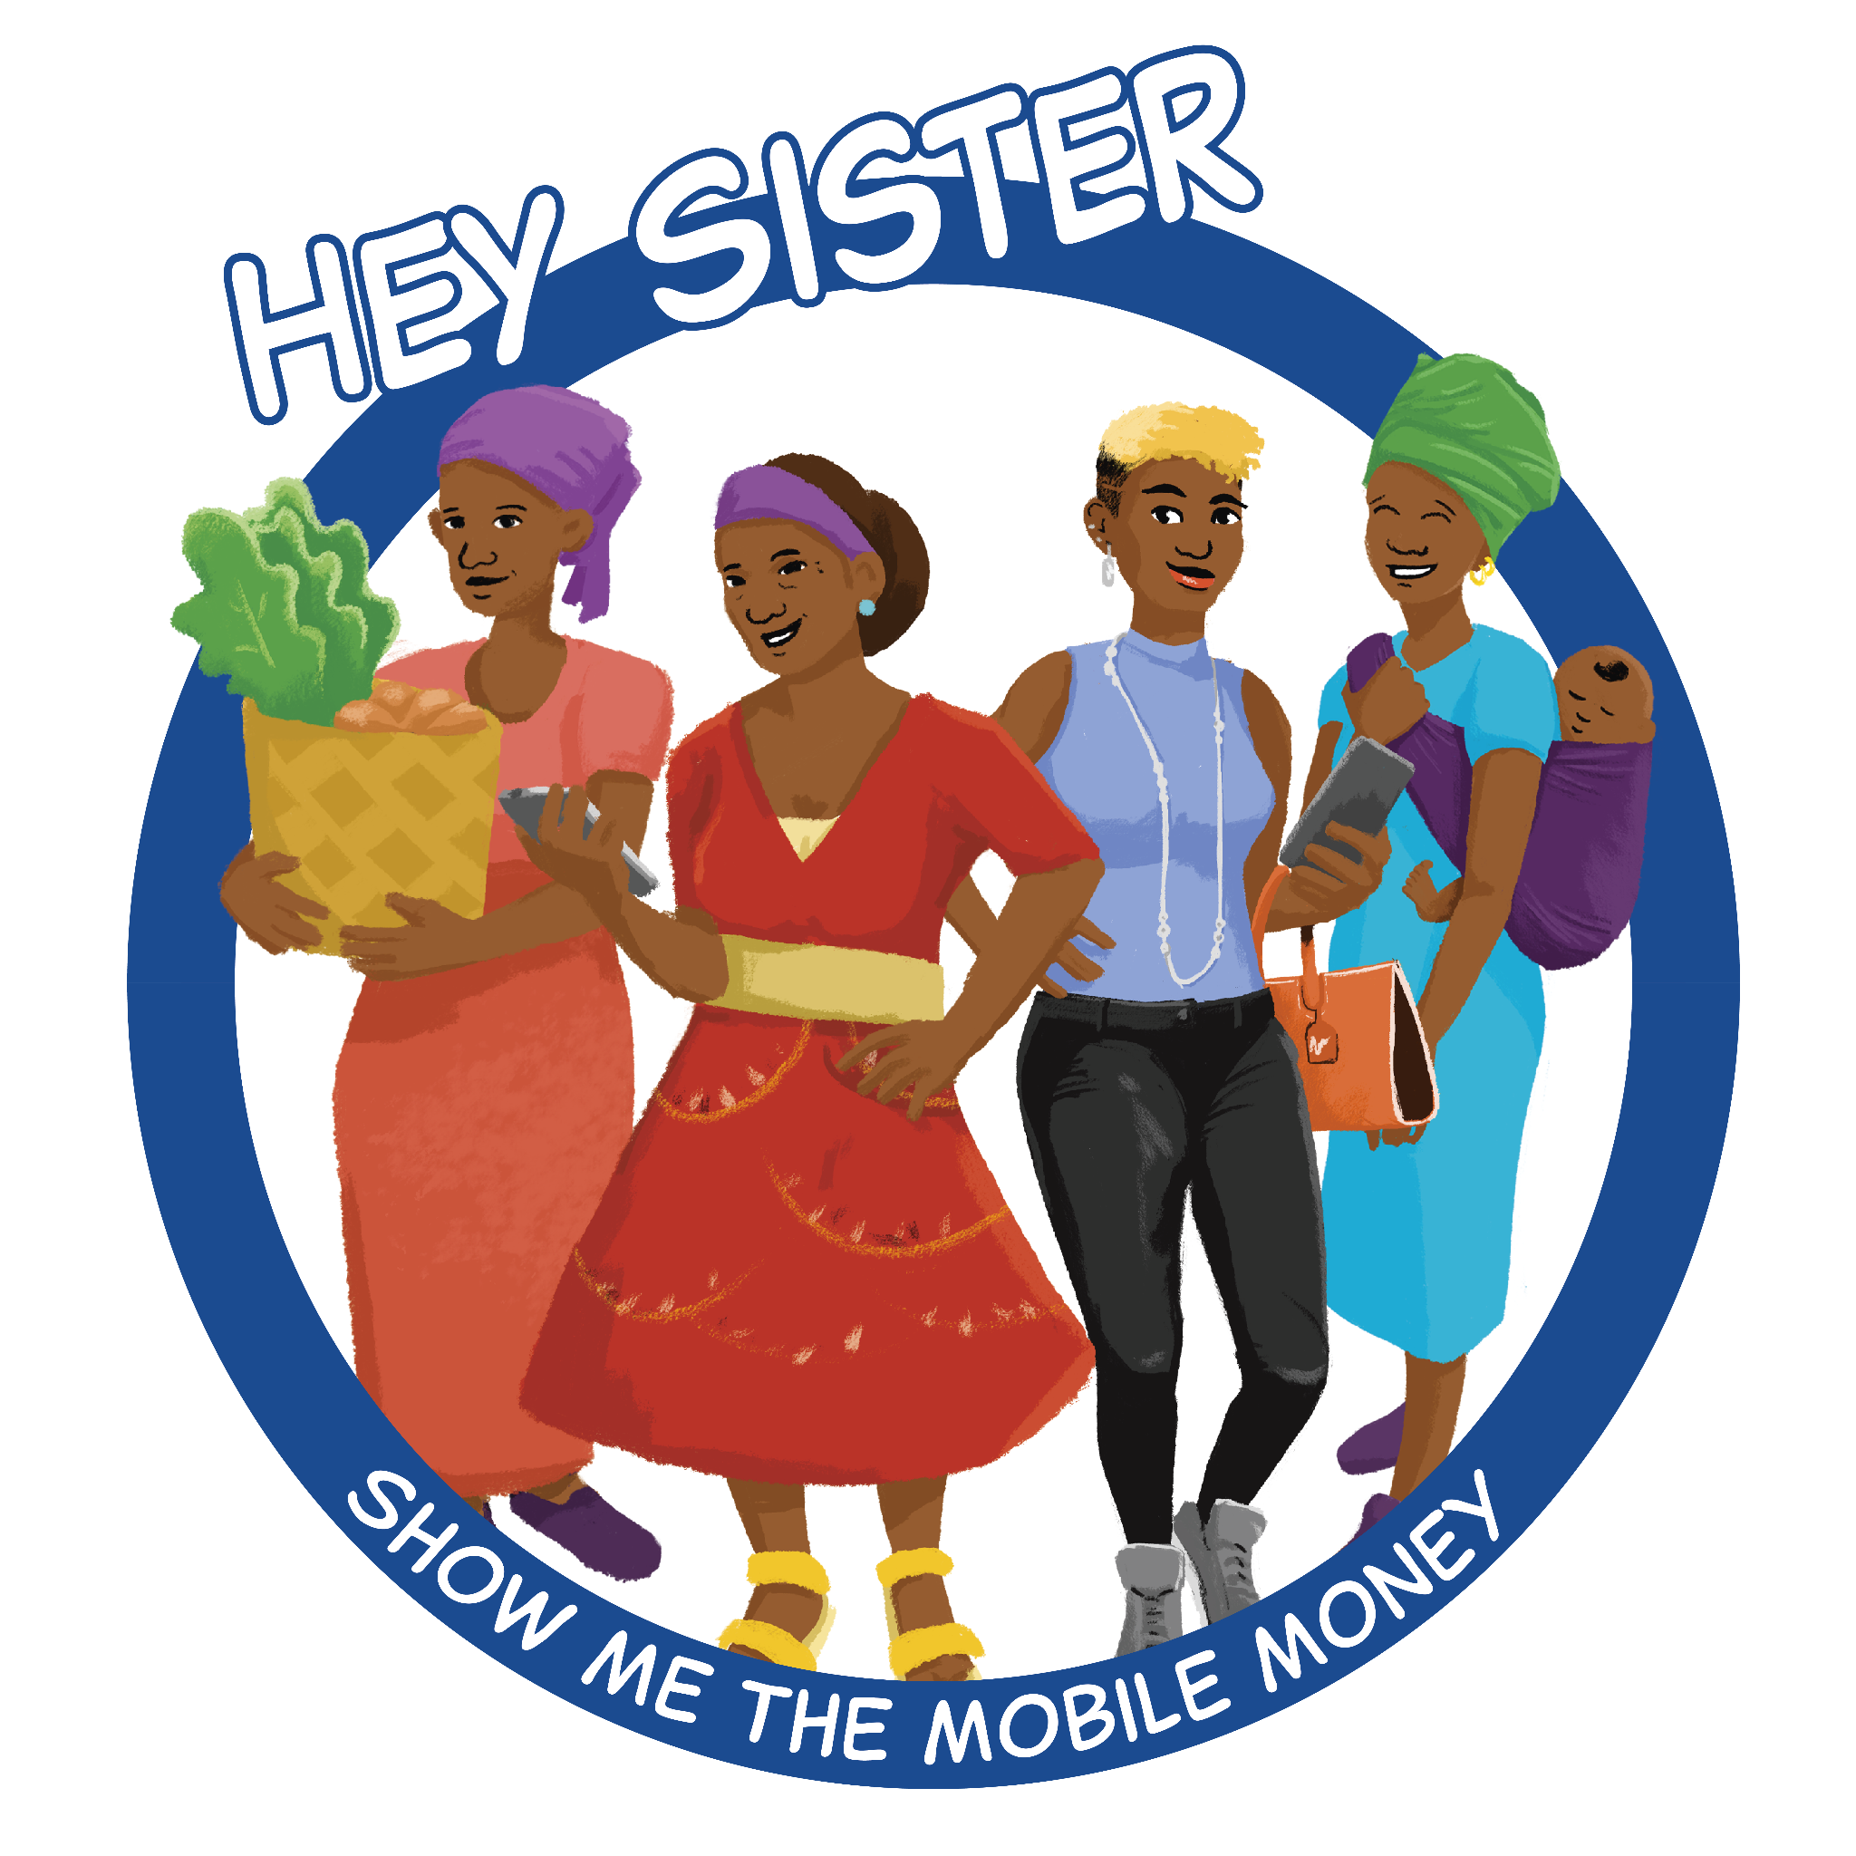

Hey Sister! Show Me the Mobile Money!
Facilitator Guide
Episodes 11 - 25

GLOBAL VERSION

This publication is made possible by the generous support of the American people through the United States Agency for International Development (USAID). The contents are the responsibility of Strategic Impact Advisors and do not necessarily reflect the views of USAID or the United States Government.

Table of Contents

- Introduction 5
- Facilitation overview 5
  - Engaging participants
  - Recommended practices
  - Facilitating for women’s safety and empowerment
- Hey Sister audio facilitation 7
  - Facilitation by episode
- Episode guides 7
Mobile money general topics
Episode 11: How can I reduce cash out fees and avoid agent fraud? 8
Episode 12: What are my rights under mobile money terms and conditions? 11
Loans, savings, insurance, and budgeting
Episode 13: What should I consider in taking out a loan? 12
Episode 14: How should I evaluate digital loan options? 15
Episode 15: How much should I save? 17
Episode 16: Where should I save? 18
Episode 17: Should I buy insurance? 19
Episode 18: How can my household manage our finances better? 24
Privacy and scams
Episode 19: How can my personal information be used? 25
Episode 20: How can I avoid different types of scams? 27
Using a smartphone effectively
Episode 21: How can I figure out airtime and data management 29
Episode 22: How do I use apps? 32
Tips for entrepreneurs
Episode 23: How should I manage finance for my business? 36
Episode 24: How can a digital “footprint” grow opportunities for my business? 38
Episode 25: How can I use my phone to expand sales? 40
- Resources 45
- Reporting 45
- Annex 46
  - Full size graphics/images
  - Additional Information
Full list of Hey Sister episodes
Developed under two phases
The Facilitator Guide for Episodes 1-10 is available for download here.

Mobile money general topics
- Episode 2: How do I set up a mobile money account?
  - Script begins with “Hello, my sister, are you there?”
- Episode 11: How can I reduce cash out fees and avoid agent fraud?
  - Script begins with “Annette, why do you look upset?“
- Episode 12: What are my rights under mobile money terms and conditions?
  - Script begins with “Josephine? Josephine?”

Basic mobile money transactions
- Episode 4: How do I send and receive money on my phone?
  - Script begins with “Good morning, Ladies! How are you today?”
- Episode 6: How do I pay bills on my phone?
  - Script begins with “Annette, I am so glad you came when business is slow.”
- Episode 7: How much does it cost to transfer money?
  - Script begins with “Why do you keep a worried face all day Annette?”

Loans, savings, insurance, and budgeting
- Episode 13: What should I consider in taking out a loan?
  - Script begins with “Oh hi, Annette! What’s new?”
- Episode 14: How should I evaluate digital loan options?
  - Script begins with “Hello Josephine!”
- Episode 15: How much should I save?
  - Script begins with “Hello Annette! You look so happy. What’s happening?”
- Episode 16: Where should I save?
  - Script begins with “Josephine, are you ready? We need to go to our savings group meeting!”
- Episode 17: Should I buy insurance?
  - Script begins with “Hi sisters, Josephine, how has this dry weather been for your crops?”
- Episode 18: How can my household manage our finances better?
  - Script begins with “Yoo-hoo! Annette! Kingsley! Oh — you look cross. Am I interrupting?

Privacy and scams
- Episode 9: How do I know which news is true?
  - Script begins with “Oh, hello! Myriam! Annette!”
- Episode 10: How do I protect myself from scams?
  - Script begins with “Good morning, Annette, it’s so good to see you at the market!”
- Episode 19: How can my personal information be used?
  - Script begins with “Ugh, another advertisement for something I want…”
- Episode 20: How can I avoid different types of scams?
  - Script begins with “Hi Myriam! The store is looking very clean!”

Using a smartphone effectively
- Episode 21: How can I figure out airtime and data costs?
  - Script begins with “Oh hi, Josephine! I haven’t seen you in a while!”
- Episode 22: How do I use apps?
  - Script begins with “Myriam, what is that on your phone?”

Tips for entrepreneurs
- Episode 5: How do I set up a merchant account for my business?
  - Script begins with “Oh, Annette! I’m glad to see you well!”
- Episode 23: How should I manage finance for my business?
  - Script begins with “Oh Lily, my daughter, you look exhausted!”
- Episode 24: How can a digital “footprint” grow opportunities for my business?
  - Script begins with “Good morning Josephine! How was the market today for you?”
- Episode 25: How can I use my phone to expand sales?
  - Script begins with “Shhh. Lily! Your phone is making so much noise.”

- Introduction

The audio series, “Hey Sister! Show Me the Mobile Money!” follows four women as they learn from each other how to conduct financial activities on their mobile phones. Its 25 episodes feature engaging conversations among the women (and sometimes the men in their lives) on specific topics. The series is designed to raise awareness and confidence among women, so that they may consider and effectively use digital financial services (DFS) to support their economic goals and grow their economic empowerment and financial independence. The scripts were written by Strategic Impact Advisors (SIA) under an initiative of the United States Agency for International Development (USAID).

People can listen to the “Hey Sister! Show Me the Mobile Money!” audio content available for download at https://www.siaedge.com/lessons. This guide was created to support leaders, local champions, and anyone interested in facilitating group listening and discussion, as permitted amid pandemic distancing restrictions.

Listening and discussing the content together will help people to learn more. This guide offers general facilitation tips, as well as specific guidance for episodes 11 to 25 and the types of mobile money transactions they cover. Our focus audience is women. Facilitators are asked to support the development of women’s voices and confidence by making sure they create a space where women feel safe and empowered to ask questions and practice together.

- Facilitation Overview

- Engaging participants

You may be integrating this as part of an existing group structure, or seeking to engage people in a new group. Here is how you can describe the audio content: A series that follows four women as they learn how to conduct finances on their mobile phones together.

The audio series is available to everyone, though women are intended to be the main discussion participants. Men can be welcome to participate, so long as they do not disrupt women’s learning. In some cases, where men are resistant to women’s learning, you might wish to invite a group of men to attend the first session to learn what it is about. Having a supportive, respected male figure present may help to win the support of other men.

Individuals do not need to commit to using mobile money in order to participate. The goal is that they learn and are able to make well-informed decisions for themselves.

- Recommended practices for small group facilitation
Create a comfortable atmosphere.
- If the group members don’t already know each other, start with a fun activity. (See an idea in the Resources section.)
- Demonstrate an encouraging and appreciative attitude toward ideas. If someone says something that is incorrect, correct it gently to avoid making people afraid to speak if they are unsure. Discourage any aggressively negative participants who excessively correct or criticize others.

Promote inclusive participation. Some people are more likely to speak than others. To give quieter people (especially women) some space to speak, consider trying the following strategies:
- Direct a question to a specific person who has not spoken. It can be an easy question, like “What do you think?”
- If your group is large (more than 15 people), consider breaking participants into smaller groups for discussion, so that more people are able to speak, and may feel less nervous in doing so.
- If your group has men and women, women may feel less comfortable to speak. As women are the target audience for this initiative, you should encourage them to speak. In some cases, you might consider breaking the group up into smaller groups based on gender (a men’s group and a women’s group). However, valuable discussions can happen when women and men speak together. (More on this in the next section.)

- Facilitating for women’s safety and empowerment

Group participants should understand that women are the primary audience and that, as a facilitator, you will be focused on ensuring they are learning and able to take action. Men can be a welcome part of the group but, most of the speaking should come from women.

Some men tend to dominate conversations — especially those who are in roles of authority (whether formal or informal). If such a man is in your group, it may be wise to speak to him separately. Rather than telling him he is doing something wrong, you could try asking him to be your ally in growing women’s voices and confidence.

If you learn or suspect that a woman may be facing retaliatory action from a male household member as a result of participating or taking actions she learned about from the program, consider taking one or more of the following steps:
- As mentioned above, inviting men to participate in the group may help to change their attitudes, especially if there are supportive men present. The gender-focused questions on page 44 offer some useful questions for groups to discuss on this topic, if men are somewhat open.
- If a woman is in an unsafe situation (e.g., facing violence at home), the group may be a valuable space for community members to support her in finding a safer solution. Allow time for and encourage such conversations. Section V. C. offers some outside resources that may be able to offer guidance or assistance with this issue.

Do not pressure anyone to continue participating in the group or mobile money activities if they do not feel safe.

- Facilitation around the audio content

The audio content is 25 episodes of 2-3 minutes in length that provide an introduction to digital financial services. We recommend that groups listen to one episode at a time, discussing each one directly after listening to it. You can listen to and discuss several episodes in a single meeting.

- Facilitation by episode

Preparation: Listen to the episode yourself. Read through the discussion questions and answer them for yourself.

Suggested group process:
- Have the group listen to one 2-3 minute episode together.
- Use suggested discussion questions for the episode to try to guide the group toward the learning objective. Some questions have “sample answer” suggestions to help you guide the discussion. You can also add your own questions! Make time to receive and respond to questions from participants on each episode to enhance understanding and comprehension.
- At the end of each episode, ask participants what actions they plan to take as a result of what they heard. Some episodes have suggested follow-on actions; you can ask the group if anyone would like to commit to doing the action, and report on it at the beginning of the next meeting. Such actions should be 100% voluntary without pressure from the group.

- Episode Guides

The following section contains episode guides for Hey Sister episodes 11 to 25. The Facilitator Guide with episode guides for episodes 1 to 10 can be found here. These guides provide facilitators with a roadmap of learning objectives, discussion questions, possible activities, and detailed information on the new “Hey Sister! Show Me the Mobile Money!” episodes. Facilitators are invited to review these guides before facilitating meetings and use them during group meetings to lead their conversations.
Note: You’ll see the icon on the right for episodes and activities designed for smartphones throughout episode guides. If there are some smartphone users in your group, you can have them share with others. If there are very few smartphone users, you may decide to skip the activity.
Episode 11: How can I reduce cash out fees and avoid agent fraud?

LEARNING OBJECTIVE | Participants can make more informed decisions on how to use a mix of digital transactions and cash out to reduce the cost of withdrawing their funds from a mobile money wallet.
KEY LEARNINGS | - How fees are listed and apply to different types of transactions.  - Flat fees cost more (as a percentage) of smaller amounts.  - Keeping funds digital and using them to make purchases can help you save on cash-out fees.

DISCUSSION QUESTIONS
- What is typically one of the most expensive parts of using mobile money?
Sample answer: Cashing out is typically the more expensive part of using mobile money. It is expensive to cash out because the mobile money operators have to compensate their agents for providing the service. Agents have costs they have to cover too.
Sample answer: It’s usually cashing out. But sometimes if you are cashing out smaller amounts, a push to the bank or a bill payment could cost more. You just need to know how to find the provider’s tariffs and how to read the tariff sheet that your agent is required to provide in order to confirm the costs being charged are correct.
- Are fees for cashing out all the same?
Sample answer: No. Mobile money fees are typically dependent on a range of the amount you are cashing out. The fees may be the same if the amounts are in the same range. While the actual cost goes up for larger amounts of cash out, the fee is usually a smaller percentage of those higher amounts.
- Are merchant payments the same as sending money to a friend?
Sample answer: No, merchant payments are generally a different type of payment on your mobile money menu. The merchant also typically has what is called a “merchant code,” which is a different number from their actual phone number. You use this merchant code to pay for goods and services.

ACTIVITIES

- Tariffs:
  - Explain that mobile money providers typically publish their fees on their website in what is called a “tariff.”
  - Display a tariff table for different mobile money transactions (see Country-specific information for an example) or access online via smart device.
  - Discuss the different payment types on the tariff table, noting that they provide fees by transaction type (such as cashing out) and amount.
  - Facilitate the conclusion that while the amount of the fee goes up for higher tiers of transaction value, the relative fees charged go down with higher value. (For example, a large transaction may have a tariff of 6% of the value, while for a smaller transaction it might be 10%.)
    - A way to help the group see this is to compare the fees for 1) cashing out a large, single transaction versus 2) cashing out the same amount in two separate transactions, each of half its value. The two transactions should be in a lower tier, and the total fees should add up to more than that for the single transaction.

- QR Codes:
  - Explain that a QR code is a block print you take a picture of to get a ‘shortcut’ for making a transaction or accessing a website.
  - Show the group the QR code below. Have someone with a smartphone scan the QR code, which should take them to the Hey Sister website.
  - Explain that merchants may display QR codes close to where you would normally pay for a good or service. Cameras on more recent smartphones have an inbuilt QR code scanner. This way you can just open your smartphone camera app and scan the QR code. Once you have scanned the code, your phone or the merchant should be able to give you instructions on how to finalize the transaction. If your smartphone does not have an in-built QR code scanner, see additional information below.
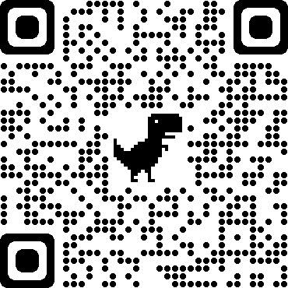
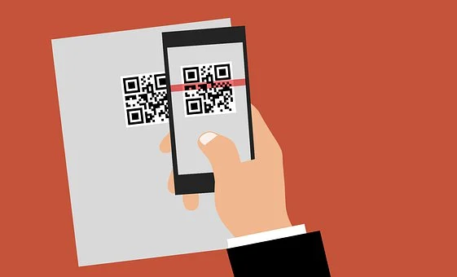

ADDITIONAL INFORMATION

Tariffs
Mobile money providers typically publish their fees on their website in what is called a “tariff.” In some countries, the Central Bank may set the tariff amounts. Tariff tables provide the fees by transaction type and amount, including for cashing out. Providers typically apply set fees based on value being cashed out using ranges or tiers, meaning a specific fee is taken during cash out based on the amount you cash out. See tariff tables in Country-specific information below.

QR Codes
QR codes are a type of short-cut meant to make the payment experience easier than using a mobile money menu to pay the merchant. The use of QR codes is growing at different rates across different countries. There are different QR code user experiences.

How to scan a QR code without an inbuilt QR code reader on Android:
Note that even if your Android smartphone does not have an inbuilt scanner in its camera, you can set it up. To do so, follow these steps:
1. Open the camera of your smartphone and here on the right hand corner, click More.
2. Here, click on the Settings option
3. As the settings open, you will see the option of Google Lens Suggestion. Activate this option.
4. Once it is activated, keep your smartphone camera close to the QR Code.
5. As the camera detects the QR Code, you will be directed to the target content.
(Source: https://scanova.io/blog/blog/2016/03/11/inbuilt-qr-code-reader/)
Episode 12: What are my rights under mobile money terms and conditions?

LEARNING OBJECTIVE | Listeners understand basic contract principles and common consumer protection/grievance resources.

DISCUSSION QUESTIONS
- Who in the group has read the terms and conditions of their mobile money provider? Were they easy to find and understand?
- Who in the group has contacted their mobile money provider’s customer service line in the past?
- Why is it important to read the terms and conditions of your mobile money provider?
Sample answer: The Terms and Conditions contain important information regarding your mobile money. They can contain information about what to do when your mobile, PIN or your sim card are lost or stolen.

ACTIVITIES

- Terms and Conditions Search
Have participants search for the terms and conditions of their mobile money provider and discuss what topics the terms and conditions address. (Reference: How to do an internet search - Annex pg. 57)

Episode 13: What should I consider in taking out a loan?

LEARNING OBJECTIVE | Participants understand what they will owe and consider/evaluate future ability to repay so they can choose whether to take a loan/the amount of the loan.
KEY LEARNINGS | - Loans can be used when money is short but it might be better to first use savings. It’s best to have a plan for how you will repay a loan before taking it out.  - You need to add up all the fees and interest in calculating how much a loan will cost you.  - Loans from different sources may have different total costs.  - You will get your own credit history when your name is on the loan.  - Government licensed lenders may be subject to rules that restrict how much they can charge you.

DISCUSSION QUESTIONS
- Myriam suggests that Annette consider borrowing from her group and that a microfinance institution (MFI) may charge her less for a loan than the street lender, Samuel. What information does Annette need to compare the cost of taking a loan from her group, Samuel and an MFI?
Sample answer: Annette needs to know: 1) if she has to pay fees to take the loan (such as an “origination fee”, a filing fee, and others), 2) when the loan must be paid back in full (the “term”), 3) what interest rate will be applied during the loan, and 4) how that interest rate is applied (over a year, month, to lower balances as payments are made). She needs to make a plan to pay back her loan by regularly putting that money aside in order to avoid late payment fees.
- If Annette decides to apply to an MFI for a loan to buy a refrigerator, should she ask for that loan by herself or ask her husband Kingsley to apply? What documents do you think she will need to collect before going to the MFI?
Sample answer: If Annette’s applies for the loan she will start to build her own credit history. If she repays on time this would be good for her. If she doesn’t repay on time, she might hurt her chances of getting a loan again in the future. Kingsley and Annette could apply for the loan together. If only her husband applies, Annette will not establish a credit history. To apply for the loan, Annette will need to bring her ID and documents showing things like her residence (e.g., a utility bill), marital status, and income to show she is going to be able to make the payments on time. The MFI might ask for the right to take back her refrigerator if she doesn’t make the payments.

ACTIVITIES

- Comparing loan costs and interest rates
- Compare the different total costs of these loans when the interest rate differs.
  - More advanced participants may also notice that while each monthly payment is the same, the amount that goes to interest each month declines.
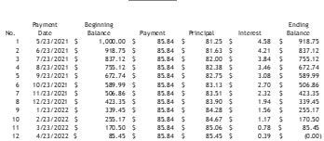
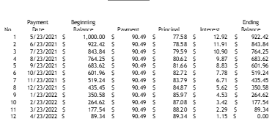
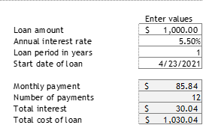
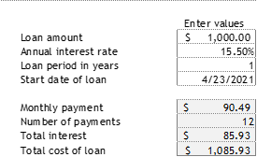
- Convert ‘per annum’ interest into monthly payments (assuming flat rate):
  - Assume a 1-year loan of 5,000 x 24% per annum interest rate
  - To calculate the monthly payments:
    - Method 1: Calculate the total that will be paid in interest: 5,000 x 24% = 1,200. Divide the total amount by 12 (months): 1,200 / 12 = 100 monthly payment amount
    - Method 2: Divide the interest rate by 12 (months): 24% / 12 = 2%, then multiply that by the total loan amount: 2% x 5,000 = 100 monthly payment amount

ADDITIONAL INFORMATION

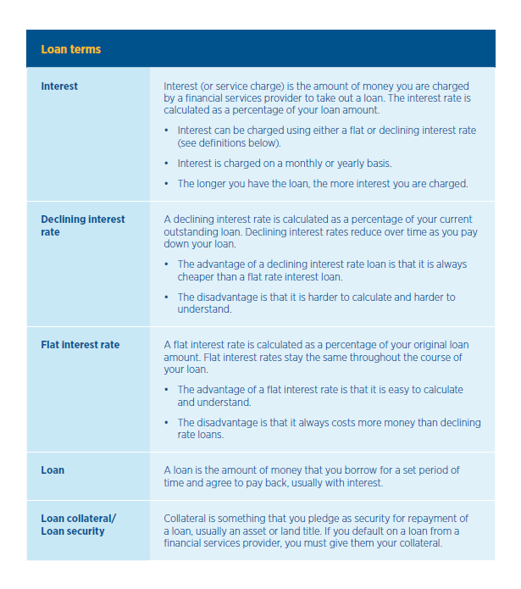
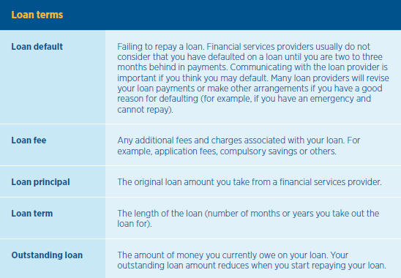

(Source: GSMA, Grameen Digital Literacy Training Guide, 2020)
Episode 14: How should I evaluate digital loan options?

LEARNING OBJECTIVE | Listeners understand how digital credit offerings work and its costs and how they differ from traditional loan options.
KEY LEARNINGS | - Loans provided over the phone (digital loans) may be easier to get but they can lead to overborrowing and get expensive quickly. Borrowers should be careful not to overborrow.  - Digital loans may include fees beyond interest.  - Digital loans usually have short durations (e.g., 30 days).

DISCUSSION QUESTIONS
- Annette and Kingsley may apply for a loan on their phone loan because the MFI takes too long and they might not qualify. What do they need to consider besides speed in taking the loan?
Sample answer: They need to understand what the loan will cost them beyond what they borrow. In addition to repaying the loan amount there may be fees that apply, Annette and Kingsley need to do the math on the additional fees to make sure it’s worth it.
- Annette wants to use the loan to buy cleaning supplies for her business to clean her new clients’ houses. Should Annette take the digital loan for this small amount of cash? Would it make sense for Kingsley to get a digital loan to buy a motorbike?
Sample answer: Digital loans must be repaid quickly so it makes more sense to use them when cash is short and you feel confident you will have money to repay the loan. People may push you to borrow because they make money, but be sure you need the money and are confident you can pay it back.
- While Annette is confident she can repay the loan on time, what if her new clients cancel and she doesn’t have the money?
Sample answer: Digital lenders can add late fees on top of the other fees that apply to the loan, or they may increase the interest rate. Make sure you understand if those would apply and how much cost they would add to the loan. Some providers let you set up automatic payments that could help you avoid late payments.

ADDITIONAL INFORMATION

Here’s what a digital credit offering can look like on your mobile phone:
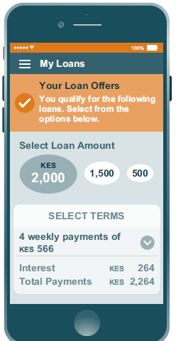

Source: https://www.cgap.org/sites/default/files/researches/documents/Focus-Note-Consumer-Protection-in-digital-Credit-Aug-2017.pdf
Episode 15: How much should I save?

LEARNING OBJECTIVE | Listeners gain a deeper appreciation of the value of savings and are able to make strategic decisions on percentage of income to save.
KEY LEARNINGS | - Saving is important.  - Always set money aside regularly for emergencies.  - Even small amounts of savings add up.

DISCUSSION QUESTIONS
- How much do you save? Why do you save this amount?
- Does anyone save with mobile money? Please share your experience.
- Do you find it difficult to save money on a regular schedule?
- What types of expenses could you reduce in order to save more? What are “needs” vs. “wants”?
- How many savings accounts does a person need?
Sample answer: You can save for multiple purposes in the same account, or sometimes mobile money operators will let you have different “wallets” that you can dedicate to different purposes (emergency, and other savings). Some people save both in their mobile money account and in a bank.

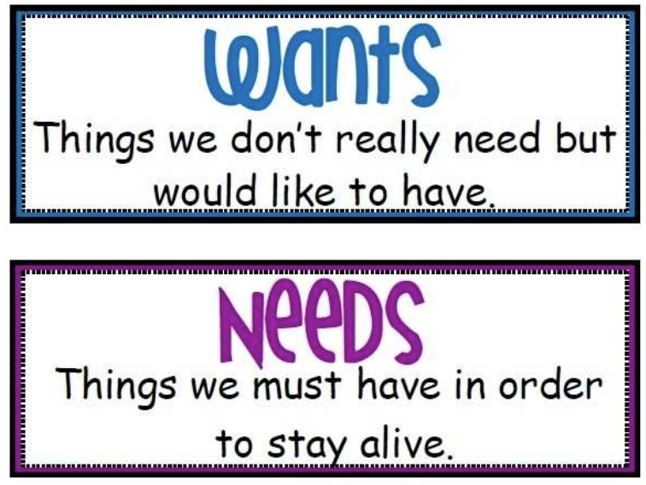
ACTIVITIES
- Saving goals.
  - Have participants divide into small groups. Have them discuss how they currently save, and make goals for savings: emergency, short-term, and long-term.
- Understanding interest.
  - Explain to the group: The interest rate earned by savings is set by the bank, MFI, or mobile money provider. There are two different ways interest is applied:
    - Simple interest: applied only to the ‘principal’ (the money you put in)
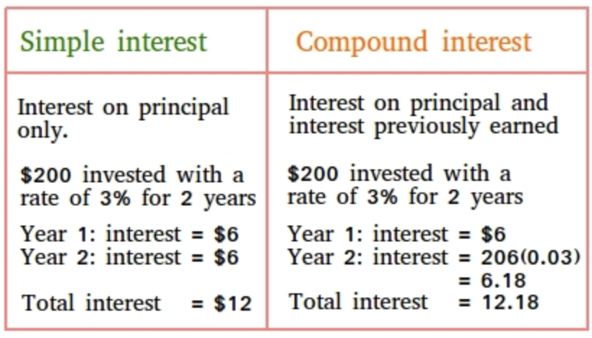
    - Compounded interest: applied to the principal as well as interest you previously earned
  - Show the table that illustrates these and talk through how these two types of interest result in different amounts of money earned. Under simple interest, $6 is earned in interest each year. With compound interest, $6 is earned in Year 1 and $6.18 in Year 2. Ask participants what they think the difference would look like after 10 years.

Episode 16: Where should I save?

LEARNING OBJECTIVE | Listeners appreciate the value of digital as they make strategic decisions on where to save.
KEY LEARNINGS: | - Saving with a mobile phone is easy, convenient, and safe.  - You can use any phone to save digitally.  - Operators and banks offer different ways of saving:  - Saving wallet, which can be used for emergencies  - Savings account, which can used for short term and long term goals  - You can use the “cash-in” option with an agent who will take the cash and put it in the account or wallet of your choice.

DISCUSSION QUESTIONS
- Who has used their phones to save digitally? What was your experience? Do you do it regularly?
- What advice would you give to others who are learning to save digitally?
- Do you think it is safer or less safe to save with your phone? Why?
Sample answer: Paper money can be stolen, lost, or damaged (think of losing your purse, money taken from your home or lost in a fire). Money stored on your phone is held in an account and shown through your balance. It is harder for someone to take from you or lose. If you lose your phone, you can still access the money in your digital savings account by going to an agent who can help you access the money and transfer it to a new phone.
- Do you think Josephine made the right decision in paying a fee to put her money in savings?

Episode 17: Should I buy insurance?

LEARNING OBJECTIVE | Listeners understand the basic concept of insurance, what terms to look for in evaluating products, and can weigh the cost against the benefits it might bring.

DISCUSSION QUESTIONS
- What is a ‘premium’?
Sample answer: A premium is the amount you pay to get insurance coverage. Many premiums are charged monthly. If a covered event takes place, the benefits you receive from the insurance company may be more than the total you paid in premiums. Under most insurance products, you will not receive premiums back if no event happens.
- Has anyone taken insurance? What were the conditions and what was your experience?
- How do you decide to take insurance or to save?
Sample answer: It is always important to have savings, as not all risks can be planned for or covered by insurance. Whether to add insurance depends on a few things:
- Your risks. How likely are specific events to occur? If they do occur, how much money would you lose/need?
- The insurance product. How much are the premiums? What is covered? How much are the payouts if specific events happen?

ACTIVITIES

- (Intensive) Scenario simulation for insurance
- Select something that can be used as currency (e.g., dried beans)
- Have a writing surface available, such as a flip chart or chalkboard
- Divide participants into three groups. Each group should assign a ‘treasurer’ to handle transactions of the ‘currency.’
- If possible, keep track of the group balances on a flip chart or other material for the group to see.

Facilitator script | Bean Exchange / Balance
 | Group 1 | Group 2
Round (Season) 1
Each group is a farm. You have spent 20 beans planting your crops. You have 20 beans as your leftover cash. You are hoping for a harvest that you can sell for 30 beans in 6 months. | ‣ Facilitator gives 20 beans.  Balance: 20 | ‣ Facilitator gives 20 beans.  Balance: 20
You are presented with insurance options.  (Written on flip chart if possible)  - A firm offers index insurance. They will pay you 15 beans in case of drought, which they will measure if the rainfall over the next 6 months is below a certain level. The monthly premium is 1 bean for the 6 month season. Group 1 selects this option.  - Group 2 decides not to take insurance and instead puts the 20 beans into a savings account. They earn 1 bean in interest over the 6 month season. You are presented with insurance options. | Pays 1 bean/month x 6 months for insurance premium  ‣ Facilitator collects 6 beans  Balance: 14 | Earns 1 bean in interest  ‣ Facilitator gives 1 bean  Balance: 21
The 6 months of the season go by. The weather is fine, but disease is a big problem. Each farm loses ⅓ of their expected harvest as a result, so total revenue is only 20 beans, which is the same amount you invested.  I’ll keep the 20 beans, as this is the amount you will spend on planting for the next season.  Because the weather was fine, Group 1 receives no insurance payout. | 20 bean harvest revenue is reinvested in the next season  ‣ No bean exchange with facilitator  Balance: 14 | 20 bean harvest revenue is reinvested in the next season  ‣ No bean exchange with facilitator  Balance: 21
Let’s compare current balances to where you were at the beginning of the season.
Why does Group 2 have more beans than Group 1?

(Discussion)
Now let’s proceed to the next season.
Round (Season) 2
Again, you have 20 beans invested in this season’s crop, from which you hope to earn 30 beans.  Each group keeps their same insurance or savings plan from the previous season. | Pays 1 bean/month x 6 months for insurance premium  ‣ Facilitator collects 6 beans  Balance: 8 | Earns 1 bean in interest  ‣ Facilitator gives 1 bean  Balance: 22
The 6 months of the season go by. It was a great season — good weather, no major pests or disease. Each of your farms was able to earn your expected 30 beans with the harvest — congratulations! Since you will reinvest 20 beans for next season, I will give you 10 beans now.  There were no insurance payouts. | Of the 30 bean harvest revenue, 20 is reinvested into the next season.  ‣ Facilitator gives 10 beans  Balance: 18 | Of the 30 bean harvest revenue, 20 is reinvested into the next season.  ‣ Facilitator gives 10 beans  Balance: 32
Let’s compare current balances again. Compared to the end of last season, Group 1 has 4 more beans, and Group 2 has 11 more beans. Why?

So far, does insurance look like an attractive option?

(Discussion)
Round (Season) 3
Welcome to Season 3. Again, you have 20 beans invested in this season’s crop, from which you hope to earn 30 beans.  Each group keeps their same insurance or savings plan from the previous season. | Pays 1 bean/month x 6 months for insurance premium  ‣ Facilitator collects 6 beans  Balance: 12 | Earns 1 bean in interest  ‣ Facilitator gives 1 bean  Balance: 33
Now I’ll give you the news from this season. There was a big drought, and crop losses were large. You only earn 10 beans each from your crop.  Group 1’s insurance coverage was activated and receives a payout. Group 1 receives 15 beans from that.  Again, you invest 20 beans in the next season. | 10 is earned from harvest,  15 is received from insurance payout  20 is reinvested into the next season  ‣ Facilitator gives 5 beans  Balance: 17 | 10 is earned from harvest, 20 is reinvested into the next season  ‣ Facilitator collects 10 beans  Balance: 23
So, what observations do you make from the balances now? Which groups have more vs. less money than last season? Why?
(Discussion)

What would happen to Group 2 if there were several more drought seasons?

(Discussion)
Round (Season) 4
Up until now, I have told you what your group decides. Now it is your turn to decide! I will return each group’s balance to the starting point of 20. | ‣ Facilitator gives 3 beans  Balance: 20 | ‣ Facilitator collects 3 beans  Balance: 20
The options from the insurance companies and savings rates remain the same.  I have three pieces of paper.  - One says: “Pests! Harvest income = 20 beans”  - Another says: “Great season! Harvest income = 30 beans”  - The last one says: “Drought! Harvest income = 10 beans”  - You may notice these are the three scenarios we just did. I will pick one piece of paper at random.  First, which insurance or savings option will your group pick? (Review costs and what coverage they provide)  (Pick a piece of paper at random, without looking) | If group chooses insurance:  ‣ Facilitator collects 6 beans  If group chooses savings:  ‣ Facilitator gives 1 bean  Balance: ?
(Announce the result) | If pests: Income equals reinvestment amount  ‣ No exchange of beans  If great season: Of the 30 bean harvest revenue, 20 is reinvested into the next season.  ‣ Facilitator gives 10 beans  If drought: 10 is earned from harvest, 20 is reinvested into the next season. Insurance gives a payout of 15.  ‣ Facilitator gives 5 beans to group(s) that selected insurance.  ‣ Facilitator collects 10 beans from group(s) without insurance  Balance: ?
Final discussion questions:
Key insights (facilitator should share if not raised by group members)
- Were you happy with your choice for the final round? Had you known the result (pests/good season/drought) ahead of time, would you have picked a different option?
→ The real world is unpredictable; we have to make choices based on how likely risks are (like bad weather for farming), and what the impact will be on them if they do occur.
- What was different about this game compared to the real world?
→ In the game, there was a one in three chance of bad weather destroying the crop. How does that compare to the local environment?
→ In the real world, households would probably draw from their balances for living expenses.
→ In the real world, index insurance may cover additional weather events beyond drought; it depends on the specific policy.
- The rates in this game were made up. What would have happened if the insurance premiums were more or less expensive, or paid out more or less?
→ Whether an individual will be better off with insurance depends on both conditions and the policy terms. For instance, if the insurance in the game had cost only 3 beans each season and the payout had been 20 beans, Group 1 would have finished Round 3 with 31 beans — a big difference that would have put them much ahead of Group 2’s balance.

ADDITIONAL INFORMATION

Weather-based index insurance (agriculture)
- Registration requirements will include location and possibly measurement of your plot.
- Interested farmers should ask the provider how they measure weather, and to provide any details they can on accuracy. (There have been some cases where insurance companies have not issued a benefit where rainfall was insufficient for crops but their satellites and weather stations stated that the area did receive enough rainfall.)
- Livestock insurance products may also be available.
Episode 18: How can my household manage our finances better?

LEARNING OBJECTIVE | Participants create a basic budget and have tips to use in household budget negotiation.

DISCUSSION QUESTIONS
- What strategies have you used to come to financial agreement within your household?
- The characters talk about unpaid work. What type of unpaid work do you do? Is it valued by your other household members?
- Does your household have a financial plan or budget? Is it written down? How much do you allocate to different areas, including savings?
- How do you prioritize your expenses? Does your income cover all your expenses?
- Do you or other members of your household have your own accounts? Why might this be useful?
Sample answer: There are several reasons it may be useful for individual household members to have a separate account in their name. For example:
- If one of them runs an enterprise, they should keep their business expenses separately.
- An individual might want to have their own account for a specific purpose, e.g. saving for a future expense.

ACTIVITIES

- Budgeting Practice
- In one column list all of the household’s sources of income. Consider income from enterprises (including farming), trade, wage labor, remittances, and so on.
- Write all of the household’s expenses for each month. Keep in mind that it cannot be more than their income.
- How much will they save?

Option to refer to the sample budget in country-specific information.
Episode 19: How can my personal information be used?

LEARNING OBJECTIVE | Participants understand the information that is collected when they use their phones and the risks and opportunities this can bring, particularly for establishing creditworthiness.

DISCUSSION QUESTIONS
- What types of activities do you do on your phone on a regular basis? What information about yourself do you think is revealed when you use your phone?
Sample answer: I make calls using my phone, so I suppose the phone company knows who I am calling and how often. They also know how much I spend on airtime.
- What concerns, if any, do you have about the type of information being collected?
Sample answer:
- When it comes to them knowing who I call, this does not concern me.
- It makes me uncomfortable knowing that companies like Facebook can know who my closest friends are and what I am interested in. I do not like it.
- What is the difference between the type of information collected on a basic phone vs. a smartphone?
Sample answer: On a basic phone, typically only one company, the mobile network operator – and maybe sometimes a bank that the mobile network operator works with – collect information. And that is information like the airtime I purchase and the mobile money transactions I do. Smartphones have apps, like Facebook, so the companies that run those apps also collect information on you, and there is a lot more information. For example, your network of friends, the pictures you post, and sometimes your location.
- What do you think your rights are when it comes to your information?
Sample answer:
- The best way to know your rights is to consult the mobile network operator or app’s terms and conditions or data privacy policy. These documents can be long though. Most mobile network operators will not share your personal information with other companies (like banks or marketing agencies) without your consent.
- Some countries have what are called data protection laws, which highlight what companies can and can not do with your personal information. These laws typically require companies to seek your consent to use your data. Consent is often given when you register or sign up for the service. Terms and Condition Agreements, which you often agree to without reading, are the ways companies get your consent.

ACTIVITIES
- Smartphone navigation
- Smartphone users navigate to privacy settings in common apps (i.e., Facebook, WhatsApp) and look through what options can be adjusted.

ADDITIONAL INFORMATION

Privacy Settings
Some apps have options to change your privacy settings. Users should keep in mind that in most cases, these settings deal with privacy with respect to other users of the app, and generally don’t limit information that the company that owns the app will access.

It is possible that your social media could be checked by a lender to establish your credit worthiness, if privacy settings allow them to do so.

Episode 20: How can I avoid different types of scams?

LEARNING OBJECTIVE | Participants become familiar with additional common types of scams and are able to recognize more signs of a scam.
KEY  LEARNINGS | - Never give out personal information and never send money unless you are sure of the person’s identity.  - You don’t have to respond at all to messages from people you don’t know.  - If you do respond you have to think about what information you provide to protect yourself from losing money.  - Mobile money providers and the government may want to know if you have been scammed.  - You are unlikely to get your money back if you are scammed.

DISCUSSION QUESTIONS
- Myriam tells her son Wisdom not to believe the text message saying she won a free smartphone. Do you agree that the message is a scam or do you think Wisdom is right that it might be a true offer?
Sample answer: Myriam doesn’t know the name of the company that sent the message or recognize the phone number, so she is right to be suspicious. They also want her bank information which could allow them to take her money from her bank account. Companies can get your phone number and send you scams in order to take your information or money. Myriam says she doesn’t trust messages from companies unless she calls them with a number she knows is correct.
- Have you or someone you know received fake messages asking you to send money? What did they say? What did you do?
Sample answer: Scams can offer all kinds of things. Usually they want you to feel like you won something or someone needs money from you. Other scams might suggest that they can get you a COVID vaccine if you pay. Be careful that you only send money when you are sure it is to someone or a company you trust and you know it will be used the right way.
- Josephine wants to know how to get her money back if she sends it to someone and it is a scam. Do you think Josephine will get her money back?
Sample answer: You can report scams, but it is unlikely you will get your money back.
- Have you had to check whether a certain offer you received on your phone was true? What did you do?

ADDITIONAL INFORMATION
Mobile network operators also want to stop scams. Most have a phone number you can call to report scams you receive.
Scammers may use different numbers to contact you, but you can still ‘block’ their number to avoid getting future messages from them.

Below are a few screenshots on how to block a phone number or contact on an Android smartphone:
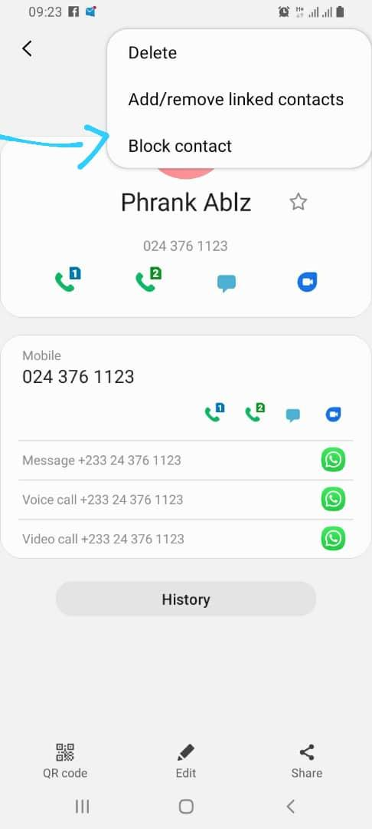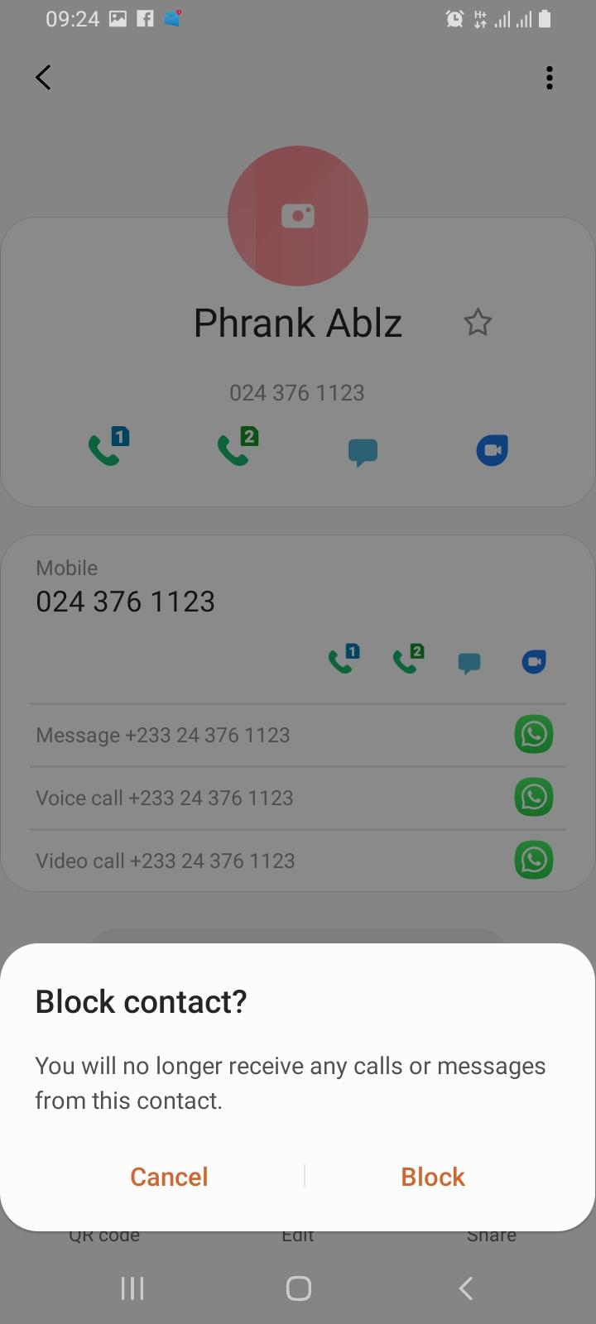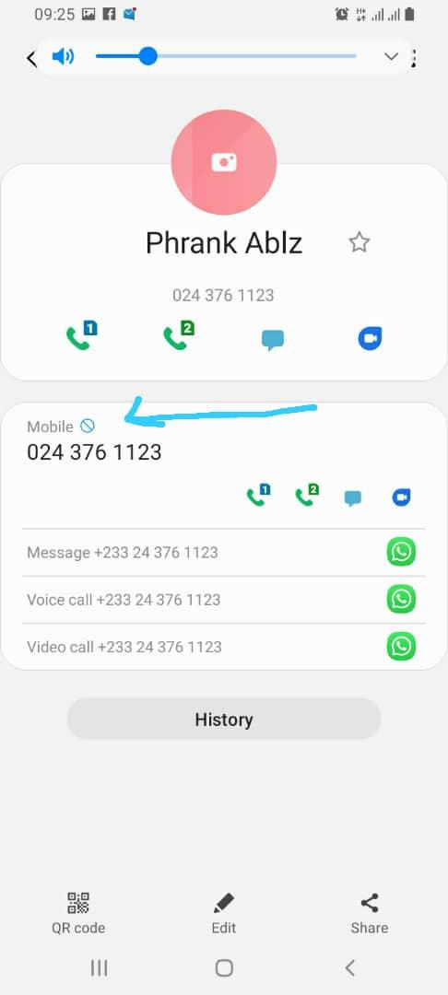

Episode 21: How can I figure out airtime and data costs?

LEARNING OBJECTIVE | Participants can make more informed decisions about how much airtime and data to use, and when.

DISCUSSION QUESTIONS
- If you have a smartphone, have you ever been surprised about how much data is used? What strategies do you use to manage your data use?
- Myriam references “the Internet.” What is the Internet?
Sample answer: The Internet is a network of millions of computers and phones around the world that are connected to each other. (See Additional Information section.)

ACTIVITIES
- Smartphone navigation
- Practice navigating to cellular (mobile) data and switching it on and off
- Find the wifi option on your phone
- Check data remaining on plans

- Guess which smartphone activities use data:
Facilitator reads out each prompt, and group guesses before the facilitator confirms the correct answer.

ACTION | NO, DOESN’T USE DATA | YES, USES DATA
Turning your phone on | x
Checking Facebook |  | x
Using the calculator | x
Sending a WhatsApp message |  | x
Downloading a new game, document or file |  | x
Recording a video | x
Watching a video someone sends you |  | x

ADDITIONAL INFORMATION

The Internet  The internet is a network of millions of computers and phones around the world that are connected to each other. It gives you access to a huge range of information and services and it is growing all the time. Anyone can connect to and use the internet to access information quickly.  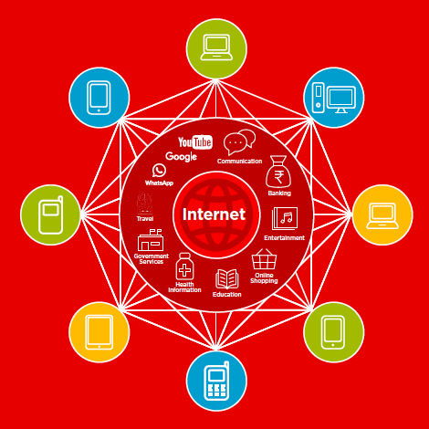  (Source: GSMA Mobile Internet Skills Training Toolkit) | Data Usage  Data costs vary based on the ways you use your mobile phone. For instance, watching videos on the Internet or on apps like YouTube and Facebook uses the largest amount of data, while sending messages on Whatsapp uses the least.  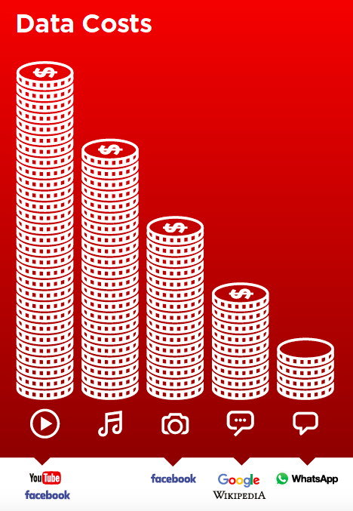  (Source: GSMA Mobile Internet Skills Training Toolkit)
Settings/Turning off Cellular (Mobile) Data
Smartphones may have different interfaces. But the settings symbol is universal.

Here are some example screenshots of how to switch cellular (mobile) data on and off:
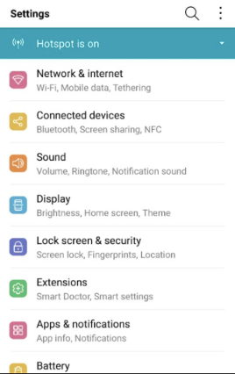
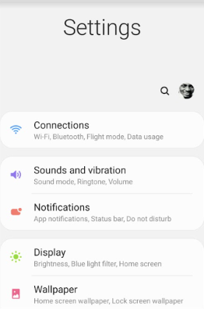

Episode 22: How do I use apps?

LEARNING OBJECTIVE | Participants are able to make strategic decisions about what apps to get and figure out how to use them.

DISCUSSION QUESTIONS
- Who in the group has already downloaded apps from the Play Store? Did you find the process to be easy or difficult?
- Are you able to use apps not written in your language? How does that work?
- What are the apps you spend the most time on? Do you find they use a lot of your data?
Sample answer: Apps like YouTube and Facebook use up the most data very quickly. Be careful how long you spend watching videos on these because they will quickly eat up your data.
- What kind of apps don’t use data?
Sample answer: The Camera, Photo Album, and Clock apps, for example, do not use data, because they don’t interact with the internet to operate.
- How can you make your phone PIN something secretive that you won’t forget?
Sample answer: You may consider making your PIN an important date to you, symbol or pattern that you won’t forget and can keep to yourself. Just don’t make it too easy to guess!
Examples (PINS): A date: If your child was born on the 5th of March 2018, your PIN could be 050318
ACTIVITIES
- Have participants browse the Play Store and search for apps that have purposes related to their lives (e.g.,. agriculture, health, finance).
- Have participants search through their phone settings and change location tracking settings for different apps.
- Divide the participants into groups (each with at least one smartphone), each tasked with conducting a web search to find information.
Example searches (facilitator should try ahead of time/can choose others):
  - What is the customer service phone number of MTN?
  - What jobs are advertised in the nearest city?
  - What is recent news from the country’s president?
  - How do you make [national dish]?
When finished, groups report the information they learned, as well as how they found it.

ADDITIONAL INFORMATION

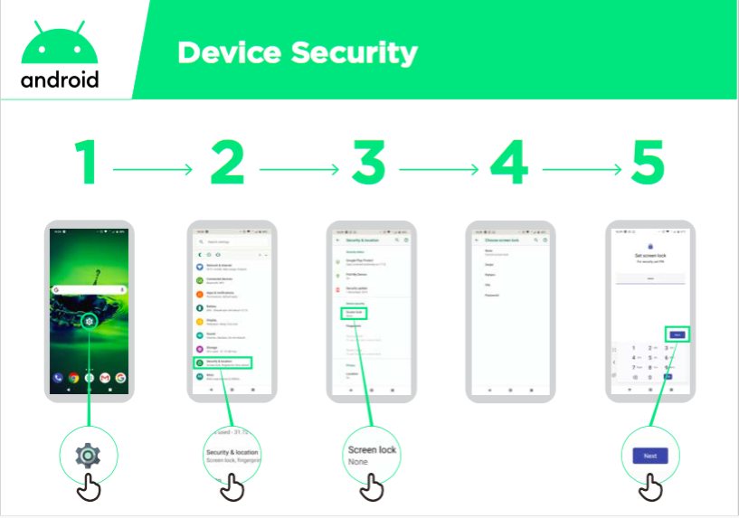
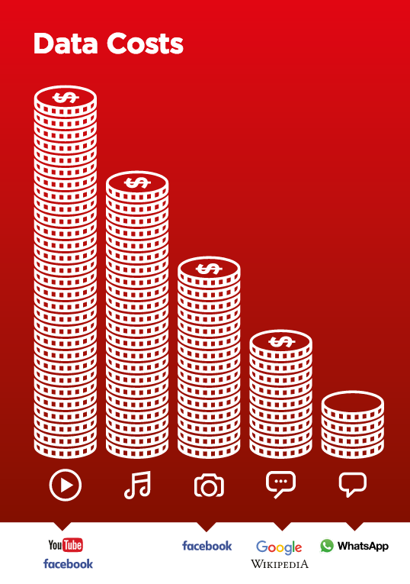
(Full images can be found in Annex pg. 47-48)
Steps for finding the settings page, adjusting app settings, and changing location tracking settings:
Exact steps may differ between devices. Usually the first step is to click on the settings icon.

Wifi
Wifi is another way to connect your phone to the internet without using cellular data. Instead, your phone connects to an internet connection. For example, a cafe might pay for an internet connection, and have a cable or satellite that provides the connection. You will need to know the name of their network to connect to it, and you may need a password. Here is the wifi symbol.

Web Searches
The world wide web is the part of the internet that contains websites. You can access it through several apps that may be on your phone.

A web search can be a valuable way to find information. Entering keywords in the search bar will bring up websites that may contain the information you seek. Websites each have an “address” that is shown at the top… they often start with ‘http://www’.

Remember that not all information on the internet is legitimate. If you find information on an official site, like a government, UN, or trusted news organization, it is more likely to be accurate than the website of someone you are unsure of.

Common web browsers:
Chrome | Firefox | Google Search Bar
Google Play Store

The Play Store may look slightly different between phones. Here are some examples:
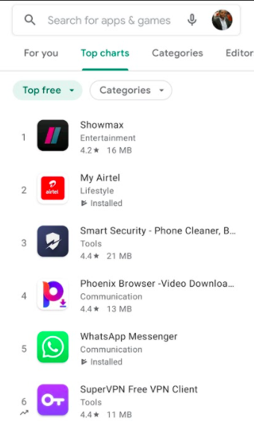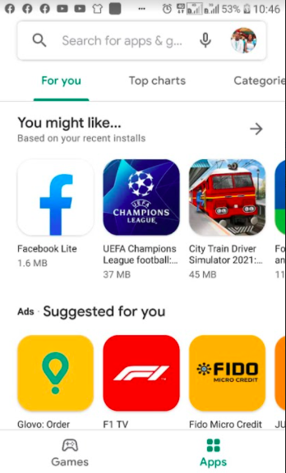

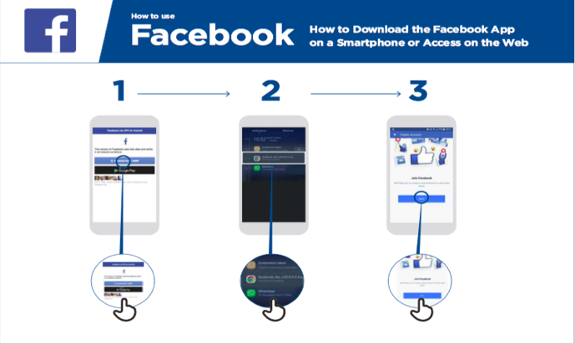
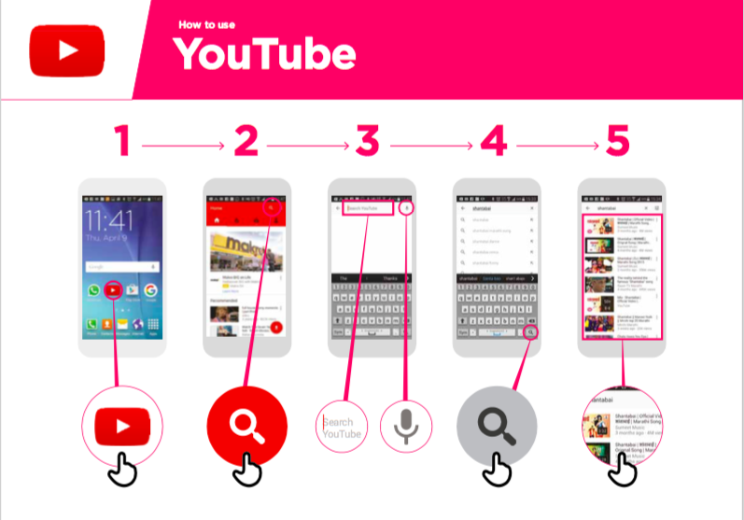
How to download/use Facebook, YouTube, and WhatsApp
(Full images can be found in Annex pg. 49-50)

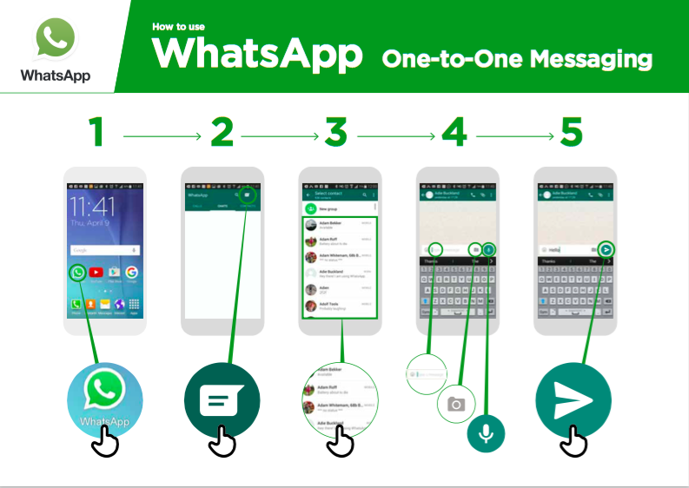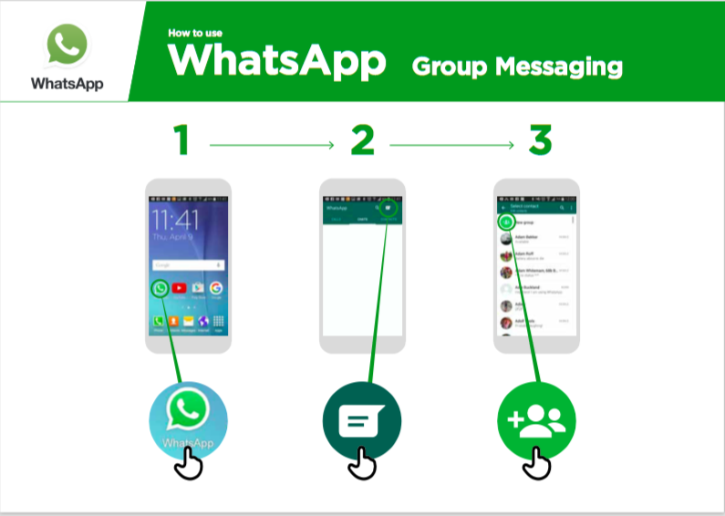
(Full images can be found in Annex pg. 51-52)

Example of PIN patterns
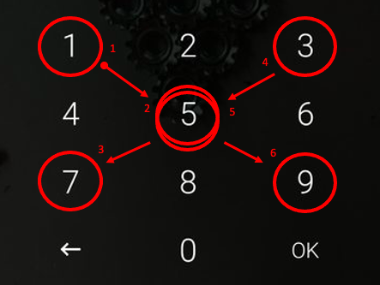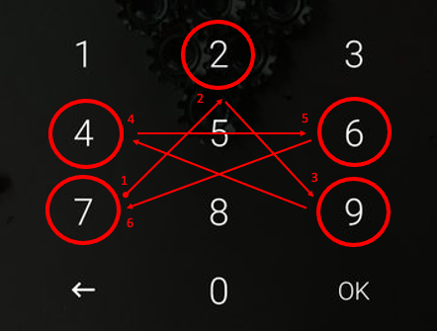

Episode 23: How should I manage finance for my business?

LEARNING OBJECTIVE | Participants have an understanding of basic business financial planning and credit concepts.
KEY LEARNINGS | - Keeping good financial records helps accessing loans because you can show sales and profit.  - Getting organized helps planning for future expenses.

DISCUSSION QUESTIONS
- What is the benefit of having a Merchant ID?
Sample answer: Having a Merchant ID allows you to conduct mobile money transactions for your business — to both receive and make payments. Not having to deal with cash can be more convenient and safe. Having a Merchant ID for business transactions allows you to keep your personal details private and your business expenses separate from your personal expenses.
- What is the advantage of using an app instead of pen and paper to track your business finance?
Sample answer: An app can automatically track your digital transactions and keep a clear record. If you want to apply for a business loan, having all of the financial data in the app may help.
- Has anyone used an app to keep track of their business finances? What was your experience?
- What is a QR Code?
Sample answer: It is a code that can be scanned with a smartphone to make a payment.

ADDITIONAL INFORMATION

Standard financial record keeping may look like this:
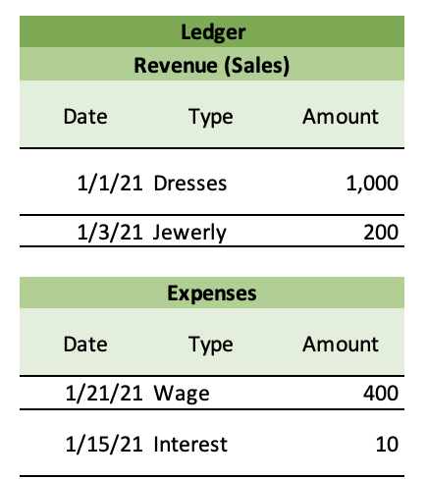 | 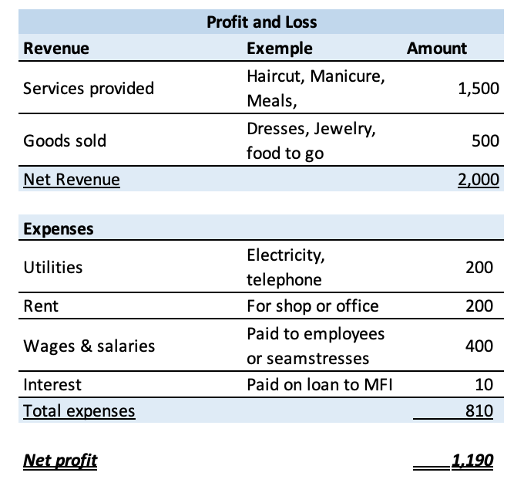
An app to keep track of financial records may look like this:
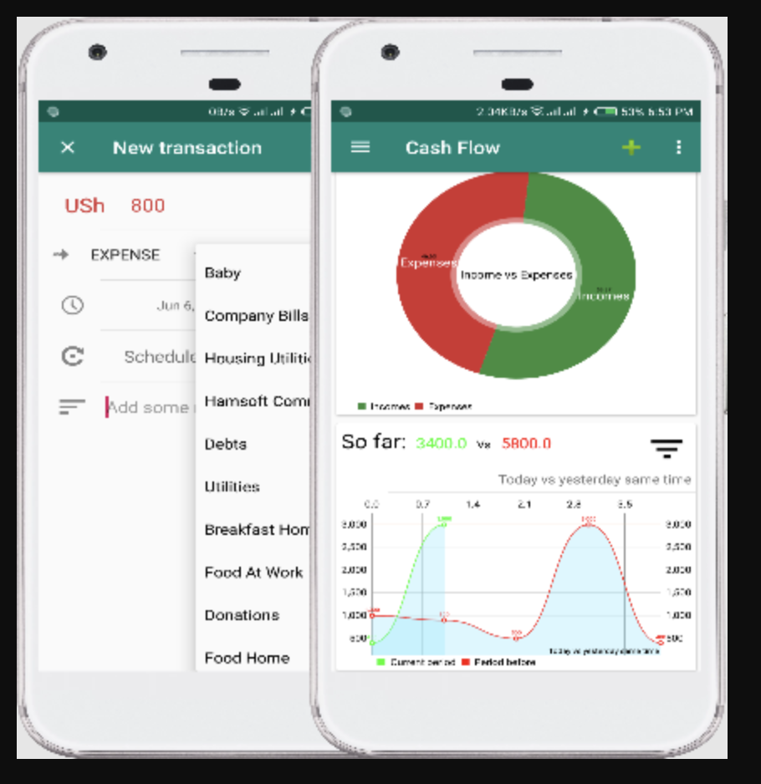

Getting a Merchant ID.
To start the process, business owners will need to contact a mobile money agent or the main line of the mobile money provider. Some mobile money providers (but not all) require proof of business registration.
Episode 24: How can a “digital footprint” grow opportunities for my business?

LEARNING OBJECTIVE | Entrepreneurs learn how they can build a digital footprint to access additional financial resources.

DISCUSSION QUESTIONS
- How can smartphone services use our information to help our businesses?
Sample answer: In the case of Josephine, the service used her farm information to help match her with buyers. Some services can provide sellers and buyers with more trust and certainty. In the case of Josephine, the service has key information such as crop types, fertilizers she uses, etc. which can also allow them to provide specific information or advice on how to tend to her crops.
Sample answer: By just having where her farm was located, the company Josephine signed up with can offer her insurance that uses weather information on her location to determine whether or not there has been enough rain for her crops.
Sample answer: In another episode, Lily talks about keeping track of her business expenses on an app, which helped the bank speed up the process of approval for her loan.
- What are some risks associated with having more of your information collected?
Sample answer: Not knowing what information is collected and how it is used can be a risk. Sometimes I feel like I just am more comfortable with having as little information about me collected as possible. What is most concerning is when the information that is collected by the mobile network operator or companies that provide my smartphone apps is sold to other companies I do not know about.
Sample answer: Sometimes I feel nervous about my personal data being collected, but less nervous about my business data.
- Do you have a right to limit which of your personal information is collected and shared?
Sample answer: You can always choose not to use a certain app or service that collects information. For others, you may be able to decide what information to share vs. not. Once you enter the information into the service, they must follow the information sharing rules required by law and their own policies.

ACTIVITIES
- Smartphone navigation
- If participants have smartphones, practice going through the settings on an Android to show how to set location settings and other data collection elements and privacy settings of each app (See Annex pg. 56). Actions to practice could include:
  - Allowing apps to only track your location when the app is being used;
  - Adjust whether the apps can notify you and push messages onto your phone;
  - Give/remove app access to your camera and microphone;
  - Removing some app’s ability to use cellular data (possible with some apps, if the user wants to protect data).

ADDITIONAL INFORMATION

Information collected on smartphones vs. feature phones
Both types collect information on activities happening in the phone (i.e. calls, messages, transactions) and keep a record. Smartphones also have sensors, which detect things happening outside of the phone, and can be used for a number of purposes.

 | Records of activities in the phone, like calls, SMS messages, mobile money transactions | Sensors that detect information outside your phone, like location and motion
Smartphones | x | x
Feature phones | x

Episode 25: How can I use my phone to expand sales?

LEARNING OBJECTIVE | Entrepreneurs appreciate the digital opportunities for marketing and commerce and can evaluate options.

DISCUSSION QUESTIONS
- Who in the group has already purchased something online through a Facebook business page, WhatsApp business number, or some other online platform?
- Who in the group has already sold something online through a Facebook business page, WhatsApp business number or some other online platform?
- Why is it important to keep a good record of sales, purchases, inventory, and other transactions for your business?
Sample answer: Keeping a good record of these transactions can help you when you are discussing with a bank of MFI about taking out a loan.
ACTIVITIES
- Participants go through their favorite Facebook business pages and highlight what they like the most about these pages and how they can adopt these strategies to their own business.

ADDITIONAL INFORMATION

Steps for connecting your WhatsApp business account with your Facebook Page:
- Navigate to your Facebook business Page.
- Click Settings.
- In the left side column, click WhatsApp.
- Choose your country code.
- Enter your WhatsApp number and click Send Code.
- Input the code and click Confirm.
Tips for making a strong Facebook Business Page:
- Make sure you are creating a Business Page for your business and not a personal profile for your business. A Facebook Business Page gives you access to specific content creation tools, paid promotional opportunities, and important analytics/insights. A Business Page also makes sure everyone has access to your page and all posts.
- Add a recognizable profile picture: make the page profile picture a clear image of your logo or something that represents your brand.

Fill out your 'About' section with basic information, and add company milestones.

Post photos and videos to your Timeline: visual content is prominent on all social media, but make sure the images are clear and neat.

Determine the ideal timing and frequency for your posts: create a balance in posts by posting often but not too often that followers get bored of the content.
- Add a button. Every Facebook Page has a prominent call-to-action (CTA) button below its cover photo. It is a great opportunity to get your Page visitors to take an action, such as sending you a message or learning more about your business.

Adding a Facebook call-to-action (CTA) button:
(For full image see Annex pg. 55)
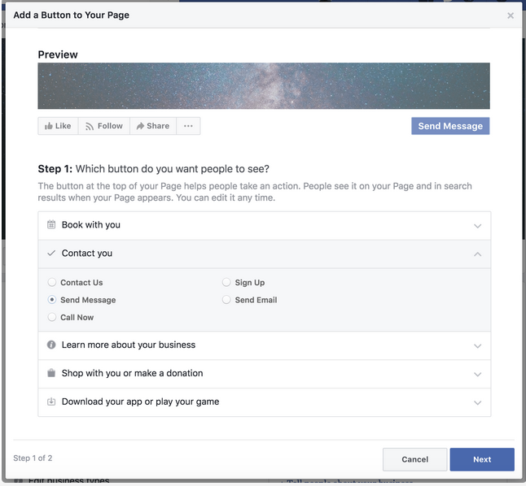

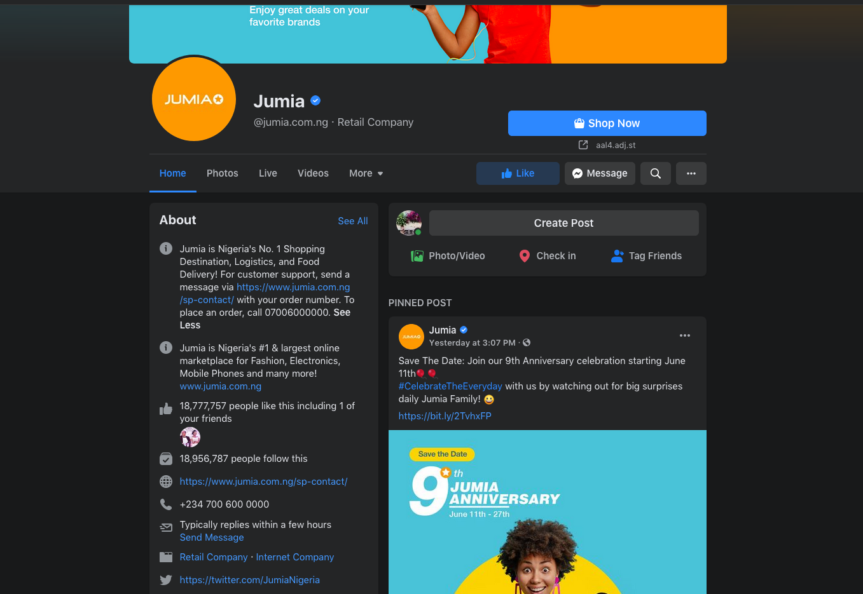
Examples of Strong Digital Marketing pages:

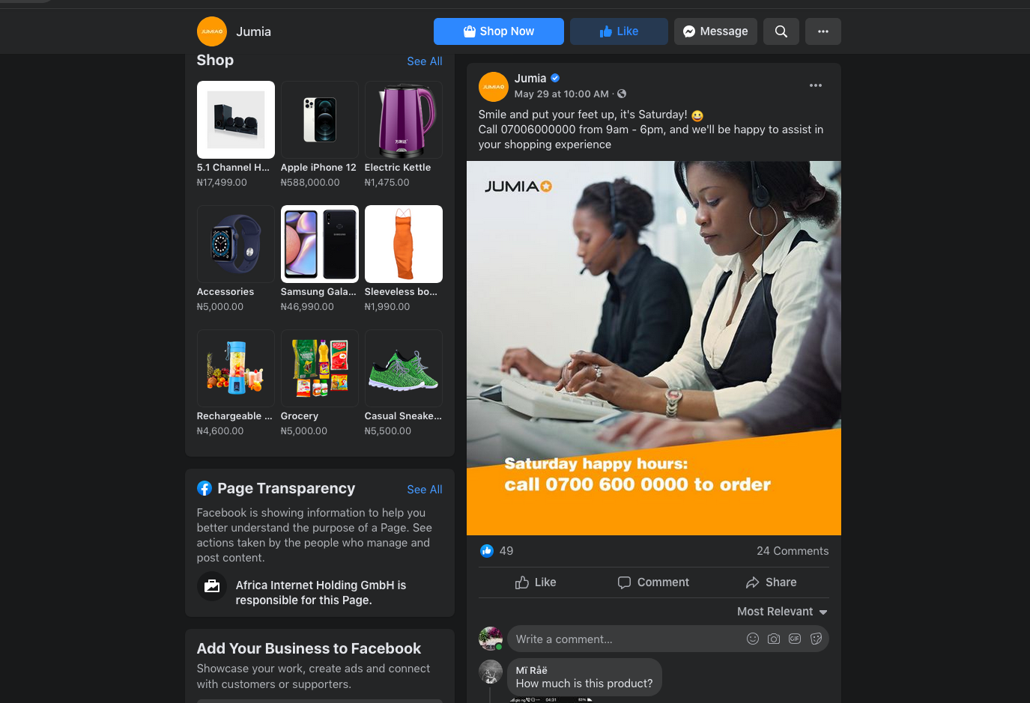
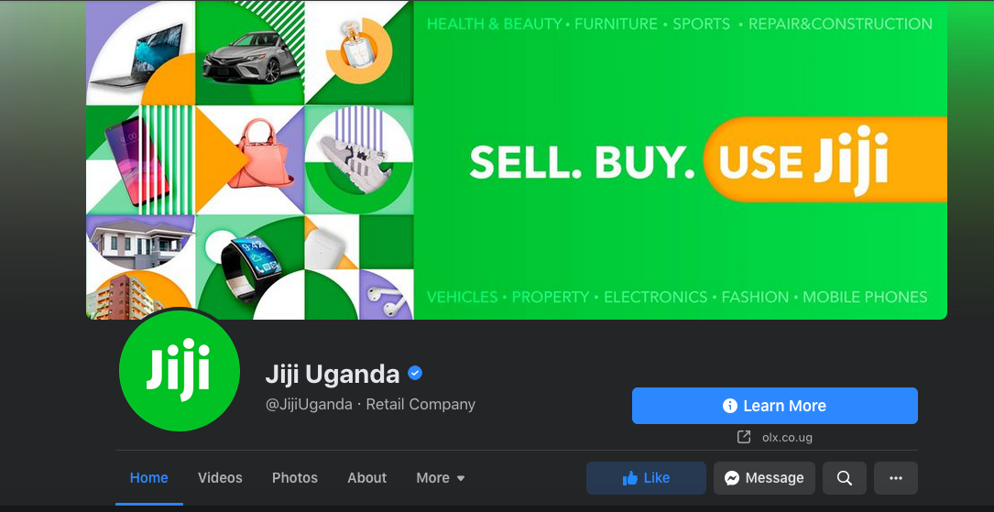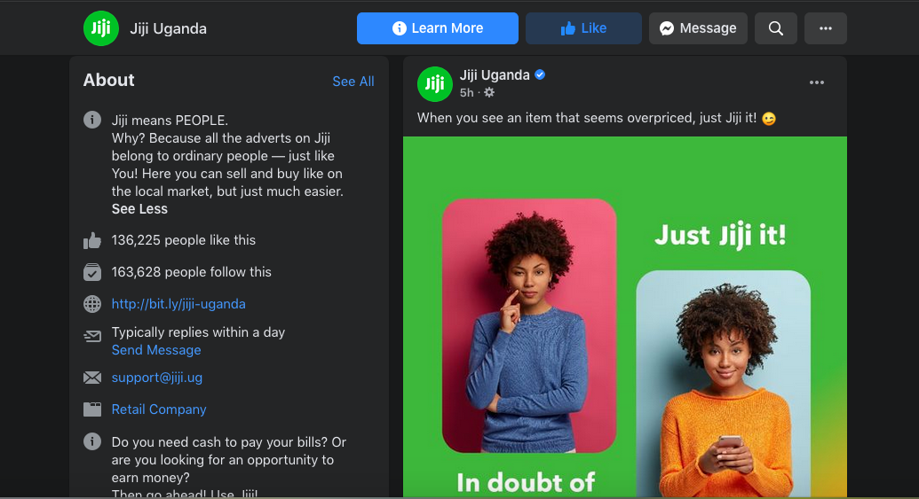

WhatsApp Business App: https://www.whatsapp.com/business/

Additional Resources
- Facebook’s #SheMeansBusiness: trainings, tips, and community for women entrepreneurs online

General facilitation questions

These can be asked after any episode:
- Which character do you identify most with? (Who feels most like Myriam? Josephine? Annette? Lily?) Why?
Sample answer:
- Myriam is the most advanced of the women in knowledge of digital and financial services. She likes to share her knowledge with other women. She is the main income earner for her household.
- Josephine has some knowledge around mobile phones and money, but is not as advanced as Myriam.
- Annette has little knowledge around mobile phones and money, but she is eager to learn. She is pregnant with her first child.
- Lily is an ambitious young entrepreneur who is trying to grow her business by using digital tools and services.
- Annette knows much less about mobile phones and financial concepts than Josephine and Myriam. What is her attitude around learning new things?
Sample answer: Annette does not feel ashamed about what she does not know and finds that learning new things improves her life.

Gender-focused questions:

- Do women and men have different capabilities to handle money and technology?
Sample answer: No, women can be just as effective as men in managing money and using technology. Some people have less training and experience than others, but they can learn and develop their skills.
- How much control do you (women) have in the money you earn? In your household’s finances?
- Has anyone negotiated with their husband to have a greater role in financial decisions for the household? What worked well? How would you advise other women?
- What benefits come from women having an important role in decisions about money?
Sample answer: Many women are smart financial managers. Women tend to prioritize money for the well-being of the household members. Women can also be effective business owners; if they have money they can invest in their enterprise, they may be able to generate good profits.

- Resources

- Guide to all active mobile money providers in country

For each:
- Short codes
- How to register an account
- How to transfer to savings
- How to see fees

- Idea for icebreaker (get to know each other)

Web
Group members in a circle, use a ball of yarn or cloth: A first participant says her name and one thing she likes, then throws the ball to someone else in the circle. This continues until all participants have spoken and a web has been created linking them all together.

Option: Instead of one thing they like, participants say one word reflecting their state of mind (e.g., energy, excitement, curiosity, fear).

- Outside resources to address gender-based violence

- Recommendations may differ by country (local CSOs/NGOs focusing on GBV)

- Reporting

Please tell us about your facilitation activities! After each facilitation session, please send us the following information.

- Date
- Location
- Total # of participants (not counting young children)
- Total # of female participants (not counting young children)
- Episodes covered
- Any observations/feedback/concerns (including any reported or suspected incidents of gender-based violence as a result of the program)

You can send information through Facebook (page name), WhatsApp (group name/phone number), or send an SMS to (local staff).
- Annex

- Full-size Graphics/Images

The Internet
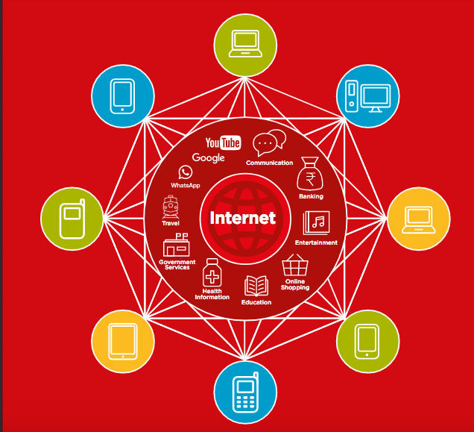
(Source: GSMA Mobile Internet Skills Training Toolkit, 2017)

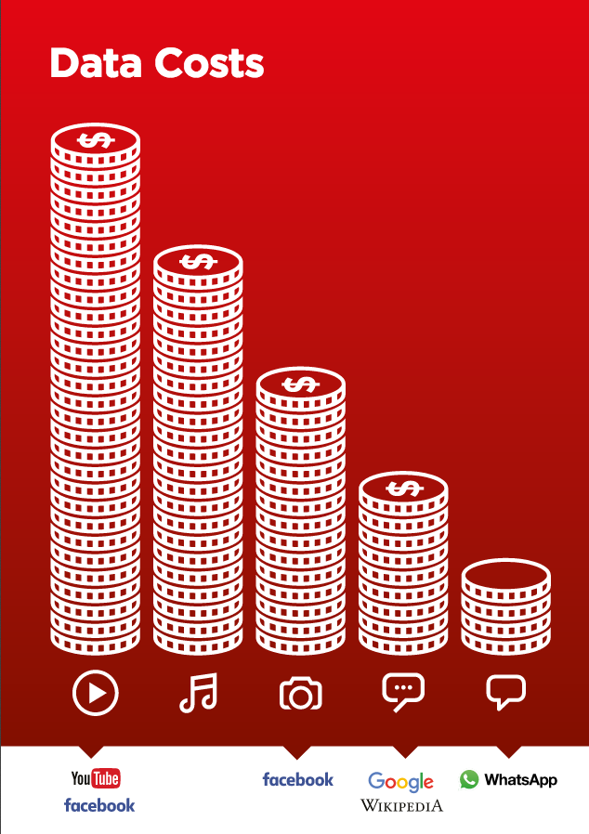
(Source: GSMA Mobile Internet Skills Training Toolkit, 2017)
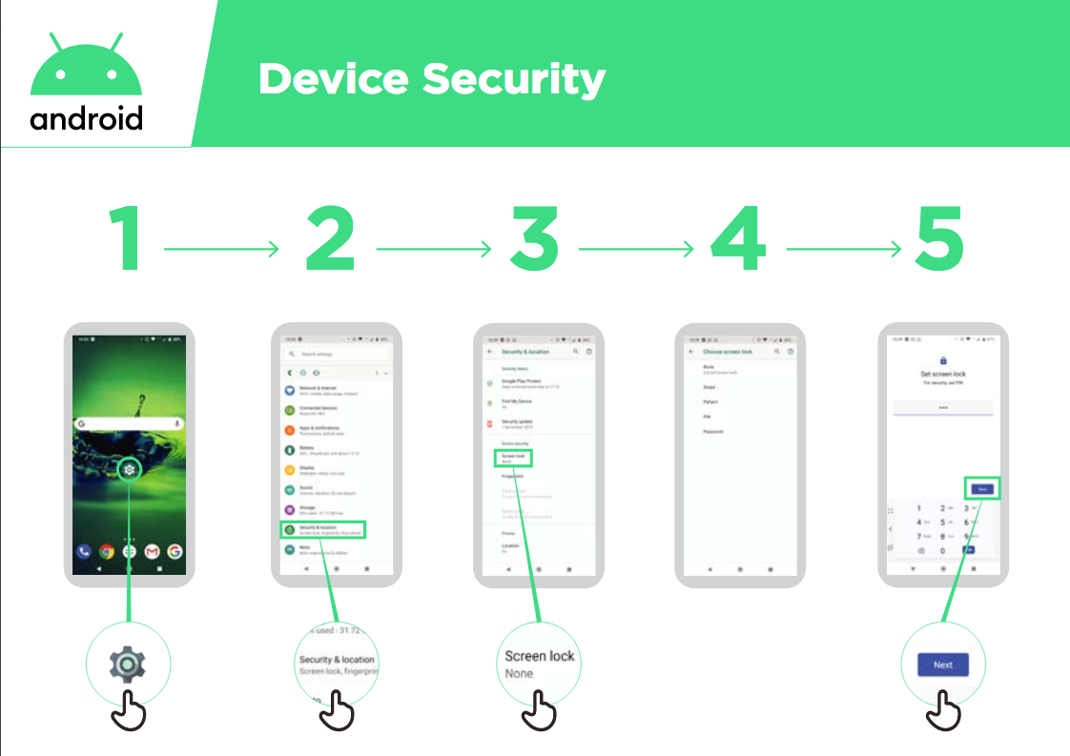
(Source: GSMA Mobile Internet Skills Training Toolkit, 2017)
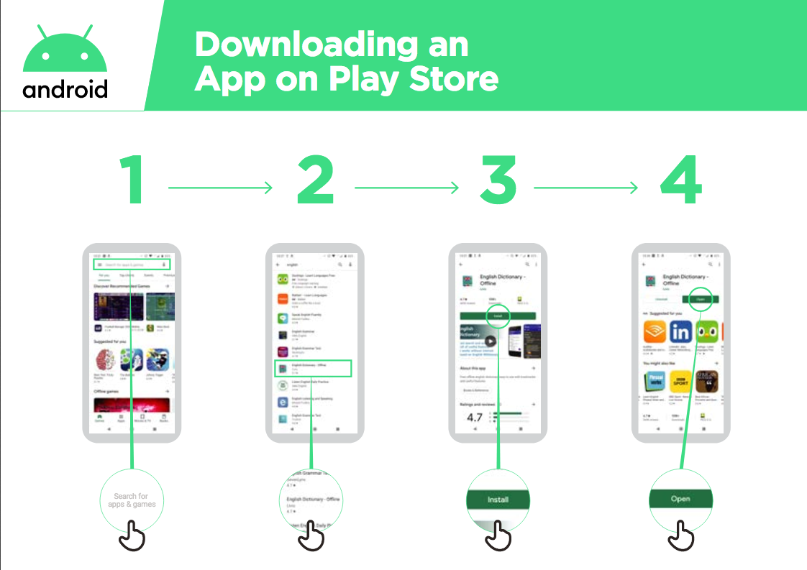
(Source: GSMA Mobile Internet Skills Training Toolkit, 2017)
Google Play Store Screenshots

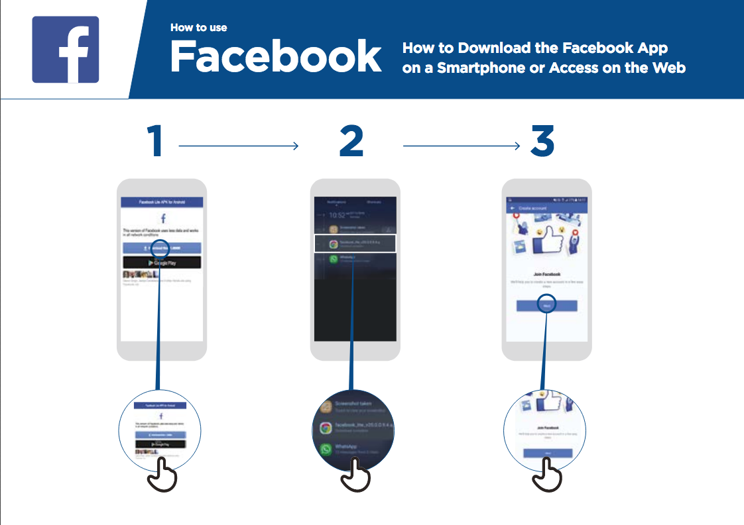
How to download/use Facebook, YouTube, and WhatsApp
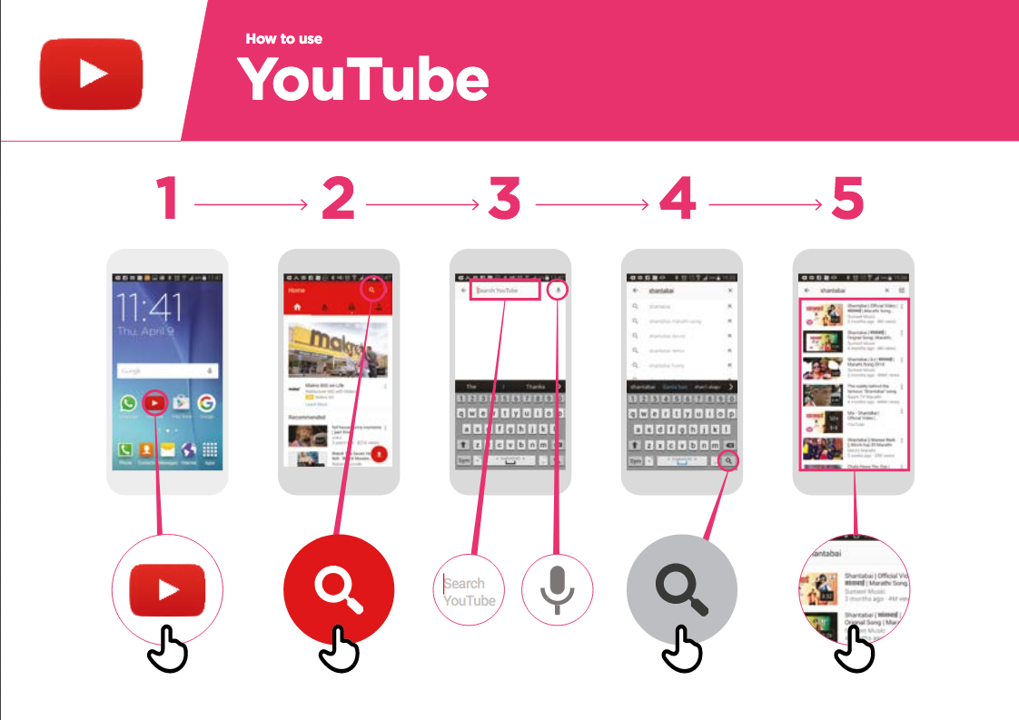
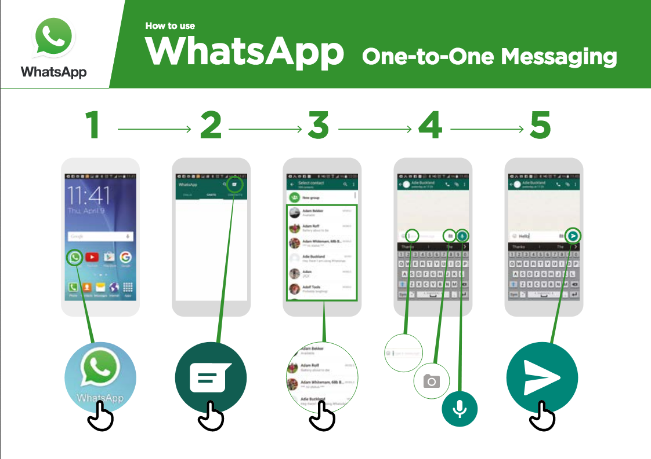
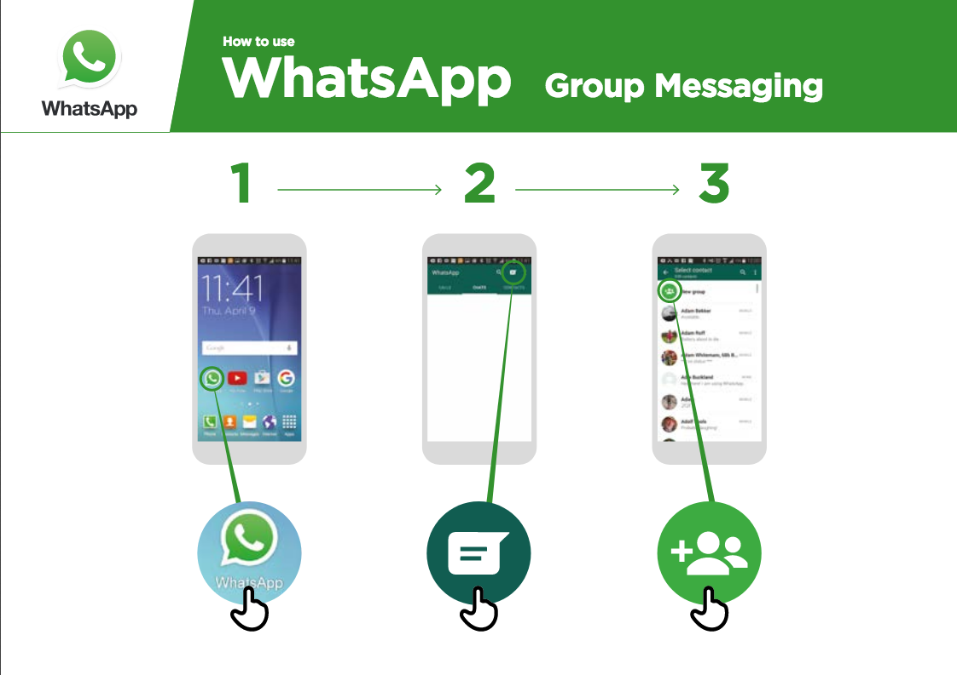
Adding a Facebook call-to-action (CTA) button:
- Additional Information
Settings/Turning off Cellular (Mobile) Data
Smartphones may have different interfaces. But the settings symbol is universal.

Here are some example screenshots of how to switch cellular (mobile) data on and off:

Information collected on smartphones vs. feature phones

Both types collect information on activities happening in the phone (i.e. calls, messages, transactions) and keep a record. Smartphones also have sensors, which detect things happening outside of the phone, and can be used for a number of purposes.

 | Records of activities in the phone, like calls, SMS messages, mobile money transactions | Sensors that detect information outside your phone, like location and motion
Smartphones | x | x
Feature phones | x
How to do an internet search:
What is a Google Search - “Google Search helps you to find information that you want. You tell Google what information you want to find, e.g., ‘what is the population of the world’ and it will search through all the information that people have put on the internet, to find what you want” (GSMA Internet Skills Toolkit, 2018)

Google can be found as an app on your smartphone or can be found on your web browser (Chrome, Android web browser).

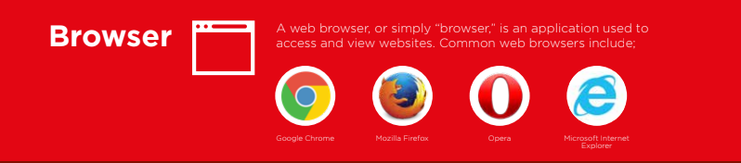

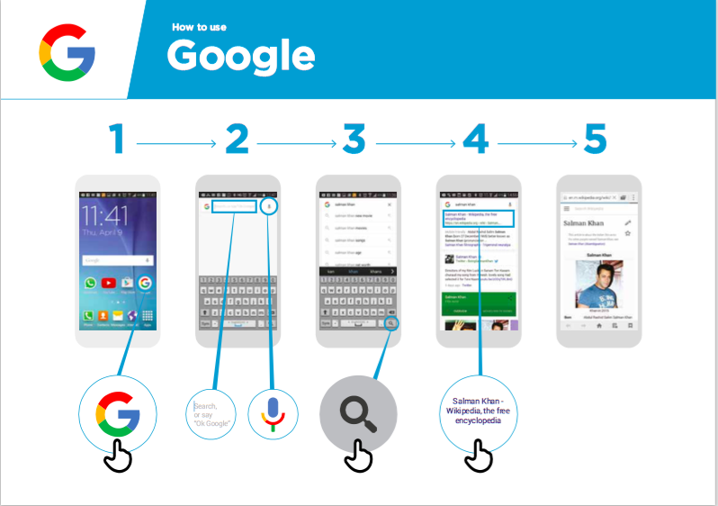
(Source: GSMA Mobile Internet Skills Training Toolkit, 2017)

