ISIFUNDO SESIBILI: GOOGLE
YISIBUNGU BANI I GOOGLE
I Google ngelinye lama bhurawuza asetshenziswa ngabantu ukudinga abakufunayo ku internet.
AMANYATHELO OKULANDELA EKUSEBENZISENI I GOOGLE
- “Ukudingisisa usebenzisa iGoogle kuyakuphathisa ukuthi uthole ulwazi olufunayo, Uyatshela iGoogle lololwazi ofuna ukuluthola, isibonelo, ‘Abantu bangaki emhlabeni wonke jikelele?’ ngokunjalo izakudingela kulo lonke ulwazi oselufakwe ngabantu kuyinthanethi, ukuze ithole lololwazi olufunayo.”
- “Ungathola ulwazi ngezindawo, ngemisebenzi, indlela zokupheka, amabhayisikopo, izingoma, ulwazi ngomsebenzi wesikolo, wekolitshi, wemihloliso lokunye”
UKUSEBENZISA I GOOGLE
Hlaba umfanekiso ofana lalo ongaphansi
- Ngemva kwalokho bhala lokho ofuna ukubakwazi ngakho (Njengesibonelo) “izaga lengcazelo”
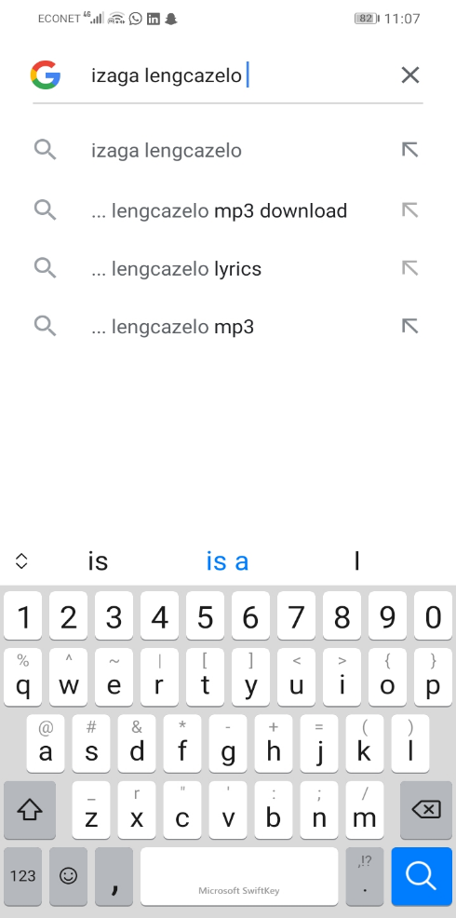

Elikudingayo kuyahle kuphume njengalokhu

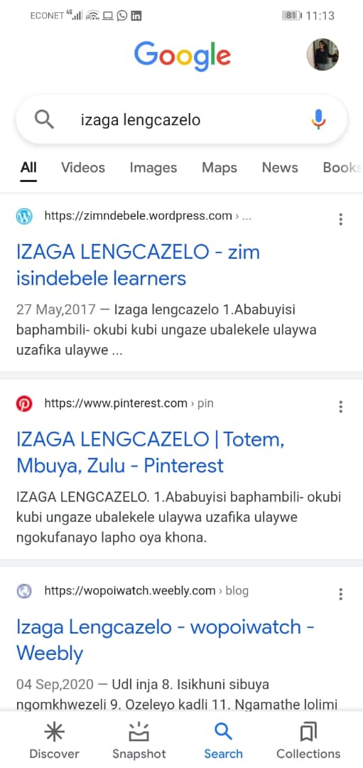

UKUKHALIPHA OKUKHULU
- Singavula kukhasi le Google sithola ukuthi I google isipha ukuthi sikhethe ukuthi impendulo zethu ukuthi sizifuna zinjani njengalokhu
impendulo zika “konke” (‘konke’, ‘imifanekiso’, ‘amavidiyo’ ‘lamamephu’ ‘izingwalo’
Ngokunjalo ungahlaba imifanekiso uyaphiwa impendulo yakho iyimifanekiso , ungahlaba amavidiyo uyithola ikumavidiyo
UKUZENQABELA NXA SISEBENZISA I GOOGLE
- Kuqakathekile ukubalolwazi ukuthi I inthanethi yindawo kazulu wonke jikelele ngakhoke kubalulekike ukuyithatha ngaleyo ndlela ukuthi lihlale livikelekile
- Zivikele ngokungakhulumi labantu ongabaziyo kumbe ukukhuluma labantu abahluphayo.
- Izinto eziphathelane lawe kakhulu mazihlale ezindaweni ezivikelekileyo okufana lemipikitsha , okuphathelane lemali lokunye okunjalo.
- Hlonipha abanye abantu abasebenzisa I internet/Google

