CHIDZIDZO 2: GOOGLE
Chii chinonzi Google
Google ibhurauza rinoshandiswa kutsvaga zvinhu pa Internet
Tsananguro yekutsvaga zvinhu pa Google
- “Panotsvagwa zvinhu paGoogle panokubatsira kutsvaga ruzivo rwamunoda. Unoudza Google mashoko amunoda kutsvaga, somuenzaniso ‘ Tsumo nemadimikira’, uye yotsvaga mumashoko ose akaiswa nevanhu paindaneti, kutsvaga zvamunoda.
- Munogona kuwana ruzivo pamusoro penzvimbo, mabasa, mabikiro, mafirimu, nziyo, nhau, nyaya dzechikoro, korichi, bvunzo, nezvimwewo.
Zviitwa: Kushandisa Google
- Dvanyai pachikwangwani chakaita sechiri pasi kuti mupinde paGoogle;
- Nyorai mazwi ezvamurikutsvaga. Semuenzaniso “Tsumo nemadimikira”
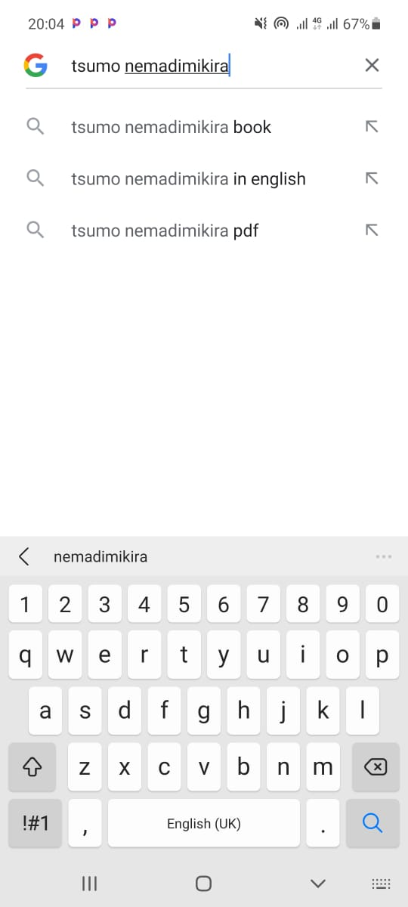

Zvamurikutsvaga zvinobva zvabuda seizvi
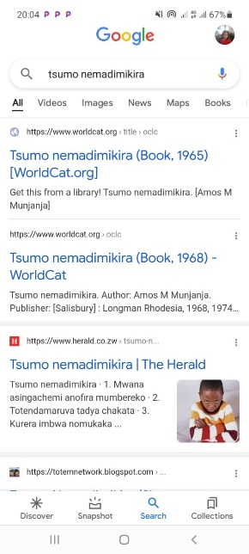
Chenjedzo: Google in tebhu dzakasiyana siyana dzinosanganisira images (mifananidzo), videos nemaps. Kana ukabaya tebhu dzakasiyana siyana, Google inoburitsa zvakasiyana siyana. Somuenzaniso, kana ukabaya tebhu yemufananidzo, unoona mifananidzo chete
Kuzvichengetedza paGoogle
- Zvakakosha kurangarira kuti indaneti inzvimbo yeruzhinji, uye zvakakosha kuitora saizvozvi kuti mugare makachengetedzeka.
- Rega kutaura nevanhu vamusingazivi kana kuti vari kukunetsai.
- Kana musina kugadzikana nekuda kwezvamaona kana kuti zvaitika pakutaura nemunhu wamunoziva huye wamunovimba naye.
- Zvinhu zvine chekuita nemi pachenyu zvinofanirwa kuchengetedzwa pakavanzika.
- Remekedzai vamwe vanhu vanoshandisawo Google

