

Connected Society

Mobile Internet Skills Training Toolkit

A guide for training people in basic mobile internet skills

Copyright © 2017 GSM Association

case.

**9**

**MODULE 9 – ANDROID**

**Module 9 – Android**

# Bitesize Training

**BITESIZE - ANDROID**

**BITESIZE – MOBILE MONEY**

 What is it?

**Explain:**

“A smartphone is like a mini computer that you control by touching the screen rather than using buttons. They can take photos, play music and videos and have apps that can help you enjoy the best of the internet and do more with your phone. Android enabled devices are the most popular smartphones across the world. Your Android enabled phone quickly gives you access to the internet, so you can use it to search for information you need on Google, watch videos on YouTube, and share photos.”

|  |  |
| --- | --- |
| **Materials you will need**    Mobile Phone  Diagram  Description automatically generated with medium confidence  Android Posters | **What can you use it for?**  **Explain:** “An Android smartphone can help you access the internet. This means you can search for the latest news and information, share pictures with friends and enjoy your favourite music and sport. It also means you can get a map and pick the best route to your next destination with Google Maps, or learn a new skill on YouTube.”  **Share** examples from your own life about how  smartphones are useful to you.  **Make it relevant** to the trainee by discussing how it can be beneficial in the trainee’s own life. |

BITESIZE – ANDROID

**BITESIZE - ANDROID**

**BITESIZE – MOBILE MONEY**

How Does It Work?

|  |  |
| --- | --- |
| **Place the phone  in the trainee’s hand and help them follow the steps** | **Demonstrate** how the trainee can download an app using  the Play Store.  Graphical user interface, application  Description automatically generated  Show the “Downloading an App in  Play Store” poster. |



Practise

**“Now that you can download apps from the Play Store, what kind of Apps are you interested in?”**

**Demonstrate:** Help your trainee download an app from the Play Store. Then, help them use it. If they are unsure what kind of app they are interested in, give them some prompts (e.g. sport, weather, language learning, music).

**Tip:** Once you have an App on your phone it will stay there until you delete it. You don’t need to keep going to the Play Store to get it.

BITESIZE – ANDROID

**Posters, Cut-outs and  
Info Sheets**



Icon Cutouts - Android

Icon Cutouts - Android

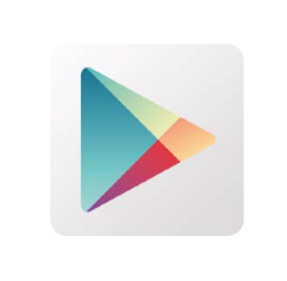



Icon Cutouts - Android





### Downloading an App on Play Store

**Open**

**Install**

English Dictionary

Search for   
apps & games

### Create Google account

**Create account**

### Connecting to a Wi-Fi network

Password

**Connect**

### How to use Chrome

**

### Sending an email on Gmail

**

### Data Saver

**Network & Internet**

**Data usage**

**Data Saver**  
Password

**

### Battery Saving

**Turn on now**

**Battery**

**Battery Saver**  
Off

**

### Device Security

**Next**

**Security & Location**

**Screen lock**  
None

**

### Google Assistant



**CERTIFICATE**

has completed

**BASIC MOBILE INTERNET SKILLS**

training

Date Signed

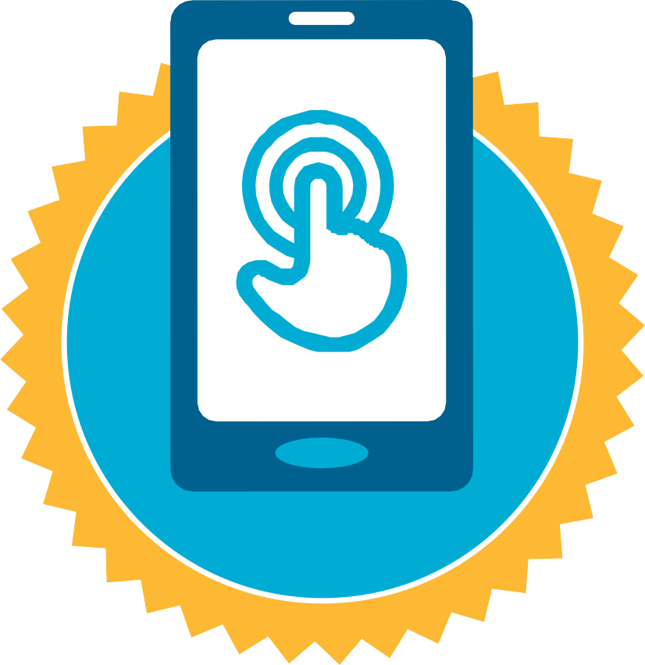

**CERTIFICATE**

has completed

**BASIC MOBILE INTERNET SKILLS**

training

Date Signed