

Connected Society

Mobile Internet Skills Training Toolkit

A guide for training people in basic mobile internet skills

Copyright © 2017 GSM Association

case.

**9**

**MODULE 9 – ANDROID**

**Module 9 - Android**

**In-  
Depth Training**

**BITESIZE - ANDROID**

**BITESIZE – MOBILE MONEY**

|  |  |
| --- | --- |
| Learning Objectives  **This module will give trainees:**  • A basic idea of what Android is and how it can help them access the internet  • An understanding of what a Google Account is and why it is important  • An introduction to some of the apps and features available in Android  • Some basic tips on how to save money and stay safe in Android | 45-60  **Time Duration:** 45-60 minutes |

|  |  |  |
| --- | --- | --- |
| **Materials you will need:** | | |
|  |  |  |
| Android  Smartphones | Diagram  Description automatically generated  Android  Posters | A picture containing text, businesscard  Description automatically generated  Icon Posters |

BITESIZE – ANDROID

INTRO / CREATING A GOOGLE ACCOUNT / PLAY STORE / CHROME / GOOGLE ASSISTANT

GMAIL / COST / BATTERY SAVING / SAFETY / RECAP

**BITESIZE - ANDROID**

**BITESIZE – MOBILE MONEY**

**MODULE 9 - ANDROID**

Introduce Android

|  |  |
| --- | --- |
|  | **Explain:** “A smartphone is like a mini computer that you  control by touching the screen rather than using buttons.  They can take photos, play music and videos and have ‘apps’  that can quickly take you to an internet service. Android  enabled devices are the most popular smartphones across  the world. Your Android enabled phone quickly gives  you access to the internet, so you can use it to search for  information you need on Google, watch videos on YouTube,  and share photos.”  **Explain:** “An Android enabled phone can help you access  the internet. This means you can search for the latest news  and information, share pictures with friends and enjoy your  favourite music and sport. It means you can get a map and  pick the best route to your next destination with Google  Maps, or learn a new skill on YouTube.” |

**Share** examples from your own life about how smartphones are useful.

**Make it relevant** to the trainee by discussing how it can be beneficial in the trainee’s own life.

BITESIZE – ANDROID

INTRO / CREATING A GOOGLE ACCOUNT / PLAY STORE / CHROME / GOOGLE ASSISTANT

GMAIL / COST / BATTERY SAVING / SAFETY / RECAP

**MODULE 9 - ANDROID**



Activity: Creating a Google Account

|  |  |
| --- | --- |
|  | **Explain Google Accounts**  **Explain:** “If you want to use an Android phone you will need to  create a ‘Google Account’. A Google Account is really important for  using your Android mobile phone. It will allow you to get apps. It will also save all your information – like your contacts, apps and photos - in one place. It will also help if you want to change to a different phone in the future.” |

**Explain:** “If you create a Google Account you will be able to:

• Download some of the millions of apps from Google Play

• Find your new favourite video on YouTube.

• Use Gmail for email on your phone”

**Show the “Creating a Google Account” poster**

|  |  |
| --- | --- |
|  | • **Explain:** “You are now going to create a Google Account.  To do this you will need to be connected to the internet  - either on Wi-Fi or mobile data. It is better if you can do  this on Wi-Fi as it saves money.”  • **Trainer:** Help trainee connect to Wi-Fi if this available.  • **Show:** trainee the Wi-Fi and connectivity icons on the  phone to show when they are connected to the internet. |

MODULE 9 – ANDROID

**MODULE 9 - ANDROID**

**Show the “How to connect to Wi-Fi on Android**

INTRO / CREATING A GOOGLE ACCOUNT / PLAY STORE / CHROME / GOOGLE ASSISTANT

GMAIL / COST / BATTERY SAVING / SAFETY / RECAP

**Show the “How to connect to Wi-Fi on Android” poster**

|  |  |
| --- | --- |
|  | • **Explain:** what Wi-Fi is: “When you connect to a Wi-Fi  network, you can go online without using data from your  phone. This means you can search for information or watch  videos without using data.”  • **Explain:** “You will normally need to enter a ‘password’  before you can use Wi-Fi. The person who owns the Wi-Fi  can tell you what this is.” |

**Tip**: “It is not always safe to connect to Wi-Fi if you are not sure who owns it.

Make sure you know who owns the Wi-Fi before you connect.”

• **Ask** if the trainee would like to create a Google Account. If they do, walk them

through the steps on the poster.

**Explain:**

• “An account is something that belongs to you. It will help you with your phone.”

• “If you have an email, type that into the first box. If you don’t have one, don’t worry!

You can create one or you can use your phone number!”

• “In order to create an ‘account’ you will need to put some personal information on the

phone. If you don’t know your birthday, give it a guess.”

**Tip:** Wi-Fi may not be available in your local area. Also, it is not always safe to connect to Wi-Fi if you are not sure who owns it. Make sure you know who owns the Wi-Fi before you connect.

MODULE 9 – ANDROID

MODULE 9 – ANDROID

**MODULE 9 - ANDROID**

INTRO / CREATING A GOOGLE ACCOUNT / PLAY STORE / CHROME / GOOGLE ASSISTANT

GMAIL / COST / BATTERY SAVING / SAFETY / RECAP

Activity: Play Store

|  |  |
| --- | --- |
|  | **Explain**: “The Play Store is where you can find - and download -  Apps. Apps are simple ways to access internet services like the  Google app, YouTube and Gmail. There are also Apps that are games  or that give you news or help you learn something. Music, video, TV  and books may also be available from the Play Store.”  **Explain**: “Many of these Apps are free and there are currently  millions of Apps in the Play Store.” |

|  |  |
| --- | --- |
|  | **Show the “Downloading an App in Play Store”**  **Poster**  **Ask** If you can help the trainee would like to download an  app, then walk them through the steps on the poster.  **Explain:** “Many apps are free – you do not have to pay for  them. But some apps cost money and you will have to pay  before you can download them. Other apps are free to  download but you can pay for extra features later.”  **Demonstrate:** Show trainee both the free and paid apps in  the Play Store and where the information about price is. |

**Practise!**

“Now that you can download Apps from the Play Store, what kind of Apps are you interested in?”

**Trainer:** Help your trainee download an app from the Play Store. Then, help them use it.   
If they are unsure what kind of App they are interested in, give them some prompts for areas   
they might be interested in (e.g. sport, weather, language learning, music) or apps you think   
they might like (e.g. YouTube).

**Explain:**

“Once you have an App on your phone it will stay there until you delete it. You don’t need to keep going to the Play Store to get it. Apps will sometimes ‘update’- this means the app is getting better!”

MODULE 9 – ANDROID

**MODULE 9 - ANDROID**

INTRO / CREATING A GOOGLE ACCOUNT / PLAY STORE / CHROME / GOOGLE ASSISTANT

GMAIL / COST / BATTERY SAVING / SAFETY / RECAP

**MODULE 9 - ANDROID**

Activity: Chrome

|  |  |
| --- | --- |
|  | **Explain:**  • “Every Android phone has Chrome. This is a ‘web browser’ –  where you can search for any ‘website or information you want.”  • “Many people, businesses, governments and other organisations  have websites where you can find information.” |

**Bring these benefits to life!**

**Share personal examples of how Chrome helps you, your friends and family.**

Some examples might include:

• Finding specific information (e.g. about local healthcare or educational facilities)

• Searching for tips for problems you have

• Chrome can help you reduce the amount of mobile data that you use

**Get practical!**

**Explain:** “Using Chrome allows you to go to any website in the world! This means

you can find information about anything! Let’s find a topic to learn!”

**Show the “How to use Chrome” poster**

**Demonstrate:** On Chrome, show the trainee how they can access   
a website by typing in the URL (e.g. www.google.com). Try to take   
them to a website that you think the trainee will be interested in.

MODULE 9 – ANDROID

**Tip:** There are many different ‘web browsers’ for using the internet. Some of the most common icons for these are displayed below. Depending on the phone you use, you may use one of these rather than the one shown above.

**MODULE 9 - ANDROID**

**MODULE 9 - ANDROID**

INTRO / CREATING A GOOGLE ACCOUNT / PLAY STORE / CHROME / GOOGLE ASSISTANT

GMAIL / COST / BATTERY SAVING / SAFETY / RECAP

Activity: Google Assistant

|  |  |
| --- | --- |
|  | **Explain:** “With Google Assistant, you can get things done on your  Android phone using just your voice. You can ask it to help you call  a friend, play videos or help you find businesses in your local area.  You just have to speak to your Android phone using the microphone,  using your voice.” |

**Show the “How to use Google Assistant” Poster**

|  |  |
| --- | --- |
|  | • **Explain:** “You are now going to use Google Assistant. Just  say “Hey Google” or press and hold the home button. The  home button is often the big button at the bottom of your phone.”  • **Explain:** “If you have an older version of Android on  your phone, it is possible you may not have the Google Assistant”  • **Demonstrate** how to activate Google Assistant: Just say  “Hey Google” or press and hold the home button.  • **Demonstrate** how to use it: “Speak loudly, clearly and  slowly. Ask Google Assistant a question or to help you do  something on your mobile phone.” |

**Get practical!**

**Tip:** For the best experience while using the Google Assistant, speak loudly and clearly into your phone. You might need to change the language settings to make it easier to understand the Google Assistant as you can select the language you understand best if available.

**Show** trainees that they can access Google Assistant by pressing on the microphone in the middle of their Android home screen.

**Ask** your trainees to ask Google Assistant something they would like to do. This could be a question they have about music, sport or something else they want to know. Or it could be something they want Google Assistant to do on their phone.

This could include:

|  |  |
| --- | --- |
| • Asking ‘how many people live in the  world’  • Send an SMS message | • Open an app on the phone  • Play a song  • Call one of their contacts |

MODULE 9 – ANDROID

INTRO / CREATING A GOOGLE ACCOUNT / PLAY STORE / CHROME / GOOGLE ASSISTANT

GMAIL / COST / BATTERY SAVING / SAFETY / RECAP

**MODULE 9 - ANDROID**

Activity: Gmail

|  |  |
| --- | --- |
|  | **Explain:** “Email is another way to communicate with people like SMS,  calling or WhatsApp. It is better for writing longer messages and is  used more for business communication.”  **Explain:** “Gmail is an easy-to-use email app on Android devices. It  saves you time and keeps your messages safe. You can send emails  from Gmail on a computer or on a phone. All you need is your  Google Account, which you can create while setting up your Android  phone! You will be able to find all your email even if you switch  phones in the future.” |

|  |  |
| --- | --- |
|  | **Show the “Sending a message on Gmail” poster**  **Get practical!**  **Show** trainees that they can access Gmail through the home  screen and by logging into their Google Account.  **Demonstrate** how to send an email by sending a simple email with the subject ‘Hello’ to your email address. Walk them through the steps on the poster.  **Make Gmail relevant to your trainees**  **Discuss** how Gmail might help them in their lives.  **Ask:** “How could you use Gmail in your own life?” Provide some suggestions based on their interests – from either your work or personal life. |

**Tip:** There are many different ways to send and receive an email. Some of the popular ones are shown below. It does not matter which one you have; all can send to each other!

MODULE 9 – ANDROID

**MODULE 9 - ANDROID**

**MODULE 9 - ANDROID**

INTRO / CREATING A GOOGLE ACCOUNT / PLAY STORE / CHROME / GOOGLE ASSISTANT

GMAIL / COST / BATTERY SAVING / SAFETY / RECAP

**MODULE 9 - ANDROID**

Activity: Cost

|  |  |
| --- | --- |
|  | **Explain:** “To access the internet via your mobile phone, you can  either use a mobile data connection or a Wi-Fi connection. Using Wi-Fi  means that you do not have to use your data.” |

|  |  |
| --- | --- |
|  | **Show the “Data Cost” poster**  **Explain:** “Normally, when you use the internet on your phone, you are using mobile data. You may have data included in your plan or subscription or you will need to buy this from your local mobile network agent or a shop that sells phone credit. Some things you do on the internet, like watching videos or listening to music, use more data, so it will cost you more money.”  **Explain:** “Your Android phone can help you control and manage the data you use, which can save you money!” |

|  |  |
| --- | --- |
|  | **Get Practical**  Demonstrate how trainees can access information about  their data usage on their Android phone.  **Show the “Turn on Data Saver in Android” poster**  **Explain:** “In Android you can see how much data you have  used so that you don’t run out of your data pack. You can  also turn on Data Saver which will mean you use less data  and spend less money.”  **Show** trainees that they can turn on Data Saver by following  the ‘Turn on Data Saver in Android’ poster. |

**Tip:** If you turn on Data Saver some of your apps may work a little differently.

If you don’t like this you can turn Data Saver off just like you turned it on.

MODULE 9 – ANDROID

INTRO / CREATING A GOOGLE ACCOUNT / PLAY STORE / CHROME / GOOGLE ASSISTANT

GMAIL / COST / BATTERY SAVING / SAFETY / RECAP

**MODULE 9 - ANDROID**

Activity: Battery Saving

|  |  |
| --- | --- |
|  | **Explain:** “When you use many apps on your Android phone it will  use your phone battery. Some apps - like video - use the battery  more than others and this means the phone will need charging  sooner.”  **Explain:** “Your Android phone can help you so that your battery lasts  for longer!” |

|  |  |
| --- | --- |
|  | **Get Practical**  Demonstrate how trainees can access information about their  battery on their Android phone (if available). |

|  |  |
| --- | --- |
|  | **Show the “Turn on Battery Saver in Android” poster**  **Explain:** “In Android you can change the way your battery works so that it lasts for longer.”  Show trainees that they can turn on Battery Saver by following the  ‘Turn on Battery Saver in Android’ poster. |

**Tip:** Your battery will run out much faster if it is hot, even if you are not using it. Keep your phone cool! If it is hot it may get damaged.

MODULE 9 – ANDROID

INTRO / CREATING A GOOGLE ACCOUNT / PLAY STORE / CHROME / GOOGLE ASSISTANT

GMAIL / COST / BATTERY SAVING / SAFETY / RECAP

**MODULE 9 - ANDROID**

Activity: Safety

|  |  |
| --- | --- |
|  | **Show the “Internet safety” poster**  **Explain:** “There are many great things that you can use the internet  for, but it is important to remember the internet is open to everyone  around the world and so it is essential to treat it like a real-life public  place (e.g. a market place) and stay safe.”  **Discuss** with your trainees what these tips mean for using the internet.  Bring the tips to life by using examples that are relevant for your  trainees. For example, women may be more concerned about how to prevent harassment.  **Explain:** “When you download an application from Google Play, it  checks it to make sure that it is safe for you to use. You must still take care when using the internet as there are other dangers.” |

|  |  |
| --- | --- |
|  | **Get Practical**  **Explain:** “An important part of staying safe is stopping people that you  don’t know from using your Android phone. If they can use your phone  they can access all your contacts and information.”  **Explain:** “If you don’t use your Android phone for some time it will turn  the screen off to save the battery. It is important to create a password  so that other people can’t use your phone if they find it.” |

|  |  |
| --- | --- |
|  | **Show the “Device Security” poster**  Show trainees how they can change their device PIN by  following the ‘Turn on Data Saver in Android’ poster. |

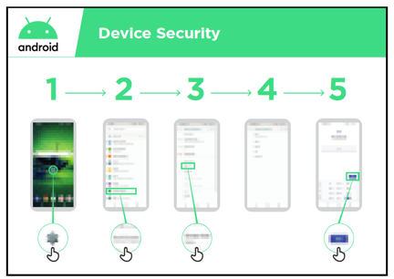

MODULE 9 – ANDROID

**Tip:** If you prefer to make a pattern on the screen rather than use numbers, you can change to make this happen in the same place you change your PIN.

INTRO / CREATING A GOOGLE ACCOUNT / PLAY STORE / CHROME / GOOGLE ASSISTANT

GMAIL / COST / BATTERY SAVING / SAFETY / RECAP

**MODULE 9 - ANDROID**

Recap

|  |  |
| --- | --- |
|  | **Play the Android icon game**  Demonstrate how trainees can access information about their  battery on their Android phone (if available). Hold up each  Android icon, one at a time (Play Store, Chrome, Wi-Fi, Settings,  Google Assistant, Gmail).  • **Ask** “What application is this?”  • **Ask** trainees which app they have enjoyed using the most.  • **Explain** to your trainees what each icon is if they are not  sure (ask if they need support).  • **Give small rewards** (e.g. sweets) for correct answers and  stick the icons on the wall afterwards to help remind your  trainees what they are. |

|  |  |
| --- | --- |
| **Discuss** with your trainees what they have learned about Android.  • “What have you learned about setting up an Android phone?”  • “What are apps? Where do you download them?” What apps are you interested in?”  • “How do you access Google Assistant? What can you use it for?”  • “How can you save money on data?”  • “How can you help make your battery last longer?”  • “What are some ways you can make your Android phone more secure?”  • “What uses could you have for it in your work life?” | **Next Level**  If you reach the end of the session and have extra  time:  **Ask:** “Do you have any further questions about  Android?”  **Ask**: “What else would you like to know about the  mobile internet?”  Some more advanced features you can discuss with  your trainees include:  • “How can you “make more space” inside your phone?”  • “How can you create your own network to share  your mobile data with other people?”  • “How can you change your privacy and security settings in Chrome?”  • “How can you use Google Maps to get directions?”  **Show** trainees how to download additional apps from  the Google Store. Choose an application that you use yourself. |

MODULE 9 – ANDROID

**Posters, Cut-outs and  
Info Sheets**



Icon Cutouts - Android

Icon Cutouts - Android





Icon Cutouts - Android





### Downloading an App on Play Store

**Open**

**Install**

English Dictionary

Search for   
apps & games

### Create Google account

**Create account**

### Connecting to a Wi-Fi network

Password

**Connect**

### How to use Chrome

**

### Sending an email on Gmail

**

### Data Saver

**Network & Internet**

**Data usage**

**Data Saver**  
Password

**

### Battery Saving

**Turn on now**

**Battery**

**Battery Saver**  
Off

**

### Device Security

**Next**

**Security & Location**

**Screen lock**  
None

**

### Google Assistant



**CERTIFICATE**

has completed

**BASIC MOBILE INTERNET SKILLS**

training

Date Signed

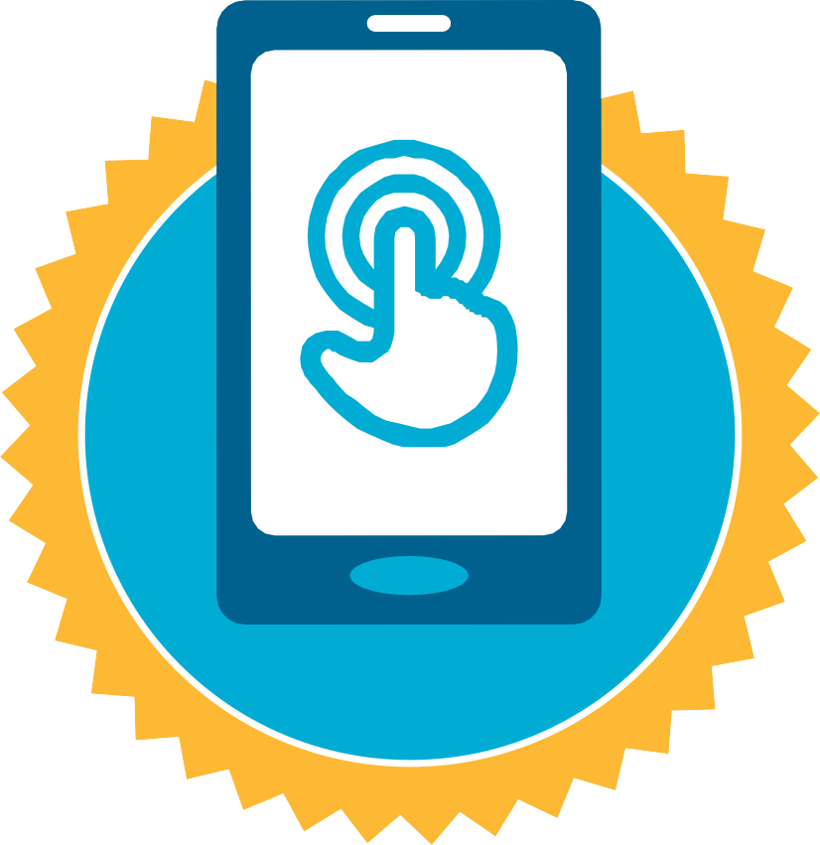

**CERTIFICATE**

has completed

**BASIC MOBILE INTERNET SKILLS**

training

Date Signed