Connected Society
Mobile Internet Skills Training Toolkit
A guide for training people in basic mobile internet skills

Copyright © 2017 GSM Association

case.

6

MODULE 6 - FACEBOOK

Module 6 - Facebook

Bitesize Training

BITESIZE - FACEBOOK

What is it?

Show Facebook on the phone

“Facebook connects you to people in your community and around the world. You can use it to correspond with business contacts, receive news, stay in touch with family and friends or follow your favourite celebrities and sports teams.”

“Using words, photos and videos, you can communicate with one person, a specific group of people or people around the world.”

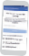
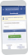
Materials you will need

Smartphone Handsets

What can you use it for?

“You can use it to stay connected with family and friends, in any town or village, read local and global news and stay up to date or get updates on your favourite celebrities or sports teams.”

“You can also share your own photos, videos and thoughts with everyone, your friends or just a few friends.”

Make it relevant to the trainee: provide examples and discuss how it can be beneficial in the trainee’s own life.
How to Create an Account
1 2 3 4 5 6 7
Facebook
How to Add Friends
3
How to Download the Facebook App
on a Smartphone or Access on the Web
4

Example: Sharing pictures with friends, finding news or connecting with new people for business.

Facebook Posters
BITESIZE – FACEBOOK
How to use
Facebook
How to use
1
2
How to use
Web
App
Facebook
2
3
1

BITESIZE - FACEBOOK

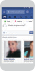
How does it work?

How to use
Facebook How to Make a Post
1 2 3 4

How to use
Facebook How to Make a Post
1 2 3 4

How to use
Facebook How to Make a Post
1 2 3 4
Put the phone in the

trainee’s hands and help them follow the steps
  - Access Facebook 2) Create an account 3) Add Friends
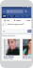

How to use
Facebook How to Make a Post
1 2 3 4

How to use
Facebook How to Make a Post
1 2 3 4

    - “Like” Celebrities, Sports and News
Help the trainee download Facebook and register for an account.

Ask them what they care about most – e.g. something they want to learn about, job opportunities, sports/ entertainment or their business — and focus your limited time on what is most important to them.

Practise!

“Now you know how to use Facebook, what do you want to use it for?”

Trainer: Provide support to user to run through one of the above posters.

BITESIZE – FACEBOOK
5) Post text or photos
Explain: “You control who can see the information you put on Facebook.
You can have a post appear to the public (everyone using Facebook) or only to specific friends.”
BITESIZE – FACEBOOK

Posters, Cut-outs and
Info-sheets

Icon Cutouts - Facebook

Icon Cutouts - Facebook

Icon Cutouts - Facebook
How to use

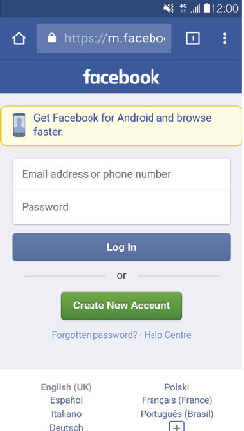
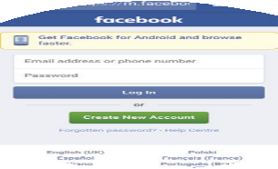

How to use
Facebook
How to Download the Facebook App on a Smartphone or Access on the Web
Facebook

1 2 3 4

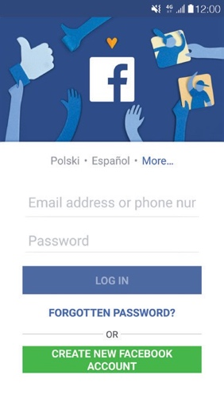
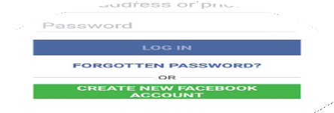
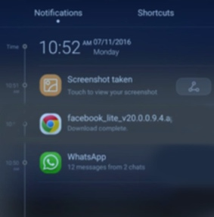
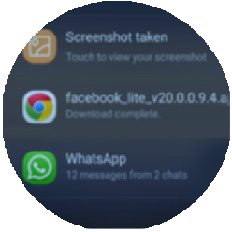
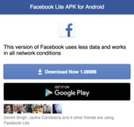

How to Create an Ac
Facebook
How to Create an Account
How to use
How to Add Friends

1 2 3 4 5 6 7
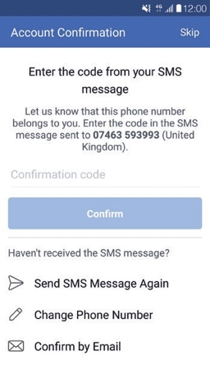
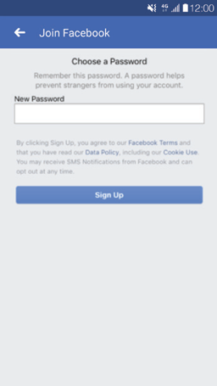
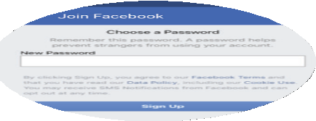
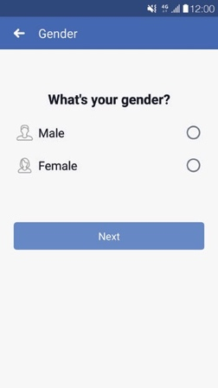
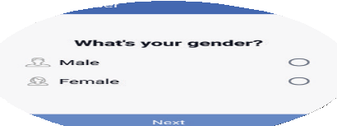
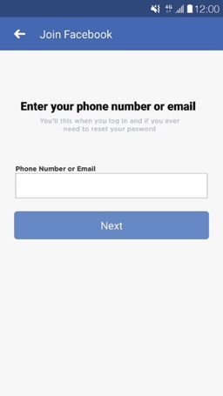
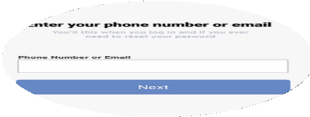
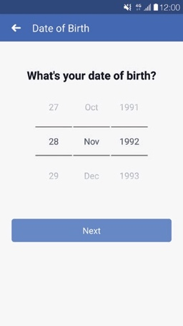
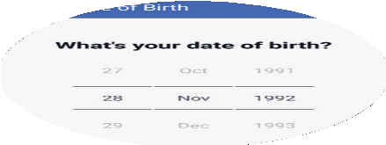
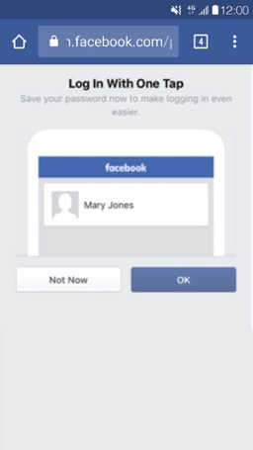
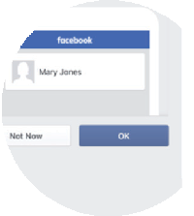
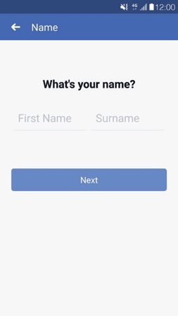
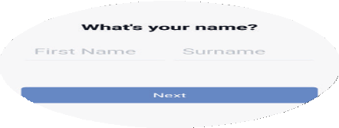

Facebook
How to use
How to Add Friends

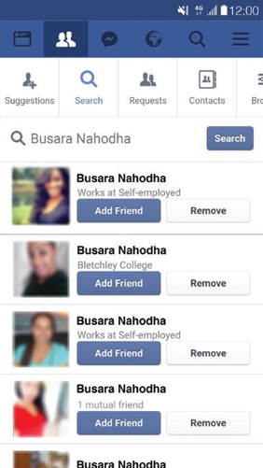
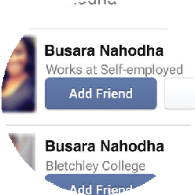
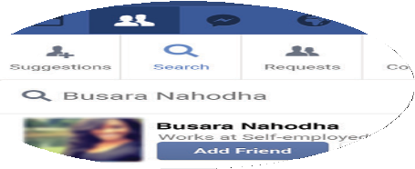
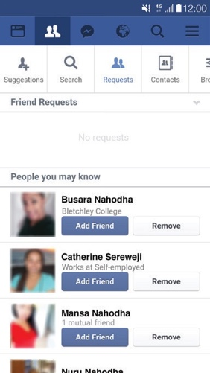
1 2 3
F Facebook
How to use
How to Follow Pages
How to use

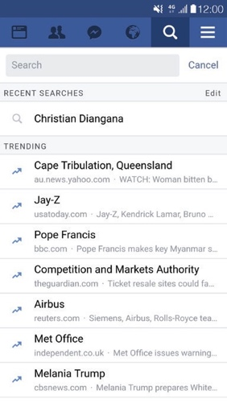
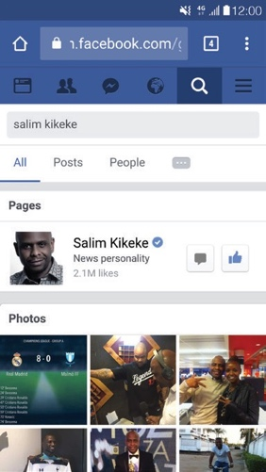
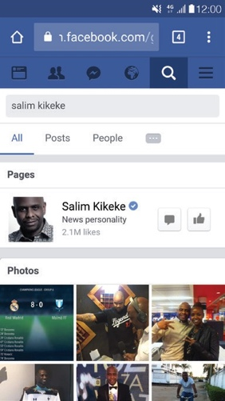
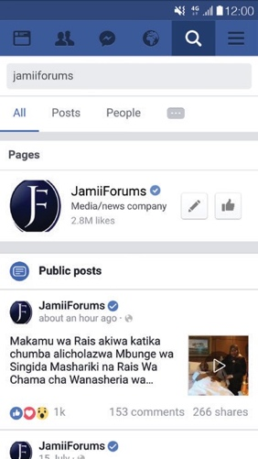
1 2 3 3

Facebook How to Make a Post
How to use

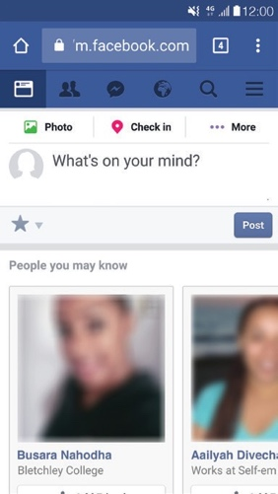

1 2 3 4
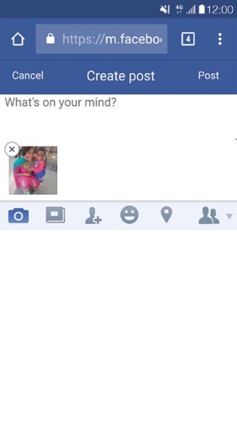
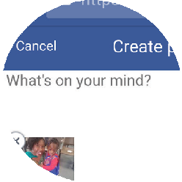
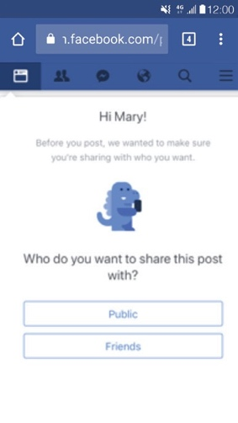

CERTIFICATE

has completed
BASIC MOBILE INTERNET SKILLS
training

Date Signed

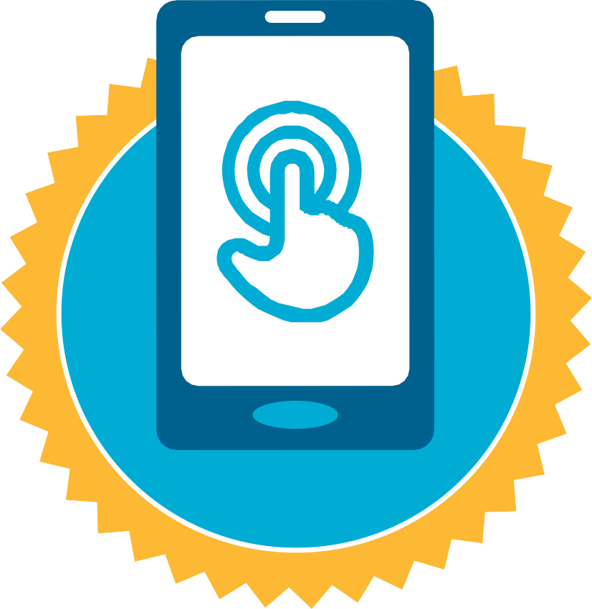
CERTIFICATE

has completed
BASIC MOBILE INTERNET SKILLS
training

Date Signed

