Connected Society
Mobile Internet Skills Training Toolkit
A guide for training people in basic mobile internet skills

Copyright © 2017 GSM Association

case.

411

MODULE 4 - GOOGLE

Module 4 – Google

Bitesize Training

BITESIZE - GOOGLE

What is it?

Show Google Search on the phone

“Google Search helps you to find information that you want. You tell Google what information you want to find
e.g. ‘what is the population of the world’ and it will search through all the information that people have put on the internet, to find what you want.”

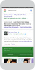
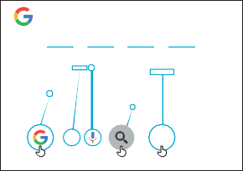
Materials you will need

Smartphone Handsets

How to use
Google
1 2 3 4 5

What can you use it for?

“You can get information on jobs, cooking recipes, movies, songs, news or information for school and college.”

“You don’t have to go anywhere to find the information; it is all available on the internet on your phone.”

Trainer to include their own personal examples of the benefits of Google and what they use it for.

Make it relevant to the trainee: discuss how Google Search can be beneficial in the trainee’s own life.

Google Poster
BITESIZE – GOOGLE

BITESIZE - GOOGLE

How does it work?

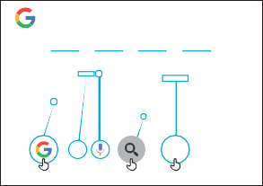
Put the phone in the trainee’s
How to use
Google
1 2 3 4 5
Search, or say
“Ok Google”
Salman Khan - Wikipedia, the free encyclopedia
hands and help them follow the steps

Practise!

“Now that you know about Google, what are you interested in using it for?”

Give the trainee keywords to search for, according to their interest (Try to keep the search simple, use only 1-2 words)

Tip: “There is a lot of great information on the internet, but also some that is not so great, and some that is not truthful. It is always best to look at a minimum of 2-3 results to get the best answer to what you are looking for.”

Explain: that there are other similar services to Google, which allow people to search. Some examples of this are Yahoo and Bing.

BITESIZE – GOOGLE

Show the poster and go through the steps for a simple search
e.g. search for a famous local landmark or a celebrity.

Explain “The microphone can be used to do voice searches. You do not have to type in any text.”

Demonstrate the microphone: where it is and how to use it.

Posters, Cut-outs and Info-sheets
Icon Cutouts - Google

Icon Cutouts - Google
Icon Cutouts - Google
Info Sheets
Icon Cutouts - Google

Google

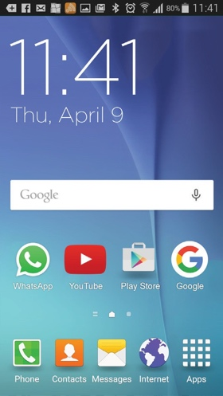
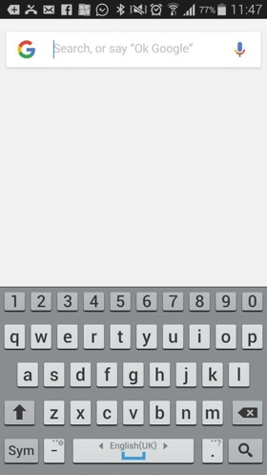
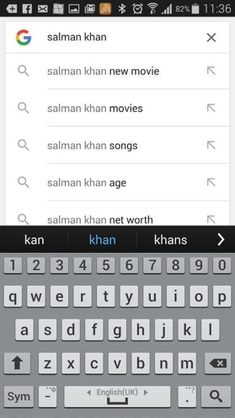
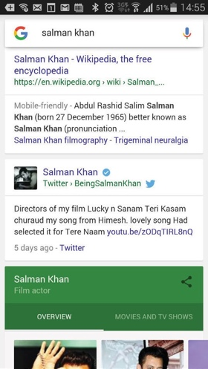
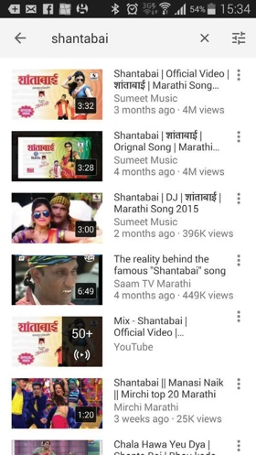
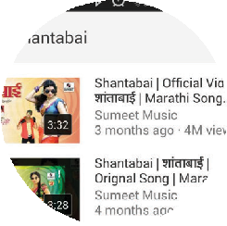
1 2 3 4 5
Search, or say
“Ok Google”

Salman Khan - Wikipedia, the free encyclopeadia

CERTIFICATE

has completed
BASIC MOBILE INTERNET SKILLS
training

Date Signed

CERTIFICATE

has completed
BASIC MOBILE INTERNET SKILLS
training

Date Signed

