Connected Society
Mobile Internet Skills Training Toolkit
A guide for training people in basic mobile internet skills

Copyright © 2017 GSM Association

case.

411

MODULE 4 - GOOGLE

Module 4 – Google

In-
depth Training

MODULE 4 - GOOGLE

45-60

Time Duration:
Learning Objectives
- The trainees know how to use Google to access content on the internet
- The trainees understand the range of content available and feel excited and motivated about accessing relevant content on the internet
45-60mins

Materials you will need:
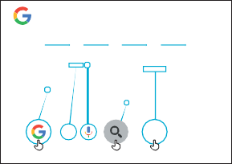
1
Google
2
How to use
3
4 5
Search, or say
“Ok Google”
Salman Khan - Wikipedia, the free encyclopedia
Pens, Paper and
Masking Tape
Smartphone
Handsets
Small Rewards
Google
Poster x 1
Data Costs
Glossary Handouts
Cost Poster
Safety Tips
Icon Cut-outs

Be polite and respectful to people

Tell someone you know and trust, if you feel uncomfortable about anything you see
or experience

Keep your personal information private

‘Block’ or ignore people you don’t know, or who are bothering you.

Easy tips for internet safety

Google is an internet service that makes it easy to find any information that you want to find on the internet
phone smartphone
Feature A mobile phone that has the ability to access the internet and
store and play music but lacks the advanced functionality of a
do with phone credit
Whenever you use the internet on your phone, you are using data.
Data You can buy data from your mobile network provider, just like you
Google Chrome Mozilla Firefox Opera Microsoft Internet
Explorer
A web browser, or simply “browser,” is an application used to
Browser access and view websites. Common web browsers include;
- Ads can be videos or images that pop up on your screen
- Ads can also be the links at the top of Google results and on
the right side of the screen.
or Ad
An ad is a piece of information that is trying to sell you something. It
Advert is good practice to avoid clicking on ads
www.india.in e.g. www.google.in
In the address bar there will always be the address of the website
Address bar The address bar shows you what website you are on.
services e.g. WhatsApp, Facebook, Google, apps provide a quick
An app gives you a shortcut to a service on your phone. For internet
App and easy way to get onto the internet to use that service
The internet can run at different speeds when you use it. 2G internet
2G / 3G / 4G is the slowest, 3G internet is faster and 4G internet is the fastest
Definitions
Trainers can add to this section to include local relevant information on the mobile internet
Buy Now!
MODULE 4 – GOOGLE
INTRO / BASE USE / MULTIPAL WORD SEARCH / PERSONAL SEARCHES / SAFETY / COST / RECAP

MODULE 4 - GOOGLE

Introduce Google

Show the trainees the Google icon and ask them to find this on the phone
Ask “Does anyone know what this is?” “What is it for?”
Give a short explanation of Google Search  - “Google Search helps you to find information that you want. You tell Google what information you want to find e.g. ‘what is the population of the world?’ and it will search through all the information that people have put on the internet, to find what you want.”  - “You can get information on places, jobs, cooking recipes, movies, songs, news, information for school, college, exams etc.” |  | Bring the benefits to life!  - Tell your own story of how Google Search is beneficial to you (the trainer), your friends and family. Some examples could include:  - Finding information on places, jobs, people, celebrities, cooking recipes, movies, songs, news, information for school, college, exams etc.  - Give specific examples or stories of how Google Search can be used.
Make YouTube relevant for your trainees
- Discuss with your trainees how Google Search can help them in their lives.
- Ask “What could you learn to use Search for in your own life?” Give them some suggestions based on their interests.”
- Ask “What are you most interested in and excited to learn about?”
Remember: Link discussions and activities in the training back to how the internet can be helpful in your trainees lives. This will help to keep the training relevant and interesting for them.
MODULE 4 – GOOGLE

MODULE 4 - GOOGLE
INTRO / BASE USE / MULTIPAL WORD SEARCH / PERSONAL SEARCHES / SAFETY / COST / RECAP
Activity: Basic use of Google

Get practical!
Explain “You are now going to try using Google Search on the phone!”

Show the ‘How to use Google’ poster
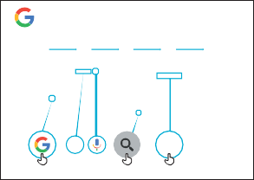
  - Explain “This poster shows the steps for using Google to search for information.”
Google
1 2
How to use
3
4 5
Search, or say
“Ok Google”
Salman Khan - Wikipedia, the free encyclopedia
- Take your trainees through the steps on their shared phones, for a simple search.”

Show the Google tabs
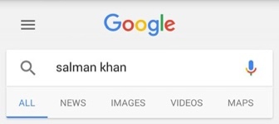
(‘all’, ‘images’, ‘videos’ and ‘maps’)
- Explain “When you click on different tabs, Google Search will show you different kinds of results or answers. For example, if you click on the ‘images’ tab, you will only see images when you search.”
- Ask your trainees to click on the different tabs on the phone and tell you what different kinds of results they get when they have searched.”

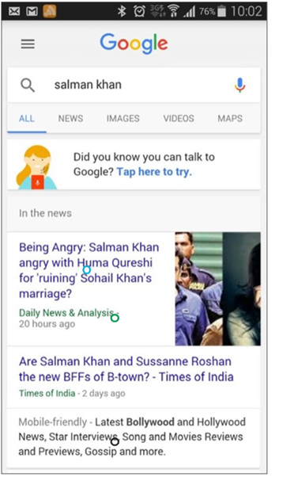
Show the results page for the ‘all’ tab
(‘all’, ‘images’, ‘videos’ and ‘maps’)
- Explain what your trainees are looking at:
“Google has given a list of lots of different websites that relate to the word you searched:
- Blue text is the link to each website, if you click on that it will take you to the website.
- Green text is the ‘address’ of each website – where it lives on the internet.
- Black text is a description or excerpt from that website.”
Ask “Have you got any questions about what you are looking at here?”
MODULE 4 – GOOGLE

INTRO / BASE USE / MULTIPAL WORD SEARCH / PERSONAL SEARCHES / SAFETY / COST / RECAP

MODULE 4 - GOOGLE
Activity: Basic use of Google

Hold up the microphone icon for Google
- Explain “The microphone can be used so that you do not have to type any text. When you can’t spell or write the words you want to search, you can just tell Google the words you want to search for.”
- Demonstrate where to find it: “The microphone icon appears on the right of the search box.”
- Demonstrate how to use it: “Press the microphone icon and speak loudly, clearly and slowly.”
- Ask your trainees to search for the name of a popular celebrity using the microphone.

Ask your trainees to practise searching for information with the following word searches:
- Type the name of a celebrity into the search box and search for them.
- Type the name of a local famous location into the search box and search for it.
- Give your trainees 1 word to type into the search box that is relevant to them (e.g. ‘bicycle’, ‘shop’, ‘recipes’, ‘jobs’, ‘farming’), and help them explore the results.

Wikipedia is a website that is often near the top when you do a Google search. It provides information on a huge range of subjects. Wikipedia is written by the people who use it, and thousands of changes are being made every hour. The information it provides can be useful but you must also evaluate the information for yourself, as you do not know who the author was.
MODULE 4 – GOOGLE

MODULE 4 - GOOGLE
INTRO / BASE USE / MULTIPAL WORD SEARCH / PERSONAL SEARCHES / SAFETY / COST / RECAP
Activity: Multiple word search

Explain “We are now going to try a more detailed search by using more search words – this can be helpful to find the information you want.”
Ask your trainees to practise searching for information by putting different combinations of 2-3 words into the Google search box. They can do this using the microphone or by typing in text. Give your trainees different words to combine, based on what they searched for earlier.
Tip: Give your trainees plenty of time to explore different results and different word combinations.

Activity: Personal searches
- Discuss with your trainees how Google Search can help them in their lives.
- Ask “Now you know how to use Google Search, what do you want to use it for in your own life?” Give them some ideas based on their interests.
- Discuss with your trainees what words they can use to search, according to their interest (try to keep the search words simple, and use only one to two words).
- Ask each trainee to take turns using the phone to search for information they are interested in, and ask the other trainees to support them with this.
- Ask “What information do you want to search for next?”
MODULE 4 – GOOGLE
Tip: “There is a lot of great information on the internet, but also some which is not so great, and some that is not completely truthful. It is always best
to look at two to three results to get the best answer to what you are looking for.”

MODULE 4 - GOOGLE
INTRO / BASE USE / MULTIPAL WORD SEARCH / PERSONAL SEARCHES / SAFETY / COST / RECAP

Safety

Ask “What does safety mean to you?”
Ask your trainees to imagine they are in a typical public place, like the market. Ask them to discuss what they would do to keep safe in this place. Prompt them with the following questions and answers:

Prompts | Potential Answers
What do you do if someone you don’t know bothers you? | You avoid or ignore them  Be careful – they are not always who they say they are.
What do you do if someone you don’t know or trust asks you for your personal information? | You don’t give out personal information to someone you don’t know or trust because they may misuse it.
What do you do if you feel unsure or uncomfortable about something you see or experience? | Tell someone you know and trust about what happened.
How do you treat people you interact with? | You are polite and respectful to people.

Explain “It is important to remember the internet is also public place, and it is important to treat it like a public place and stay safe.”
MODULE 4 – GOOGLE

MODULE 4 - GOOGLE
INTRO / BASE USE / MULTIPAL WORD SEARCH / PERSONAL SEARCHES / SAFETY / COST / RECAP

Safety

Give your trainees the ‘Safety tips’ handout.
Easy tips for internet safety
‘Block’ or ignore people you don’t know, or who are bothering you. | Keep your personal information private
Tell someone you know and trust, if you feel uncomfortable about anything you see  or experience | Be polite and respectful to people

  - Discuss with your trainees what these tips mean for using the internet.
  - Bring the tips to life by using examples that are relevant for your trainees. For example, women may be more concerned about how to prevent harassment.

Google Safety
  - Ask “Is there anything that you are concerned about when using Google?”
  - Ask “If you are looking at information on Google and you see or open something you think is bad or offensive, what can you do next?”
  - Explain and demonstrate for your trainees “You can press the back button, delete the words in your search box and refine your search by using different words.”
  - Explain “When you use Google Search, you build up a ‘search history’, which is remembered by Google on your phone. You can see some of your search history when you click in the search box. This search history can be deleted.”
MODULE 4 – GOOGLE
Tip: “You are in control of what you search for – you can search for good things or you can search for bad things. It is your responsibility to search for good things.”

INTRO / BASE USE / MULTIPAL WORD SEARCH / PERSONAL SEARCHES / SAFETY / COST / RECAP

MODULE 4 - GOOGLE

$ Cost

If you have already covered cost in the previous WhatsApp and YouTube modules, only use this as a recap.

Explain “Now you know how to use Google, and what it can be used for, let us talk about how much it costs to use! To use the internet on you mobile, you have to buy data from your mobile network provider, just like you do with phone credit.”

Show the ‘Cost’ poster
Data Costs
  - Explain “Different activities use different amounts of data. Looking at text uses the least data, looking at images uses more, playing and downloading music uses a bit more and playing videos uses the most.”
  - Explain “Some internet services are linked to activities that use more data.”
  - Ask “Where is Google on the poster? What does that mean for how much it tends to cost?”
  - Ask “What makes it cost more? Answer “Videos”
  - Ask “What makes it cost less? Answer “Text”
MODULE 4 – GOOGLE

INTRO / BASE USE / MULTIPAL WORD SEARCH / PERSONAL SEARCHES / SAFETY / COST / RECAP

MODULE 4 - GOOGLE
$ Cost

Checking Data
Tip: The data checking process varies depending on which country you are in
and which network the phone is on. Ask a mobile agent if you need support with how to check data.
- Ask “Why is it useful to check how much data you have used?”
- Answer: “To understand how much of your data you have used up and how much different activities cost to do.”
- Explain “You can check how much data you have, just like you check how many minutes or texts you have by typing in a code on your phone from your mobile network.”
- Explain “You can buy data in different amounts depending on what you are going to use the internet for. Ask advice from your local mobile agent on which amount is best suited to you.”
- Explain “If you access the internet in a Wi-Fi zone, you will not use your data package. Your local mobile agent may be able to help you find your local Wi-Fi zones. However, the nearest zone may be too far to travel to.”
- Demonstrate to your trainees how to check their data.

Recap

Play the Google icon game
  - Hold up each Google icon, one at a time.
  - Ask “Where is this on the phone and what is it?”
  - Explain to your trainees what each icon is, if they need support.
  - Ask trainees to search for how old Shah Rukh Khan or Alia Bhatt are.
  - Give small rewards (e.g. sweets) for correct answers and stick the icons on the wall afterwards to help remind your trainees what they are.
MODULE 4 – GOOGLE

INTRO / BASE USE / MULTIPAL WORD SEARCH / PERSONAL SEARCHES / SAFETY / COST / RECAP

MODULE 4 - GOOGLE

Recap

Explain: that there are other similar services to Google, which allow people to search. Some examples of this are Yahoo and Bing.
Tip: “Many applications and services on the internet use similar icons and words. When you are using the internet look out for these icons, so next time you see them, you can remember what they mean.”

Recap on Google Search
Tip: Run the recap as a quiz and give rewards (e.g. sweets) to trainees for playing.
Discuss with your trainees what they have learned about using Google Search
- “What have you learned about using Google Search?”
- “Do you still have any concerns about using Google Search?”
- “What personal uses could you have for it?” “What professional uses could you have for it?”
- What do you want to use Google Search for in your own life? What are you most interested in and excited about using it for?”
Tip: If trainees would like to access the internet and Google on their own phones, give them some time here to practise what they’ve learned and offer support and encouragement.
MODULE 4 – GOOGLE

MODULE 4 - GOOGLE
INTRO / BASE USE / MULTIPAL WORD SEARCH / PERSONAL SEARCHES / SAFETY / COST / RECAP

Recap

Going to the next level
If you reach the end of the session and have extra time:
- Ask “Do you have any further questions about anything we have covered in the session?”
- Ask “What else would they like to know about the mobile internet?”

Some more advanced features you can discuss with your trainees include:
- Evaluating results: “How do you decide which link to select on the search results page?” “How do you know if one option is better than another?”
- Identifying advertising: “How can you identify which Google results are paid adverts?”, “How does Google use your search history to tailor advertising to you?”
- Google Maps: “How do you use directions?” “Where is Buckingham Palace?”
- Downloading apps from the app store (you will need to cover email also, as having email is necessary to download
MODULE 4 – GOOGLE

Posters, Cut-outs and Info-sheets
Icon Cutouts - Google

Icon Cutouts - Google
Icon Cutouts - Google
Info Sheets
Icon Cutouts - Google

Google

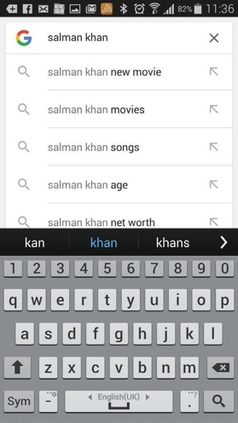
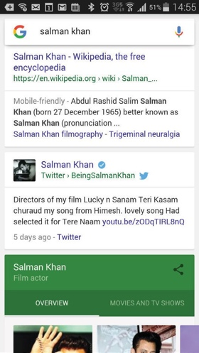
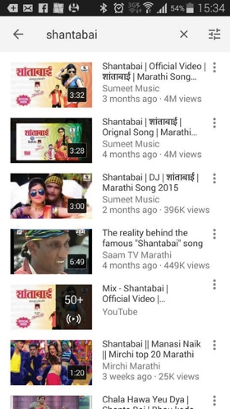
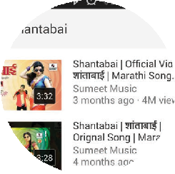
1 2 3 4 5
Search, or say
“Ok Google”

Salman Khan - Wikipedia, the free encyclopeadia

CERTIFICATE

has completed
BASIC MOBILE INTERNET SKILLS
training

Date Signed

CERTIFICATE

has completed
BASIC MOBILE INTERNET SKILLS
training

Date Signed

