Connected Society
Mobile Internet Skills Training Toolkit
A guide for training people in basic mobile internet skills

Copyright © 2017 GSM Association

In-
Depth Training
1

Module 1 - Introduction

MODULE 1 - INTRODUCTION
“Aarti uses the internet
to help support her
business”
‘’Arvind uses the
internet to help him
learn more skills’’
“Pradip uses the internet
to support and care for his
family and friends”

45-60

Time Duration:
Learning Objectives
- Understand the purpose of the training and know who is in the room
- Set the tone: ensure the trainee feels safe, confident and motivated to learn about the mobile internet and knows the ground rules
- Understand the potential benefits of using the internet in their lives
45-60mins

Tip: Set the internet homepage on the shared devices to the Google image results of a famous local place. This provides trainees with a fun and
interesting first experience of getting on the internet. To set the homepage, open your browser and go to the website you want to set as your homepage. Open your browser menu and click on settings, then set the ‘current page’ as your homepage.

Material you will need:
Support my
business
Learn more
skills
Take care
of my
family

Smartphone Handsets | Pens, paper, masking tape and  a small ball | Icon Cut-outs
Definitions  Trainers can add to this section to include local relevant information on the mobile internet  2G / 3G / 4G The internet can run at different speeds when you use it. 2G internet  is the slowest, 3G internet is faster and 4G internet is the fastest  An app gives you a shortcut to a service on your phone. For internet  App services e.g. WhatsApp, Facebook, Google, apps provide a quick and easy way to get onto the internet to use that service  Address bar The address bar shows you what website you are on.  In the address bar there will always be the address of the website  www.india.in e.g. www.google.in  Advert Buy An ad is a piece of information that is trying to sell you something. It is good practice to avoid clicking on ads  Now!  or Ad • Ads can be videos or images that pop up on your screen  - Ads can also be the links at the top of Google results and on  the right side of the screen.  Browser A web browser, or simply “browser,” is an application used to  access and view websites. Common web browsers include;  Google Chrome Mozilla Firefox Opera Microsoft Internet  Explorer  Data Whenever you use the internet on your phone, you are using data.  You can buy data from your mobile network provider, just like you  do with phone credit  Feature A mobile phone that has the ability to access the internet and  phone smartphone  store and play music but lacks the advanced functionality of a  Google is an internet service that makes it easy to find any information that you want to find on the internet  Glossary Handouts | Session Ground Rules  This space is:
A shared
Safe community
There are people with different
Keep all information in this training backgrounds, knowledge and confidential. We suggest you don’t opinions. This is our shared space, so
share personal numbers with the other respect and support everyone members of group
Positive & open Fair
Please be respectful and positive in We will work in small groups and we your opinions and discussions. There will provide you with shared phones. are no right or wrong answers and we We would like to give everyone an
are not here to test you equal chance to be heard and to take
turns using a phone
 | Ground Rules | Small Rewards

MODULE 1 – INTRODUCTION

WARM UP / INTRODUCE TRAINING / CREATE MINI GROUPS / INTERNET BENEFITS /
GIVE OUT SMART PHONES

MODULE 1 - INTRODUCTION

Warm up with fun and games

Introduction game
- Take a small ball in your hands and briefly introduce yourself as the trainer: say your name, your background and why you are here.
- Then throw the ball to one of your trainees and ask them to stand up and introduce themselves to the group. Once they have finished, ask them to throw it to the next person.
- The game finishes when everyone in the room has caught the ball and introduced themselves.

Introduce the training

Explain the purpose of the training:
Session Ground Rules
This space is:
Safe  Keep all information in this training confidential. We suggest you don’t share personal numbers with the other members of group | A shared community  There are people with different backgrounds, knowledge and opinions. This is our shared space, so respect and support everyone
Positive & open  Please be respectful and positive in your opinions and discussions. There are no right or wrong answers and we are not here to test you | Fair  We will work in small groups and we will provide you with shared phones. We would like to give everyone an equal chance to be heard and to take turns using a phone

  - “We are here to learn about the mobile internet: what it is, how to use it and what you can do with it.”
- Discuss the ground rules.
- Explain what you will be covering in the training e.g. How to use WhatsApp, YouTube, Google, Wikipedia and Facebook and what each is particularly useful for.
- Explain “You will be introduced to the internet on smartphones”.
- Explain the role of trainers: “As trainers we are here to help you learn and to support you.”
- Explain “Today is all about you! There are no right or wrong answers or questions. It is not a test; we want to help you to learn!”
MODULE 1 – INTRODUCTION

WARM UP / INTRODUCE TRAINING / CREATE MINI GROUPS / INTERNET BENEFITS /
GIVE OUT SMART PHONES

MODULE 1 - INTRODUCTION

Create mini groups

Split your trainees into mini groups (no more than 6 people per group):
Make a line down the middle of the room and mark three points on the line:
I think using the internet on my mobile is easy
I have used the internet on my phone but don’t know it very well
I have never used the internet on my mobile

- Ask your trainees to stand on a place on the line that represents where they feel most comfortable with their ability to use the mobile internet.
- Split the trainees into groups of no more than 6 according to where they stand - each trainer in the room will work with one group.
- Explain that these groups will be used throughout the training.

Tip: It is very important that the trainees are a similar skill level to the others in their group, so that they feel confident and comfortable. Feel free to move trainees into different groups after the training has started if it becomes apparent that trainees are not at a similar skill level in their groups.

Small group introductions:
• Ask each person to tell the group their name / where they are from / what they are interested in.
• Ask your trainees to write their names on masking tape and stick it onto their chest.
• Set intentions for the training: Ask “What do you want to learn?”
• Write each trainee’s intentions for the training on paper and stick up on the wall.
MODULE 1 – INTRODUCTION

WARM UP / INTRODUCE TRAINING / CREATE MINI GROUPS / INTERNET BENEFITS /
GIVE OUT SMART PHONES

MODULE 1 - INTRODUCTION

Explain internet benefits

Explain that the trainer is going to ask questions and the trainees can put up their hands to answer
- “Who here has used the internet on a mobile phone before?”
- “Can anyone stand up and tell us what the internet is?”

Explain what the internet is and where it comes from
- Explain “Your mobile network provider can connect you to it through your mobile phone.”

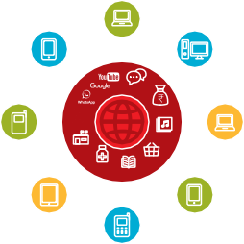
Show the ‘Internet Poster’
Education
Online Shopping
Health Information
Government Services
Entertainment
Travel Internet
Banking
Communication
Introduction to the Internet
  - Explain “The internet is a network that allows computers and some mobile phones to send and receive information across the world. It is like a big library of information that people across the world can access, use and add to.”

WARM UP / INTRODUCE TRAINING / CREATE MINI GROUPS / INTERNET BENEFITS /
GIVE OUT SMART PHONES

MODULE 1 - INTRODUCTION

Explain internet benefits

Bring the benefits of the internet to life!
Tell your own story of how the internet is useful for you (the trainer), your friends and family or your community. Some examples might include:
- Connecting with people on WhatsApp - getting news from friends and family, advertising your business to your network etc.
- Learning and developing your skills and being entertained on YouTube e.g. ‘how to’ videos such as how to do a dance, how to cook a recipe or how to fix a tyre on a bicycle.
- Finding useful information on Google to help with your life, schoolwork, business, etc.

Make the internet relevant for your trainees
Discuss with trainees how the internet could help them:
- Ask “What could you learn to use on the internet that would help you?” Give them some suggestions.
- Ask “What are you most interested in and excited to learn about?”

MODULE 1 – INTRODUCTION
Tip: Link discussions and activities in the training back to how the internet can be helpful or useful in their lives. This will help to keep the training relevant and interesting for them.
WARM UP / INTRODUCE TRAINING / CREATE MINI GROUPS / INTERNET BENEFITS /
GIVE OUT SMART PHONES

MODULE 1 - INTRODUCTION

Give out the smartphones

Give out the smartphones (ensure that there are no more than three people to one phone)
  - Demonstrate how to ‘tap’ (touch an icon on the screen), ‘swipe’ (drag finger to right or left across screen), ‘zoom’ (drag two fingers apart on screen).
  - Ask the trainees to take turns holding the phone, encourage them to play with it and try tapping, swiping and zooming.
  - Ask the trainees to ‘tap’ on the icons on the screen and see what happens.

Tip: Show the trainees who are nervous or unfamiliar with the phone where the ‘camera’ icon is and encourage them to take photos with the phone. This can help them to have fun and feel comfortable with touching the phone.

Ask your trainees to take a group photo (group selfie!) with the phone
- Ask the trainees to show the trainer and other trainees the photo.
Discuss with your trainees what they recognise on the phone
- Ask “Where does it show the battery life?”
- Ask “Where does it show the phone signal?”
Discuss with your trainees why it is a ‘smart’ phone
- Ask “What makes it ‘smart’?”
MODULE 1 – INTRODUCTION
Tip: Give your trainees as much time as they need to explore and feel comfortable with the phone.

WARM UP / INTRODUCE TRAINING / CREATE MINI GROUPS / INTERNET BENEFITS /
GIVE OUT SMART PHONES

MODULE 1 - INTRODUCTION

Activity: Play ‘Find the icon’ game

  - Hold up each mobile icon, one at a time.
  - Ask “Where is this on the phone and what is it?”
  - Explain to your trainees what each icon is, if they need support.
  - Give small rewards (e.g. sweets) for correct answers and stick the icons on the wall afterwards to help remind your trainees what they are.
MODULE 1 – INTRODUCTION

WARM UP / INTRODUCE TRAINING / CREATE MINI GROUPS / INTERNET BENEFITS /
GIVE OUT SMART PHONES

MODULE 1 - INTRODUCTION

Activity: Get onto the internet

- Ask your trainees to find the ‘ball’ internet icon on their phone screen and click on it (the internet will open on the website of your choice if you have set this up – see Introduction Overview on p20 for details). Please note that different phones may have different browsers (see below).
- Explain “You are all now on the internet! That’s how easy it is! Congratulations!”
- Give your trainees plenty of time to explore and discuss what they can see.
Tip: There are many different ‘browsers’ for using the internet. Some of the most common icons for these are displayed below. Depending on the phone you use, you may use one of these rather than the one shown above.
MODULE 1 – INTRODUCTION

Posters, Cut-outs and
Info-sheets

Session Ground Rules

This space is:

Safe
Keep all information in this training confidential. We suggest you don’t share personal numbers with the other members of group.

Positive & open
Please be respectful and positive in your opinions and discussions. There are no right or wrong answers and we are not here to test you.

A shared community
There are people with different backgrounds, knowledge and opinions. This is our shared space, so respect and support everyone.

Fair
We will work in small groups and we will provide you with shared phones. We would like to give everyone an equal chance to be heard and to take turns using a phone

Easy tips for internet safety

‘Block’ or ignore people you don’t know, or who are bothering you

Tell someone you know and trust, if you feel uncomfortable about anything you see
or experience
Keep your personal information private

Be polite and respectful to people

Definitions
Trainers can add to this section to include local relevant information on the mobile internet

2G / 3G / 4G

App Address bar
www.india.in
Advert or Ad
Buy Now!

Browser
The internet can run at different speeds when you use it. 2G internet is the slowest, 3G internet is faster and 4G internet is the fastest.

An app gives you a shortcut to a service on your phone. For internet services e.g. WhatsApp, Facebook, Google, apps provide a quick and easy way to get onto the internet to use that service.

The address bar shows you what website you are on.
In the address bar there will always be the address of the website
e.g. www.google.in

An ad is a piece of information that is trying to sell you something. It is good practice to avoid clicking on ads.
- Ads can be videos or images that pop up on your screen
- Ads can also be the links at the top of Google results and on the right side of the screen

A web browser, or simply “browser”, is an application used to access and view websites. Common web browsers include;

Data
Google Chrome Mozilla Firefox Opera Microsoft Internet
Explorer

Whenever you use the internet on your phone, you are using data. You can buy data from your mobile network provider, just like you do with phone credit.

Feature phone

A mobile phone that has the ability to access the internet and store and play music but lacks the advanced functionality of a smartphone
Google is an internet service that makes it easy to find any information

Definitions
Trainers can add to this section to include local relevant information on the mobile internet

Internet

Link
The Internet is a network of millions of computers around the world connected to each other with phone lines, satellites and cables. It gives you access to a huge range of information and services and
it is growing all the time. The internet is for everybody. There are no restrictions on who can use it. You just need a computer, mobile phone or tablet and a data connection.

A link connects you from one website to another. To go to the other website, you can touch the link and this will connect you and take you to that other website.

Megabytes & Gigabytes

Megabytes (MB) and Gigabytes (GB) are units of data that you use when using the mobile internet. GB are 1000 x bigger than MB. If you download or stream a song, that will use approximately 5MB (1MB per minute).

Search
The search function helps you find what you are looking for. You type the words to what you are looking for into a search box and then you will see a list of links to potential answers.

SmartphoneA mobile phone that has the ability to access the internet, store and play music and videos, and run ‘apps’. These phones typically also have a touchscreen.

YouTube is an internet service that makes it easy to find, watch and listen to videos on the internet (and only videos).

Website
Information on the internet is kept on different websites. There are lots of separate and different websites on the internet e.g. Google is a website, YouTube is a website.

WhatsApp is an internet service that makes it easy to connect and communicate with people that you know; family, friends and colleagues.

WiFi
A WiFi zone is an area where you do not have to use your own data to access the internet on your phone; you can connect to the
internet for free. WiFi zones are available in some public places such as coffee shops and cafes
Introduction to
the Internet

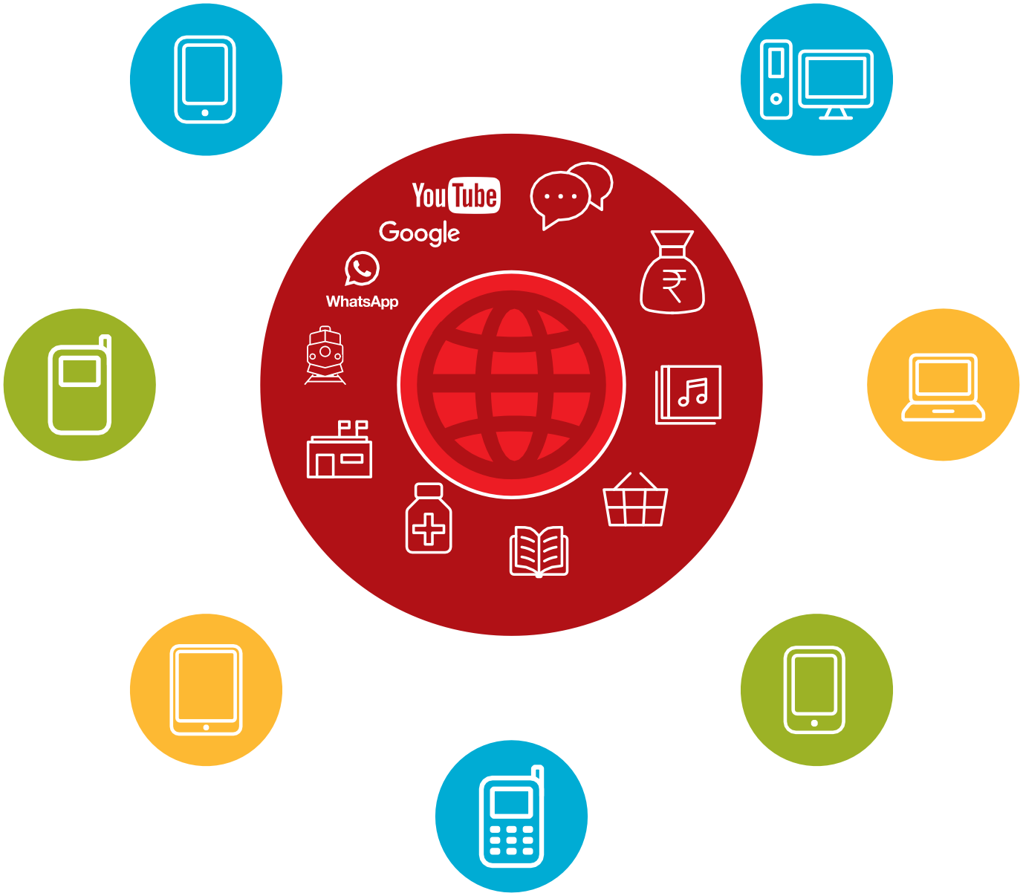

Communication

Travel
Internet
Banking
Entertainment

Government Services

Health
Information
Educatio2n

Online Shopping

Data costs
Icon Cutouts - Apps

Icon Cutouts - Apps

Icon Cutouts - Phone Functions

CERTIFICATE

has completed
BASIC MOBILE INTERNET SKILLS
training

Date Signed

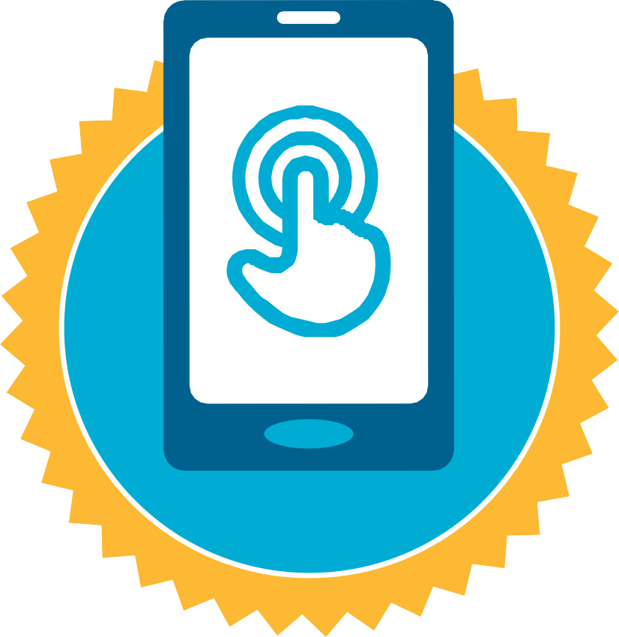

CERTIFICATE

has completed
BASIC MOBILE INTERNET SKILLS
training

Date Signed

