Connected Society
Mobile Internet Skills Training Toolkit
A guide for training people in basic mobile internet skills

Copyright © 2017 GSM Association

case.

3

MODULE 3 - YOUTUBE

Module 3 - YouTube

Bitesize Training

BITESIZE - YOUTUBE

What is it?

Show YouTube on the phone

“YouTube lets you watch videos, like TV, but you have more videos to choose from, and you can also choose what videos to watch and when to watch them.”

“You tell YouTube what kind of videos you want to find, and it will search through all the videos that people have put on YouTube, to find the kinds of videos that you want.”

Materials you will need

Smartphone Handsets

What can you use it for?

“You can watch lots of different videos, movies, songs, news, sports, recipes, educational ones. There are also lots of ‘how to’ videos e.g. how to learn a language, how to
do a dance, how to cook a recipe, how to fix a tyre on a bicycle…”

“You can also create your own videos and share them on YouTube.”

The trainer can include their own personal examples of the benefits of YouTube and what they use it for.

How to use
YouTube
1 2 3 4 5

Search YouTube

Make it relevant to the trainee: discuss how YouTube can be beneficial in the trainee’s own life.

YouTube Poster
BITESIZE – YOUTUBE

BITESIZE - YOUTUBE

How does it work?
Put the phone in the trainee’s

How to use
YouTube
1 2 3 4 5

Search YouTube
hands and help them follow the steps

BITESIZE – YOUTUBE

Show the poster and go through the steps for a simple video search (e.g. search a popular local song).

“The microphone can be used to do voice searches. You do not have to type in any text.”

Demonstrate the microphone: where it is and how to use

BITESIZE - YOUTUBE

Practise!

“Now that you know about YouTube, what are you interested in using it for?”

Give the trainee keywords to search for, according to their interest (try to keep the search simple, use only 1-2 words).

Tip: YouTube is great for videos, but the internet is bigger than YouTube! There is a lot more information on the internet. If you want to search the whole internet, you can try using ‘Google Search’.

Explain: that there are other similar services to YouTube, which allow people to upload and watch videos. Some examples of this are Daily Motion and Vimeo.
BITESIZE – YOUTUBE
1

Posters, Cut-outs and
Info-sheets

Icon Cutouts - YouTube

Icon Cutouts - YouTube

How to use

YouTube
How to use

YouTube

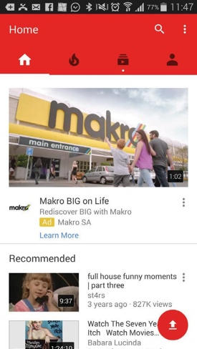
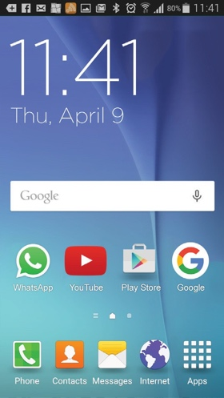
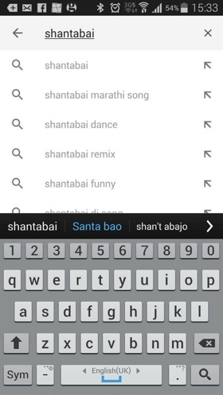
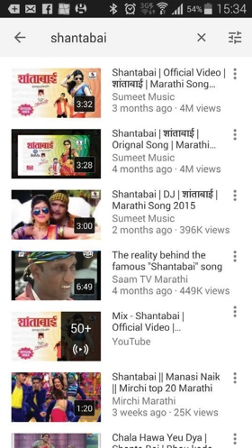
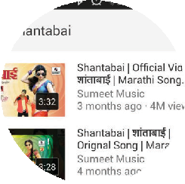
1 2 3 4 5
Search YouTube

CERTIFICATE

has completed
BASIC MOBILE INTERNET SKILLS
training

Date Signed

CERTIFICATE

has completed
BASIC MOBILE INTERNET SKILLS
training

Date Signed

