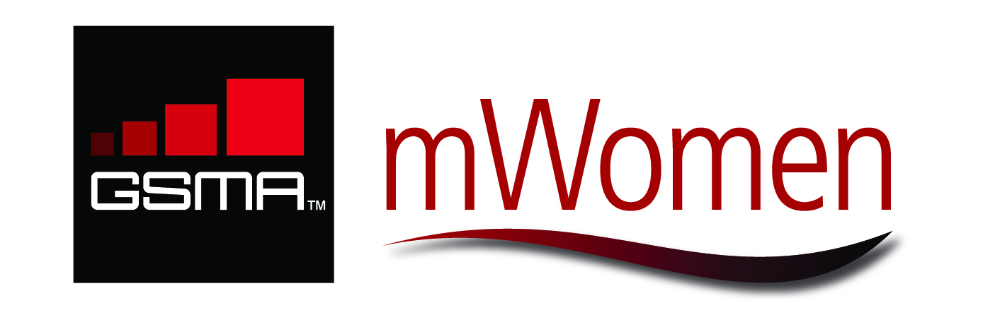
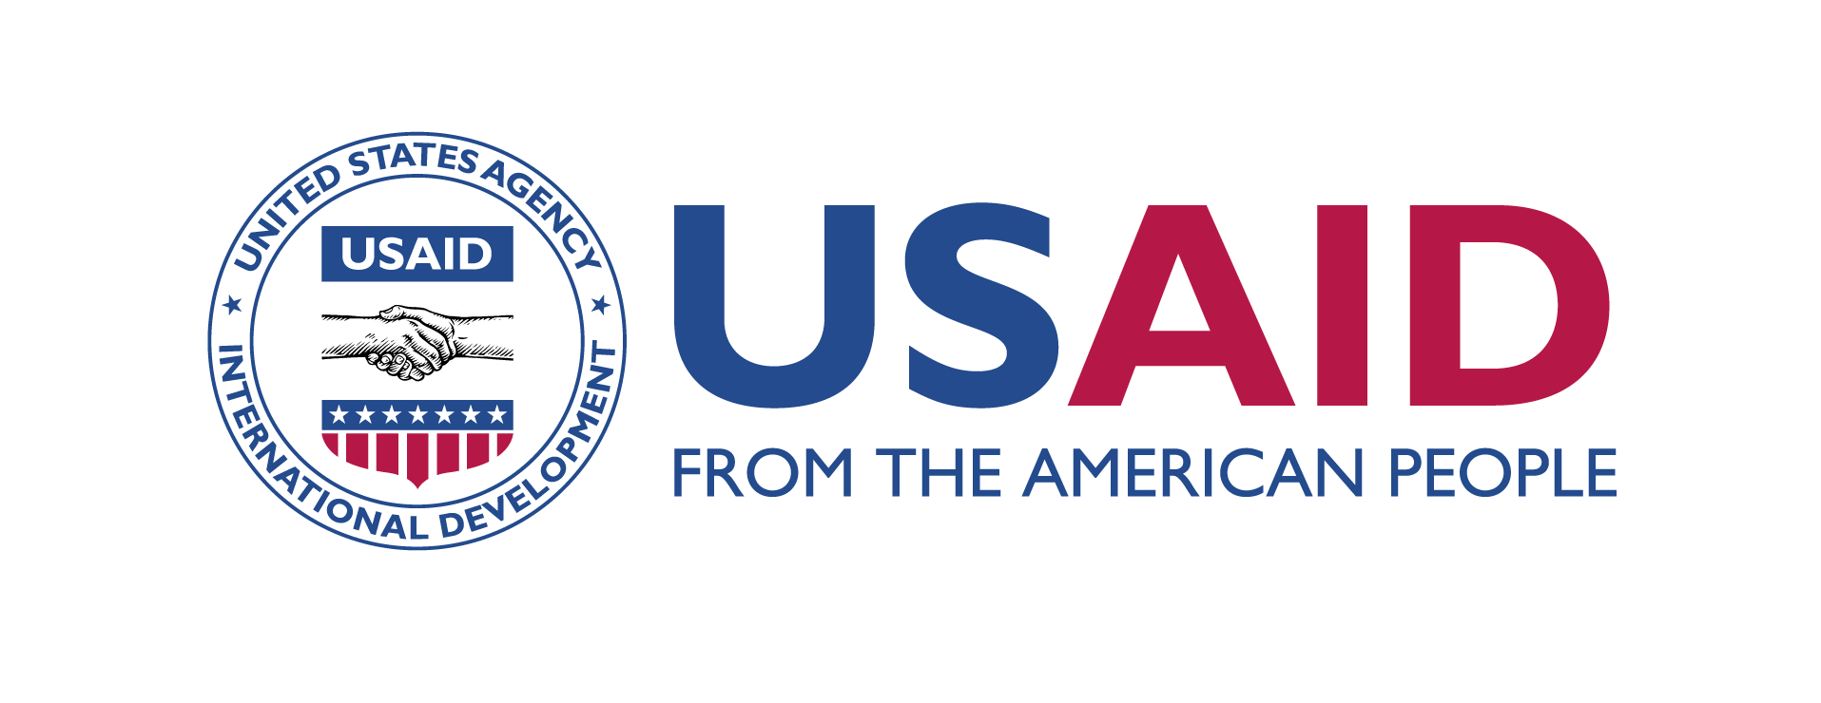
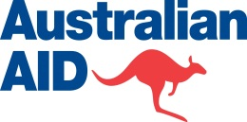

GSMA mWomen Working Group Meeting
Summary Notes

12 November 2012
Cape Town, South Africa

Hosted by



Update on the GSMA mWomen Programme 2
Women and mobile financial services 2
Visa: Mobile money: in search of scale 2
Bankable Frontier Associates: Women and mobile financial services research 3
Ericsson: Women and technology 3
Etisalat: Mobile Baby 3
USAID: Introduction to Mobile Alliance for Maternal Action (MAMA) 4
GSMA mWomen: Innovation Fund grants 4
GSMA mWomen: Introducing the Marketing Toolkit 5
Google: State of mobile internet in Ghana and Kenya 5

Update on the GSMA mWomen Programme
Beth Gertz, GSMA mWomen Programme Director

Update on the GSMA mWomen Programme objectives and strategy.

- The programme aims to promote greater mobile phone access and usage by resource-poor women in in Africa, Asia Pacific and the Middle East by encouraging industry to serve the segment, increasing the availability of life-enhancing value added services (VAS) and promoting solutions to access and usage barriers
- The programme works with industry and development partners to identify products, services, marketing approaches and distribution mechanisms that increase women’s mobile access in an economically sustainable way
- Highlights in the upcoming months include:
  - Issue 1st round of Innovation Fund grants, launching next round for operators and development partners in the coming weeks (see p. 5)
  - Reward innovation and encourage user experience design via the Design Challenge (https://designchallenge.mwomen.org/ ).
  - Complete research into women’s wants and needs for mobile financial services in partnership with Visa and Bankable Frontier Associates (see p. 2-3)
  - Prepare a marketing toolkit in partnership with Altai Consulting to distil lessons to help industry improve how it reaches resource-poor women (see p. 5)
  - Prepare several events at Mobile World Congress 2013

Women and mobile financial services
Daryl Collins, Director, Bankable Frontier Associates

Exercise to identify themes around women’s financial management needs and solutions.

Using profiles of resource-poor women from Indonesia, Pakistan, Papua New Guinea and Tanzania, teams suggested mobile money tools to meet women’s needs, as well as the effect of these tools on their families and communities. Discussion highlights include:
- Savings clubs are a popular, trusted method of managing money amongst women
- Women often rely on insecure ways of saving and transferring money, e.g. money jars and in luggage on public transport
- Mobile money could increase the security, efficiency, reliability and transparency of financial management and increase women’s peace of mind
- Such tools could lead to a more stable economic situation for women, benefiting their communities from the expansion of small businesses and better management of children’s education and healthcare costs
- Mobile money providers could target offerings to savings clubs, to facilitate the cash flowing between them and their individual members. This would increase the women’s familiarity with and trust of the tools, making them more likely to use them for individual financial management in the future

Visa: Mobile money: in search of scale
Gavin Krugel, Chief Customer Strategy Officer, Visa

An overview of recent research into use of mobile money in emerging markets.

Key findings include:
- Unbanked consumers are sophisticated money managers, able to articulate their financial service needs very clearly
- To reach low-income emerging market consumers, providers need to understand the vernacular of the users
  - For example, the term ‘savings’ did not resonate with the participants; they instead refer to storing money for school fees, weddings or other specific purposes
- Women are a distinct segment to men, with different needs and a key role in determining usage of funds, including remittances and husbands’ incomes

Bankable Frontier Associates: Women and mobile financial services research
Daryl Collins, Director, Bankable Frontier Associates

Description of GSMA mWomen’s Visa-funded research on women’s wants and needs for mobile financial services, a key VAS with potential to enhance women’s lives.

- GSMA mWomen, Visa and Bankable Frontier Associates have partnered to:
  - Increase awareness of the gap in women’s access to and usage of mobile financial services
  - Close knowledge gaps about women’s wants and needs for mobile financial services, as well as the barriers to their access and usage
  - Generate actionable insights and implications for mobile operators, financial service institutions, governments and other partners to employ as they consider how to serve underserved women
- Qualitative and quantitative research is being undertaken in five markets at different levels of mobile money market maturity: Indonesia, Kenya, Pakistan, Papua New Guinea and Tanzania,
- Results will be shared at Mobile World Congress 2013

Ericsson: Women and technology
Nokuzola Makai, Strategic Business Development Director, Ericsson

Overview of Ericsson’s work to empower women through ICT in partnership with operators, governments and NGOs.

- Ericsson’s objective is to close the digital gender divide and help women understand the power of ICT
- Projects include education programmes such as Connect to Learn, which links students in remote schools with high quality education practitioners, and mobile apps e.g. Refugees United, a service that re-connects refuges with their families
- Recent Ericsson ConsumerLab research into mCommerce opportunities for the mobile industry in sub-Saharan Africa offers the following takeaways:
  - Consumers are familiar with existing mobile money services such as purchasing airtime; long-distance person-to person transfers and bill payment
  - By building on these services, operators have opportunities to offer in-store payment, wage payment and savings via mobile
  - The driving factors for mCommerce expansion are speed and convenience. Lack of trust remains the key barrier
  - As women often have primary responsibility for household finances, they are important potential mCommerce customers
  - Traditional advertising is not sufficient to encourage uptake. Merchants and agents need incentive to accept mobile money and to educate their customers

Etisalat: Mobile Baby
Stephen King, Senior Manager, CSR

Etisalat shared its experiences launching and replicating in multiple countries its GSMA Global Mobile Award winning Mobile Baby solution for supporting safe baby deliveries.
- Etisalat leverages the power of its mobile services to elevate the efforts of the existing ecosystem of partners required to ensure safe deliveries, including traditional birth attendants, hospitals, diagnostics centres, government, etc.
- Finding the right partners with whom to work is one of the most important steps in driving such an ecosystem. Etisalat partnered with an non-governmental organization to help link the various ecosystem partners
- Mobile Baby is economically sustainable, ensuring that service providers throughout the system are paid market rates for their services. Etisalat earns voice and data revenue from the service.
- In Saudi Arabia, the service is also being used by hospitals as a differentiator and a VAS to promote their services
  - In these cases the hospitals enter a direct billing agreement with the local OpCo Mobily and provide the images of the babies to the mothers so they can send to their friends and families

USAID: Introduction to Mobile Alliance for Maternal Action (MAMA)
Nida Parks, Health Officer, Southern Africa, USAID

Overview of MAMA, a public-private partnership between the USAID, Johnson & Johnson, the United Nations Foundation, mHealth Alliance, and BabyCenter to engage an innovative global community to deliver maternal health information via mobile.

- MAMA’s objective is to engage the global community to deliver maternal health information via mobile, reaching 20 million mothers in 35 countries. On-the-ground projects are underway in Bangladesh, India and South Africa
- Apps are adapted to suit local needs and preferences, e.g. instant messaging applications and SMS in South Africa, voice in Bangladesh
- In order to obtain community support for and women’s use of the services, MAMA’s project in Bangladesh marketed to male community leaders as well as to women. (N.B. this insight was inspired by GSMA mWomen Programme’s research Striving and Surviving research.)
- MAMA offers a growing body of health content, tools and lessons to that can be localized to support replication

GSMA mWomen: Innovation Fund grants
Beth Gertz

Review of the first tranche of GSMA mWomen Innovation Fund Grants and current thinking for the next round, which will be open to MNOs and development partners.

- There are two concurrent grant streams offering seed funding in order to test business models and generate evidence about what works
  - One for MNOs and another for development partners working with industry
  - Both should aspire to create both commercial and social impact
  - Can increase women’s access to mobile in general or a life-enhancing VAS
- The next round of applications will open soon. Dates will be announced shortly
- For the next application round, GSMA mWomen will:
  - Offer longer deadlines for concept notes and application preparation
  - Reinforce the commercial objectives of the grants to operators
  - Create stronger distinction in the content between concept notes and applications
  - Offer more substantial assistance throughout the grant concept note/application period
- Recommendations for operators in the first round include:
  - Propose projects for operators that have commercial, rather than purely CSR, objectives
  - Submit projects that will test a new approach, rather than replicate an existing approach
  - Consult with the GSMA mWomen team as you consider your ideas
  - Take into account the difficulty of partnering, and consider some of that work as part of the funded activities
- We have a limited number of grants, but can also advisory support to projects falling outside the grants mechanism

GSMA mWomen: Introducing the Marketing Toolkit
Beth Gertz

Request for input into the emerging GSMA mWomen Marketing Toolkit, currently under development by partners Altai Consulting (http://www.altaiconsulting.com/).

The Marketing Toolkit will offer insights and case studies from both mobile and other industries of how to market to resource-poor women. Working Group members suggested the toolkit offer insights on the following:
- Consideration of new products and services, but also modifications of existing products and services to better reach women audiences
- Guidance on how operators can better analyse their existing datasets to improve marketing to women
- Understanding and leveraging local realities e.g. how to leverage the community in rural settings, examples of marketing to men to build support for women’s use of mobile
- Understanding how women can be further segmented
- Understanding that consumers may shift between segments, e.g. live in peri-urban setting but work in urban setting
- Consideration of resource-poor women’s aspirations, as well as their current needs

Google: State of mobile internet in Ghana and Kenya
Paul Lee, Senior Product Manager, Google.org, Shikoh Gitau, User Experience Researcher / Designer, Emerging Markets, Google & Alyssa Caulley, Software Engineer, Google.org

Sharing Google research on use of mobile internet, designed by Google with field data collected by iHub Research in Kenya and Ghana, exploring attitudes towards mobile data pricing and usage patterns.

- Findings from a Kenya survey of 82 respondents at retail outlets and a university campus
  - Service cost is a material factor, but for non-users, not as large an issue as lack of access to an internet-enabled handset
  - Mobile data costs may be inversely correlated with usage
  - Transparency of costs may increase usage
  - Non-users cite a willingness to pay more for data than current users, but this may be due to user confusion regarding pricing
- Findings from a Ghana survey of 798 respondents in Accra
  - Mobile data users spend more, on average, on calls and SMS than on data
  - 54% of users complained about slow connection speeds; 18% of users complained about cost, while another 16% complained about lack of transparency around usage
  - Users do not have an accurate understanding of billing, although women seem to understand better than men that bundles are a better value
  - Women seem to prefer communication websites, while men tend to prefer entertainment
  - On average men visit web sites that are more expensive to access than women

