GSMA mNutrition Initiative
Request for Information

Covering letter

The GSMA represents the interests of the worldwide mobile communications industry. Spanning 219 countries, the GSMA unites nearly 800 of the world’s mobile operators, as well as more than 200 companies in the broader mobile ecosystem, including handset makers, software companies, equipment providers, Internet companies, and media and entertainment organisations. The GSMA is focused on innovating, incubating and creating new opportunities for its membership, all with the end goal of driving the growth of the mobile communications industry.

The GSMA is partnering with the UK Government to deliver a mNutrition initiative across Africa and Asia. Under nutrition is a major challenge to human and economic development globally. On annual basis, a billion people face hunger and are unable to get enough food to meet their dietary needs. Agriculture is a major source of livelihood in many poor countries and the sector has a potentially critical role in enhancing health, specifically maternal and child health and nutritional status.

The mNutrition Initiative will aim to improve nutrition and food security of the poor, especially women by harnessing the power of mobile technologies to improve access to information on nutrition, health and agricultural practices especially for farmers and the rural population particularly women and adolescent girls.

This will be achieved by delivering four key components:
- mNutrition Content services;
- Launch of scalable and sustainable mHealth services in 10 priority African countries;
- Launch of scalable and sustainable mAgri services in 6 priority Asian and African countries;
- Robust, independent evaluation of the activities and services being launched.

Specific to the mNutrition Content services, the GSMA will contract a global content partner (s) to deliver the following across the 14 priority countries:

Africa - Cote d’Ivoire, Ghana, Kenya, Malawi, Mozambique, Nigeria, Rwanda, Tanzania, Uganda and Zambia
Asia (South) - Bangladesh, India, Pakistan and Sri Lanka

This document details the mNutrition Content component and stipulates the request for information from interested parties wishing to bid for the global content partner contract. The information contained herein is strictly confidential and is provided solely to assist the respondent in preparing a response to this RFI.

Table of Contents
Covering letter 1
1. Project Overview 3
1.1. Background: GSMA mNutrition Initiative 3
1.2. Objective: GSMA mNutrition initiative 3
1.3. Deliverables: GSMA mNutrition Initiative 3
1.4. mNutrition Content Services 4
1.5. Expected outcomes 4
2. Content process 5
2.1. Approach 5
2.2. Global content technical partner 5
2.3. Country Content Framework 6
2.4. Identification of local “content” organization 6
3. Project Governance 7
3.1. Governance 7
3.2. mNutrition Advisory Group 8
4. RFI Requirement Process 8
4.1. Participation and submission 9
4.2. Timelines 9
4.3. RFI Queries 9
5. RFI Terms and Conditions 10
5.1. Liabilities of GSMA 10
5.2. Confidentiality & RFI Ownership 10
6. RFI RESPONSE FORMAT 11
6.1. Respondent’s information 11
6.2. Content Experience 13
6.3. Project References 14
6.4. Disclosure of any “Conflict of Interest”. 14
Appendix 1: mNutrition content development process 15
Appendix 2: Content workstream timelines 17

Project Overview

Background: GSMA mNutrition Initiative
The UK government is providing £20.5m to the mNutrition initiative and partnering with the GSMA to develop and scale-up the delivery of nutrition and agriculture related services using sustainable, mobile phone based services. The UK Government funds will enable the mNutrition initiative to reach 10 countries in Africa (six New Alliance countries: Cote d’Ivoire, Ghana, Malawi, Mozambique, Nigeria, Tanzania, and four additional nutrition priority countries: Kenya, Rwanda, Uganda, Zambia), as well as four countries in South Asia (India, Pakistan, Sri Lanka and Bangladesh). The mNutrition initiative will deliver a range of services including nutrition, agriculture and health messages that support beneficial behavior change; increase demand for agricultural extension and health services; facilitate population-level registration; and enable health data surveillance.

The mNutrition initiative builds on the expertise and capacity of two existing development initiatives within GSMA Mobile for Development - the mHealth and the mFarmer initiatives. Both of these are designed to leverage the unique position that GSMA holds within the mobile industry. The GSMA Mobile for Development approach aims to bring together mobile network operators, the wider mobile industry and the development community to develop, test and roll-out commercial mobile services for underserved people in emerging markets.

Objective: GSMA mNutrition initiative

‘The improved nutrition for the poor as a result of behavior change promoted by accessible mobile-based services delivered at scale through sustainable business models.’

The initiative plans to reach at least 3 million beneficiaries across 10 Sub-Saharan African and 4 Asian countries. The change in nutrition levels are expected to occur as a result of the following – support change as it relates to nutrition, registration of target populations, cultivation, consumption of crops with high nutritional value (s)and; timely and efficient data surveillance of key nutrition indicators. This will be complemented by improved access to food as a result of improved agricultural production and income.

Improved access to relevant mobile services for the poor is to be facilitated by a range of support mechanisms provided to the mobile industry by the GSMA mNutrition initiative. These include, but are not limited to: providing risk capital (e.g. innovation grants) for the launch and scale of mobile services for nutrition and agriculture; neutral brokerage between mobile and health stakeholders to develop scalable business cases in each country; technical assistance to the service providers to launch and scale mNutrition services; advocacy and regulatory support at the national level; documentation of best practices; guidelines and resources; and M&E and content frameworks.

Deliverables: GSMA mNutrition Initiative
The GSMA is committed to delivering the following across priority countries:

Deliverable | Description | Country
mNutrition Content Services | Work with a consortia of local partners in each country to either scale existing nutrition related content services and/or launch scalable and sustainable mNutrition content services | All 14 priority countries
mHealth Services (specific) | Support the launch of scalable and sustainable mHealth services in each country that target rural, poor women and children and focus on:  - Behavior change communications services  - Registration services  - Data surveillance services | Cote d’Ivoire, Ghana, Kenya, Malawi, Mozambique, Nigeria, Rwanda, Tanzania, Uganda and Zambia
mAgri Services  (specific) | Support and launch of scalable and sustainable mAgri services in each country targeting small holder farmers and focus on:  - Agriculture information and advisory services through mobile platform for conventional and nutrition-sensitive agriculture  - Promotion of nutrition-sensitive agriculture technology and practices  - Where applicable, mobile financial solutions for smallholders | 6 countries from the priority list from Sub-Sahara Africa and South Asia.
Evaluation | The UK Government will appoint a credible third party to conduct a robust, independent evaluation of the GSMA mNutrition Initiative | Ghana, Bangladesh, Malawi

mNutrition Content Services

Nutrition content, as an integral part of health and agriculture related information services, aims to promote behavior change related to key health and farming decisions and practices, and maternal and child nutrition practices and interventions for a given target population.

The mNutrition content services will aim to influence the following:
- Maternal nutrition practices;
- Children feeding practices, including breast-feeding;
- Diet practices, such as supplementation of key nutrients and elements in food, consumption of diverse food groups;
- Farming practices and technologies that could result in higher productivity, improved income, better quality and higher nutritional value of food produced;
- Decision making around types of food produced and consumed within the household.

To be able to promote the intended change within the target population, mobile services have to be highly relevant to local health, agricultural and the socio-economic context, both in terms of service design and content.

In each country the GSMA will aim to understand the landscape of available content services and either work with vendors to scale existing services or launch new mNutrition services. The mobile services supported by the GSMA mNutrition initiative will be designed with the intention of reaching the target audience, in this case vulnerable, poor, rural and under-served population groups. In each country, the scope of content, product design, delivery channel, pricing strategies and ultimately, the integration into existing mobile services, will be determined by understanding who the target audience is, how they are influenced, what their mobile usage habits are and what particular socio-economic factors affect their decision making. The nutritional content will be developed in accordance with comprehensive country-specific frameworks and guidance by credible national and international experts to ensure maximum impact. In addition, the content partner will initiate, develop and maintain relevant partnerships with similar projects globally to enhance the success of the project through cross-learning and knowledge sharing.

Expected outcomes

The expected outcomes and outputs for the GSMA mNutrition Initiative will include specific indicators related to behavior change communication:
- A cost-effective, sustainable business model for mobile phone enabled nutrition and agriculture content services in the selected countries.
- By 2017, at least 25% of active registered users in 6 countries acting on information provided in relation to either one or several of the knowledge domains:

- Adoption of agricultural technology and practices that support nutrition sensitive food production
b) Adoption of new agricultural technology and practices to improve agricultural productivity
c) Uptake of new post-harvest technologies and practices to improve availability and quality of agricultural produce after harvesting.

- By 2017, at least 15% of registered active users demonstrating changes in knowledge or behaviour in relation to nutrition practices as recommended by the Lancet June 2013, in either one or several knowledge domains:

a) Improved maternal nutrition practices during pregnancies;
b) Infant and young child feeding practices;
c) micro-nutrient supplementation to children at risk (i.e. Vitamin A, Zinc and ORS), across 10 SSA countries.

Content process

Approach
The GSMA will support the localization and launch of nutrition-focused content services that impact the lives of the intended target audience and are effectively integrated into health and agriculture practices. This will be achieved through:

- Identifying and appointing a credible, authoritative, content technical partner(s) to manage the mNutrition Content component of the GSMA mNutrition Initiative;
- Landscape analysis of available nutrition content and evidence-based intervention practices in each country;
- Through consultation with international and country experts and relevant stakeholders, provide a per country content framework for the integration of nutrition content into country-specific health and agriculture practices;
- Launch and/or scale a mNutrition content service in each of the 14 priority countries by providing catalytic support to the local content partner through a competitive process;
- Together with the global health and agriculture content technical partners, provide robust technical assistance to a local organisation(s) most strategically aligned to being able to deliver, in partnership with GSMA member mobile operators, the mNutrition Content objectives; and
- In each country, ensure that locally contracted content partners meet quality standards and are compliant to and collecting information that contributes to the evaluation framework implemented by the UK Government contracted evaluation partner.

Global content technical partner
The GSMA will identify and appoint a credible, authoritative, technical content partner(s) to manage the mNutrition Content component of the GSMA mNutrition Initiative.

The partner(s) will be selected and contracted by GSMA through a competitive bidding process. Criteria for selection will include (but not be limited to):

- Extensive experience in development focusing on health, nutrition and agriculture;
- Demonstrable corporate experience and expertise in development communications specifically in the areas of nutrition and health knowledge management;
- Inter-continental experience and presence, particularly in Asia and Africa;
- Multiple and effective networks in Asia and Africa, specifically in mNutrition project countries which can be leveraged to support project implementation;
- Extensive experience and expertise in knowledge management and first-hand experience with Content Management Systems (CMS);
- Experience working with Mobile Network Operators (MNOs) or Value Added Services (VAS) providers is a benefit; and
- Extensive project management experience within the organisation and the ability to manage multiple projects across several countries.

The global content technical partner(s) will report to GSMA on the progress, work alongside the GSMA to report to the global mNutrition advisory group and be ultimately responsible for delivering the following in each of the 14 priority countries:

- Drawing on the WHO guidance on nutrition, provide a landscape analysis of available nutrition content and evidence-based intervention practices with recommendations for a key set of messages, launching and/or scaling nutrition content services;
- Through consultation with country experts, country content partners and relevant stakeholders, develop a per country content framework for the integration of nutritional content into the health and/or agriculture practices;
- Host a per country technical workshop to launch the country content framework and advocate the applicability amongst all relevant stakeholders;
- Together with the GSMA and member mobile operators in each country, objectively identifythe most credible, strategically aligned organisation able to scale and/or launch nutrition related content services in collaboration with with GSMA mobile operator members;
- Together with the GSMA, provide technical assistance to the local organisation and mobile operator(s) in each country to ensure the scale and/or launch of quality nutrition related content services that comply with the country content framework and UK Government managed evaluation process;
- Provide regular feedback to GSMA and funding partners of progress, risks and mitigation strategies as they relate to the mNutrition Content services.

Country Content Framework
The GSMA understands that content development at a country level will require a significant amount of technical assistance and a comprehensive understanding of the local socio-economic context. To this extent, content development will be based on the development of comprehensive and robust country frameworks, based on global and local evidence-based nutrition intervention practices.

Country content frameworks will be provided for 6 countries where granted mFarmer projects operate (countries are selected through a competitive process across South Asia and Sub Saharan African markets), and 10 countries in Sub Saharan Africa. In at least 2 (possibly 3) SSA countries, both nutrition-sensitive agriculture and health advisory services will be integrated. For the overlapping countries the health and agriculture technical partners need to provide an integrated health and agriculture framework.

It is expected that each country framework will include (but not be limited to) the following critical areas that need to be addressed and recommendations made to ensure success, scale and sustainability:

- A current state of nutritional needs, content availability, stakeholders, pricing and regulation for nutrition;
- Recommendations for a core set of health and/or agriculture messages in each country that are evidence based and approved by Government and regulators;
- Sources/partners that can make nutrition content available to local, content partners;
- Processes for content localisation;
- Recommendations for the national governance of content services;
- Recommendations for business model of content integration into mHealth/Agriculture mobile phone based services;
- Recommendations for data collection and evaluation of content services; and
- Country content framework published in document format.

Identification of local “content” organization
Informed by the country landscape and framework developed in each country, a local organisation will be selected to scale and/or launch content services in compliance with the country framework.

The criteria for selection will need to be developed in each country to identify, through an objective, comparable process, a local partner capable of sourcing, localizing, launching and maintaining mNutrition content services.

Criteria for the selection of the local organization will likely focus on:

- Demonstrable experience and expertise in development communications specifically in the areas of nutrition and nutrition sensitive agriculture and agriculture knowledge management;
- Capable of working with mobile operators across the implementing country;
- Able to incorporate a core set of nutrition messages as stipulated by Government and/or country regulators;
- Extensive experience and expertise in knowledge management and first-hand experience with Content Management Systems (CMS);
- Experience working with Mobile Network Operators (MNOs) or Value Added Services (VAS) providers is a benefit;
- Extensive project management experience within the organisation and the ability to manage multiple projects across several countries;
- Able to design and launch mNutrition services in compliance with international and national best practices relevant to the country and country framework;
- Able to develop sustainable business model, networks and systems to ensure continuity of mNutrition content development and messaging beyond the project;
- Willing to work with Government to ensure ongoing regulatory compliance and integration into national nutrition programmes; and
- Contract obligation to report legal and financial compliance to the GSMA grant process.

The quality and the format of the content developed by the grantee and their partner(s) in each country are critical to the success of each of the in-country services and in achieving the overarching objectives of the GSMA mNutrition Initiative.

In each country, robust technical assistance will be provided by the Global content technical partner and GSMA to the local organization and GSMA member mobile operators. Technical assistance for content services will be led by the Global Content Partner(s) and supported by GSMA in each country. In each country, the nature of the technical assistance will depend on: the country; maturity and/or lack of mNutrition content services; organisations involved; availability of content; ease of doing business; target audience; pricing structures; and other socio-economic factors not already mentioned.

Content developed for each of the mobile services has to be protected by adequate IP rights to ensure financial viability of the business model. Thus IP for the content belongs to the consortia of partners, however both GSMA and UK Government will be granted a license to use the content. As far as possible, GSMA will make available the content through open access channels, to help maximize the development impact. UK Government will be granted a worldwide, non-exclusive irrevocable and royalty-free license to use all the content developed. The term ‘use’ means, without limitation, the reproduction, publication and sub—license of all the content and the intellectual property rights therein, including the reproduction and sale of the content and products incorporating the same for use by any person or for sale or other dealing anywhere in the world. GSMA mNutrition is also part of the GODAN network (Global Open Data for Agriculture and Nutrition network) which seeks to support global efforts to make agricultural and nutritionally relevant data available, accessible, and usable for unrestricted use worldwide.

Please refer to section 4.2 for the suggested timelines for country frameworks and content development.

Project Governance

Governance
The governance framework for the GSMA mNutrition Initiative is shown in Figure 1 below. The main components are individual steering committees for the Health and Agriculture sub-programmes, responsible for the delivery of the programmes, and a mNutrition Advisory Group responsible for providing advice on the mNutrition aspects to the programmes and for the governance of the Monitoring and Evaluation work. The overall governance structure will be reviewed jointly during the first annual review and adjusted if deemed necessary.

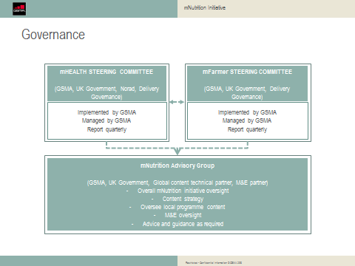

Figure 1: mNutrition governance framework

mNutrition Advisory Group
The mNutrition Advisory Group will consist of representatives of GSMA and UK Government. The Global Content Services and Independent Evaluation partners are expected to provide inputs to the Advisory Group and participate in part of the meetings. Neither will be full members of the mNutrition Advisory Group. The Advisory Group will provide strategic direction and validation required to implement mNutrition services at a country level.

The Advisory Group will be responsible for:
- Providing strategic content direction to the two programmes of the mNutrition initiative, including local content;
- Approving the appointment of the global content technical partner(s), who will then become a member of this group;
- Advising on the country content frameworks for the integration of nutrition content into the health and agriculture sub-programmes;
- Ensuring that the content technical partner and each country content partner are meeting the target outputs and impacts of the mNutrition initiative;
- Ensuring the content service launched and/or leveraged in each country are reaching the poor, rural, disadvantaged target audiences;
- Overseeing the selection and appointment of the external impact evaluation partner; and
- Overseeing the evaluation impact work.

This group will meet within one month of the mNutrition initiative start date and then at regular intervals as agreed at the first meeting. The reporting schedule will to be agreed at the first meeting.

RFI Requirement Process

Participation and submission
Participation in the RFI is open to all organisations or consortia of partners with extensive development experience in any or all of the following sectors - health, nutrition and agricultural information services across Asia and Africa particularly in the stated project countries. In cases where organisations have partnered to respond to the RFI, the lead organisations should be clearly indicated and should submit the RFI on-behalf of the partners.
- All RFI responses should be in English.

- A response must be received by the Close Date indicated in the schedule in this document. Extensions to this date cannot be granted.

- Responses must be submitted complete and in writing. All requests for information in all sections of this document must be answered as concisely as possible.

- Responses must include a statement that indicates that the respondent understands the requirements of the RFI and accepts the terms and conditions under which the RFI was issued.

- Any information of a confidential or proprietary nature contained in the response should be clearly marked ‘PROPRIETARY’ or ‘CONFIDENTIAL’ by item or at the top of each page. Reasonable precautions will be taken to safeguard any part of the response identified by as being confidential or proprietary.

- Responses must address all items outlined within the Request for Information Section of this document. Where Incomplete RFIs shall not be considered for evaluation.

- All responses, once delivered, become the property of GSMA.

Timelines

Date | Action
30/10/2013 | Issue of RFI & NDA
30/10/2013 – 27/11/203 | Meetings for further clarification of RFI
27/11/2013 | Submission of RFI
04/12/2013 | Issue of RFP
08/01/2014 | Receipt of RFPs
By 31/01/2014 | Contract award

RFI Queries
All general queries in relation to this RFI shall be sent by email to the point of contact indicated below. Queries shall only be through email or phone.

Name: Michael Nkonu
Telephone: +254733152135
Email:mnkonu@gsma.com

RFI Terms and Conditions

Liabilities of GSMA
- This is a Request for Information (RFI). No cost can be charged to the GSMA for any reason.

- This document shall not be construed as a request or authorisation to perform work. Any work involved in responding to this RFI will be at the respondent's own discretion and expense.

- This RFI does not represent a commitment to engage. Submission of a response constitutes acknowledgement that the respondent has read and agrees to be bound by such terms.

- The GSMA intends to submit a formal Request For Proposal (RFP) for the services described in this document as per the timelines indicated herein. There is no guarantee that GSMA will submit an RFP or, if an RFP is submitted, that it will occur in the time frame described in this RFI. If submitted, the RFP will be sent to respondents that demonstrate adequate capabilities in response to this RFI.

- The information in this RFI is accurate to the best of GSMA’s knowledge but is not guaranteed to be correct.

Confidentiality & RFI Ownership
This RFI is both confidential and proprietary to the GSMA. The GSMA reserves the right to recall the RFI in its entirety or in part. All respondents cannot and agree that they will not duplicate, distribute or otherwise disseminate or make available this document or the information contained in it without the express written consent of the GSMA.

Respondents shall not include or reference this RFI in any publicity without prior written approval from the GSMA. Respondents must accept all of the foregoing terms and conditions without exception. All responses to the RFI will become the property of the GSMA and will not be returned.

RFI RESPONSE FORMAT

State in Tabular format the information requested from potential content partners:

Respondent’s information

Primary Respondent
Company Name
Company Registration Number (if any)
CEO Name
Person responsible for RFI information
Address of Registered Office
Street
Town
County
Country
Post Code
Telephone
Fax
Web Site
Financial Details
Current year (2013)
Previous year (2012)
VAT registration No.
Financial Year-End
Respondent Legal Structure
Parent Company Name
Regional Offices
Country Offices in Asia and Africa
Any affiliated companies/ organizations
Describe any third party alliances

Secondary Respondent (s) information (duplicate as necessary)
Company Name
Company Registration Number (if any)
CEO Name
Person responsible for RFI information
Address of Registered Office
Street
Town
County
Country
Post Code
Telephone
Fax
Web Site
Financial Details
Current year (2013)
Previous year (2012)
VAT registration No.
Financial Year-End
Respondent Legal Structure
Parent Company Name
Regional Offices
Country Offices in Asia and Africa
Any affiliated companies/ organization (s)

Content Experience

Briefly describe experience across each of the following areas:
Key Area | Response
Experience and expertise specifically in the areas of knowledge management and information dissemination
Agriculture, health and human nutrition management experience
Content management and Content Management System expertise
International, regional and local networks and affiliation and how this will impact on the project
Inter-continental experience and presence, particularly in Asia and Africa
International project management including budget management experience
Engagement with key and influential nutrition and/or mobile related organisations in each of the GSMA mNutrition Initiative countries
Experience initiating and managing complex grant management processes in multiple countries
Previous and current engagement with Mobile Network Operators and (or) Value Added Service Operators.
Provide a list of current and on-going content development and management projects
Any further comments on the content approach

Project References

The Primary respondent should provide the following:

- Two (2) letters of reference detailing recent projects of a relevant scope that the respondent has undertaken;

- Two (2) letters of support for the position of GSMA mNutrition Global Content Services partner from an international nutrition partner and/or development organisation and/or Government with an active interest in at least one of the 14 priority mNutrition countries;

Disclosure of any “Conflict of Interest”.
The respondent (s) should disclose any conflict of interest relevant t this RFI. In case of any, non-disclosure will disqualify the respondent from further consideration.

Appendix 1: mNutrition content development process

Sample framework for mNutrition content
A country framework for developing nutrition-focused content is aimed at promoting nutritional health in the country via direct health interventions and nutrition-sensitive agricultural practices. The country frameworks will define the central pillars around which content should be developed. The framework will also define the parameters, approaches and processes to follow in developing mNutrition content. The aim is to provide a prescriptive model that works in each country but underpinned by globally recognized evidence-based best practices in nutritional health and nutrition-sensitive agriculture.

There are differences in the approaches for developing health-focused vs agri-focused frameworks for nutrition content. There is a well documented set of evidence-based health nutrition content, that could be formulated as a set of key messages providing the starting point for the design in-country framework.

The approach to nutrition-sensitive agriculture is suggested with cognisance to the currently weak empirical evidence of leveraging agriculture for nutritional health improvement. There is currently a lack of sound, empirical evidence of efficacy, effectiveness at scale, and cost effectiveness of agricultural interventions on nutrition (Webb and Kennedy, 2012). In addition, there is lack of effective guidance on how to best leverage agriculture’s potential for nutritional health. This therefore means that there is no robust widely acceptable metholdology currently available to engage for this project.

The aim therefore is to develop robust country frameworks based on the sample generic framework (see Figure 3 below), taking into consideration the local context. The contextualised country frameworks will ensure effective identification of key influencing factors (direct and indirect), thereby ensure decisions on strategies are focused on those major factors with the greatest likely impact of agriculture on nutritional health. It is important that the four components of the framework are seen as interdependent and interactive.

Identification of key nutritional issues affecting a target population is cardinal to the development and dissemination of nutrition related content. The identification of the nutritional issues should be based on data obtained from national institutions responsible for health and from published documents. The nutritional issues identified should play a major role in categorization of the target group and ultimately, in the messaging.

Classification of the target group with significant consideration of the nutritional issues is significant for effective messaging. Classification of the various groups could differ from country to country and may be based on other factors such as age or socio-economic factors. The chosen categorization must make sense and be useful in the messaging process.

There are key influencing factors which have greater impact on nutritional health of a target population. These may include eating and food management habits, technology for food production, type of crops, varieties, the quality of agronomic inputs used in the production process, post-harvest management and processing as well as packaging techniques. These factors should be categorized and prioritized based on their relevance in ensuring greater nutritional health.

The final stage is determining an appropriate methodology to improve upon key influencing factors to achieve greater impact. The influencing factors will play a major role in the determination of an intervention strategy to mitigate nutritional issues. The selection of a strategy should be based on what is appropriate for the target group in the context of key influencing factors.
Figure 2: Sample local content framework

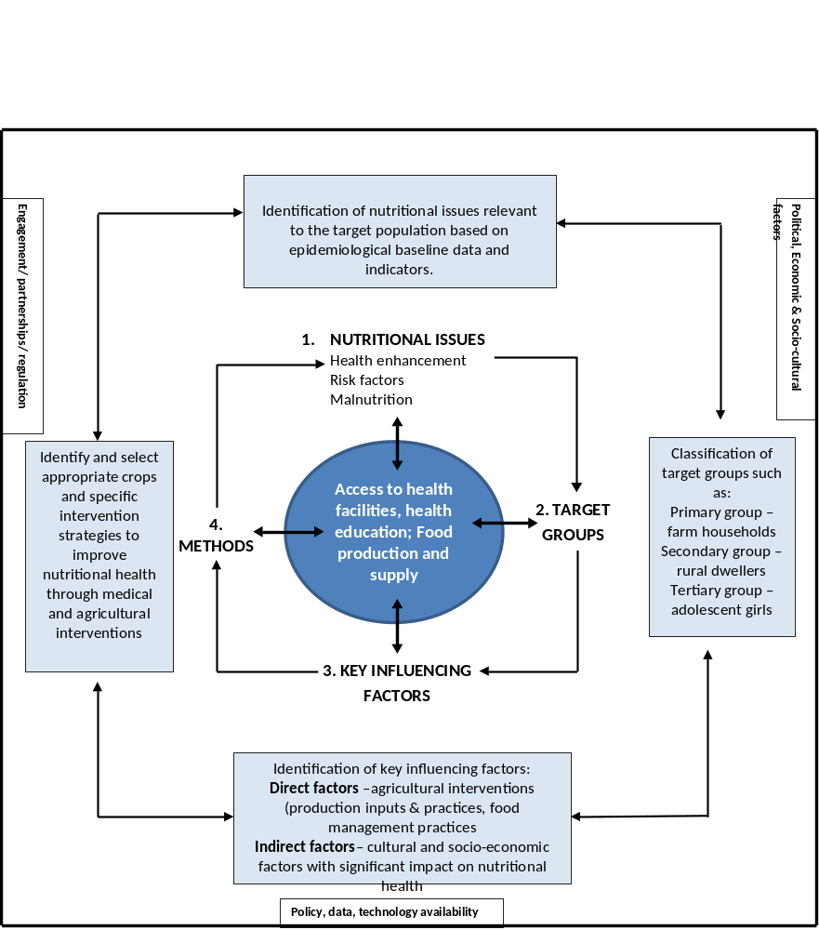

Appendix 2: Content workstream timelines (draft)
