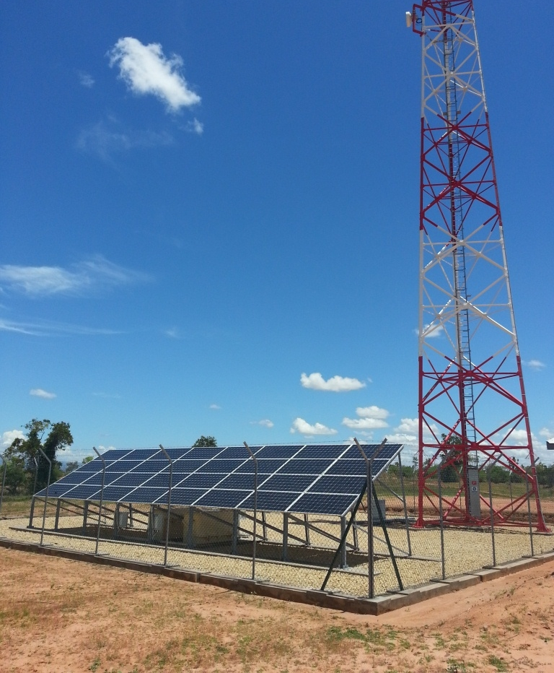
Green Power Design Approach and Feasibility Analysis
Green power for Mobile Technical White Paper
August 2014
Contents
Introduction 4
Why consider green power for telecoms? 4
Limited Grid power infrastructure 4
Unreliability of Grid power 4
Diesel is expensive and dirty 4
What is green power? 6
How to go about green power? 7
Strategy – Invest or Outsource? 7
Green Power Feasibility – Approach and Scenarios 9
Case 1 (MNO): Feasibility of Green power for Single-tenant scenario 11
Scenario I: Green Energy Contribution 11
Scenario II: Site Load 13
Scenario III: Green Resources 15
Case 2 (Tower Co): Feasibility of Green power for Multi-tenant scenario 16
Scenario I: Green Energy Contribution 16
Scenario II: Tenancy 18
Summary and Conclusions 20
Green Power Feasibility – Technology specific factors 21
Energy efficiency and the importance of optimum system design 21
Diesel hybrid systems and the effect of battery sizing on the overall system efficiency 22
Comparative analysis of Green Technologies and their Feasibility parameters 23
Comparison of Power Generation Costs per kWh 24
Conclusion 26

Figures
Figure 1: Global Off-grid and Unreliable-grid Mobile Network: Current Size and Future Growth 5
Figure 2: A typical Telecom Power System and Components 9
Figure 3: Feasibility (CDC vs. Green): Varying Green Energy Contribution – impact on TCO and Payback 12
Figure 4: Feasibility (CDC vs. Green): Change (+/-) in Site Load – impact on TCO and Payback (at constant green contribution) 13
Figure 5: Feasibility (CDC vs. Green): Change (+/-) in Site Load – impact on TCO and Payback (at constant CAPEX) 14
Figure 6: Feasibility (CDC vs. Green): Varying solar radiation – impact on TCO and Payback 15
Figure 7: Multi-tenant Feasibility (CDC vs. Green): Varying green contribution – impact on TCO and Payback 17
Figure 8: Multi-tenant Feasibility (CDC vs. Green): Tenancy scenarios – impact on TCO and Payback 18
Figure 9: DG loading and OPEX performance 22
Figure 10: DG loading and impact on TCO 23
Figure 11: Comparison green technologies: Cost of generation ($ / kWh) 25

Tables
Table 1: Invest vs. Outsource 7
Table 2: Design Assumptions – Single Tenant 11
Table 3: Design Assumptions – Multi tenant 16
Table 4: Comparison of green technologies: Pros and Cons 23

Objective
The technical paper focuses on identifying the right design approach for analysing the feasibility of green power as an alternative to diesel based power solution for powering off-grid telecom base station sites. In this paper we look at various design parameters and analyse scenarios related to green power feasbility.

The paper highlights the importance of some of key design parameters and their effect on green power feasibility – both technical and commercial. A comparative analysis of various green technology choices is also presented looking at pros and cons of each technology choice for understanding the deployment suitability and commercial feasibility for powering telecom base station sites.

Audience
The Green Power for Mobile Technical paper could benefit all stakeholders inlcuding MNOs and Tower Cos as well as the solution providers and integrators in understanding the essential design approach and key parameters affecting the feasibility of green power alternatives for power base station sites.

Glossary:
MNO: Mobile network operator or mobile operator
Tower Company (Tower Co): A company that manages a part or the entire assets of a telecom tower.
CAPEX Model: Mobile Operator or Tower Company invests CAPEX of their own to rollout the renewable solution.
OPEX Model: A Renewable ESCO invests CAPEX to generator power at site level and sells power to Mobile Operator or Tower Company.
Tenancy Ratio: A tenancy ratio is expressed as a fraction of the total number of operators sharing towers/total number of sites present.
Off-grid site: Telecom Base Station Site which is NOT connected to the commercial Grid power supply
On-grid site: Telecom Base Station Site which is connected to the commercial Grid power supply
Grid: Electricity Utility Grid
DG: Diesel Generator
IRR: Internal Rate of Return is the Rate of Return of an Investment.
TCO: Total Cost of Ownership for understanding the life time cost of a power system
OPEX: Operational Expenditure
CAPEX: Capital Expenditure
ROI: Return on Investment
kWh: Kilo Watt Hour
Power Factor: The ratio of the actual electrical power dissipated by an AC circuit to the product of the r.m.s. values of current and voltage
GHG: Green House Gas (CO2)

Introduction

Why consider green power for telecoms?
Energy provision is a critical aspect of telecom network operations and energy constitutes as high as 60% of the total network OPEX. With a requirement of 99.95% benchmark uptime, telecom networks must be powered up 24x7 throughout the year. Therefore, electricity supply and grid infrastructure play a very vital role in the day-to-day operations of an MNO.

However, the MNOs in developing countries face many challenges in powering up their network in a cost effective and efficient manner. The below are some of the key reasons for the power problems in telecoms.

Limited Grid power infrastructure
The reach and spread of grid power infrastructure in the developing world is poor leading to many telecom sites being deployed in areas without grid power. The graph below shows the grid electrification rate of selected countries in Asia, Africa and Latin America.

Unreliability of Grid power
Despite the grid connectivity (wherever there is grid), the MNOs may face frequent power outages – both scheduled and unscheduled, due to shortages in power generation capacities unable to meet the demand. Also, the quality of power supply is a major concern in many countries, leaving the MNOs with very less amount of quality power supply to power up their telecom base station sites.

Diesel is expensive and dirty
The limited reach of grid infrastructure and the unreliable power supply, where there is grid, have forced the MNOs to rely on diesel generators to power up their network. MNOs rely on diesel generators as both primary and backup power sources depending on the grid and power supply situation. In off-grid areas DGs act as the primary source and in unreliable-grid areas, DGs are used as backup to substitute for grid power outages. However, diesel based power is very expensive and dirty for the environment.

In the above context, MNOs have looked at alternative green power solutions for their feasibility to reduce energy OPEX and benefit the environment by reducing CO2 emissions. With their sustainable business strategies, reduction of environmental impact from business operations has become a top priority for many MNOs. Through their energy efficiency and green power initiatives, MNOs have been making slow but steady progress towards greener networks.

However, the implementation of green power alternatives is far from reaching its true potential. There are 320,000 off-grid and over 700,000 unreliable-grid telecom sites in the world today (2014). The off-grid and bad-grid network globally is estimated to reach a total of approximately 1.2 million tower sites by 2020 from the current size of 1 million off-grid and bad-grid towers in 2014. Therefore, The MNOs and Tower Cos will deploy an additional 160,000 off-grid and bad-grid tower sites by 2020.
Figure 1: Global Off-grid and Unreliable-grid Mobile Network: Current Size and Future Growth
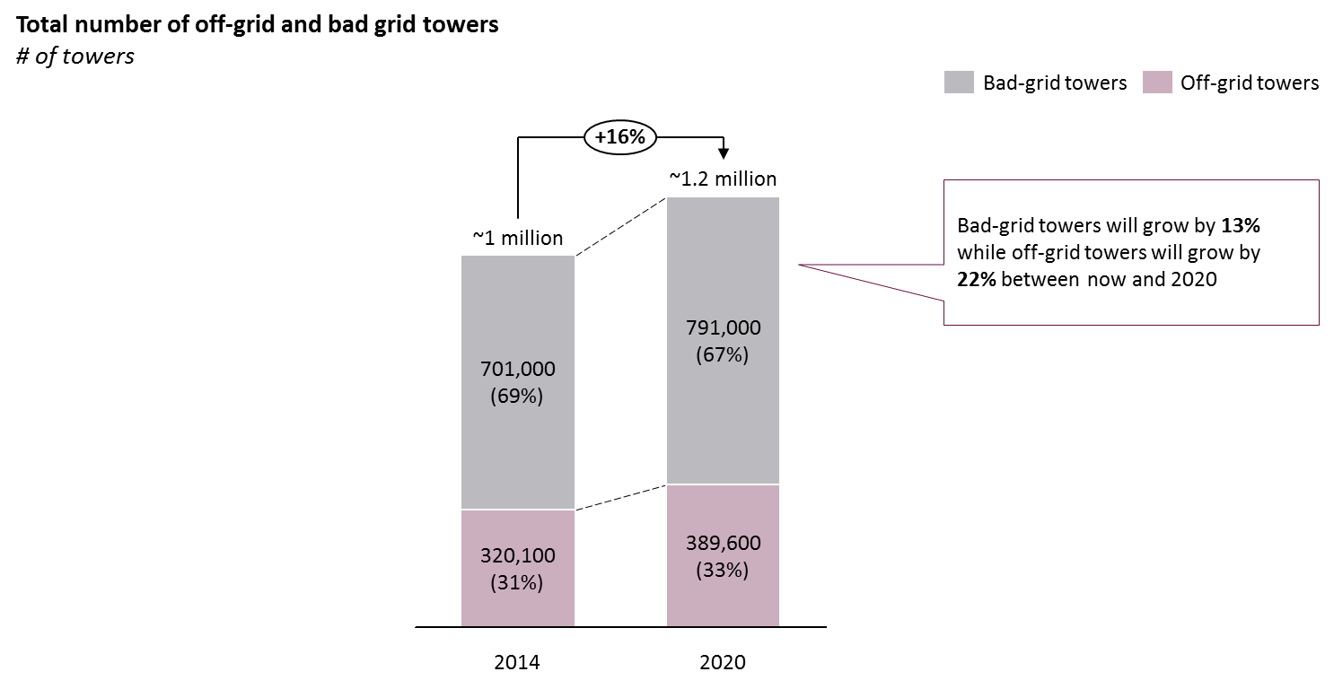

The major driver of the estimated growth in off-grid and bad-grid towers is the expected expansion of mobile networks into rural regions in Africa and Asia, large parts of which face limited access to reliable grid electricity and poor grid power infrastructure. Therefore, green alternatives for telecom power present a huge opportunity for MNOs and other stakeholders.

This technical paper will focus on the aspects of analyzing the technical and economic feasibility of green power and the important parameters as well as clear approach to understanding the strategy and benefits of green power for telecoms.

What is green power?
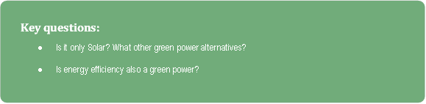
Green power technology in the mobile industry traditionally refers to a renewable energy source used to generate and supply power to a mobile base station site. The most commonly adopted green power sources in telecom include solar PV, wind turbines and hydrogen or methanol based fuel cells. The other renewable sources including biomass and micro (or Pico) hydro power generation are also being evaluated for telecom power and still in the early pilot stages of adoption.

The definition of green power has evolved from adoption of pure (100%) renewable energy sources to a broader concept of adopting an approach to optimizing power systems, by reducing power requirements as well as reducing the dependence on fossil fuels, in an effort to drive efficient, greener and sustainable ways to power up the telecom base station sites. Therefore, energy efficiency has become an important aspect of green strategy for telecom operators.

The development of new energy storage technologies and performance improvements in traditional battery technologies have made a way for optimizing the existing power systems to be more efficient in utilizing the diesel generators (DGs), thereby reducing their use and consumption of diesel. Mobile operators have been aggressively adopting the DG-battery hybrid solutions to quickly reduce the dependence on diesel generators and consumption of diesel and hence realize quick short term savings in energy OPEX.

Therefore, besides the adoption of renewable power sources, the various energy efficiency initiatives as well as the adoption battery hybrid solutions have become a great part of the overall green power strategy for mobile network operators.

How to go about green power?

Given the prevailing challenges in powering telecoms and the possible opportunity for green power telecoms, the MNOs need to analyze, understand and draft a strategy for adopting green power alternatives for telecom power.

The strategy highly depends on the procurement approach and the energy provision business model adopted by the MNOs. The various aspects of the green strategy including the associated business models and their pros and cons are presented below.

Strategy – Invest or Outsource?
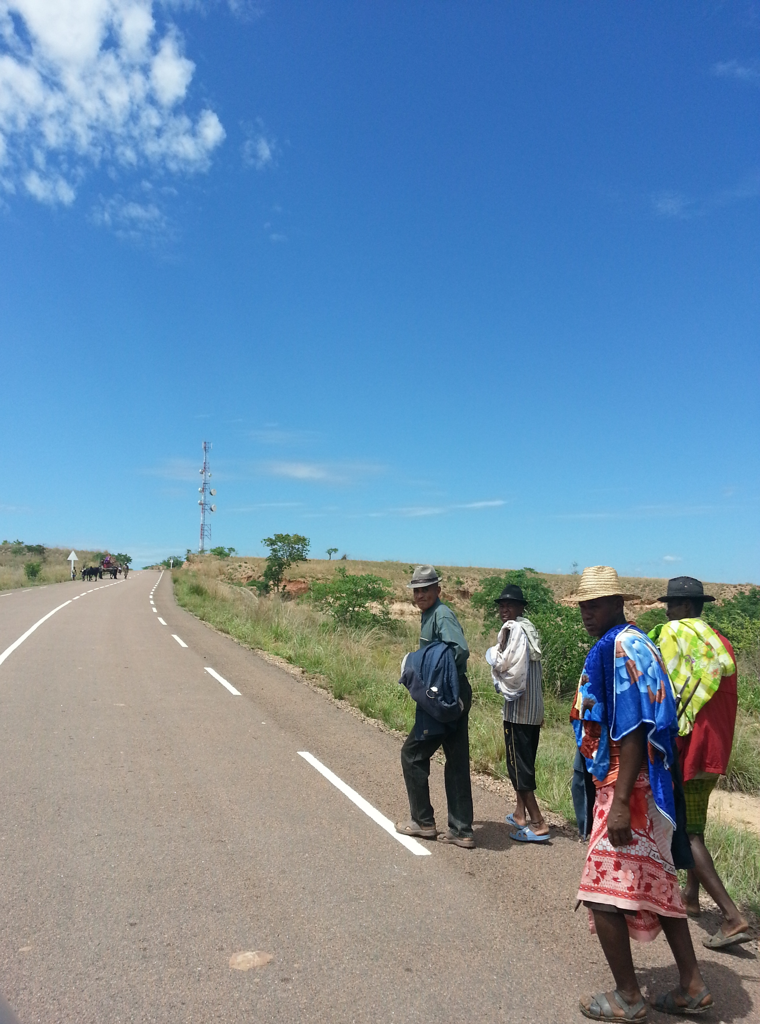
Traditionally, the practice of energy provision in telecom is highly driven by the low CAPEX approach. Historically, the investments in energy efficiency and green power systems have been pushed down due to limited availability of capital and competing investment priorities for MNOs including spectrum licenses, upgrade to new network technologies etc.

The low CAPEX approach is associated with a higher than possible optimum OPEX and is not sustainable in the long run. The green power alternatives will present excellent opportunity for huge OPEX savings in a sustainable manner, however, require considerably higher upfront CAPEX.

The MNO is presented with a choice to choose between investing in green power on its own and outsourcing the energy provision to a Tower Company or 3rd party Energy Service Company (ESCO). The in-house model (or CAPEX model) will require huge capital outlay from MNOs to reap the benefits of investing in green power. However, the outsourced model (or ESCO model) would provide the MNOs with financial and operational benefits without investing in green power systems. The comparison of both approaches is presented below

Table 1: Invest vs. Outsource
 | CAPEX model (in-house) | ESCO model (outsourced)
Financial | - Operator has to invest all CAPEX either from its own source or from capital market; therefore financial risk belongs to Operator  - IRR and NPV of Green Power deployment is significantly attractive.  - For mass deployment, CAPEX investment comes as a barrier since it may require hundreds of millions of dollars. | - Operator does not have to invest for CAPEX, therefore no financial risk to deploy green power  - IRR and NPV increases for telecom site since site OPEX reduces  - Since mass deployment increases the business opportunity for ESCO, it comes more viable to invest
Operational | - Regular day-to-day site operation is a responsibility of operator  - All cost related to site operation is incurred by operator  - Site uptime and SLA maintenance is typically on operator. If fails, Operator bears all financial loss/penalty  - OPEX for technical operation is low  - OPEX for site operation is high | - Site operation is a responsibility of ESCO; therefore Operator does not need to deploy resource for site operation  - Operator pays only based on energy usage in a pre-agreed rate, therefore operational cost is forecast-able and comparatively lower than DG based energy cost  - SLA and Uptime is a responsibility of ESCO. If fails, ESCO bears penalty
Strategic | - All asset of green power belongs to operator, therefore increases portfolio & branding value of organization  - Maximize utilization of existing asset.  - Easy to cope-up with variable changes  - Multi 3rd parties’ engagement makes the model complex for operator to handle at last mile  - Increase debt for organization | - Easy to control last mile performance sine ESCO is the only last mile partner  - Get full benefit of GHG emission reduction  - Increases complexity of state management  - Not so easy to cope-up with increase of power requirement on regular basis  - Reduces the risk of unforeseen energy OPEX due to market change and consumer inflation

The decision to invest (or outsource) in energy provision depends on clear understanding of both the technical and financial feasibility of green power alternatives for current and future operating context. A thorough design and analysis needs to be carried out in order to understand each aspect of technical and financial feasibility and the underlying parameters which affect the feasibility.

Green Power Feasibility – Approach and Scenarios
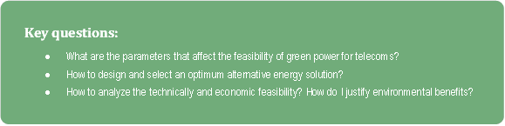
The analysis of green power feasibility depends largely on the understanding of the current operating context, the underlying goals and objectives and the design approach. A right approach to design and thorough analysis is required for a clear understanding of the technical and financial aspects of investing in green power in order to help in decision making.

A typical power system and its components at a telecom site is illustrated in the figure below.
Figure 2: A typical Telecom Power System and Components

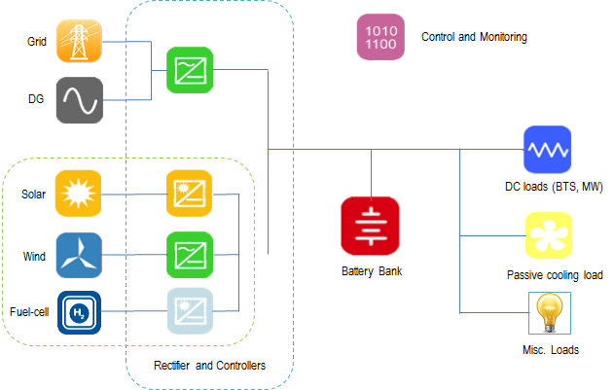

The technical design and financial feasibility of green power is affected various design as well as commercial parameters as explained below.

- Site Load: Site load affects the dimensioning of power system and components and hence, financial viability. Future load increases of MNOs and multi-tenant scenarios of Tower Companies present challenges for optimum power system design. A comprehensive approach to green power design and feasibility analysis required for taking right investment decisions.
- Renewable Resources: The availability of good renewable resources, such as suitable solar radiation and wind speeds, affects both the technical and financial feasibility of green power solutions. Seasonal variation in renewable resource availability presents a big challenge in power system design. Usually, an average case scenario is considered for design and analysis.
- Energy contribution: Energy contribution from the green power source as part of the entire power system is very important parameter which affects dimensioning of the power system components including the green component. Power system designs with 100% green power contribution may not be feasible for all categories of sites. Depending on the load and renewable resource context, choosing an optimum energy contribution from green component is very crucial for financial feasibility of green power solutions.
- DG loading and efficiency: The efficiency of diesel generators have a non-linear efficiency characteristic depending on the loading at any point of time. For better efficiency, it is suggested to operate the DG above 50% loading. Therefore, the average loading on the diesel generators is a key design parameter to consider while dimensioning the green power system.
- Battery autonomy and Cycle life: Another key component of the power system design is battery. The autonomy of the battery is a key parameter for any green power system design. Choosing an optimum autonomy of battery is crucial for overall efficiency of the system and its components. The battery autonomy and sizing depends on various design inputs including battery cycle life, efficiency, as well as some of the site specific conditions such as resources and their seasonal variations.
- CAPEX: CAPEX of each component especially the battery and the solar PV components affects the overall feasibility of green power alternatives. The pricing of components and hence the CAPEX of green power varies by country and region due to different macroeconomic conditions including taxation, import duties and the availability of local or regional manufacturing base.
- Diesel price: The price of diesel varies by country and it hugely affects the commercial feasibility of green power vis-à-vis diesel based power system and the potential OPEX savings.
- Land space: Certain green power technologies such as solar, biomass etc. would require a large amount land for deployment. Hence, space availability at the site and ease of acquisition of addition space become critical parameters while analyzing the technical feasibility of green power solutions.

The following sections present a detailed analysis of green power feasibility for various technical and commercial scenarios.

Case 1 (MNO): Feasibility of Green power for Single-tenant scenario
In this section we build and analyze various scenarios for green power design and feasibility for a single tenant (MNO) case. For each scenario in this case, we consider a base case of DG-battery hybrid (CDC) solution for comparative feasibility analysis. In each case, Solar PV is considered as the green power component in the design.
Table 2: Design Assumptions – Single Tenant
Site Load per tenant | 1.5 kW
DG run hours (CDC) | 12 hours
Battery autonomy (CDC) | 6 hours
DG Capacity (@ 0.8pf) | 15 KVA
DG Loading (avg. % of Capacity) | 70%
Solar Radiation | 5.5 kWh/m2/day
Battery Autonomy (Green) | 24 hours

The technical design and dimensioning of green power system is calculated based on the above basic assumptions for a single tenant site. The designs are developed for various technical scenarios including varying green energy contribution, varying load, and renewable resources availability and then, each scenario is analyzed for commercial feasibility considering the long-term TCO term and payback. A comparative analysis is presented along with insights on feasibility of alternative power systems.

Scenario I: Green Energy Contribution
Scenario:
This scenario takes into consideration the effect of green energy contribution on the overall design and feasibility metrics. Design and feasibility analysis is carried out for various solar energy contribution fractions ranging from 20% to 100%.

Analysis:
The scenario analyses the effect of energy contribution from green resource (solar) as percentage of the total energy requirement for the base station site. Energy contribution is an important parameter in dimensioning the optimum green power system for telecoms. The analysis below answers the question as to what percentage of green (solar) contribution to be considered for the optimum design so that it is feasible both technically and financially.

Figure 3: Feasibility (CDC vs. Green): Varying Green Energy Contribution – impact on TCO and Payback

The above graph illustrates TCO analysis of various scenarios of green energy contribution over a 10 year period and compares it to the base case of DG-battery hybrid (or CDC) power solution. As can be seen from the graph, the TCO and payback varies with the percentage of energy contribution from green source.

Which solution to choose?
One parameter to consider while selecting the best solution is the payback period. Compared to the CDC solution, the green power designs with green contribution between 20% and 80% have a payback period of around 2.5 years where as the design with 100% green contribution (or pure green design) has a payback period of over 3 years.

Long term TCO is another factor to consider while selecting the best long term power solution for sustainably powering telecom site. As shown in the illustration above, the green design with 80% green contribution has the nest long term TCO as compared to the CDC and other green designs. The green designs with 60% and 100% green contribution have almost equal long term TCO at 10 years, however, the design with 60% green contribution has a better payback.

Besides the payback period and the long term TCO, the initial CAPEX requirement puts a major constraint on choosing a solution design. Each of these green designs presented above have different CAPEX requirements compared to CDC solution. For example, the design with 80% green contribution has the best long term TCO and almost similar payback period, but the CAPEX requirement more than other green designs.

Inference:
As explained above, the green energy contribution has a great impact on the overall solution feasibility and selection. A solution with optimum green energy contribution must be chosen considering reasonable tradeoff between long-term TCO, payback period and the CAPEX requirement. As shown in the above illustration, the design with 60% green contribution has the 2nd best long-term TCO and 3rd best CAPEX requirement with almost similar payback period amongst the 5 green power designs analyzed.

Scenario II: Site Load
Scenario:
This scenario takes into consideration the effect of changes in site load (increase or decrease) on the overall design and feasibility metrics. Design and feasibility analysis is carried out for load changes of -25%, +25% and +50% from the base load assumption. The green contribution of 60% is assumed for all the designs in this scenario.
Analysis:
The impact of site load on the overall feasibility of green power design is analyzed and compared to the base case CDC power solution. The graph below illustrates the TCO analysis of the green power designs for various load scenarios.
Figure 4: Feasibility (CDC vs. Green): Change (+/-) in Site Load – impact on TCO and Payback (at constant green contribution)

The load requirement of a site will directly affect the design and dimensioning of the green power solution and thereby, impact the overall feasibility metrics including the CAPEX, TCO, payback and the OPEX savings.

As illustrated in the above graph, lower the load better the long term TCO, CAPEX and payback for the green power design. The payback (or break-even) of the green designs for all the load scenarios above is between 2 and 3 years as compared to the base case CDC power solution.

Higher site loads will require higher CAPEX for the same level green energy contribution as compared to the lower site loads. The MNO must choose an optimum solution design based on CAPEX availability and payback expectations considering the overall feasibility metrics and associated benefits as presented above.

The below graph illustrates the TCO and payback analysis for the various load scenarios on a same green power design and CAPEX basis.
Figure 5: Feasibility (CDC vs. Green): Change (+/-) in Site Load – impact on TCO and Payback (at constant CAPEX)

As shown above, for a green power design and CAPEX, the payback and long term TCO vary with the site load. The higher site loads will have longer payback and higher TCO as compared to lower site loads for a same green power design dimensions.

Inference:
Sites with lower loads present a better feasibility for green power solutions as compared to sites with higher loads based on similar design assumptions. For the same CAPEX, sites with higher loads will have a longer payback, higher TCO, and lower GHG reduction.

A design analysis must be carried out for various design scenarios in order to find an optimum feasible green power solution with the right green contribution, payback, and TCO and CAPEX requirements.

Scenario III: Green Resources
Scenario:
This scenario runs on the available green resources and its impact on the green power feasibility metrics. In this example we consider a single solar design and dimensions for various solar radiation conditions – 3.0, 4.5, 5.5 and 6.5 kWh per sq. m. per day.

Analysis:
The green resource availability has a considerable impact on TCO and payback of a particular green power solution. As shown in the below illustration, a site with higher solar radiation will have better payback and TCO for the same solar design as compared to a site with poor solar radiation.
Figure 6: Feasibility (CDC vs. Green): Varying solar radiation – impact on TCO and Payback

For the same design dimensions, a site with better renewable resources will have higher green energy contribution compared to a site with poor renewable resources.

Inference:
Better the renewable resource availability, higher the green contribution, lower the dependence on diesel power and better the feasibility metrics for the same renewable design.

Case 2 (Tower Co): Feasibility of Green power for Multi-tenant scenario
This section presents the analysis of green power feasibility and various design scenarios for a multi-tenant case of a Tower Co. As in the single tenant case, the multi-tenant case also considers a base example of DG-battery hybrid (CDC) solution for comparative feasibility analysis. In each scenario, Solar PV is considered as the green power component in the design.
Table 3: Design Assumptions – Multi tenant
Site Load per tenant | 1.5 kW
DG run hours (CDC) | 12 hours
Battery autonomy (CDC) | 6 hours
DG Capacity (@ 0.8pf) | 15 KVA
DG Loading (avg. % of Capacity) | 70%
Solar Radiation | 5.5 kWh/m2/day
Battery Autonomy (Green) | 24 hours

The technical design and dimensioning of green power system is calculated based on the above basic assumptions for a single tenant site. The designs are developed for various technical scenarios including varying green energy contribution and tenancy scenarios, and then, each scenario is analyzed for commercial feasibility considering the long-term TCO term and payback. A comparative analysis is presented along with insights on feasibility of alternative power systems.

Scenario I: Green Energy Contribution
Scenario:
The scenario demonstrates the importance of optimum green energy contribution as part of the overall green power design approach in a multitenant scenario for Tower Cos. Here we consider a two-tenant scenario and analyze the effect of varying green contributions on the overall design and feasibility metrics.

Analysis:
The analysis below presents an approach to understanding the feasibility of green power for multi-tenant scenario. The graph below illustrates the long term TCO comparison for various green power contribution scenarios for a 2-tenant case.
Figure 7: Multi-tenant Feasibility (CDC vs. Green): Varying green contribution – impact on TCO and Payback

From the figure above, it can be observed that the payback for green scenarios as compared to CDC solution varies over a long range from nearly 4 years to more than 8 years. It is also observed that, the differential of long-term TCO between scenarios is not very significant as against the single tenant case where the long-term TCO differential was quite significant when compared to the base CDC scenario.

As shown above, in comparison to the CDC solution, the design with 80% green contribution offers the best long-term TCO and a payback of less than 4 years which is better than other green power designs. However, this solution would require a huge CAPEX of around 75,000 US$ which may come as constraint for deployment of this green power solution. Similarly, the green design with 100% green energy contribution may not a feasible option given the huge CAPEX requirement of over 100,000 US$.

However, with a long term outlook, a trade-off between CAPEX, TCO and payback can be arrived so that the benefits of green power solution can be realized as compared to the diesel based CDC solution. For example, as shown in the above illustration, the design with 40% green contribution has a moderate CAPEX of 55,000 US$ and a better long-term TCO with payback of approximately 5 years as compared to CDC solution.

The decision to invest in green power with a long term outlook will also depend on a crucial infrastructure scenario of possible grid power extension over the years. In an optimistic scenario of grid extension within short term of within 3-5 years, it may not make a case for huge investments in green power.

Inference:
The green power design for a multitenant scenario is very tricky. At the beginning it may appear that green power may not be feasible for multi-tenant situations of a Tower Company. However, as demonstrated above, a design approach looking at optimum green contributions and a long-term outlook will give a better visibility to the feasibility of green power for multi-tenant context.

A tower company should take a long-term view of green power feasibility in order to make green power a feasible and sustainable energy choice for providing power to their tenants. The contract tenure with MNOs and the long-term tenancy growth outlook will have a great impact on the investments in green power from a Tower Co.

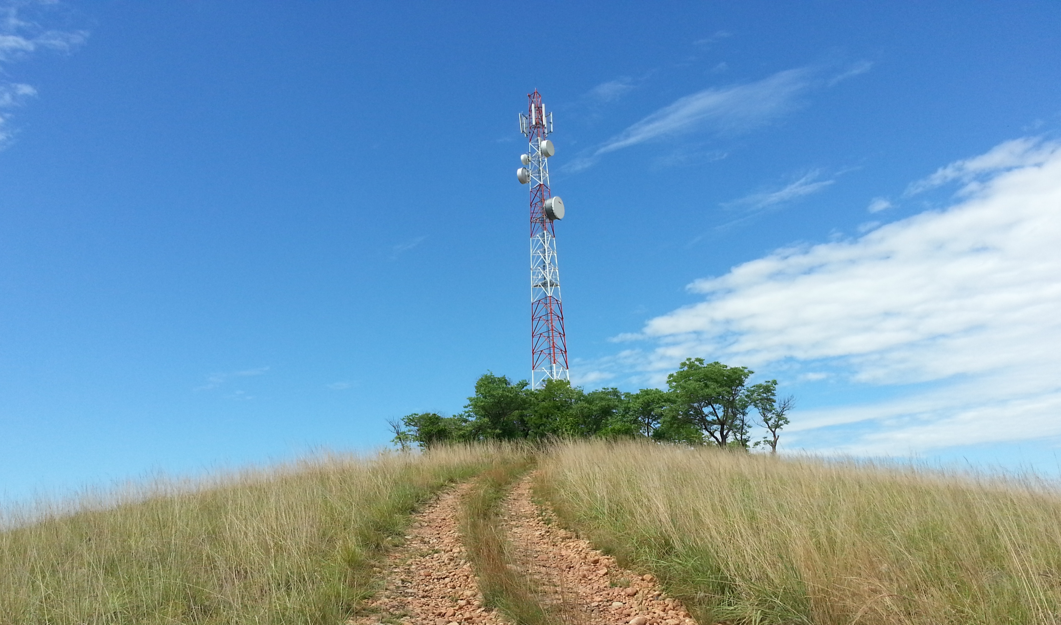
Hence, green power investments for a Tower Co should have a long term view of at least 5 years and an optimum design selection in order to achieve a lower long-term TCO, lower energy costs, and environment friendly sustainable energy operations.

Scenario II: Tenancy
Scenario:
In this scenario, we compare and analyze green power feasibility metrics for a multi-tenant scenario. A solar design is compared and analyzed for three tenancy scenarios – 1 tenant, 2 tenants and 3 tenants.

Analysis:
The tenancy of a site will hugely affect the feasibility of green power solution. The TCO and payback analysis for various tenancy scenarios is presented in the figure below.
Figure 8: Multi-tenant Feasibility (CDC vs. Green): Tenancy scenarios – impact on TCO and Payback

The figure above shows that the long term TCO differential of green power solutions vis-à-vis diesel based CDC solution is not very significant for 2 and 3 tenant scenarios. Besides, the CAPEX differential between green power and CDC solutions is too high to be justifiable for the small TCO benefits in the 2 and 3 tenant scenarios.

Inference:
Given the large CAPEX requirement for green power, green power feasibility for a multi-tenant scenario will require a long-term view of more than 5 years in order to realize the benefits of lower TCO when compared to the diesel based CDC solution. The possibility of grid extension is very critical to consider while taking up a long-term investment in green power.

Summary and Conclusions

- The energy contribution from green power source has a great impact on the overall solution feasibility and selection. A solution with optimum green energy contribution must be chosen considering reasonable tradeoff between long-term TCO, payback period and the CAPEX requirement.
- Sites with lower loads present a better feasibility for green power solutions as compared to sites with higher loads based on similar design assumptions.
- For a given green power design – better the renewable resource availability, higher the green contribution, lower the dependence on diesel power and better the feasibility metrics.
- Green power investments for a Tower Co should have a long term view of at least 5 years and an optimum design selection in order to achieve a lower long-term TCO, lower energy costs, and environment friendly sustainable energy operations.
- The contract tenure with MNOs and the long-term tenancy growth outlook will have a great impact on the investments in green power for a multi-tenant context of a Tower Company.
- The possibility of future grid extension is very critical to consider while taking up a long-term view on investing in green power for telecoms.
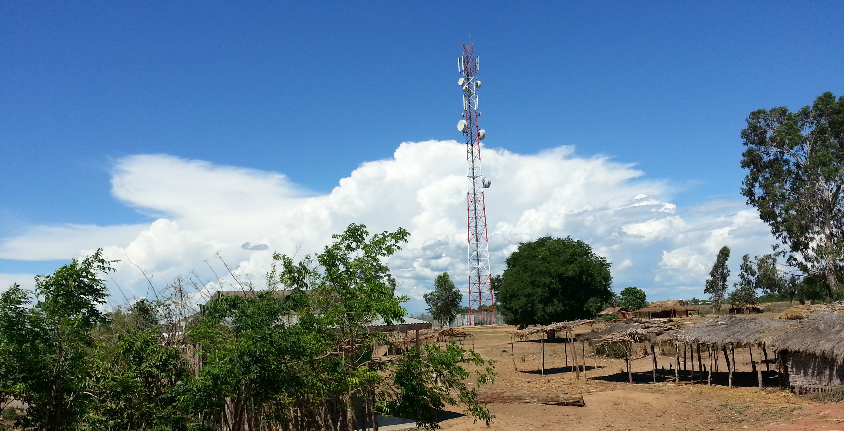

Green Power Feasibility – Technology specific factors
The feasibility of greener alternatives to power up mobile base stations greatly depends on the choice of technology adopted. Therefore it is very crucial to understand and analyze the technology specific parameters while analyzing the feasible green power alternatives. In this section, various technologies and their specific design and implementation specific parameters are analyzed to understand their effects on overall green power feasibility and adoption for telecom power applications.

Energy efficiency and the importance of optimum system design

Energy efficiency has become a key part of overall strategy to reduce energy OPEX of a telecom site in the short run. Energy efficiency can be looked at from both reducing energy consumption as well as improving generation efficiency. Reduction in energy consumption can be achieved through various elements including equipment upgrade, optimizing operating environment such as cooling systems, and reducing miscellaneous loads at the site. However, a greater benefit in energy efficiency is achieved through overall power system optimization using high performance equipment, and optimum calibration of parameters for running power system at its maximum efficiency. It is a proven in some cases that, energy efficiency initiatives could save MNOs and Tower Cos up to a 30% in energy OPEX for a site.

Some of the key energy efficiency initiatives for an MNO/Tower Co are listed below.
For existing networks,
- Energy Optimization and Efficiency
  - Upgrade or swap indoor equipment to outdoor equipment for Off-grid sites
    - Reduce overall site load and optimize energy requirements
    - Improve equipment performance for extreme weather conditions
  - Replace old diesel generators for improved performance and reduced O&M costs
    - Reduce fuel consumption
    - Reduce number of site visits and reduce operational expenses
    - Improve performance during extreme weather conditions especially during winter
- Implement smart energy monitoring and site equipment control mechanism to control site operations
- Implement smart power source control mechanism to intelligently select between various power sources including Renewables, Grid power, Batteries and DG
For future networks,
- Consider Light Rural site solutions for extending network to remote, low ARPU, low traffic regions
  - Feasibility of renewable alternatives to power
  - Less or zero dependence on diesel power
- Deploy outdoor equipment for upcoming network rollout for better network energy efficiency

Diesel hybrid systems and the effect of battery sizing on the overall system efficiency

Of the many greener alternatives, diesel generator plus battery hybrid power systems have become a popular choice of solutions to power up base station sites. There has been a great trend towards adopting DG-battery hybrid systems to power telecom sites owing to their lower CAPEX and short term OPEX saving benefits. However, the optimum dimensioning of diesel generator as well as the size of the battery bank has a huge impact on the overall system efficiency, performance and the realized OPEX savings.

The two parameters that greatly affect the overall efficiency and performance are the dimensioning of the battery and the diesel generator as well as the design parameters such as the average loading on the diesel generator and the overall energy throughput realized from the battery bank.

The effect of generator loading on overall system efficiency and OPEX savings is illustrated below.
Figure 9: DG loading and OPEX performance

As demonstrated above, a design with and optimum diesel generator loading can improve the overall generation efficiency and save energy OPEX by reducing overall diesel consumption. Diesel generators are more efficient when run at a higher loading and require less maintenance. For the same required energy output, the overall diesel consumption is reduced at higher average loading and hence reduces overall energy OPEX.

The impact on overall TCO of the diesel hybrid system is illustrated below.
Figure 10: DG loading and impact on TCO

The TCO of a generator-battery hybrid solution improves by designing the system at a higher DG loading factor. The higher the DG loading, the better the generation efficiency and lower the number of run hours hence improves overall OPEX performance of the power system.

Comparative analysis of Green Technologies and their Feasibility parameters
The choice of feasible green power technology depends on various technology specific parameters as well as overall powering context of telecom base station site. Following the technical and commercial feasibility of a particular green technology, we need to look into site specific and operating context in order understand the most appropriate deployment choice.

The pros and cons of various green choices are presented below.
Table 4: Comparison of green technologies: Pros and Cons
 | Pros | Cons
Solar | - Ubiquitously available solar resource  - Suitable for distributed power generation  - Widely scalable owing to its modular technology  - No maintenance cost of solar panels, except for some un-skilled labor cleaning the panels occasionally  - Cost-competitiveness compared to other green technology options  - Reached commercial scale of adoption for small scale applications | - High space requirements for higher capacity deployments  - High upfront CAPEX compared traditional diesel based solutions  - Theft and vandalism of panels leading to high risk of investment in Solar
Wind | - Suitable for small scale distributed power generation  - Less space requirement compared to Solar | - Low reliability – due to the variability of wind speed; Wind energy costs sensitive to wind resources  - Low scalability and High investment  - Need tall towers, 20 – 40m for optimum power generation  - Reliability of wind products varies widely  - High regular maintenance costs
Fuel Cell | - Reliable technology  - Compact system and requires less space  - Suitable for rooftop and urban contexts  - Low Maintenance  - Low emissions and low noise  - Less prone to theft and vandalism | - High upfront investment and cost of technology makes less cost-effective green choice  - Highly dependent on fuel supply eco-system and logistics; Requires to build fuel reformer plants and supply chain for reliable performance  - Low range of capacities for distributed generation
Biomass | - Abundant biomass potential  - Wide range of plant capacities  - High reliability can be achieved with strong supply chain integration  - Technology is widely available | - Operational complexity  - High resource and operations costs  - Biomass feed supply challenges and dependence on unreliable supply chain eco-system  - Sensitive to cost of inputs due fluctuating feed prices

Comparison of Power Generation Costs per kWh
The levelized of cost of energy (LCOE) differs with type of green technology deployed. For a typical telecom site with 1.5kW load, and a green power design with approximately 60% green energy contribution, the below figure illustrates the cost of energy ($/kWh) for various green technologies.

Figure 11: Comparison green technologies: Cost of generation ($ / kWh)

As shown in the example above, the solar power solution has the lowest cost of energy ($/kWh) compared to other technologies. This has been mainly due to the drastic reduction in solar module prices across the world owing to increased manufacturing capacities and huge economies of scale. The wind technology, once a very cost competitive technology choice as compared to solar, has not seen much significant cost reduction over the years. However, new product development and improvements in balance of system components (such as the innovative tower designs) has enabled wind turbine supplier to improve the cost competitiveness of wind power solutions for telecom base station sites.

Fuel cell technology is far from reaching the cost competitiveness of other green technologies such as solar PV or wind turbine technologies. However, fuel-cell power systems have gained traction especially for specific conditions such as urban, rooftop and bad-grid areas where the practical feasibility of solar or wind is a challenge. Also, shown in the above diagram, fuel-cell power systems present a cost effective alternative when compared to diesel-battery power systems, in addition to many benefits such as low noise, high reliability, and environment friendliness.

Besides the generation costs, the MNOs and Tower Cos need to consider other site specific conditions in order select the best suitable green technology choice for powering the networks. Therefore, a right selection of green technology have to take into consideration various design, commercial, deployment factors including – optimum design parameters for efficient power generation, optimum OPEX savings and TCO, practical deployment parameters such as space, noise levels, rooftop conditions etc.

Conclusion
The approach to green power feasibility based on key design and commercial parameters will require a comprehensive design and comparative financial analysis. The technical design will have a strong impact on the financial feasibility of the solution. Therefore, an optimum design based on right selection of design parameters such as green energy contribution, generation efficiency, load and tenancy, and the availability of renewable resources is essential for choosing the best possible energy solution for powering up the telecom sites.

The contribution from green power to overall energy requirement is a key design parameter to optimize the technical design and the associated business case for green power feasibility within the defined boundaries of financial metrics. In addition to the evaluation of key financial metrics including CAPEX, TCO and payback, the benefits of OPEX savings, reduction in diesel consumption and the reduction GHG emission are key parameters to support the investment decisions in green power technologies to power telecom base station sites.

About the GSMA Association
The GSMA represents the interests of mobile operators worldwide. Spanning more than 220 countries, the GSMA unites nearly 800 of the world’s mobile operators with 250 companies in the broader mobile ecosystem, including handset and device makers, software companies, equipment providers and Internet companies, as well as organizations in industry sectors such as financial services, healthcare, media, transport and utilities. The GSMA also produces industry-leading events such as Mobile World Congress and Mobile Asia Expo.

For more information, please visit the GSMA corporate website at www.gsma.com. Follow the GSMA on Twitter: @GSMA.

About Mobile for Development - Serving the underserved through mobile
Mobile for Development brings together our mobile operator members, the wider mobile industry and the development community to drive commercial mobile services for underserved people in emerging markets. We identify opportunities for social and economic impact and stimulate the development of scalable, life-enhancing mobile services.

For more information, please visit the Mobile for Development website at http://www.gsma.com/mobilefordevelopment/. Connect with us on Twitter @GSMAM4D
About the GSMA Green Power for Mobile Programme
Green Power for Mobile works to extend the coverage, reduce the cost and minimize the environmental impact of mobile networks by championing renewable energy.
Whilst it continues to serve mobile network operators globally, the programme will place key focus on a number of target markets in Africa and Asia including Indonesia, Bangladesh, Pakistan, Afghanistan, Nigeria, Ghana, Kenya, Tanzania, Uganda, Senegal and Cameroon. With Project Managers based in each of these regions, GPM is well positioned to engage with the industry and address the requirements of these markets.
For more information on the GSMA's Green Power for Mobile Programme, please contact us on greenpower@gsma.com
http://www.gsma.com/mobilefordevelopment/programmes/green-power-for-mobile

GSMA GPM-Dalberg Research and Analysis, June 2014

