CHIDZIDZO 1 : INTERNET : NHANGANYAYA
Chii chinonzi Internet?
Indaneti inetiweki inotendera makombiyuta nedzimwe nharembozha kutumira nekugamuchira mashoko kubva pasi rese. Idura remashoko guru rekuti vanhu pasi rese vanogona kuwana mashoko, kushandisa kana kuawedzera”.
Internet inotibatsirei mukurarama kwedu?
- Kutsvaka mabhuku ekuverenga kunyanya kuvana vechikoro.
- Kutaura nevarikure kuburikidza ne WhatsApp, Facebook nepaGoogle.
- Kubatsira mubhizimusi rako, kuvandudza hunyanzvi hwako, kubatana nemhuri neshamwari dzako, nemamwewo mabasa akawanda akasiyana-siyana.
- Kudzidza nekuvandudza hunyanzvi uye kutandadzwa paYouTube, semuenzaniso: mavhidhiyo akaita sekuti kutamba mumhanzi kunoitwa sei, kubika kunoitwa sei kana kuti unogadzirisa sei taira rebhasikoro raponja.
- Kutsvaga zvinyorwa zvinobatsira paGoogle zvinobatsira hupenyu hwako, chikoro, basa, bhizimusi, zvichingodaro.
Mhando yenharembozha yamuri kushandisa kuenda paInternet.
Nharembozha yamuri kushandisa kupinda paInternet ndeyerudzi rwunonzi Smart Phone. Nharembozha idzi ndidzo dzechizvinozvino. Munodzishandisa kuchibaya pasikirini.
Zviitwa: Pindai paindaneti
- Indaneti inovhura dandemutande raunoda kana waisa gadziridzo yacho. Onai kuti nharembozha dzakasiyasiyana dzinogona kuva nemabhurauza akasiyanawo onai pazasi,
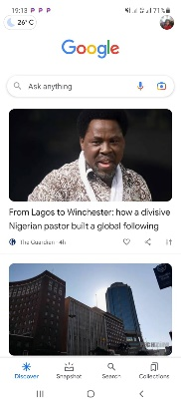

Chenjedzo: Pane mhando dzakasiyana-siyana dzakawanda ‘dzemabhurauza’ anoshandiswa paindaneti. Zvichienderana nenharembozha yauri kushandisa, unogona kushandisa chimwe cheizvi pachinhambo chezvakaratidzwa pamusoro.

CHIDZIDZO 2: GOOGLE
Chii chinonzi Google
Google ibhurauza rinoshandiswa kutsvaga zvinhu pa Internet
Tsananguro yekutsvaga zvinhu pa Google
- “Panotsvagwa zvinhu paGoogle panokubatsira kutsvaga ruzivo rwamunoda. Unoudza Google mashoko amunoda kutsvaga, somuenzaniso ‘ Tsumo nemadimikira’, uye yotsvaga mumashoko ose akaiswa nevanhu paindaneti, kutsvaga zvamunoda.
- Munogona kuwana ruzivo pamusoro penzvimbo, mabasa, mabikiro, mafirimu, nziyo, nhau, nyaya dzechikoro, korichi, bvunzo, nezvimwewo.
Zviitwa: Kushandisa Google
- Dvanyai pachikwangwani chakaita sechiri pasi kuti mupinde paGoogle;

- Nyorai mazwi ezvamurikutsvaga. Semuenzaniso “Tsumo nemadimikira”
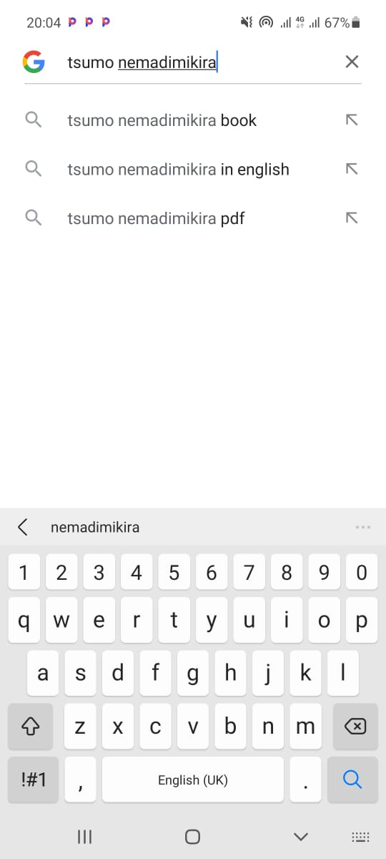

Zvamurikutsvaga zvinobva zvabuda seizvi
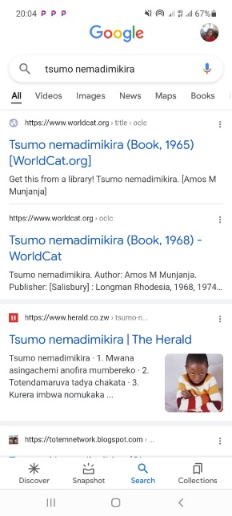
Chenjedzo: Google in tebhu dzakasiyana siyana dzinosanganisira images (mifananidzo), videos nemaps. Kana ukabaya tebhu dzakasiyana siyana, Google inoburitsa zvakasiyana siyana. Somuenzaniso, kana ukabaya tebhu yemufananidzo, unoona mifananidzo chete
Kuzvichengetedza paGoogle
- Zvakakosha kurangarira kuti indaneti inzvimbo yeruzhinji, uye zvakakosha kuitora saizvozvi kuti mugare makachengetedzeka.
- Rega kutaura nevanhu vamusingazivi kana kuti vari kukunetsai.
- Kana musina kugadzikana nekuda kwezvamaona kana kuti zvaitika pakutaura nemunhu wamunoziva huye wamunovimba naye.
- Zvinhu zvine chekuita nemi pachenyu zvinofanirwa kuchengetedzwa pakavanzika.
- Remekedzai vamwe vanhu vanoshandisawo Google

CHIDZIDZO 3: WHATSAPP
Chii chinonzi WhatsApp
WhatsApp iapurikesheni inoshandiswa kufambisa mashoko pakati pevanhu.
Tsananguro yeWhatsApp
- WhatsApp inoita kuti zvive nyore kubatana nekutaurirana nevanhu; mhuri, shamwari nevadyidzani.
- WhatsApp inoita mabasa ebetsero ekufambisa mashoko, inoda kufanana neSMS, asi WhatsApp inogoneka kutuma mazwi okutaura, mifanaidzo uyewo kutumira mashoko kumapoka evanhu vakawanda nguva imwe.
- WhatsApp inoshandisa bhanduro redhata reindaneti pachinhambo chebhanduro remari. Izvi zvinoreva kuti inogona kusadhura pakutuma mashoko uyewo kuva pedo kana kure nemunhu waunotumira mashoko hakunei nechekuita nemutengo.
Zviitwa:
Dzvanya pamureza weWhatsApp wakaita seuyu:

Kutumira mashoko akanyorwa kuchiitwa nevanhu vaviri
- Munovhura WhatsApp yenyu nekudzvanya pane chimureza cheWhatsApp chakafanana nechiri pamusoro apo
- Motsvaga zita remunhu wamurikuda kutumira meseji mobaya pazita iroro
- Dvanyai muchibhokisi chinonyogwa mavara monyora zvamunoda mobva matumira sezvakataridzwa pasi:
- Munokwanisa kutumira mashoko muchitaura kuburikidza nemaikirofoni inowanikwa padivi pechibhokisi chekunyorera mashoko.
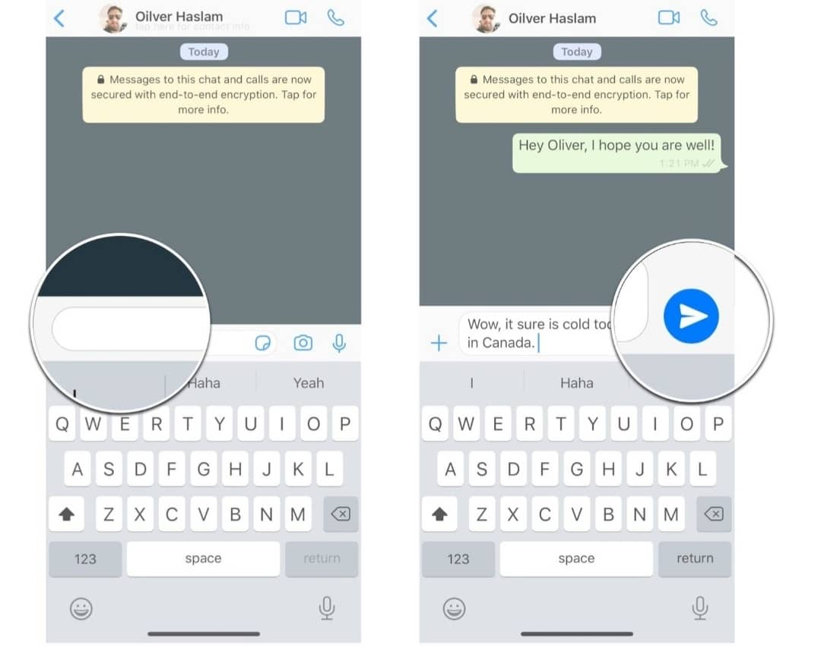
- Munokwanisa kupinda muzvikwata zvakasiyana siyana kuburikidza ne WhatsApp. Vamwe vane zvikwata zvemumakereke, zvikoro kana mabhizimusi chaiwo.Munokwanisa kutumira mashoko muzvikwata umu sematumiriro amunoita munhu mumwechete.
- WhatsApp inoshanda zvakawanda zvinosanganisira kutumira mifananidzo, mavideo, madocuments ne location.
Chenjedzo: WhatsApp inoshanda senzira yakachipa nekufona nayo. NeWhatsApp unogona kufona uchishandisa video uchiona munhu wauri kufonera zvisinei nekuti arikure sei.
Kuzvichengetedza paWhatsaApp
- Ngwarirai mashoko amunotumirana nevamwe paWhatsApp
- Remekedzai vamwe venyu varipaWhatsaApp
- Kana paine wamusiri kuwirirana naye musatambidzana mashoko akaipa
- Munokanisa kuisa mukaha pakati penyu nearikukunetsai nekudzvanya pakanzi block
- Zvinhu zvine chekuita nehupenyu hwenyu ngazvigare pakavanzika
Chenjedzo: Kuti mukwanise kupinda paWhatsApp munofanira kuva neWhatsApp bhanduru mufoni menyu. Mabhanduru eWhatsApp anemitengo yakasiyana siyana.
Kushandisa mabhanduru nekuona kuti ashanda zvakadii.
- Zivai mashandisa mari yakawanda sei huye kuti zvamunoita zvakasiyana-siyana paindaneti zvingada marii.
- Munogona kuona kuti wasara nemarii sekungoona kwamunoita kuti wasara nemamineti mangani ekuchaya runhare kana kuti masara nemashoko akawanda sei amungakwanisa kutumira. Izvi munozviita nekubaya kodhi panharembozha yenyu inoenderana neinoshandiswa nekambani iri kukupai masaisai.
- Munogona kuisa mari dzakasiyana-siyana dzedandemutande muzvikwama zvenyu zveindaneti zvichienderana nekuti paindaneti pacho muri kuda kuzoitei. Pihwai mazano kubva kumumiririri wevanopa masaisai amunoshandisa kuti mari ingakukwanira pane zvamunoda kushandisa ingaita marii.
- Kana muchikwanisa kuenda paindaneti munzvimbo ine WI-FI zvinoreva kuti hamuna mari yekuenda paindaneti yamuchashandisa. Mumiririri wevanopa masaisai munzvimbo yamuri anogona kukubatsirai kutsvaga nzvimbo dzinowanikwa WI-FI. Asi nedzimwewo nguva kunowanikwa WI-FI kunogona kunge kuri kure.
Chenjedzo: Nzira dzekuona nadzo mari yasara yekuenda paindaneti dzinosiyana zvichienderana nenyika yamuri huye mhando yemasaisai amuri kushandisa. Kana muchida rubatsiro nekuona kuti masara nemarii yekuenda paindaneti, munokwanisa kubvunza mumiririri wevanopa masaisai ari pedyo nemi.

CHIDZIDZO 4: YOUTUBE
Chii chinonzi Youtube?
Youtube iapurikesheni inoshandiswa kuona mavhidhiyo paInternet
Tsananguro yeYoutube
- PaYotube panowanikwa mavhidhiyo akasiyana siyana anosanganisira mimhanzi, kudzidzira mutauro mutsva, mafirimu, madhirama, zvekubika, mharidzo, zvechikoro nezvemabhizimusi.
- Munogona kutogadzira enyuwo mavideo momaisa paYoutube.
Zviitwa
Mureza weYoutube
Kana muchida kupinda paYoutube munodzvanya pamureza wakafanana neuyu:

Nzira dzekupinda nadzo paYoutube.
- Munobaya mureza yeYoutube monobvanya pachibhokisi chionyorerwa mashoko.
- Tsvagai zvamurikuda, semuenzaniso GRINGO , mobva mabvanya pobuda vhidhiyo yedhirama raGringo.
- Munokwanisa zvekare kutsvaga mavhidhiyo muchishandisa maikirofoni. Munotsvaga chimureza chemaikirofoni motaura zita revhidhiyo yamurikuda.
Chenjedzo: Munesimba pamusoro pezvamuri kutsvaga. Une simba pamusoro pezvauri kutsaga – munogona kutsvaga zvinhu zvakanaka kana zvakashata. Simba rekutsvaga zvinhu zvakanaka rinemi.

