



Connected Society
Mobile Internet Skills Training Toolkit
A guide for training people in basic mobile internet skills

Copyright © 2017 GSM Association

12

MODULE 12 – TIKTOK

Module 12 - TikTok

Bitesize Training

BITESIZE - TIKTOK

What is it?

Show TikTok on the phone

“TikTok is an app on your phone that lets you watch, create
or share videos. It is like YouTube, Facebook, or even TV, but
normally the videos are quite short.”
“These videos are made by people around the world – some of them may be people you know, but some you won’t. People like you and me make these videos!”
“These videos can be about everything! A lot of videos are about the news, famous people, music or sports, but other videos can help you to learn new things that can help with your business, cooking, looking after your family or taking care of your farm.”

Materials you will need
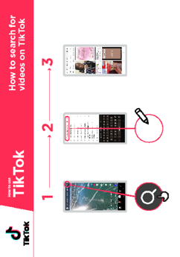
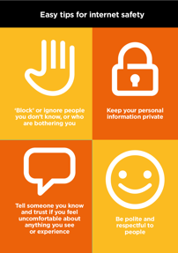

Mobile Phone
Safety Posters
How to search for videos in TikTok’
poster

BITESIZE - TIKTOK

What can you use it for?

Explain “On TikTok you can watch videos about your favourite sport, music or
dance, but you will also find a lot more! For example, you can find tips on how to
grow a particular crop (e.g. corn), how to cook a particular recipe, or educational
videos for your kids or videos that can teach you a new skill or share new
information.”

“TikTok is not just for watching videos, you can also create your own videos. The
people making TikTok videos are just like you and me!”

The trainer can include their own personal examples of the benefits of TikTok and
what they (or their friends or family) use it for.

Make it relevant to the trainee: discuss how TikTok can be beneficial in the
trainee’s own life. Ask them what they what they do for a living or what their
interests are and what they might like to see on TikTok.

Explain “Anyone can make a video on TikTok. This means that there are a lot of
videos, which is great! But some of them you might not agree with, and others
may be dangerous or violent or perhaps not true. You need to be careful when
using TikTok! Don’t believe everything you see and think before you share videos
with friends and family!”
BITESIZE – TIKTOK

BITESIZE - TIKTOK

How does it work?
Put the phone in the trainee’s hand

Ask “Do you know what this is? What is it for? “Can you find it on your phone?”
Explain how to find and open TikTok on the phone.

Explain To find the videos and information that interests you, you can search for things on TikTok. By using search, TikTok will show you things that you might like
to see.

Explain Using the ‘How to Search for Videos on TikTok’ poster, explain how to search for videos on TikTok.
- Click the ‘search’ icon on the top right of the screen.
How to search for videos in TikTok’
poster
- Enter a search word or phrase into the bar. Allow the trainee to search for something they are interested in. You can give guidance on how they can best find what they want (e.g. using key words). Examples include: how to deal with pests, how to cook their favourite dish, or how to learn to juggle a football.
- Choose one of the videos. Remember you may need to scroll down to find the best video.
Ask “What videos would you like to watch on TikTok?”

Help them search for videos they might not know would be on TikTok. These might include: cooking videos, educational videos for children, or videos explaining how to fix something (e.g. bicycle or a leak) or something you (the trainer) are particularly interested in.

BITESIZE – TIKTOK

BITESIZE - TIKTOK

Practise!

“Now that you know about TikTok, what are you interested in finding out
about?”
Ask the trainee for some keywords to search for, according to their interest. (Try
to keep the search simple, use only 1-2 words).
Tip: “Remember watching TikTok videos can be quite fun, but watching a lot
of TikTok videos uses a lot of mobile data / credit so be careful about how
much time you spend watching as it could consume a lot of data. Consider
limiting the time you spend watching videos on TikTok.”

Explain “There are other apps like TikTok where you can watch and make videos.
For example, Instagram, Snapchat or YouTube. On these apps, like TikTok, many
of the people in the videos are just like you!”
BITESIZE – TIKTOK
1


Safety

Explain “TikTok is an exciting app and there are many things you can find there! It is important to remember that TikTok and all the internet is open to everyone around the world and so it is essential to treat it like a real-life public place (e.g. a marketplace) and stay safe by protecting yourself and being responsible about
what you put on the app.”
Show the “Internet Safety” Poster

Discuss with your trainee what these tips mean when using TikTok.
Bring the tips to life by using examples that are relevant for your trainee. For example, certain people may be worried about some of the content on TikTok. Some people may be worried about scammers using TikTok and some women may be more concerned about how to prevent harassment.

Icon Cutouts - TikTok





Icon Cutouts - TikTok



Icon Cutouts - TikTok




Icon Cutouts - TikTok

How to create a TikTok account
How to use

TikTok
How to use

YouTube

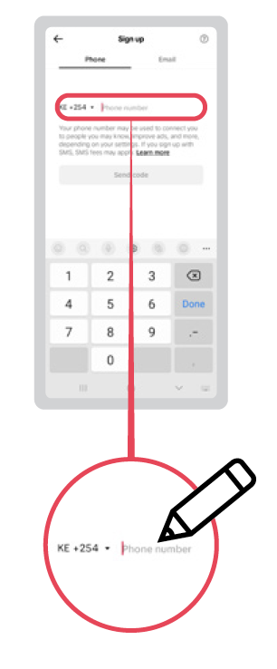
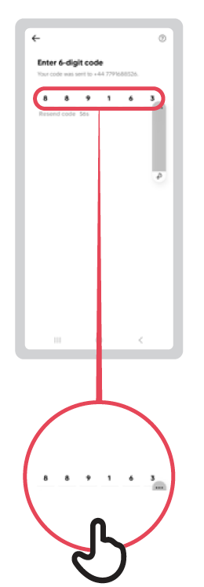
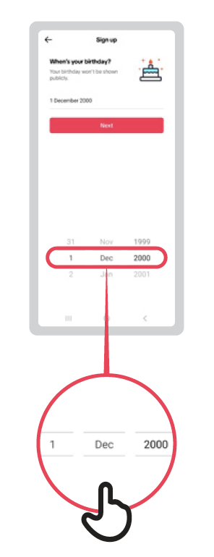
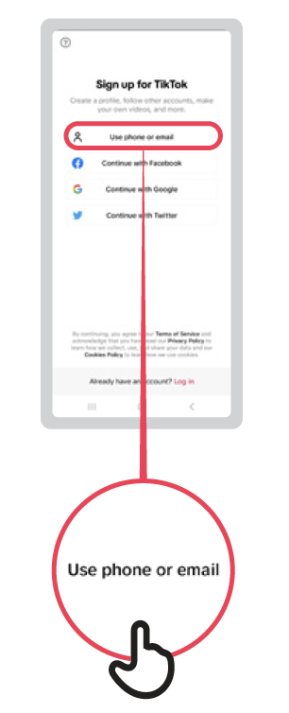
1 2 3 4 5
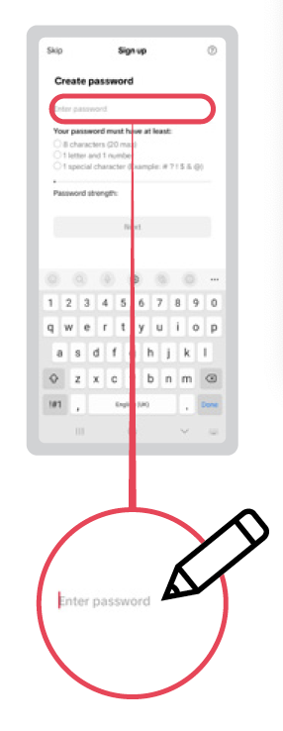

How to search for
videos on TikTok
TikTok
How to use

How to use

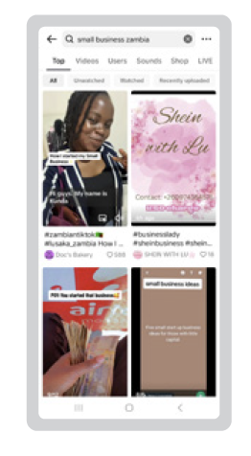
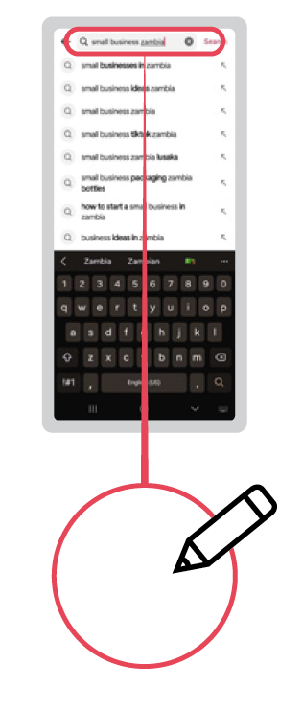
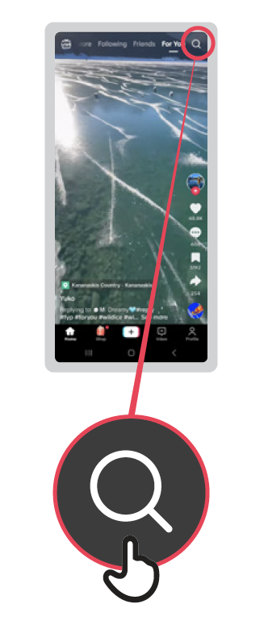
1 2 3
Understanding the
TikTok ‘For You’ page
How to create a TikTok account
How to use

TikTok
How to use

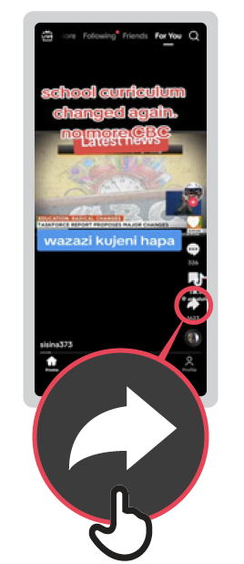


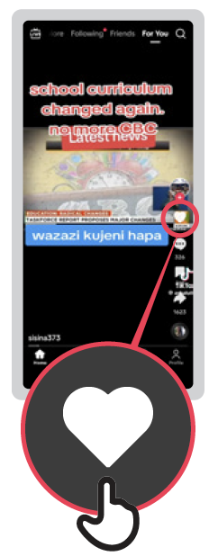
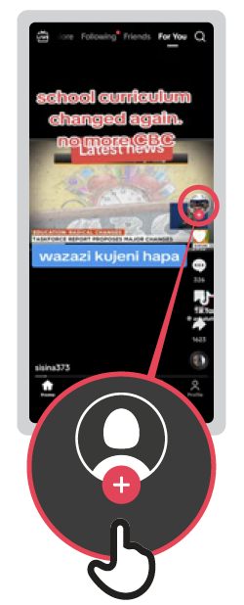
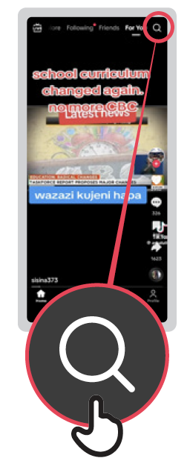

Share: You can send this
video to your friends or
family – including by
WhatsApp
Like: Pressing the heart means you ‘like’ the video. You will get similar videos shown to you if you press ‘like’. The number is how many people have liked it!
Comment if you want to say something about this video or look at what other people have said. The number is how many people have commented!
Favourite: Making this
video a ‘favourite’ means
you can put it on a list to
watch again later.
Creator’s profile:
The creator is the person who made the video. You can find
more videos like this one.
Search:
Find videos you like.

Swipe down: If you want
to see the last video again
you can swipe your finger
down the screen

Swipe up: If you move
your finger up the screen
you will move onto the
next video!



How to ‘Favourite’
a video on TikTok
How to create a TikTok account
How to use

TikTok
How to use

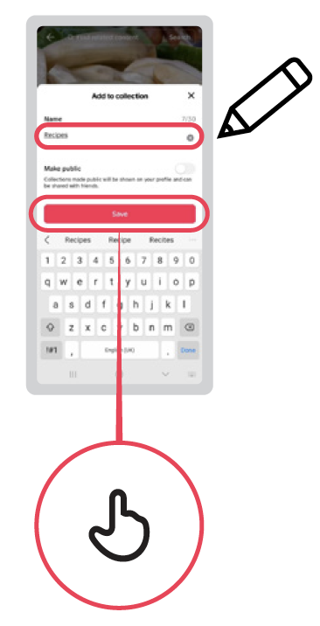
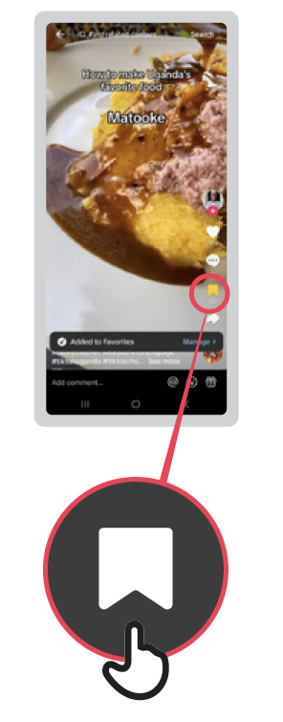

1 2 3
How to find ‘Favourite’
videos in TikTok
How to create a TikTok account
How to use

TikTok
How to use


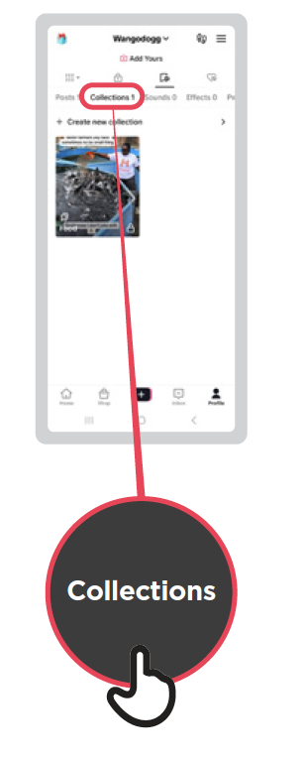

1 2 3

1 2 3 4
TikTok
How to report a
video on TikTok
How to use

How to use

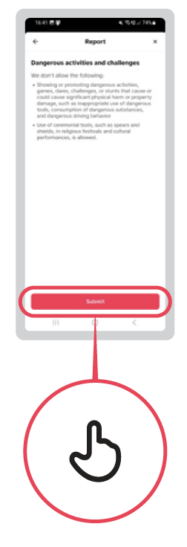
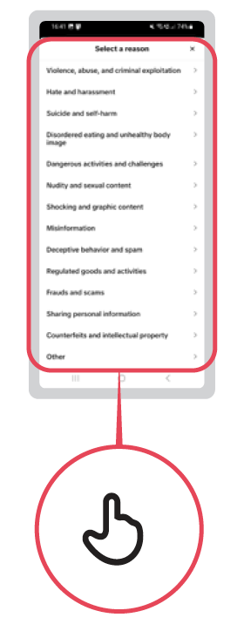



1 2 3 4 5
Turning on ‘Data Saver’
mode in TikTok
TikTok
How to use

How to use

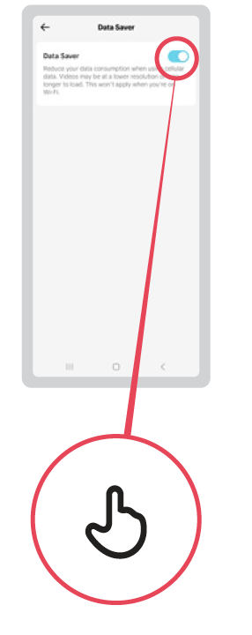
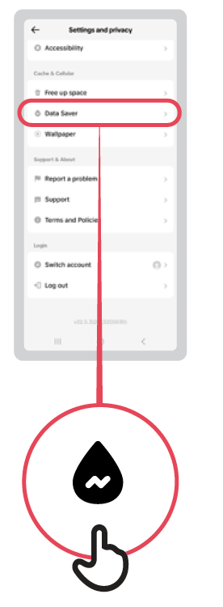
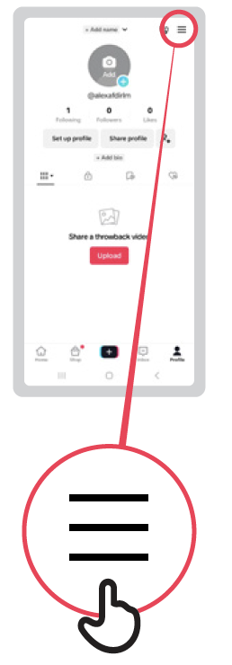

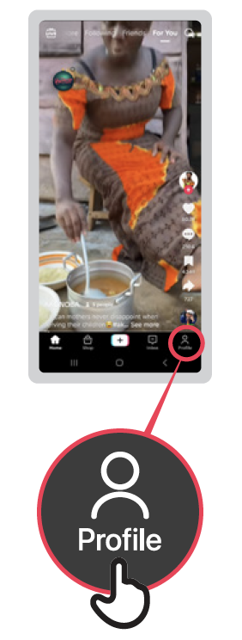

1 2 3
TikTok
Why you’re seeing
this video
How to use

How to use

