


Connected Society
Mobile Internet Skills Training Toolkit
A guide for training people in basic mobile internet skills

Copyright © 2017 GSM Association

12

MODULE 12 – TIKTOK

Module 12 - TikTok
In
Depth
Training

BITESIZE - TIKTOK


Learning Objectives

• Trainees have created a TikTok account (if required)
• Trainees know how to watch videos on TikTok
Time duration:
40 – 60mins
• Trainees understand the range of content available on
TikTok and feel excited and motivated about accessing
content in areas relevant for them that can support their
Note: This
training focuses
on the basics of
using TikTok and does not cover how to create on the platform.

interests (e.g. cooking, agriculture, business) that they may
not be aware are served by TikTok
• Trainees understand how to stay safe and use TikTok cost-effectively
• Some trainees will have begun to understand how the
TikTok algorithm works

Materials you will need:


Small Rewards

TikTok Posters x8
Smartphone Handset


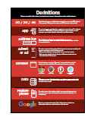
BITESIZE – TIKTOK

Safety Posters
Cost Poster
Glossary Poster

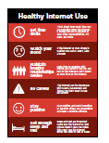

Icon Cutouts
Healthy Internet Use

MODULE 12 - TIKTOK

INTRO / CREATING AN ACCOUNT / SEARCHING FOR CONTENT / TIKTOK ‘FOR YOU’ PAGE
‘FAVOURITE’ A VIDEO / SAFETY / REPORT A VIDEO / COST / NEXT LEVEL

Introduce TikTok


Show the trainees the TikTok icon and ask them
to find it on their phone

• Ask “Does anyone know what this is?” “What is it for?”
“Can you find it on your phone?”
• Explain How to find and open TikTok on the phone

BITESIZE – TIKTOK
Give a short explanation of TikTok
• “TikTok is an app on your phone that lets you watch, create or share videos. It is
like YouTube, Facebook, or even TV, but normally the videos are quite short.”
• “These videos are made by people around the world – some of them may be
people you know, but some you won’t. People like you and me make these
videos!”
• “These videos can be about everything! A lot of videos are about the news,
famous people, music or sports, but other videos can help you to learn new
things that can help with your business, cooking, looking after your family or
taking care of your farm.”

Bring the benefits to life!
Explain “Tell a story of how TikTok has helped you (the trainer), your friends or
family to seek out information and learn new things to benefit your/ their life”.
Some examples might include:
• How to grow a particular crop (e.g. seasonal planting techniques for
tomatoes or corn) or tips to treat a certain pest
• How to cook a particular recipe for your catering business or your family
• Education (e.g. support your children to do better in school and to complete
their homework)
• Learn how to do your favourite craft and make money from it (e.g. makeup,
woodworking or tailoring)

MODULE 12 - TIKTOK

INTRO / CREATING AN ACCOUNT / SEARCHING FOR CONTENT / TIKTOK ‘FOR YOU’ PAGE
‘FAVOURITE’ A VIDEO / SAFETY / REPORT A VIDEO / COST / NEXT LEVEL

Make TikTok relevant for your trainees
Discuss with your trainees how TikTok
can be beneficial in their lives:
Ask “What could you learn to use
TikTok for in your own life?”
Give them some suggestions based
on their interests. For example, help
them find something about their job,
something they want to learn or their
main hobby.
Remember Link discussions and
activities in the training back to how
TikTok can be helpful or useful in your
trainees’ lives. This will help to keep
the training relevant and interesting for
them.

Activity: Creating an account on TikTok
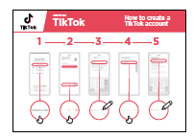
Show the “Creating a TikTok account” poster
Explain “To use TikTok it is better to have a TikTok account
that is personal to you. When you have an account it is
much easier to watch videos and even create your own!”

Explain “If you create an account, you will be able to save videos to watch later,
share them easily with friends, and follow people whose videos you like.”
Ask the trainees if they have a TikTok account. If they do not, you can help them
make one using the steps on the poster.
Explain “There are many ways to create a TikTok account. You can use your email
or Facebook account but I am going to show you how to create a TikTok account
using your phone number.”
Explain “To use your TikTok account you will need a password. This is a special
word you use with your TikTok app to make sure only you can access and use
your TikTok account. You need to keep your password safe and don’t share it with
anyone, even me! It should be a word you can remember so don’t make it too
difficult!”

BITESIZE – TIKTOK
INTRO / CREATING AN ACCOUNT / SEARCHING FOR CONTENT / TIKTOK ‘FOR YOU’ PAGE
‘FAVOURITE’ A VIDEO / SAFETY / REPORT A VIDEO / COST / NEXT LEVEL

MODULE 12 - TIKTOK

1. Open the TikTok app – on the ‘Sign Up for TikTok’ page, select ‘Use Phone or
Email’
2. Enter a date of birth
3. Have the trainees enter their phone numbers and receive the codes
4. If the 6 digit code doesn’t fill automatically, then enter the code sent by SMS
5. Encourage the trainees to choose a secure password that is easy to remember
Tip: If the trainees do not want to use their phone number (or are nervous
about doing so) to set up their TikTok account and want to set up their
account using their Facebook, Google or Twitter / X account, then skip this
Activity. If they want to use their email, then follow the steps in the poster
(helping the trainees access their email to get the 6-digit code). Allow them
to take their time on this.

Activity: Searching for content on TikTok

Explain “TikTok has so many videos about all sorts of things and you could
never watch them all! It is important to learn how to search for videos that are
interesting and important for you.”

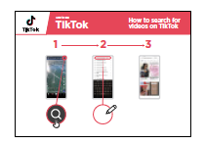
Show the ‘How to search for videos on TikTok’
poster
Explain To find the videos and information that interests
you, you can search for things on TikTok. By using search,
TikTok will show you things that you might like to see.
Explain Using the ‘How to search for videos on TikTok’ poster, explain how to
search for videos on TikTok.
1. Click the ‘search’ icon on the top right of the screen.
2. Enter a search term into the bar. Allow the trainees to search for something
they are interested in. You can give guidance on how they can best find what
they want (e.g. using key words). Examples include: how to deal with pests,
how to cook their favourite dish, or how to learn to juggle a football.
3. Choose one of the videos. Remember you may need to scroll down to find the
best video

BITESIZE – TIKTOK
INTRO / CREATING AN ACCOUNT / SEARCHING FOR CONTENT / TIKTOK ‘FOR YOU’ PAGE
‘FAVOURITE’ A VIDEO / SAFETY / REPORT A VIDEO / COST / NEXT LEVEL

MODULE 12 - TIKTOK

Personal uses: Discuss with trainees how TikTok can be beneficial in their lives
Ask “What videos would you like to
watch on TikTok?”
Discuss with your trainees what they
might like to watch on TikTok. Share
what you (or your friends and family)
watch on TikTok.
Help them search for videos they
might not know would be on TikTok.
These might include: cooking videos,
educational videos for children, or
videos explaining how to fix something
(e.g. bicycle or a leak) or something
you (the trainer) are particularly
interested in.

Explain “The ‘#’ symbol is called
a ‘hashtag’. If you put it in front of
something (e.g. #farmingtips), TikTok
will show you videos on that topic.
Hashtags can help you find videos on
specific topics that are useful for you.”
Ask “Are there any videos you would
like to search for using a ‘hashtag’?”
Run through the ‘How to search for
videos on TikTok’ poster again but this
time use a ‘hashtag’.
Practice Try searching for several
different topics using a hashtag.
Some examples are: #marketingtips,
#smallbusiness, #homeworkhelp.

Tip: There may be hashtags or search terms you can use in your own
language. Give it a try!

Tip: Trainees can also search for words or phrases using voice search if they
have trouble typing or writing. In the righthand side of the search bar, they
can click the microphone symbol to speak their key word and get results.
Give it a try!

Remember: Link discussions and activities in the training back to how TikTok can
be helpful or useful in your trainees’ own lives. Continue throughout the training
to highlight the use cases that trainees have shown interest in. This will help to
keep the training relevant and interesting for them.

BITESIZE – TIKTOK
INTRO / CREATING AN ACCOUNT / SEARCHING FOR CONTENT / TIKTOK ‘FOR YOU’ PAGE
‘FAVOURITE’ A VIDEO / SAFETY / REPORT A VIDEO / COST / NEXT LEVEL

MODULE 12 - TIKTOK
Activity: Understanding the TikTok
‘For You’ page

Explain “The TikTok ‘For You’ feed is a page you can go to on TikTok, where the
app will show you videos that you may want to watch.”
Explain “Everyone will see different videos on the ‘For You’ page, depending on
what you have watched before, what you have ‘liked’ and where you are in the
world!”

Get practical!
Explain “We are now going to look at the ‘For You’ page and learn what all the
icons mean.”
Show trainees where the ‘For You’ page can be found (top right of screen).
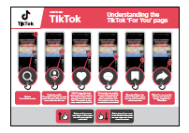
Show the ‘Understanding the TikTok ‘For You’’
poster
Explain Open the ‘For You’ page on TikTok on your / the
trainee’s phone and explain what the main icons mean.
Ask “Have you got any questions about what you are
looking at?”

Tip: You can reinforce trainees’ knowledge of the icons by playing the ‘TikTok
icon game’ (see below).

BITESIZE – TIKTOK
INTRO / CREATING AN ACCOUNT / SEARCHING FOR CONTENT / TIKTOK ‘FOR YOU’ PAGE
‘FAVOURITE’ A VIDEO / SAFETY / REPORT A VIDEO / COST / NEXT LEVEL

MODULE 12 - TIKTOK

How to ‘Favourite’ a video in TikTok

Explain “TikTok lets you save videos to watch later. This is useful if you want to
save a video to learn new skills – like changing the wheel on a bicycle or mending
your clothes.”

Explain “You can save videos together in a ‘Collection’. This means that you can
save all your videos on cooking and recipes in one area, your videos about doing
business in another, and videos of your favourite music in another! This makes it
easy to find videos later, which is helpful as TikTok can be confusing, and it is hard
to find a video you have watched before unless you favourite it”.

Get practical!

Explain “We are now going to
‘favourite’ a video you want to save!”
Ask “What video are you interested in
saving to watch later?”
If the trainees are struggling to come
up with an idea, you could suggest
something. For example: a new (or
favourite) dish they would like to learn
to cook, getting tips on how to take
good photos to promote your business,
or a type of music or dance you like.
Take the trainees through the steps for
‘favouriting’ a video using the poster.

1. Press the ‘favourite’ icon
2. When the bar appears at the bottom
of the screen, press ‘Manage’
3. Create a collection to save the
video into (e.g. ‘recipes’, ‘business’,
‘learning’, ‘music’)
Explain “It is easy to find videos that
you ‘favourite’, they are saved in your
‘profile’.”
Ask “Do you want to see how you find
a video you have made a ‘favourite’?”
If they are interested, take them
through the poster below (optional).

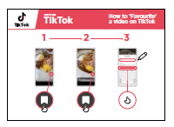
Show the ‘How to find ‘Favourite’ videos in
TikTok’ poster
Take the trainees through the steps for finding all their
‘favourite’ videos using the relevant poster.
1. Go to ‘Profile’
2. Select the ‘Collections’ tab
3. Find the video you want

BITESIZE – TIKTOK

MODULE 12 - TIKTOK
INTRO / CREATING AN ACCOUNT / SEARCHING FOR CONTENT / TIKTOK ‘FOR YOU’ PAGE
‘FAVOURITE’ A VIDEO / SAFETY / REPORT A VIDEO / COST / NEXT LEVEL

BITESIZE – TIKTOK
1

Safety

Explain “TikTok is an exciting app and there are many things you can find there! It is important to remember that TikTok and all the internet is open to everyone around the world and so it is essential to treat it like a real-life public place (e.g. a marketplace) and stay safe by protecting yourself and being responsible about
what you put on the app.”
Show the “Internet Safety” Poster

Discuss with your trainee what these tips mean when using TikTok.
Bring the tips to life by using examples that are relevant for
your trainees. For example, certain people may be worried
about some of the content on TikTok. Some people may be
worried about scammers using TikTok.
If necessary, use some of the following prompts:

Prompts | Suggested answers
What do you do if you see  a video, you don’t like or  that worries you? | You can always move to another video by  ‘swiping up’ on the screen. If you are really  concerned about what you see take a break  from the app, or follow the instructions on how to report a video on the app.
What do you do if you feel  unsure or uncomfortable  about something someone  asks you on the app? | Tell someone you know and trust about what  happened and ask for their advice. You should  ignore messages or videos that make you concerned. You can ‘block’ people who you don’t want to receive messages from.
What do you do if someone  you don’t know or trust  asks you for your personal  information? | Always be on the lookout for people asking  you for personal information. You should never  give out personal information to someone you don’t know or trust because they may misuse it.
BITESIZE – TIKTOK
INTRO / CREATING AN ACCOUNT / SEARCHING FOR CONTENT / TIKTOK ‘FOR YOU’ PAGE
‘FAVOURITE’ A VIDEO / SAFETY / REPORT A VIDEO / COST / NEXT LEVEL

MODULE 12 - TIKTOK

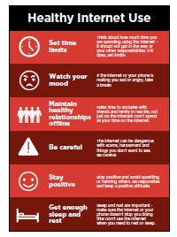
Explain “TikTok is an exciting app! But when using TikTok,
or any app on your phone, it is important that you use it in
a healthy way. It is easy to watch TikTok videos for a long
time, as there are so many on the app and the app will
continue to show you videos until you close it. The videos
will never stop on their own. However, this could mean you
spend a lot of time watching videos on TikTok instead of
doing something else that is important to you.”
Explain “If you make a video and put it on TikTok other
people might use it to make something else. Everything
you put on TikTok is public, so you should be careful what
videos you post on TikTok because someone else might use
your video in a way that you do not agree with. Remember
not to put personal information about yourself or others in
videos you make on TikTok.”
Discuss with your trainees what these tips mean when using
TikTok.
Bring the tips to life by using examples that are relevant for
your trainees. Talk about your (the trainer’s) experiences or
those of friends and family.

Get practical!
Explain “Anyone can make videos on TikTok, which makes it exciting but also
means that not all information in the videos may be true. There are risks involved
when using TikTok.”
Explain “If you think a video is dangerous, illegal or a scam, you can report it to
TikTok. It is important to stay safe when using TikTok.”
Tip: If trainees are very concerned or interested in online safety, you can show
them the Online Safety Module or show the poster explaining the 5 key tips
for spotting false information online.

BITESIZE – TIKTOK

MODULE 12 - TIKTOK
INTRO / CREATING AN ACCOUNT / SEARCHING FOR CONTENT / TIKTOK ‘FOR YOU’ PAGE
‘FAVOURITE’ A VIDEO / SAFETY / REPORT A VIDEO / COST / NEXT LEVEL

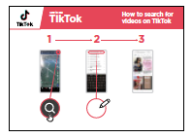
Show the ‘How to report a video on TikTok’ poster
Show trainees how they can report a video on TikTok using
the stages listed in the poster.

1. Press the ‘share’ button on the video
2. Press the first icon: ‘Report’
3. Show all the reasons listed. Explain any reasons that trainees do not
understand. Select a reason.
4. Explain that you submit a report by pressing the ‘Submit’ button. Do not press
this unless you want to submit a report on the video.
Explain “This lets TikTok know that there is a problem with the video. They may
get in contact for more information, but they may not.
Discuss with your trainees the different reasons that videos can be reported to
TikTok. Explain the importance of avoiding bad content on TikTok.
Explain “If you are watching videos on the ‘For You’ page you can also tell TikTok
if you don’t like a video. TikTok will then show you fewer videos like this”
Show trainees how they can do this if they are interested. This can be done
through the following steps (images below to help you)
1. Press the ‘share’ button on the video
2. Press the second icon: ‘Not interested’
3. If you select ‘Details’ you can select any hashtags you want to see fewer videos of
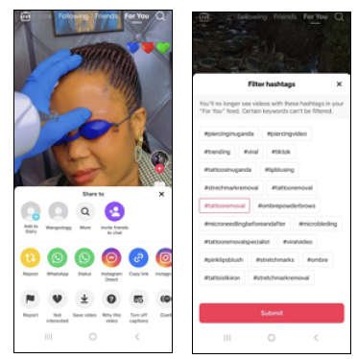

BITESIZE – TIKTOK

MODULE 12 - TIKTOK
INTRO / CREATING AN ACCOUNT / SEARCHING FOR CONTENT / TIKTOK ‘FOR YOU’ PAGE
‘FAVOURITE’ A VIDEO / SAFETY / REPORT A VIDEO / COST / NEXT LEVEL

Activity: Cost


Explain “Different activities use different amounts of data. Looking
at text uses the least data, looking at images uses more, playing and
downloading music uses a bit more and watching videos online uses
the most.”
Explain “The more you use your phone, the more data you will use.
TikTok will start to show you videos as soon as you open TikTok. This
will use data.”

Show the ‘Data costs poster’
Ask “Which type of activity tends to cost more to use?”
Answer “Videos: watching videos on YouTube, TikTok, or
other apps will use the most data.”
Explain that watching videos uses a lot of mobile data. You
can save your credit by waiting until you are connected to
Wi-Fi to watch videos.

Activity: Turning on ‘Data Saver’ mode

Explain “Because it is a video app, TikTok uses a lot of mobile data/
credit. If you want to reduce this, you can turn on ‘Data Saver’. This
makes the videos less high quality but will save you money!”
Explain You can help the trainees turn on ‘Data Saver’ mode in
TikTok, walking them through the below steps using the poster:
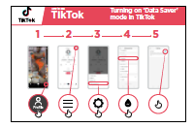
Show the “Turning on ‘Data Saver’ in TikTok”
poster

1. Go to your profile
2. Click menu icon (the three
horizontal lines on the top
right of your screen)
3. Go to ‘Settings and Privacy’
4. Scroll down to ‘Data Saver’
5. Turn it on using the button
(it is on if the button is blue)

BITESIZE – TIKTOK
INTRO / CREATING AN ACCOUNT / SEARCHING FOR CONTENT / TIKTOK ‘FOR YOU’ PAGE
‘FAVOURITE’ A VIDEO / SAFETY / REPORT A VIDEO / COST / NEXT LEVEL

MODULE 12 - TIKTOK

Recap


Play the TikTok icon game
Hold up each TikTok icon, one at a time.
Ask “Where is this on the app, and what does it do?”
Explain to your trainees what each icon is, if they need
support.
You can give small rewards (e.g. sweets) for correct answers
and stick the icons on the wall (if you can) afterwards to
help remind your trainees what they are.
Explain “There are other apps like TikTok where you can
watch and make videos. For example, Instagram, Snapchat
or YouTube. You will see some of these icons when you are
using these apps.”

Going to the next level

If you reach the end of the session and have extra time or if
trainees understand the basics, you can:
Ask “Do you have any further questions about anything we have covered in the
session?”
Ask “What else would they like to know about TikTok?”
Some more advanced features you can discuss with your trainees could include:
• Making videos on TikTok
• Changing the privacy settings on videos they make
• Sending messages to contacts on TikTok
• Why you are seeing this video
• Show how they can control the amount of time they spend on TikTok daily
(using ‘Screen Time’ within ‘Settings’)

BITESIZE – TIKTOK

MODULE 12 - TIKTOK
INTRO / CREATING AN ACCOUNT / SEARCHING FOR CONTENT / TIKTOK ‘FOR YOU’ PAGE
‘FAVOURITE’ A VIDEO / SAFETY / REPORT A VIDEO / COST / NEXT LEVEL

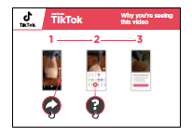
Show the “Why you are seeing this video’ poster

Explain “The ‘For You’ page shows videos that TikTok thinks
you will like. This is based on where you are in the world,
what videos you have watched before and what creators
you ‘like’.”
Explain “Everyone sees different videos on the ‘For You’
page, although you may get some videos that are the same
as friends and family.”
Ask “Are you interested in understanding why a video has
been shown to you on your ‘For You’ screen?”
1. Open the ‘For You’ page and ask the trainees to pick a
video they like
2. Press the ‘Share’ button
3. Select the ‘Why this video’
Discuss the reasons they have been shown the video (e.g.
the video is popular in your country).

BITESIZE – TIKTOK
Icon Cutouts - TikTok

MODULE 12 - TIKTOK




Icon Cutouts - TikTok



Icon Cutouts - TikTok




Icon Cutouts - TikTok

How to create a TikTok account
How to use

TikTok
How to use

YouTube

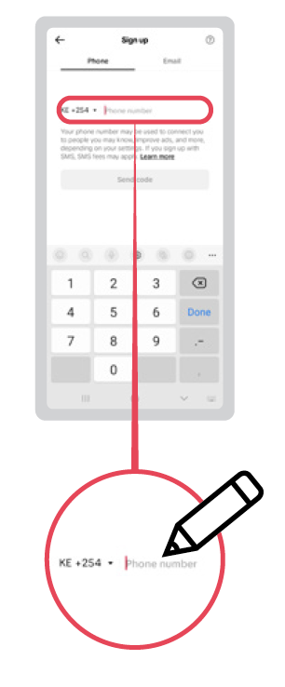
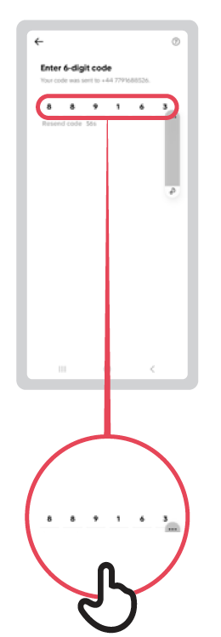
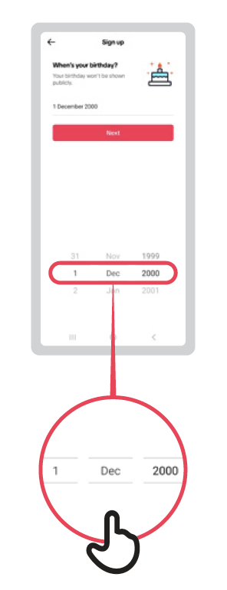
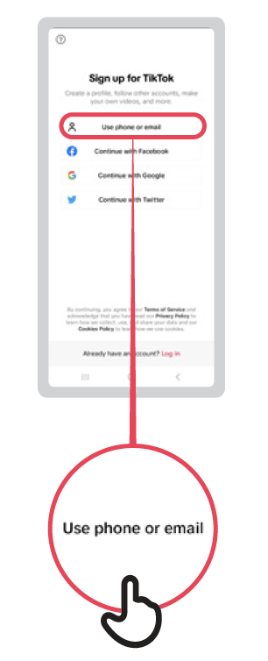
1 2 3 4 5
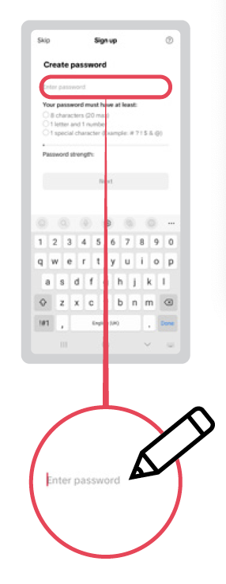

How to search for
videos on TikTok
TikTok
How to use

How to use


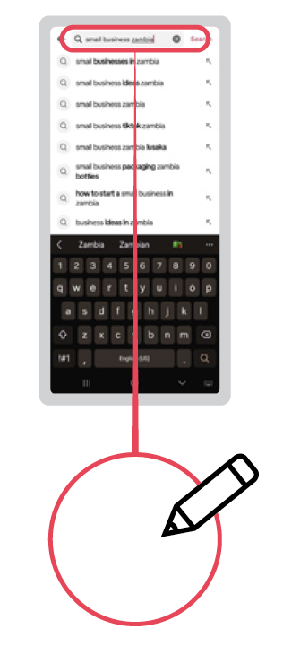
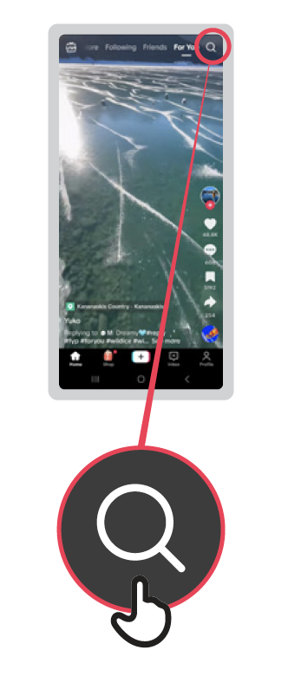
1 2 3
Understanding the
TikTok ‘For You’ page
How to create a TikTok account
How to use

TikTok
How to use

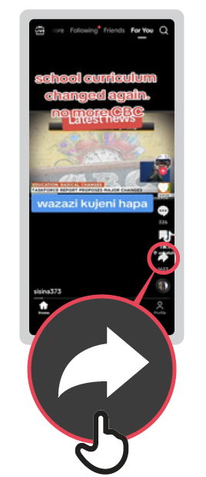


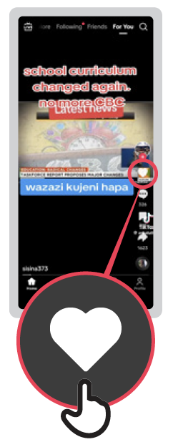
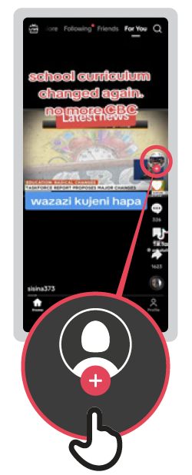
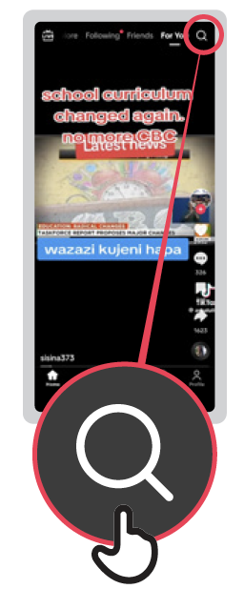

Share: You can send this
video to your friends or
family – including by
WhatsApp
Like: Pressing the heart means you ‘like’ the video. You will get similar videos shown to you if you press ‘like’. The number is how many people have liked it!
Comment if you want to say something about this video or look at what other people have said. The number is how many people have commented!
Favourite: Making this
video a ‘favourite’ means
you can put it on a list to
watch again later.
Creator’s profile:
The creator is the person who made the video. You can find
more videos like this one.
Search:
Find videos you like.

Swipe down: If you want
to see the last video again
you can swipe your finger
down the screen

Swipe up: If you move
your finger up the screen
you will move onto the
next video!



How to ‘Favourite’
a video on TikTok
How to create a TikTok account
How to use

TikTok
How to use

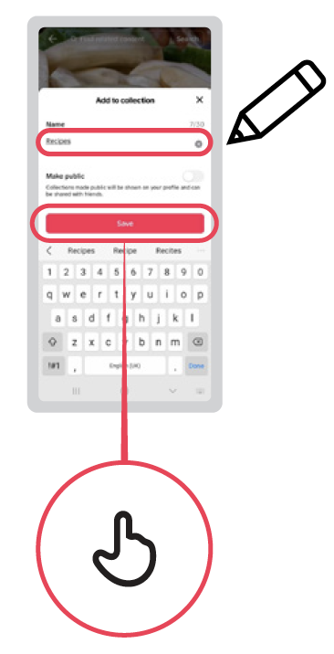


1 2 3
How to find ‘Favourite’
videos in TikTok
How to create a TikTok account
How to use

TikTok
How to use


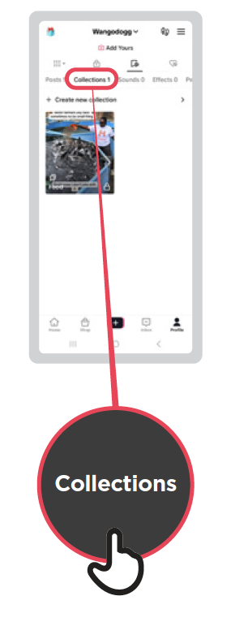

1 2 3

1 2 3 4
TikTok
How to report a
video on TikTok
How to use

How to use

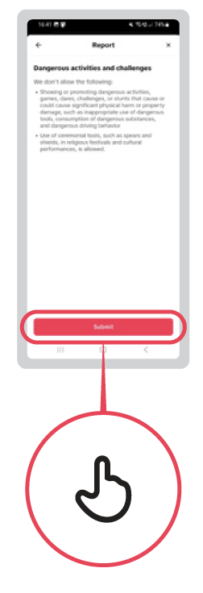
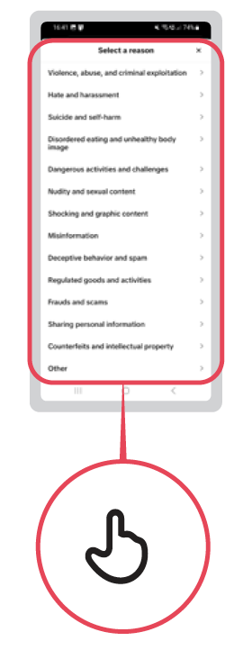



1 2 3 4 5
Turning on ‘Data Saver’
mode in TikTok
TikTok
How to use

How to use

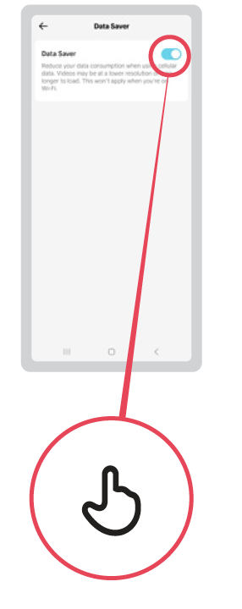
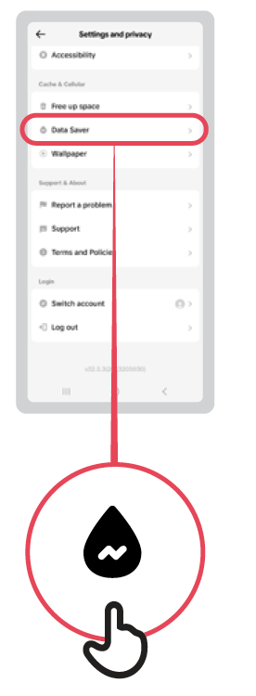


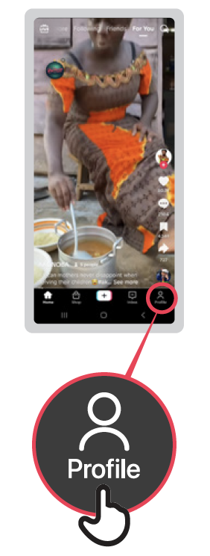

1 2 3
TikTok
Why you’re seeing
this video
How to use

How to use

