

Connected Society
Mobile Internet Skills Training Toolkit
A guide for training people in basic mobile internet skills

Copyright © 2017 GSM Association

case.

111
111

MODULE 11 – KAIOS

Module 11 – KaiOS

Bitesize Training

BITESIZE - KAIOS

BITESIZE – MOBILE MONEY

What is KaiOS?

Show a KaiOS-Wha


What is KaiOS?


Show a KaiOS-enabled phone
“A KaiOS-enabled phone is like a smartphone without a
touchscreen. It is cheaper than a traditional smartphone. It
comes with a camera, Wi-Fi, Bluetooth, GPS and apps so
you can do more than calling and texting. KaiOS-enabled
phones use less data and the batteries last longer.”
“A KaiOS phone gives you access to the internet, so you
can use it to search for information you need on Google,
watch videos on YouTube, and share photos on WhatsApp
and Facebook. Over 100 million people use KaiOS phones
to connect to the internet and improve their lives.”

What  you’ll need    KaiOS Phone  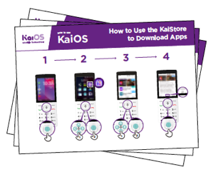  KaiOS Posters |  What can you use it for?  “You can use your KaiOS phone to search for information, share pictures with friends and stay up to date with the news.”  “You can use your KaiOS phone to do the same as you would do on a smartphone: See what your friends are posting on Facebook, message your contacts for free using WhatsApp, get a map and directions to your next destination with Google Maps, or learn a new skill on YouTube.”  Share examples from your own life about how internet connected phones are useful.  Make it relevant to the trainee by discussing how it can be beneficial in the trainee’s own life.

BITESIZE – KAIOS

-en

BITESIZE - KAIOS

BITESIZE – MOBILE MONEY

abled phone

How Des

How Does It Work?

Place the phone  in the trainee’s hand and help them follow the steps | Help the trainee download their first app and perform their first search in the browser.
  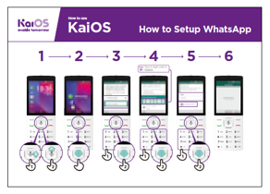  How to connect to Wi-Fi  Show the poster and go through the steps for connecting to  Wi-Fi  (Press centre button > Settings icon > Wi-Fi > On > Find available network > Select) | 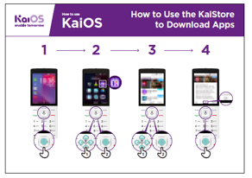  How to download  apps  Show the poster and go through the steps for downloading apps  (Press centre button > Store icon > Select app > Press) | 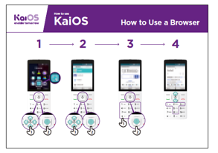  How to use a browser  Show the poster and go through the steps for using the browser  (Press centre button > Browser icon > Select app)


Practise

“Now that you’ve discovered what you can do on a KaiOS phone, what do you want to use it for?”

Trainer: Help your trainee download an app from the KaiStore. Then, help them use it.
Tip: If it’s difficult to read a website, press “1” to zoom out and “3” to zoom in.

Explain: “Apps are easier to use than the browser, because they are made
specifically for KaiOS.”

“Visit the KaiOS website to learn more about the internet, apps and KaiOS phones: https://life.Kaiostech.comthe person what they would like to do with their phone.
BITESIZE – KAIOS

Posters, Cut-outs and
Info Sheets

Icon Cutouts - YouTube




Icon Cutouts - YouTube




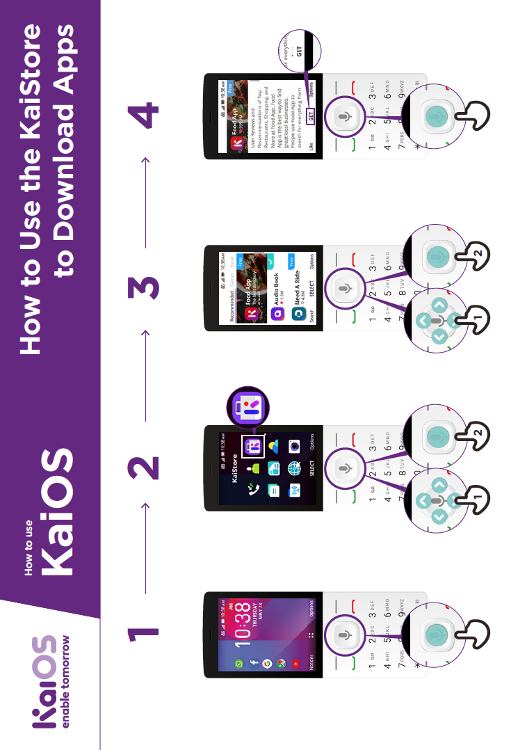
How to use

How to use the KaiStore
to download Apps
Display
Night Light
Off
TURN ON NOW

GET

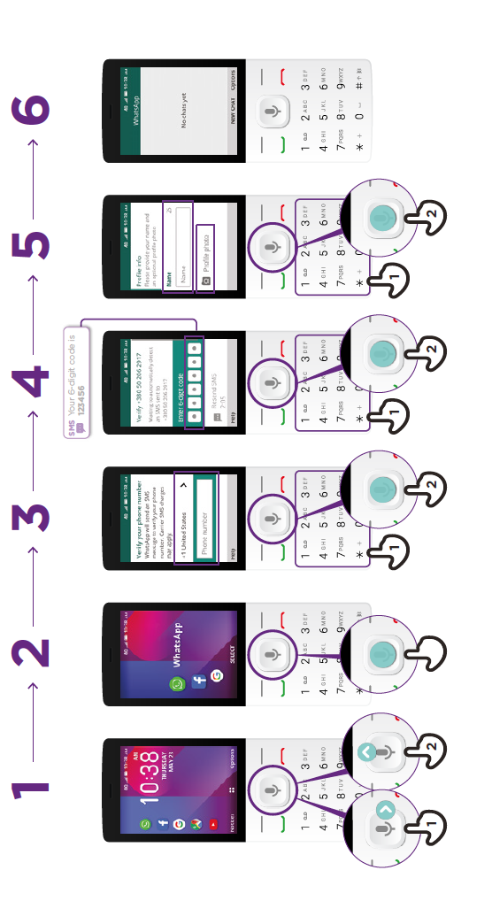
How to
setup WhatsApp
How to use

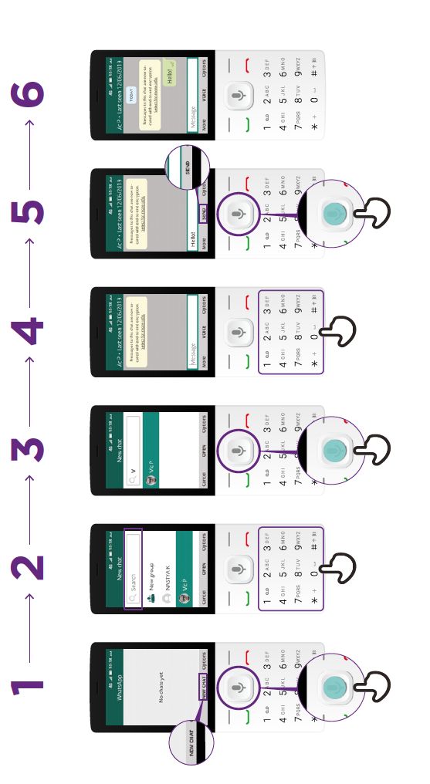
How to send a Message
on WhatsApp
How to use

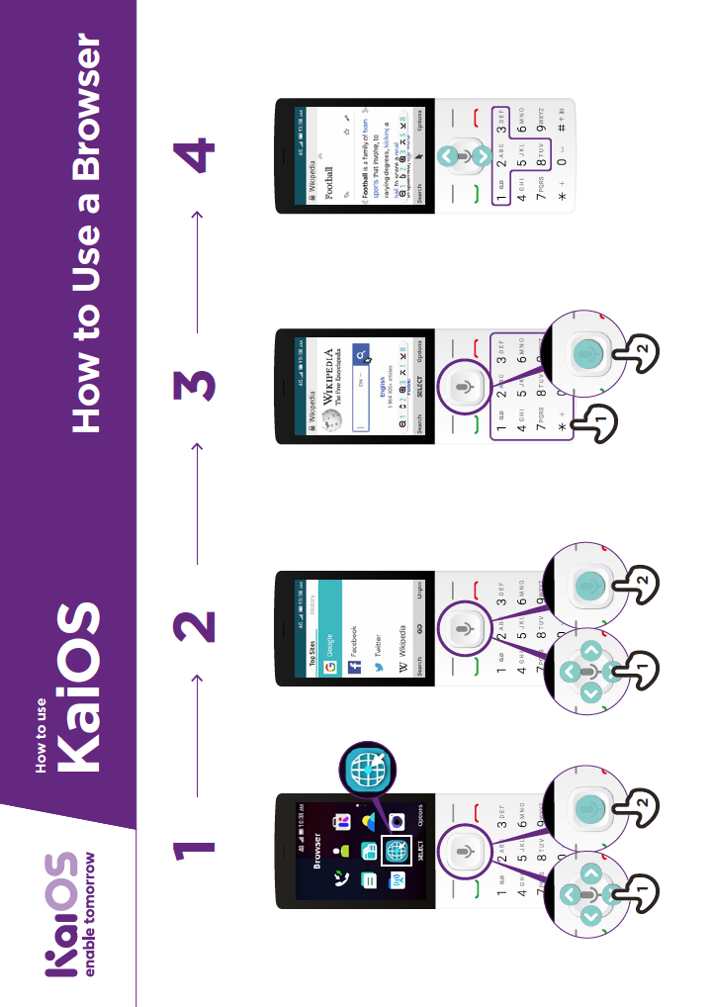
How to use
a Browser
How to use





CERTIFICATE

has completed
BASIC MOBILE INTERNET SKILLS
training

Date Signed





CERTIFICATE

has completed
BASIC MOBILE INTERNET SKILLS
training

Date Signed

