

Connected Society
Mobile Internet Skills Training Toolkit
A guide for training people in basic mobile internet skills

Copyright © 2017 GSM Association

case.

111
111

MODULE 11 – KAIOS

Module 11 - KaiOS

In-
Depth Training

BITESIZE - KAIOS

BITESIZE – MOBILE MONEY
Learning Objectives  • Trainee learns how to perform basic operations on a KaiOS-enabled phone  • Trainee has downloaded and used an app, has opened the browser and navigated a website  • Trainee feels excited about using a KaiOS phone to accomplish some of their goals |   Time Duration:  45-60 minutes  45-60
Materials you will need:
  Pens |   KaiOS Phone |   Small Rewards
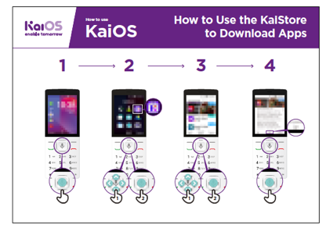  KaiOS Poster #1:  KaiStore | 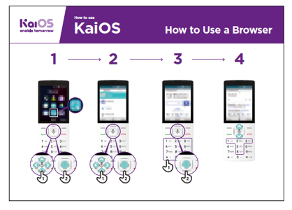  KaiOS Poster #2:  Browser | 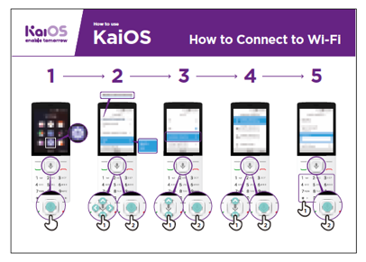  KaiOS Poster #3:  Connecting to Wi-Fi
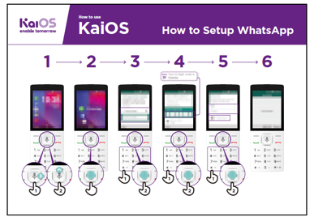  KaiOS Poster #4:  Setup WhatsApp | 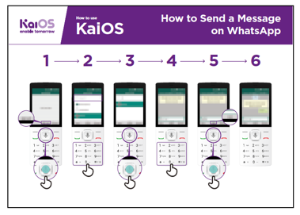  KaiOS Poster #5:  Sending a message on WhatsApp

MODULE 11 - KAIOS
INTRO / DOWNLOADING APPS / USING THE BROWSER / CONNECT TO WI-FI /
USING APPS / RECAP / NEXT LEVEL

MODULE 11 - KAIOS


Introducing KAIOS

 | KaiOS phones enable you to connect online and access all the benefits of a smartphone
Give a short explanation of  KaiOS  • “A KaiOS-enabled phone means that you can connect to the internet, use WhatsApp and other apps, and enjoy all the benefits of a smartphone at a cheaper cost.”  • “KaiOS phones have a browser, similar to Opera, and an Applications Store, where you can download free apps.” | Bring the benefits to life!  Share personal examples of how  KaiOS helps you (the trainer), your friends and family. Some examples might include:  • Connecting with groups of friends/family members to make arrangements and share news.  • Learning new skills on YouTube videos. Offer specific examples.  • Help friends by finding answers to the questions they have about any topic.  • Use the internet for free by connecting to Wi-Fi. If you have data, you can even share your internet with friends who don’t have data.
Make KaiOS relevant to your
trainees

Discuss how a KaiOS phone might help
them in their lives:
• Ask “How could you use the Google app in your own life?” Provide some suggestions based on their interests.

• Ask “What apps would you like to use?”

MODULE 11 - KAIOS

Remember: Connect discussions and activities in the training to how the internet can be helpful or useful in your trainees’ own lives. This will help keep the training relevant and interesting for them.
INTRO / DOWNLOADING APPS / USING THE BROWSER / CONNECT TO WI-FI /
USING APPS / RECAP / NEXT LEVEL

MODULE 11 - KAIOS


Activity: Downloading Apps

Explain: “Every KaiOS-enabled phone has a KaiStore, from which you can add new tools to your phone. Most of these tools are free. It’s the place where you can get free WhatsApp, games and other useful apps.”

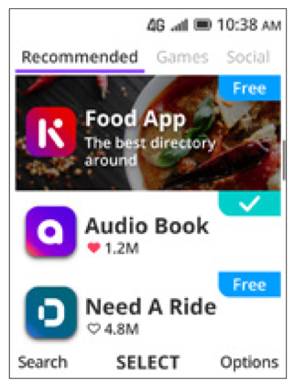 | Show trainees the KaiStore  Give a short explanation of apps and the KaiStore:  • “KaiOS allows you to get free games, find out sport scores  and access free news information on your phone. These  are called apps. You can get these apps for free in the KaiStore.”  • “From the KaiStore you can also access free apps like  Xender, WhatsApp, Religious texts and more.”

Bring these benefits to life!
Share personal examples of how apps help you, your friends and family. Some
examples might include:

• Sharing files like pictures and videos even without an internet connection
• Learning what new words mean in the dictionary
• Reading recipes from around the world
• Ask trainees to open the KaiStore and find an app they want to get for free.

Make KaiOS relevant to your trainees:

• Discuss what they want to learn or improve and find an app that can do that.
• Discuss what apps can do: entertain, teach, help, remind...
• Ask: “Which apps are useful to have?” Provide some suggestions based on their interests.
• Ask: “What apps would you like to use?”

MODULE 11 - KAIOS
INTRO / DOWNLOADING APPS / USING THE BROWSER / CONNECT TO WI-FI /
USING APPS / RECAP / NEXT LEVEL

MODULE 11 - KAIOS

Get Practical!
Explain: “You are now going to try using a KaiOS phone.”

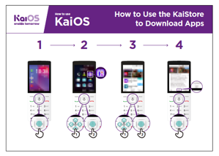 | Show the “How to use the KaiStore” poster  Explain: This poster shows how to download an app from  the KaiStore.

• Show the trainees how to go through the steps on their phones and explain that they can
download as many apps as they want. Downloading most apps are free, and some don’t
even use data.

• Explore different apps. Share text and photos on WhatsApp, see updates from a celebrity
on Facebook, get live football scores on FlashScore, read the news on KaiNews etc.

Make KaiOS relevant to your trainees:

• Discuss what they want to learn or improve and find an app that can do that.
• Discuss what apps can do: entertain, teach, help, remind...
• Ask: “Which apps are useful to have?” Provide some suggestions based on their interests.
• Ask: “What apps would you like to use?”
Tip: It’s best to download some apps (for example, WhatsApp) beforehand.

Take your trainees through the steps to download a game.
1. Go to the KaiStore.
2. Open any of the apps shown in the recommended tab.
3. Tap Download Now.
4. Open the app by pressing GO.
MODULE 11 - KAIOS

INTRO / DOWNLOADING APPS / USING THE BROWSER / CONNECT TO WI-FI /
USING APPS / RECAP / NEXT LEVEL

MODULE 11 - KAIOS

Activity: Access Wikipedia via your browser
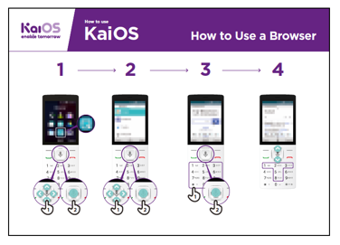 | Show the “How to Use a Browser” poster  • Explain: “Every KaiOS phone has a browser, where you  can search for any website or information you want.”  • “You can use the Google app and the browser app to  access information.”  • “A lot of businesses, governments and other organisations  have websites where you can find information about what  they offer. “

Bring these benefits to life!
Share personal examples of how the browser helps you, your friends and family.
Some examples might include:
• Finding specific information
• Searching for tips for problems you have
• Explain that not everything on the internet is true. There is a lot of incorrect
information, so it’s best to check on official websites for real information. Even
friends can send information that is not true.

Get Practical!
Explain: “You can learn about any topic on Wikipedia. Let’s find a topic to learn!”

• Go to Wikipedia and search for a topic the trainee is interested in.
• Bookmark the website so the trainee can find it again.
Tip: “It’s important to remember that the internet is a public place, so don’t believe everything you see or read online.”

MODULE 11 - KAIOS
INTRO / DOWNLOADING APPS / USING THE BROWSER / CONNECT TO WI-FI /
USING APPS / RECAP / NEXT LEVEL

MODULE 11 - KAIOS

Activity: Connect to a Wi-Fi Network
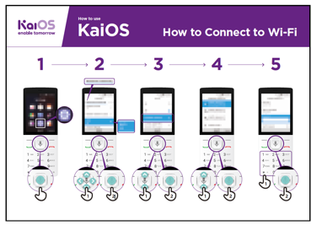 | Show the “How to connect to Wi-Fi” poster  • Explain: You are now going to connect to Wi-Fi.  • Explain what Wi-Fi is: “When you connect to a Wi-Fi network, you can go online without using data from your phone.”  • “You can also share your data with other people. When  you do this you create Wi-Fi from your phone and others  can connect to it. You can do this from the Settings app.”

Explain: “If you want to watch videos or browse the web without using data, then you can
connect to the Wi-Fi network if there is one available. Explain where they can find Wi-Fi
around them.”

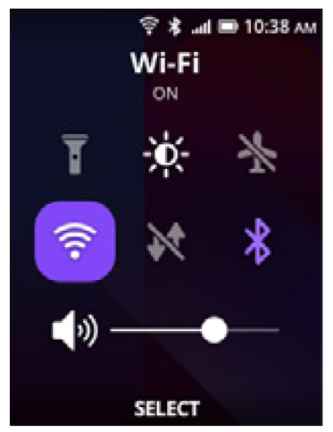 | Get Practical!  • Go to Settings and click on Wi-Fi. Make sure it’s turned on.  • You can turn Wi-Fi on and off from the Home screen. Tap  the “Up” button and select the Wi-Fi button. Press the  center button to turn it on or off.  • Then, select a network and enter a password. The phone  remembers this information, so you’ll only need to do this  once for each network.  • After your demonstration, ask the trainees to connect to  a Wi-Fi network. Help them with any questions they have  during the process.

MODULE 11 - KAIOS

INTRO / DOWNLOADING APPS / USING THE BROWSER / CONNECT TO WI-FI /
USING APPS / RECAP / NEXT LEVEL

MODULE 11 - KAIOS

Activity: Google Maps

Ask: “How can I go to Johannesburg from here?”

Tell your trainees how you’ve found the answer to this question: in Google Maps.
Then, explain that sometimes you need to find your way to another city. Share
personal examples of situations where it’s helpful to use Google Maps.
Now, explain how Google Maps can show you the fastest route to a destination.

Explain: “Google Maps comes with every KaiOS phone. When you open the app,
you can search directions with your voice – no need to read or write. Tap on the
yellow icon with a microphone and say where you want to go.”
Prompt them with the tasks below and ask them to complete them using Google
Maps.

• Find out how to get to the nearest village by foot.
• Find where you are on the map.
• Search for places and ways to get there.

MODULE 11 - KAIOS

MODULE 11 - KAIOS
INTRO / DOWNLOADING APPS / USING THE BROWSER / CONNECT TO WI-FI /
USING APPS / RECAP / NEXT LEVEL

Activity: Message someone on WhatsApp
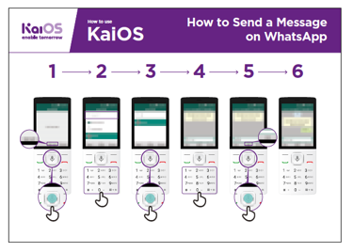 | Show “How to use WhatsApp” poster  • Ask: How can you message a friend who lives in the  United States for free?  • Explain: “With WhatsApp, you can message anyone for  free if you are connected to a Wi-Fi network. Even if a  friend lives in another country, you can chat with them for  free via WhatsApp if you have Wi-Fi.”

• Explain: “To send someone a WhatsApp message, they need to: 1) Be saved as
a contact on your phone; 2) Have WhatsApp installed on their phone.”

• “On KaiOS you can also make voice messages on WhatsApp by pressing the
center button.”

• Explain: You can type or record a message via WhatsApp. You can tell if
your message was sent, delivered, and read by the checkmarks next to the
messages. Here’s what each one means:


Message successfully sent.

Message successfully delivered to the recipient’s phone.

The recipient has read your message.

Show your trainees how to:
• Sign up to WhatsApp
• Open a chat with a contact
• Record a voice message via WhatsApp

MODULE 11 - KAIOS
INTRO / DOWNLOADING APPS / USING THE BROWSER / CONNECT TO WI-FI /
USING APPS / RECAP / NEXT LEVEL

MODULE 11 - KAIOS

Activity: Read new on KaiNews
 | Show the trainees the KaiStore and the  KaiNews Icon  • Explain: “It’s like a newspaper, but for free!”  • “The KaiNews app is a place for you to learn about your local news.”  • “The news you read on KaiNews are from reliable sources.”  • “To read the news, you need to download the KaiNews app from the KaiStore for free.”

MODULE 11 - KAIOS
Bring the benefits to life!  Tell your own story of how reading the news is beneficial to you (the trainer).  Some examples might include:  • Being able to tell your friends and family about the news you read and share the information you learned.  • Know the latest from what is happening in your country and in the world, even if the news is happening in another city.  • You can follow news about food, sports, politics, celebrities, the economy and much more!  • You may be able to explain to a friend/neighbour more about some news they have read from the articles you read. Offer specific examples.  • Ask trainees to share what kind of news they are interested in. The answers could be finding out sports scores, news from other cities, learning what’s happening in the  world... | Make KaiOS relevant for your  trainees:  • Discuss with your trainees how a KaiOS phone can help them in their lives.  • Ask: “What could you learn from reading the news?” Give them some suggestions based on their interests.  • Ask: What topic would you like to read about?  Remember: Link discussions and  activities in the training back to  how the KaiNews app can be  helpful or useful in your trainees’  own lives. This will help to keep the training relevant and interesting for them.
INTRO / DOWNLOADING APPS / USING THE BROWSER / CONNECT TO WI-FI /
USING APPS / RECAP / NEXT LEVEL

MODULE 11 - KAIOS

Activity: Introduce the FM/Radio App
 | Show the trainees the Radio Icon  Just like in your previous feature phone, you can access the  radio!

Give a short explanation:

• Explain: “The Kai Radio app is just like the radio you had in your previous phone!”
• “You can access the radio from the radio app, you don’t need data to install it. It
comes already installed in your phone!”
• “You can listen to the news from the speaker or from your headphones. Press
the “options” button in the radio app to change it.”
• “Using the radio app does not consume data!”

Bring the benefits to life!
• Tell your own story of how using the radio is beneficial to you (the trainer).
Some examples might include:
• Being entertained
• Listening to music from your community and abroad
• You can listen to and learn about other topics
• You can put the radio on the phone’s speaker and listen to it while you do other things.
• Ask trainees to share what news they are interested in. The answers could be
finding out sports scores, talking about news from other cities, learning what’s
happening in the world...

MODULE 11 - KAIOS
INTRO / DOWNLOADING APPS / USING THE BROWSER / CONNECT TO WI-FI /
USING APPS / RECAP / NEXT LEVEL

MODULE 11 - KAIOS
 | Play the KaiOS icon game  • Hold up each KaiOS icon, one at a time (KaiStore,  Browser, Settings, KaiNews)  • Ask “Where is this on the phone and what is it?”  • Explain to your trainees what each icon is and ask if they need support.  • Ask trainees which app from the KaiStore they have enjoyed using.  • Give small rewards (e.g. sweets) for correct answers and  stick the icons on the wall afterwards to help remind your  trainees what they are.


Recap
Recap on KaiOS

Discuss with your trainees what they have learned about the KaiStore.
“What have you learned about the KaiStore?”, “What are apps?”, “What can you
do with apps?”
- “Do you still have any concerns about using the browser?”
- “What personal uses could you have for the KaiNews app?”
- “What professional uses could you have for it?”
- “What do you want to use the browser for in your own life? What are you most
- interested in and excited about using it for?”
Tip: “If you don’t know what an app does, don’t be scared. You can download and explore any KaiOS app for free. If you spend some time with an app, you will learn how to use it. Just make sure you connect to a Wi-Fi network so you don’t use all your data.”

MODULE 11 - KAIOS
INTRO / DOWNLOADING APPS / USING THE BROWSER / CONNECT TO WI-FI /
USING APPS / RECAP / NEXT LEVEL

MODULE 11 - KAIOS


Going to the next level

If you reach the end of the session and have extra time

Ask: “Do you have any further questions about anything we have covered in the
session?”

Ask: “What else would you like to know about the mobile internet?”
Some more advanced features you can discuss with your trainees include:

Evaluating results: “How do you decide which app uses data when being used?”
“How do you know if an app uses more data than another (streaming content
on YouTube, Facebook and WhatsApp will use more data than other apps like
games)?”

How to save memory on your phone: “How can you identify which files occupy
more storage space on your phone?”, “How can you “make more space” inside
your phone?”

Google Maps on KaiOS: “How do you get directions?”

Downloading apps from the KaiStore, how to find it, how downloading works,
and how much they cost (apps are mostly free).

MODULE 11 - KAIOS

MODULE 11 - KAIOS

Posters, Cut-outs and
Info Sheets

Icon Cutouts - YouTube




Icon Cutouts - YouTube




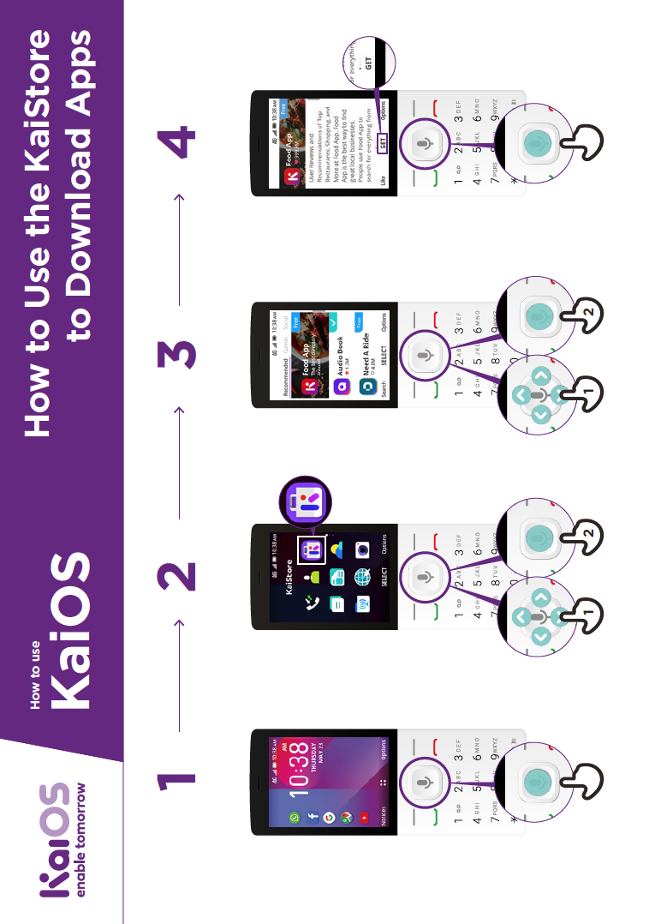
How to use

How to use the KaiStore
to download Apps
Display
Night Light
Off
TURN ON NOW

GET

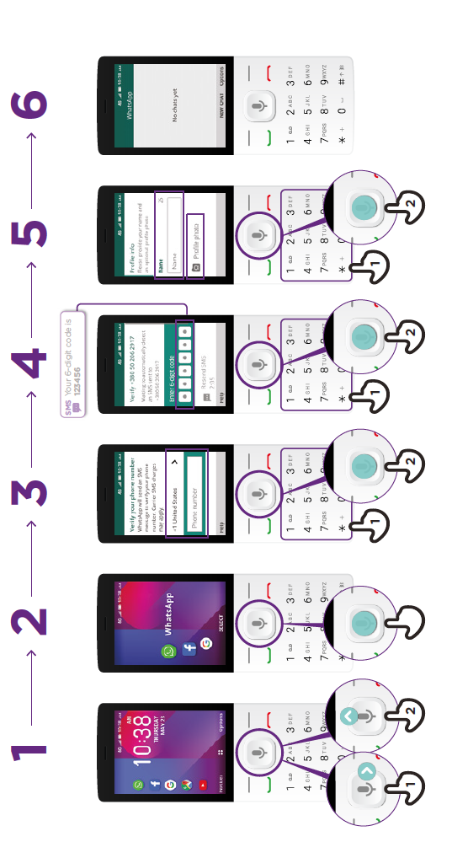
How to
setup WhatsApp
How to use

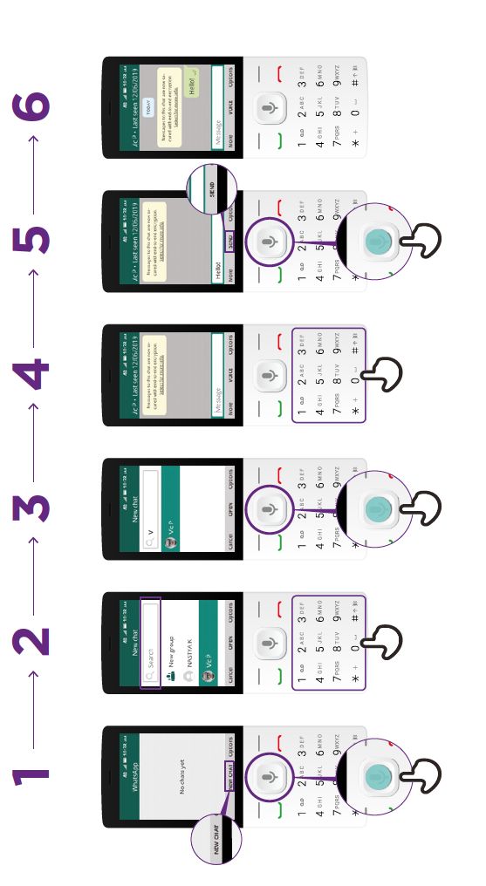
How to send a Message
on WhatsApp
How to use

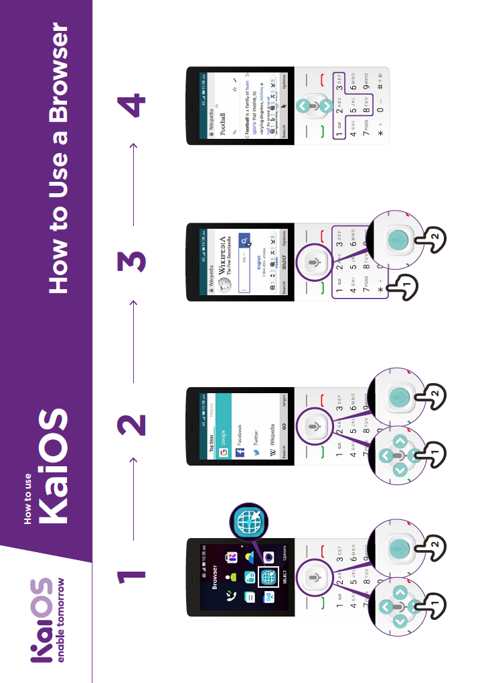
How to use
a Browser
How to use





CERTIFICATE

has completed
BASIC MOBILE INTERNET SKILLS
training

Date Signed





CERTIFICATE

has completed
BASIC MOBILE INTERNET SKILLS
training

Date Signed

