


Mobile Internet
Skills Training
Toolkit
A guide for training people in
basic mobile internet skills
Copyright © 2024 GSM Association
Copyright © 2024 GSM Association
Bitesize Training
Accessibility Features

Mobile Internet
Skills Training

Toolkit

A guide for training people

in basic mobile internet skills

Module 13:

Accessibility Features

What is it?
 | Explain: “Some people with low or no vision may find it difficult to see what is on the screen. There are features on the phone that can help them. We need to show a variety of options relevant to their needs. Often people use a combination of features.”
What can you use it for?
“Your mobile phone can help you if you cannot see it. Three of these ways are:”

Magnification (making things bigger on the screen):

“Magnification is a function that makes everything on your phone look larger. Many people use magnification to help them view small things. For people with low vision, it makes it possible for them to see what’s on the screen.”
Materials you will need:

- Android phone
- Accessibility features posters

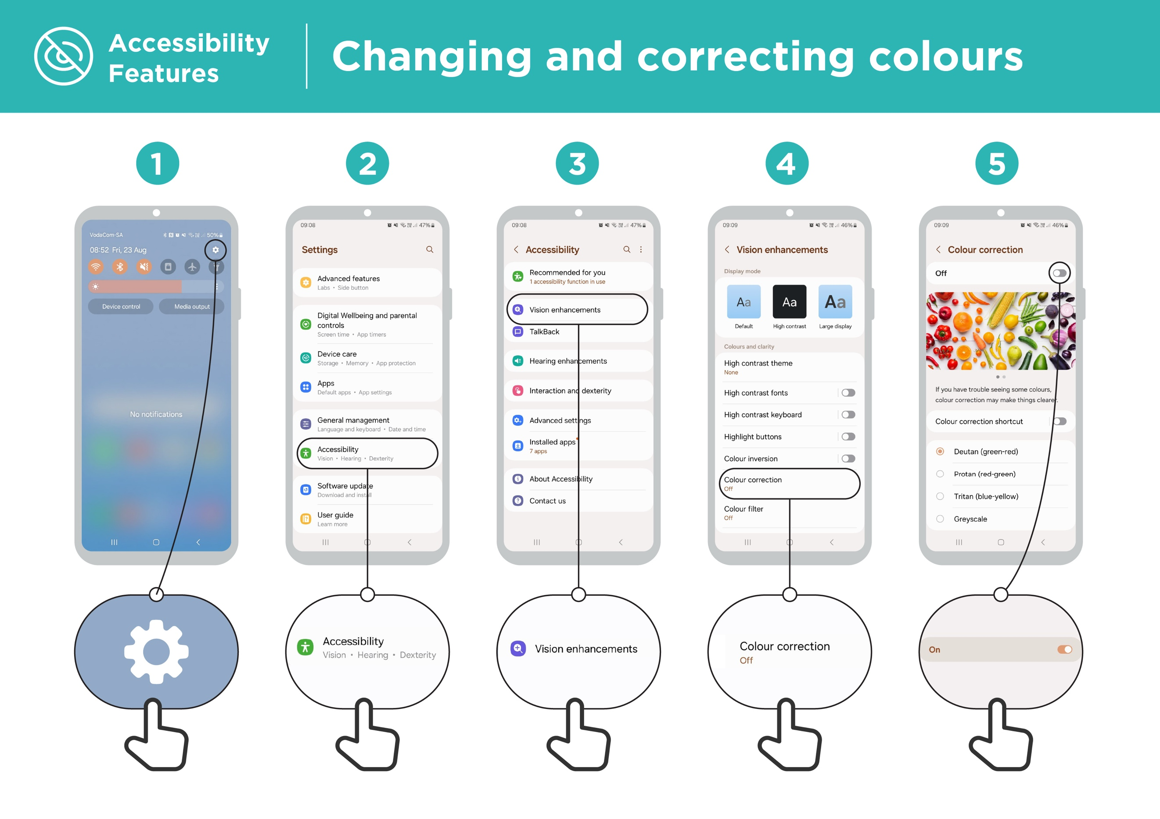
“Michael uses magnification to read the news each day, he finds it easier to read stories with lots of text if the text is three times the normal size.”

“Ayesha has always used magnification (making the screen appear larger) on her phone but has found that recently this makes her eyes sore after a few hours and she uses TalkBack when this happens.”

What can you use it for?

Making the phone speak aloud:

“‘TalkBack’ is when you can listen to your phone without needing to see the screen. When you do something on your phone it will speak to you and tell you what is happening, it will also vibrate to let you know what is happening.”


Changing colours and contrasts:

“Some people find it difficult to see some colours and contrasts, making it difficult to read what is on the screen. You can change the way the colour on the phones look to make it easier to use.”
“Susan uses high contrast display settings to easily read what she is writing when using WhatsApp or email. She finds that she makes fewer mistakes when everything is clearer.”

How does it work?
- Ask the person what they would like to do with their phone.

- Trainer: Check whether the trainee’s phone has the accessibility features set up.

What is it?
 | Explain: “People who are hard of hearing or deaf can use phones like anybody else as mobile phones have features that can help.”

What can you use it for?
“Your mobile phone can help you if you cannot hear it. Three of these ways are:”

Amplification:

“If you find it hard to hear what people are saying around you, your Android phone can help. There is something called Sound Amplifier that will make sounds clearer for you to hear.”
Materials you will need:

- Android phone
- Accessibility features posters

“Andrew uses Sound Amplifier when he is talking to people in the café, this allows him to hear what someone is saying much more clearly as it reduces the background noise.”

What can you use it for?

Captions:

“When your phone is playing a video or audio, you can turn on captions. This means you can see the words on the screen of what is being said. It is very helpful when people find it difficult to hear a song or a video.”

“Sandra uses captions in video calls. She often finds that the captions help her to pay attention to the call when the words become difficult for her to hear.”


Transcription:

“Live Transcribe is similar to captions. It means that when people are talking, you can see text on the screen of what they are saying. For people with a little hearing or no hearing, Live Transcribe can be very useful.”
How does it work?
- Ask the person what they would like to do with their phone.

- Trainer: Check whether the trainee’s phone has the accessibility features set up.
Make it relevant to the trainee: Discuss how these features could be beneficial in the trainee’s own life.
“Sahid connects his hearing aid to his phone which makes speech much clearer and easier for him to understand when talking to his brother and sister through WhatsApp.”

Bitesize Training
Accessibility Features

Mobile Internet
Skills Training

Toolkit

A guide for training people

in basic mobile internet skills

Posters and Cut-Outs
Top tips to stay safe online

 | Remember that not everything you see online is real  Anyone can post anything online, so don’t believe everything you see. Even if it’s from someone you trust, it might not be true. Be careful before sharing information with others
 | Think twice before sending money to someone you meet online  Be careful with emails, messages or pop-ups you didn’t ask for, especially if they ask for money or contain strange links.
 | Keep your personal information private, including passwords  Avoid sharing personal details like your full name, home address or phone number unless absolutely necessary.
 | Don’t cause harm to others online  Be kind and respectful. Don’t bully, spread false information or harass anyone. Your actions online can affect people in real life.
 | Be aware of scams and fraudsters  Just like in real life, thieves and criminals are on the internet too.  Some people online pretend to be someone else.
 | Take action by blocking or ignoring someone who is bothering you  If someone is bothering or harassing you online, ask for help and tell someone or report it.

Remember that the internet is open to everyone around the world and so it is essential to treat it like a real-life public place (e.g. a marketplace) and stay safe by protecting yourself and being responsible with what you do online.

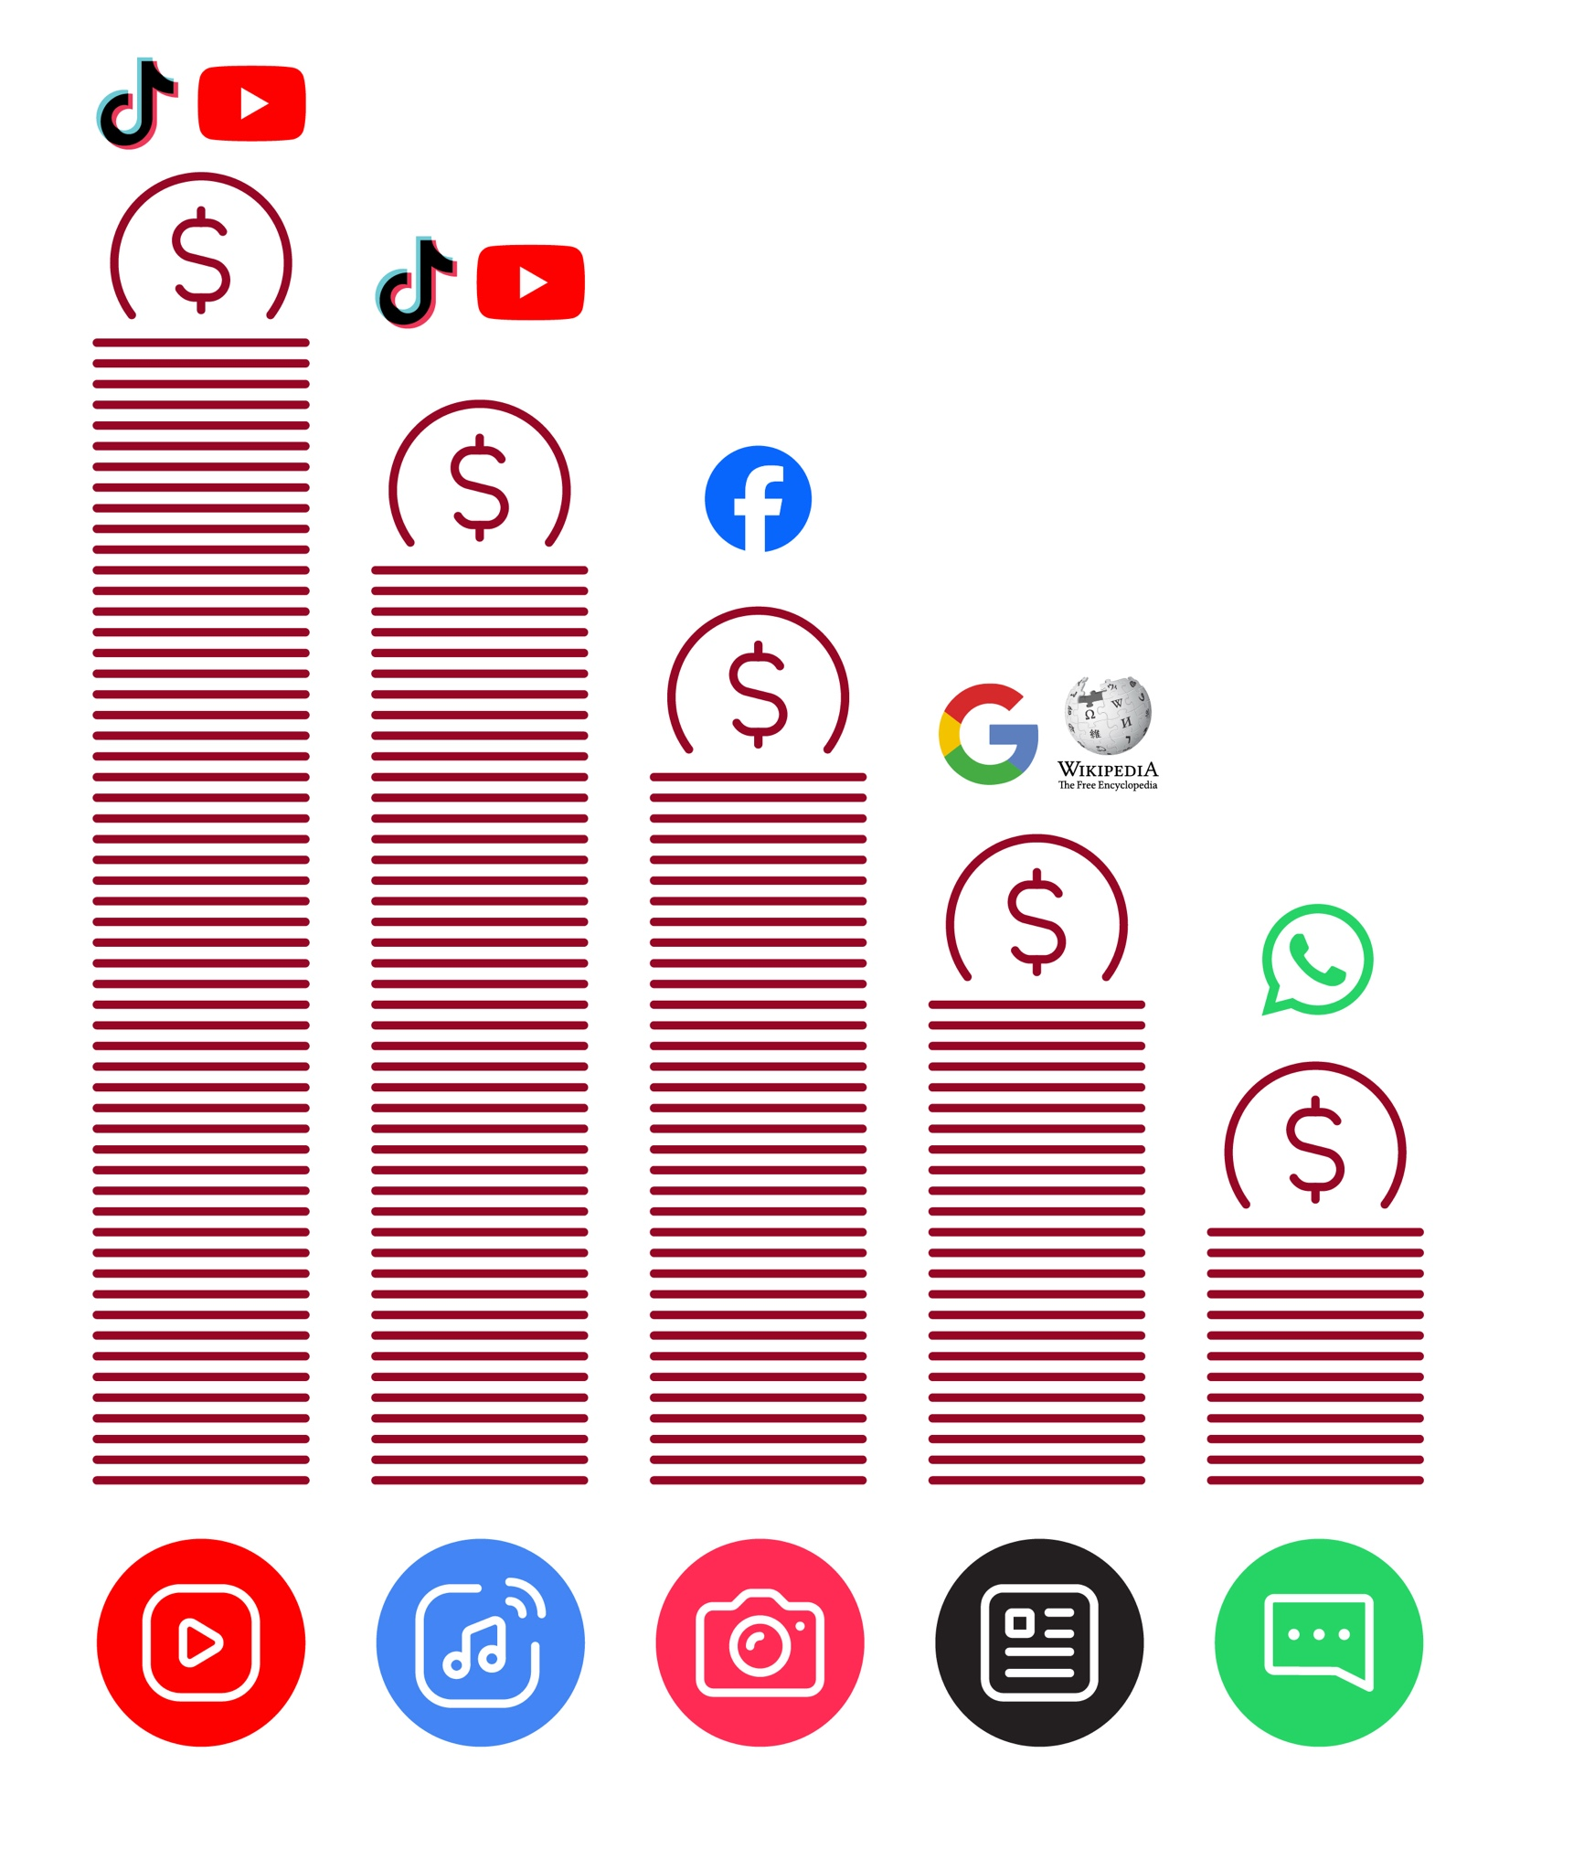
Data Costs
Accessibility | Changing and correcting colours
Features | Changing and correcting colours



1 2 3 4 5
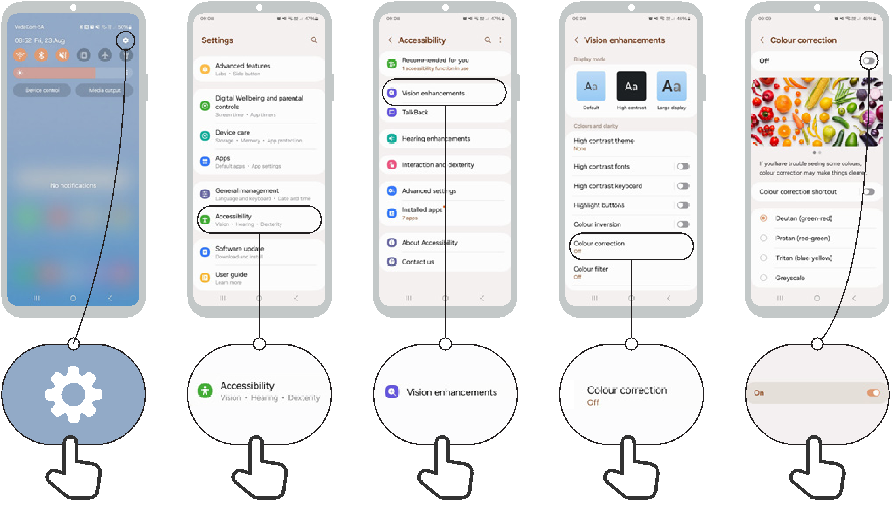

Changing font sizes
Accessibility
Features

1 2 3 4 5
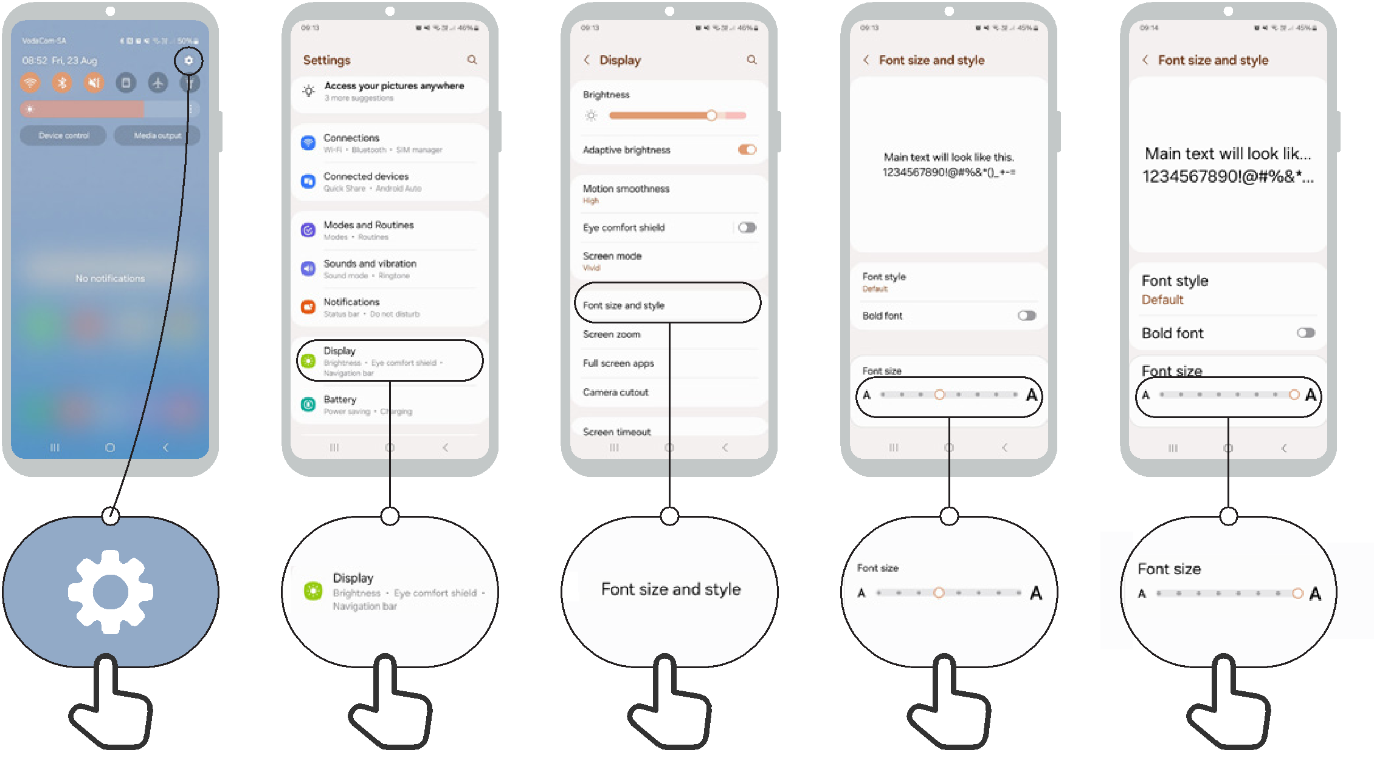

Changing display
Accessibility
Features

1 2 3 4 5

Accessibility
Features

Magnification for people with low vision
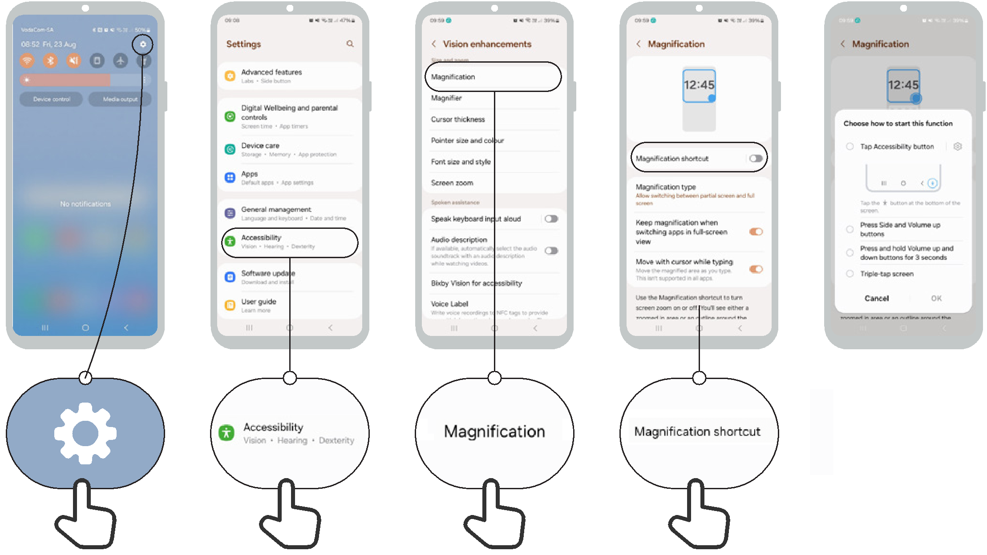
1 2 3 4 5

Temporary magnification
Accessibility
Features

1 2 3 4 5
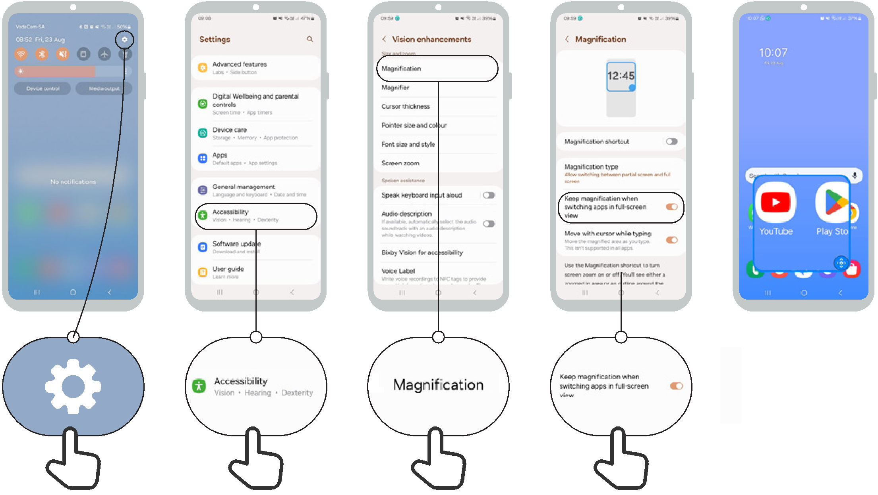

Set up TalkBack
Accessibility
Features

1 2 3 4 5 v
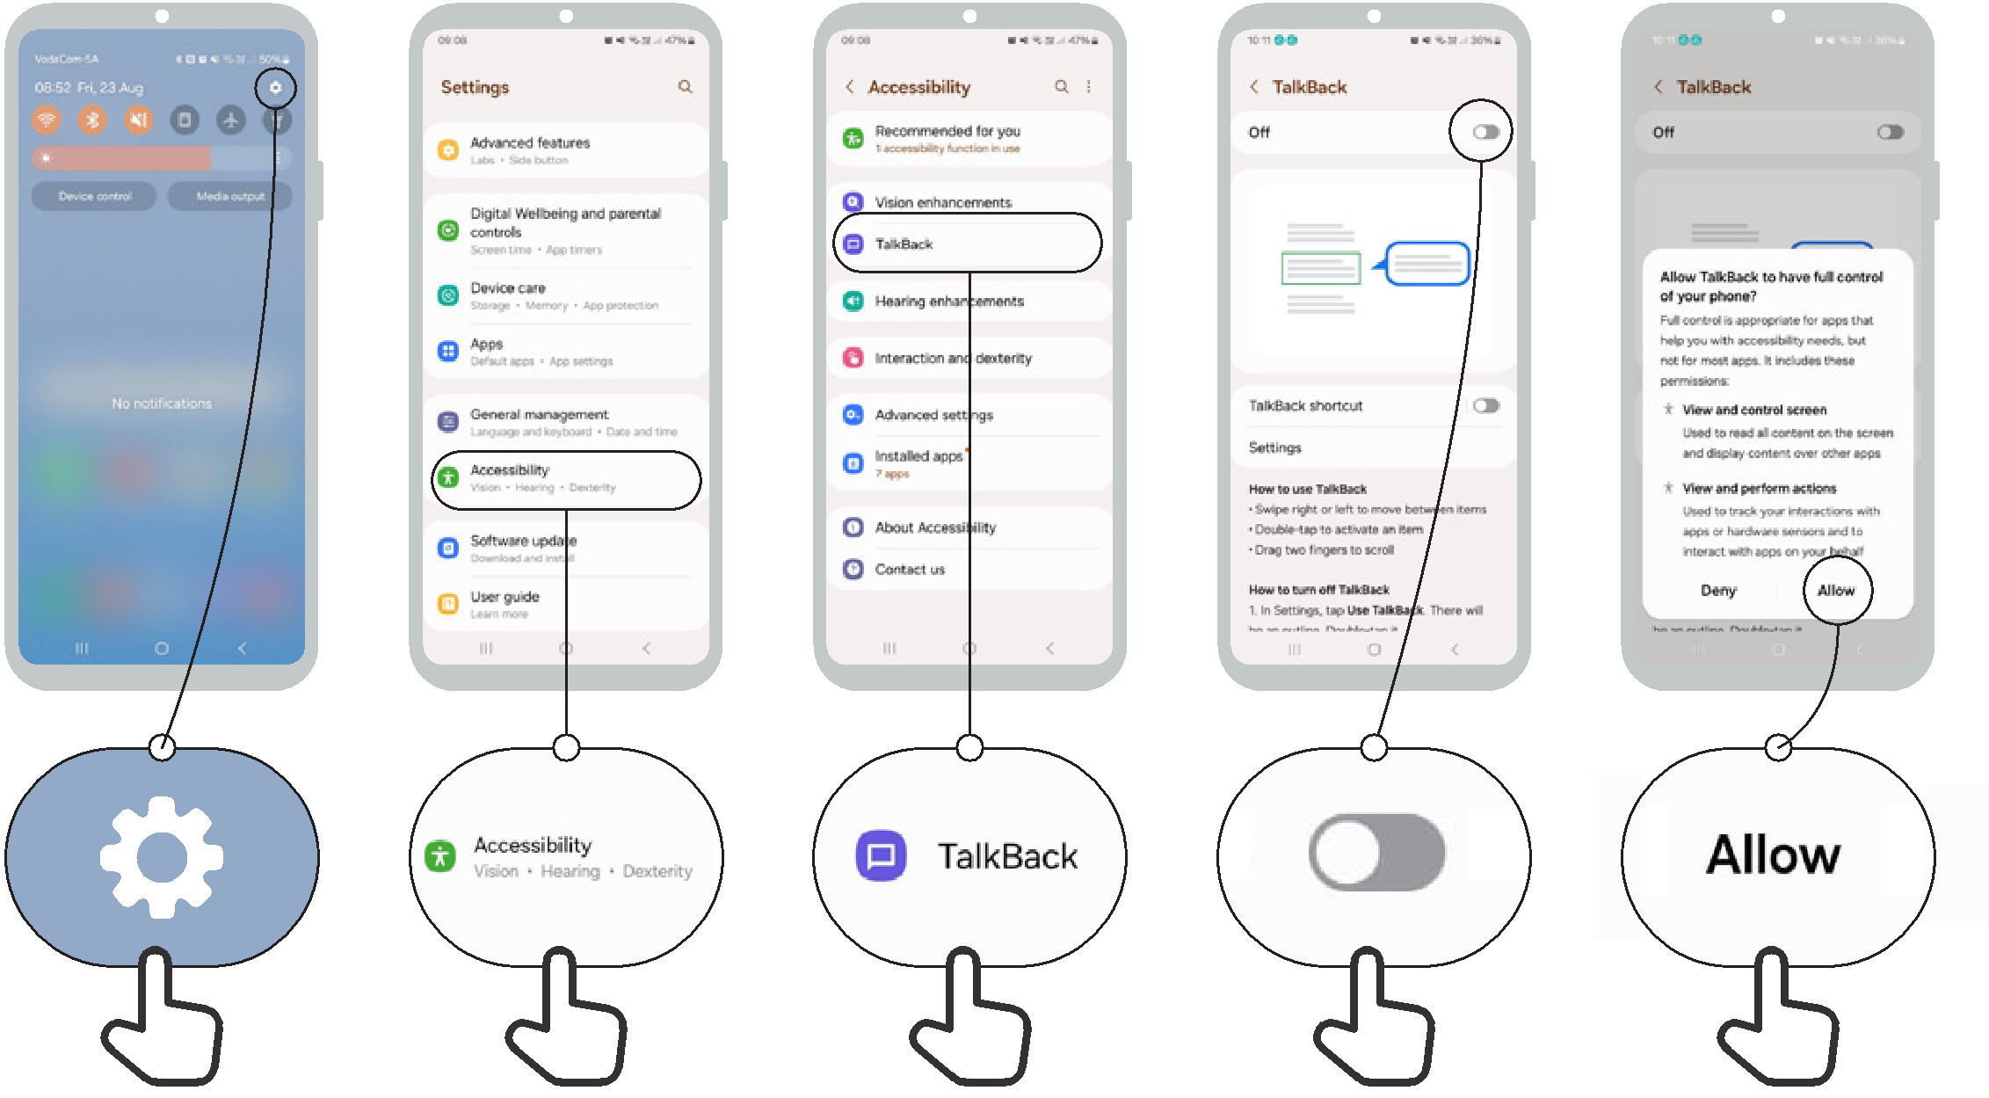

Sound enhancement
Accessibility
Features

1 2 3 4
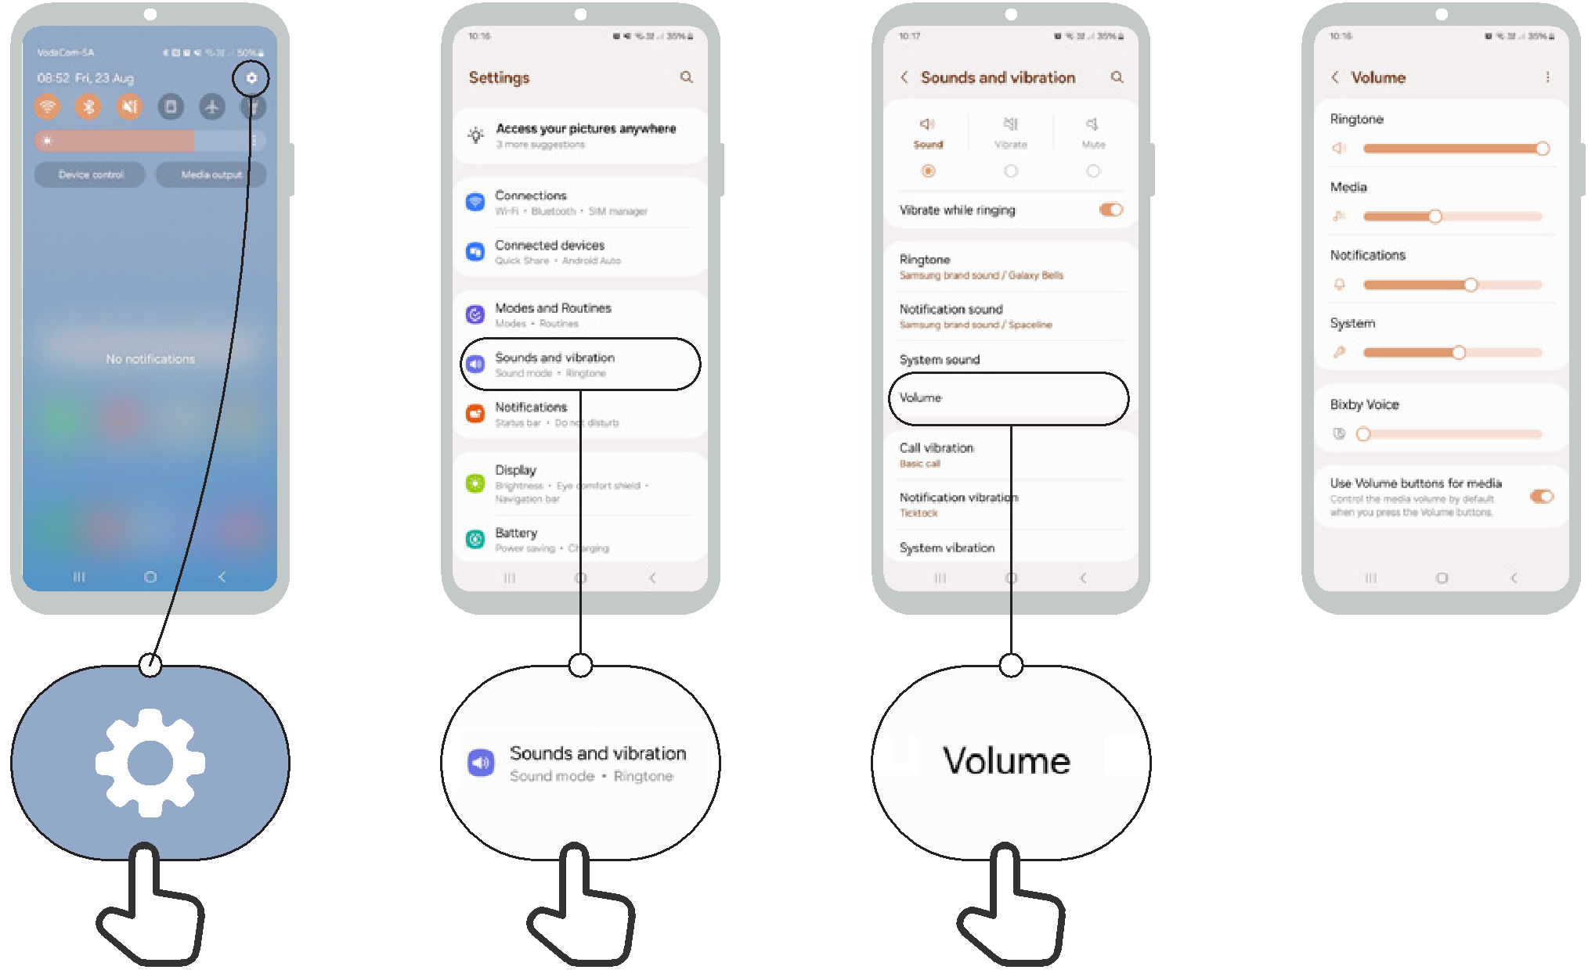

Sound amplification
Accessibility
Features

1 2 3 4
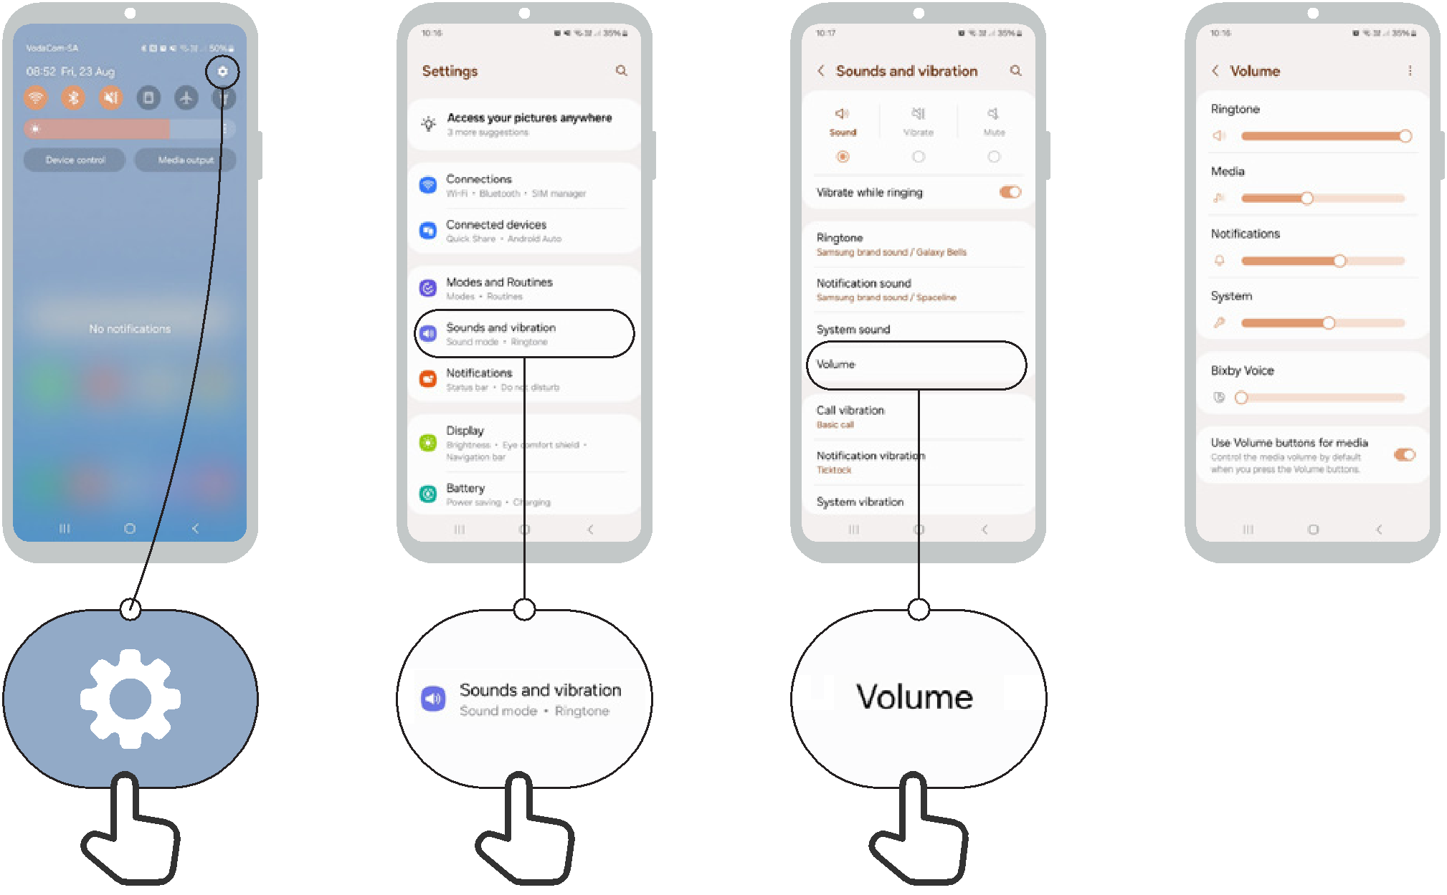

Set up captions


Accessibility
Features

1 2 3 4 5 6
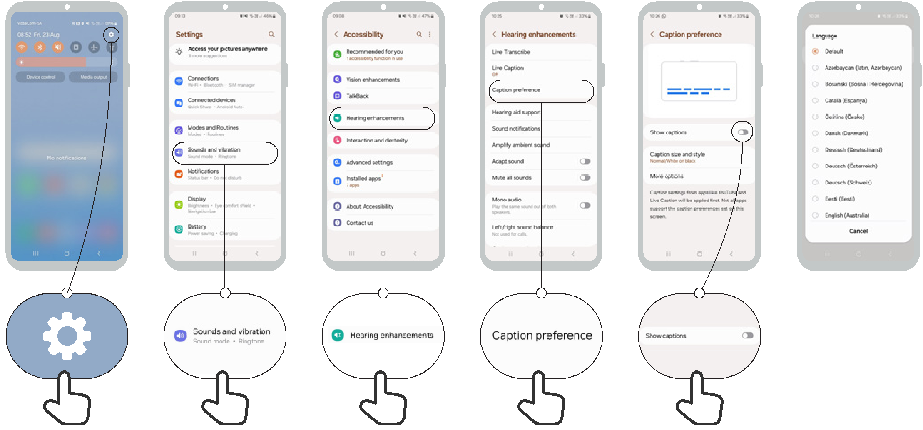

Accessibility | Set up live transcriptions
Features | Set up live transcriptions

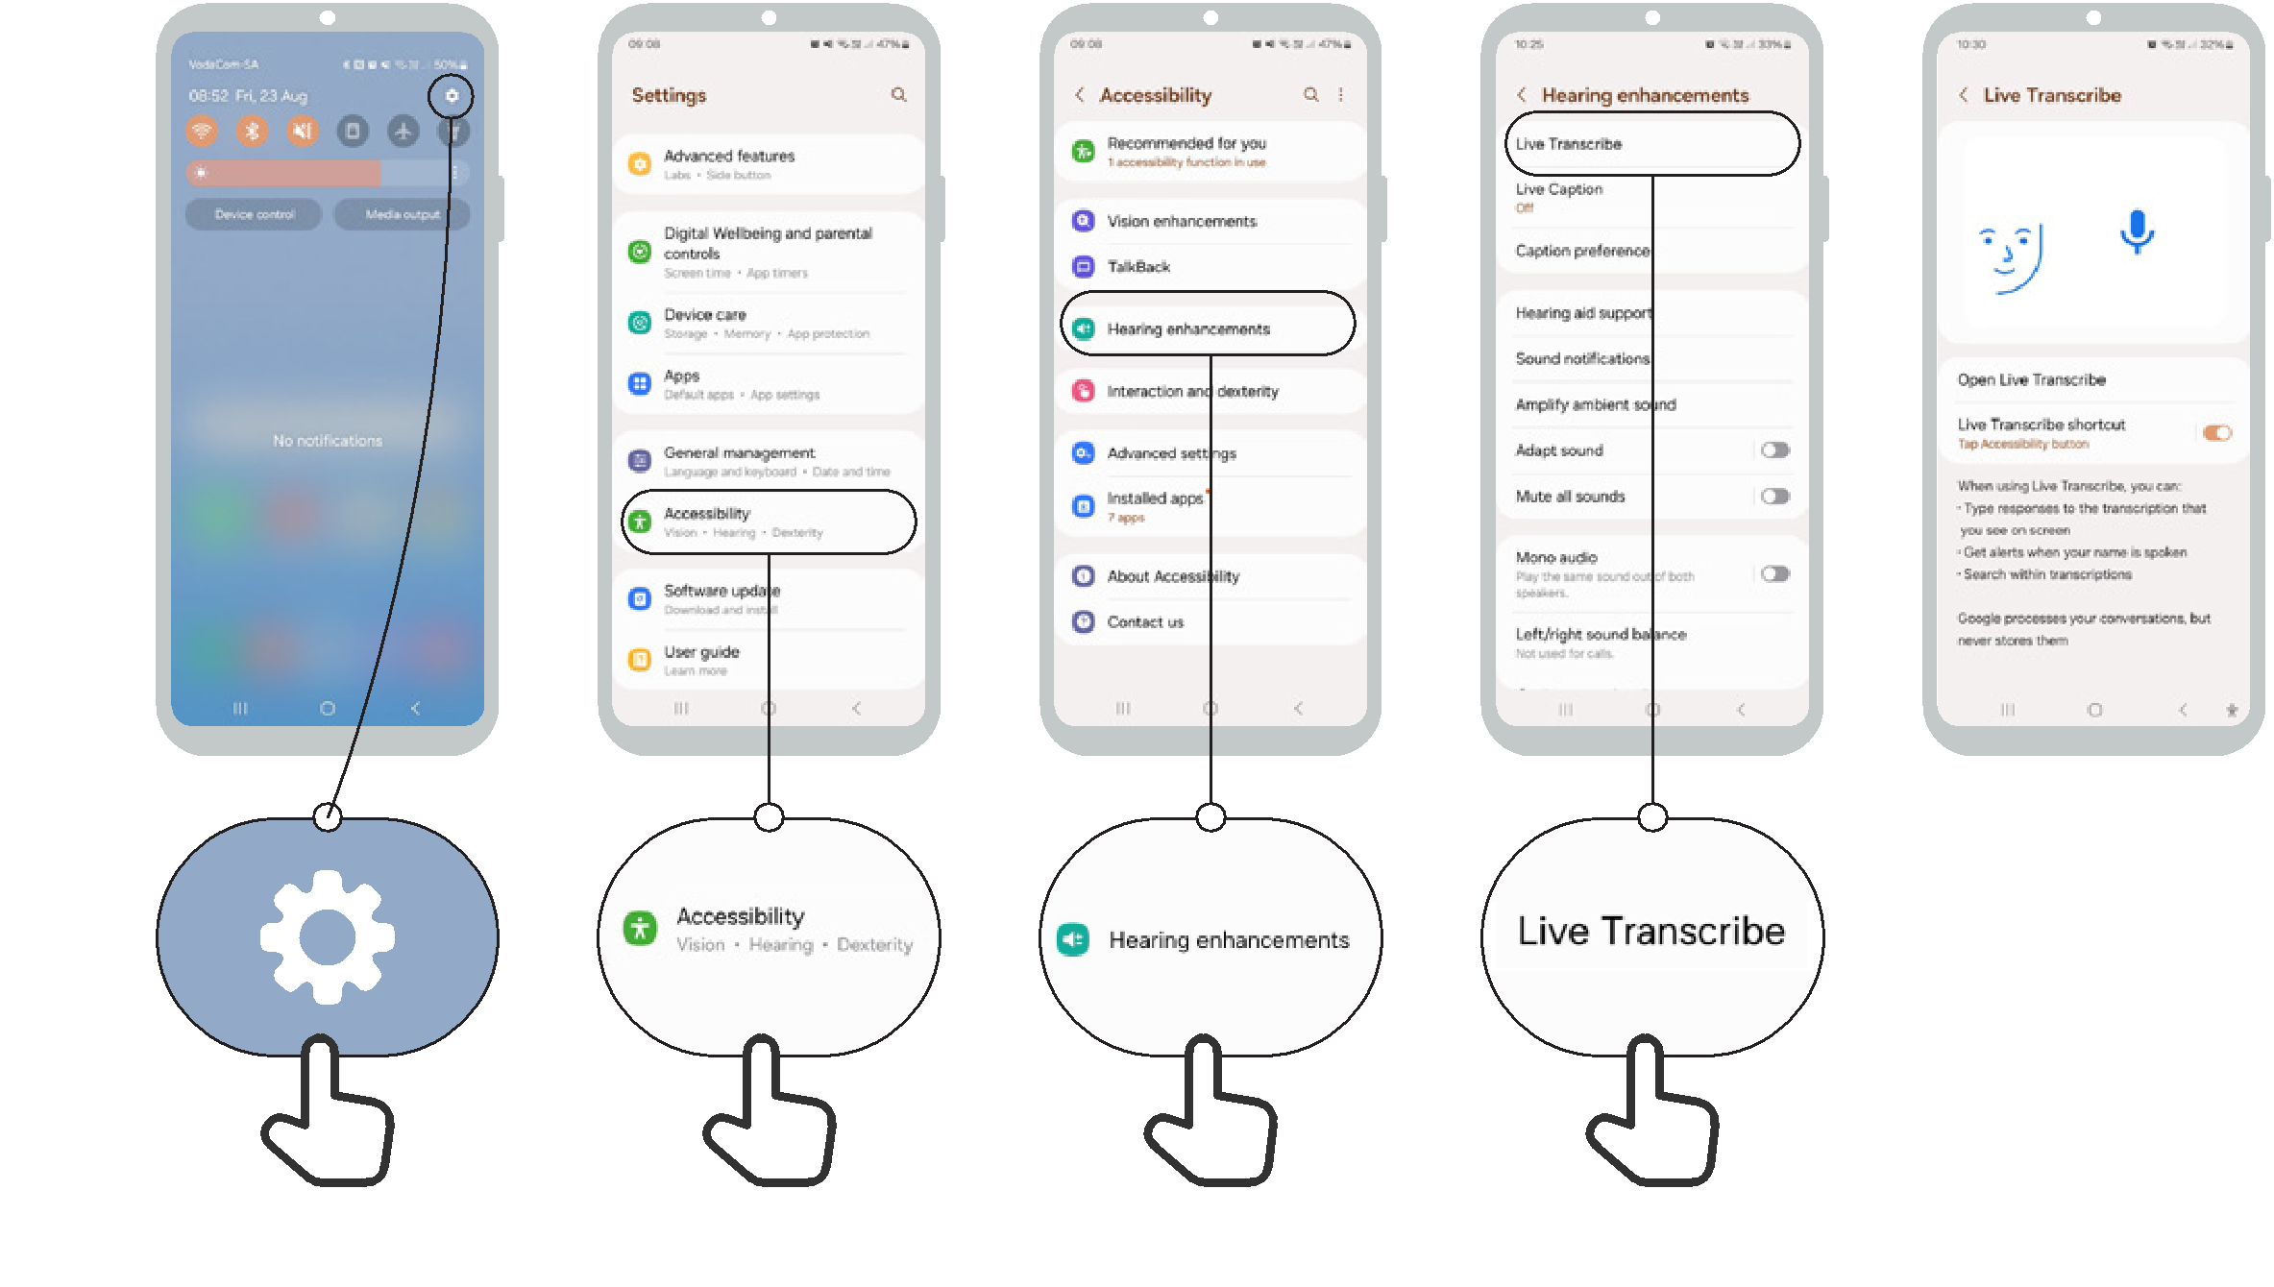
1 2 3 4 5

