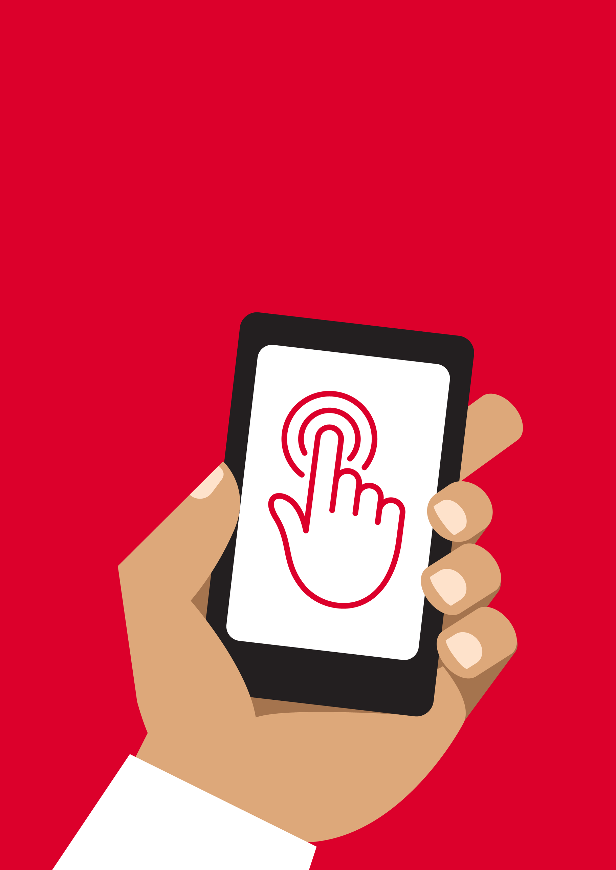


Mobile Internet
Skills Training
Toolkit
A guide for training people in
basic mobile internet skills
Copyright © 2024 GSM Association
Copyright © 2024 GSM Association
In-Depth Training
Accessibility Features

Mobile Internet
Skills Training

Toolkit

A guide for training people

in basic mobile internet skills

Module 13:

Accessibility Features
Working with people with disabilities
Around 15% of people in the world have some form of disability. For many people with disabilities, life can be challenging because they face barriers to access services such as education and healthcare that other people don’t face. However, mobile phones can help remove some of these barriers and allow people with disabilities to do everyday things that they would otherwise find difficult to do.

There are many benefits that mobile can bring to the lives of people with disabilities. Mobile can be used to connect people with their friends and relatives using WhatsApp, calls or SMS. Mobile also makes it easier to access mobile money, entertainment, news and online information. Also, for many people with disabilities, mobile is the gateway to transportation, education, healthcare services and community groups.

Maybe you are wondering how someone who cannot see or hear can use a mobile phone? There are a set of functions known as accessibility features that can help people to improve the user experience of mobile phones. These features can help someone with low vision to make things larger on the screen, for instance, or help someone who cannot hear to read what is being said in a video. However, many people are not aware that these accessibility features exist, or they do not know how to use them.

People with vision and/or hearing impairments may need support to use a mobile phone in two ways. Firstly, the same as with other customers, they may need to learn how to use WhatsApp, Google, YouTube, etc. Secondly, they will need to learn how to use accessibility features to use their phone and apps. In this module you will see accessibility tips for each of the main services, followed by an in-depth look at the different types of accessibility features that people with low/no vision or hard of hearing/deaf may find useful.

By teaching your customers both elements, you will contribute to empowering them to live more independently and participate more fully in society.

Communicating with customers with a disability: Getting started
“Ask before…” is important in any situation and the same applies when interacting with a person with a disability. We should always ask the person before offering assistance or support and making assumptions.

You might be nervous when meeting a person with a disability and feel afraid of using the wrong words or saying something offensive. Make sure that you respect the person as you would with anyone else.

Top tips for communicating with customers with a disability

Speak directly rather than through a companion or any sign language interpreter who may be present.

If you offer help, wait until it is accepted.

Then listen or ask for instructions.

Treat adults as adults. Address people with disabilities by their first names only when extending that same familiarity to all others.
Do not lean against or hang on someone’s wheelchair or scooter or play with a guide dog.
Listen carefully to those who have difficulty speaking, give them time to finish. If necessary, ask questions that require short answers.

Never pretend to understand;

check with the person if you are unclear.

Relax. Don’t be embarrassed if you happen to use common expressions such as “see you later” or “did you hear about this?” that seem to relate to a person’s disability.

Supporting customers with hearing loss
Get the person’s attention before speaking. There are many ways to attract attention – like a gentle touch on the arm. Ask the person for suggestions.

Speak clearly and at a moderate pace. Raising your voice volume excessively and shouting is not helpful.

Look directly at the person while speaking and be at the same eye level if possible.

When giving information, ask the person if they have understood (e.g. “Did that make sense?”).

Feel comfortable to show facial and body expressions. Smiling, pointing etc. all help to communicate.

Be aware that your face may be in shadow, and that light behind you might make it harder for the person to learn from your expression.

Reduce background noises where possible, background noises can make listening very difficult.

Use pencil and paper to supplement your communication if necessary. In a
noisy environment, writing down keywords may assist those who are hard of hearing.
When in doubt, ask the person with hearing loss for suggestions to improve your communication.
Many people with a hearing impairment use hearing aids. Find out if the person is using an aid and ask how you can help them in using it.

Be patient, confident and relaxed.

Supporting customers with vision loss

Introduce yourself.

Not everyone recognises voices or remembers them.

Don’t shout.

Being visually impaired or blind does not mean you can’t hear clearly.

Let people know when you are moving.

Don’t leave a person who is blind talking to themselves.

Avoid hand signals as it can be hard to understand directions and gestures if you cannot see them well.

Don’t worry about words such as, “see” or “look”. People with visual impairments understand that these words are part of regular conversations.

Don’t push, pull or grab a person who is blind.

Do offer your arm for assistance.

Ask how someone prefers to be guided.

If the person has a guide dog, avoid talking or playing with the dog. Never stroke, feed, or direct a service dog while they are wearing a harness or vest, they are there to help and are not a pet.

Learning objectives
- Trainees understand the benefits that mobile can bring to the lives of people with disabilities.

- Trainees are able to change display settings and use features such as the magnification function.

- Trainees are able to use TalkBack, sound enhancement, sound amplification and turn on captions.
Note to trainer

Using a mobile phone with little or no vision, or little or no hearing, is not complex. All Android phones have accessibility features to help people to use the phone when they cannot easily see the screen or hear sounds. Most customers will have some vision or hearing, and they will need to make the phone easier to see and hear. Some customers will have very little sight or hearing and they will need help to use the phone in a different way.

For each of the activities below, there is a simple activity, but there is also a more detailed activity if you have the time to complete it.
Time duration
45-60
minutes
Tip: The accessibility features that help a person use a phone can be used across many apps, but may not work in some apps.

Google Assistant can be very useful – particularly for people with little or no vision (more information can be found in the Android module).
Materials you will need:
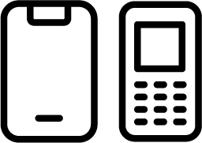

Mobile phone
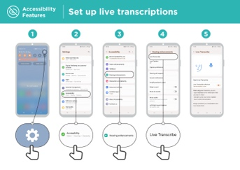

Accessibility features

posters

Tip: The accessibility features that help a person use a phone can be used across many apps, but may not work in some apps.

Google Assistant can be very useful – particularly for people with little or no vision (more information can be found in the Android module).
Activity: Changing display settings (for low vision)

Explain: “You can change the way the screen looks on the general settings menu.”

Ask what trainees are interested in: Changing and correcting colours; changing fonts and display size; increasing the contrast or reducing white light.

Demonstrate how to change settings for people with low vision using one of the following posters:

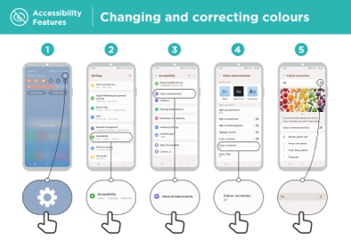
- Changing and correcting colours

- Changing font sizes

- Changing display

- Turning on ‘Night Light’
If you know someone who uses these settings, bring the benefits to life by telling their story.

Explain: “We are going to practise this using WhatsApp to send a message.”
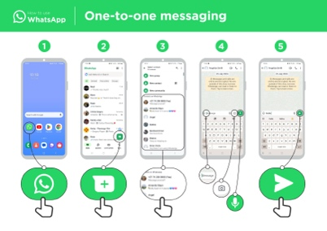
Demonstrate using the ‘How to use WhatsApp one-to-one messaging’ poster.

1. Help the group find the WhatsApp icon.

2. Check that everyone knows about WhatsApp and how to use it.

- Demonstrate sending a message.

- Increase the font size and send a WhatsApp message to someone else in the group.

Activity: Changing and correcting colours
Explain: “Some people find it difficult to see some colours and they might not be able to see the phone screen properly. You can change the way the colour on your phone looks to make it easier for people to use.”

Tip: These settings may not be on all phones. Try to help trainees to set it up.

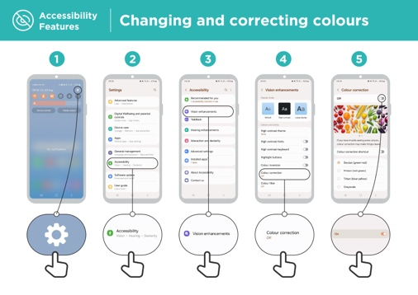
Demonstrate using the ‘Changing and correcting colours’ poster.

- Follow the instructions to adjust the settings for colour correction.

- Open a picture that you have taken – it could be of the trainee if they agree.

- Look at the photo before you set up the correction and after.
Get practical!

“Try using colour correction with a variety of different apps. Include a local website, a social media app such as Facebook and a messaging app such as WhatsApp.”

Tip: Make it relevant by telling a story of colour blindness or if you know someone who is colour blind, tell a story about your or their use of mobile.

Activity: Magnification for people with low vision
(making things look larger on screen)
Explain: “Magnification is a function that makes everything on your phone look larger. Many people use magnification to help them view small things. For people with low vision, it makes it possible for them to use a screen.”

“Magnification works like a magnifying glass but it is part of the phone. You can use it for a short time (e.g. to look at a picture) or whenever you use your phone.”
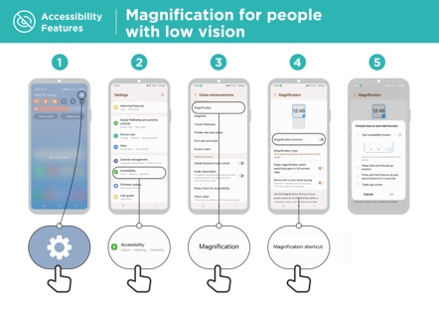
Demonstrate using the ‘Magnification for people with low vision’ poster.

Explain: “We will use magnification to send and receive messages. We are going to practise by sending a message with WhatsApp.”

- Increase the magnification for continual use on the phone.

- Send a WhatsApp message to someone else in the group.
Explain: “Magnification can also be a temporary function and is similar to when you zoom in. You may have used zoom to make something bigger, e.g. on a photo.”
Explain: “You are now going to zoom using magnification.”
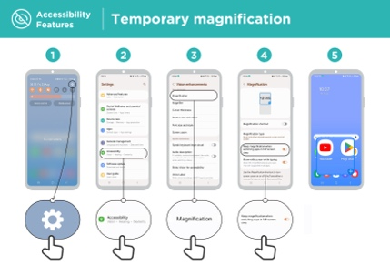
Demonstrate using the ‘Temporary magnification’ poster.
Explain: “We are going to practise using magnification by sending a message with WhatsApp.”

1. Help the group find the WhatsApp icon.

- Check they know about WhatsApp and how to use it.

- Demonstrate sending a message.

- Increase the magnification for temporary use on the phone.

- Send a WhatsApp message to someone else in the group.
Get practical!

“Try using magnification with a variety of different apps. Include a local website, a social media app such as Facebook and a messaging app such as WhatsApp.”
Activity: Text to speech – getting the phone to speak out what is on screen
Explain: “TalkBack is when you can listen to your phone without needing to see the screen. When you do something on your phone, it will speak to you and tell you what is happening. It will also vibrate to let you know what is happening. TalkBack or text to speech can really change the lives of people with no vision. It means they can use their phone without someone having to read for them.”
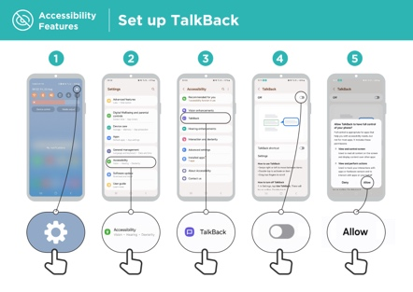
Demonstrate how to set up TalkBack using the ‘Set up TalkBack’ poster.

- Open the Google app on your phone.
- Practise starting TalkBack and switching it off – do this several times.
- Now learn the gestures to navigate with TalkBack.
- Navigate to the search box.
- Search for ‘cafés near me.’
- Listen to the results and double tap on one café to find out more about it.
- Try searching for other things.
Get practical!

“Try using magnification with a variety of different apps. Include a local website, a social media app such as Facebook and a messaging app such as WhatsApp.”

Recap
Explain: “All Android phones are able to help people to use the phone when they cannot easily see the screen. Even when you have little or no vision, using a mobile phone is not complex.”

“For those with some sight, we can make the phone easier to see. For those with little or no sight, we can help to present the information on the screen in a different way. There is a solution to help most people with vision loss.”

“The features in this module can help a person use a phone across many apps, but some may not work if they have been designed not to use the phone settings.”

“Most apps have special shortcuts. These can help you use many of the things explained in this module in an even easier way.”

Activity: Sound enhancement

Explain: “On your phone, you can change it so that different sounds are quieter or louder. For example, you can change it so that music and video are a different volume to phone calls or alarms. You can also use something called BesLoudness to make the sounds as clear as possible.”
Discuss the benefits of sound enhancement with trainees.
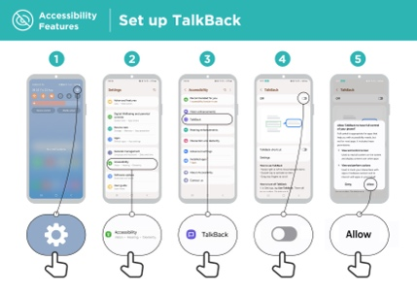
Trainer to give own examples of how increasing the volume and clarity could change their experience. For example, how it could help a person who struggles to hear clearly when they are listening to their phone.
Demonstrate how to change sound settings using the ‘Sound enhancement’ poster.

Tip: “It is important to use a good quality wired or wireless headset.”

Activity: Sound amplification
Explain: “If you find it hard to hear what people are saying, your Android phone can help. There is something called Sound Amplifier that will make sounds clearer for you to hear.”
Tip: Some phones may not have this function. You may need to help trainees download Sound Amplifier if their phone does not have it.
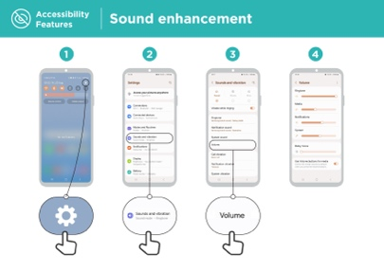
Discuss situations where it is more difficult to understand what is being said. Bring the benefits of Sound Amplifier to life using trainers’ own experience, for example, when someone is in a very loud place or they are an older person who struggles to hear properly.
Demonstrate using the ‘Sound amplification’ poster to show trainees they can change these settings step-by-step.

Activity: Captions
Explain: “When your phone is playing a video or audio, you can turn on captions. This means you can see the words on the screen of what is being said. It is very helpful when people find it difficult to hear a song or a video.”

“Captions can help everyone. They help people understand what is being said when the audio is in another language or the sound is poor quality. It also useful for people who have problems hearing.”
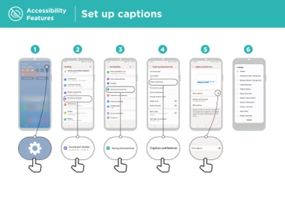
Demonstrate how trainees set up captions using the ‘Set up captions’ poster.

Explain: “Now that we have set up captions, we can try watching a video on YouTube with captions on.”

Tip: “Captions work best when the person who has made the video has added captions. Some apps - such as YouTube - automatically caption videos if none are available but these don’t work as well.”

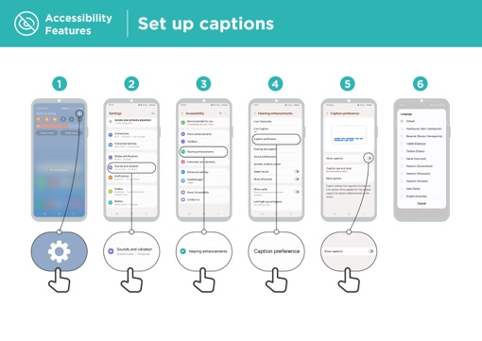
Demonstrate how trainees can watch a video on YouTube with captions using the poster.

- Using the instructions on the poster, switch on captions.

- Using the YouTube App or website, navigate to search for a favourite video.

- If the author has created captions, these will autoplay.

Activity: Live transcriptions
Explain: “Live Transcribe is similar to captions. It means that when people are talking, you can see text on the screen of what they are saying. For people with little hearing or no hearing, Live Transcribe can be very useful.”

“On some Android phones, Live Transcribe will already be on your phone. If not, you might need to download it from Google Play.”

Trainer: Help the trainee download Live Transcribe if their phone doesn’t have it.
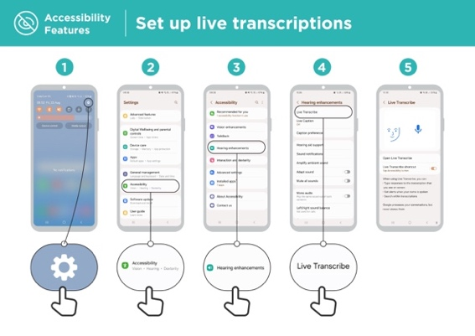
Demonstrate using the ‘Set up live transcriptions’ poster to show trainees they can change these settings step-by- step.
1. Open Live Transcribe following the instructions in the step-by-step guide.
2. Make a phone call to a friend.
3. Put the phone on speaker.
4. Watch the transcription as they speak.
Explain that when speaking (or writing) on the phone, all the
information is saved somewhere (more information can be
found in the Online Safety section module).

Tip: “Live transcribe works best in face-to-face conversations in a room. Now apps – for example Skype or Zoom – are also adding transcriptions to their apps for free.”

Recap
Explain: “All Android phones are able to help people to use the phone when they cannot hear sounds coming from the phone. Even when you can only hear a little bit, using a mobile phone is not complex. For those with some hearing, we can make the phone easier to hear and for those with little or no hearing, we can help to present the audio information in a different way, e.g. as text.”

Explain: “The features in this module can help someone use a phone across many apps, but some may not work if they have been designed not to use the phone settings.”

“Most apps have special shortcuts. These can help you use many of the things explained in this module in an even easier way.”

In-Depth Training
Accessibility Features

Mobile Internet
Skills Training

Toolkit

A guide for training people

in basic mobile internet skills

Posters and Cut-Outs
Session Ground Rules

This space is:

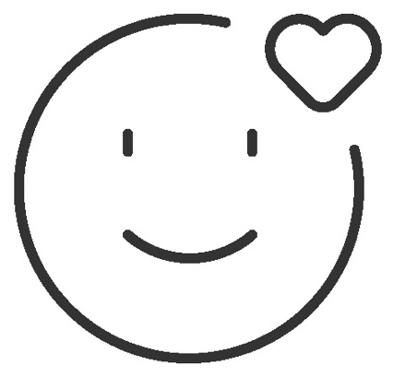

Safe

Keep all information in this training confidential. We suggest you don’t share personal numbers with the other members of group.

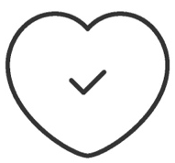

Positive & open

Please be respectful and
positive in your opinions and discussions. There are no right or wrong answers and we are not here to test you.

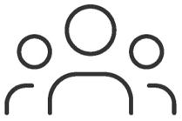

- shared
community

There are people with different backgrounds, knowledge and opinions. This is our shared space, so respect and support everyone.

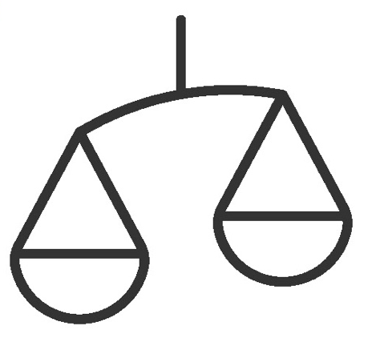

Fair

We will work in small groups and we will provide you with shared phones. We would like to give everyone an equal chance to be heard and to take turns using a phone.

Definitions

Trainers can add to this section to include local relevant information on mobile internet
3G / 4G / 5G | The internet can run at different speeds when you use it. 3G internet is the slowest, 4G internet is faster and 5G internet is the fastest.
App | An app gives you a shortcut to a service on your phone. For internet services e.g. WhatsApp, Facebook, Google, apps provide a quick and easy way to get onto the internet to use that service.
Address bar | The address bar shows you what website you are on.  In the address bar there will always be the address of the website e.g. www.google.com
Advert  or Ad | An ad is a piece of information that is trying to sell you something. It is good practice to avoid clicking on ads.  - Ads can be videos or images that pop up on your screen.  - Ads can also be the links at the top of Google results and on the right side of the screen.
Browser |   A web browser, or simply “browser,” is an application used to access and view websites. Common web browsers include:
Data | Whenever you use the internet on your phone, you are using data. You can buy data from your mobile network provider, just like you do with phone credit.
Feature  Phone | A mobile phone that has the ability to access the internet and store and play music but lacks the advanced functionality of a smartphone.
 | Google is an internet service that makes it easy to find any information that you want to find on the internet.

Definitions

Internet | The Internet is a network of millions of computers around the world connected to each other with phone lines, satellites and cables. It gives you access to a huge range of information and services and it is growing all the time. The internet is for everybody. There are no restrictions on who can use it. You just need a computer, mobile phone or tablet and a data connection.
Link | A link connects you from one website to another. To go to the other website, you can touch the link and this will connect you and take you to that other website
Megabytes & Gigabytes | Megabytes (MB) and Gigabytes (GB) are units of data that you use when using the mobile internet. GB are 1000 times bigger than MB. If you download or stream a song, that will use approximately 5MB (1MB per minute).
Search | The search function helps you find what you are looking for. You type the words to what you are looking for into a search box and then you will see a list of links to potential answers.
Smartphone | A mobile phone that has the ability to access the internet, store and play music and videos, and run ‘apps’. These phones typically also have a touchscreen.
Website | Information on the internet is kept on different websites. There are lots of separate and different websites on the internet e.g. Google is a website, YouTube is a website.
 | WhatsApp is an internet service that makes it easy to connect and communicate with people that you know; family, friends and colleagues.
WiFi | A WiFi zone is an area where you do not have to use your own data to access the internet on your phone; you can connect to the internet for free. WiFi zones are available in some public places such as coffee shops and cafes.
 | YouTube is an internet service that makes it easy to find, watch and listen to videos on the internet (and only videos).

Trainers can add to this section to include local relevant information on mobile internet

Top tips to stay safe online

 | Remember that not everything you see online is real  Anyone can post anything online, so don’t believe everything you see. Even if it’s from someone you trust, it might not be true. Be careful before sharing information with others
 | Think twice before sending money to someone you meet online  Be careful with emails, messages or pop-ups you didn’t ask for, especially if they ask for money or contain strange links.
 | Keep your personal information private, including passwords  Avoid sharing personal details like your full name, home address or phone number unless absolutely necessary.
 | Don’t cause harm to others online  Be kind and respectful. Don’t bully, spread false information or harass anyone. Your actions online can affect people in real life.
 | Be aware of scams and fraudsters  Just like in real life, thieves and criminals are on the internet too.  Some people online pretend to be someone else.
 | Take action by blocking or ignoring someone who is bothering you  If someone is bothering or harassing you online, ask for help and tell someone or report it.

Remember that the internet is open to everyone around the world and so it is essential to treat it like a real-life public place (e.g. a marketplace) and stay safe by protecting yourself and being responsible with what you do online.

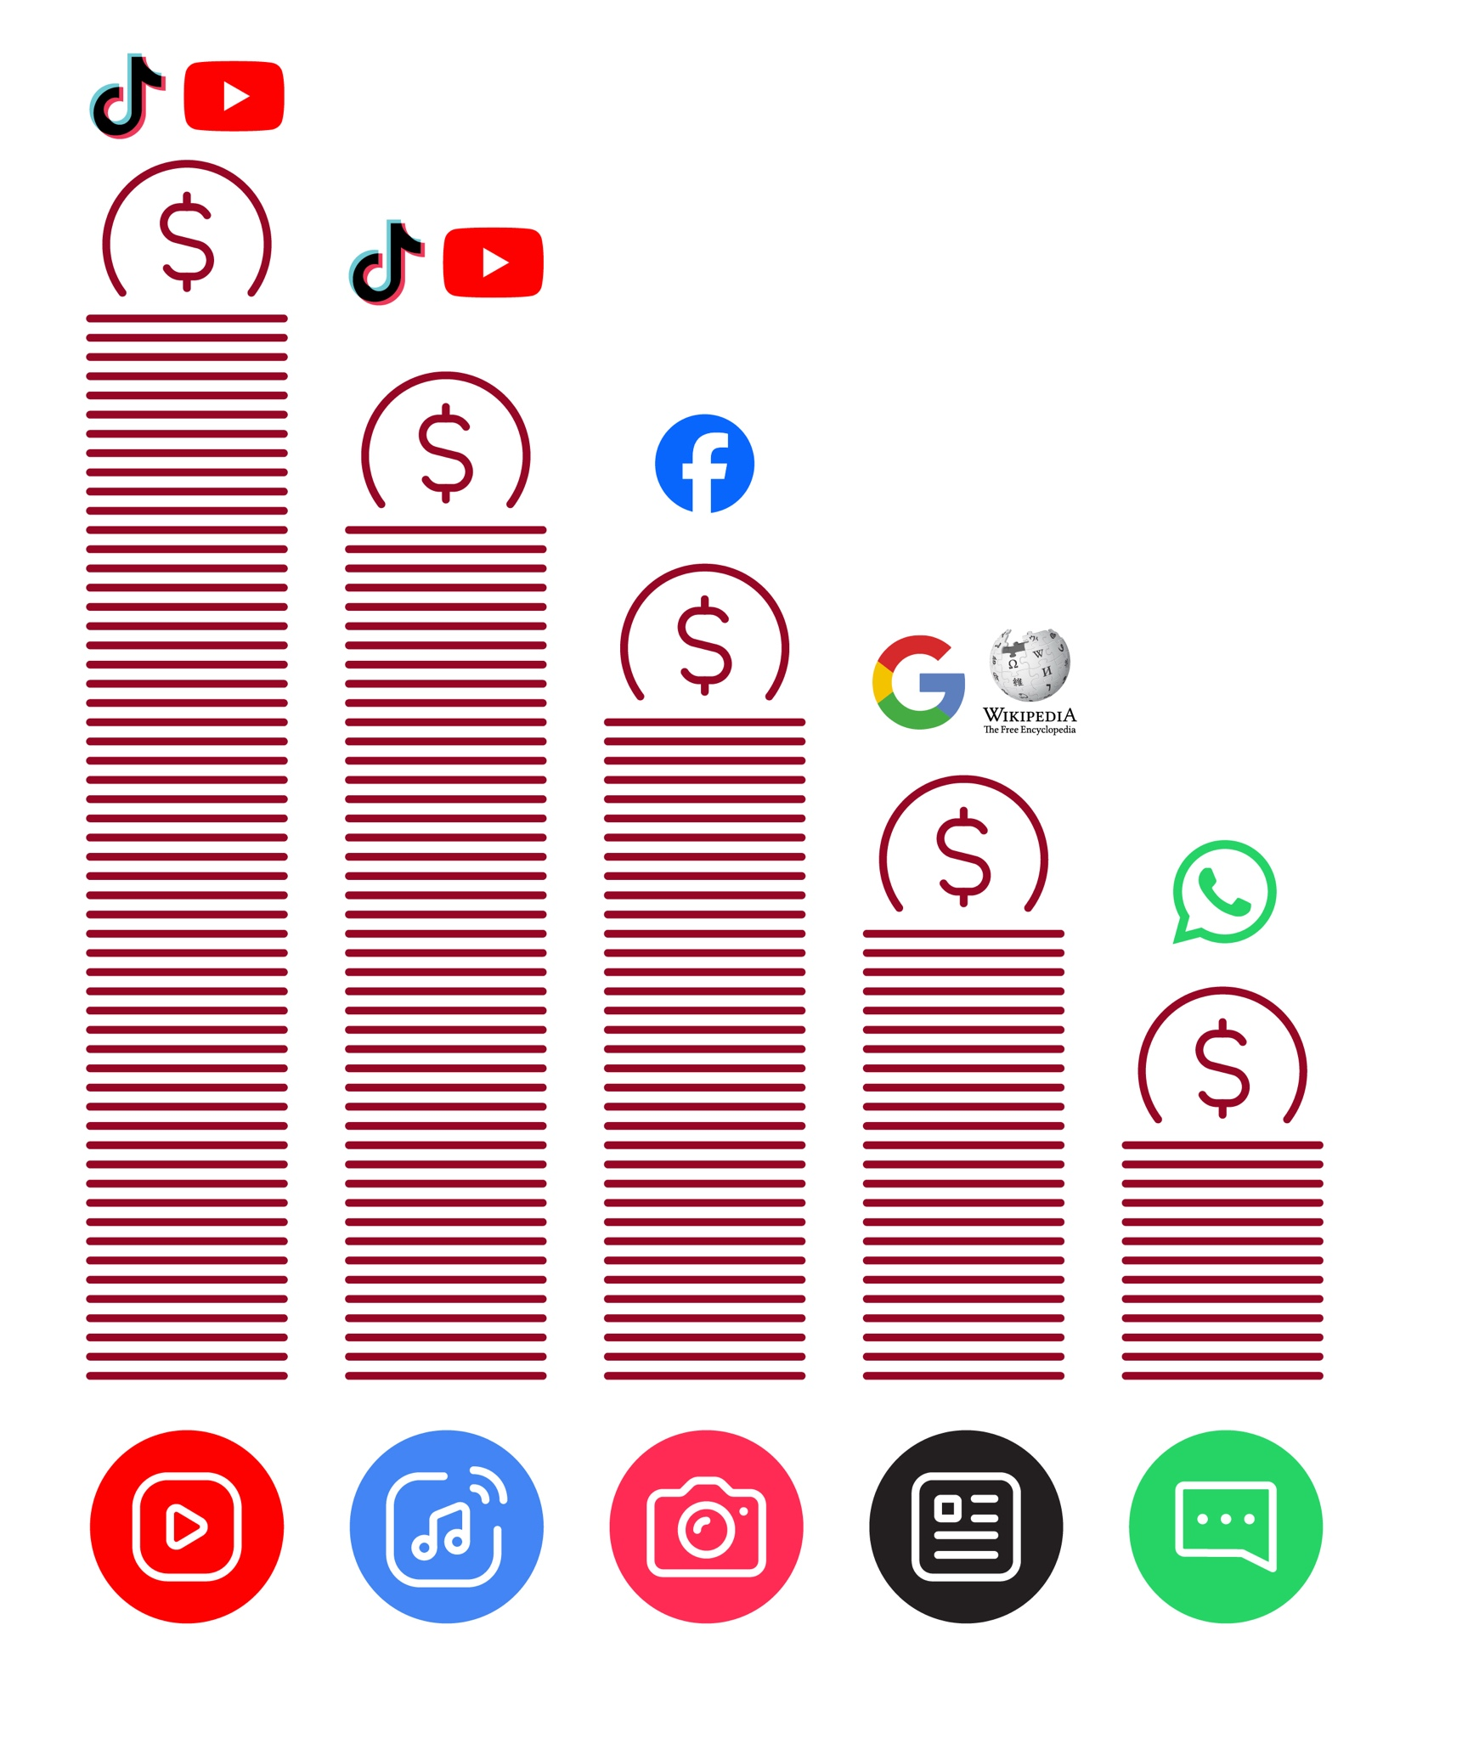
Data Cost

Healthy Internet Use

 | Set time limits  Think about how much time you are spending using the internet – it should not get in the way of your other responsibilities. If it does, set limits!
 | Watch your mood  If the internet or your phone is making you sad or angry, take a break!
 | Maintain healthy relationships online  Make time to socialise with friends and family in real life, not just on the internet! Don’t spend all your time on the internet.
 | Be careful  The internet can be dangerous with scams, harassment and things you don’t want to see. Be careful!
 | Stay positive  Stay positive and avoid upsetting or harming others. Be responsible and keep a positive attitude!
 | Get enough sleep and rest  Sleep and rest are important - make sure the internet or your phone doesn’t stop you doing this! Don’t use the internet when you need to rest or sleep.

Accessibility | Changing and correcting colours
Features | Changing and correcting colours


1 2 3 4 5
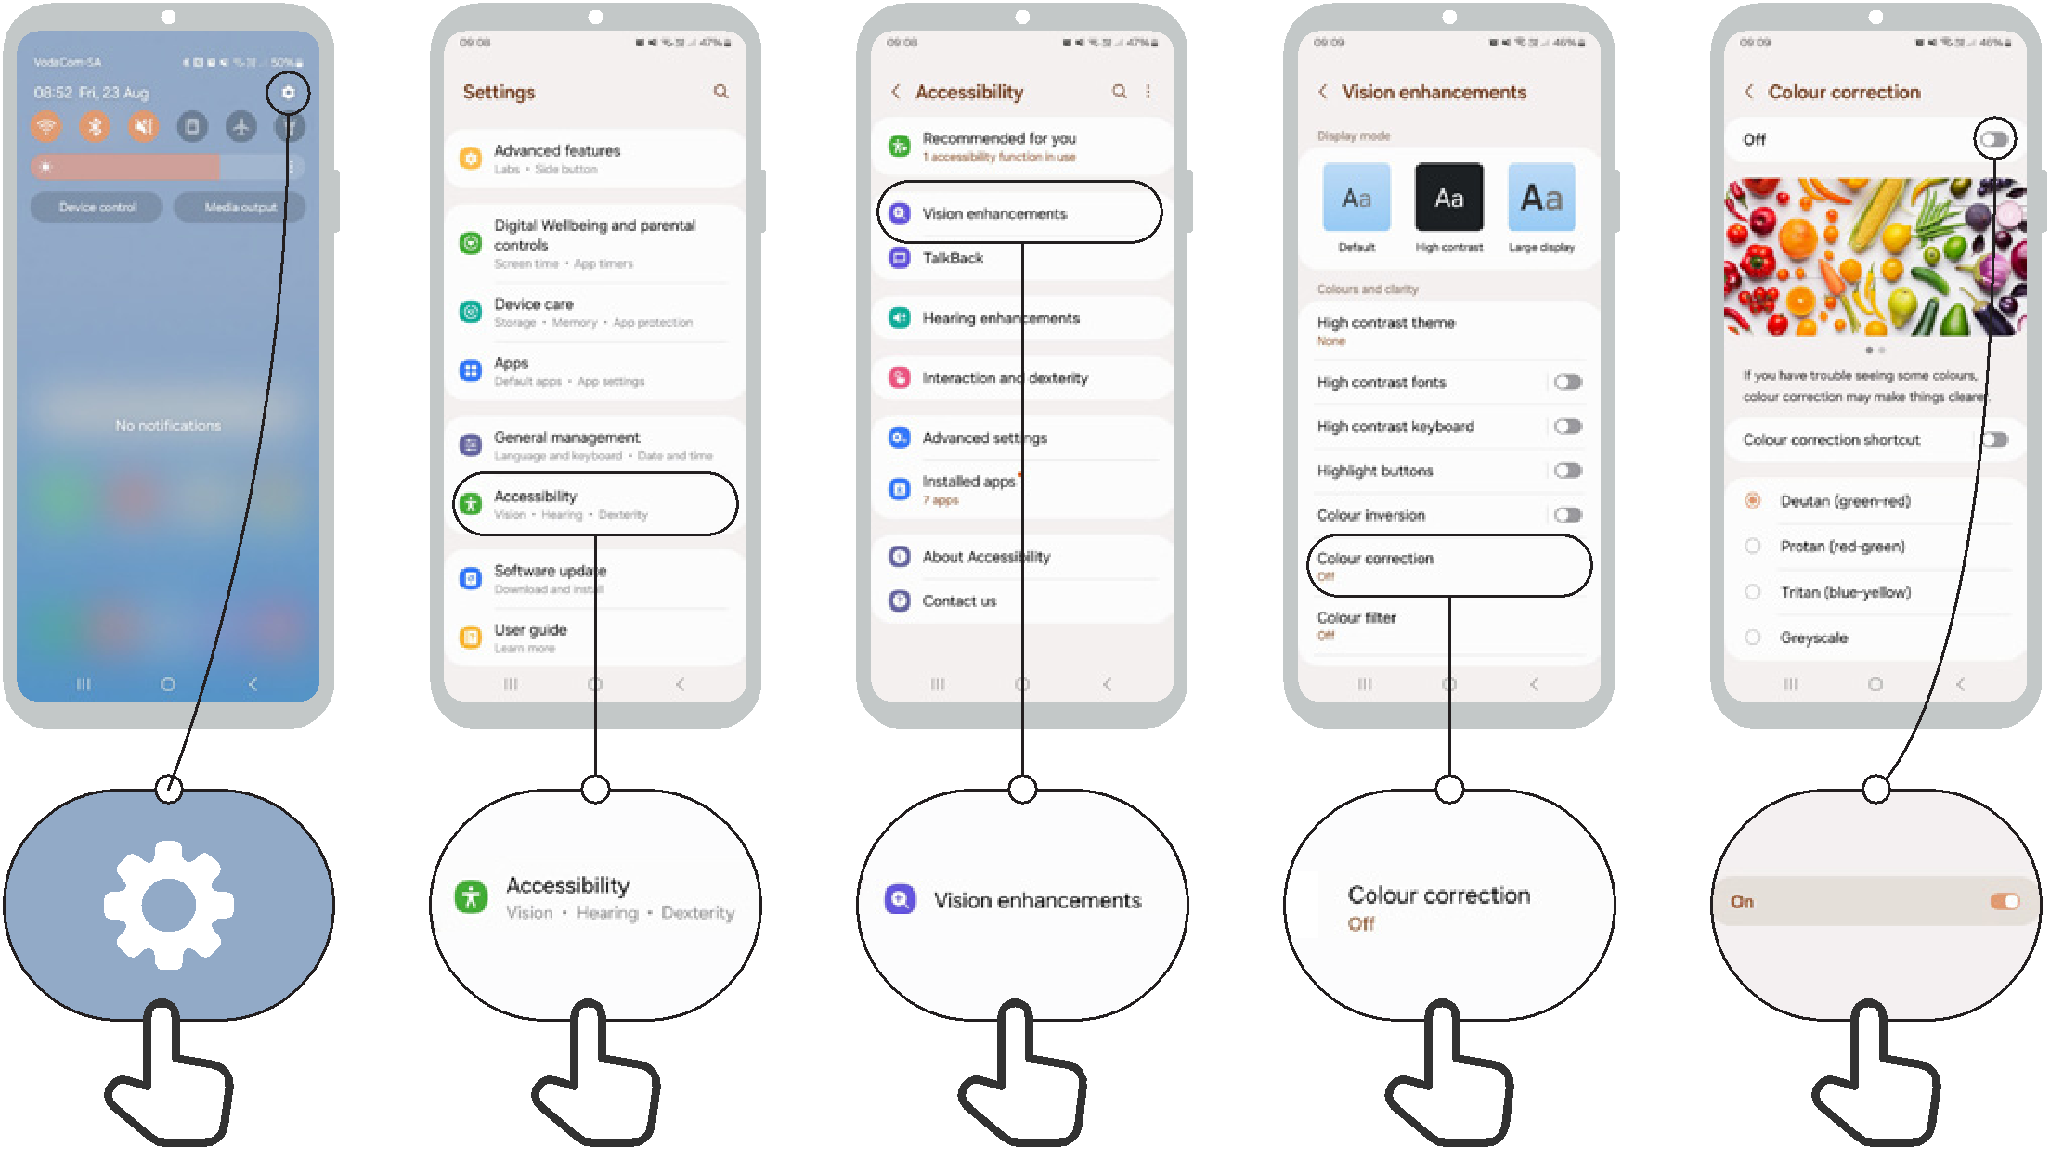

Changing font sizes
Accessibility
Features

1 2 3 4 5
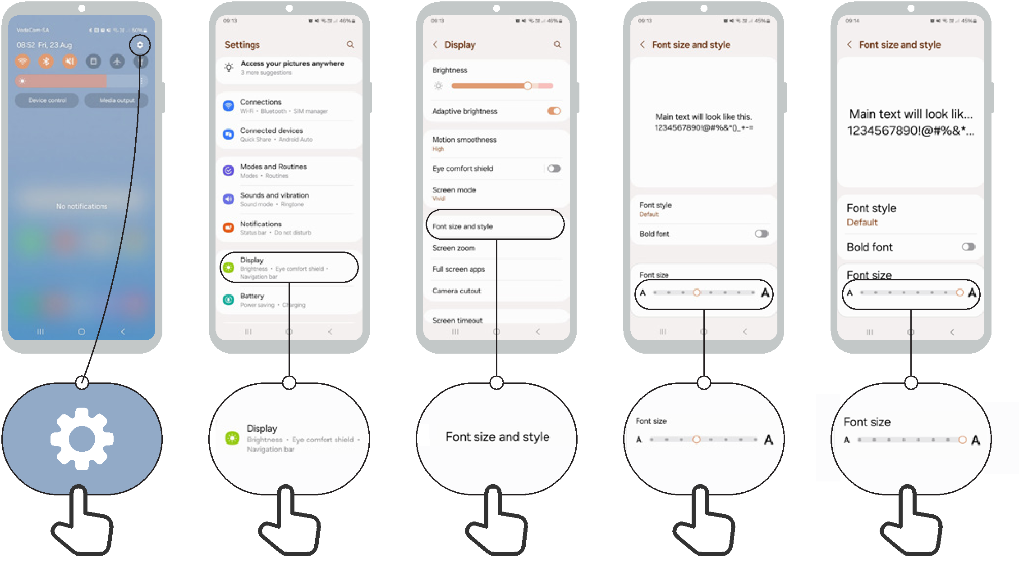

Changing display
Accessibility
Features

1 2 3 4 5

Accessibility
Features

Magnification for people with low vision
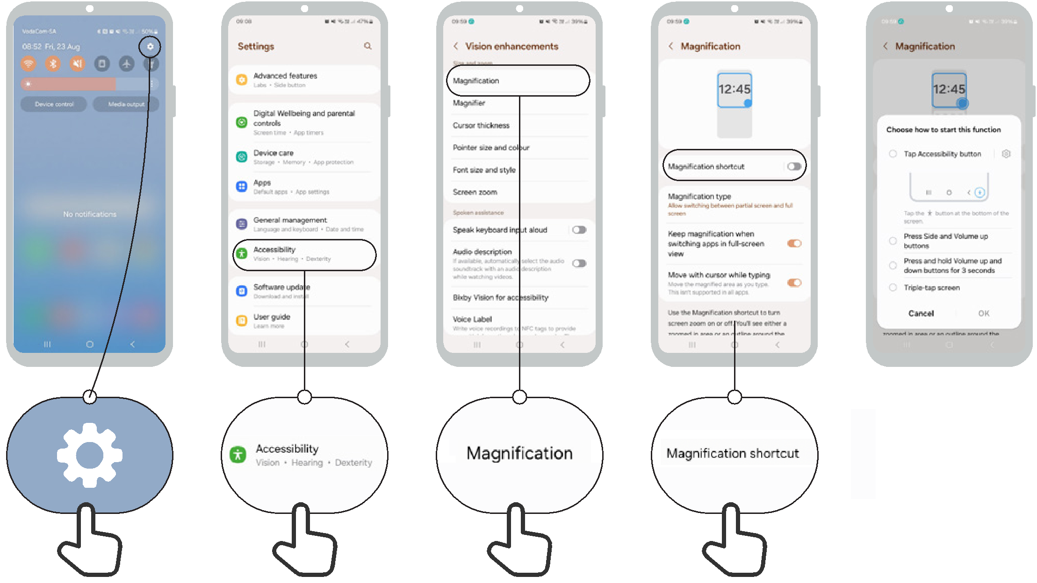
1 2 3 4 5

Temporary magnification
Accessibility
Features

1 2 3 4 5
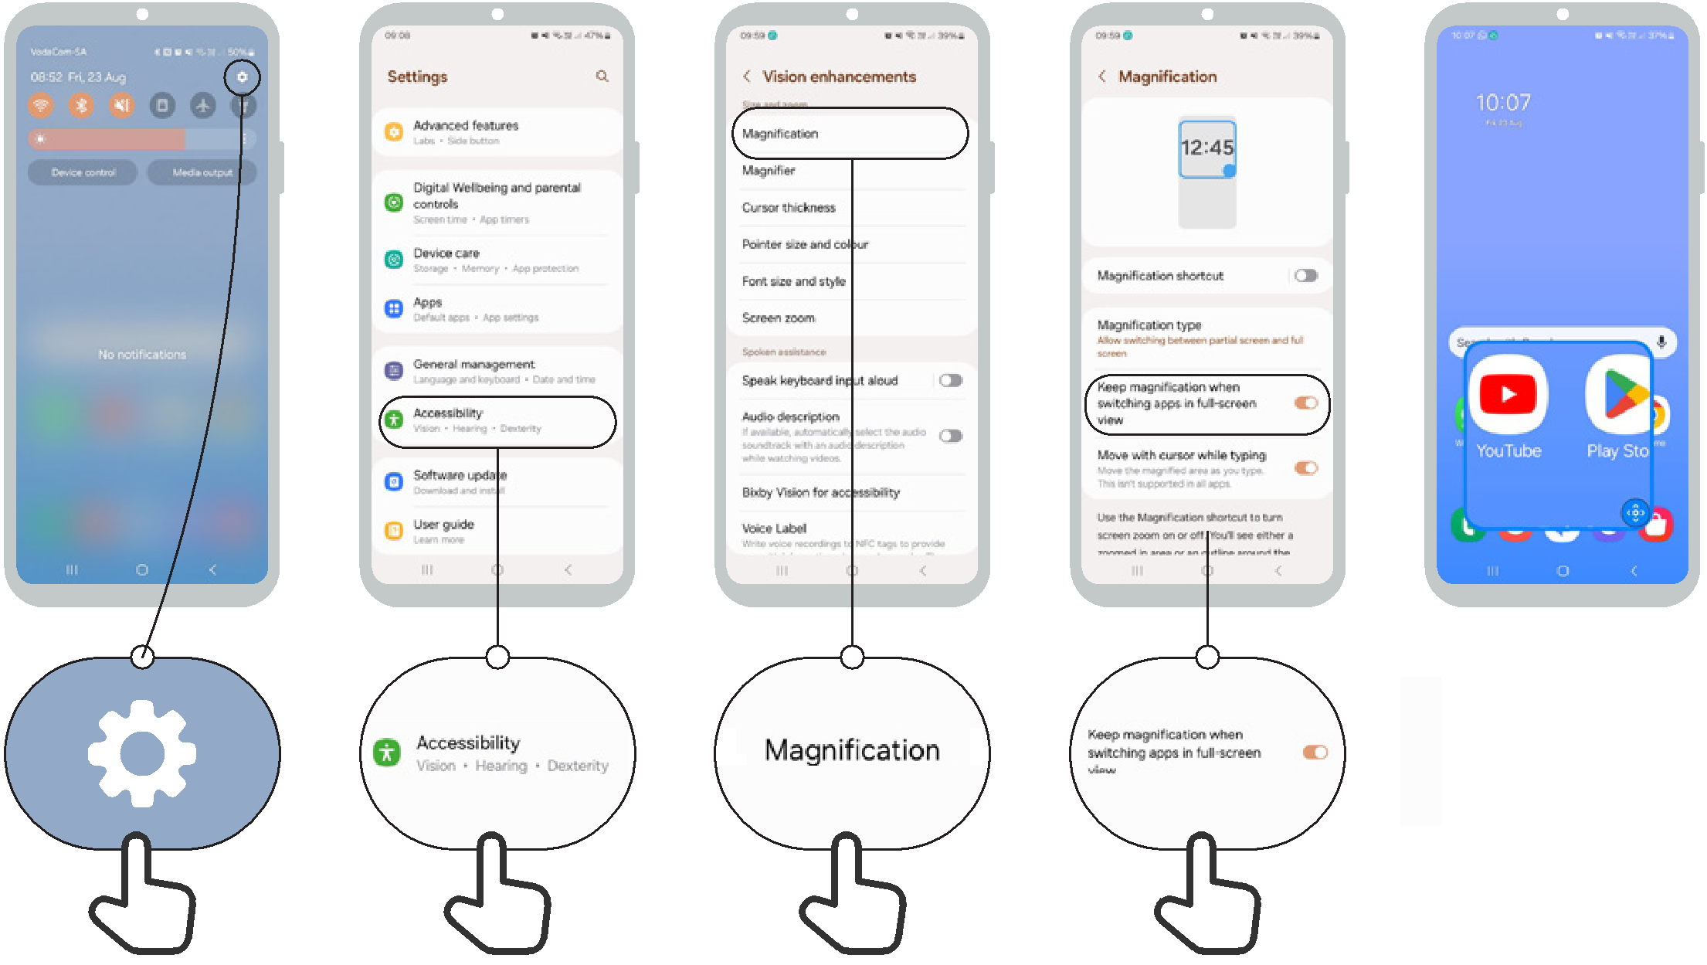

Set up TalkBack
Accessibility
Features

1 2 3 4 5 v
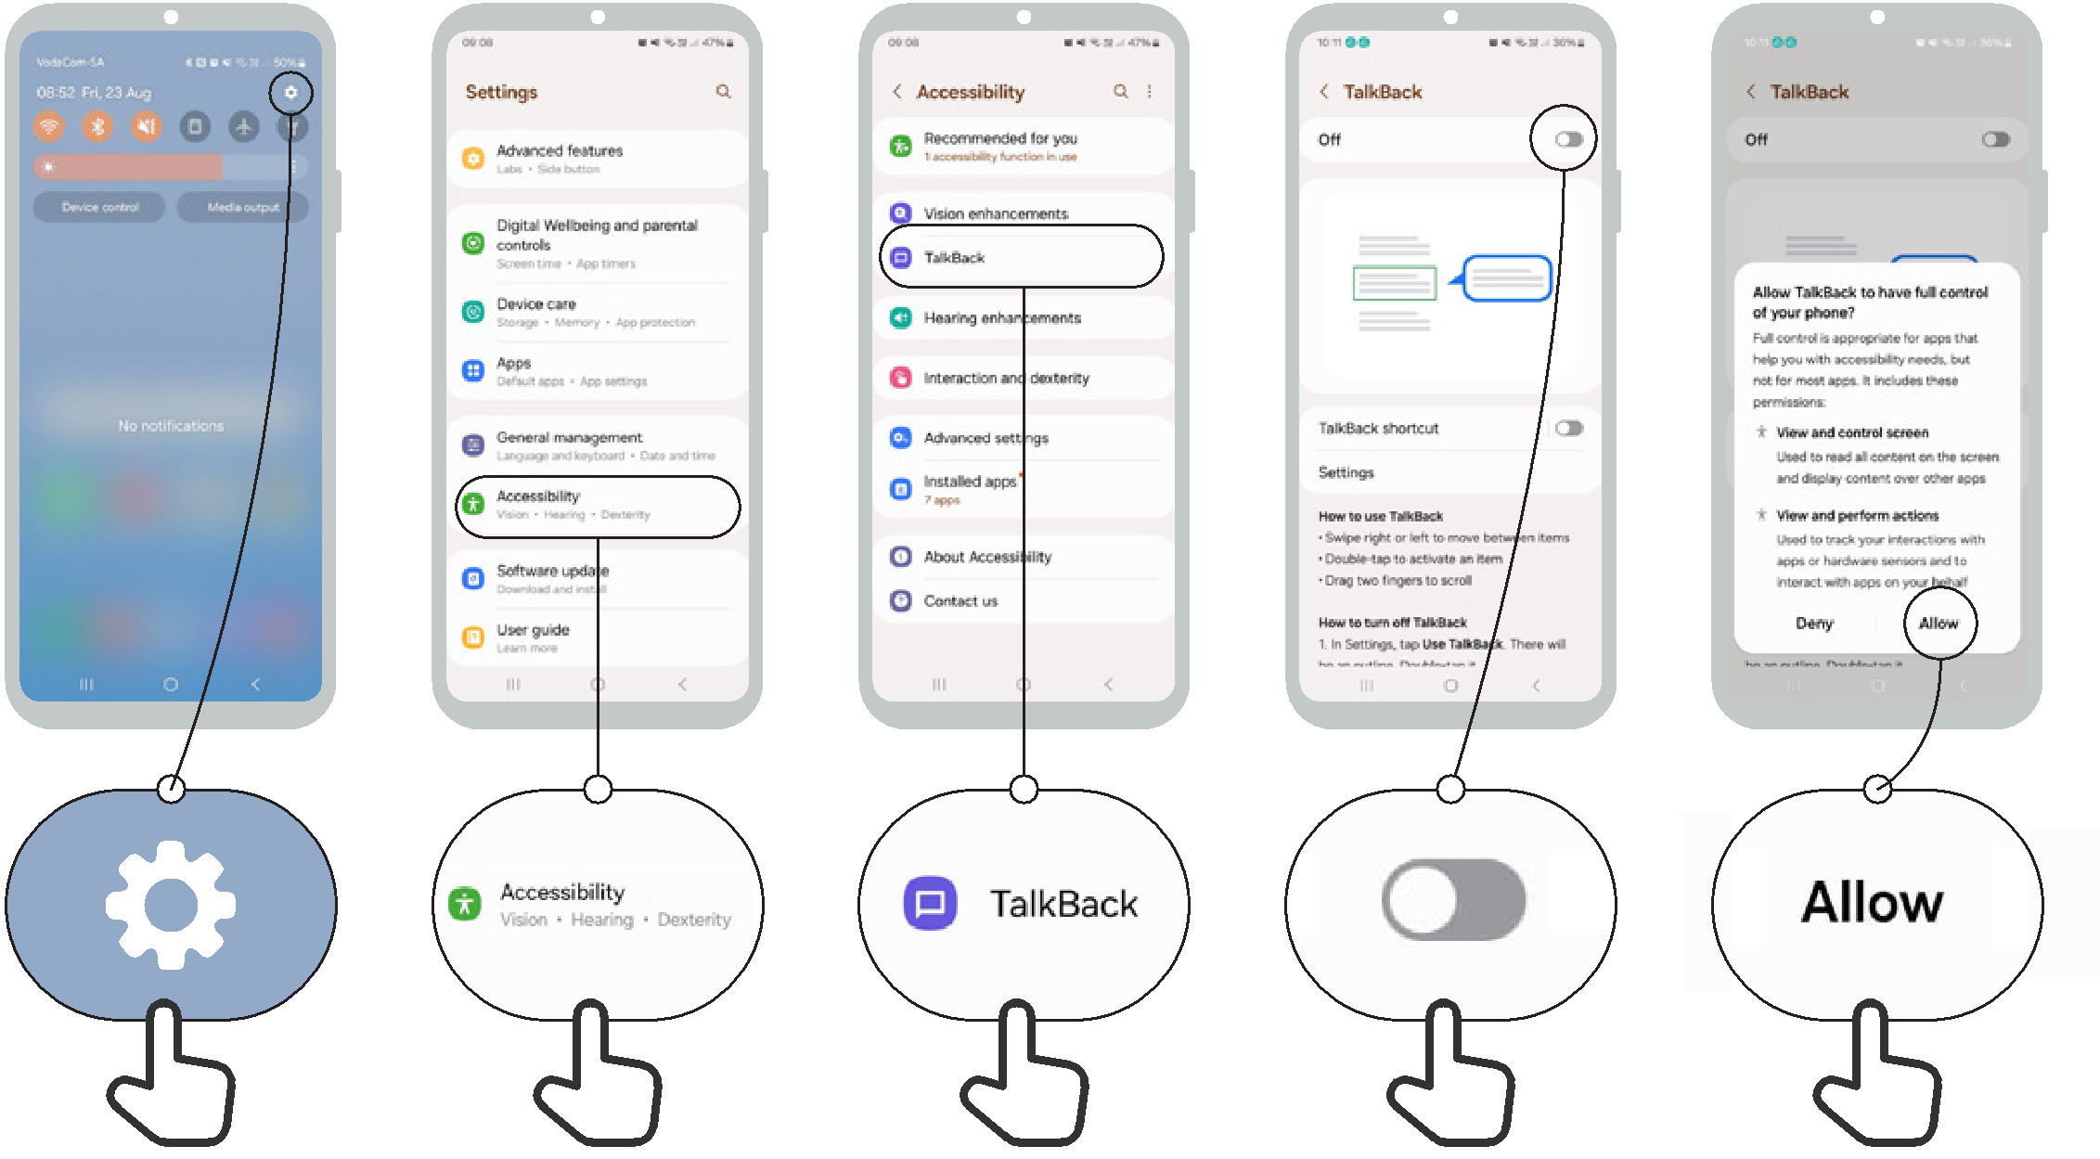

Sound enhancement
Accessibility
Features

1 2 3 4
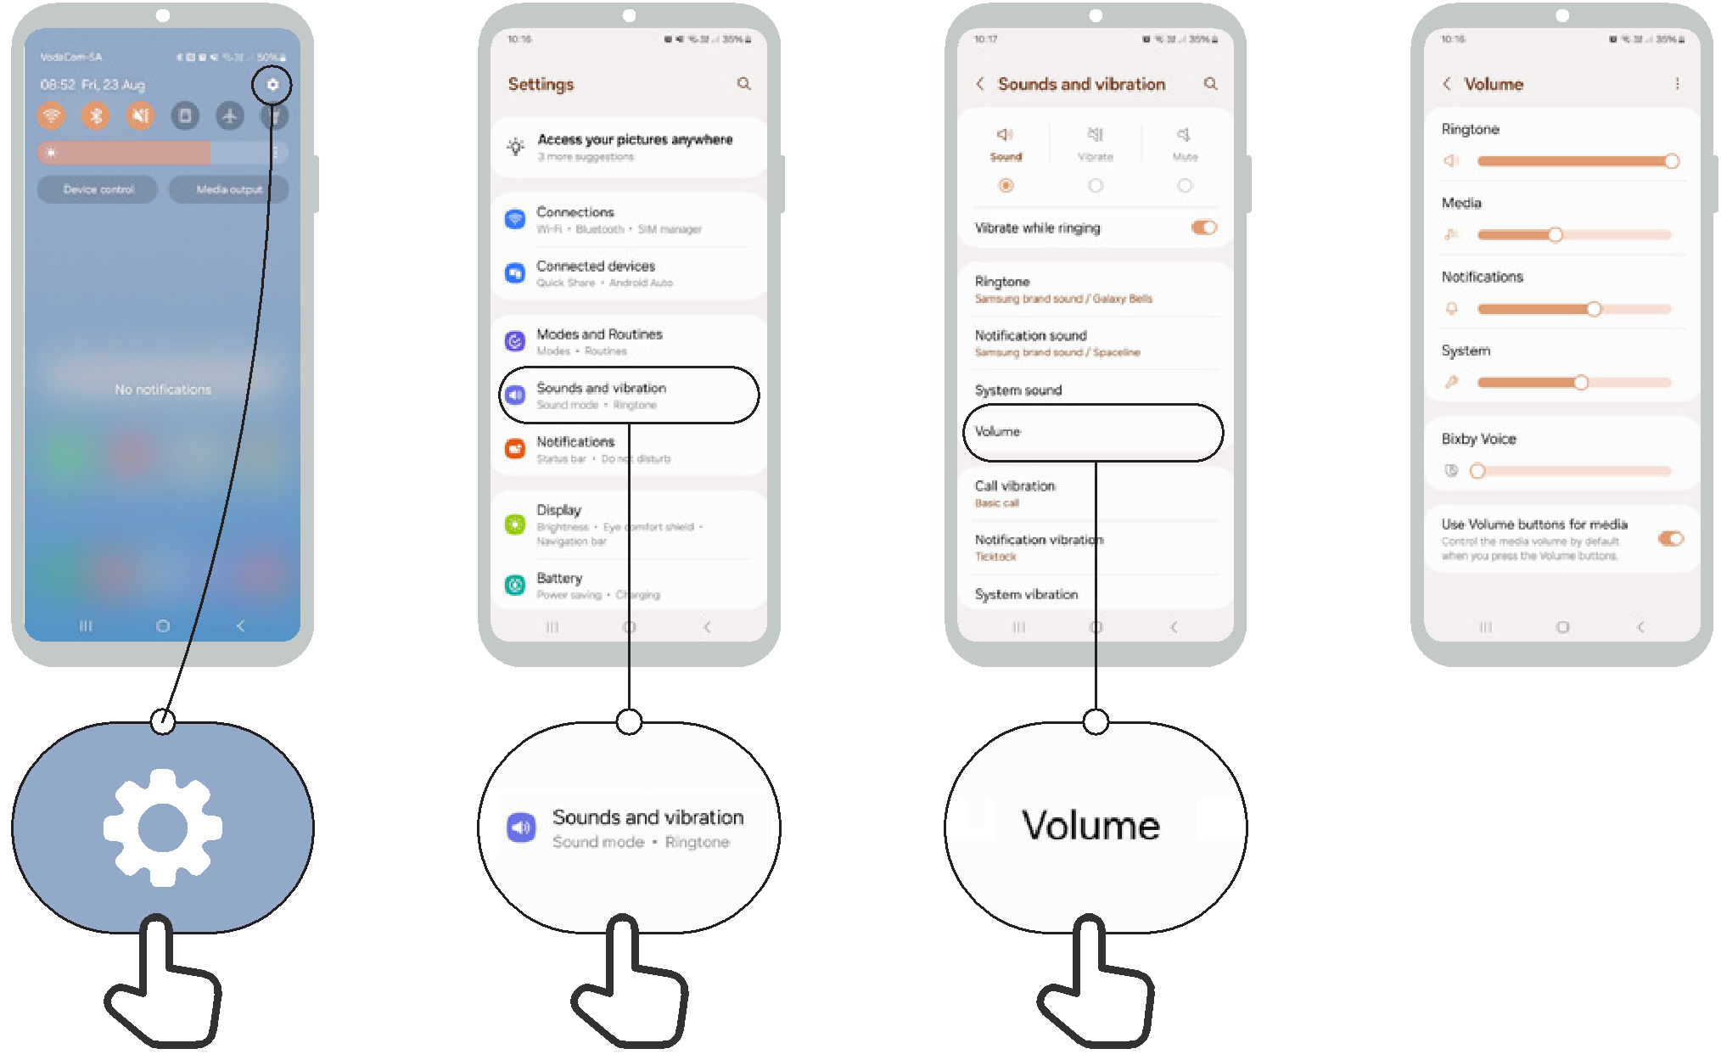

Sound amplification
Accessibility
Features

1 2 3 4
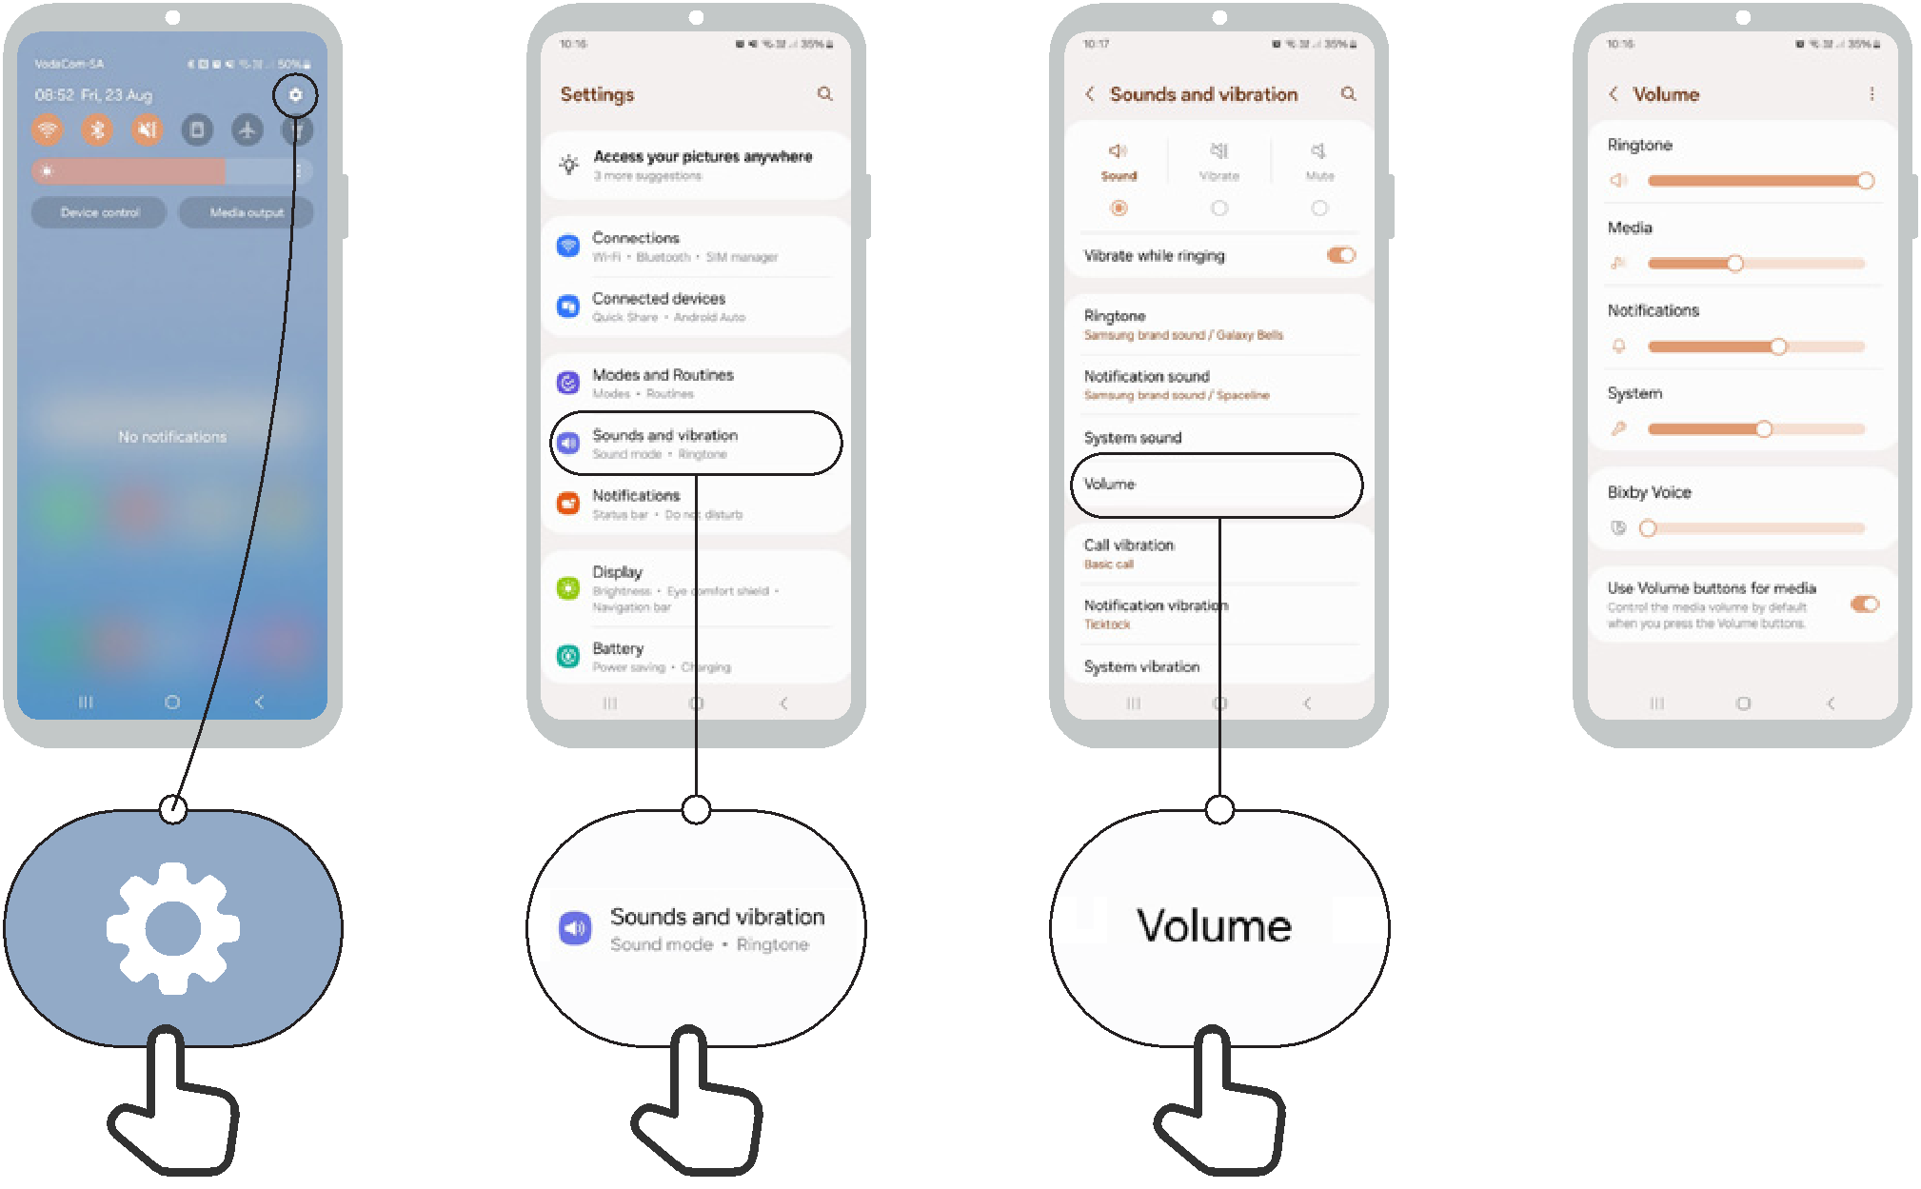

Set up captions


Accessibility
Features

1 2 3 4 5 6
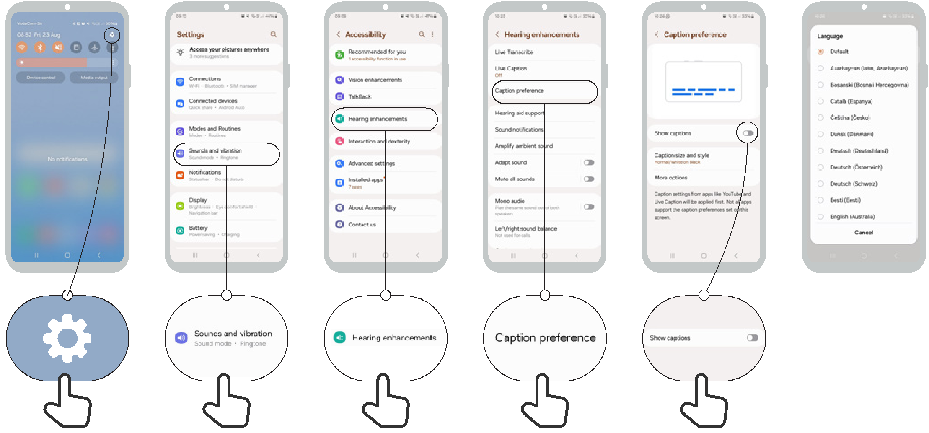

Accessibility | Set up live transcriptions
Features | Set up live transcriptions

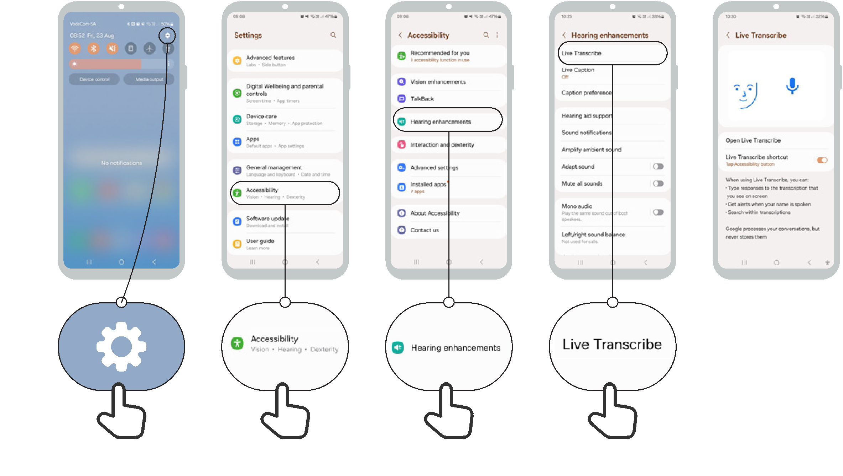
1 2 3 4 5


Mobile Internet Skills Training Toolkit

‘Thank you’ and close training

After you have completed the training, congratulate your trainees and hand out certificates as a reward.

Thank the trainees

Give out the handouts

- Give your trainees the handouts for the training if you haven’t already done so.

- These include the ‘Definitions’, ‘Top tips to stay safe online’, ‘Data costs’, ‘Healthy internet use’ and relevant module posters.

- Ask: “Do you feel confident to use these accessibility features?” or “Do you feel confident to use your mobile phone?”

- Thank your trainees for their time, input and participation in the training.

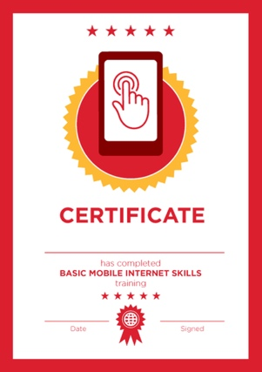

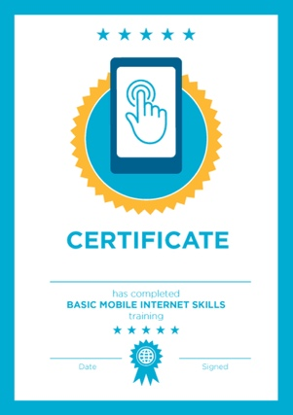

Conduct a closing ceremony

- Give each trainee a signed certificate (certificate templates are included in the toolkit).

- You can also provide the trainers with certificates for having completed the training ‘as trainers’.

Tip: You can make this more of a ceremony for trainees, by asking them to come up to the front of the room one person at a time to receive their certificate and shake the trainer’s hand.

here
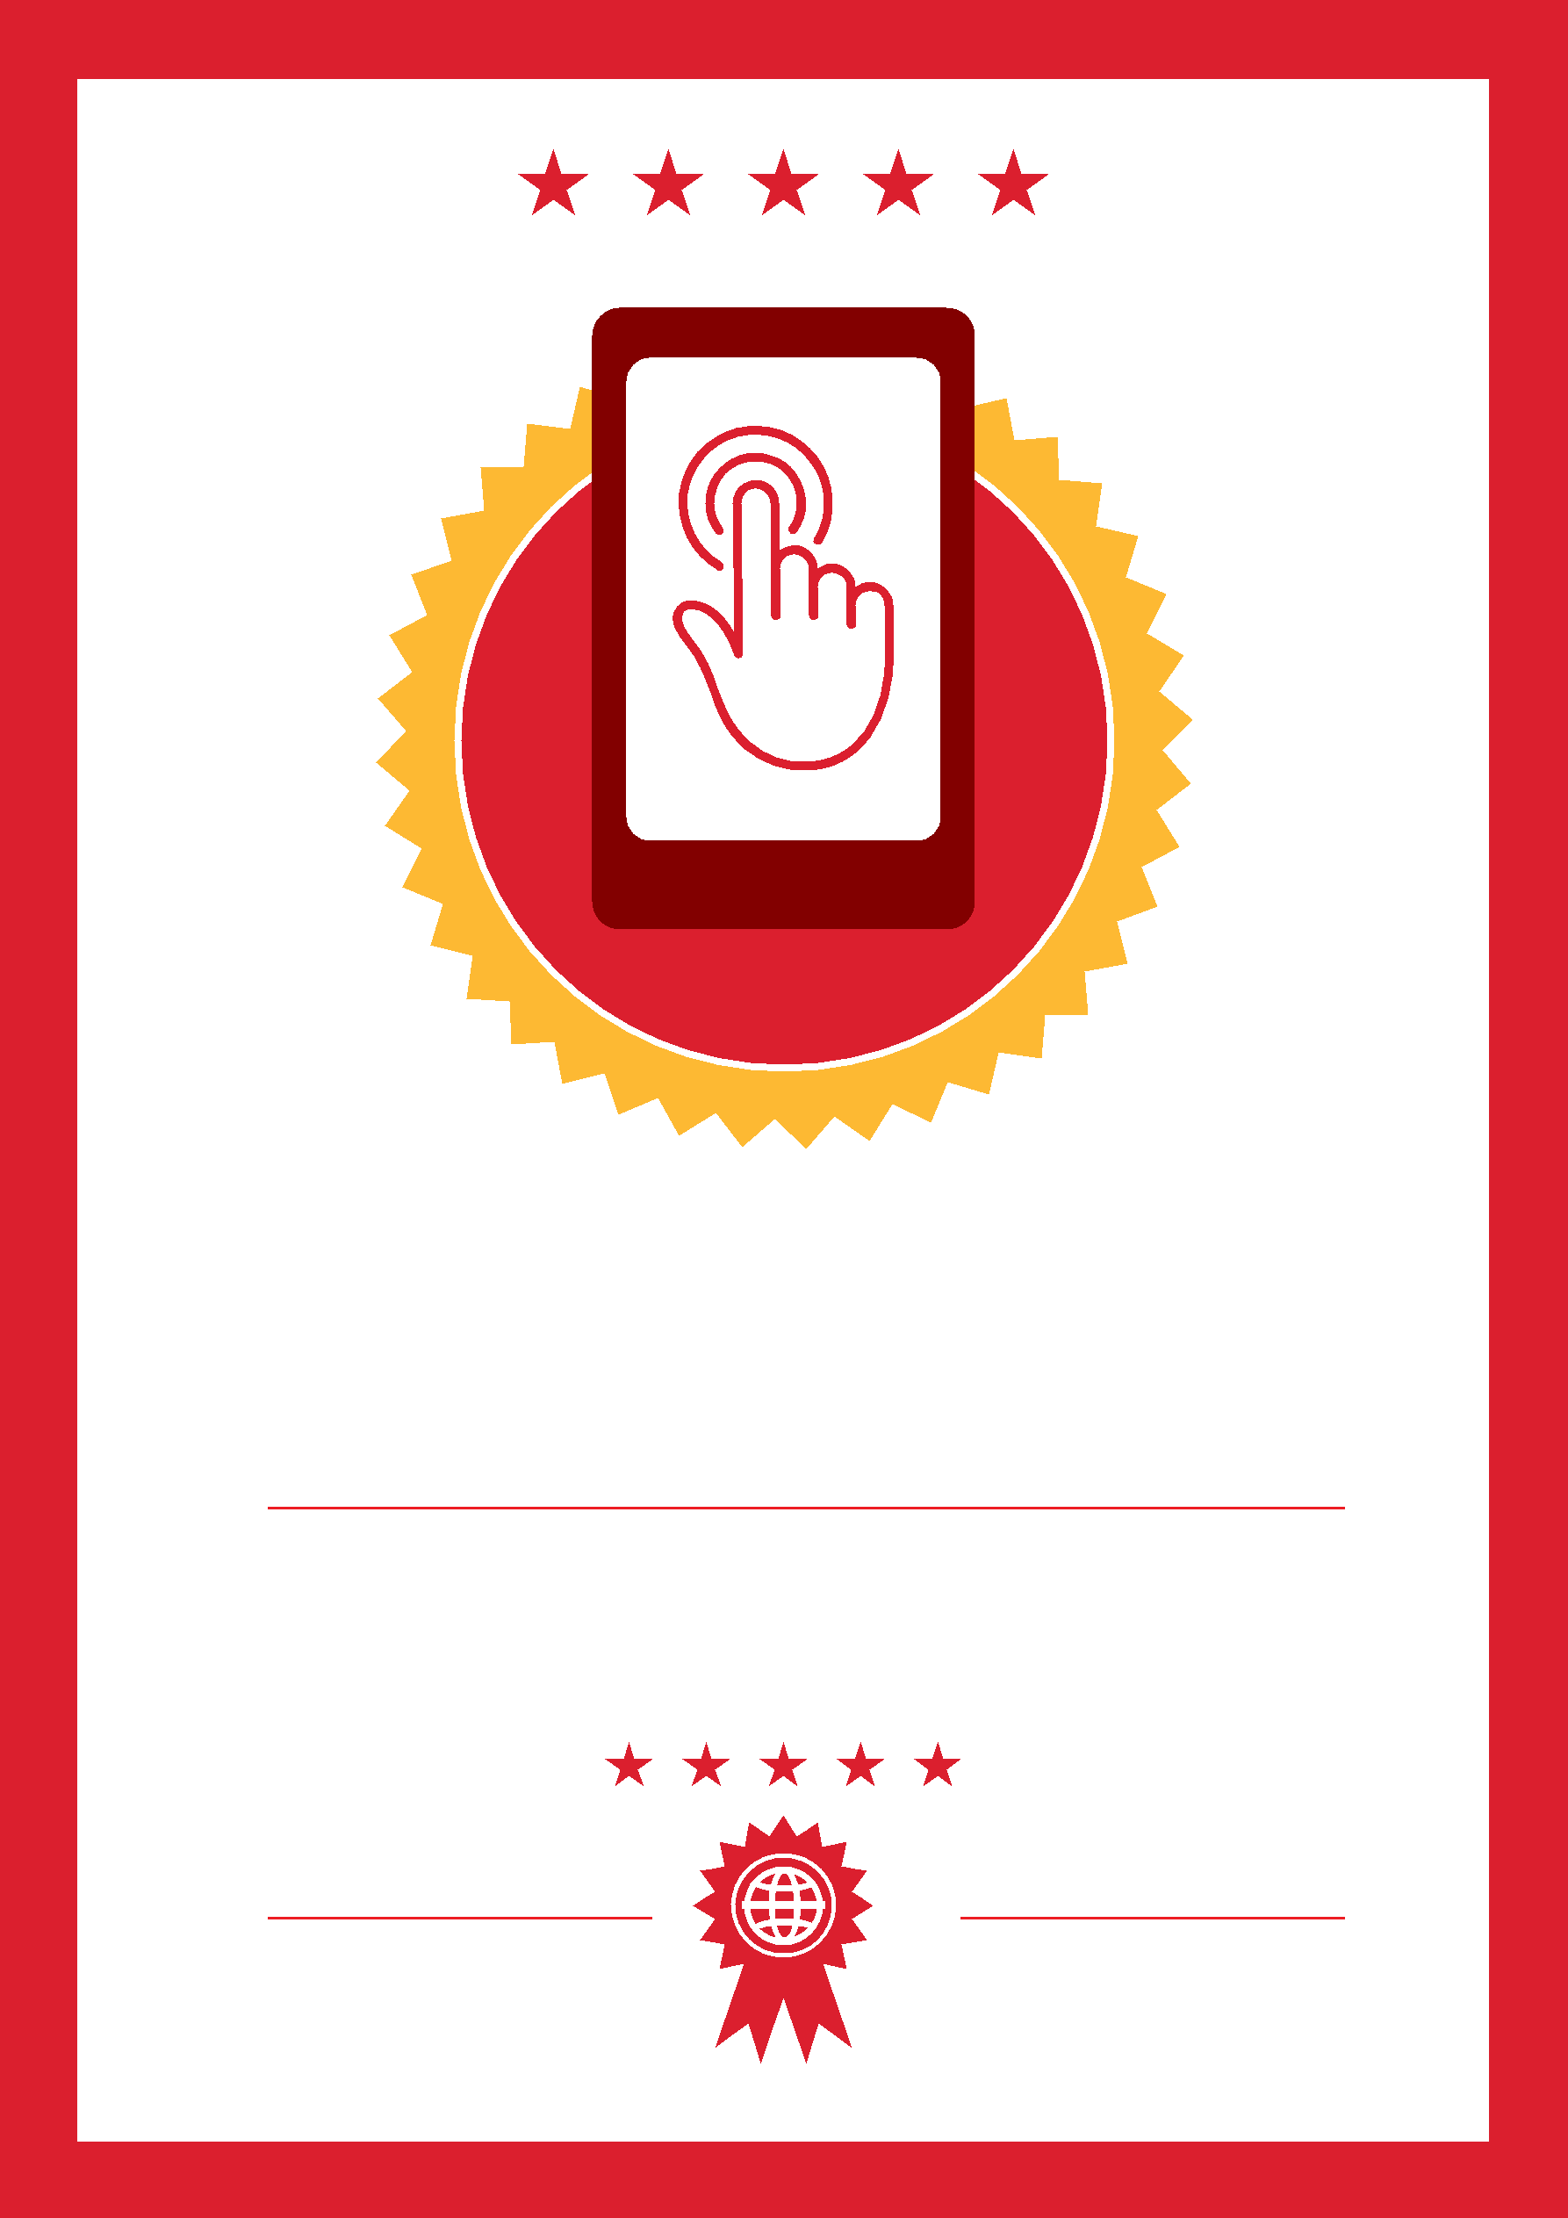

CERTIFICATE

has completed

BASIC MOBILE INTERNET SKILLS

training

Date Signed

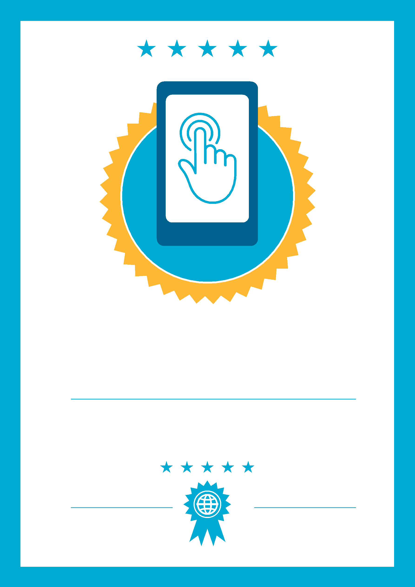

CERTIFICATE

has completed

BASIC MOBILE INTERNET SKILLS
training

Signed
Date

