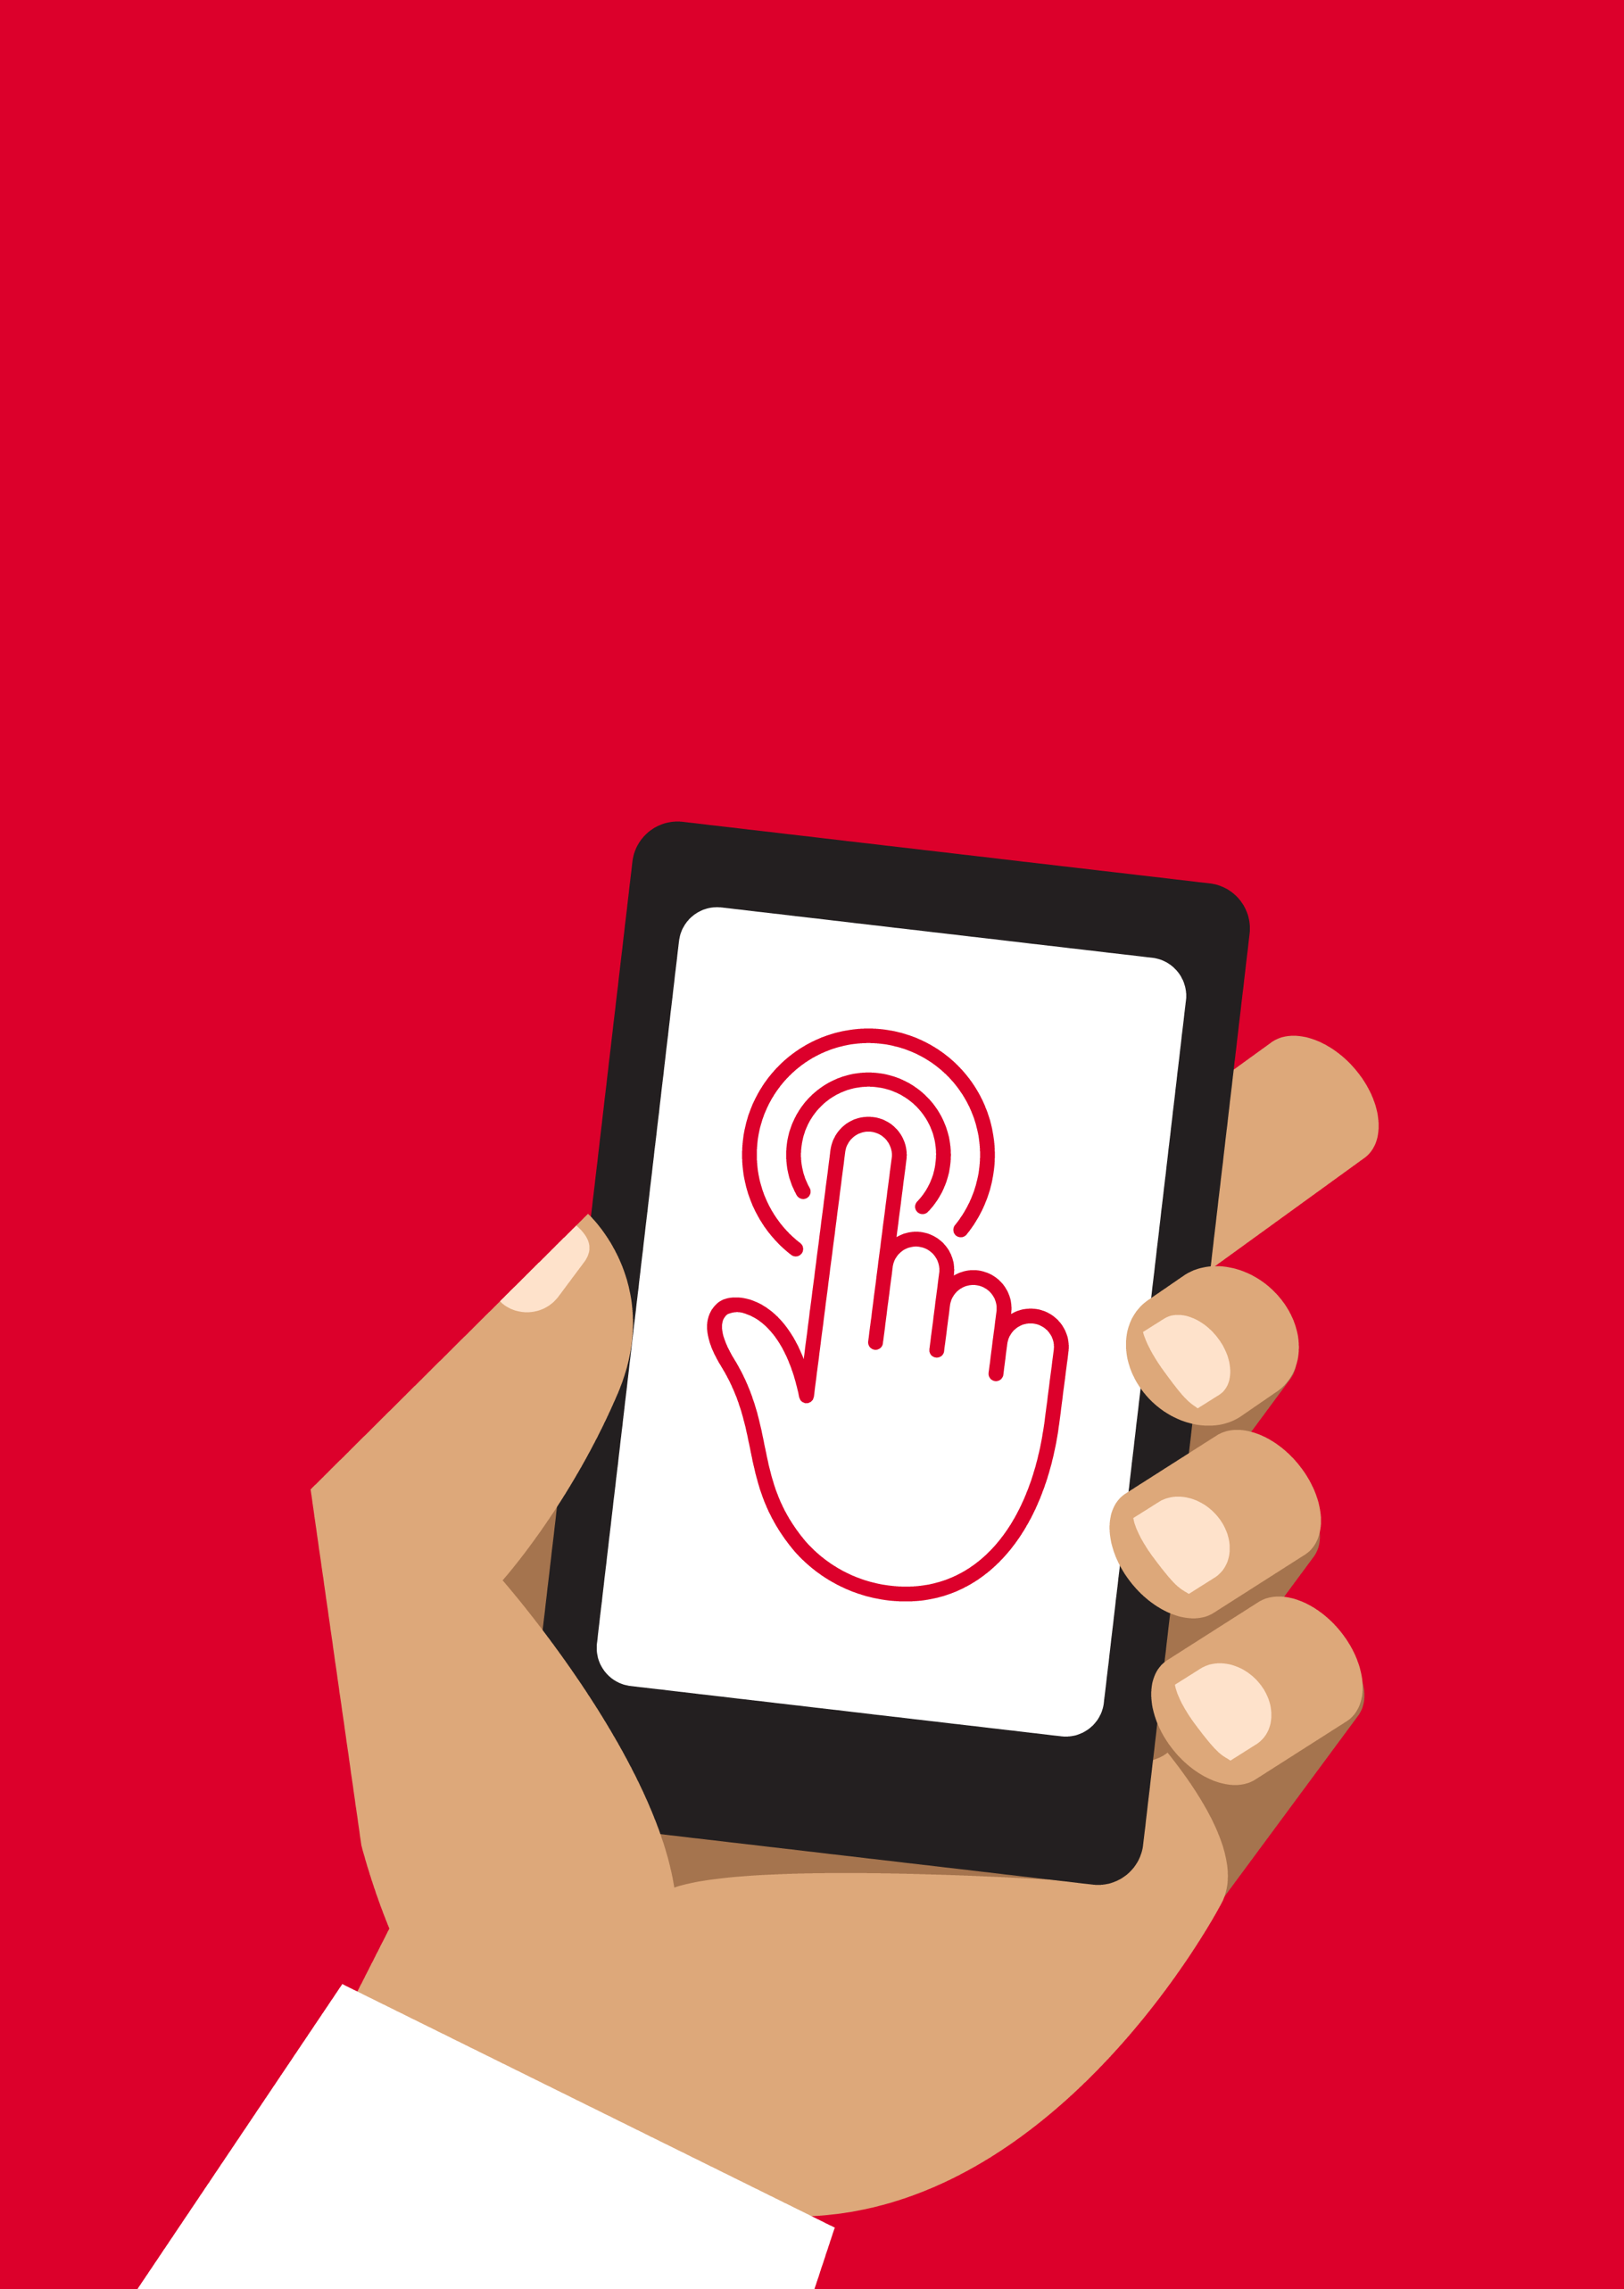

Mobile Internet
Skills Training
Toolkit
A guide for training people in
basic mobile internet skills
Copyright © 2024 GSM Association
Copyright © 2024 GSM Association
Bitesize Training
Android

Mobile Internet
Skills Training

Toolkit

A guide for training people

in basic mobile internet skills
Module 8:
Android

What is it?
 | “A smartphone is a mobile phone, but it also connects you to mobile internet which can help you in many different ways. You control most smartphones by touching and moving your finger on the screen. They can take photos, play music and videos and have apps that can help you enjoy the best of the internet and do more with your phone.  Android-enabled devices are the most popular smartphones across the world. Your Android-enabled phone quickly gives you access to the internet so you can use it to search for information you need on Google, watch videos on YouTube and share photos.”
What can you use it for?
Explain: “An Android smartphone can help you access the internet. This means you can search for the latest news and information, take good quality pictures or videos and share them with friends or family or post them on social media. Use the internet to enjoy your favourite music, TV shows and sport. Search for information on health and home maintenance, recipes, business or farming tips or learn a new skill like how to repair your bicycle. A smartphone can even help you find the best route to your next destination with Google Maps or find the location of a restaurant or business in your area.”
Materials you will need:

- Android smartphone
- Android posters

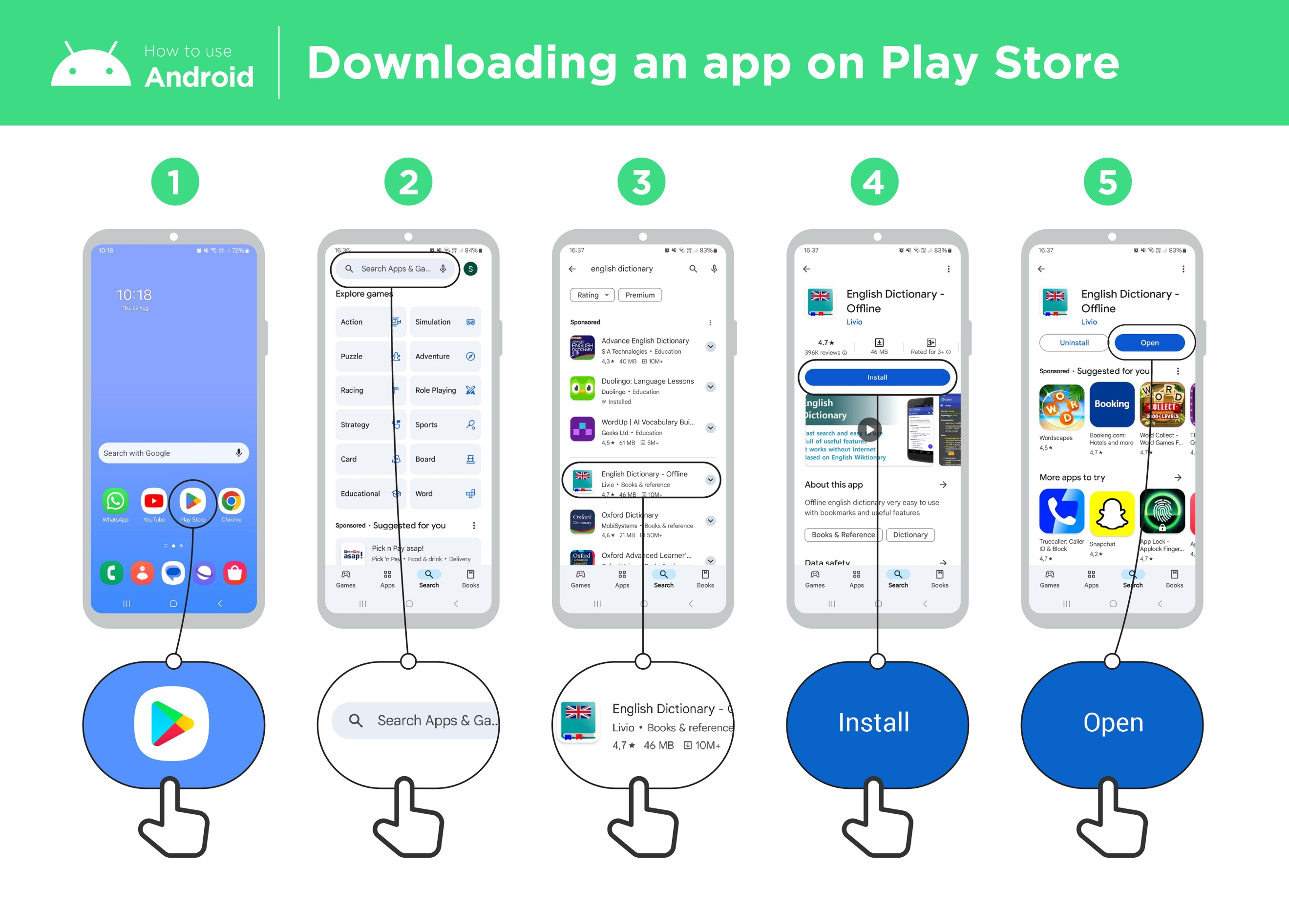

What can you use it for?
Make it relevant to the trainee by discussing how it can be beneficial in the trainee’s own life. Consider examples that will be relevant to the following types of trainees:

Older person: Search for a local business with Google Maps or find health information by searching Google. Learn new things and stay entertained by watching videos on YouTube.

Mother or homemaker: Find a local doctor or business on Google Maps; use YouTube to learn how to cook a new recipe or mend clothing.

Business owner: Use your Android phone to communicate with customers or suppliers; promote or sell your products or services through social media; learn and discover new things for your business on YouTube.

Farmer or rural person: Get access to market prices and marketplaces, weather forecasts and information on farming best practice using the internet.

Young person: Search for businesses or event locations with Google Maps; watch videos on sports, music or film trailers on YouTube.

How does it work?
Put the phone in the trainee’s hands and help them follow the steps.
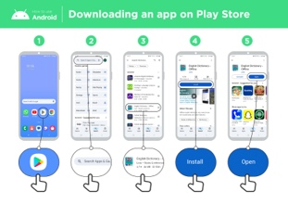
Show the ‘Downloading an app in Play Store’ poster.

Demonstrate how the trainee can download an app using the Play Store.

Practice!
“Now that you can download apps from the Play Store, what kind of apps are you interested in?”

Demonstrate: Help your trainee download an app from the Play Store. Then help them use it. If they are unsure what kind of app they are interested in, give them some prompts (e.g. sport, weather, language learning, music).
Safety
“Remember smartphones are valuable, and thieves may wish to steal your device. Keep your device safe and do not show it off or let strangers use your smartphone.”
“Remember that while there is a lot of helpful information and services on the internet, you must be careful about interacting with strangers online or sharing personal information like your bank PIN or passwords.”
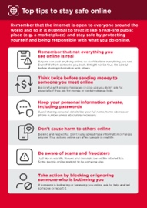

Show the ‘Top tips to stay
safe online’ poster.
Tip: “Once you have an app on your phone, it will stay there until you delete it. You don’t need to keep going to the Play Store to get it.”

Bitesize Training
Android

Mobile Internet
Skills Training

Toolkit

A guide for training people

in basic mobile internet skills
Posters and Cut-Outs

Top tips to stay safe online

 | Remember that not everything you see online is real  Anyone can post anything online, so don’t believe everything you see. Even if it’s from someone you trust, it might not be true. Be careful before sharing information with others
 | Think twice before sending money to someone you meet online  Be careful with emails, messages or pop-ups you didn’t ask for, especially if they ask for money or contain strange links.
 | Keep your personal information private, including passwords  Avoid sharing personal details like your full name, home address or phone number unless absolutely necessary.
 | Don’t cause harm to others online  Be kind and respectful. Don’t bully, spread false information or harass anyone. Your actions online can affect people in real life.
 | Be aware of scams and fraudsters  Just like in real life, thieves and criminals are on the internet too.  Some people online pretend to be someone else.
 | Take action by blocking or ignoring someone who is bothering you  If someone is bothering or harassing you online, ask for help and tell someone or report it.

Remember that the internet is open to everyone around the world and so it is essential to treat it like a real-life public place (e.g. a marketplace) and stay safe by protecting yourself and being responsible with what you do online.

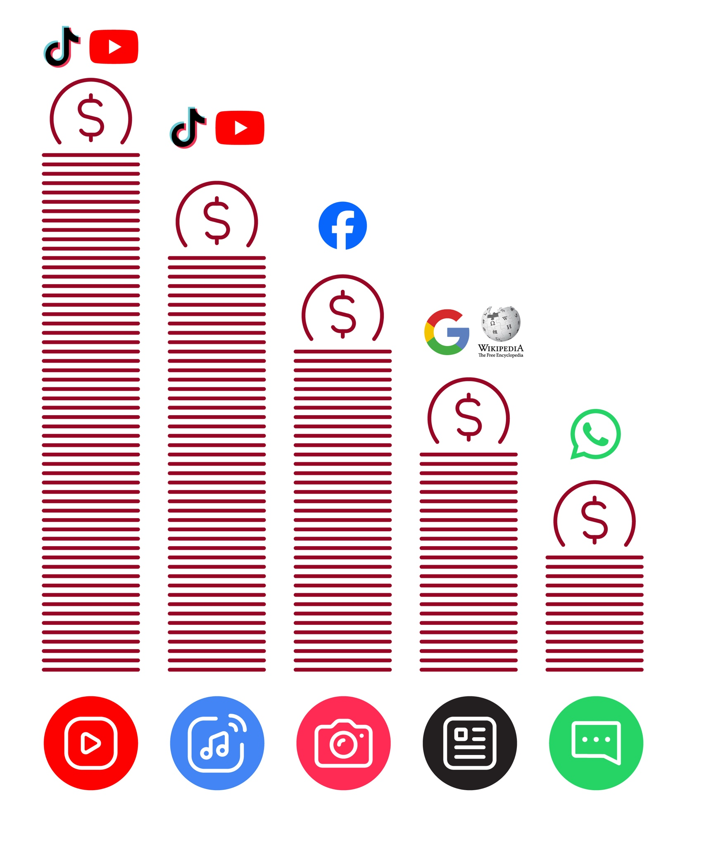
Data Costs
Downloading an app on Play Store
How to use
Android




1 2 3 4 5
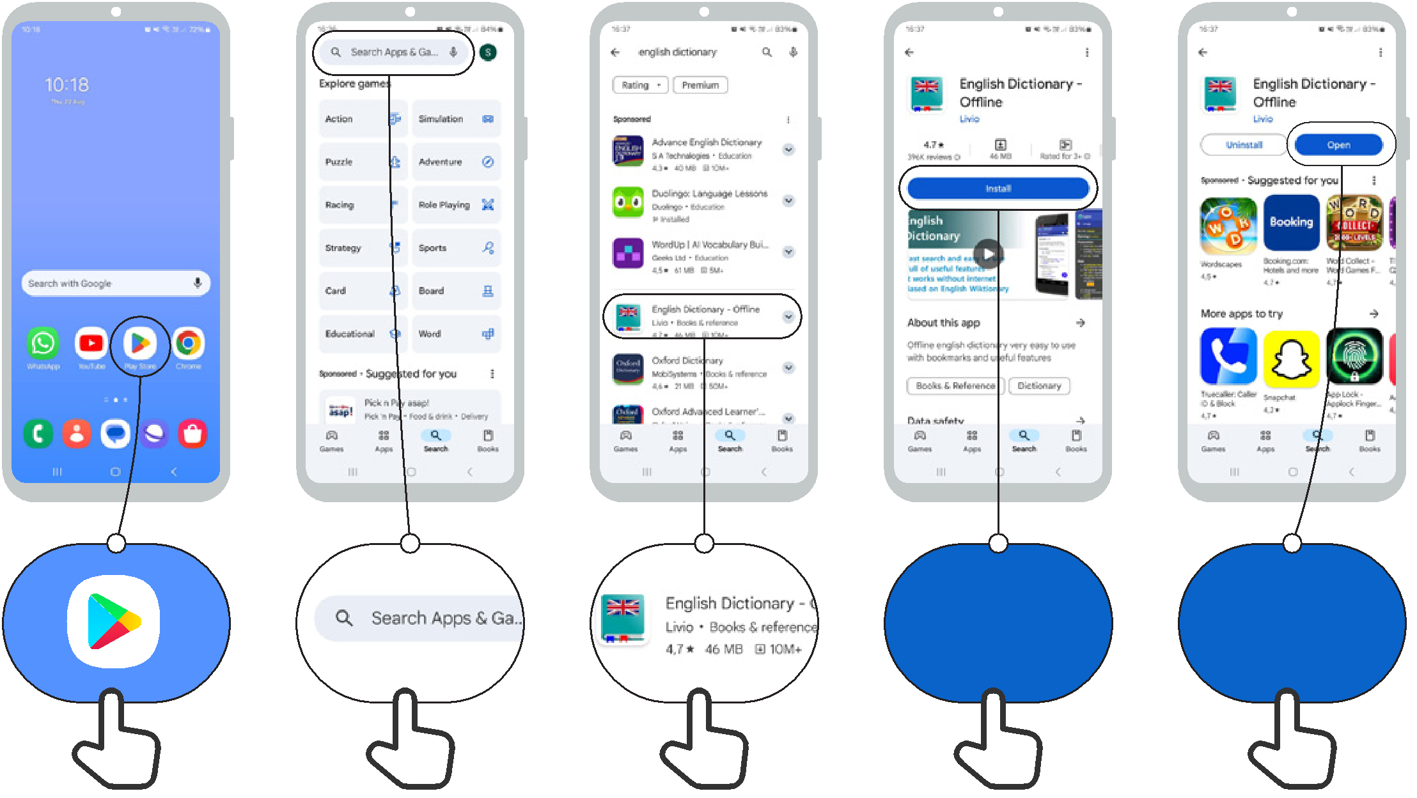

Install Open

Create a Google account
How to use
Android

1 2 3 4 5
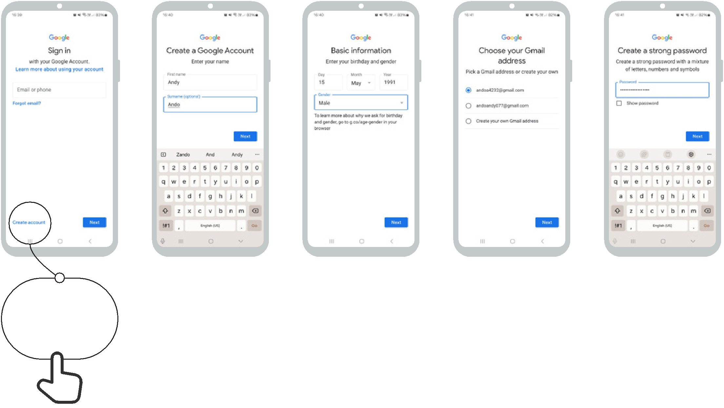

Create account

Connecting to a Wi-Fi network
How to use
Android

1 2 3 4 5
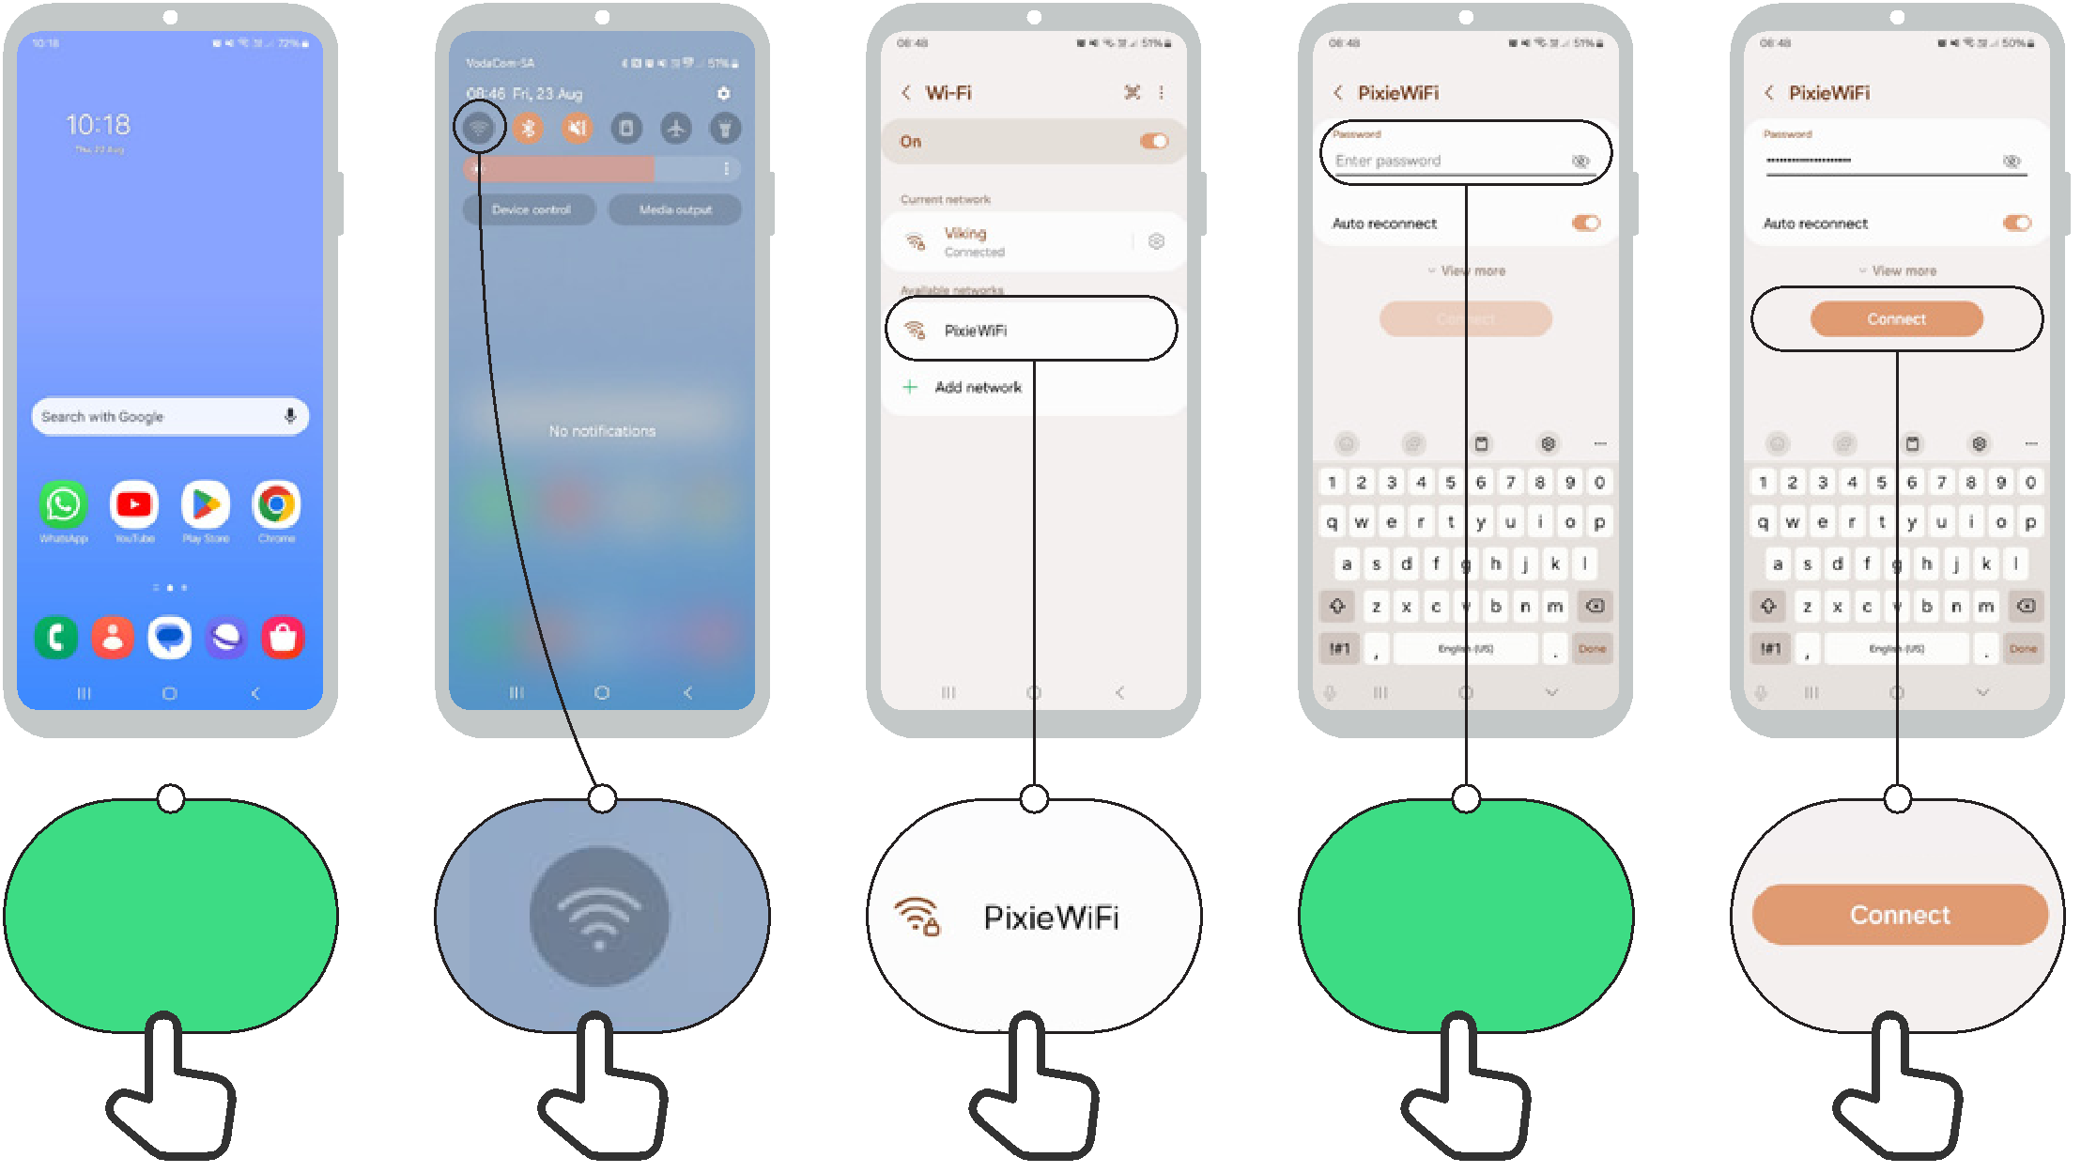

Enter

password

How to use
Android

How to use Chrome

1 2 3
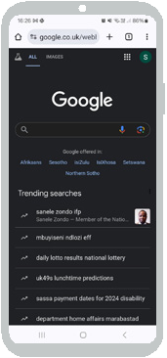
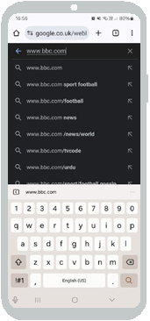


Sending an email on Gmail
How to use
Android

1 2 3 4
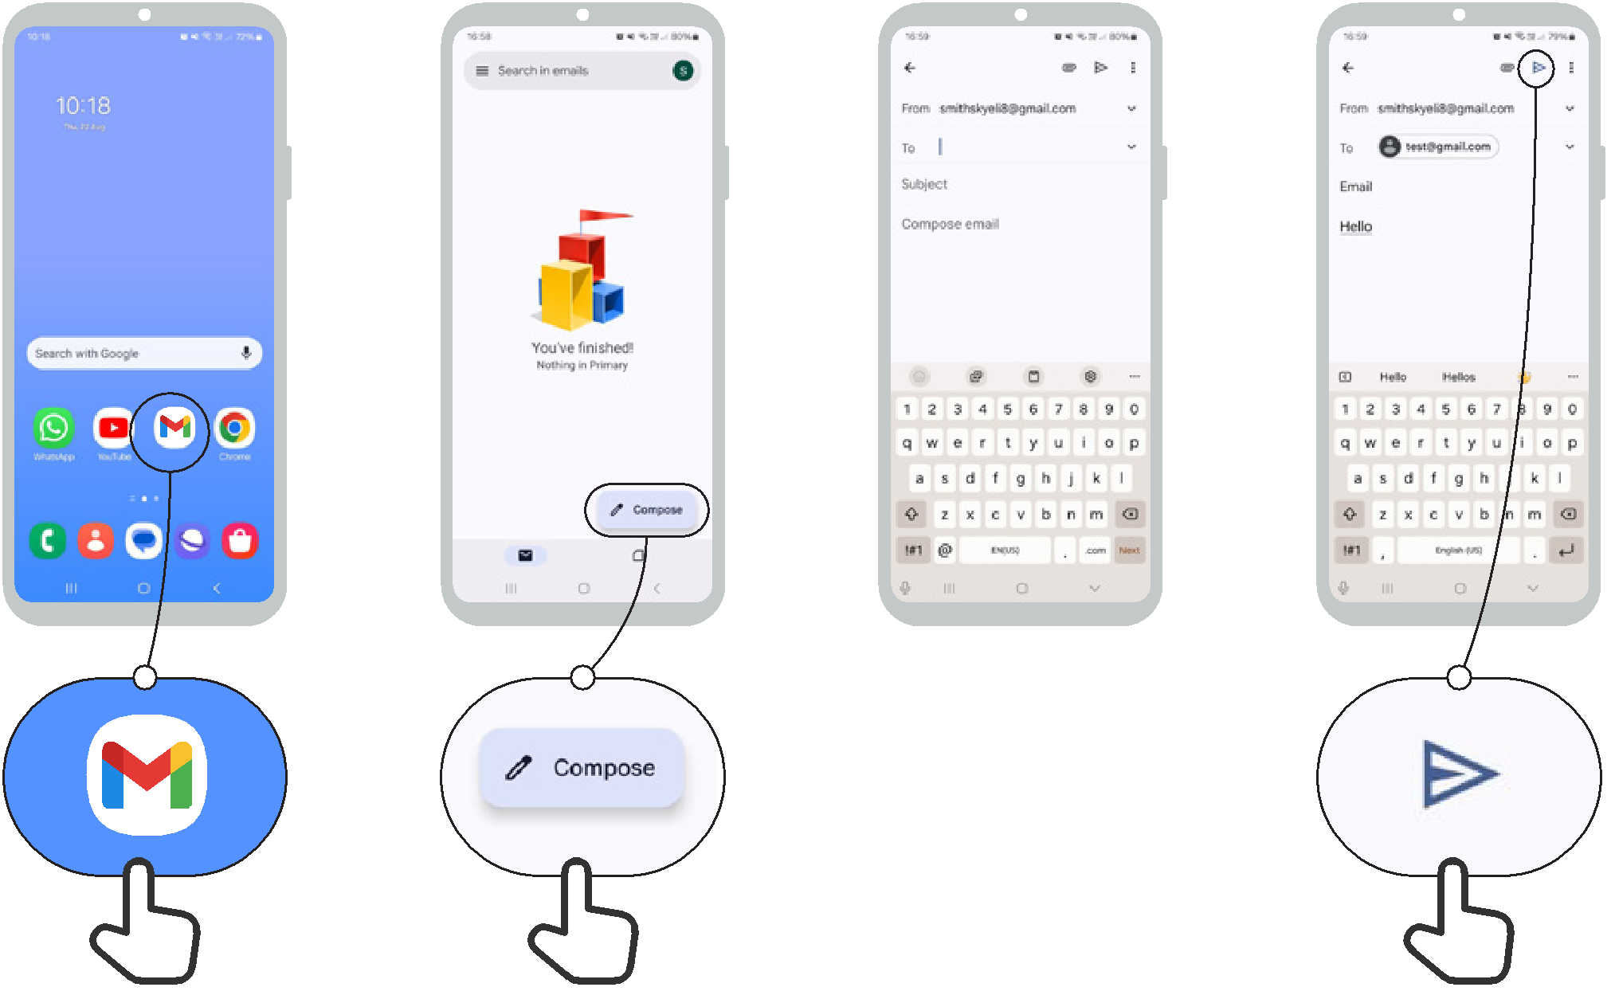

Gmail

Icons for popular email services
How to use
Android




How to use
Android

Device Security

1 2 3 4 5
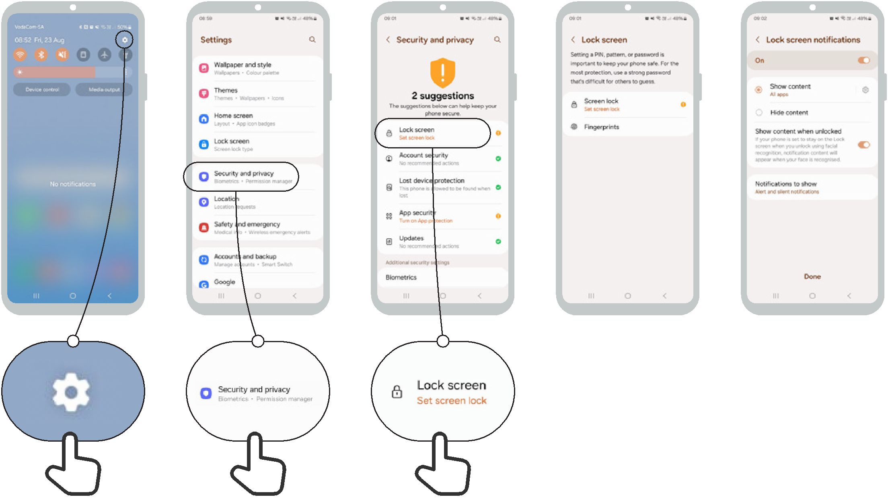

Google Assistant
How to use
Android

1 2 3 4
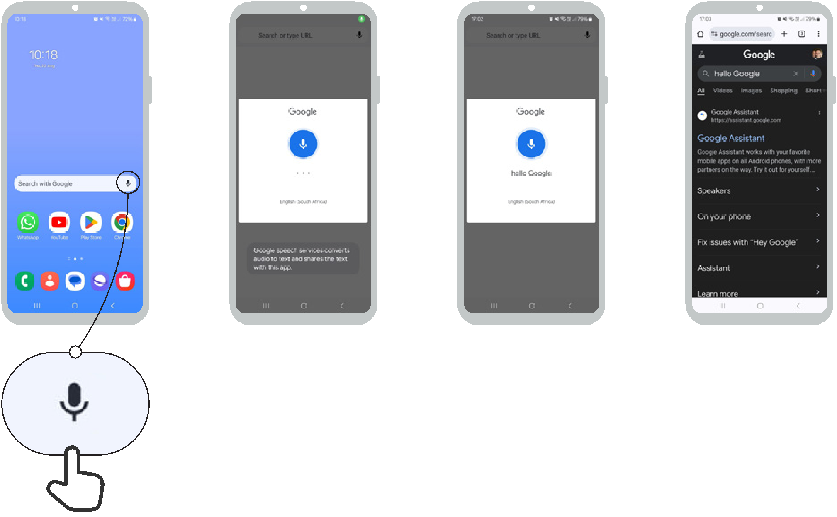

Data Saver
How to use
Android

1 2 3 4 5
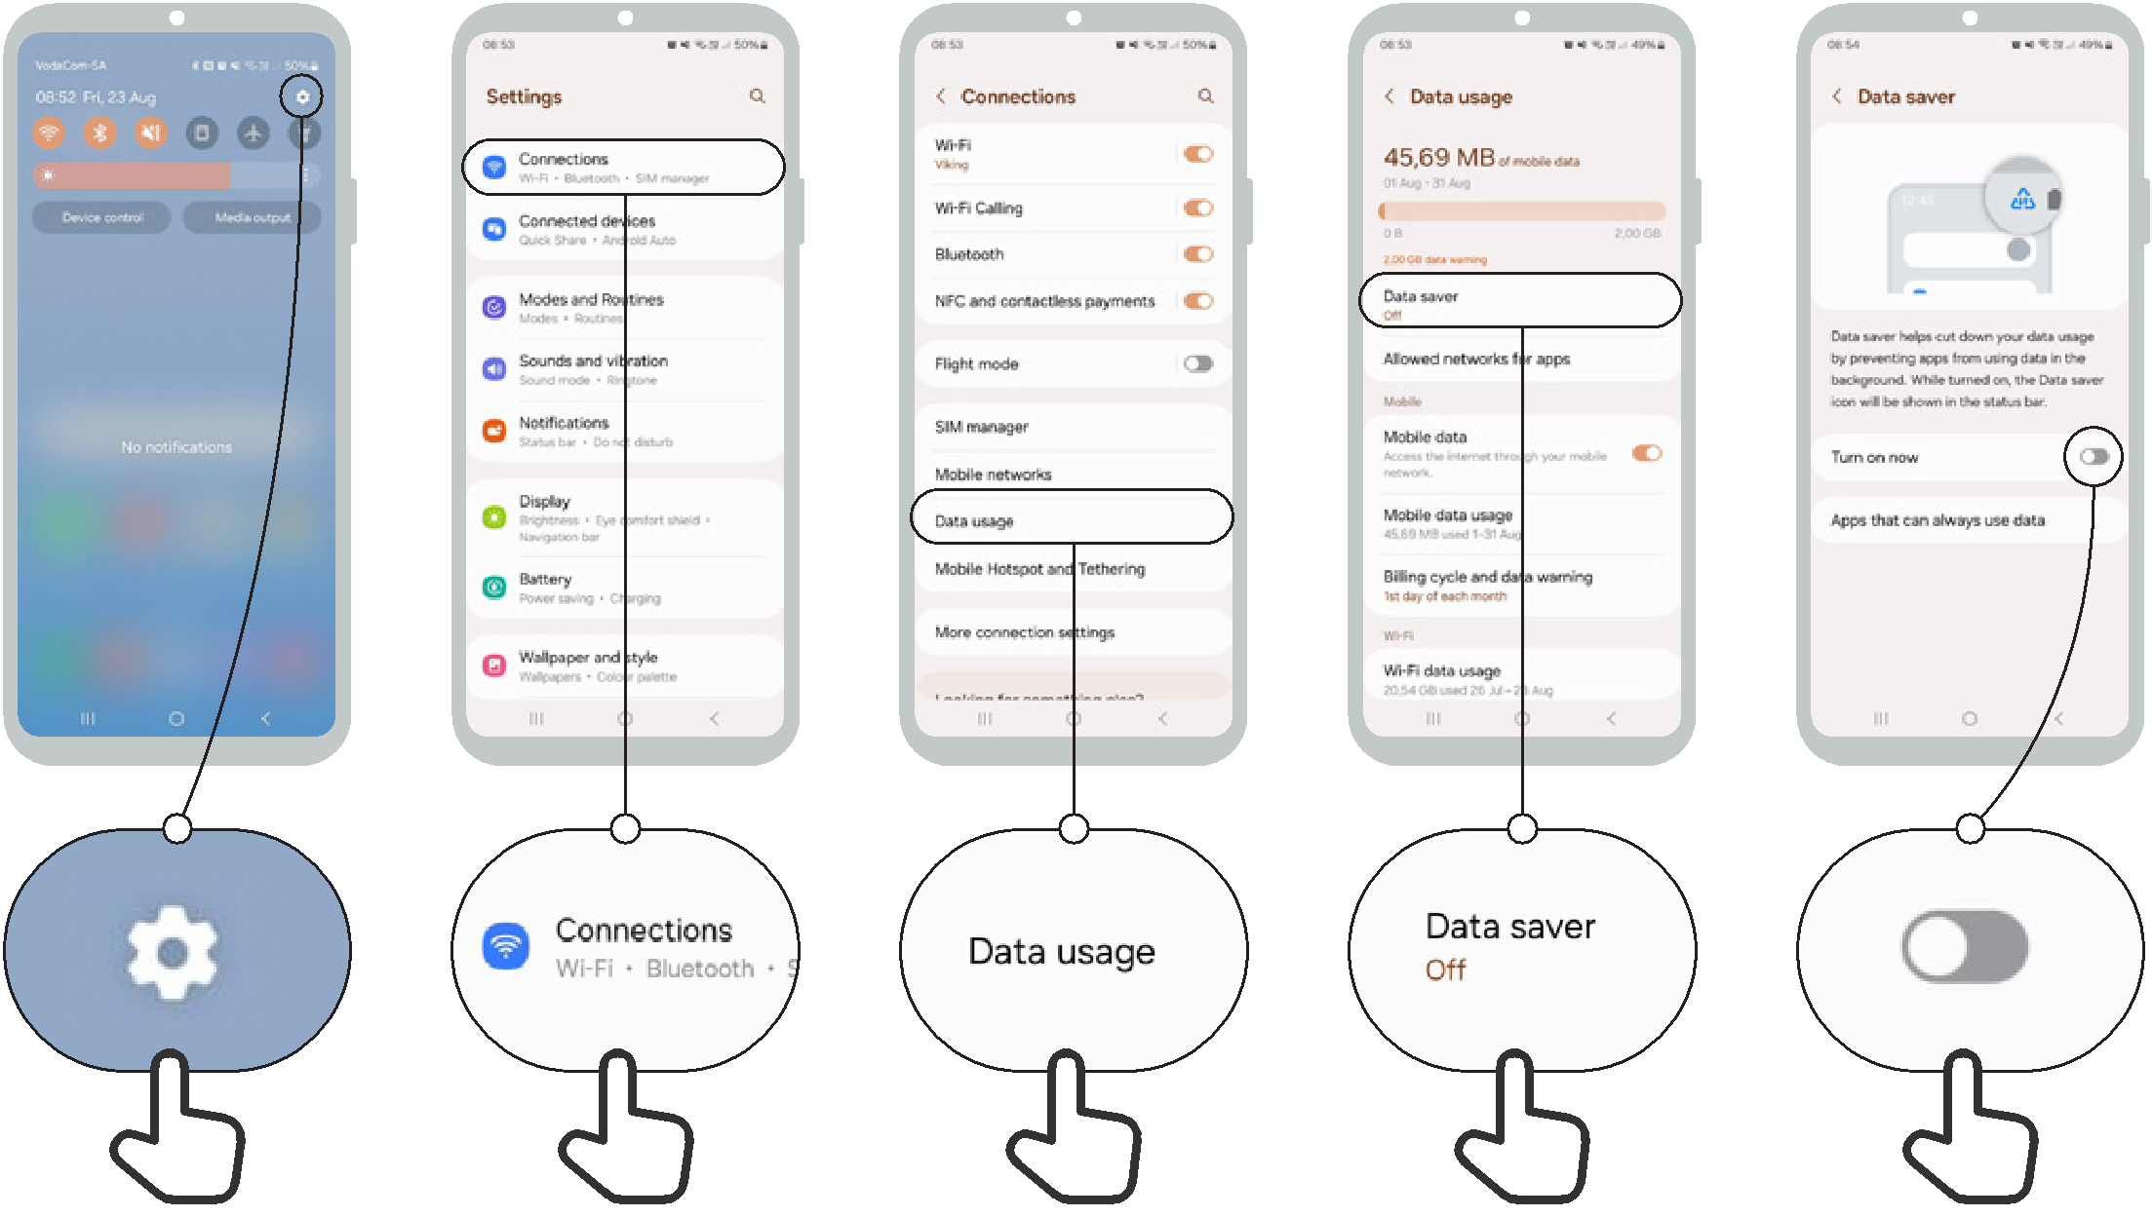

Battery Saving
How to use
Android

1 2 3 4
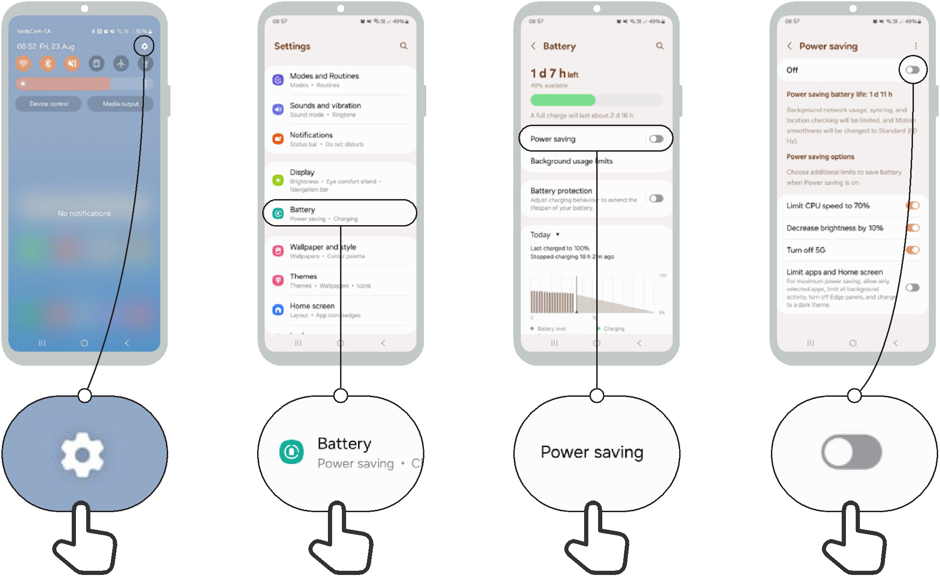

Device Security
How to use
Android

1 2 3 4 5
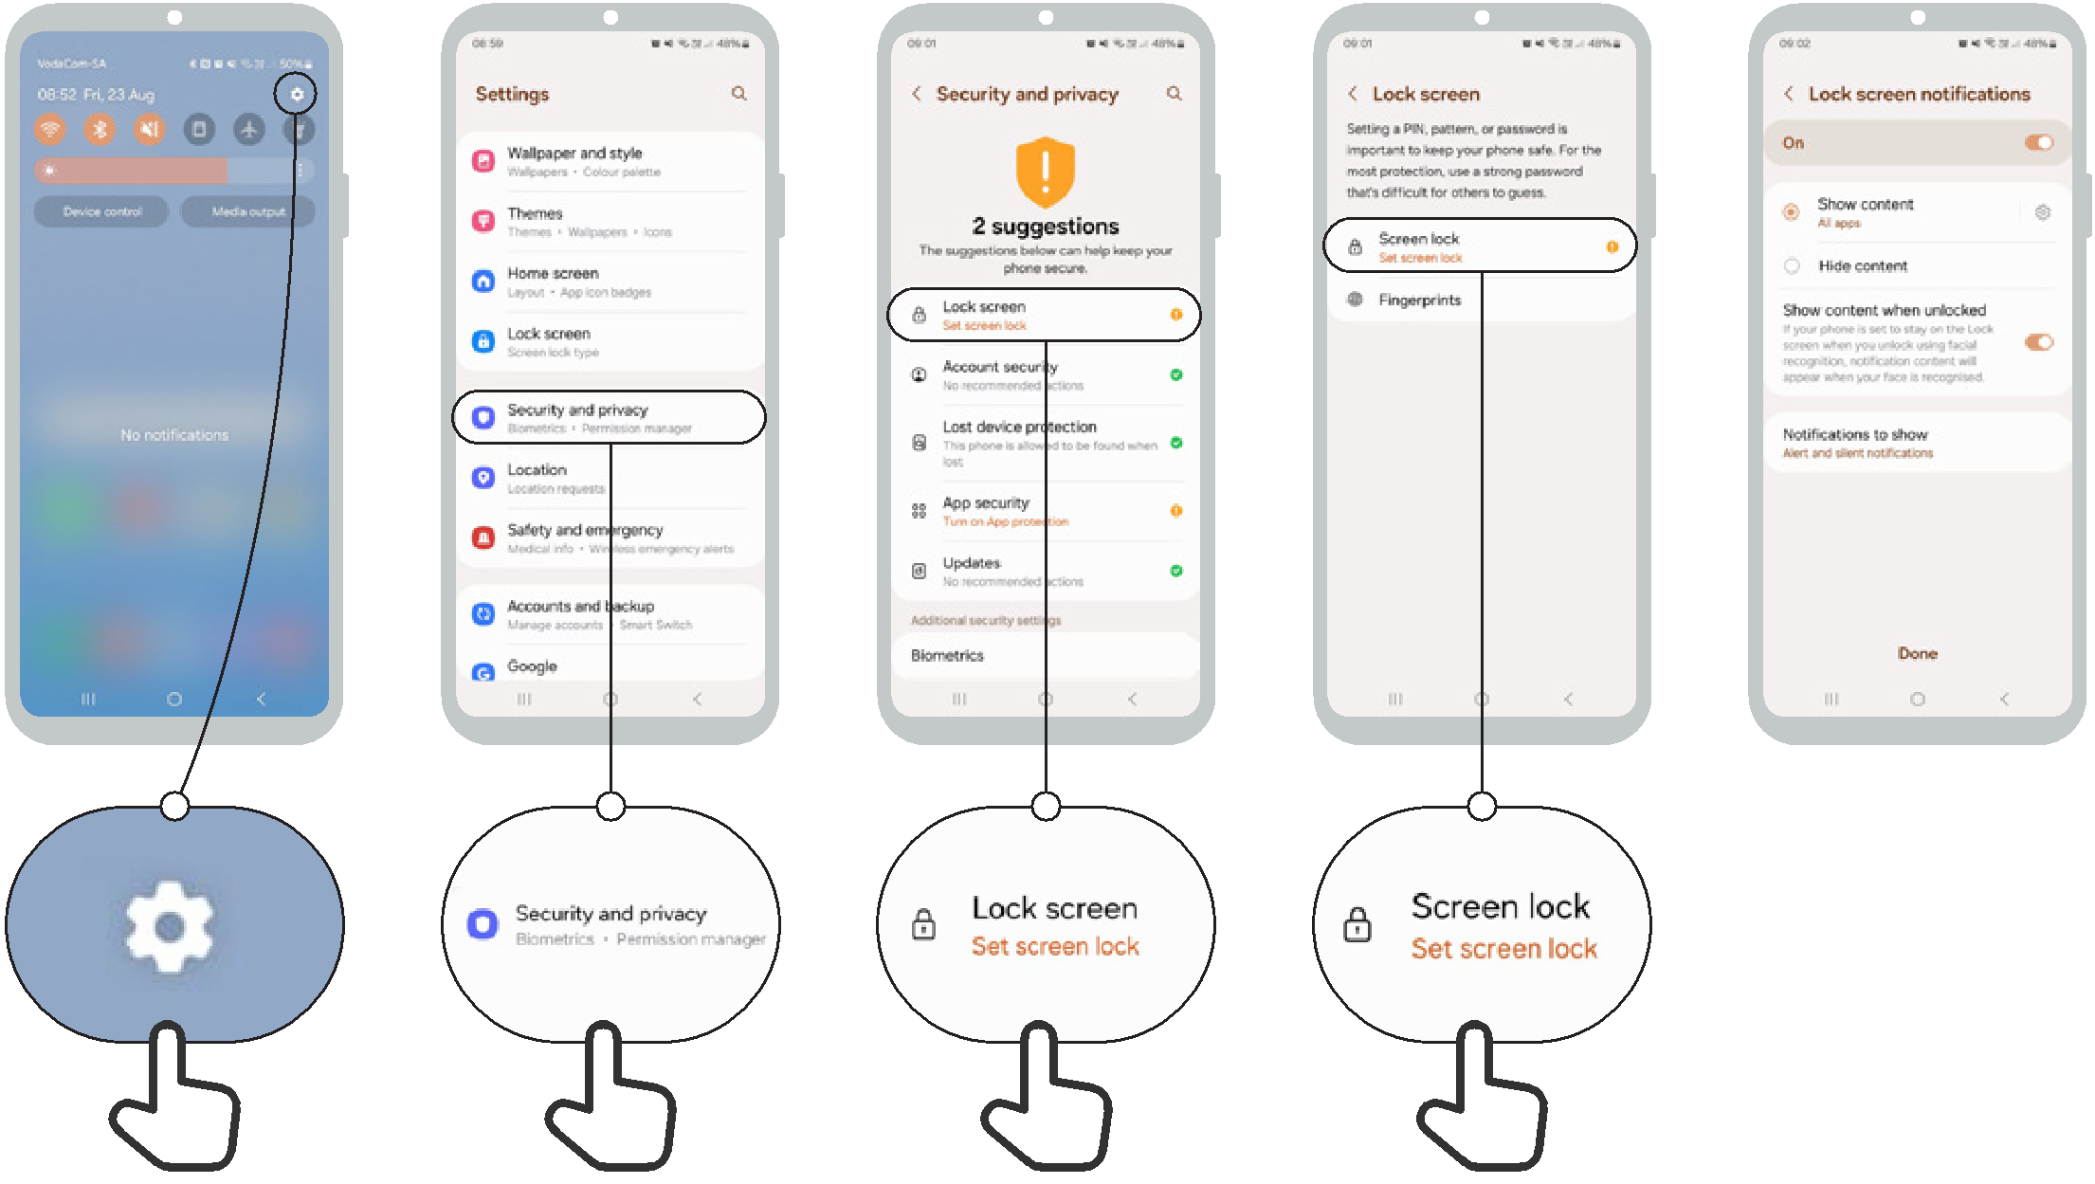


Icon Cut-Outs
Android
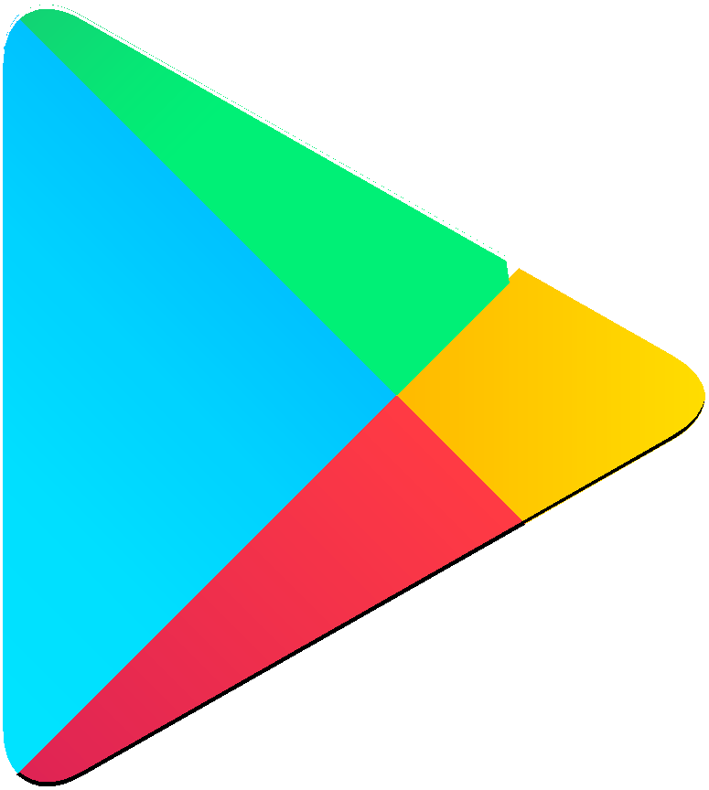

Icon Cut-Outs
Android


Icon Cut-Outs
Android


Icon Cut-Outs
Android


Icon Cut-Outs
Android


Icon Cut-Outs
Android

