
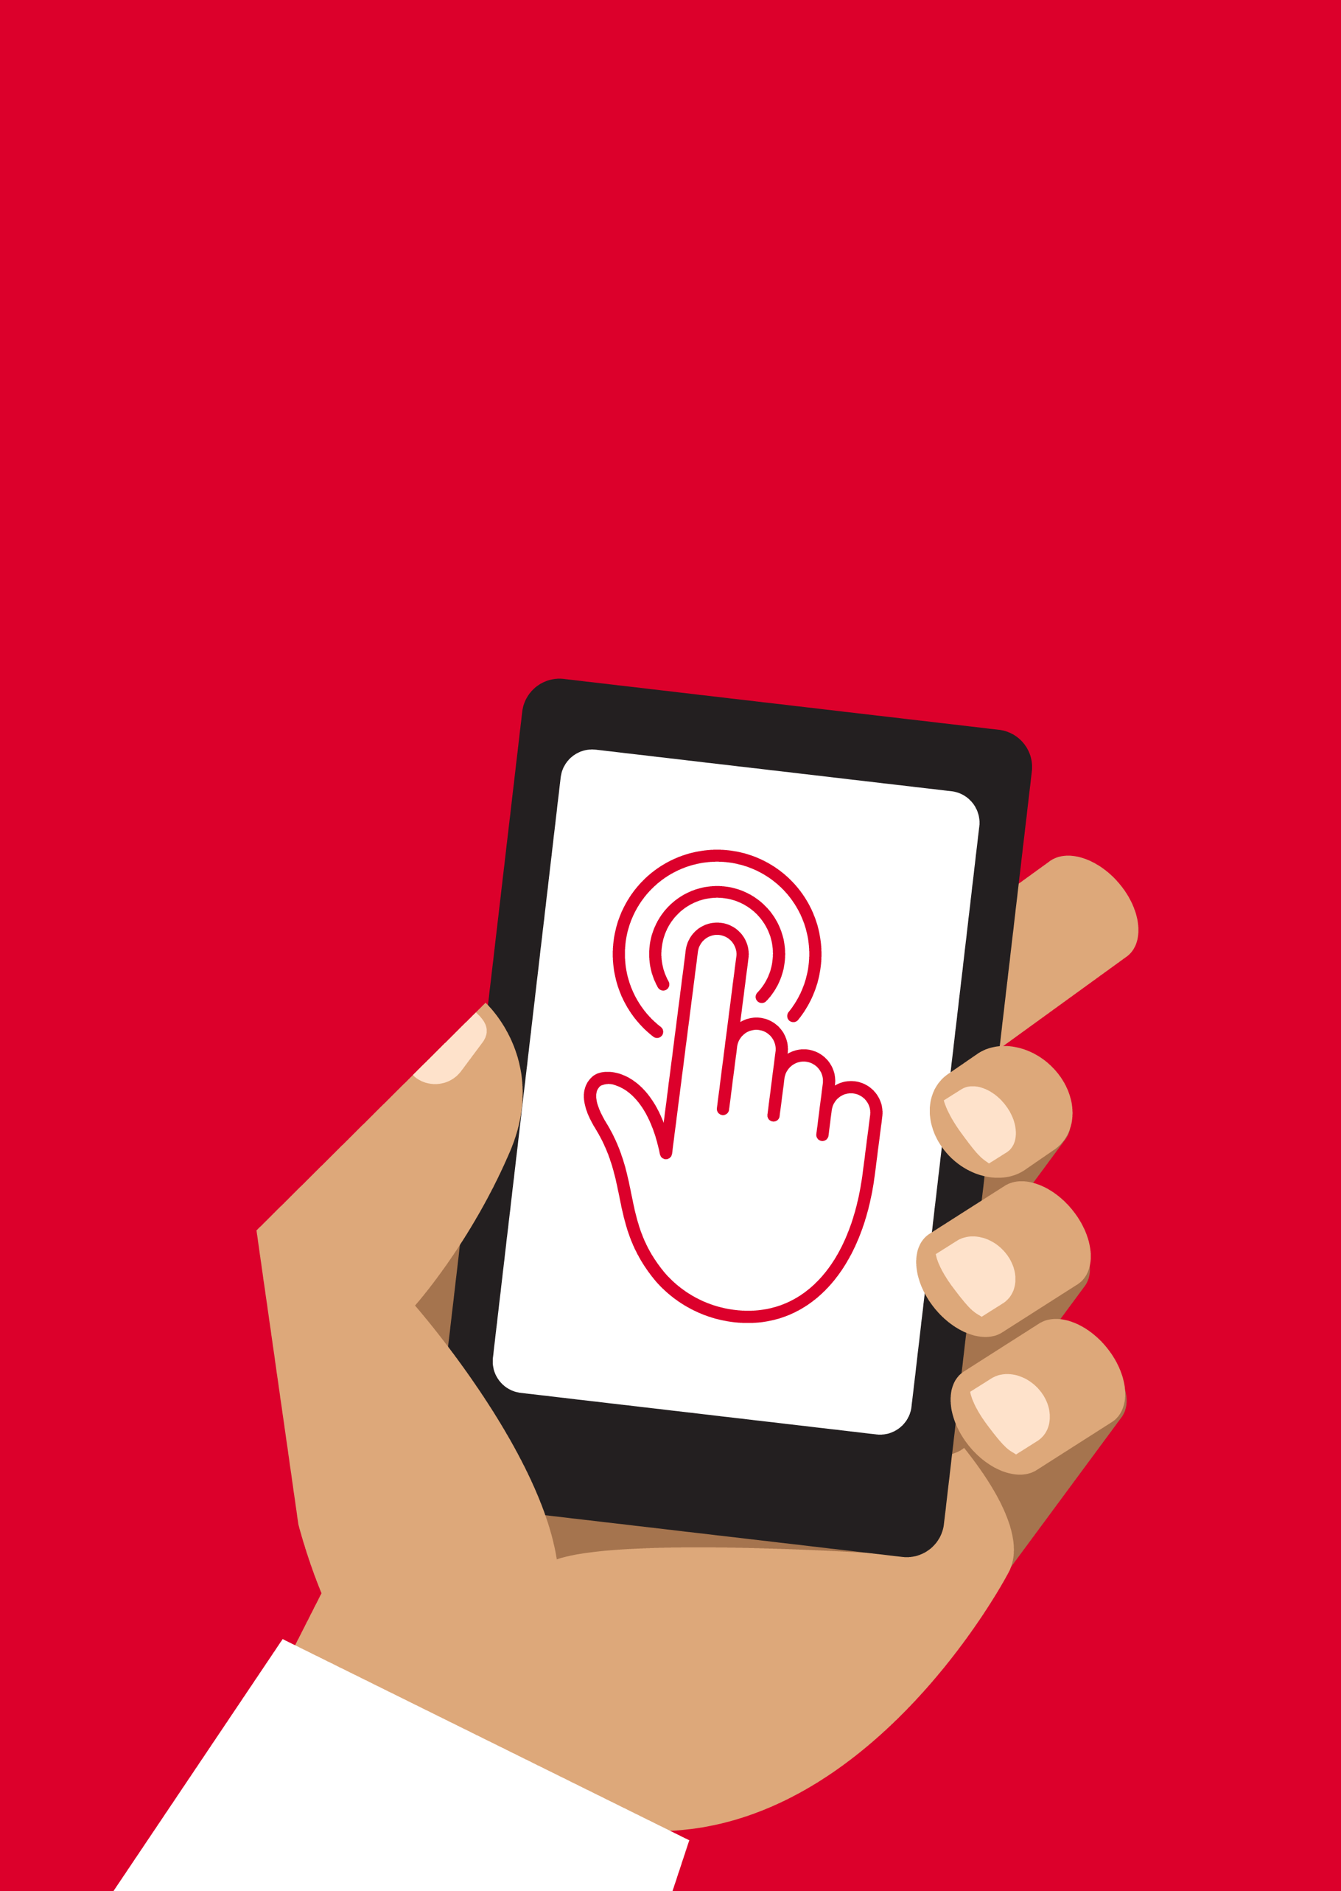

Mobile Internet
Skills Training
Toolkit
A guide for training people in
basic mobile internet skills
Copyright © 2024 GSM Association
Copyright © 2024 GSM Association
Bitesize Training
Cost

Mobile Internet
Skills Training

Toolkit

A guide for training people

in basic mobile internet skills

Module 11:

Cost

What is it?
  Materials you will need:  - Smartphone handsets  - Cost poster  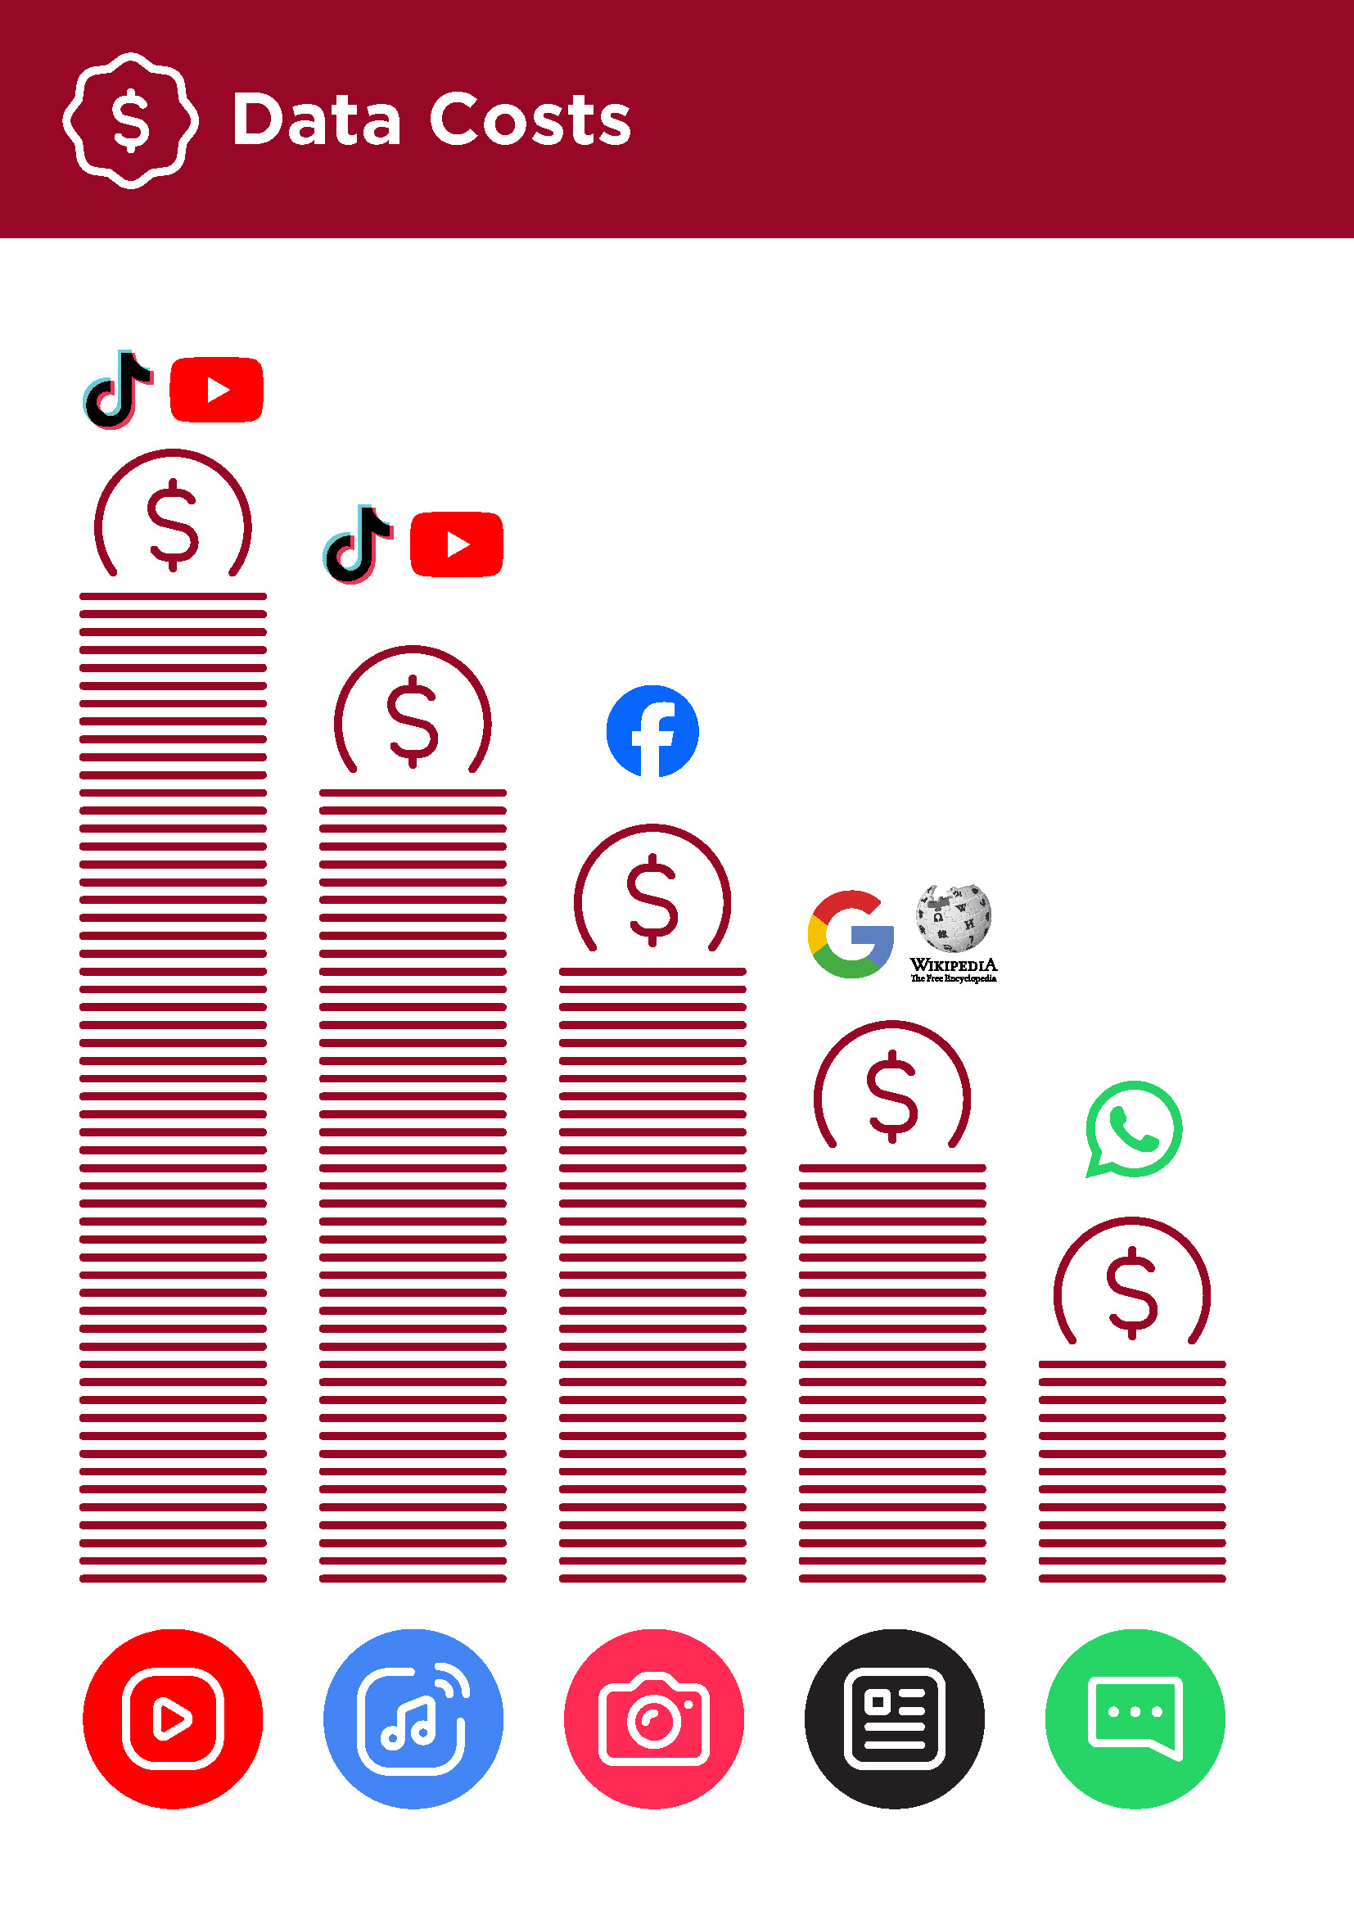 | Explain: “Whenever you use the internet on your phone, you are using data. This means you need to buy data from your mobile network. Some activities on the internet use more data, like watching videos, so cost more to do.”  “You can buy data for the internet; it is like buying phone credit for calls and messages. Data for the internet can be bought from your local mobile network agent or phone credit seller who will top it up for you.”  “Sometimes internet data can also be bought in data vouchers or data cards that you can use to top up your mobile internet yourself.”
What uses data?
Show the cost poster.

“Different activities use different amounts of data. Looking at text uses the least data, looking at images uses more, playing and downloading music, stickers and ringtones also uses more and downloading and playing videos uses the most. Videos tend to use more data than other internet uses.”

“Some internet services are linked to activities that use more data. For example:

- Watching videos on YouTube tends to use a lot of data.

- Google costs less for looking at text and images, but will cost more if you watch videos.

Software updates also use data and so will cost money.”

How do you check your data costs?
Put the phone in the trainee’s hands and help them follow the steps.

“It is useful to check your data to understand how much you have used, and how much different activities cost. You can check how much data you have, just like when you check how many minutes or texts you have by typing in a code on your phone from your mobile network.”

Demonstrate to the trainee how to check data. This is different depending on which country you are in and which network you are with. Ask a mobile agent if you need help.

Tip: “You can buy data in different amounts depending on what you are going to use the internet for. Ask for advice from your local mobile agent on which amount is best suited to you.”

Bitesize Training
Cost

Mobile Internet
Skills Training

Toolkit

A guide for training people

in basic mobile internet skills

Posters and Cut-Outs
Data Costs

