


Mobile Internet
Skills Training
Toolkit
A guide for training people in
basic mobile internet skills
Copyright © 2024 GSM Association
Copyright © 2024 GSM Association
Bitesize Training
Facebook

Mobile Internet
Skills Training

Toolkit

A guide for training people

in basic mobile internet skills

Module 6:

Facebook

What is it?
  Materials you will need:  - Smartphone handsets  - Facebook posters  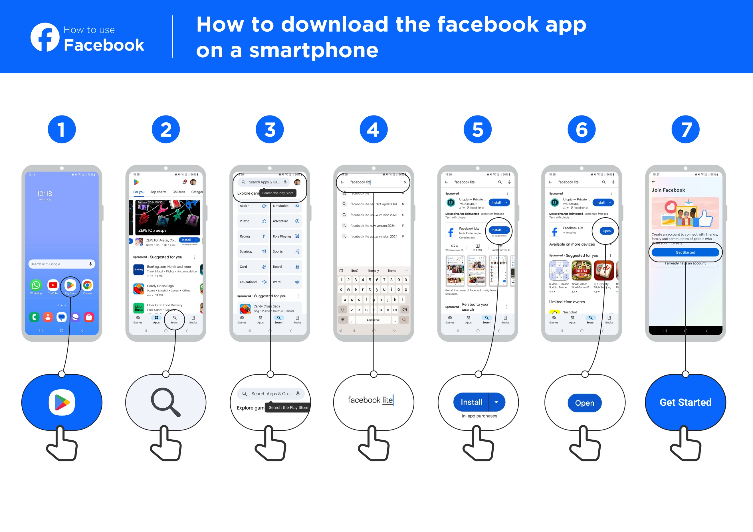 | Show Facebook on the phone.  Explain: “Facebook connects you to people in your community as well as people and businesses all around the world. You can use it to correspond with business contacts, receive news, watch videos, stay in touch with family and friends or follow your favourite celebrities and sports teams.”  “Using words, photos and videos, you can communicate with one person, a specific group of people or people around the world.”
What can you use it for?
“You can use it to promote your business goods or services.”

“You can use it to find information such as businesses offering services or goods in your area.”

“You can use it to ask for help for your farming or business.”

“You can use it to watch videos and stay entertained.”

What can you use it for?
Make it relevant to the trainee by discussing how it can be beneficial in the trainee’s own life. Consider examples that will be relevant to the following types of trainees:

Older person: Stay updated on what your grandchildren and family are doing.

Mother or homemaker: Share a life update with a family member or friend who lives far away; join parenting groups to ask other people for help with your child’s schoolwork or health.

Farmer or rural person: Join local farming communities or groups to ask questions and learn about better farming practices or stay updated on the latest tips and market trends; connect with local cooperatives or buyers on Facebook to grow your farming business and find better opportunities to sell your produce.

Business owner: Create a Facebook page for your business to reach a wider audience; share updates and promote your products or services; join entrepreneur networking groups to connect with other small business owners, exchange ideas and find potential partners or employees.

Young person: Share photos and updates with friends to stay connected; follow your favourite musicians or athletes for inspiration; join online study groups to get help with your schoolwork; explore new hobbies and join hobby groups; learn skills and stay informed on topics that interest you by watching videos or reading articles.

How does it work?
Put the phone in the trainee’s hands and help them follow the steps.
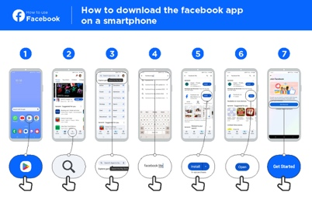  Access Facebook | 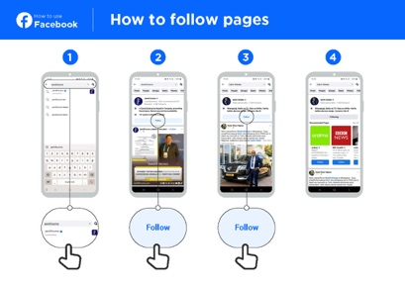  “Like” celebrities, sports and news |  | 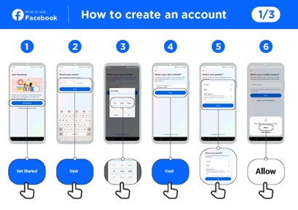  Create an account
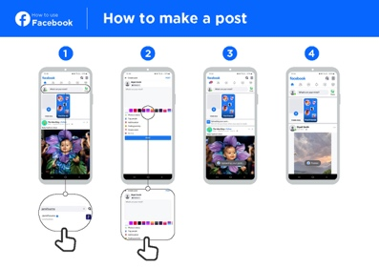  Post text or photos | 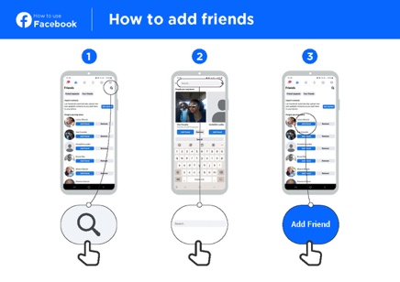  Add friends
Help the trainee download Facebook and register for an account.

Ask them what they care about most — e.g. something they want to learn about, job opportunities, sports/entertainment or their business — and focus your limited time on what is most important to them.
Practise!

“Now you know how to use Facebook, what do you want to use it for?”

Trainer: Provide support to user to run through one of the above posters.
Explain: “You control who sees the information you put on Facebook.

You can have a post appear to the public (everyone using Facebook) or only to specific friends.”

Safety
“If you don’t control who can see your Facebook posts, anyone can contact you. They might send you things you don’t want to see or ask for personal information or money. Never share personal details like your banking PIN or address with strangers. Don’t send personal images or money to people you don’t know or have met online; it could be a scam.”
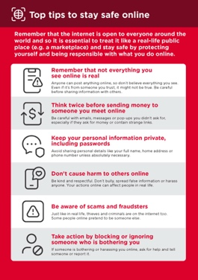
Show the ‘Top tips to stay safe online’ poster.

Discuss with your trainees what these tips mean when using Facebook.

Bring the tips to life by using examples that are relevant for your trainee. For example, certain people may be worried about some of the content on Facebook. Some people may be worried about scammers using Facebook and some women may be more concerned about how to prevent harassment.

Bitesize Training
Facebook

Mobile Internet
Skills Training

Toolkit

A guide for training people

in basic mobile internet skills

Posters and Cut-Outs

Top tips to stay safe online

 | Remember that not everything you see online is real  Anyone can post anything online, so don’t believe everything you see. Even if it’s from someone you trust, it might not be true. Be careful before sharing information with others
 | Think twice before sending money to someone you meet online  Be careful with emails, messages or pop-ups you didn’t ask for, especially if they ask for money or contain strange links.
 | Keep your personal information private, including passwords  Avoid sharing personal details like your full name, home address or phone number unless absolutely necessary.
 | Don’t cause harm to others online  Be kind and respectful. Don’t bully, spread false information or harass anyone. Your actions online can affect people in real life.
 | Be aware of scams and fraudsters  Just like in real life, thieves and criminals are on the internet too.  Some people online pretend to be someone else.
 | Take action by blocking or ignoring someone who is bothering you  If someone is bothering or harassing you online, ask for help and tell someone or report it.
Remember that the internet is open to everyone around the world and so it is essential to treat it like a real-life public place (e.g. a marketplace) and stay safe by protecting yourself and being responsible with what you do online.

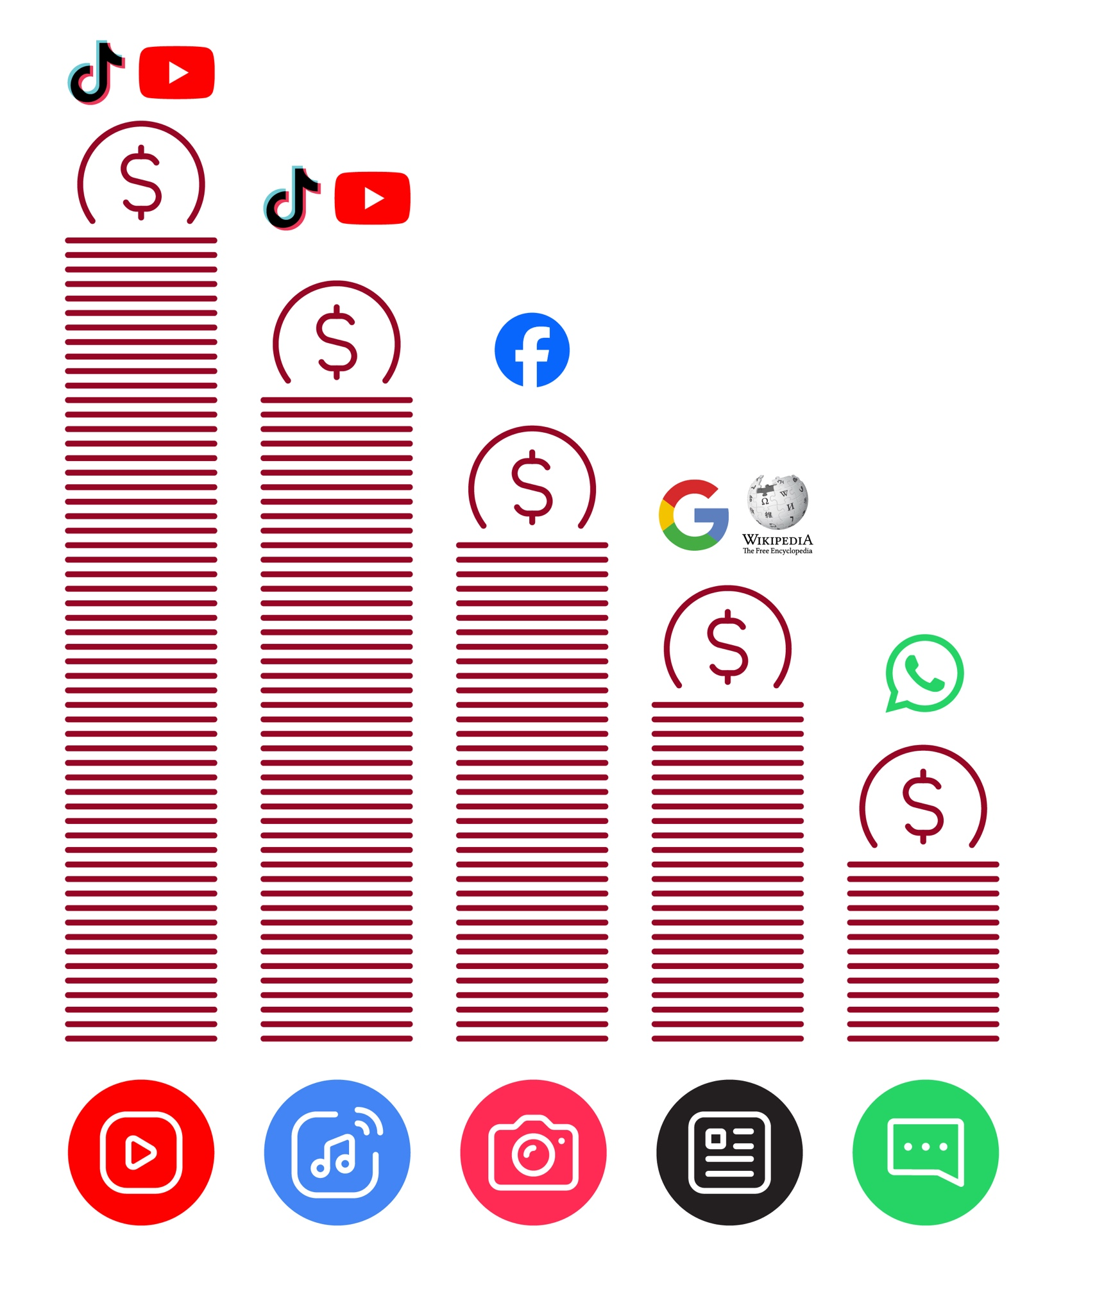
Data Costs

How to use
Facebook

How to download the Facebook app on a smartphone


1 2 3 4 5 6 7
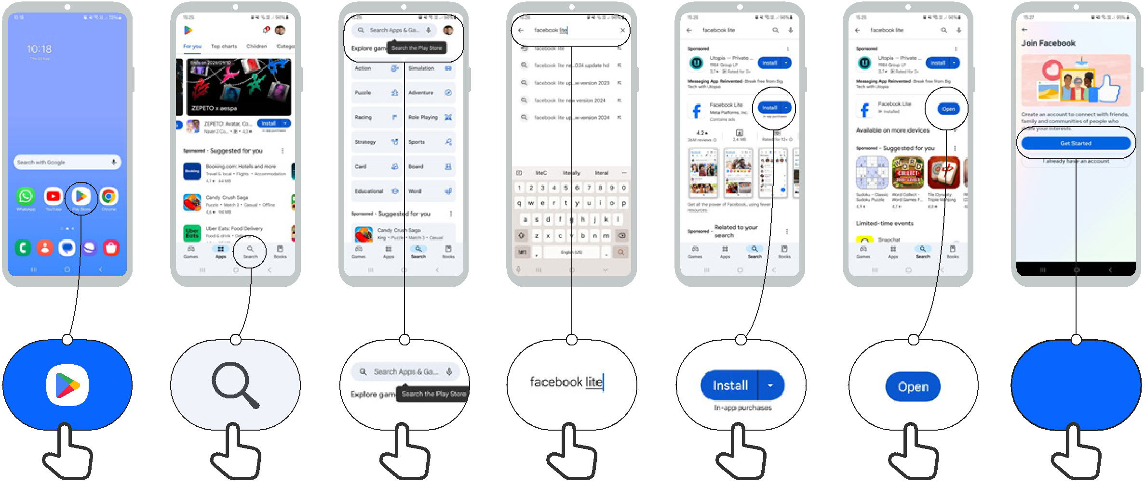

Get Started
How to use
Facebook

How to create an account | 1/3



1 2 3 4 5 6
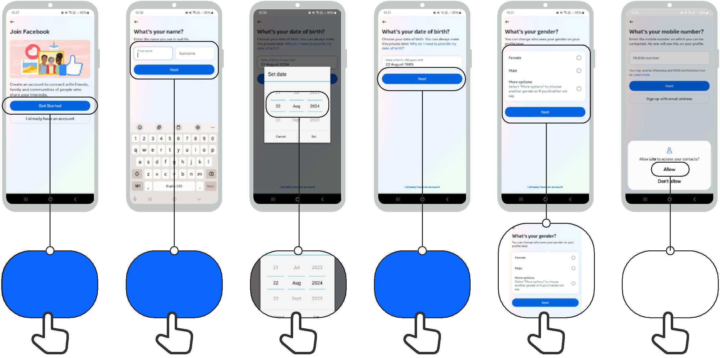

Get Started Next Next

Allow

How to use
Facebook

How to create an account | 2/3


7 8 9 10 11 12
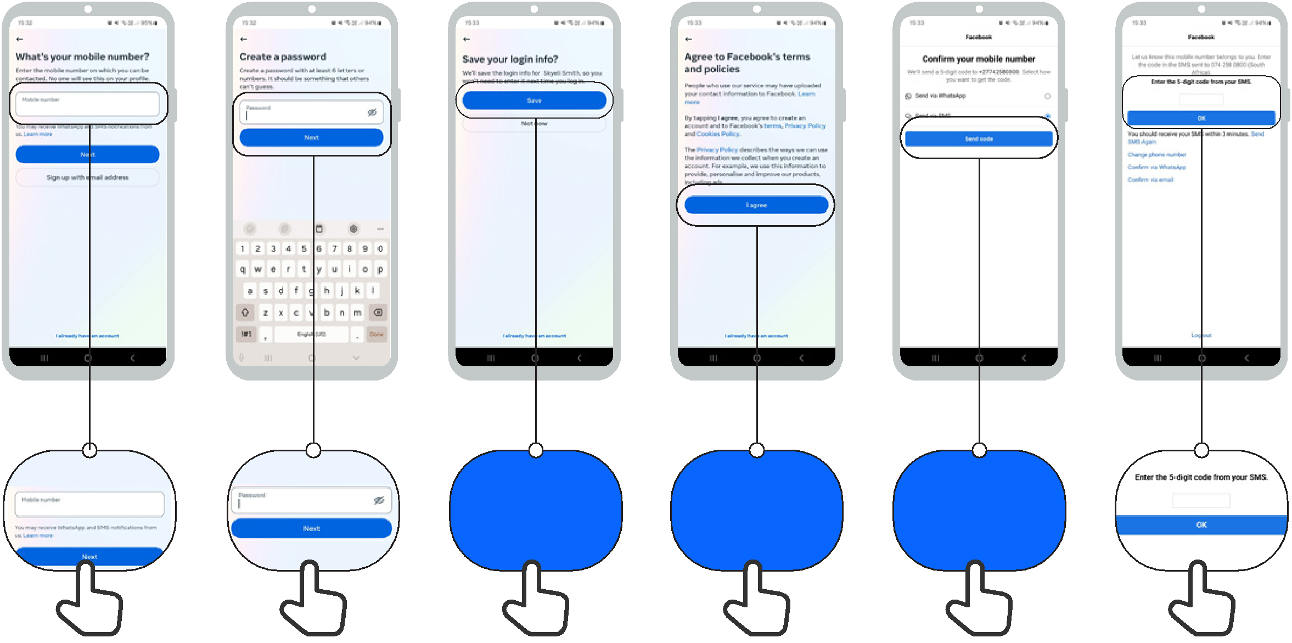

Save I Agree Send code

How to use
Facebook

How to create an account | 3/3

13 14 15 16 17
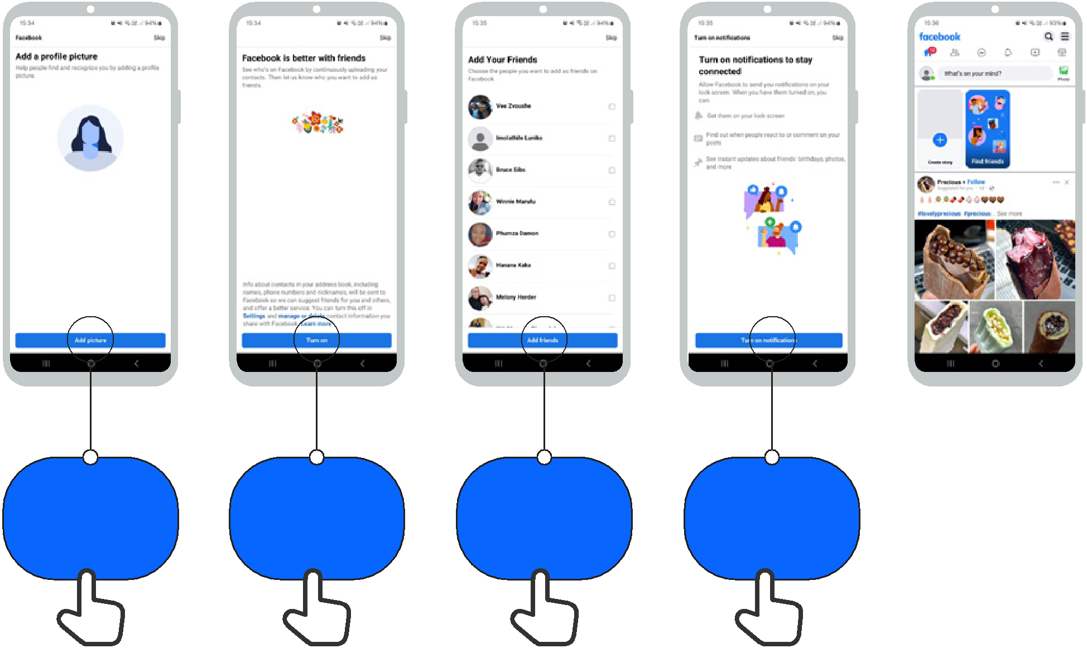

Add picture | Turn on | Add Friends | Turn on
Add picture | Turn on | Add Friends | Notifications

How to use
Facebook

How to add friends

1 2 3
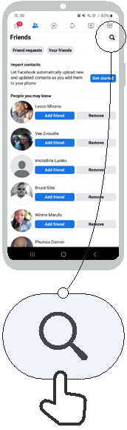
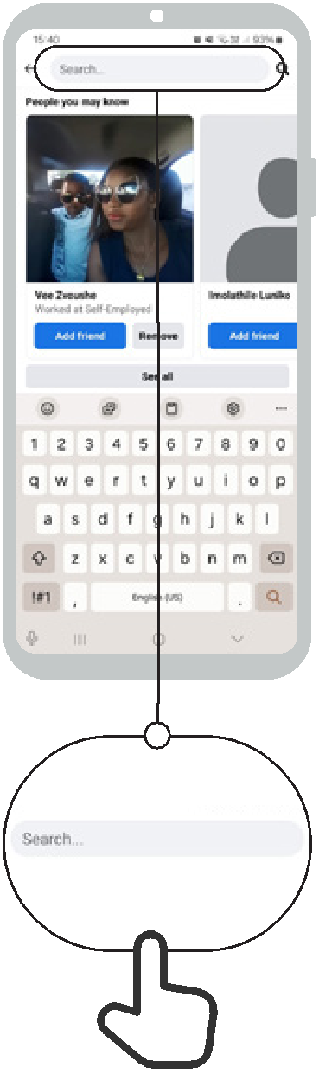


Add Friend

How to use
Facebook

How to follow pages


1 2 3 4
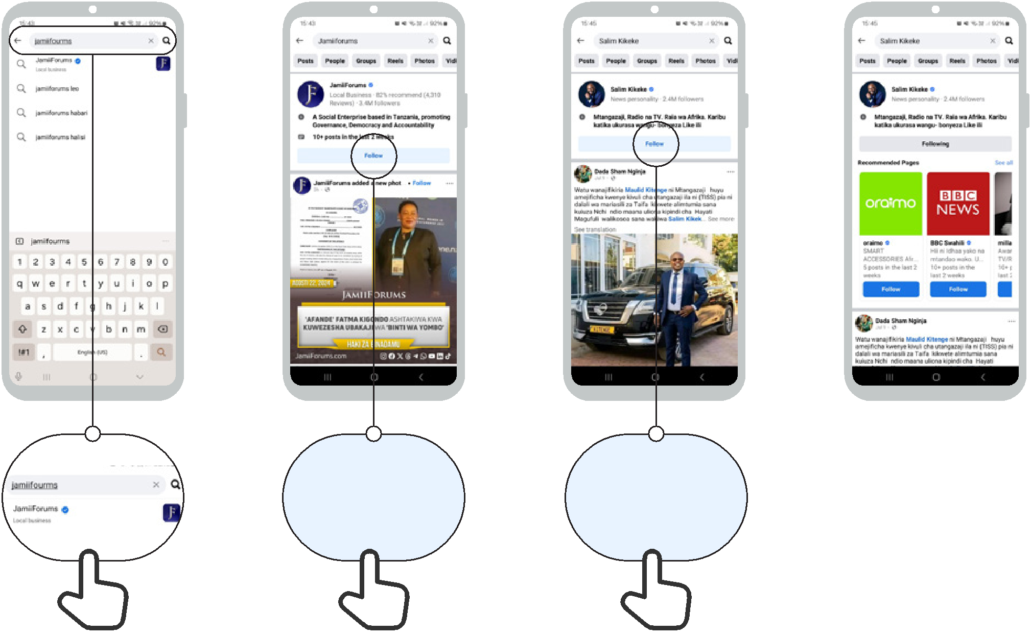

Follow Follow

How to use
Facebook

How to make a post

1 2 3 4
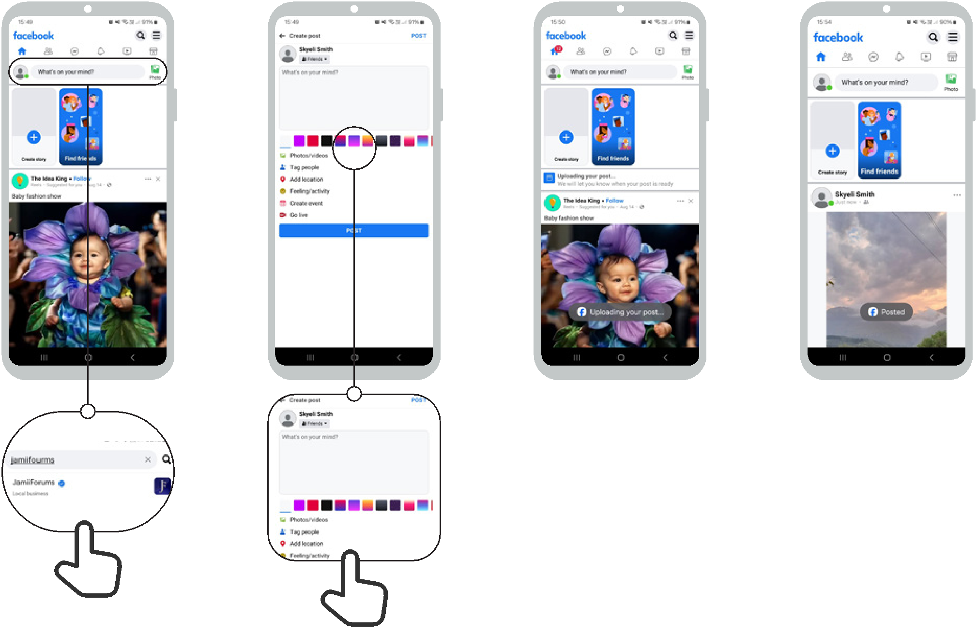


Icon Cut-Outs
Facebook


Icon Cut-Outs
Facebook


Icon Cut-Outs
Facebook


Icon Cut-Outs
Facebook


Icon Cut-Outs
Facebook



Icon Cut-Outs
Facebook



