
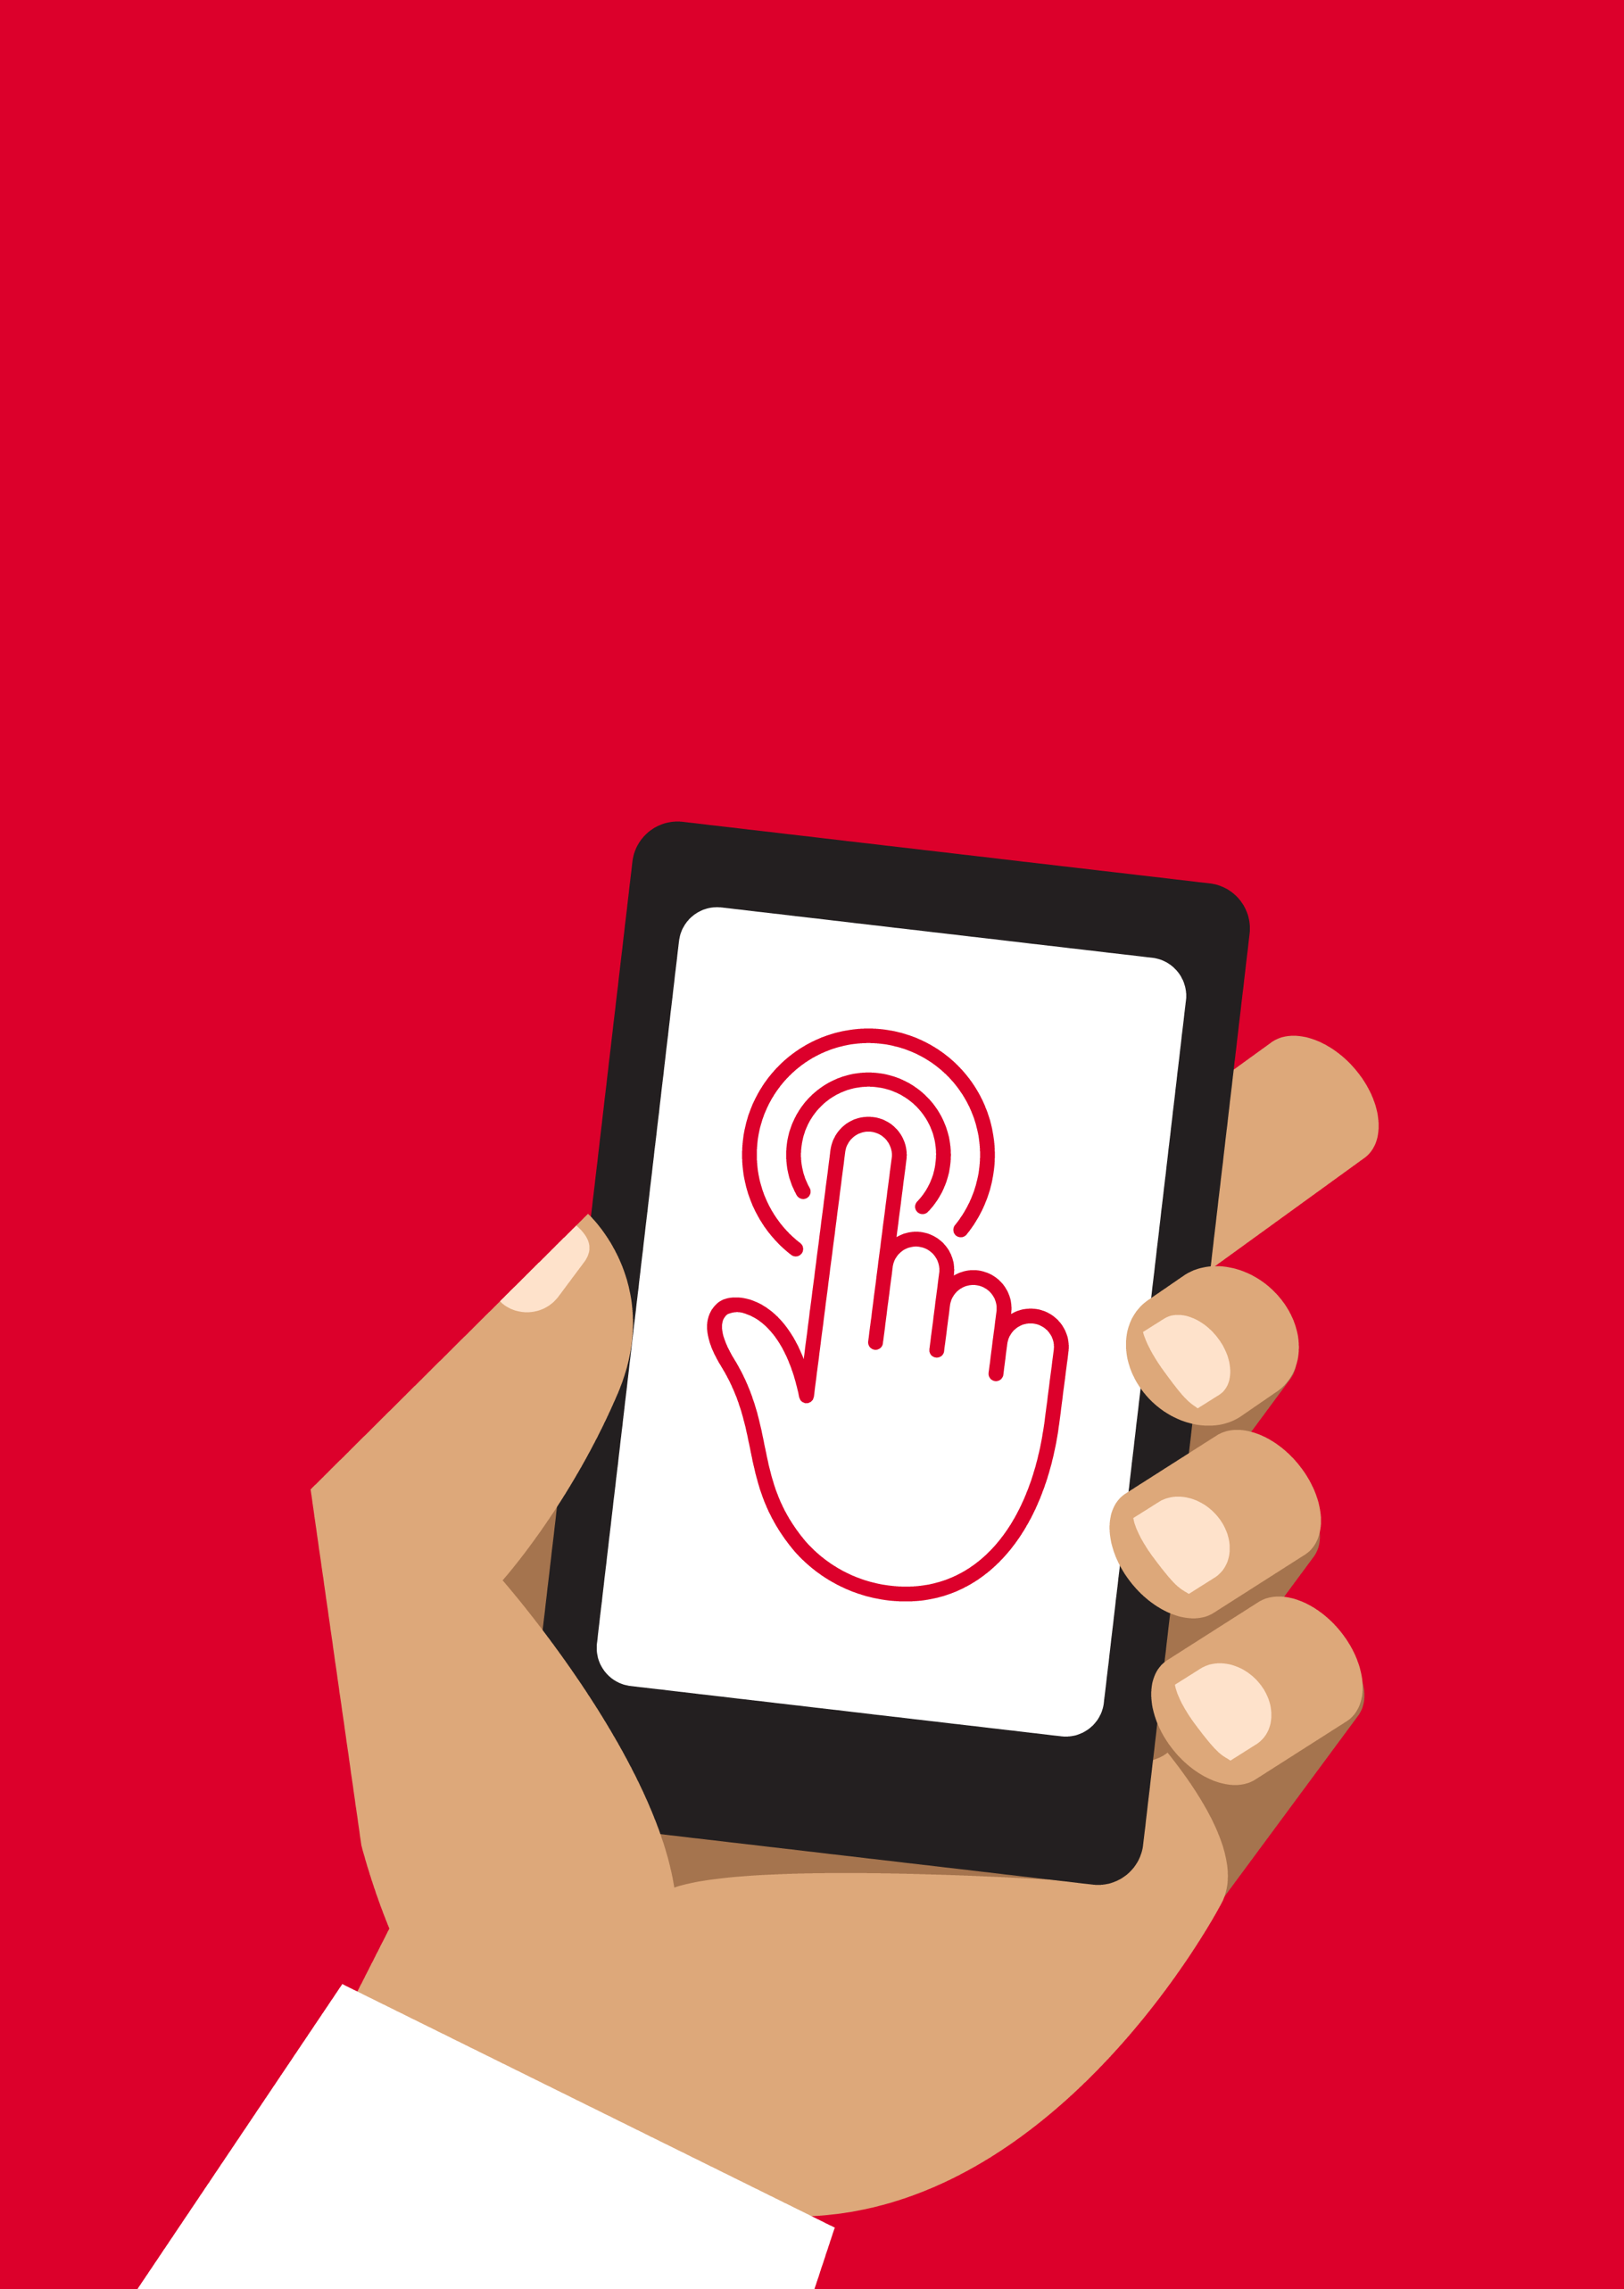

Mobile Internet
Skills Training
Toolkit
A guide for training people in
basic mobile internet skills
Copyright © 2024 GSM Association
Copyright © 2024 GSM Association

In-Depth Training
Facebook

Mobile Internet
Skills Training

Toolkit

A guide for training people

in basic mobile internet skills

Module 6:
Facebook

Learning objectives
- The trainees register for Facebook.

- The trainees add friends, follow pages and make a post.

- The trainees are excited to use Facebook and connect with friends.
Time duration
45-60
minutes

Materials you will need:
  Paper, pens and masking tape |   Smartphone handset |   Small rewards | 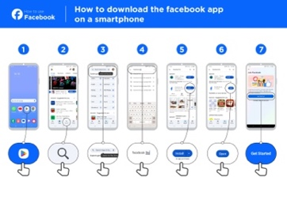  Facebook  posters x3
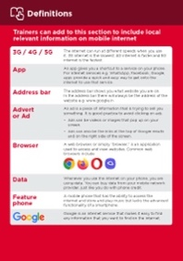  Glossary handouts | 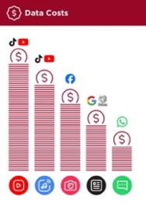  Cost  poster | 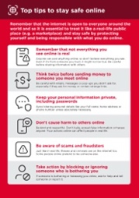  Safety  tips |   Icon  cut-outs

Introduce Facebook

Show trainees the Facebook icon and ask them to find this on their phone

Ask: “Does anyone know what this is?” and “what is it for?”
Make Facebook relevant for your trainees
Discuss with the trainees how Facebook can be beneficial in their own lives:

- Ask: “What would you like to use Facebook for?” Give them some suggestions based on their interests.

Give a short explanation of Facebook
- “Facebook connects you with your community, whether they live close to you or far away. You can use it to correspond with business contacts, receive news, stay in touch with family and friends or get updates on your favourite celebrities and sports teams.”

- “Using words, photos and videos, you can communicate with one person, a specific group of people or millions of people on Facebook.”

Bring the benefits to life!
Make it relevant to the trainee by discussing how it can be beneficial in the trainee’s own life. Consider examples that will be relevant to the following types of trainees:

Older person: Stay updated on what your grandchildren and family are doing.

Mother or homemaker: Share a life update with a family member or friend who lives far away; join parenting groups to ask other people for help with your child’s schoolwork or health.

Farmer or rural person: Join local farming communities or groups to ask questions and learn about better farming practices or stay updated on the latest tips and market trends; connect with local cooperatives or buyers on Facebook to grow your farming business and find better opportunities to sell your produce.

Business owner: Create a Facebook page for your business to reach a wider audience; share updates and promote your products or services; join entrepreneur networking groups to connect with other small business owners, exchange ideas and find potential partners or employees.

Young person: Share photos and updates with friends to stay connected; follow your favourite musicians or athletes for inspiration; join online study groups to get help with your schoolwork; explore new hobbies and join hobby groups; learn skills and stay informed on topics that interest you by watching videos or reading articles.

Activity: Access Facebook on your phone

Get practical!

Explain: “You can get to Facebook through an app or a web browser.”
Tip: “It is best to download and use the Facebook app if you have a smartphone and to access Facebook on a web browser if you are using a feature phone.”

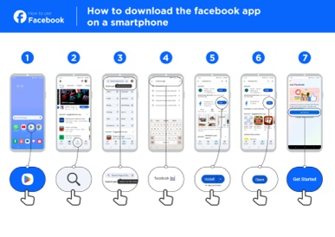
Show the ‘How to download the Facebook app on a smartphone or access on the web’ poster

- Go to free.facebook.com/lite or go to facebook.com/lite if free isn’t available.

- Tap Download Now.

- Open the Facebook Lite app.

- Explain: “This poster shows the steps for downloading, accessing and registering for Facebook.”

- Take your trainees through the steps on their phones and explain you can add friends, share text and photos and get the latest news from celebrities, sports teams, news and more.
Show user how to access Facebook on the web

Explain: “If you have a feature phone, then you can access Facebook on a web browser.”

- Go to free.facebook.com or go to facebook.com if free isn’t available.

- Bookmark the website so the trainee can find it again.

Activity: Create a Facebook account
Explain: “You need to create an account so your friends can find you on Facebook.”

Ask if you can help the trainee create an account and walk them through the steps on the posters:
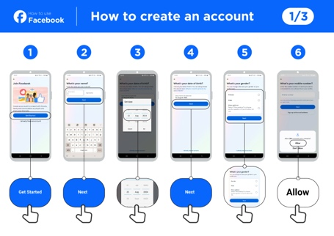
- Enter real name

  - Select birthday

  - Enter mobile number

  - Select gender

  - Choose a secure password that is easy to remember

    - Receive and type in confirmation code via SMS or WhatsApp

- Click OK to login

Activity: Add friends
Explain: “You must add people as friends on Facebook to see the pictures and information they post and share your pictures and thoughts.”
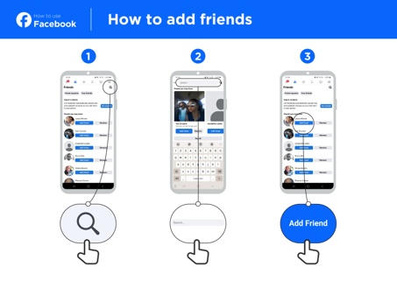
Show the ‘How to add friends’ poster

Add friends:

- Hold up the friends icon for Facebook and explain where to find it.

- Have the trainees connect with at least five friends using suggestions of people you may know.

- Have the trainees search for at least two specific friends and add them.

- Send trainees a friend request to show them how to accept (or decline).

- Explain that now when they use Facebook, they will see whatever their friends share.

Activity: Like celebrities, sports and news pages
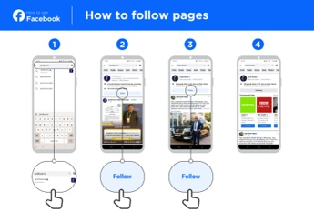
Show the ‘How to follow pages’ poster
Explain: “You can also get the latest news from your favourite celebrities and sports teams by liking their page. When you like a page, the information they post will show up when you log into Facebook.”

Like pages:

- Hold up the search icon and explain where to find it.

- Ask trainees what celebrities, sports or news they like and have them type it into the search bar and go to the page.

- Show them the like icon and show them where to click it on the page.

- Show them the News Feed icon, have them click it and see how their view has changed.
Tip: Give the trainees time to explore. Let them add as many friends and pages as they want. The more they add, the better Facebook will be for them. You can also share what pages are most popular in the local area.

Activity: Make a post
Explain: “Now let’s learn how you can share personal or business information on Facebook.”
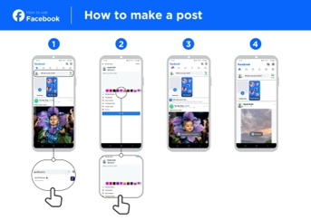
Show the ‘How to make a post’ poster
- Show the photo/video icon and have trainees click it.

- Explain that you can also select the camera icon to add a photo/video.

- Explain that photos or videos can be added from the phone or new ones can be taken.

- Explain that they can add text to the image/video or just post it alone.

- Explain they can also just make a text post if they don’t want to include a photo or video.
Personal use
Discuss with your trainees what they might like to share on Facebook.

Share what you post to Facebook. Show them some of the posts you’ve made and tell them why you shared them.

- Ask: “What would you like to share with your friends and family?”

- Ask: “What could you post to help your business?”

Safety
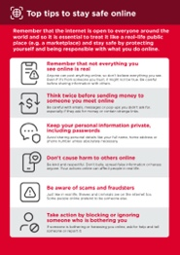 | Show the ‘Top tips to stay safe online’ poster  Discuss with your trainees what these tips mean when using Facebook.  Bring the tips to life by using examples that are relevant for your trainee. For example, certain people may be worried about some of the content on Facebook. Some people may be worried about scammers using Facebook and some women may be more concerned about how to prevent harassment.
Explain: “Just like in the real world, you can make choices on Facebook about who you do and do not want to interact with.”

Explain: “The photo you choose as a profile picture will be visible to all Facebook users. This helps people find you and add you as a friend on Facebook.”

Ask: “Do you want to choose who sees your posts?”

Demonstrate how to select the audience when making a post and how to change the privacy setting later.

Explain: “You can have a post appear to the public (everyone using Facebook) or only to your friends.”

Explain to trainees that they can access additional privacy controls. Show them privacy shortcuts where they can see who can view their profile, who can contact them with friend requests, and how to block someone who is bothering them.
Tip: “If you don’t control who can see your Facebook posts, anyone can contact you. They might send you things you don’t want to see or ask for personal information or money. Never share personal details like your banking PIN or address with strangers. Don’t send personal images or money to people you don’t know, or have met online; it could be a scam.”

Recap
Play the Facebook icon game

• Hold up each Facebook icon, one at a time.

- Ask: “Where is this on the phone and what is it?”

- Explain to your trainees what each icon is if they need support.

• Give small rewards (e.g. sweets) for correct answers and stick the icons on the wall afterwards to help remind your trainees what they are.
Tip: Let trainees play with Facebook on their own, make posts, share pictures, search pages and add friends. Encourage them to ask questions as they explore Facebook.

Recap on Facebook
Discuss with your trainees what they have learned about using Facebook.

- “What have you learned about using Facebook?”

- “What do you want to use Facebook for in your own life? What are you most interested in and excited about using it for?”

- “What will your next post be?”

In-Depth Training
Facebook

Mobile Internet
Skills Training

Toolkit

A guide for training people

in basic mobile internet skills

Posters and Cut-Outs
Session Ground Rules

This space is:

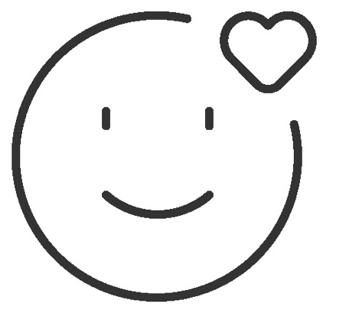

Safe

Keep all information in this training confidential. We suggest you don’t share personal numbers with the other members of group.

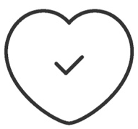

Positive & open

Please be respectful and
positive in your opinions and discussions. There are no right or wrong answers and we are not here to test you.

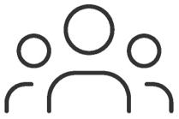

- shared
community

There are people with different backgrounds, knowledge and opinions. This is our shared space, so respect and support everyone.

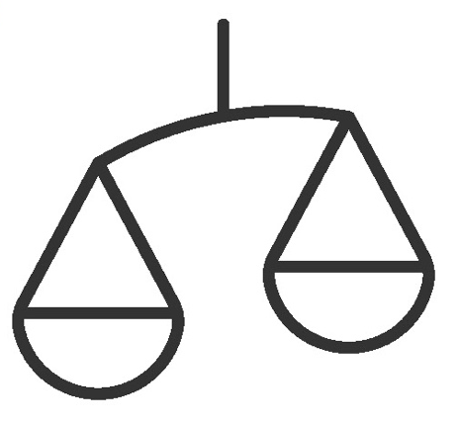

Fair

We will work in small groups and we will provide you with shared phones. We would like to give everyone an equal chance to be heard and to take turns using a phone.

Definitions

Trainers can add to this section to include local relevant information on mobile internet
3G / 4G / 5G | The internet can run at different speeds when you use it. 3G internet is the slowest, 4G internet is faster and 5G internet is the fastest.
App | An app gives you a shortcut to a service on your phone. For internet services e.g. WhatsApp, Facebook, Google, apps provide a quick and easy way to get onto the internet to use that service.
Address bar | The address bar shows you what website you are on.  In the address bar there will always be the address of the website e.g. www.google.com
Advert  or Ad | An ad is a piece of information that is trying to sell you something. It is good practice to avoid clicking on ads.  - Ads can be videos or images that pop up on your screen.  - Ads can also be the links at the top of Google results and on the right side of the screen.
Browser |   A web browser, or simply “browser,” is an application used to access and view websites. Common web browsers include:
Data | Whenever you use the internet on your phone, you are using data. You can buy data from your mobile network provider, just like you do with phone credit.
Feature  Phone | A mobile phone that has the ability to access the internet and store and play music but lacks the advanced functionality of a smartphone.
 | Google is an internet service that makes it easy to find any information that you want to find on the internet.

Definitions

Internet | The Internet is a network of millions of computers around the world connected to each other with phone lines, satellites and cables. It gives you access to a huge range of information and services and it is growing all the time. The internet is for everybody. There are no restrictions on who can use it. You just need a computer, mobile phone or tablet and a data connection.
Link | A link connects you from one website to another. To go to the other website, you can touch the link and this will connect you and take you to that other website
Megabytes & Gigabytes | Megabytes (MB) and Gigabytes (GB) are units of data that you use when using the mobile internet. GB are 1000 times bigger than MB. If you download or stream a song, that will use approximately 5MB (1MB per minute).
Search | The search function helps you find what you are looking for. You type the words to what you are looking for into a search box and then you will see a list of links to potential answers.
Smartphone | A mobile phone that has the ability to access the internet, store and play music and videos, and run ‘apps’. These phones typically also have a touchscreen.
Website | Information on the internet is kept on different websites. There are lots of separate and different websites on the internet e.g. Google is a website, YouTube is a website.
 | WhatsApp is an internet service that makes it easy to connect and communicate with people that you know; family, friends and colleagues.
WiFi | A WiFi zone is an area where you do not have to use your own  data to access the internet on your phone; you can connect to the  internet for free. WiFi zones are available in some public places  such as coffee shops and cafes.
 | YouTube is an internet service that makes it easy to find, watch and listen to videos on the internet (and only videos).

Trainers can add to this section to include local relevant information on mobile internet

Top tips to stay safe online

 | Remember that not everything you see online is real  Anyone can post anything online, so don’t believe everything you see. Even if it’s from someone you trust, it might not be true. Be careful before sharing information with others
 | Think twice before sending money to someone you meet online  Be careful with emails, messages or pop-ups you didn’t ask for, especially if they ask for money or contain strange links.
 | Keep your personal information private, including passwords  Avoid sharing personal details like your full name, home address or phone number unless absolutely necessary.
 | Don’t cause harm to others online  Be kind and respectful. Don’t bully, spread false information or harass anyone. Your actions online can affect people in real life.
 | Be aware of scams and fraudsters  Just like in real life, thieves and criminals are on the internet too.  Some people online pretend to be someone else.
 | Take action by blocking or ignoring someone who is bothering you  If someone is bothering or harassing you online, ask for help and tell someone or report it.

Remember that the internet is open to everyone around the world and so it is essential to treat it like a real-life public place (e.g. a marketplace) and stay safe by protecting yourself and being responsible with what you do online.

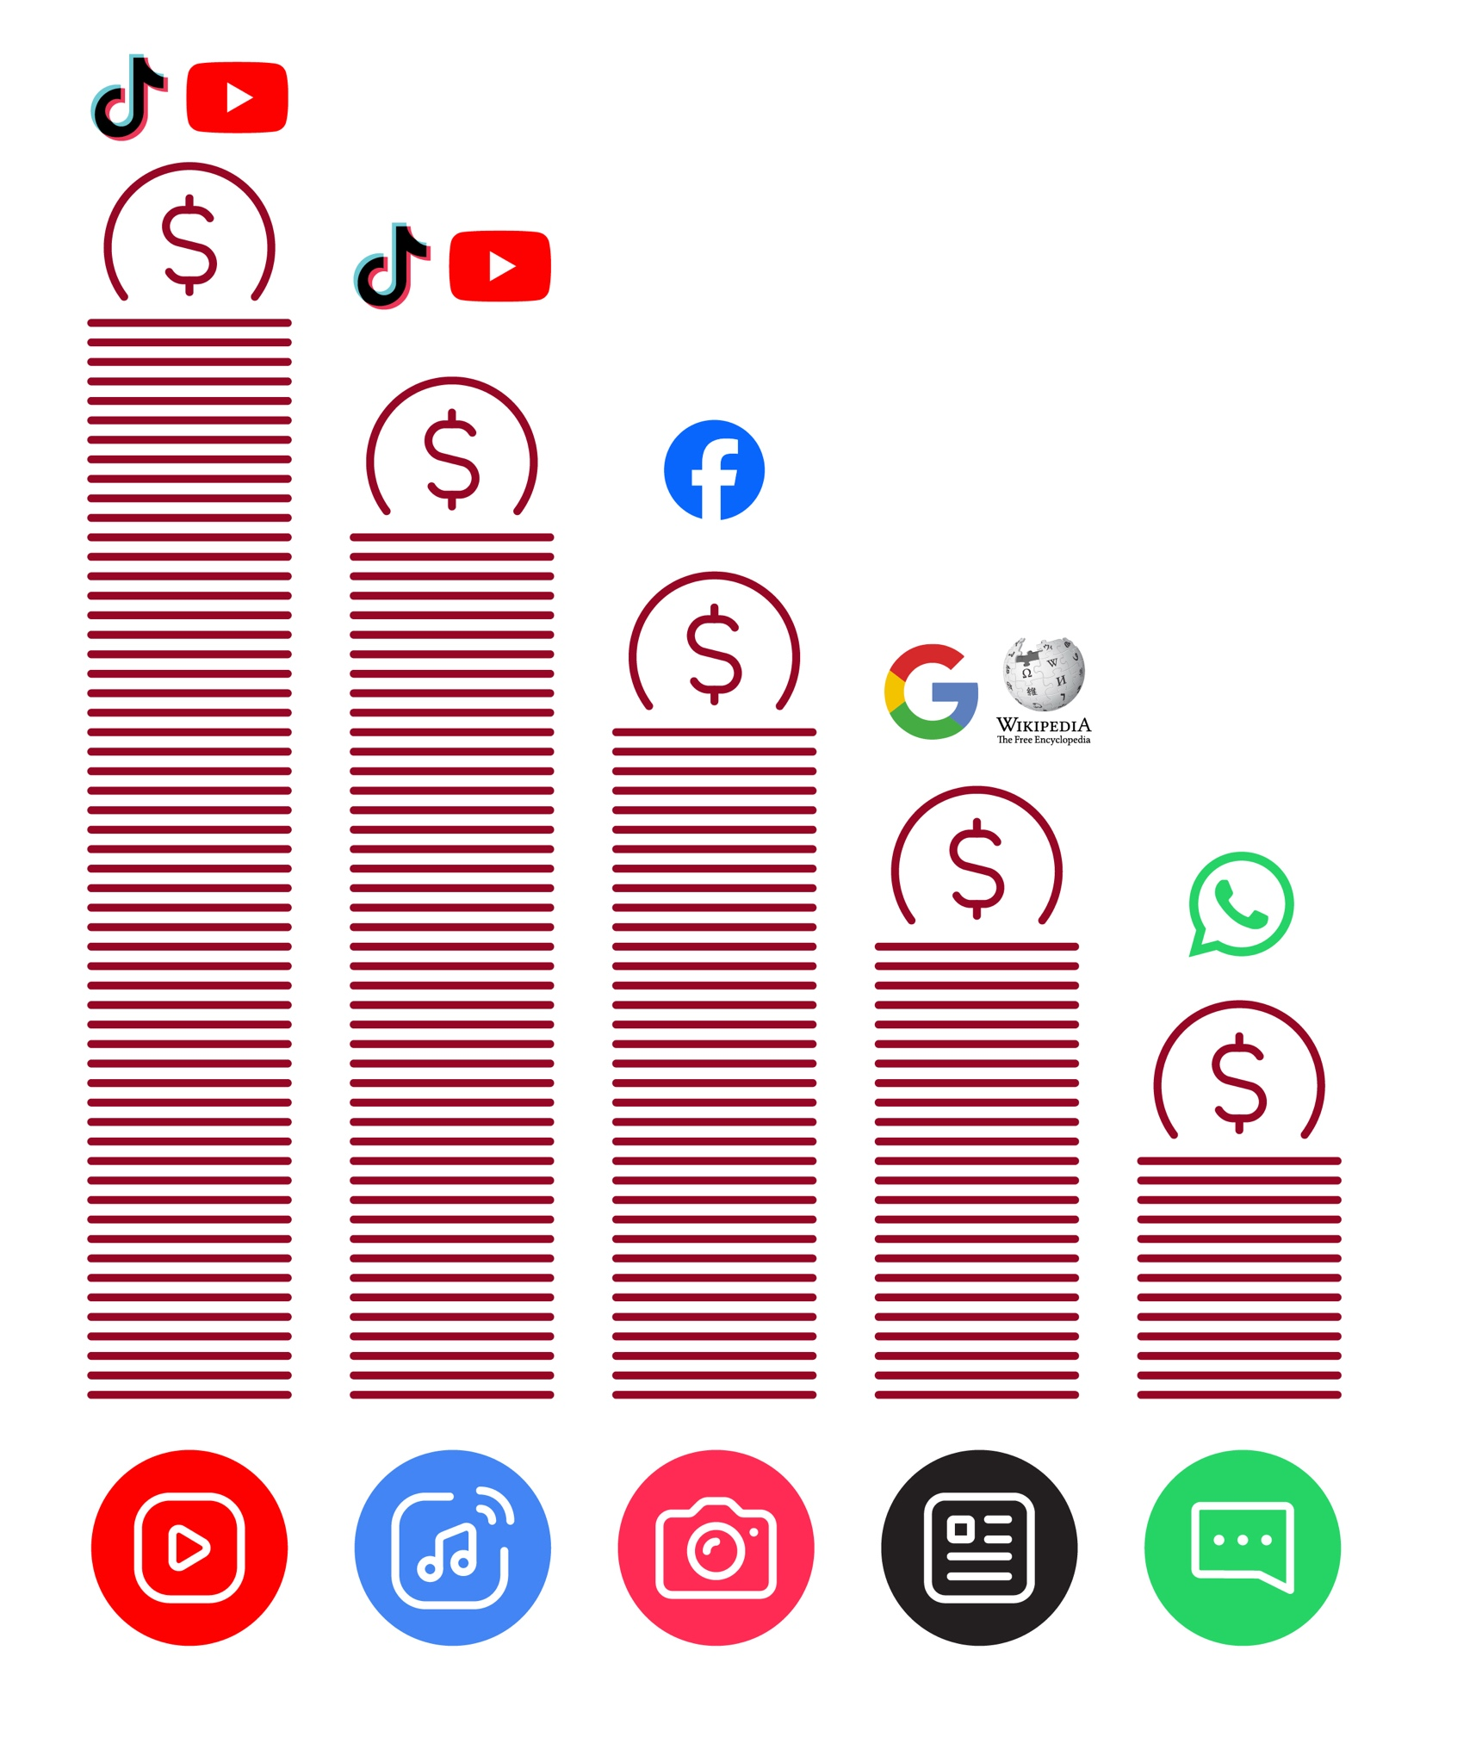
Data Costs
Healthy Internet Use

 | Set time limits  Think about how much time you are spending using the internet – it should not get in the way of your other responsibilities. If it does, set limits!
 | Watch your mood  If the internet or your phone is making you sad or angry, take a break!
 | Maintain healthy relationships online  Make time to socialise with friends and family in real life, not just on the internet! Don’t spend all your time on the internet.
 | Be careful  The internet can be dangerous with scams, harassment and things you don’t want to see. Be careful!
 | Stay positive  Stay positive and avoid upsetting or harming others. Be responsible and keep a positive attitude!
 | Get enough sleep and rest  Sleep and rest are important - make sure the internet or your phone doesn’t stop you doing this! Don’t use the internet when you need to rest or sleep.


How to use
Facebook

How to download the Facebook app on a smartphone


1 2 3 4 5 6 7
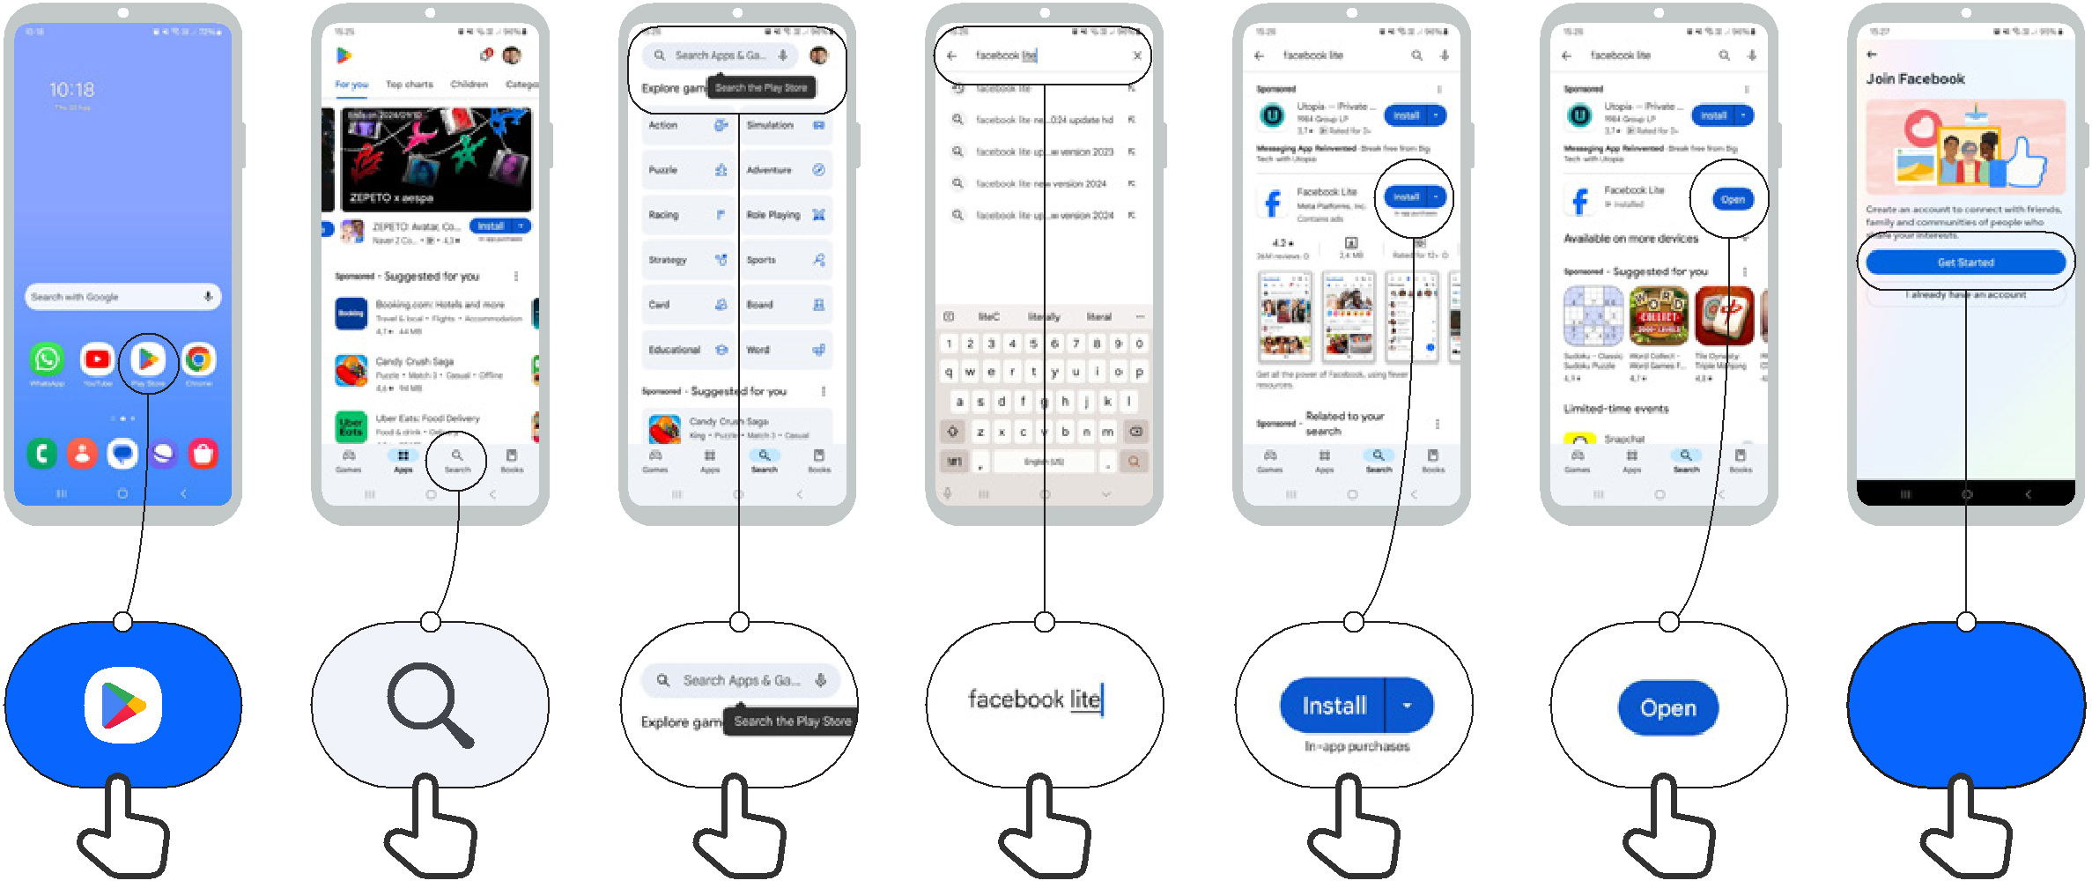

Get Started
How to use
Facebook

How to create an account | 1/3



1 2 3 4 5 6
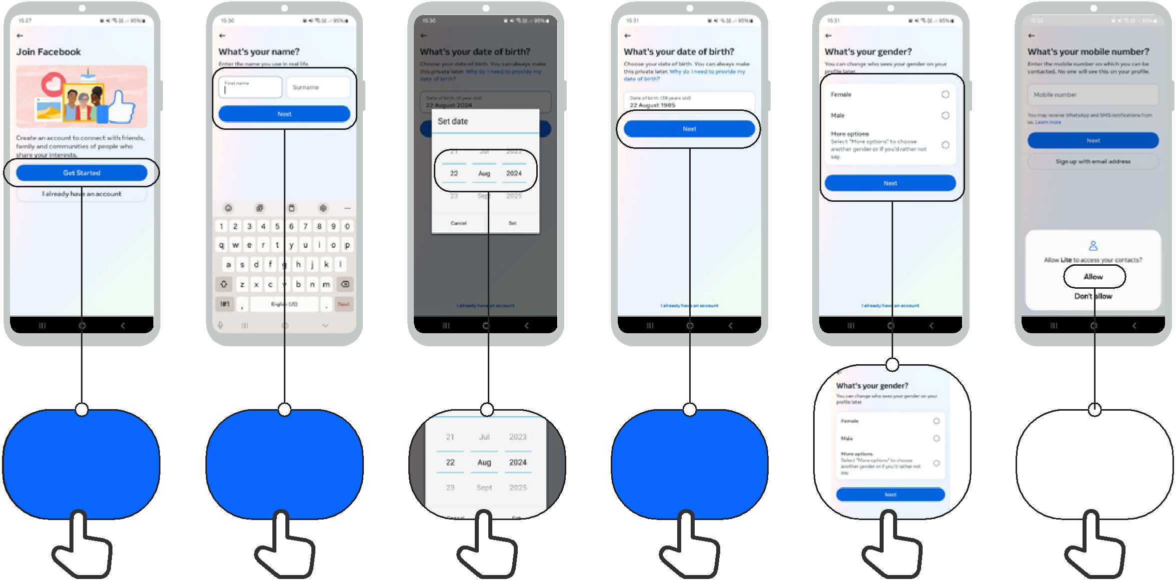

Get Started Next Next

Allow

How to use
Facebook

How to create an account | 2/3


7 8 9 10 11 12
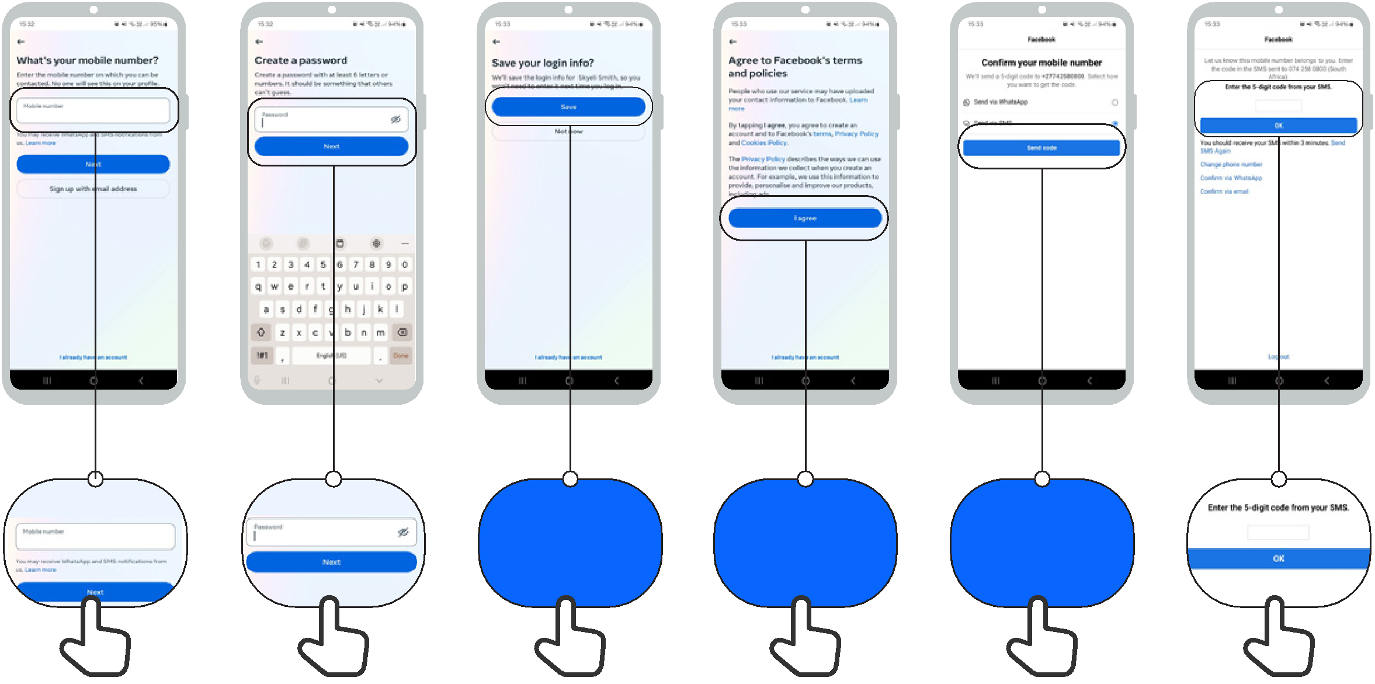

Save I agree Send code

How to use
Facebook

How to create an account | 3/3

13 14 15 16 17
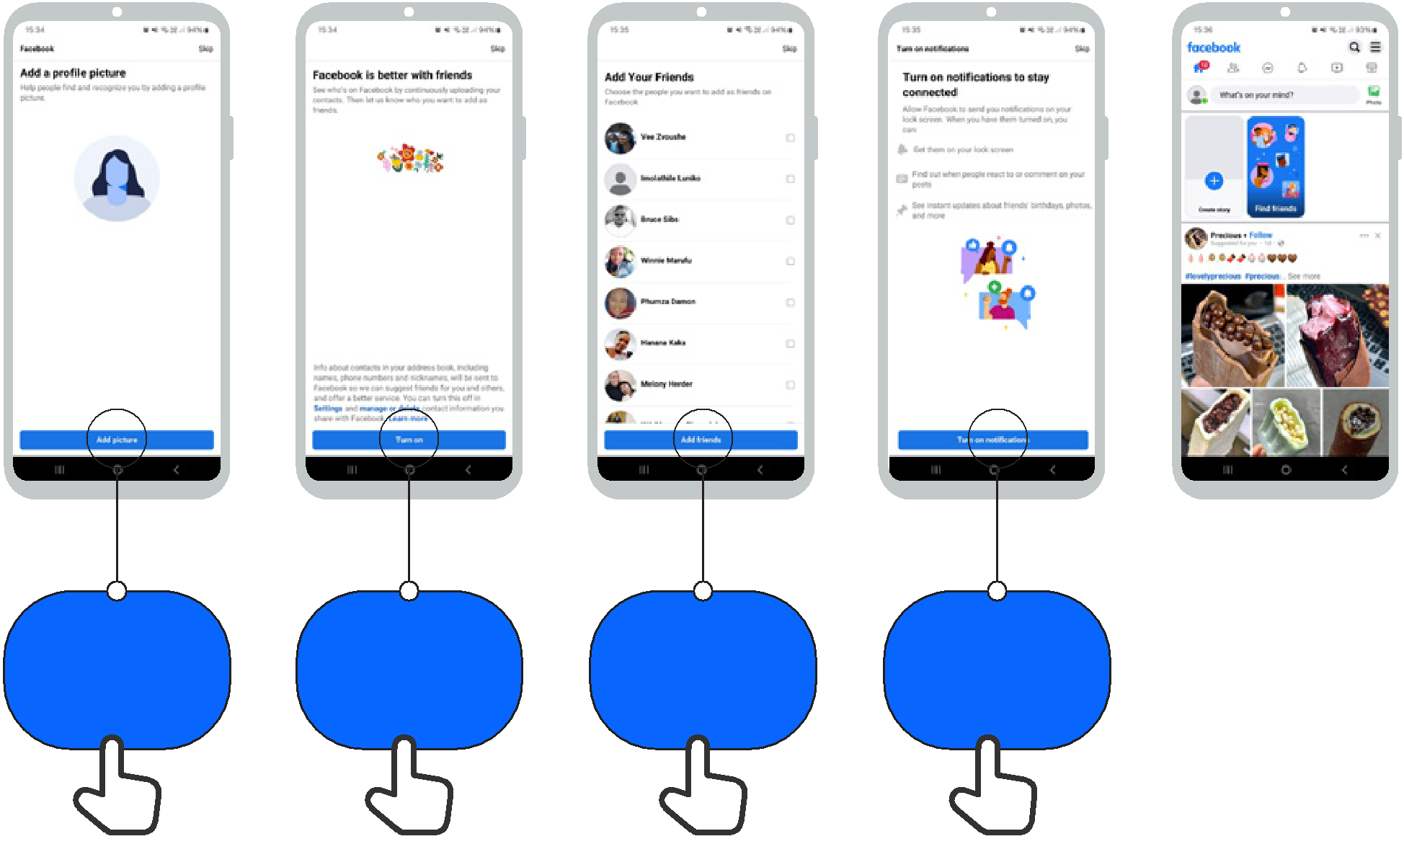

Add picture | Turn on | Add friends | Turn on
Add picture | Turn on | Add friends | notifications

How to use
Facebook

How to add friends

1 2 3
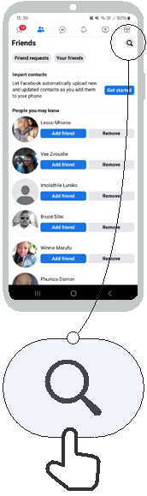
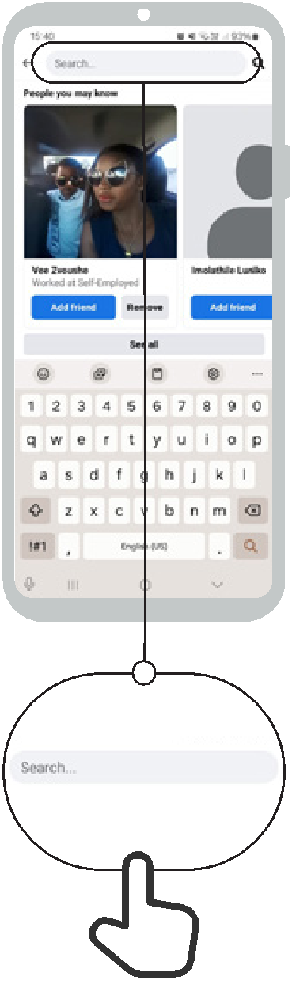


Add friend

How to use
Facebook

How to follow pages


1 2 3 4
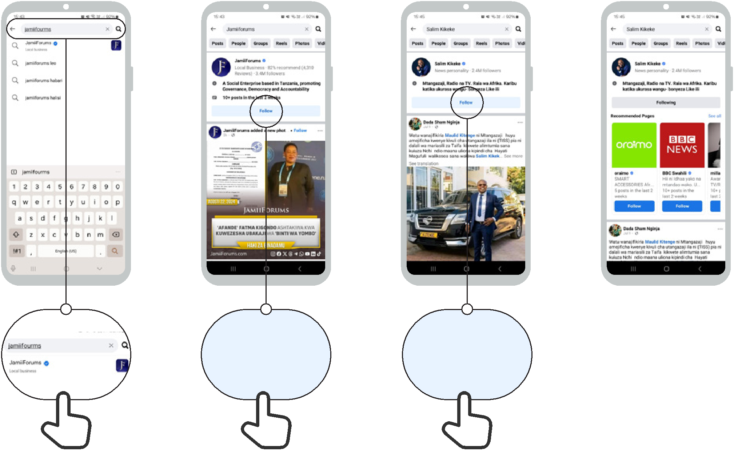

Follow Follow

How to use
Facebook

How to make a post

1 2 3 4
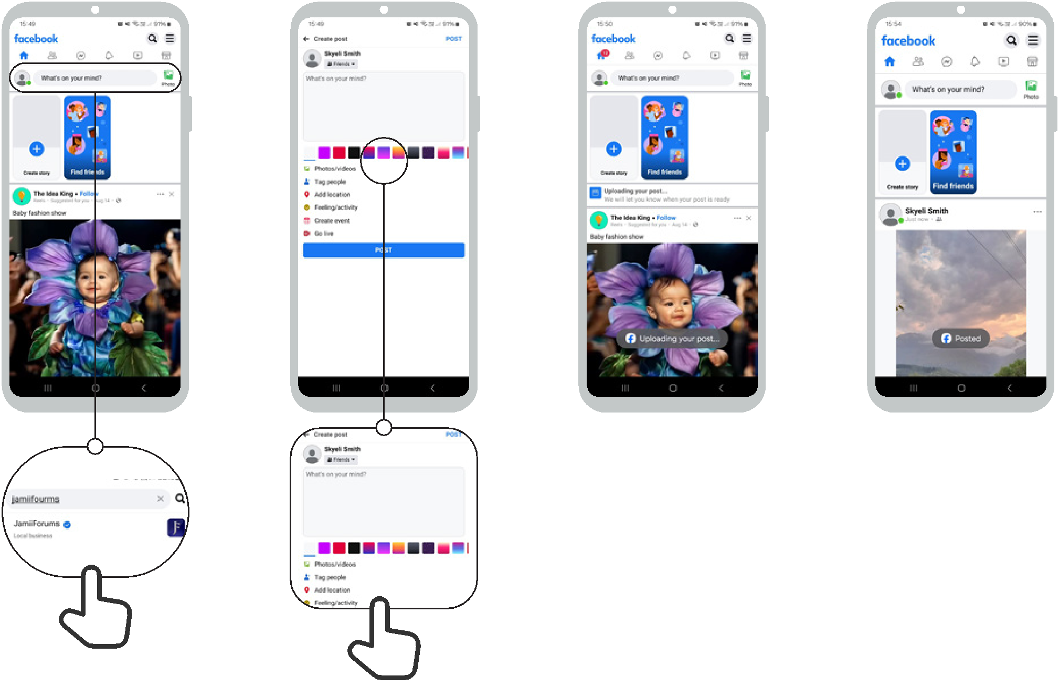


Icon Cut-Outs
Facebook


Icon Cut-Outs
Facebook


Icon Cut-Outs
Facebook


Icon Cut-Outs
Facebook

Icon Cut-Outs
Facebook



Icon Cut-Outs

Facebook


Mobile Internet Skills Training Toolkit

‘Thank you’ and close training

After you have completed the training, congratulate your trainees and hand out certificates as a reward.

Thank the trainees

Give out the handouts

- Give your trainees the handouts for the training if you haven’t already done so.

- These include the ‘Definitions’, ‘Top tips to stay safe online’, ‘Data costs’, ‘Healthy internet use’ and relevant module posters.

- Ask: “Do you feel confident to use these accessibility features?” or “Do you feel confident to use your mobile phone?”

- Thank your trainees for their time, input and participation in the training.



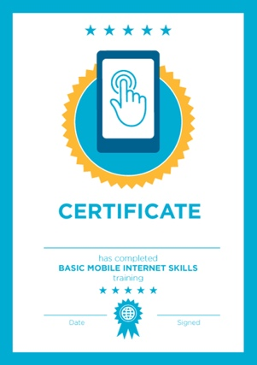

Conduct a closing ceremony

- Give each trainee a signed certificate (certificate templates are included in the toolkit).

- You can also provide the trainers with certificates for having completed the training ‘as trainers’.

Tip: You can make this more of a ceremony for trainees, by asking them to come up to the front of the room one person at a time to receive their certificate and shake the trainer’s hand.

here


CERTIFICATE

has completed

BASIC MOBILE INTERNET SKILLS

training

Date Signed

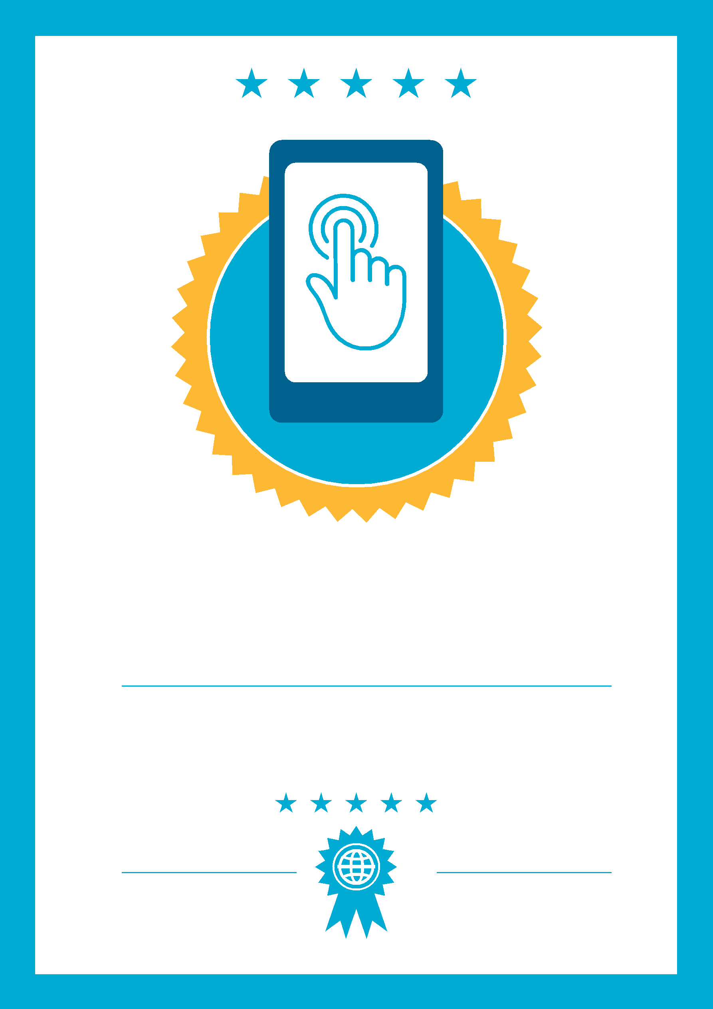

CERTIFICATE

has completed

BASIC MOBILE INTERNET SKILLS
training

Date
Signed

