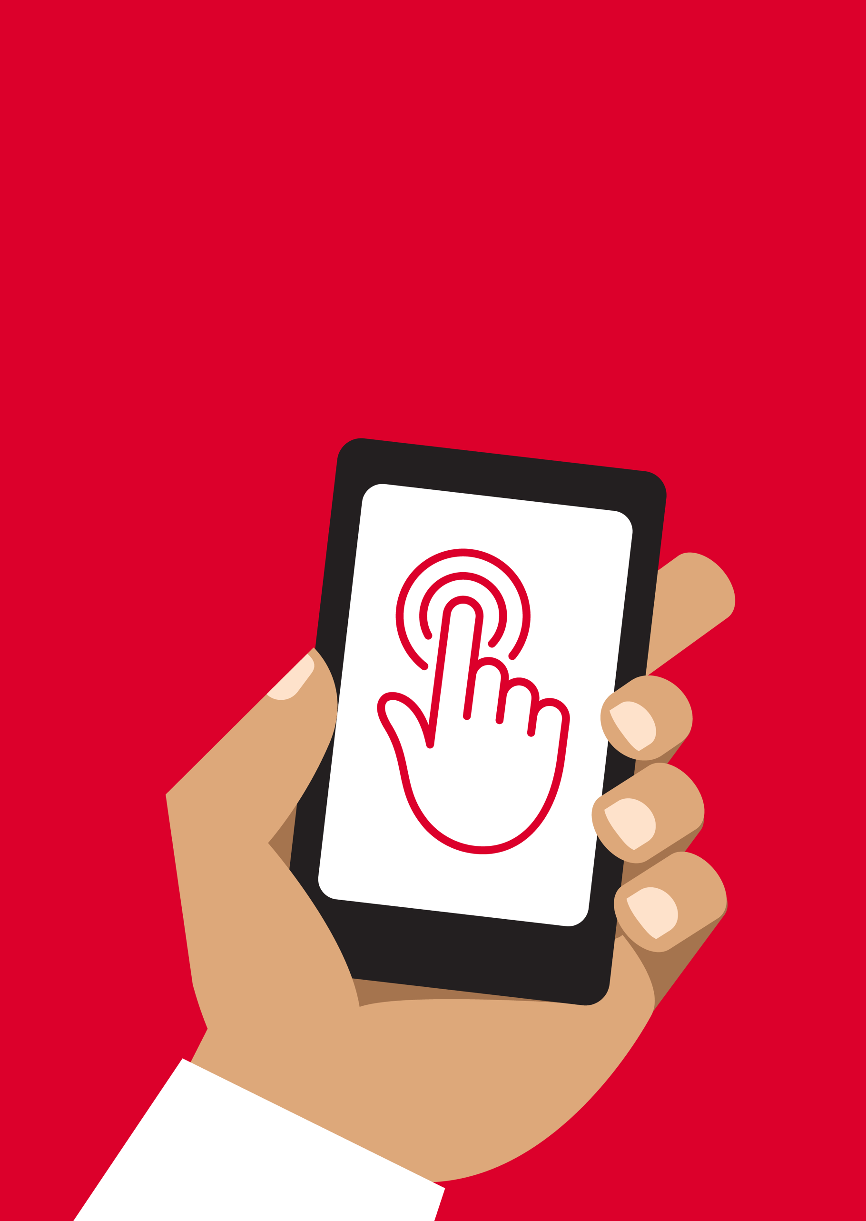


Mobile Internet
Skills Training
Toolkit
A guide for training people in
basic mobile internet skills

Copyright © 2024 GSM Association

Bitesize Training
Introduction to the Internet

Mobile Internet
Skills Training

Toolkit

A guide for training people

in basic mobile internet skills

Module 1: Introduction to the Internet

What is it?
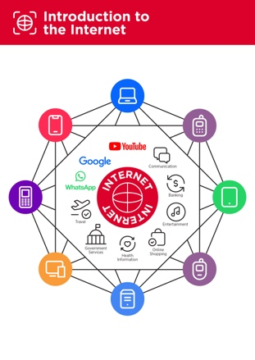 | Show the ‘Introduction to the internet’ poster.  Explain: “The internet is a network of millions of computers around the world connected to each other with phone lines, satellites and cables. It gives you access to a huge range of information and services and it is growing all the time. The internet is for everybody. There are no restrictions on who can use it. You just need a computer, mobile phone or tablet and a data connection.”
What can you use it for?
“The internet can help you do many things such as:

- Help you to manage a business, communicate with customers and suppliers and help you to easily conduct business from your home and travel less.

- Send messages and photos and stay connected with family and friends who might live far away.

- Stay entertained by watching videos, music and sports.

- Promote and sell your latest products, services or produce or buy things your family needs.

- Learn new things like new recipes, how to run a business, repair something or improve your farming practises.

- Look-up and find information on subjects like news, weather, transportation timetables, religious sermons, health advice for your family and more.

There are plenty more things the internet can help you do. These are just a few examples.”
This page is designed to help trainers answer more general questions that trainees may have about the mobile internet. It gives simple explanations to some questions that people often ask about the internet. It might be helpful to print this sheet off. You will also find these examples embedded within the modules of this toolkit.

What can you use it for?
Make it relevant to the trainee by discussing how it can be beneficial in the trainee’s own life. Consider examples that will be relevant to the following types of trainees:

Older person: Stay connected with family by messaging or using social media; search for health information online.

Mother or homemaker: Learn a new skill like making or mending clothes; support children with schoolwork; contact a doctor about a child’s illness.

Business owner: Communicate with customers or suppliers; promote or sell your products or services; learn and discover new things for your business.

Farmer or rural person: Access to market prices and marketplaces, weather forecasts and information and tips on farming best practice.

Young person: Get help with your schoolwork; learn new things and stay entertained by watching videos like those by your favourite musician or sports.

How does it work?
There are two kinds of mobile phone which you can use to access the internet.

Smartphones: “These phones are like mini computers. Normally you control them by touching the screen rather than using buttons. They can take photos, play music and videos and have apps that can quickly take you to an internet service.”

Feature phones: “These have fewer features than a smartphone. They don’t have a screen you can touch but you can play music and take photos. You can access the internet on a browser to use the online services you want.”

Data Costs
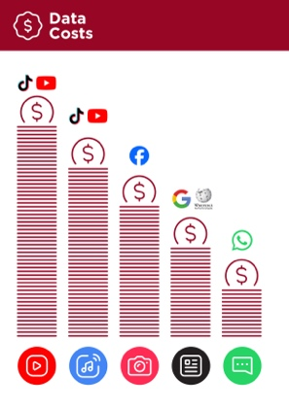
“To access the internet via your mobile phone, you can either use a mobile data connection or a Wi-Fi connection.”

Show the ‘Data costs’ poster.

“Normally, when you use the internet on your phone, you are using mobile data. You will need to buy this from your local mobile network agent or a shop that sells phone credit.

Some things you do on the internet, like watching videos or listening to music, use more data, so will cost you more money.”

Mobile Internet
Skills Training

Toolkit

A guide for training people

in basic mobile internet skills
Bitesize Training
Introduction to the Internet

Posters and
Cut-Outs
Top tips to stay safe online

Remember that the internet is open to everyone around the world and so it is essential to treat it like a real-life public place (e.g. a marketplace) and stay safe by protecting yourself and being responsible with what you do online.
 | Remember that not everything you see online is real  Anyone can post anything online, so don’t believe everything you see. Even if it’s from someone you trust, it might not be true. Be careful before sharing information with others
 | Think twice before sending money to someone you meet online  Be careful with emails, messages or pop-ups you didn’t ask for, especially if they ask for money or contain strange links.
 | Keep your personal information private, including passwords  Avoid sharing personal details like your full name, home address or phone number unless absolutely necessary.
 | Don’t cause harm to others online  Be kind and respectful. Don’t bully, spread false information or harass anyone. Your actions online can affect people in real life.
 | Be aware of scams and fraudsters  Just like in real life, thieves and criminals are on the internet too.  Some people online pretend to be someone else.
 | Take action by blocking or ignoring someone who is bothering you  If someone is bothering or harassing you online, ask for help and tell someone or report it.

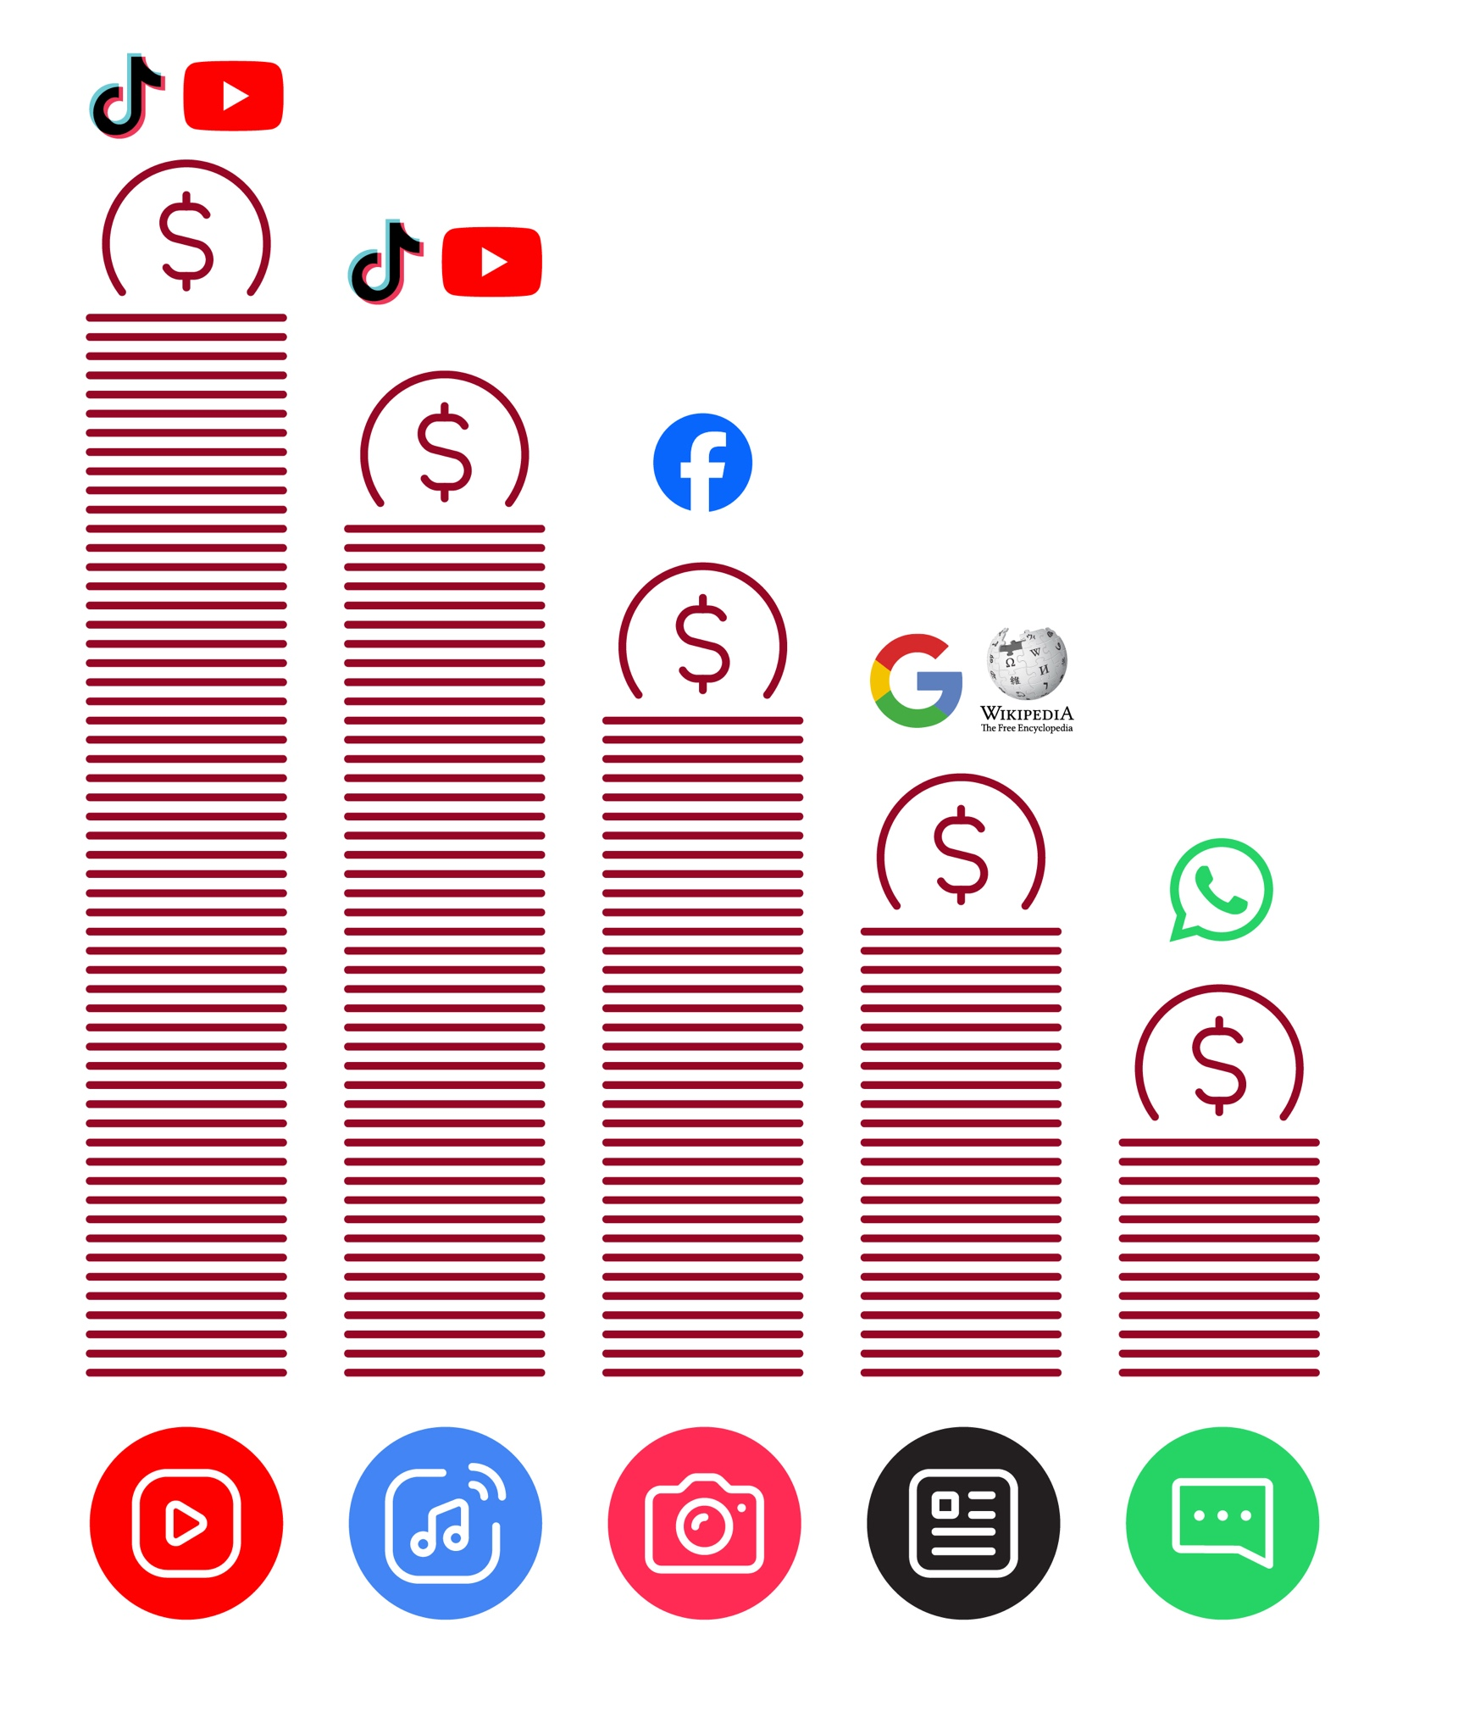
Data Costs
Introduction to
the Internet

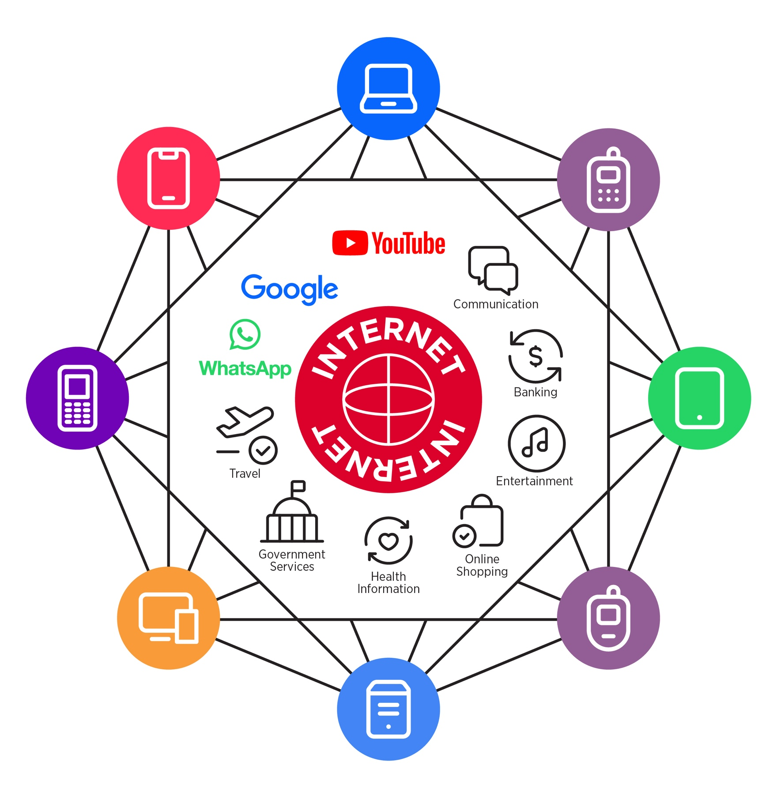

Take care of my family

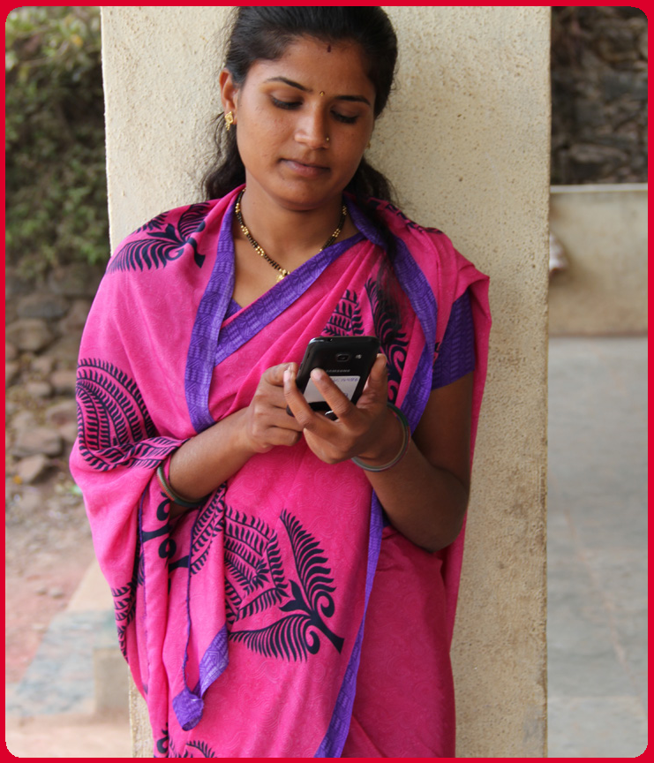

“Swati uses the internet to support and care for her family and friends”
Support my business

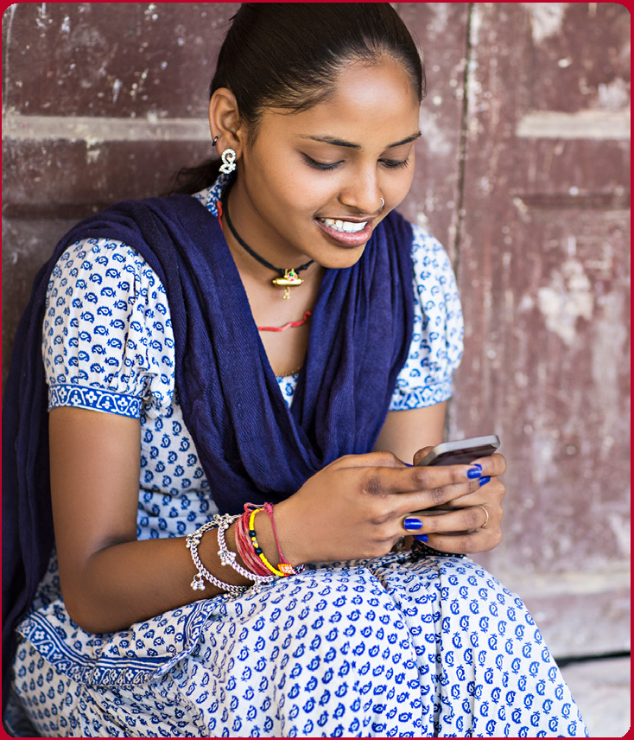

“Aarti uses the internet to help support her business”

Learn
more skills

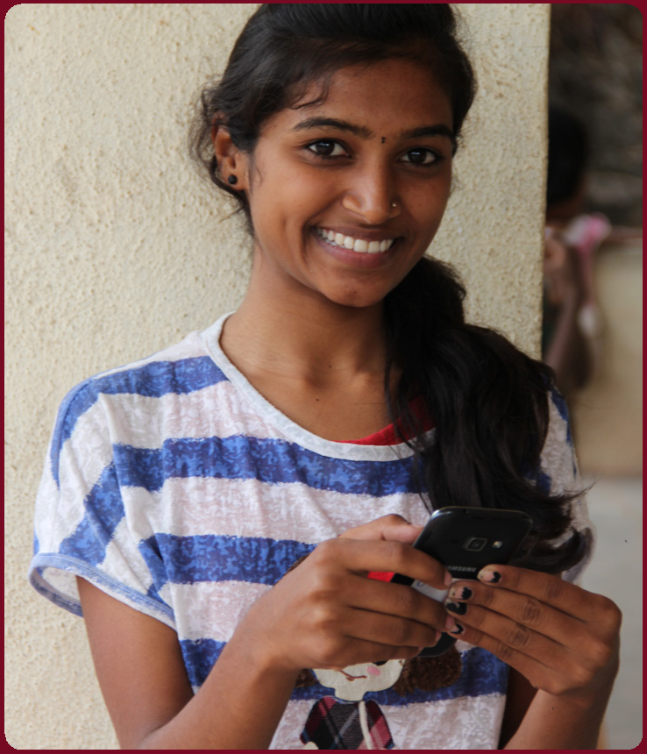

“Seema uses the internet to help her learn more skills’’

Take care of my family

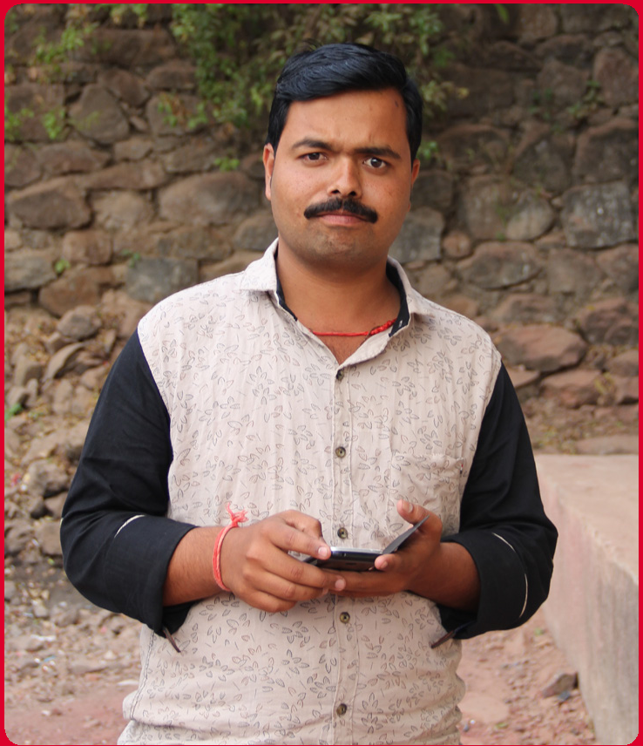

“Pradip uses the internet to support and care for his family and friends”

Support my business

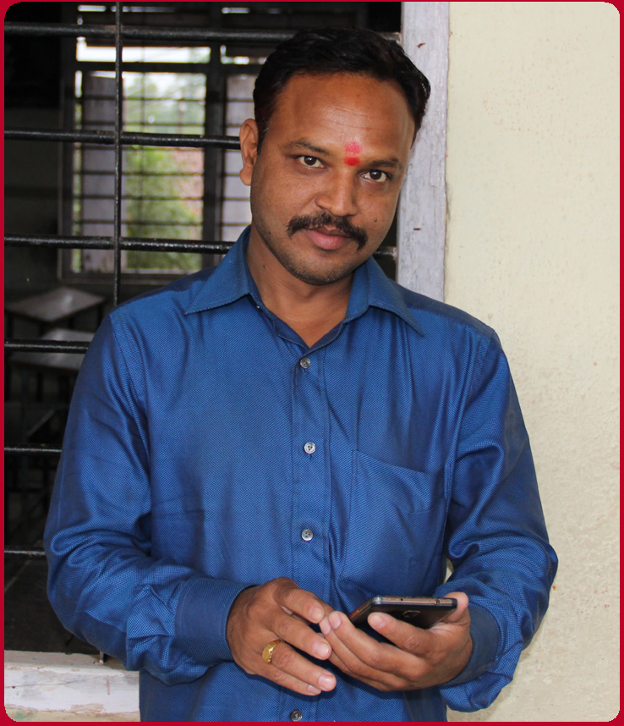

“Arunan uses the internet to help support his business”

Learn
more skills

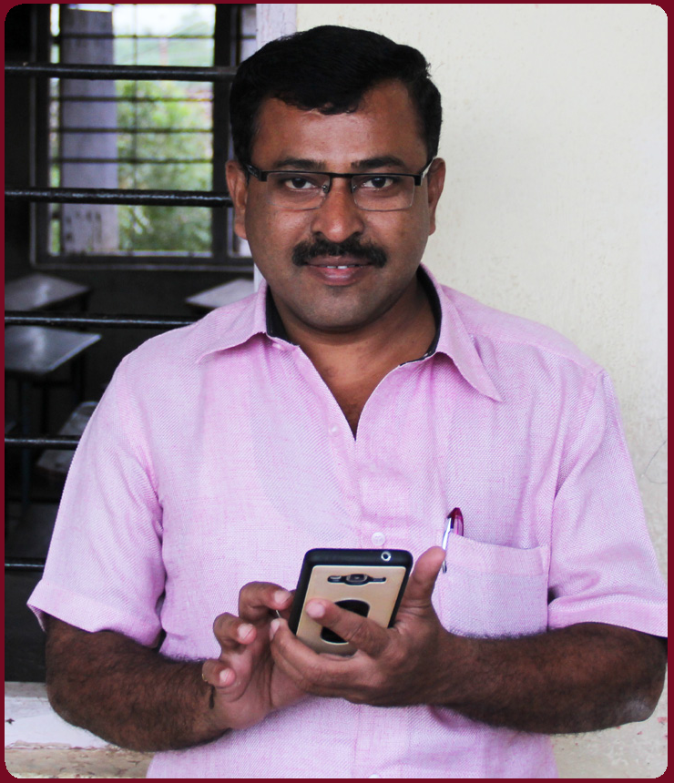

‘’Arvind uses the internet to help him learn more skills’’

Icon Cut-Outs
Introduction to the Internet



Icon Cut-Outs
Introduction to the Internet

Introduction to the Internet
Icon Cut-Outs



Icon Cut-Outs

Introduction to the Internet

Mobile Internet Skills Training Toolkit

‘Thank you’ and close training

After you have completed the training, congratulate your trainees and hand out certificates as a reward.

Thank the trainees

Give out the handouts

- Give your trainees the handouts for the training if you haven’t already done so.

- These include the ‘Definitions’, ‘Top tips to stay safe online’, ‘Data costs’, ‘Healthy internet use’ and relevant Module posters.

- Ask: “Do you feel confident to use these accessibility features?” or “Do you feel confident to use your mobile phone?”

- Thank your trainees for their time, input and participation in the training.

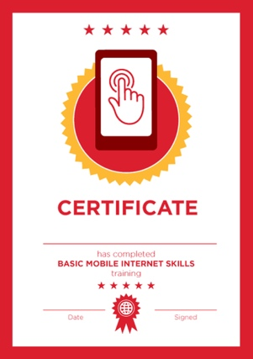

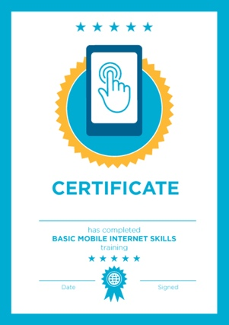

Conduct a closing ceremony

- Give each trainee a signed certificate (certificate templates are included in the toolkit).

- You can also provide the trainers with certificates for having completed the training ‘as trainers’.

Tip: You can make this more of a ceremony for trainees, by asking them to come up to the front of the room one person at a time to receive their certificate and shake the trainer’s hand.

here


CERTIFICATE

has completed

BASIC MOBILE INTERNET SKILLS

training

Date Signed

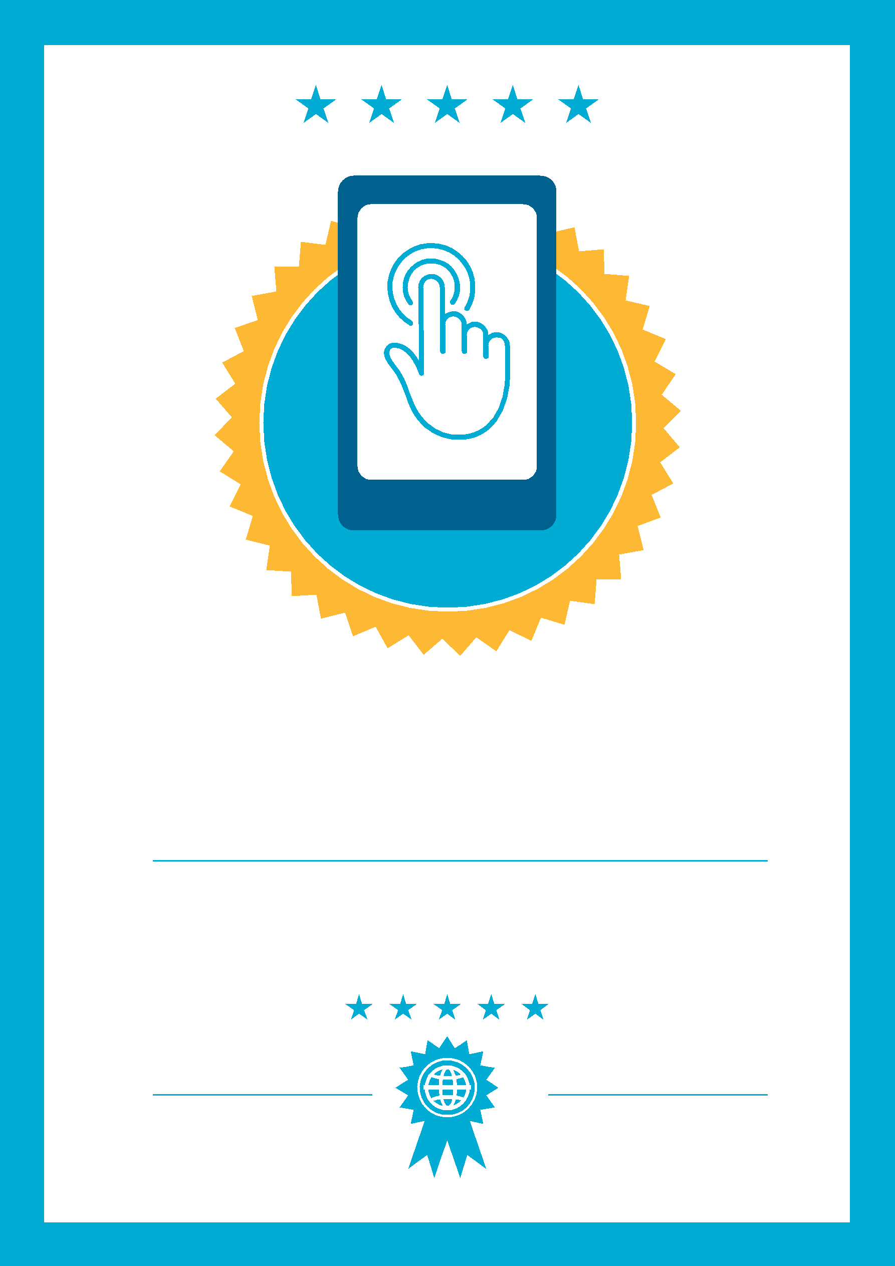

CERTIFICATE

has completed

BASIC MOBILE INTERNET SKILLS
training

Date
Signed

