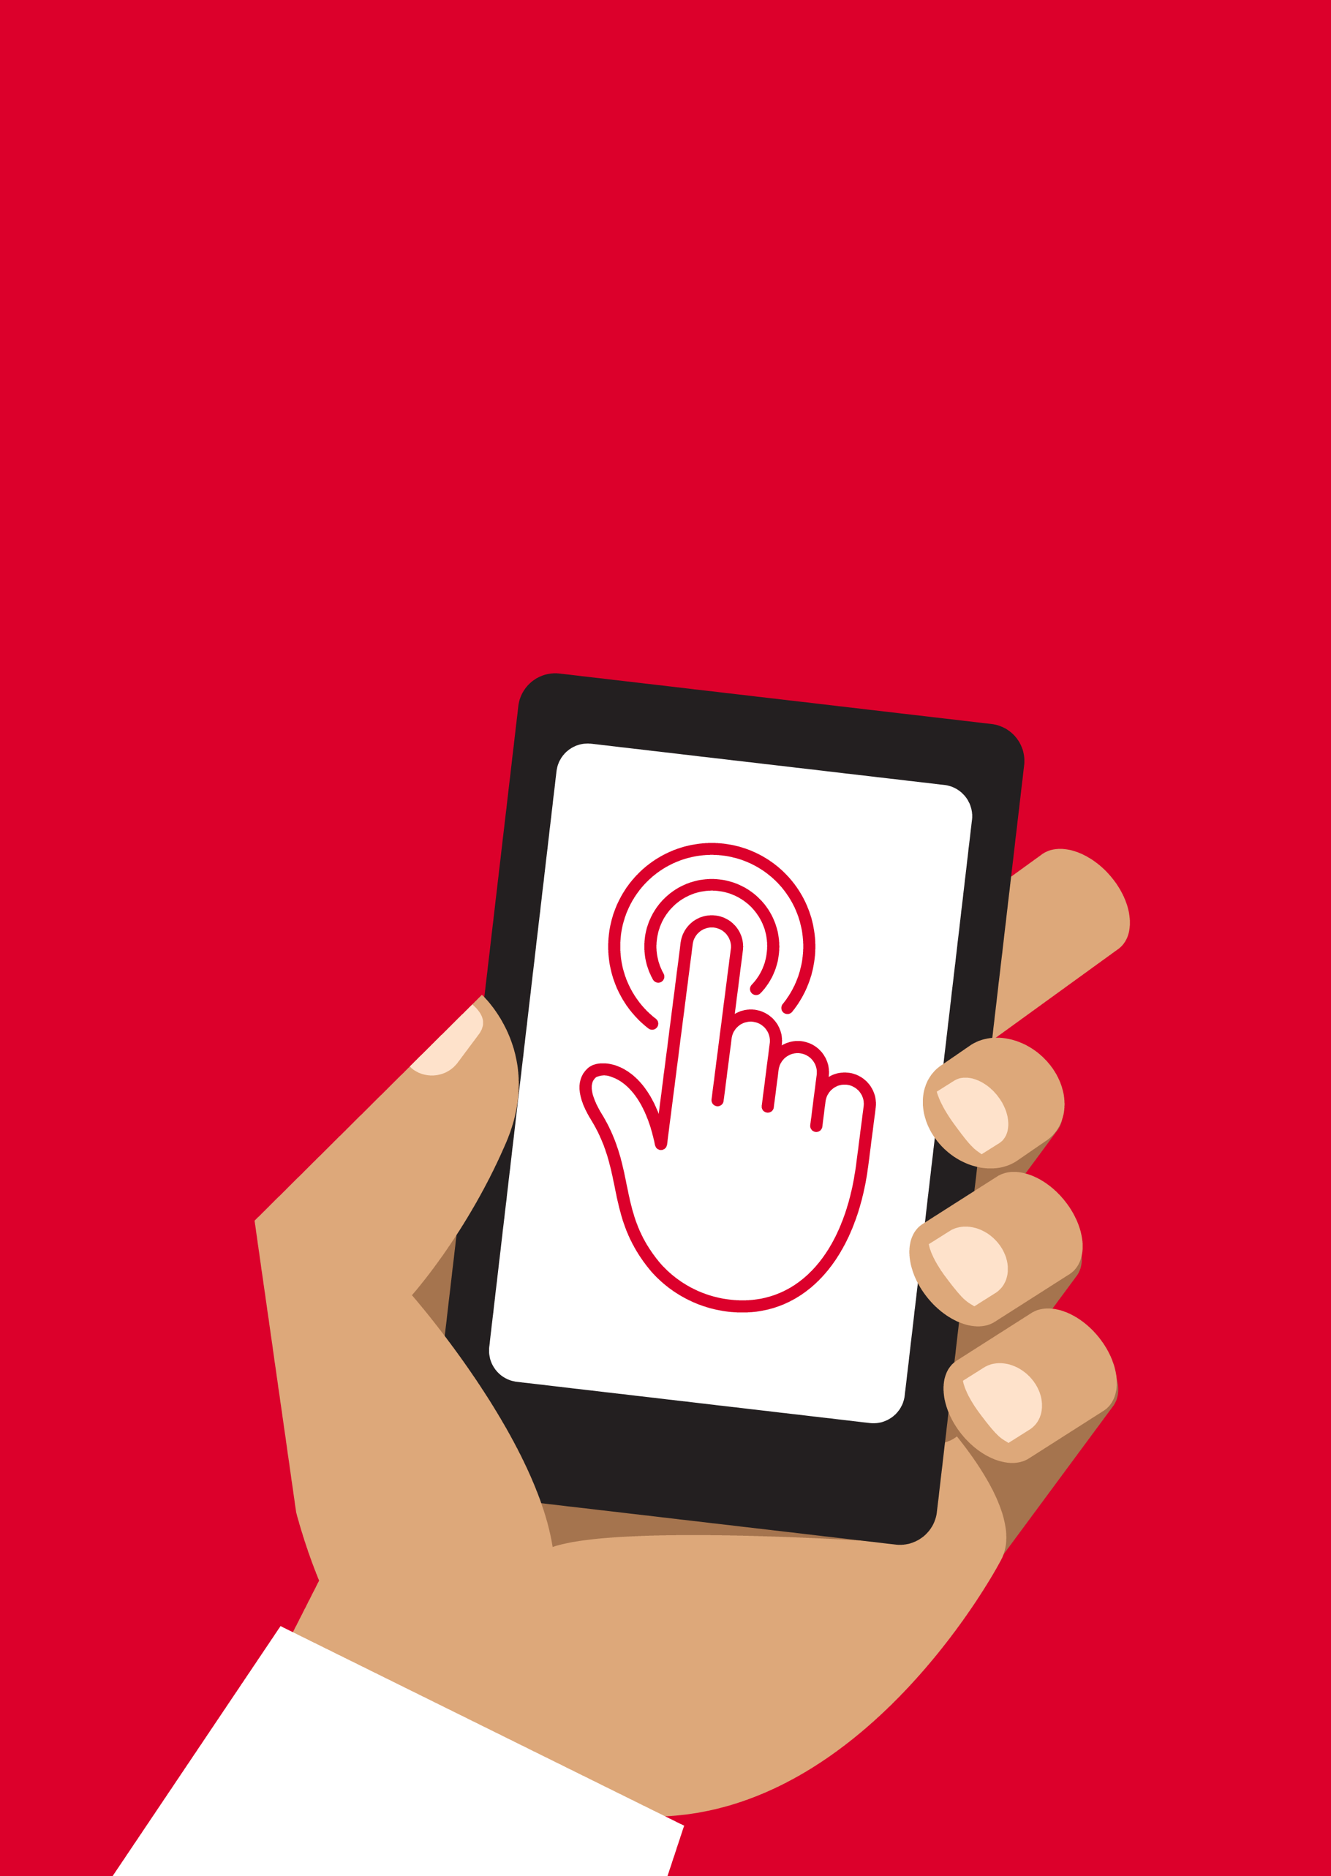

Mobile Internet
Skills Training
Toolkit
A guide for training people in
basic mobile internet skills


Copyright © 2024 GSM Association
In-Depth Training
Introduction to the Internet

Mobile Internet
Skills Training

Toolkit

A guide for training people

in basic mobile internet skills

Module 1:
Introduction
to the

Internet
Learning objectives
- Understand the purpose of the training and know who is in the room.

- Set the tone: Ensure the trainee feels safe, confident and motivated to learn about mobile internet and knows the ground rules.

- Understand the potential benefits of using the internet in their lives.
Time duration
45-60
minutes

Tip: Set the internet homepage on the shared devices to the Google image results of a famous local place. This provides trainees with a fun and interesting first experience of getting on the internet. To set the homepage, open your browser and go to the website you want to set as your homepage. Open your browser menu and click on settings, then set the current page as your homepage.

Materials you will need:
  Smartphone  handset |   Persona posters  For men show male personas, for women show Female personas |   Icon cut-outs |   Pens, paper, masking tape and a small ball
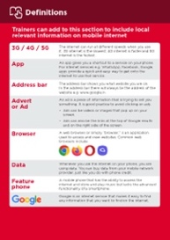  Glossary handouts | 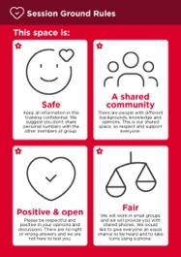  Ground rules |   Small rewards

Warm up with fun and games
Introduction game

- Take a small ball in your hands and briefly introduce yourself as the trainer. Say your name, your background and why you are here.

- Throw the ball to one of your trainees and ask them to stand up and introduce themselves to the group. Once they have finished, ask them to throw it to the next person.

- The game finishes when everyone in the room has caught the ball and introduced themselves.

Introduce the training
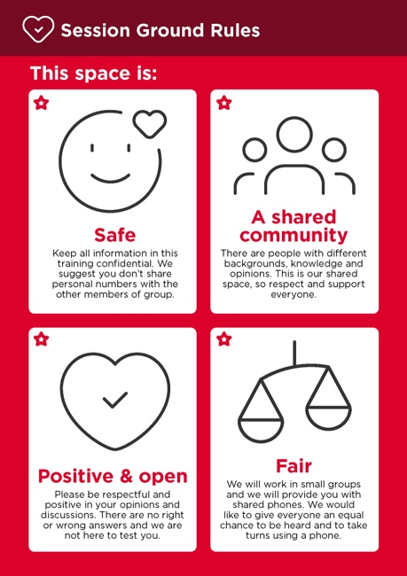
Explain the purpose of the training
• “We are here to learn about mobile internet: What it is, how to use it and what you can do with it.”
• Discuss the ground rules.
• Explain what you will be covering in the training, e.g. WhatsApp, YouTube, Google, Wikipedia, Facebook, Online Safety, Mobile Money, KaiOS, Android, Accessibility Features and TikTok. Talk about what each is particularly useful for.
• Explain: “You will be introduced to the internet on smartphones.”
• Explain the role of trainers: “As trainers, we are here to help you learn and to support you.”
• Explain: “Today is all about you. There are no right or wrong answers or questions. It is not a test; we want to help you to learn.”

Create mini groups
Split your trainees into mini groups

Make a line down the middle of the room and mark three points on the line:

I think using the
internet on my
mobile phone is
easy
I have used the internet on my mobile phone but don’t know it very well
I have never used the internet on my mobile phone

- Ask your trainees to stand on a place on the line that represents where they feel most comfortable with their ability to use the mobile internet.

- Split the trainees into groups of no more than six according to where they stand - each trainer in the room will work with one group.

- Explain that these groups will be used throughout the training.

Tip: Give your trainees plenty of time to explore different results and different word combinations.

Small group introductions
- Ask each person to tell the group their name, where they are from and what they are
interested in.
- Ask your trainees to write their names on masking tape and stick it onto their chest.
- Ask: “What do you want to learn?”
- Write each trainee’s intentions for the training on paper and stick on the wall.

Explain internet benefits
Explain that the trainer is going to ask questions and the trainees can put up their hands to answer.

- “Who here has used the internet on a mobile phone before?”

- “Can anyone stand up and tell us what the internet is?”

Explain what the internet is and where it comes from.

- Explain: “Your mobile network provider can connect you to the internet through your mobile phone.”
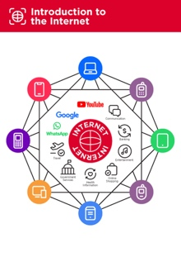
Show the ‘Introduction to the internet’ poster

- Explain: “The internet is a network that allows computers and some mobile phones to send and receive information across the world. It is like a big library of information that people across the world can access, use and add to.”
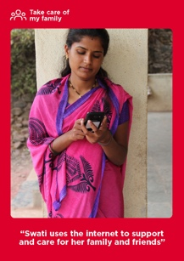
Show the ‘Persona’ posters

These posters are to help you explain to trainees what a person might use the mobile internet for.

- Explain: “The internet can help you to support your business, develop your skills, care for your family and friends, and lots more.”

Remember: Link discussions and activities in the training back to how the internet can be helpful or useful in their lives. This will help to keep the training relevant and interesting for them.
Explain internet benefits
Bring the benefits of the internet to life!

Tell your own story of how the internet is useful for you (the trainer), your friends and family or your community. Consider examples that will be relevant for these trainees:

Older person: Stay connected with family by messaging or using social media; search for health information online.

Mother or homemaker: Learn a new skill like making or mending clothes; support children with schoolwork; contact a doctor about a child’s illness.

Business owner: Communicate with customers or suppliers; promote or sell your products or services; learn and discover new things for your business.

Farmer or rural person: Access to market prices and marketplaces, weather forecasts and information and tips on farming best practice.

Young person: Get help with your schoolwork; learn new things and stay entertained by watching videos like those by your favourite musician or sports.
Make the internet relevant for your trainees.

Discuss with trainees how the internet could help them.

- Ask: “What could you learn to use on the internet that would help you?” Give them some suggestions.

- Ask: “What are you most interested in and excited to learn about?”

Tip: Show the trainees who are nervous or unfamiliar with the phone where the camera icon is and encourage them to take photos with the phone. This can help them to have fun and feel comfortable with touching the phone.
Give out smartphones
Give out the smartphones. Ensure that there are no more than three people to one phone.

- Demonstrate how to ‘tap’ (touch an icon on the screen), ‘swipe’ (drag finger right or left across the screen) and ‘zoom’ (drag two fingers apart on screen).
- Ask the trainees to take turns holding the phone, encouraging them to play with it and try tapping, swiping and zooming.
- Ask the trainees to tap on the icons on the screen and see what happens.

Ask your trainees to take a group photo (group selfie) with the phone

- Ask the trainees to show the trainer and other trainees the photo.

Discuss with your trainees what they recognise on the phone

- Ask: “Where does it show the battery life?”

- Ask: “Where does it show the phone signal?”

Discuss with your trainees why it is a ‘smart’ phone

- Ask: “What makes it ‘smart’?”
Tip: Give your trainees as much time as they need to explore and feel comfortable with the phone.

Activity: Play the mobile icon game
- Hold up each mobile icon, one at a time.
- Ask: “Where is this on the phone and what is it?”

- Explain to your trainees what each icon is if they need support.

• Give small rewards (e.g. sweets) for correct answers and stick the icons on the wall afterwards to help remind your trainees what they are.
Tip: There are many different browsers for using the internet. Some of the most common icons for these are displayed below. Depending on the phone you use, you may use one of these rather than the one shown above.

Activity: Get onto the internet
- Ask your trainees to find the ‘ball’ internet icon on their phone screen and click on it (the internet will open on the website of your choice if you have set this up). Please note that different phones may have different browsers (see below).

- Explain: “You are all now on the internet. That’s how easy it is. Congratulations.”

- Give your trainees plenty of time to explore and discuss what they can see.



In-Depth Training
Introduction to the Internet

Mobile Internet
Skills Training

Toolkit

A guide for training people

in basic mobile internet skills

Posters and Cut-Outs
Session Ground Rules

This space is:

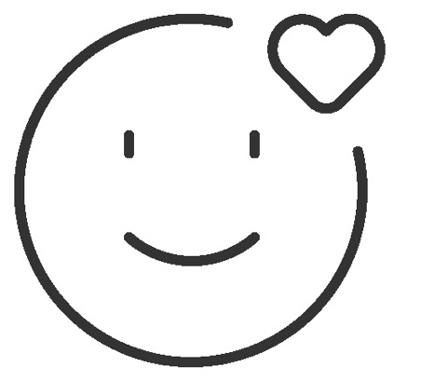

Safe

Keep all information in this training confidential. We suggest you don’t share personal numbers with the other members of group.

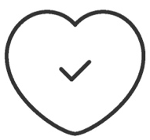

Positive & open

Please be respectful and positive in your opinions and discussions. There are no right or wrong answers and we are not here to test you.

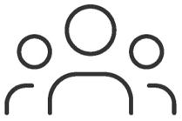

- shared
community

There are people with different backgrounds, knowledge and opinions. This is our shared space, so respect and support everyone.

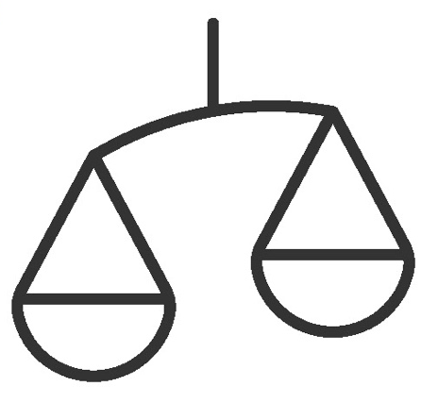

Fair

We will work in small groups and we will provide you with shared phones. We would like to give everyone an equal chance to be heard and to take turns using a phone.

Definitions

Trainers can add to this section to include local relevant information on mobile internet
3G / 4G / 5G | The internet can run at different speeds when you use it. 3G internet is the slowest, 4G internet is faster and 5G internet is the fastest.
App | An app gives you a shortcut to a service on your phone. For internet services e.g. WhatsApp, Facebook, Google, apps provide a quick and easy way to get onto the internet to use that service.
Address bar | The address bar shows you what website you are on.  In the address bar there will always be the address of the website e.g. www.google.com
Advert  or Ad | An ad is a piece of information that is trying to sell you something. It is good practice to avoid clicking on ads.  - Ads can be videos or images that pop up on your screen.  - Ads can also be the links at the top of Google results and on the right side of the screen.
Browser |   A web browser, or simply “browser,” is an application used to access and view websites. Common web browsers include:
Data | Whenever you use the internet on your phone, you are using data. You can buy data from your mobile network provider, just like you do with phone credit.
Feature  phone | A mobile phone that has the ability to access the internet and store and play music but lacks the advanced functionality of a smartphone.
 | Google is an internet service that makes it easy to find any information that you want to find on the internet.

Definitions

Internet | The Internet is a network of millions of computers around the world connected to each other with phone lines, satellites and cables. It gives you access to a huge range of information and services and it is growing all the time. The internet is for everybody. There are no restrictions on who can use it. You just need a computer, mobile phone or tablet and a data connection.
Link | A link connects you from one website to another. To go to the other website, you can touch the link and this will connect you and take you to that other website
Megabytes & Gigabytes | Megabytes (MB) and Gigabytes (GB) are units of data that you use when using the mobile internet. GB are 1000 times bigger than MB. If you download or stream a song, that will use approximately 5MB (1MB per minute).
Search | The search function helps you find what you are looking for. You type the words to what you are looking for into a search box and then you will see a list of links to potential answers.
Smartphone | A mobile phone that has the ability to access the internet, store and play music and videos, and run ‘apps’. These phones typically also have a touchscreen.
Website | Information on the internet is kept on different websites. There are lots of separate and different websites on the internet e.g. Google is a website, YouTube is a website.
 | WhatsApp is an internet service that makes it easy to connect and communicate with people that you know; family, friends and colleagues.
WiFi | A WiFi zone is an area where you do not have to use your own  data to access the internet on your phone; you can connect to the internet for free. WiFi zones are available in some public places such as coffee shops and cafes.
 | YouTube is an internet service that makes it easy to find, watch and listen to videos on the internet (and only videos).

Trainers can add to this section to include local relevant information on mobile internet

Top tips to stay safe online

           | Remember that not everything you see online is real  Anyone can post anything online, so don’t believe everything you see. Even if it’s from someone you trust, it might not be true. Be careful before sharing information with others
Think twice before sending money to someone you meet online
Be careful with emails, messages or pop-ups you didn’t ask for, especially if they ask for money or contain strange links.
Keep your personal information private, including passwords
Avoid sharing personal details like your full name, home address or phone number unless absolutely necessary.
Don’t cause harm to others online
Be kind and respectful. Don’t bully, spread false information or harass anyone. Your actions online can affect people in real life.
Be aware of scams and fraudsters
Just like in real life, thieves and criminals are on the internet too.

Some people online pretend to be someone else.
Take action by blocking or ignoring someone who is bothering you
If someone is bothering or harassing you online, ask for help and tell someone or report it.
Remember that the internet is open to everyone around the world and so it is essential to treat it like a real-life public place (e.g. a marketplace) and stay safe by protecting yourself and being responsible with what you do online.

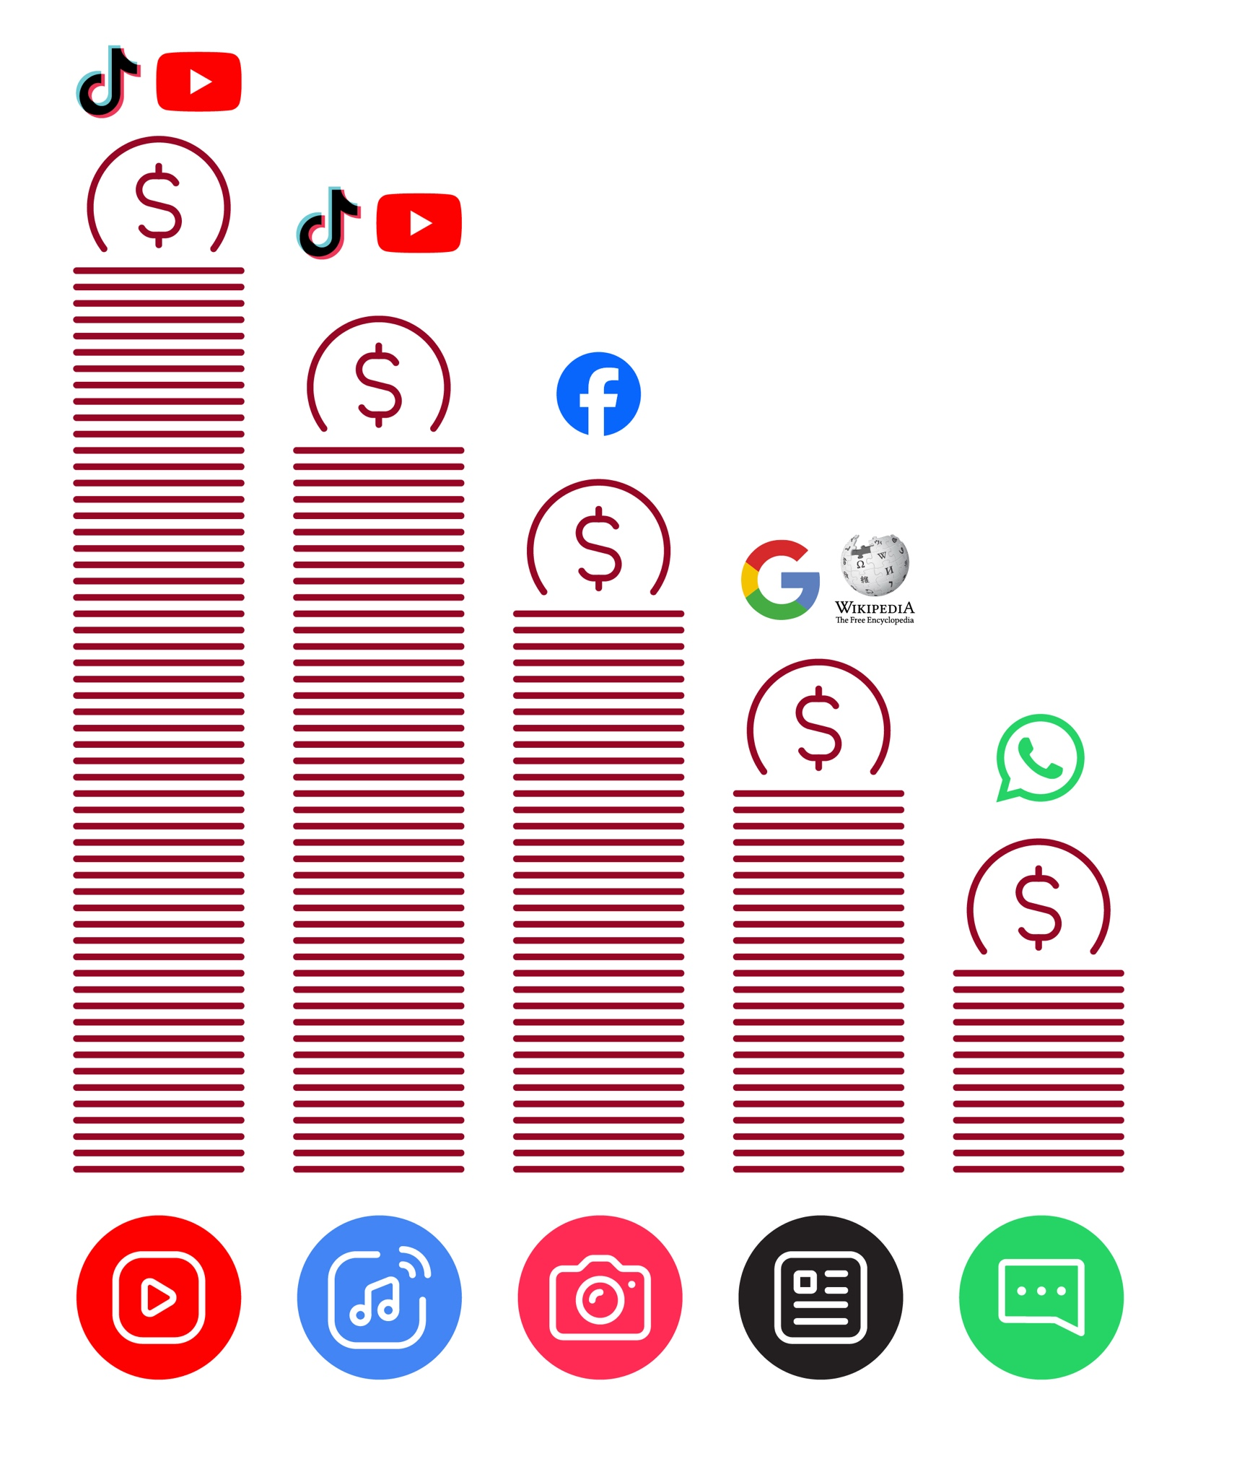
Data Costs
Healthy Internet Use

 | Set time limits  Think about how much time you are spending using the internet – it should not get in the way of your other responsibilities. If it does, set limits!
 | Watch your mood  If the internet or your phone is making you sad or angry, take a break!
 | Maintain healthy relationships online  Make time to socialise with friends and family in real life, not just on the internet! Don’t spend all your time on the internet.
 | Be careful  The internet can be dangerous with scams, harassment and things you don’t want to see. Be careful!
 | Stay positive  Stay positive and avoid upsetting or harming others. Be responsible and keep a positive attitude!
 | Get enough sleep and rest  Sleep and rest are important - make sure the internet or your phone doesn’t stop you doing this! Don’t use the internet when you need to rest or sleep.

Introduction to
the Internet

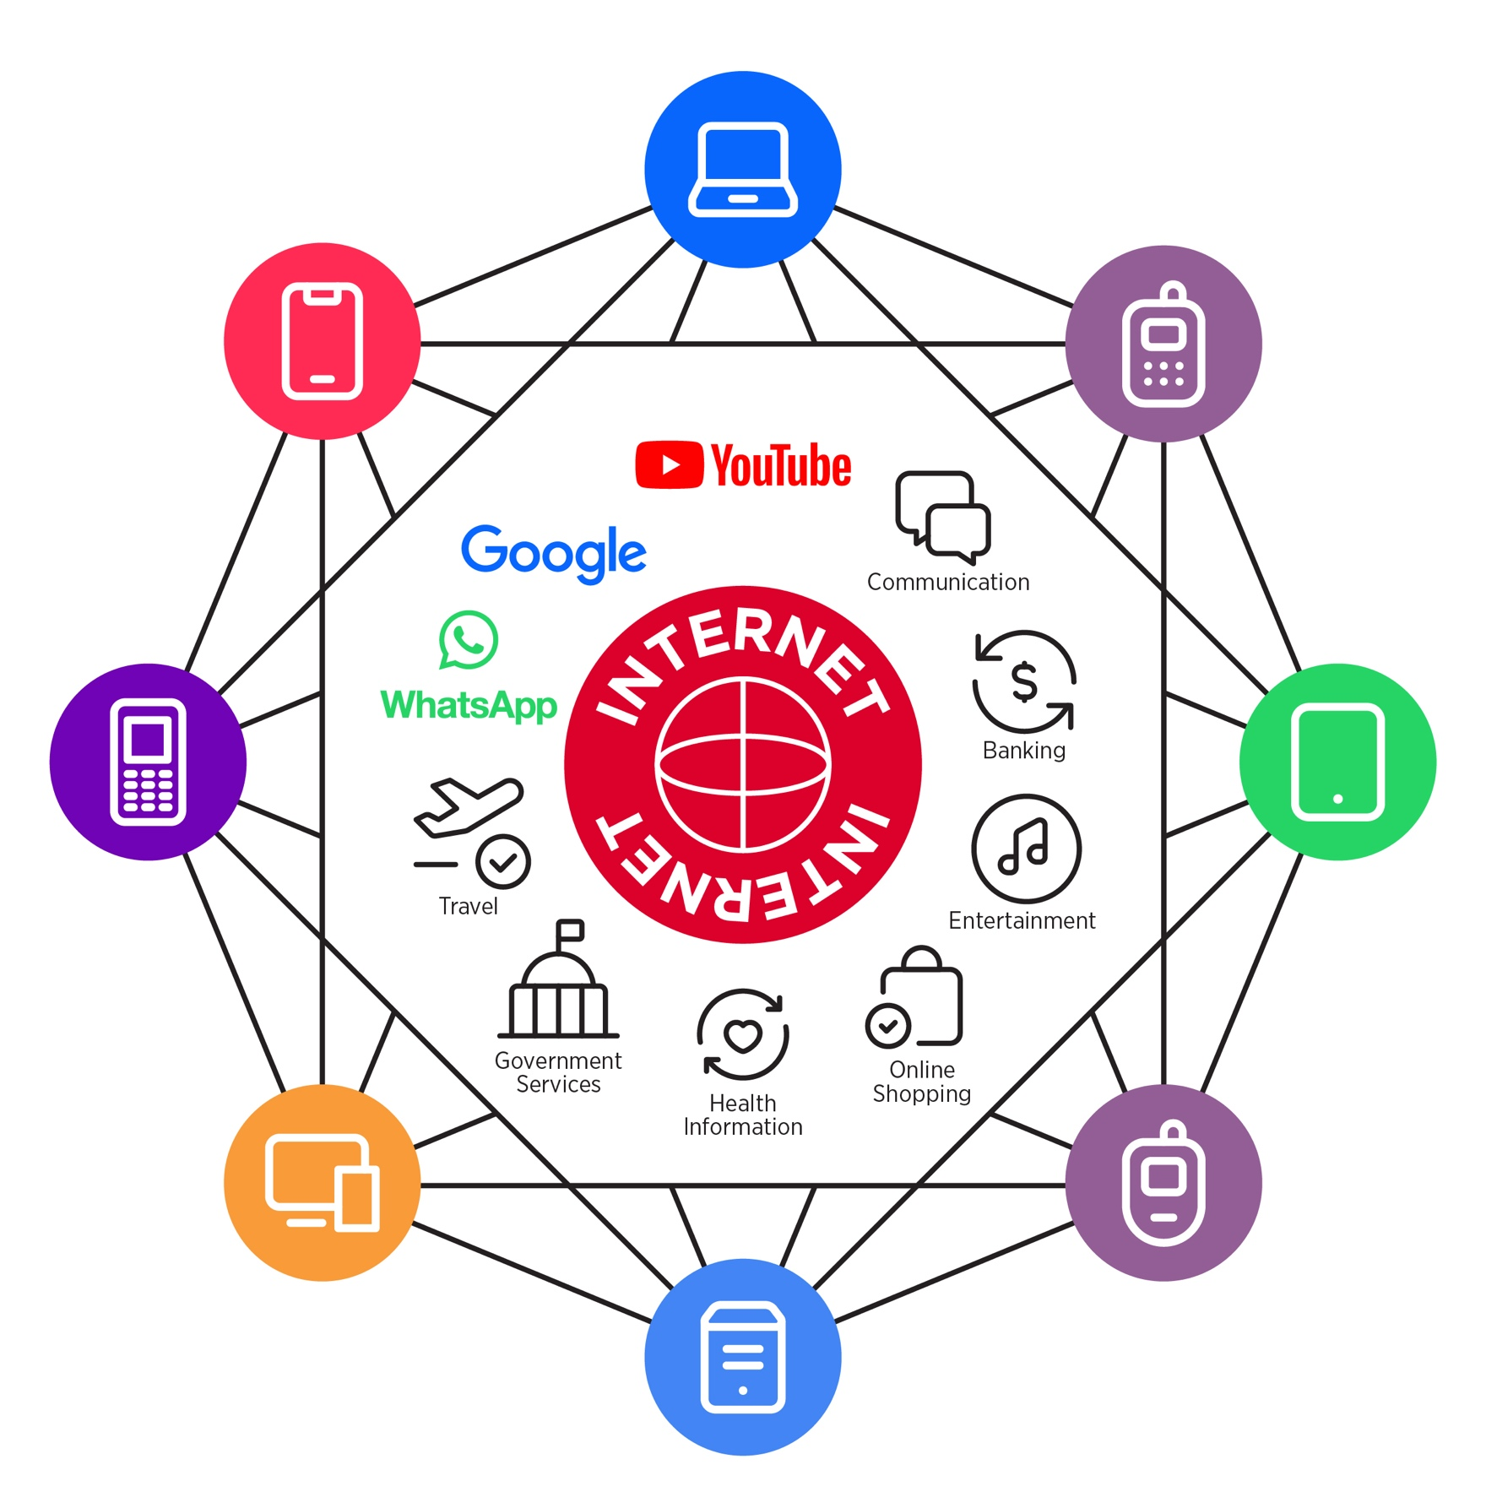

Take care of my family

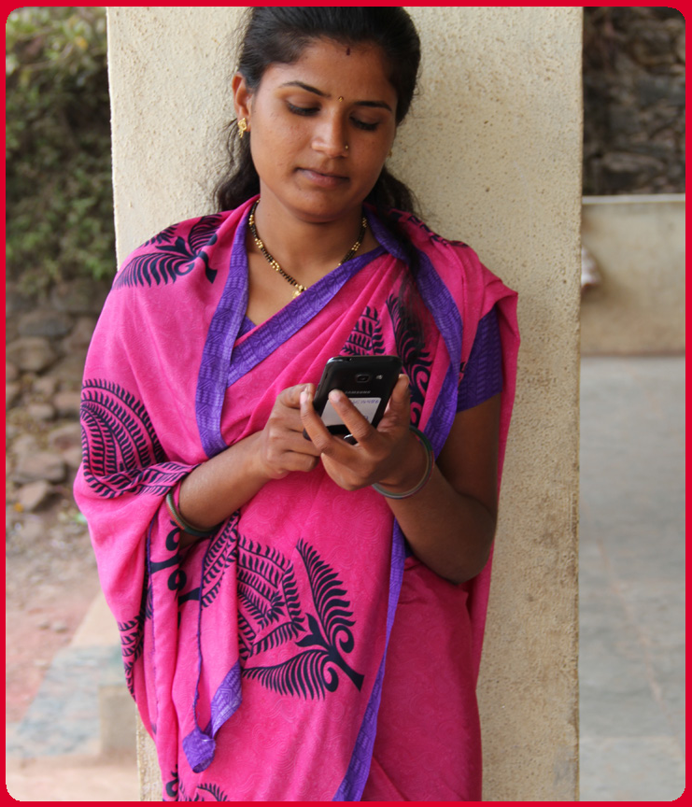

“Swati uses the internet to support and care for her family and friends”
Support my business



“Aarti uses the internet to help support her business”

Learn
more skills

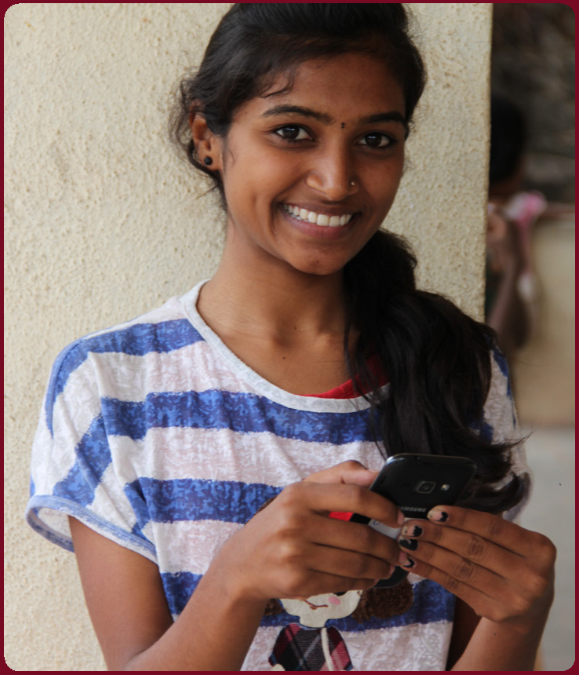

“Seema uses the internet to help her learn more skills’’

Take care of my family



“Pradip uses the internet to support and care for his family and friends”

Support my business

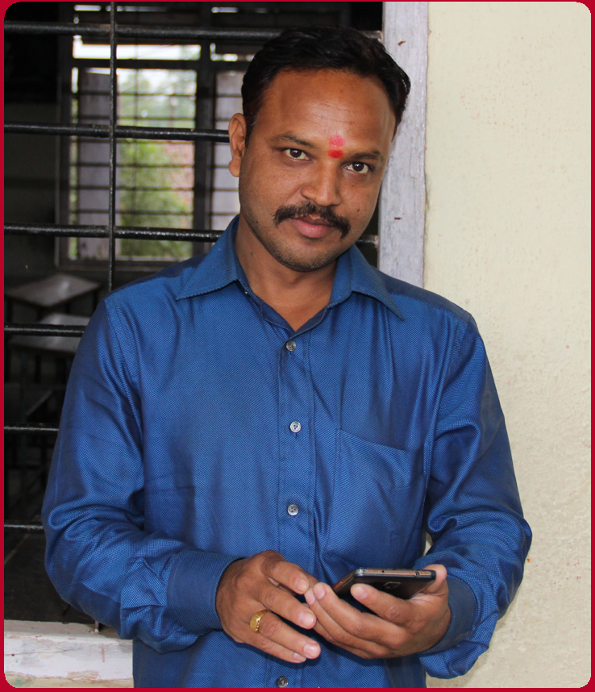

“Arunan uses the internet to help support his business”

Learn
more skills

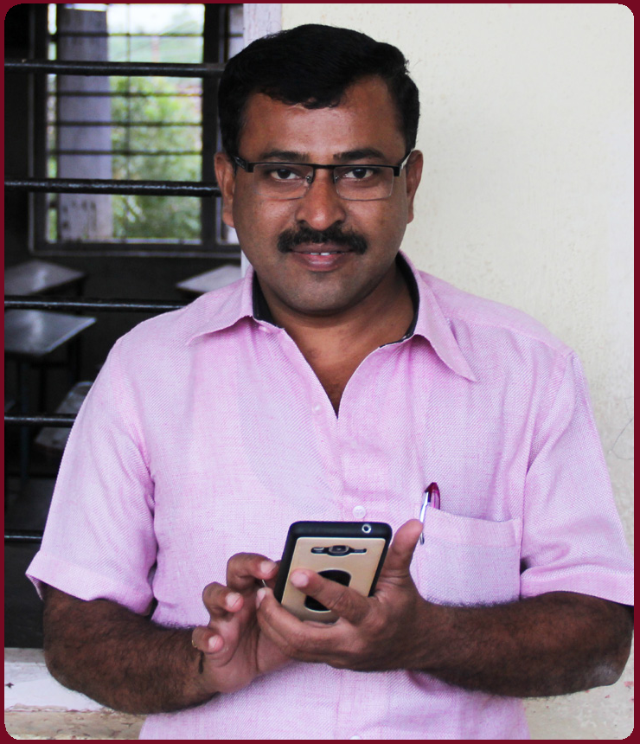

‘’Arvind uses the internet to help him learn more skills’’

Icon Cut-Outs
Introduction



Icon Cut-Outs
Introduction

Introduction
Icon Cut-Outs



Icon Cut-Outs

Introduction

Mobile Internet Skills Training Toolkit

‘Thank you’ and close training

After you have completed the training, congratulate your trainees and hand out certificates as a reward.

Thank the trainees

Give out the handouts

- Give your trainees the handouts for the training if you haven’t already done so.

- These include the ‘Definitions’, ‘Top tips to stay safe online’, ‘Data costs’, ‘Healthy internet use’ and relevant module posters.

- Ask: “Do you feel confident to use these accessibility features?” or “Do you feel confident to use your mobile phone?”

- Thank your trainees for their time, input and participation in the training.

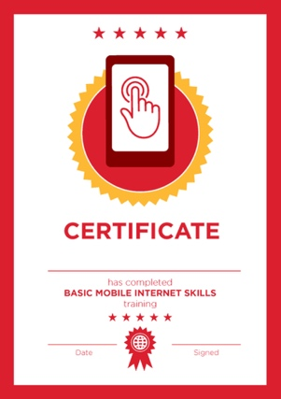

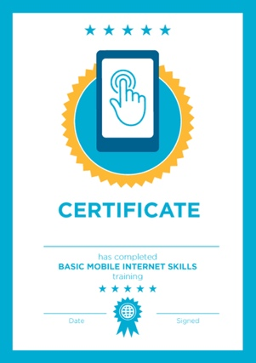

Conduct a closing ceremony

- Give each trainee a signed certificate (certificate templates are included in the toolkit).

- You can also provide the trainers with certificates for having completed the training ‘as trainers’.

Tip: You can make this more of a ceremony for trainees, by asking them to come up to the front of the room one person at a time to receive their certificate and shake the trainer’s hand.

here


CERTIFICATE

has completed

BASIC MOBILE INTERNET SKILLS

training

Date Signed

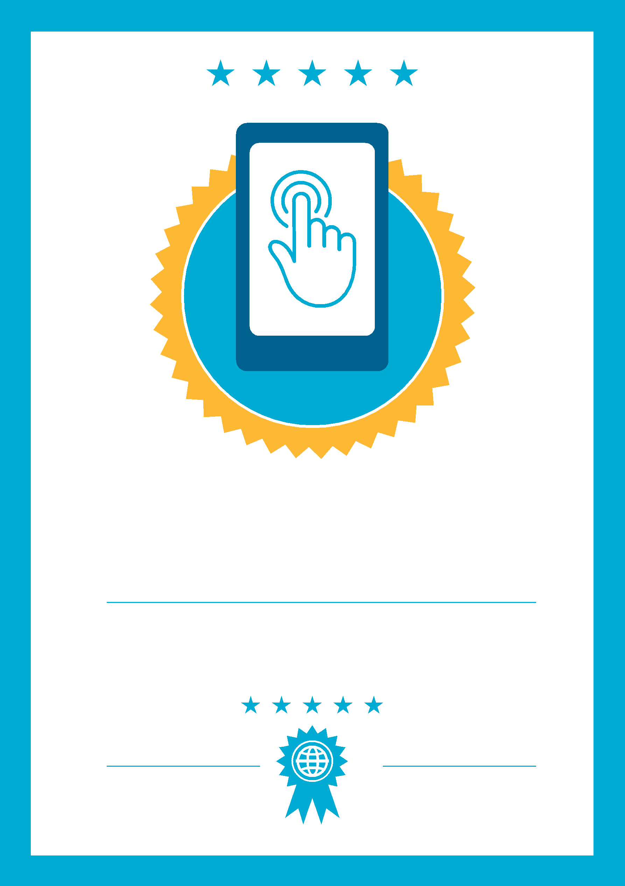

CERTIFICATE

has completed

BASIC MOBILE INTERNET SKILLS
training

Date
Signed

