


Mobile Internet
Skills Training
Toolkit
A guide for training people in
basic mobile internet skills
Copyright © 2024 GSM Association
Copyright © 2024 GSM Association
Bitesize Training
KaiOS

Mobile Internet
Skills Training

Toolkit

A guide for training people

in basic mobile internet skills

Module 9:
KaiOS


What is it?
 | Show a KaiOS-enabled phone.  Explain: “A KaiOS-enabled phone is like a smartphone without a touchscreen. It is cheaper than a traditional smartphone. It comes with a camera, Wi-Fi, Bluetooth, GPS and apps so you can do more than calling and texting. KaiOS-enabled phones use less data and the batteries last longer. A KaiOS phone gives you access to the internet, so you can use it to search for information you need on Google, watch videos on YouTube, and share photos on Facebook. Over 100 million people use KaiOS phones to connect to the internet and improve their lives.”
What can you use it for?
“You can use your KaiOS phone to search for
information, share pictures with friends and stay
up to date with the news.”
“You can use your KaiOS phone to do the same
as you would do on a smartphone: See what your friends are posting on Facebook, post photos of your latest products or services to engage customers on Facebook, get a map and directions to your next destination with Google Maps or find a local business, learn a new skill on YouTube, pay your bills or save money for school and family needs with mobile money.”
Materials you will need:

- KaiOS phone
- KaiOS posters

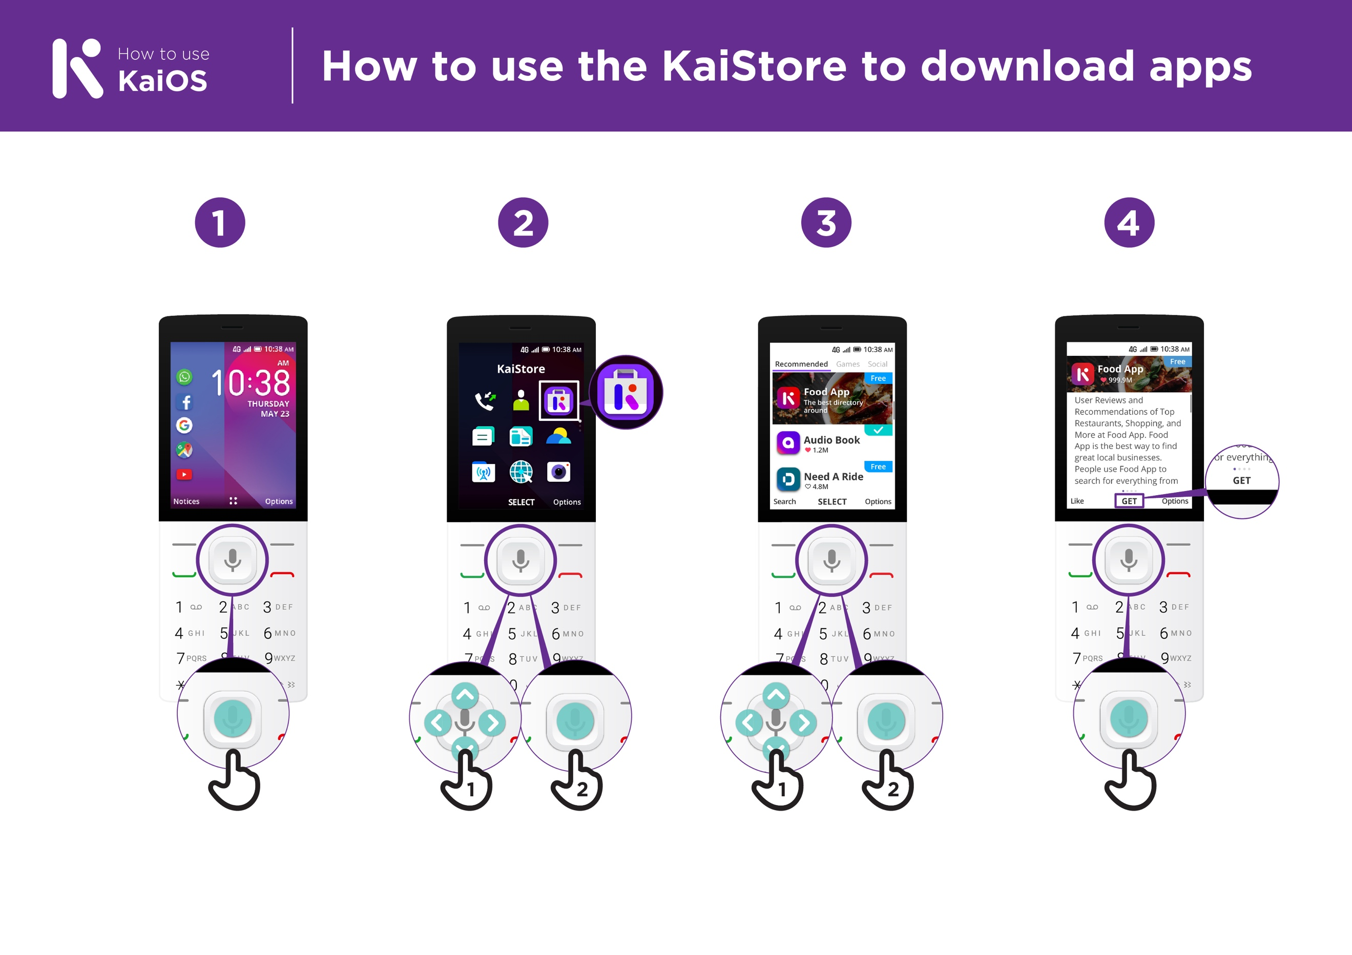

What can you use it for?
Make it relevant to the trainee by discussing how it can be beneficial in the trainee’s own life. Consider examples that will be relevant to the following types of trainees:

Older person: Keep in touch with your family and friends who live far away with Facebook.

Mother or homemaker: Help your children with their homework by searching for information on Google or YouTube; save money for family needs and school fees with mobile money.

Business owner: Learn new business skills like marketing on YouTube; reach new customers by sharing updates on Facebook.

Farmer or rural person: Learn how to grow certain crops, conserve water or deal with pests by watching videos on YouTube.

Young person: Watch film trailers on YouTube; research information for homework on Google; stay connected with friends on Facebook.

How does it work?
Put the phone in the trainee’s hands and help them follow the steps.

Help the trainee download their first app and perform their first search in the browser.
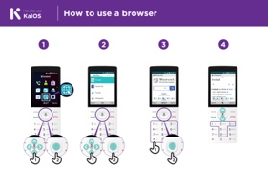
How to use the KaiStore to download apps
Show the poster and go through the steps for downloading
apps (Press centre button > Store icon > Select app > Press).
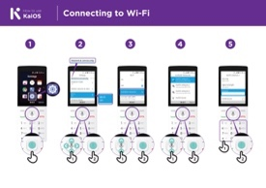
How to use a browser
Show the poster and go through the steps for using the
browser (Press centre button > Browser icon > Select app).

Practise!

“Now that you’ve discovered what
you can do on a KaiOS phone, what
do you want to use it for?”

Trainer: Help your trainee download
an app from the KaiStore. Then help
them use it.

Tip: “If its difficult to read a website, press ‘1’ to zoom out and ‘3’ to zoom in.

Explain: “Apps are easier to use than the browser, because they are made specifically for KaiOS.”

“Visit the KaiOS website to learn more about the internet, apps and KaiOS phones: https://life.Kaiostech.com.”

Bitesize Training
KaiOS

Mobile Internet
Skills Training

Toolkit

A guide for training people

in basic mobile internet skills

Posters and Cuts-Outs
Top tips to stay safe online

 | Remember that not everything you see online is real  Anyone can post anything online, so don’t believe everything you see. Even if it’s from someone you trust, it might not be true. Be careful before sharing information with others
 | Think twice before sending money to someone you meet online  Be careful with emails, messages or pop-ups you didn’t ask for, especially if they ask for money or contain strange links.
 | Keep your personal information private, including passwords  Avoid sharing personal details like your full name, home address or phone number unless absolutely necessary.
 | Don’t cause harm to others online  Be kind and respectful. Don’t bully, spread false information or harass anyone. Your actions online can affect people in real life.
 | Be aware of scams and fraudsters  Just like in real life, thieves and criminals are on the internet too.  Some people online pretend to be someone else.
 | Take action by blocking or ignoring someone who is bothering you  If someone is bothering or harassing you online, ask for help and tell someone or report it.
Remember that the internet is open to everyone around the world and so it is essential to treat it like a real-life public place (e.g. a marketplace) and stay safe by protecting yourself and being responsible with what you do online.

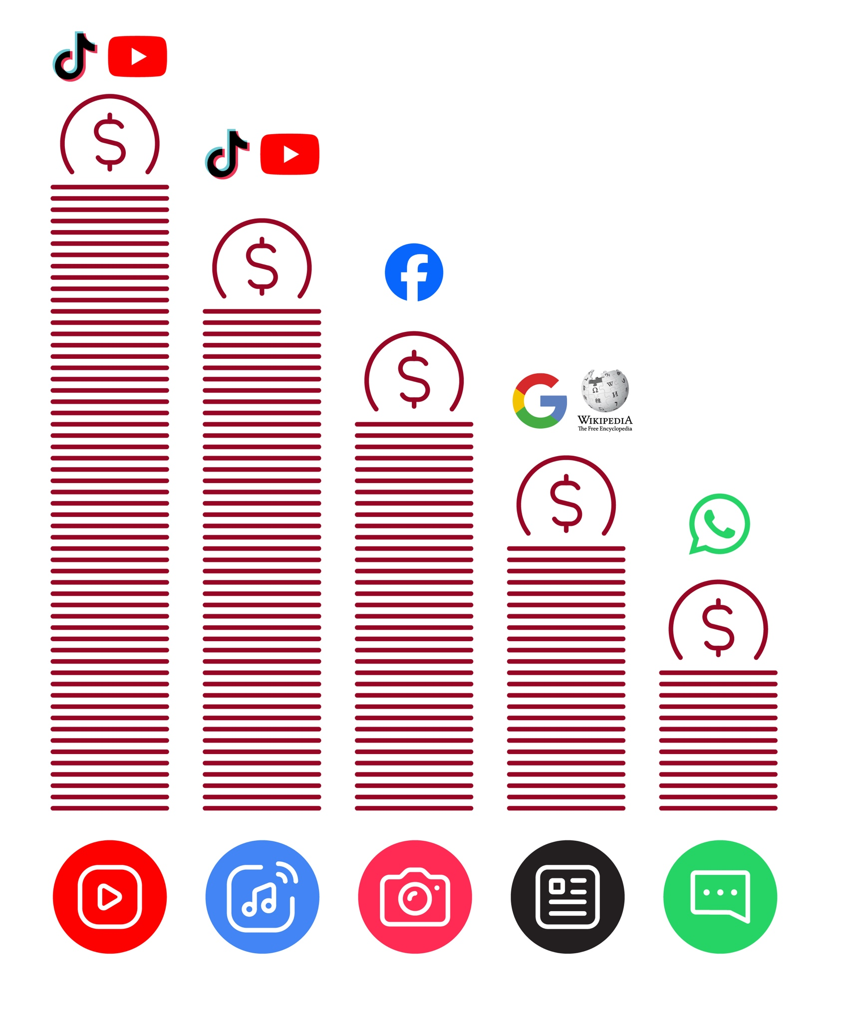
Data Costs

How to use
KaiOS

How to use the KaiStore to download apps

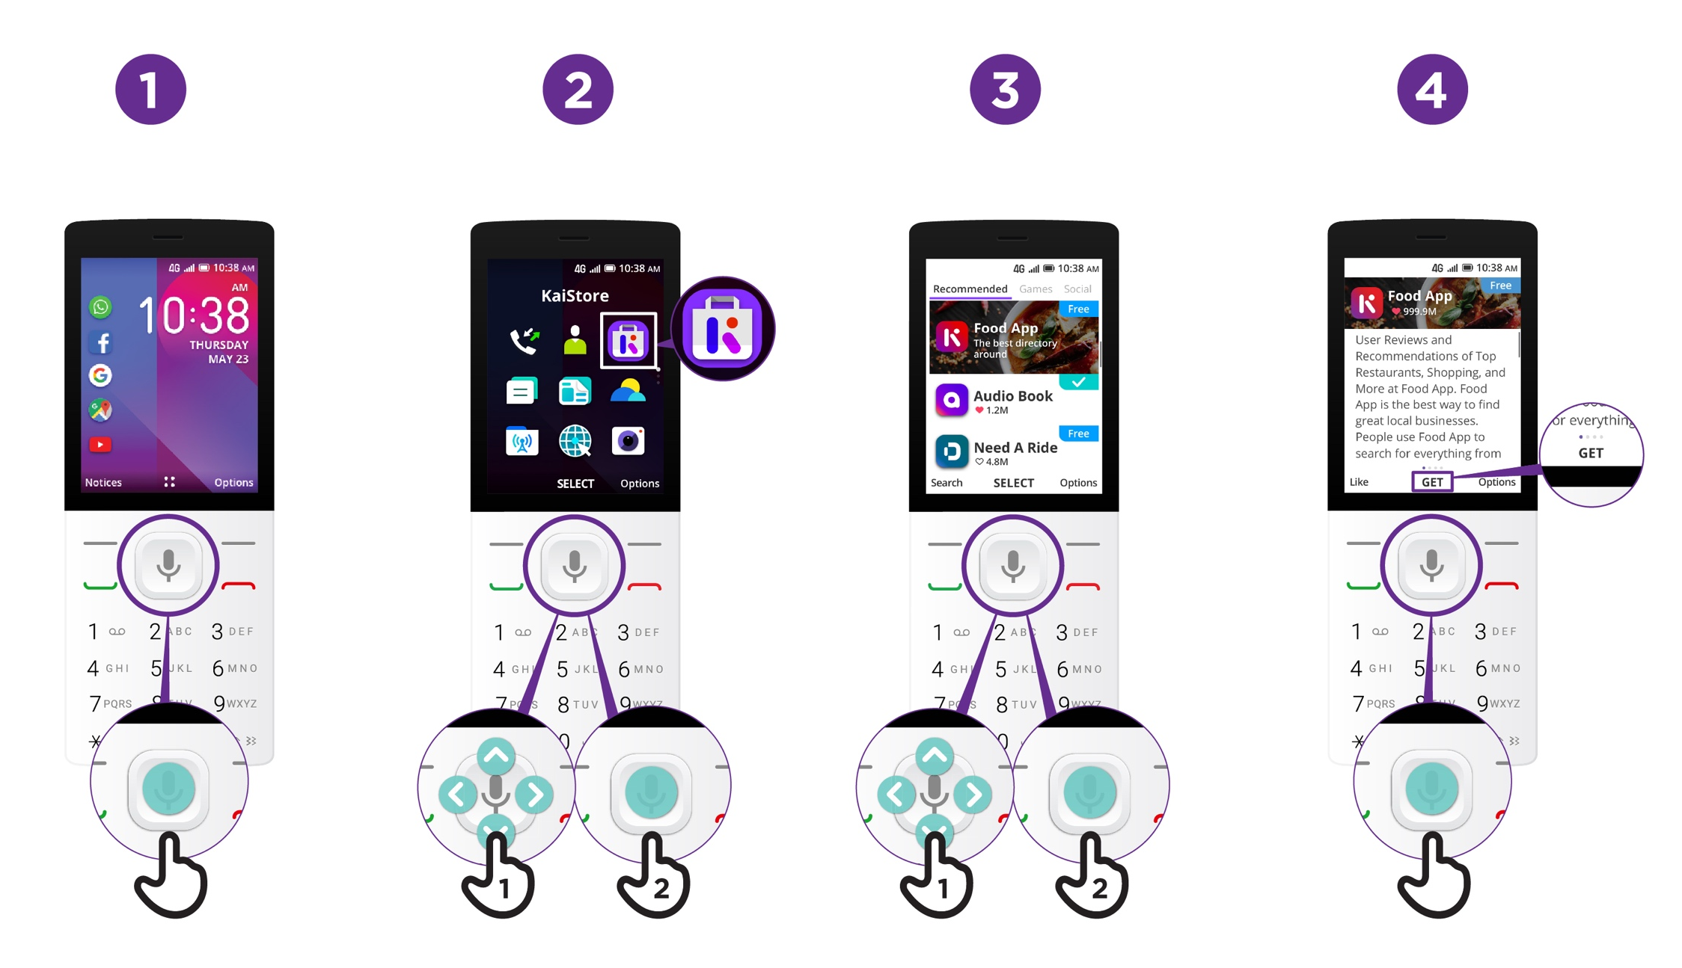

How to use
KaiOS

How to use a browser

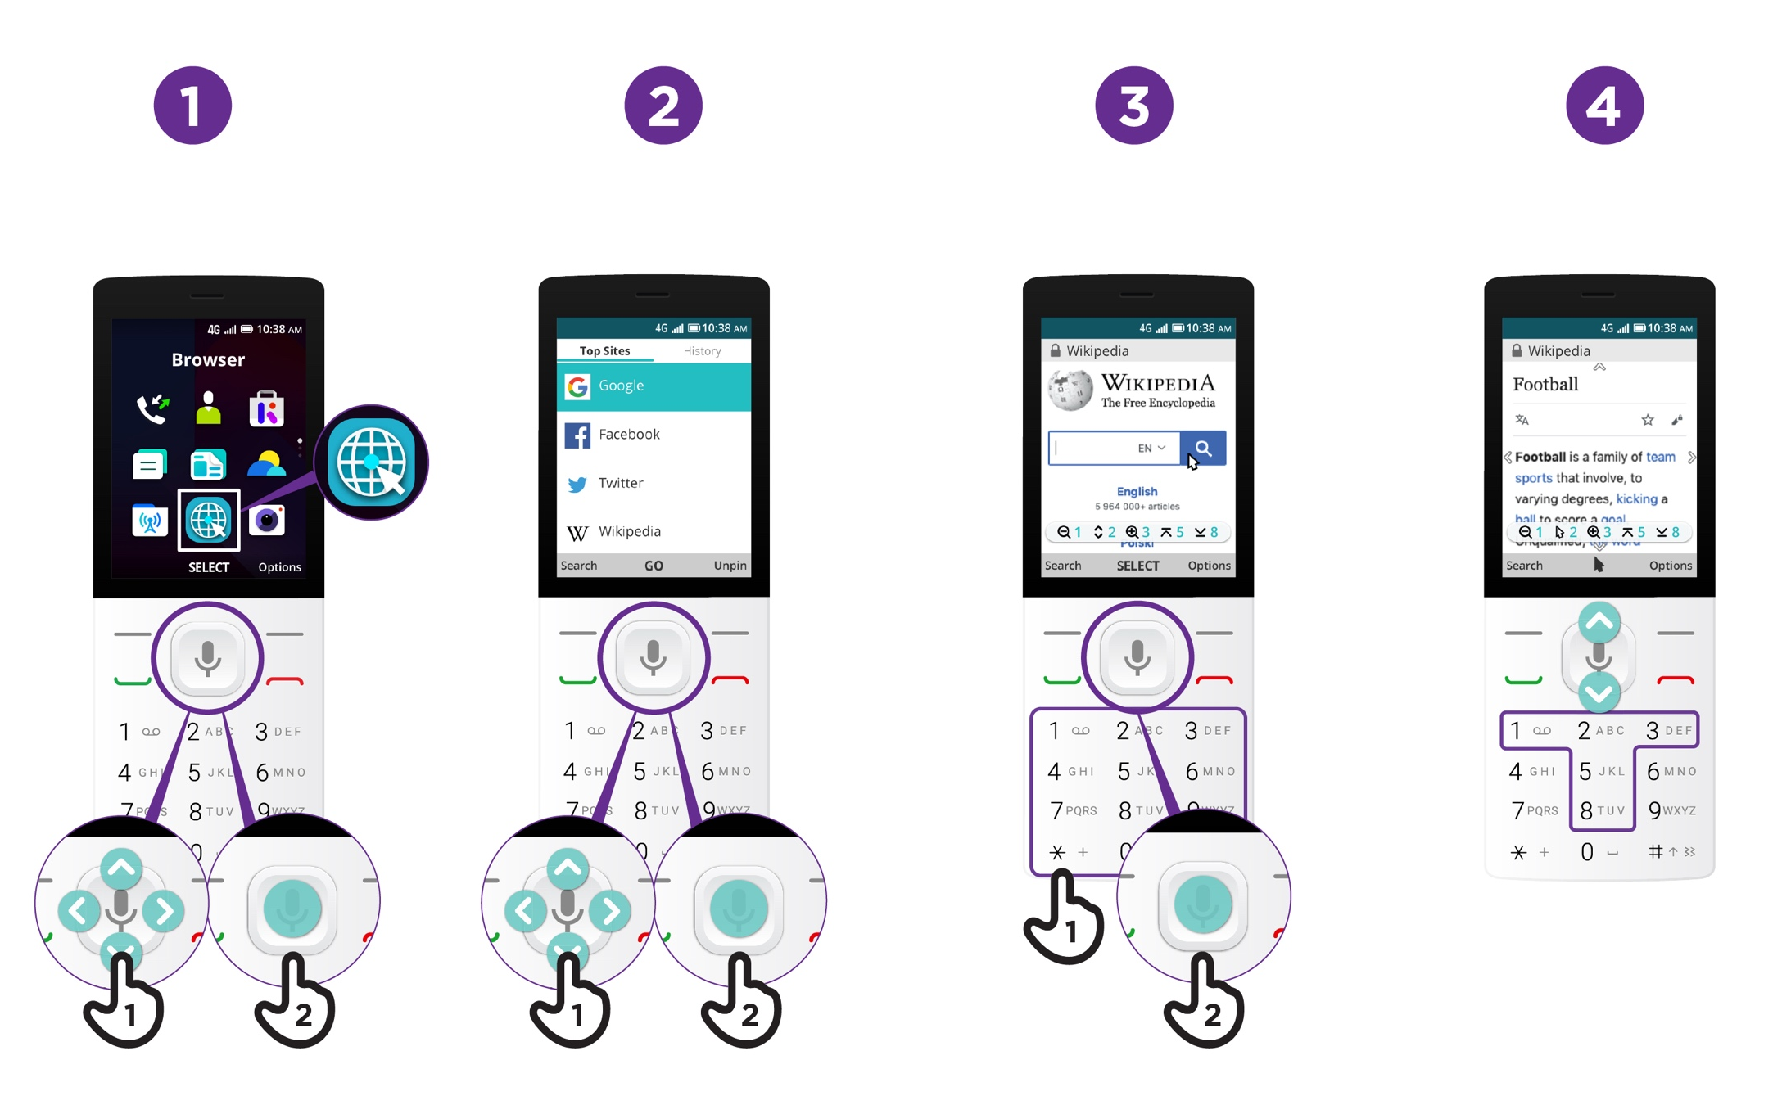

How to use
KaiOS
Connecting to Wi-Fi

