


Mobile Internet
Skills Training
Toolkit
A guide for training people in
basic mobile internet skills
Copyright © 2024 GSM Association
Copyright © 2024 GSM Association

In-Depth Training
KaiOS

Mobile Internet
Skills Training

Toolkit

A guide for training people

in basic mobile internet skills

Module 9:
KaiOS

Learning objectives
- Trainee learns how to perform basic operations on a KaiOS-enabled phone.

- Trainee downloads and uses an app, opens the browser and navigates a website.

- Trainee feels excited about using a KaiOS phone to accomplish some of their goals.
Time duration
45-60
minutes

Materials you will need:
  Pen, paper and  masking tape |   KaiOS phone |   Small rewards | 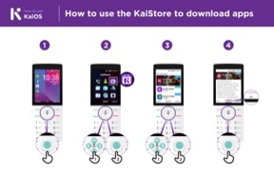  KaiOS poster

Introduce KaiOS

KaiOS phones enable you to connect online and access all the benefits of a smartphone

Give a short explanation of KaiOS
- “A KaiOS-enabled phone means that you can connect to the internet, use Facebook and other apps, and enjoy all the benefits of a smartphone at a cheaper cost.”

- “KaiOS phones have a browser, similar to Opera, and an app store, where you can download free apps.”
Bring the benefits to life!
Tell your own story of how KaiOS is useful for you (the trainer), your friends and family or your community. Consider examples that will be relevant for these trainees:

Older person: Keep in touch with your family and friends who live far away with Facebook.

Mother or homemaker: Help your children with their homework

by searching for information on Google or YouTube; save money for family needs and school fees with mobile money.

Business owner: Learn new business skills like marketing on YouTube; reach new customers by sharing updates on Facebook.

Farmer or rural person: Learn how to grow certain crops, conserve water or deal with pests by watching videos on YouTube.

Young person: Watch film trailers on YouTube; research information for homework on Google; stay connected with friends on Facebook.

Make KaiOS relevant for your trainees
Discuss how a KaiOS phone might help them in their lives:

- Ask: “How could you use the Google app in your own life?” Provide some suggestions based on their interests.

- Ask: “What apps would you like to use?”
Remember: Connect discussions and activities in the training to how the internet can be helpful or useful in your trainees’ own lives. This will help keep the training relevant and interesting for them.

Activity: Downloading apps
Explain: “Every KaiOS-enabled phone has a KaiStore from which you can add new tools to your phone. Most of these tools are free. You can get free games and other useful apps.”
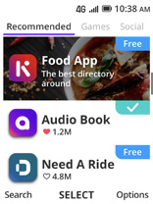
Show trainees the KaiStore

Give a short explanation of apps and the KaiStore:

- “KaiOS allows you to get free games, find out sport scores and access free news information on your phone. These are called apps. You can get these apps for free in the KaiStore.”

- “From the KaiStore you can also access free apps like Xender, Facebook, religious texts and more.”

Bring these benefits to life!

Share personal examples of how apps help you (the trainer), your friends and family. Some examples might include:

- Sharing files like pictures and videos even without an internet connection.

- Learning what new words mean in the dictionary.

- Reading recipes from around the world.

Ask trainees to open the KaiStore and find an app they want to get for free.
Make KaiOS apps relevant to your trainees

- Discuss what they want to learn or improve and find an app that can do that.

- Discuss what apps can do: Entertain, teach, help, remind.

- Ask: “Which apps are useful to have?” Provide some suggestions based on their interests.

- Ask: “What apps would you like to use?”

Get practical!

Explain: “You are now going to try using a KaiOS phone.”
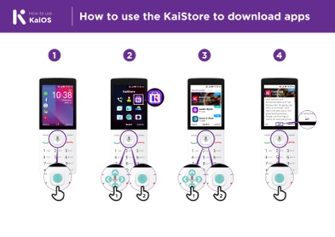
Show the ‘How to use the KaiStore to download apps’ poster

- Explain: “This poster shows how to download an app from the KaiStore.”

- Show the trainees how to go through the steps on their phones and explain that they can download as many apps as they want. Downloading most apps are free, and some don’t even use data.
- Explore different apps. See updates from a celebrity on Facebook, get live football scores on FlashScore and read the news on KaiNews etc.

Tip: It’s best to download some apps (e.g. Facebook) beforehand.
Take your trainees through the steps to download a game:

- Go to the KaiStore.

- Open any of the game apps shown in the recommended tab.

- Tap Download Now.

- Open the app by pressing GO.

Activity: Access Wikipedia via your browser
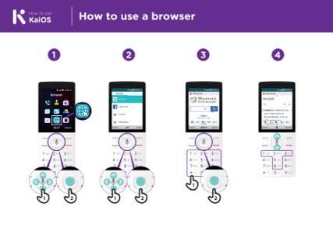
Show the ‘How to use a browser’ poster
- Explain: “Every KaiOS phone has a browser, where you can search for any website or information you want.”
- You can use the Google app and the browser app to access information.”
- “If you prefer to not type and read, you can ask questions to the Google Assistant; it’s like the browser.”
- “A lot of businesses, governments and other organisations have websites where you can find information about what they offer.”
Bring these benefits to life!

Share personal examples of how the browser helps you (the trainer), your friends and family. Some examples might include:

- Finding specific information.

- Searching for tips for problems you have.

Explain that not everything on the internet is true. There is a lot of incorrect information, so it’s best to check on official websites for real information. Even friends can send information that is not true.
Get practical!

Explain: “You can learn about any topic on Wikipedia. Let’s find a topic to learn.”

- Go to Wikipedia and search for a topic the trainee is interested in.

- Bookmark the website so the trainee can find it again.

Tip: “It’s important to remember that the internet is a public place, so don’t believe everything you see or read online.”

Tip: You can reinforce trainees’ knowledge of the icons by playing the ‘TikTok icon game’.
Activity: Connect to a Wi-Fi network
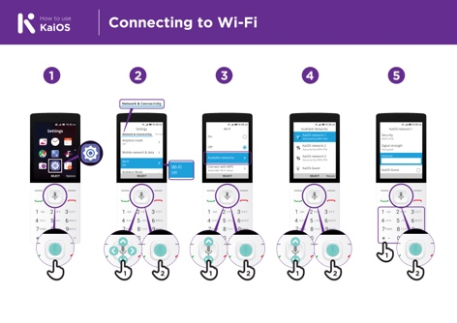
Show the ‘How to connect to Wi-Fi’ poster

- Explain: “You are now going to connect to Wi-Fi.”

- Explain what Wi-Fi is: “When you connect to a Wi-Fi network, you can go online without using data from your phone.”
- “You can also share your data with other people. When you do this, you create Wi-Fi from your phone and others can connect to it. You can do this from the settings app.”

- “If you want to watch videos or browse the web without using data, then you can connect to the Wi-Fi network if there is one available.”

- Explain where they can find Wi-Fi around them.
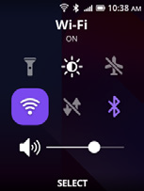
Get practical!

- Go to settings and click on Wi-Fi. Make sure it’s turned on.

- You can turn Wi-Fi on and off from the home screen. Tap the up button and select the Wi-Fi button. Press the centre button to turn it on or off.

- Then select a network and enter a password. The phone remembers this information, so you’ll only need to do this once for each network.

- After your demonstration: Ask the trainees to connect to a Wi-Fi network. Help them with any questions they have during the process.

Activity: Get started with Google Maps
Ask: “How can I go to Johannesburg from here?”

Tell your trainees how you’ve found the answer to this question: in Google Maps. Then, explain that sometimes you need to find your way to another city. Share personal examples of situations where it’s helpful to use Google Maps.

Now explain how Google Maps can show them the fastest route to a destination.

Explain: “Google Maps comes with every KaiOS phone. When you open the app, you can search directions with your voice – no need to read or write. Tap on the yellow icon with a microphone and say where you want to go.”

Prompt them with the tasks below and ask them to complete them using Google Maps.

- Find out how to get to the nearest village by foot.

- Find where they are on the map.

- Search for places and ways to get there.

Activity: Read news on KaiNews

Show the trainees the KaiStore and the KaiNews icon

- Explain: “It’s like a newspaper, but for free.”

- “The KaiNews app is a place for you to learn about your local news.”

- “The articles you read on KaiNews are from reliable sources.”
- “To read the news, you need to download the KaiNews app from the KaiStore for free.”
Bring these benefits to life!

Tell your own story of how reading the news is beneficial to you (the trainer). Some examples might include:

- Being able to tell your friends and family about the news you read and share the information you learned.

- Keeping up-to-date with what is happening in your country and in the world, even if the news is happening in another city.

- You can follow news about food, sports, politics, celebrities, the economy and much more.

- You may be able to explain to a friend/neighbour more about some news they have read from the articles you read. Offer specific examples.

- Ask trainees to share what kind of news they are interested in. The answers could be finding out sports scores, news from other cities and learning what’s happening in the world.
Make KaiNews relevant for your trainees

- Discuss with your trainees how a KaiOS phone can help them in their lives.

- Ask: “What could you learn from reading the news?” Give them some suggestions based on their interests.

- Ask: “What topic would you like to read about?”

Remember: Link discussions and activities in the training back to how the KaiNews app can be helpful or useful in your trainees’ own lives. This will help to keep the training relevant and interesting for them.

Activity: Introduce the FM/radio app

Show the trainees the radio icon

- Explain: “Just like with your previous feature phone, you can access the radio.”
Give a short explanation

- Explain: “The Kai Radio app is just like the radio you had in your previous phone.”

- “You can access the radio from the radio app, you don’t need data to install it. It comes already installed in your phone.”

- “You can listen to the news from the speaker or from your headphones. Press the ‘options’ button in the radio app to change it.”

- “Using the radio app does not consume data.”
Bring the benefits to life!

Tell your own story of how using the radio is beneficial to you (the trainer). Some examples might include:

- Being entertained.

- Listening to music from your community and abroad.

- You can listen to and learn about other topics.

- You can put the radio on the phone’s speaker and listen to it while you do other things.
- Ask trainees to share what news they are interested in. The answers could be finding out sports scores, talking about news from other cities or learning what’s happening in the world.

Recap

Play the KaiOS icon game

- Hold up each KaiOS icon, one at a time (KaiStore, Browser, Settings, Google Assistant, KaiNews).

- Ask: “Where is this on the phone and what is it?”

- Explain to your trainees what each icon is and ask if they need support.

- Ask trainees which app from the KaiStore they have enjoyed using.

- Give small rewards (e.g. sweets) for correct answers and stick the icons on the wall afterwards to help remind your trainees what they are.
Recap on KaiOS

Discuss with your trainees what they have learned about the KaiStore.

- “What have you learned about the KaiStore? What are apps? What can you do with apps?”

- “Do you still have any concerns about using the browser?”

- “What personal uses could you have for the KaiNews app?”

- “What professional uses could you have for it?”

- “What do you want to use the browser for in your own life? What are you most interested in and excited about using it for?”

- “If you want to know something without having to read or write, how can the Google Assistant help you? How can you access the Google Assistant?”
Tip: “If you don’t know what an app does, don’t be scared. You can download and explore any KaiOS app for free. If you spend some time with an app, you will learn how to use it. Just make sure you connect to a Wi-Fi network so you don’t use all your data.”

Going to the next level
If you reach the end of the session and have extra time:

Ask: “Do you have any further questions about anything we have covered in the session?”

Ask: “What else would you like to know about the mobile internet?” Some more advanced features you can discuss with your trainees include:

Evaluating results: “How do you decide which app uses data when being used? How do you know if an app uses more data than another?”

How to save memory on your phone: “How can you identify which files occupy more storage space on your phone? How can you ‘make more space’ inside your phone?”
Google Maps on KaiOS: “How do you get directions?”

Downloading apps from the KaiStore: How to find the KaiStore, how downloading works, and how much they cost (apps are mostly free).

In-Depth Training
KaiOS

Mobile Internet
Skills Training

Toolkit

A guide for training people

in basic mobile internet skills

Posters and Cuts-Outs

Session Ground Rules

This space is:

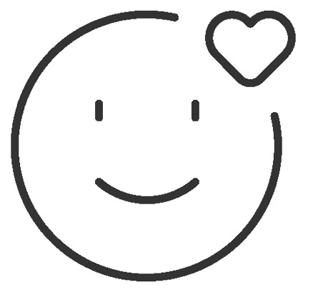

Safe

Keep all information in this training confidential. We suggest you don’t share personal numbers with the other members of group.

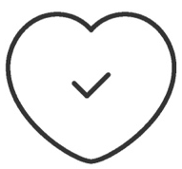

Positive & open

Please be respectful and
positive in your opinions and discussions. There are no right or wrong answers and we are not here to test you.

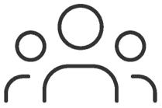

- shared
community

There are people with different backgrounds, knowledge and opinions. This is our shared space, so respect and support everyone.

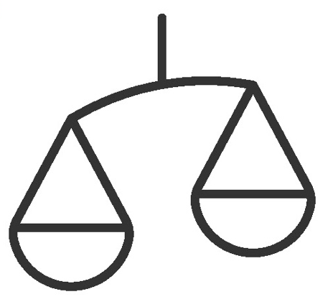

Fair

We will work in small groups and we will provide you with shared phones. We would like to give everyone an equal chance to be heard and to take turns using a phone.

Definitions

Trainers can add to this section to include local relevant information on mobile internet
3G / 4G / 5G | The internet can run at different speeds when you use it. 3G internet is the slowest, 4G internet is faster and 5G internet is the fastest.
App | An app gives you a shortcut to a service on your phone. For internet services e.g. WhatsApp, Facebook, Google, apps provide a quick and easy way to get onto the internet to use that service.
Address bar | The address bar shows you what website you are on.  In the address bar there will always be the address of the website e.g. www.google.com
Advert  or Ad | An ad is a piece of information that is trying to sell you something. It is good practice to avoid clicking on ads.  - Ads can be videos or images that pop up on your screen.  - Ads can also be the links at the top of Google results and on the right side of the screen.
Browser |   A web browser, or simply “browser,” is an application used to access and view websites. Common web browsers include:
Data | Whenever you use the internet on your phone, you are using data. You can buy data from your mobile network provider, just like you do with phone credit.
Feature  Phone | A mobile phone that has the ability to access the internet and store and play music but lacks the advanced functionality of a smartphone.
 | Google is an internet service that makes it easy to find any information that you want to find on the internet.

Definitions

Internet | The Internet is a network of millions of computers around the world connected to each other with phone lines, satellites and cables. It gives you access to a huge range of information and services and it is growing all the time. The internet is for everybody. There are no restrictions on who can use it. You just need a computer, mobile phone or tablet and a data connection.
Link | A link connects you from one website to another. To go to the other website, you can touch the link and this will connect you and take you to that other website
Megabytes & Gigabytes | Megabytes (MB) and Gigabytes (GB) are units of data that you use when using the mobile internet. GB are 1000 times bigger than MB. If you download or stream a song, that will use approximately 5MB (1MB per minute).
Search | The search function helps you find what you are looking for. You type the words to what you are looking for into a search box and then you will see a list of links to potential answers.
Smartphone | A mobile phone that has the ability to access the internet, store and play music and videos, and run ‘apps’. These phones typically also have a touchscreen.
Website | Information on the internet is kept on different websites. There are lots of separate and different websites on the internet e.g. Google is a website, YouTube is a website.
 | WhatsApp is an internet service that makes it easy to connect and communicate with people that you know; family, friends and colleagues.
WiFi | A WiFi zone is an area where you do not have to use your own  data to access the internet on your phone; you can connect to the internet for free. WiFi zones are available in some public places such as coffee shops and cafes.
 | YouTube is an internet service that makes it easy to find, watch and listen to videos on the internet (and only videos).

Trainers can add to this section to include local relevant information on mobile internet

Top tips to stay safe online

 | Remember that not everything you see online is real  Anyone can post anything online, so don’t believe everything you see. Even if it’s from someone you trust, it might not be true. Be careful before sharing information with others
 | Think twice before sending money to someone you meet online  Be careful with emails, messages or pop-ups you didn’t ask for, especially if they ask for money or contain strange links.
 | Keep your personal information private, including passwords  Avoid sharing personal details like your full name, home address or phone number unless absolutely necessary.
 | Don’t cause harm to others online  Be kind and respectful. Don’t bully, spread false information or harass anyone. Your actions online can affect people in real life.
 | Be aware of scams and fraudsters  Just like in real life, thieves and criminals are on the internet too.  Some people online pretend to be someone else.
 | Take action by blocking or ignoring someone who is bothering you  If someone is bothering or harassing you online, ask for help and tell someone or report it.

Remember that the internet is open to everyone around the world and so it is essential to treat it like a real-life public place (e.g. a marketplace) and stay safe by protecting yourself and being responsible with what you do online.

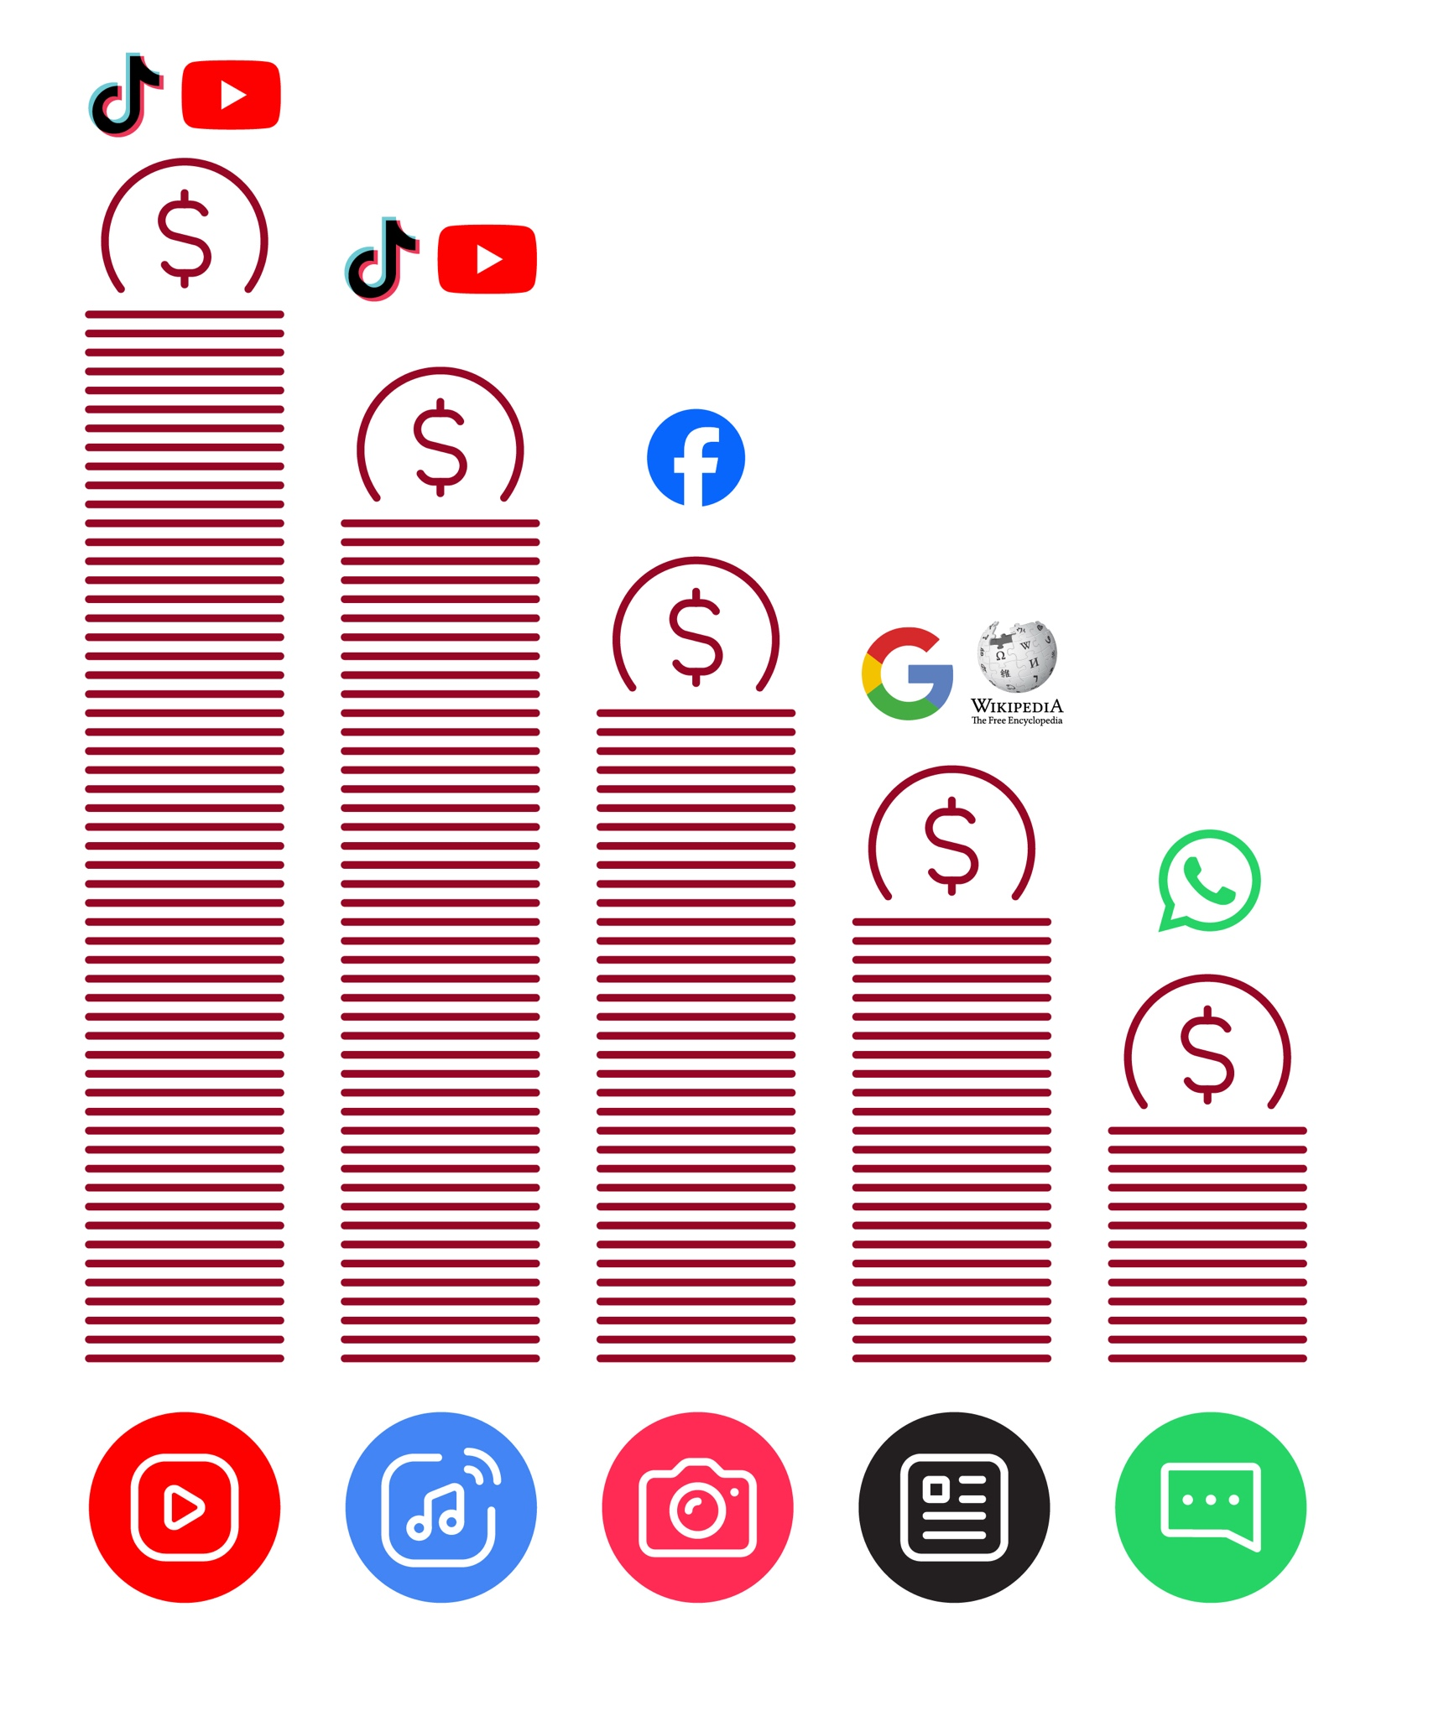
Data Costs
Healthy Internet Use

 | Set time limits  Think about how much time you are spending using the internet – it should not get in the way of your other responsibilities. If it does, set limits!
 | Watch your mood  If the internet or your phone is making you sad or angry, take a break!
 | Maintain healthy relationships online  Make time to socialise with friends and family in real life, not just on the internet! Don’t spend all your time on the internet.
 | Be careful  The internet can be dangerous with scams, harassment and things you don’t want to see. Be careful!
 | Stay positive  Stay positive and avoid upsetting or harming others. Be responsible and keep a positive attitude!
 | Get enough sleep and rest  Sleep and rest are important - make sure the internet or your phone doesn’t stop you doing this! Don’t use the internet when you need to rest or sleep.



How to use
KaiOS

How to use the KaiStore to download apps

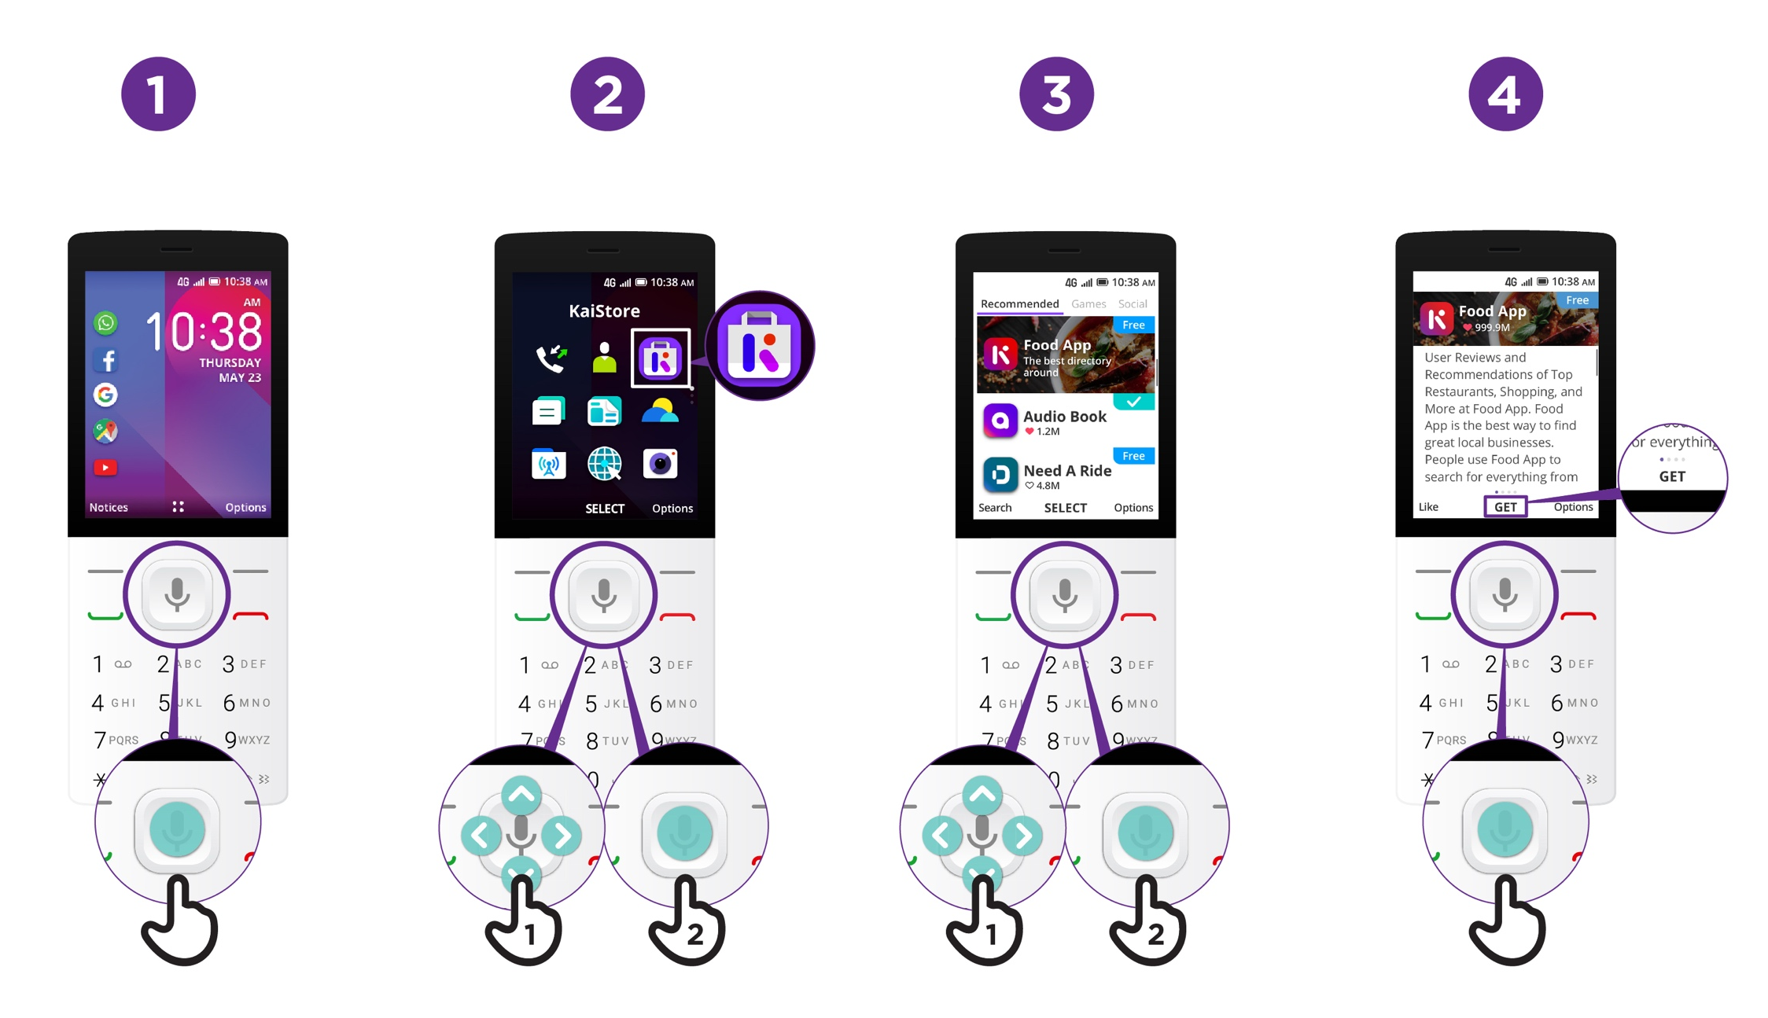

How to use
KaiOS

How to use a browser

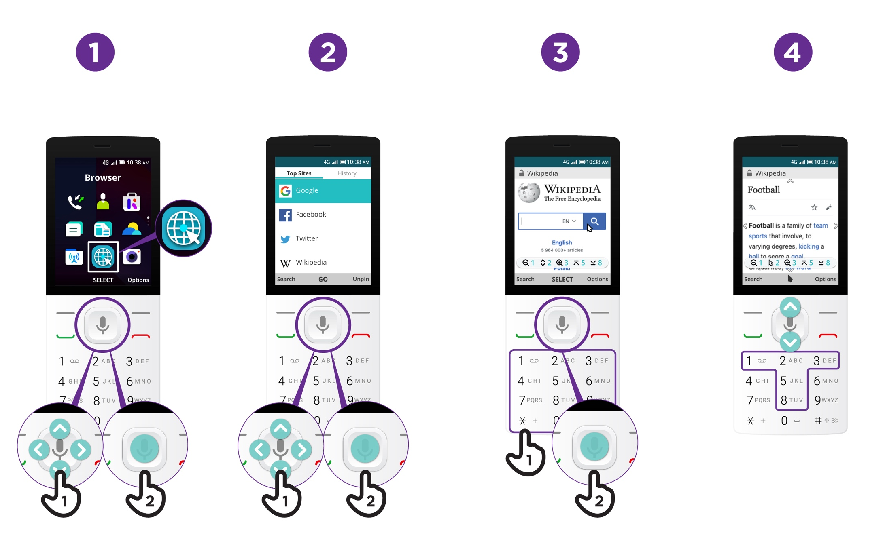

How to use
KaiOS
Connecting to Wi-Fi

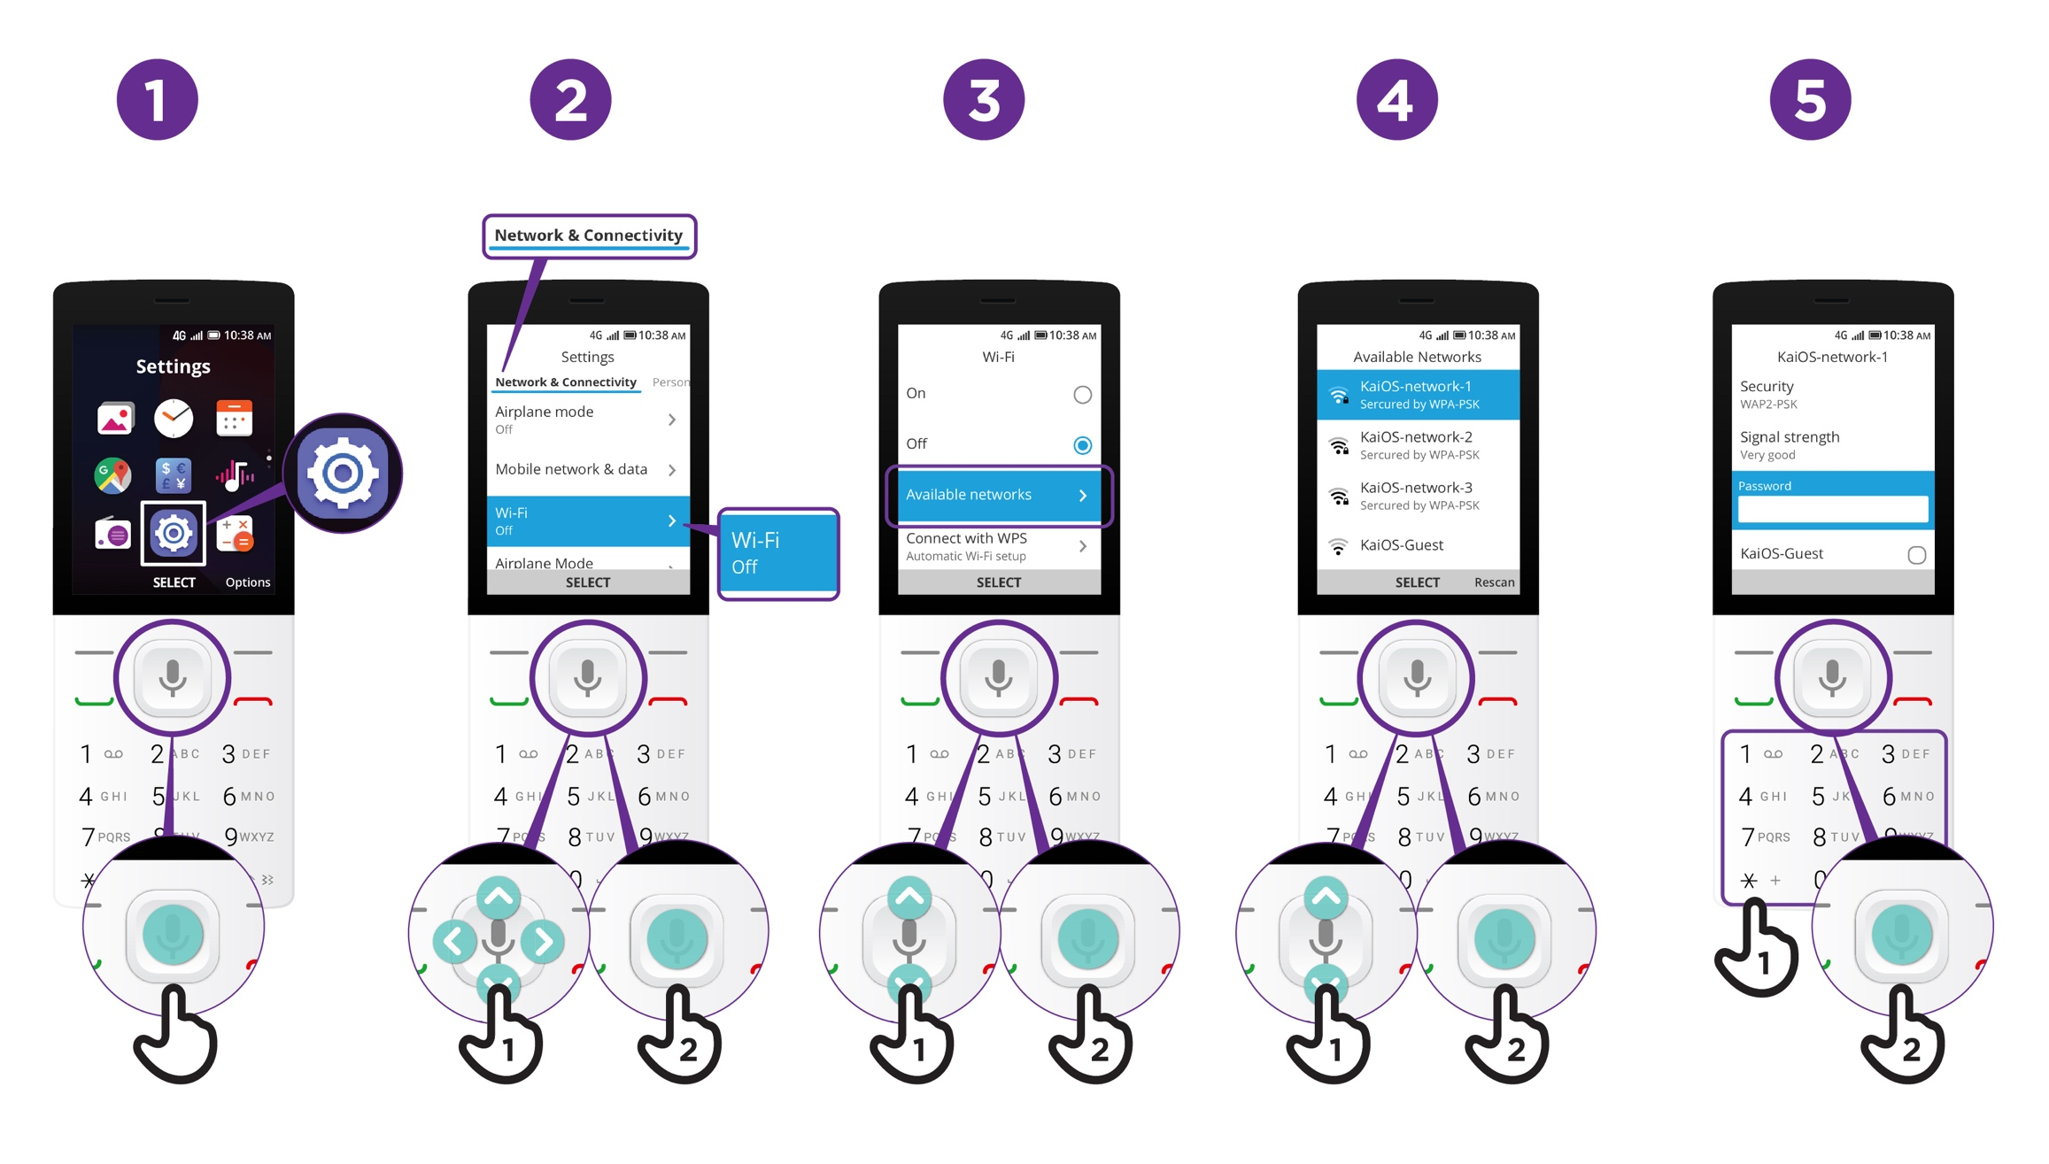


Mobile Internet Skills Training Toolkit

‘Thank you’ and close training

After you have completed the training, congratulate your trainees and hand out certificates as a reward.

Thank the trainees

Give out the handouts

- Give your trainees the handouts for the training if you haven’t already done so.

- These include the ‘Definitions’, ‘Top tips to stay safe online’, ‘Data costs’, ‘Healthy internet use’ and relevant module posters.

- Ask: “Do you feel confident to use these accessibility features?” or “Do you feel confident to use your mobile phone?”

- Thank your trainees for their time, input and participation in the training.



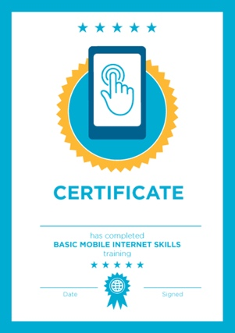

Conduct a closing ceremony

- Give each trainee a signed certificate (certificate templates are included in the toolkit).

- You can also provide the trainers with certificates for having completed the training ‘as trainers’.

Tip: You can make this more of a ceremony for trainees, by asking them to come up to the front of the room one person at a time to receive their certificate and shake the trainer’s hand.

here


CERTIFICATE

has completed

BASIC MOBILE INTERNET SKILLS

training

Date Signed



CERTIFICATE

has completed

BASIC MOBILE INTERNET SKILLS
training

Date
Signed

