
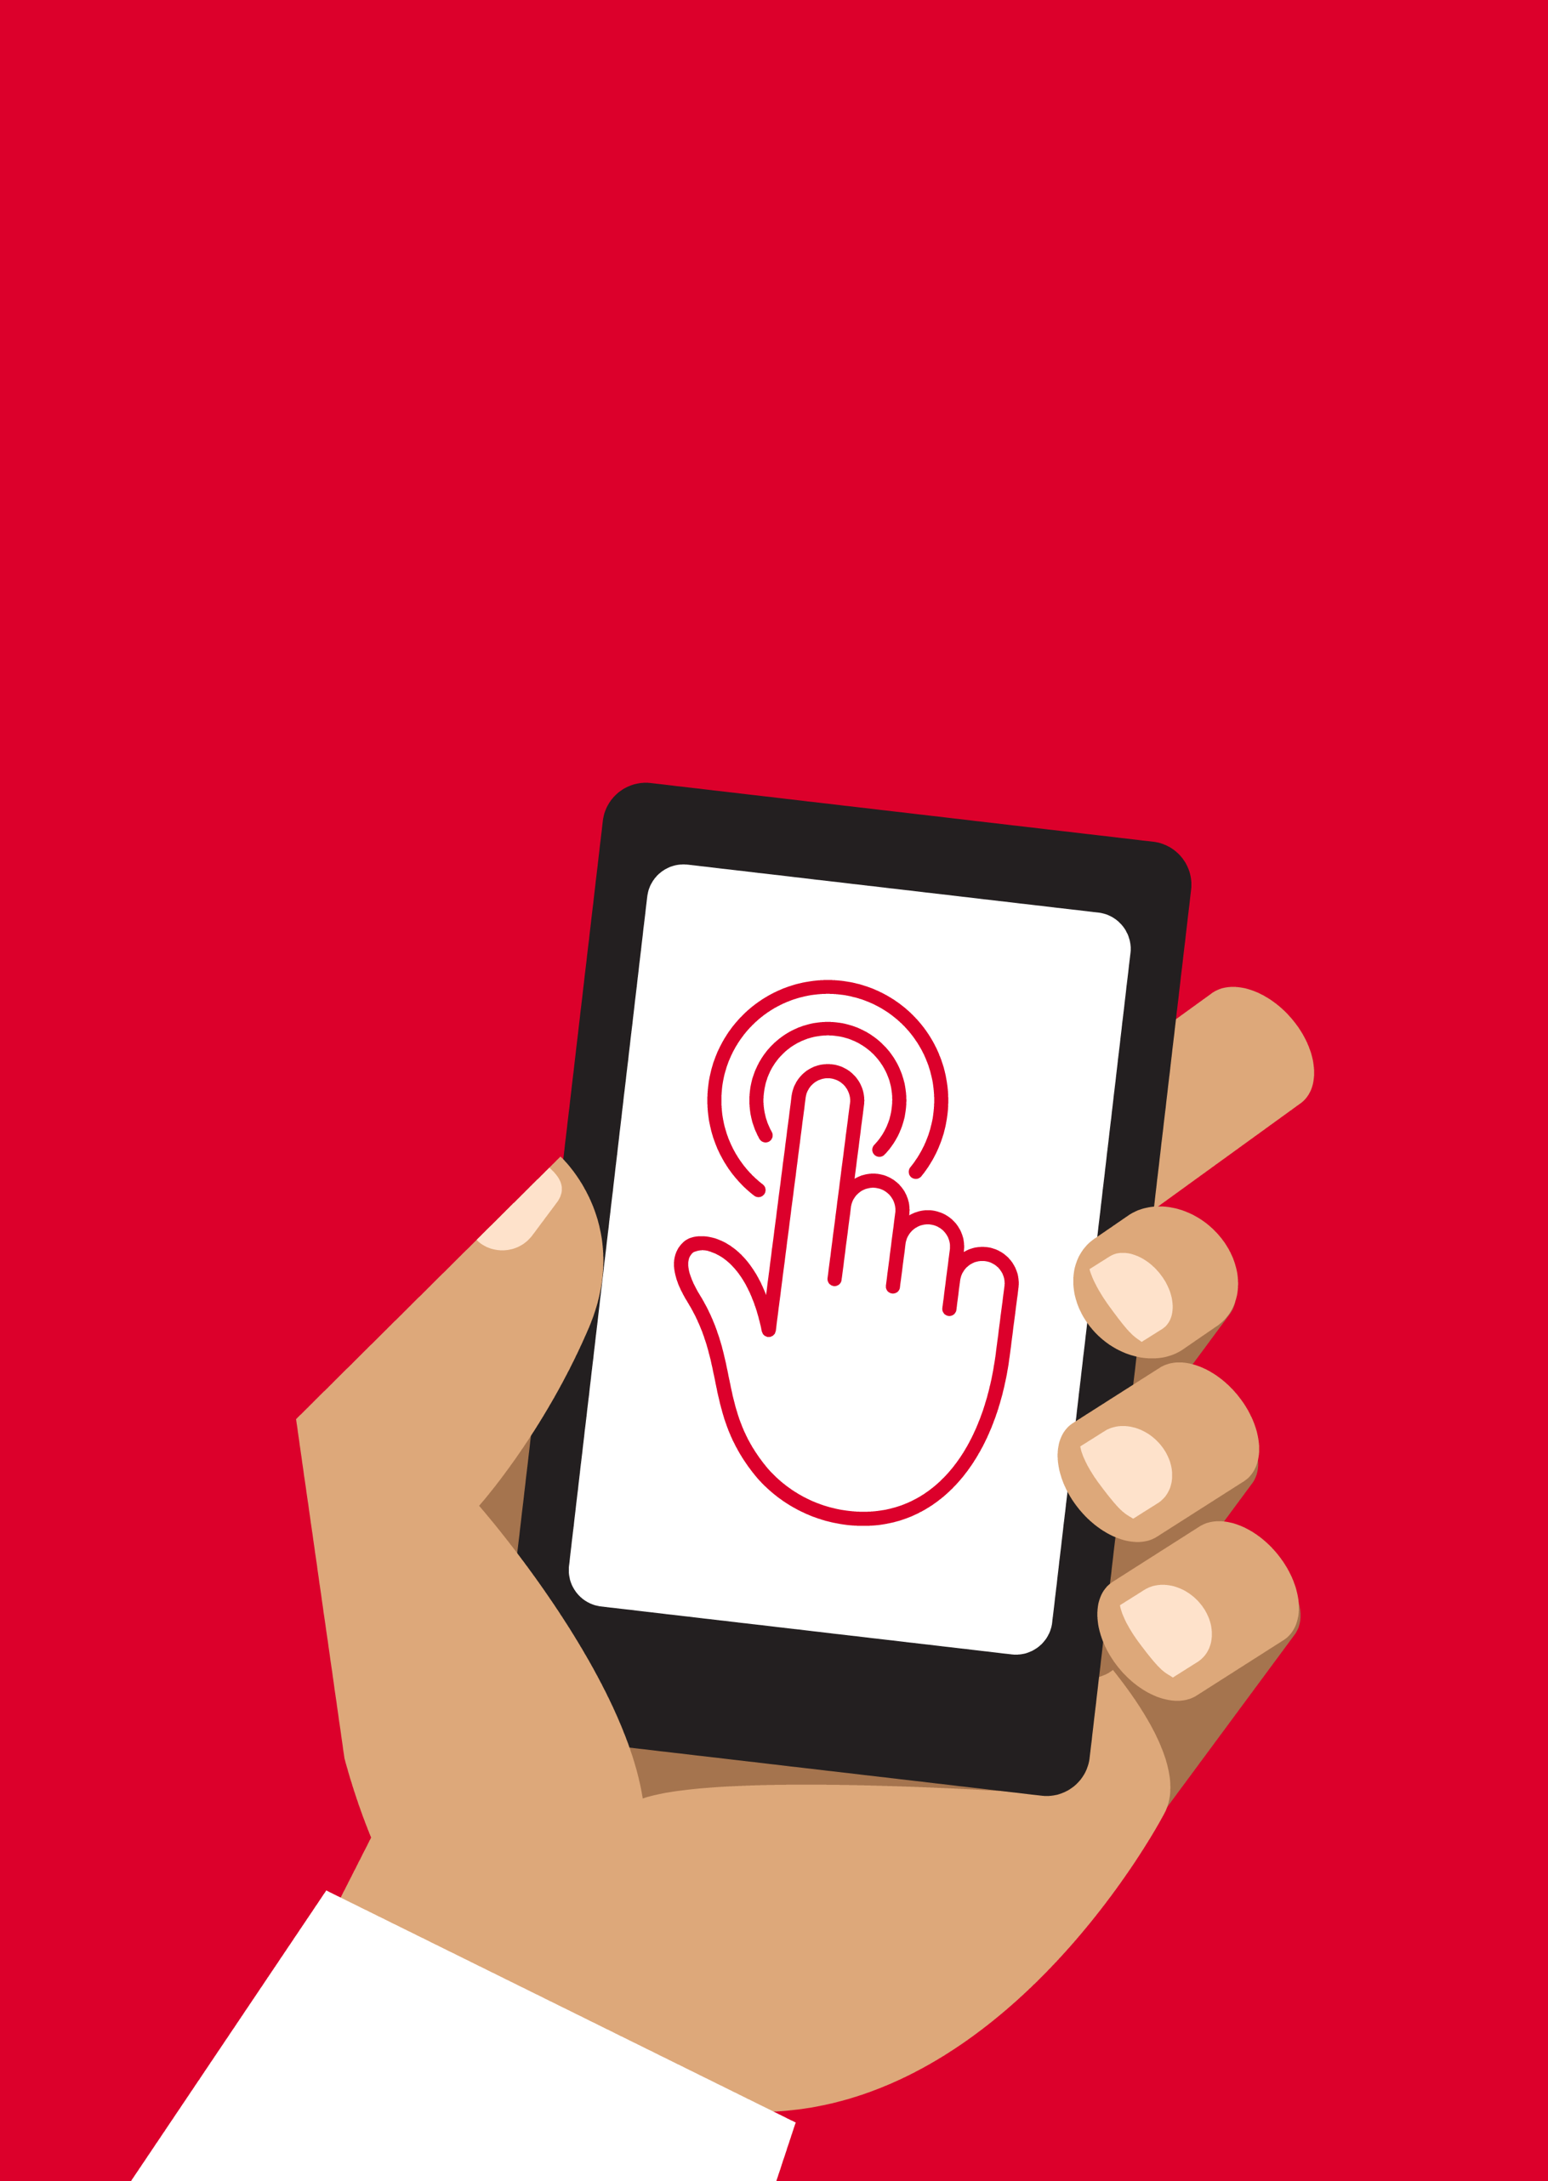

Mobile Internet
Skills Training
Toolkit
A guide for training people in
basic mobile internet skills
Copyright © 2024 GSM Association
Copyright © 2024 GSM Association
Bitesize Training
Mobile Money

Mobile Internet
Skills Training

Toolkit

A guide for training people

in basic mobile internet skills

Module 12:

Mobile Money

What is it?
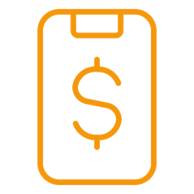 | Show a basic mobile phone with a mobile money service, ensuring the menu is open, showing key functions.  Explain: “ Mobile money is a way to send money to someone else using your mobile phone.”
What can you use it for?
Explain:

“A mobile money account is like having a wallet on your phone. With mobile money you can send and receive money from people, and make payments just using your phone - without having a bank account! Depending on your mobile money provider, you can also do lots of other things like pay your bills, school fees, purchase goods remotely, and save or borrow money.”

Share your own examples with the trainee about the benefits of mobile money and how you personally use it.
Materials you will need:

- Mobile phone
- Mobile Money posters

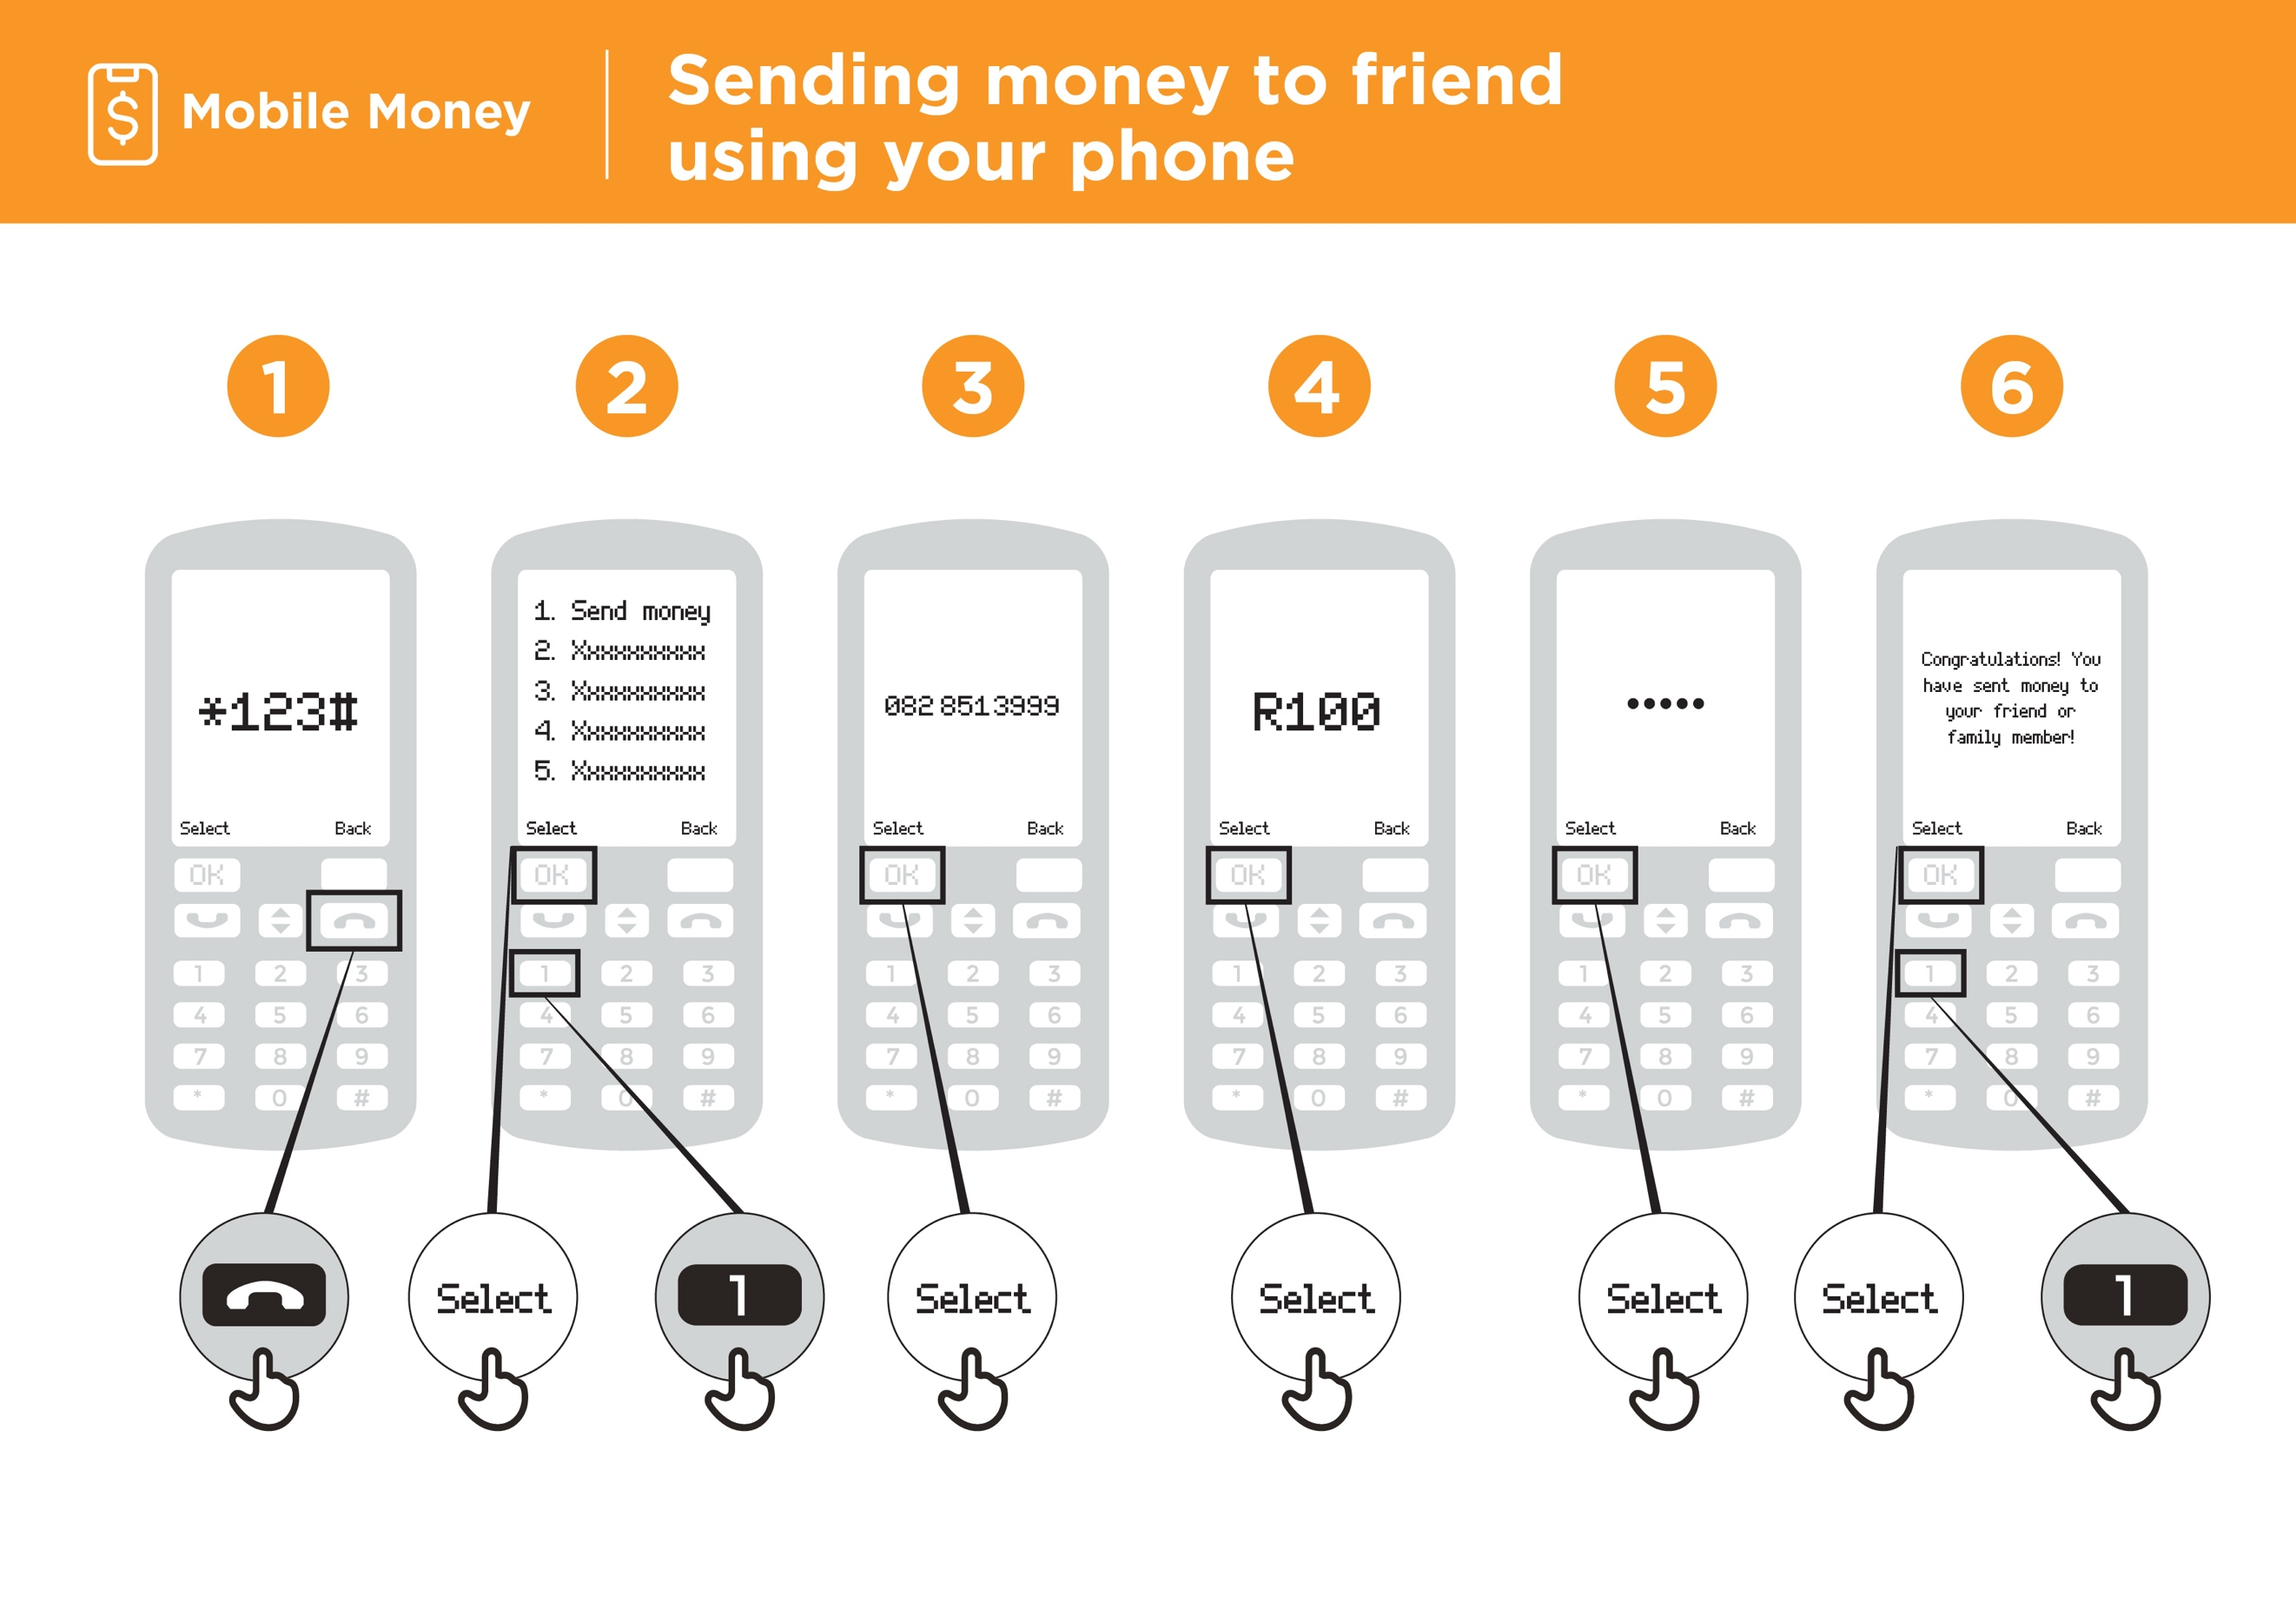

What can you use it for?
Make it relevant to the trainee by discussing how it can be beneficial in the trainee’s own life. Consider examples that will be relevant to the following types of trainees:

Older person: Receive or send money to family that lives far away or pay for bills like electricity from your home so you don’t have to travel; reduce safety risk of saving or carrying large amounts of cash.

Mother or homemaker: Pay for school fees remotely; save money more securely for future family needs or activities; gain access to loans for your family needs; receive money conveniently from someone far away; reduce safety risk of carrying large amounts of cash.

Business owner: Pay suppliers or employees and receive payments from customers conveniently without carrying cash; gain access to loans for your business.

Farmer or rural person: Pay for farming inputs or receive payments for produce remotely; reduce safety risk of carrying large amounts of cash to meetings with buyers.

Young person: Pay university fees or purchase products or services remotely; earn interest on your savings.

How does it work?
Put the phone in the trainee’s hands and help them follow the steps.
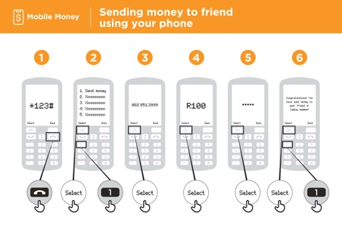
Show the ‘Sending money to a friend using your phone’ poster.

Demonstrate how the trainee can send money to a friend using the steps on the poster.

“I will now show you how you can send money to a friend using your phone.”

“If you want to send money using your account for real, we can do this. Or if you don’t have money in your mobile money account or don’t want to send it right now, I can demonstrate how it is done so that you know for the future.”
- Your mobile operator will have a short number to use their mobile money service. It will look something like *123#. Type it in and press the call button.

- You will get a list of options on screen (e.g. 1, 2, 3, 4, 5). You need to choose transfer/send money. This is normally number 1 (at the top). Press 1 on your phone keypad and move then select/OK.

- Type in the phone number of your friend or family member that you want to send the money to. Press select/OK.

- Now type in the amount of money you want to send to your friend or family member (e.g. 100). Press select/OK.

- Type in your personal PIN. This is a special number that you choose and only you will know. This helps protect your account. Choose a hard to guess PIN. Press select/OK.

- Finally, you need to press 1 to confirm that you want send this money. Press select/OK. Congratulations. You have sent money to your friend or family member.
Tip: At the beginning of the training session, check who already has a mobile money account. If there are trainees without a mobile money account, take them through the registration process (see ‘In-Depth’ section for details).

Tip: If the trainee does not want to send any money, then show them how without sending the money for real.

Practice!
“Now that we have seen how to send money using mobile money, who could you send money to?”

Trainer: Allow the trainee to run through the process of sending money to someone on their own. If they need help at any stage then assist them.

Safety
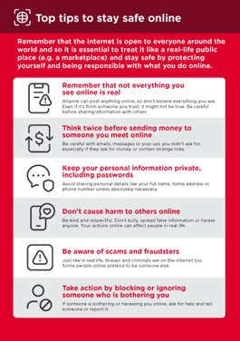
Show the ‘Top tips to stay safe online’ poster.

“Remember that your PIN is your own personal number. It is important that you keep this safe as it is how you access your account. Be careful about sharing this number with anyone, even mobile money agents or customer care staff, whether in person, via SMS or the internet.”

“Never send money to someone you don’t know or trust, or someone you have met online. People may contact you asking to send them money. Do not send them money as this might be a scam.”

Bitesize Training
Mobile Money

Mobile Internet
Skills Training

Toolkit

A guide for training people

in basic mobile internet skills

Posters and Cut-Outs
Top tips to stay safe online

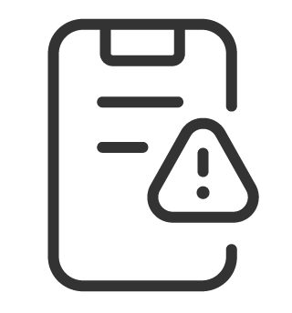 | Remember that not everything you see online is real  Anyone can post anything online, so don’t believe everything you see. Even if it’s from someone you trust, it might not be true. Be careful before sharing information with others
 | Think twice before sending money to someone you meet online  Be careful with emails, messages or pop-ups you didn’t ask for, especially if they ask for money or contain strange links.
 | Keep your personal information private, including passwords  Avoid sharing personal details like your full name, home address or phone number unless absolutely necessary.
 | Don’t cause harm to others online  Be kind and respectful. Don’t bully, spread false information or harass anyone. Your actions online can affect people in real life.
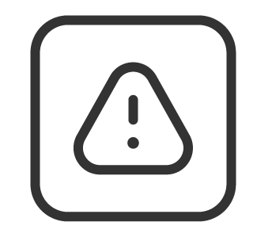 | Be aware of scams and fraudsters  Just like in real life, thieves and criminals are on the internet too.  Some people online pretend to be someone else.
 | Take action by blocking or ignoring someone who is bothering you  If someone is bothering or harassing you online, ask for help and tell someone or report it.

Remember that the internet is open to everyone around the world and so it is essential to treat it like a real-life public place (e.g. a marketplace) and stay safe by protecting yourself and being responsible with what you do online.

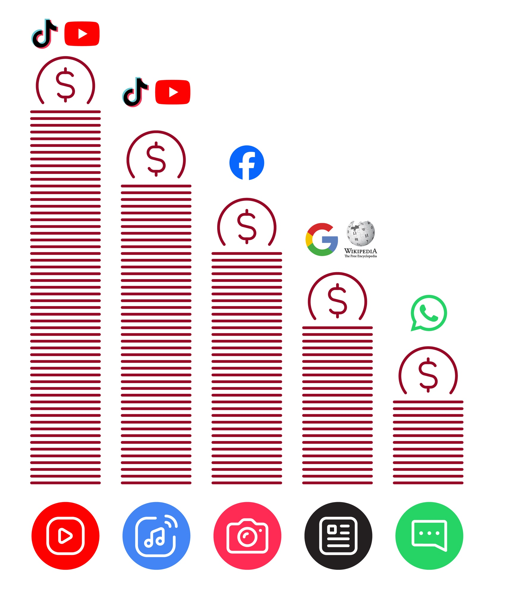
Data Costs
Sending money to friend
using your phone



Mobile Money



1 2 3 4 5 6

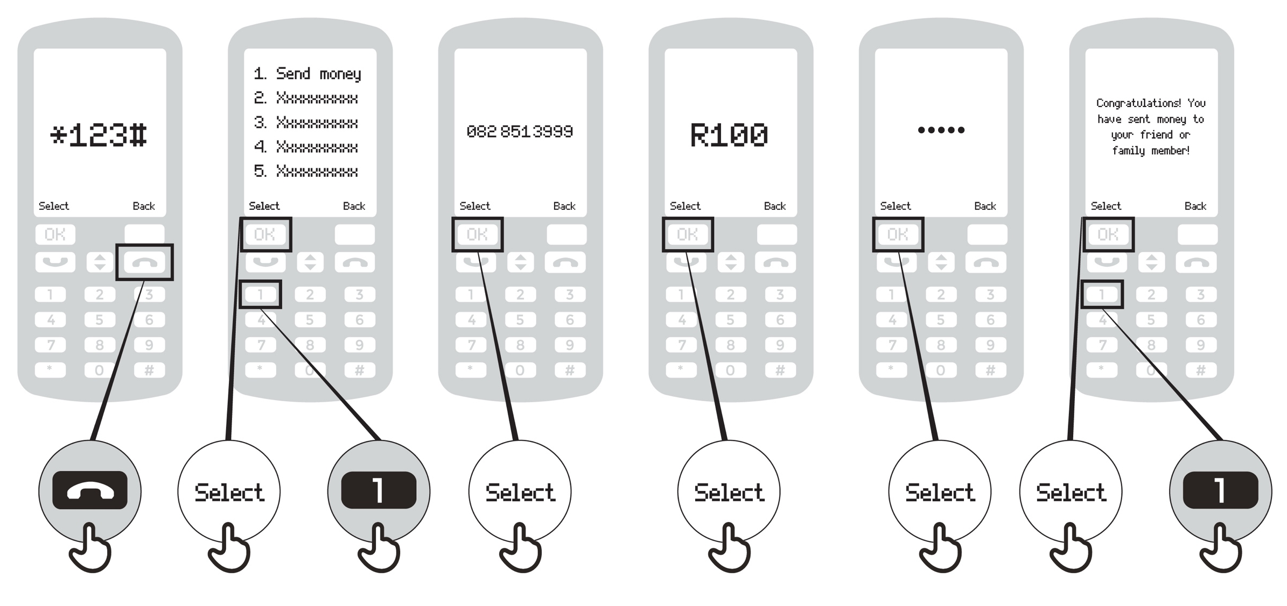

Paying a bill using your phone
Mobile Money

1 2 3 4 5 6 7 8

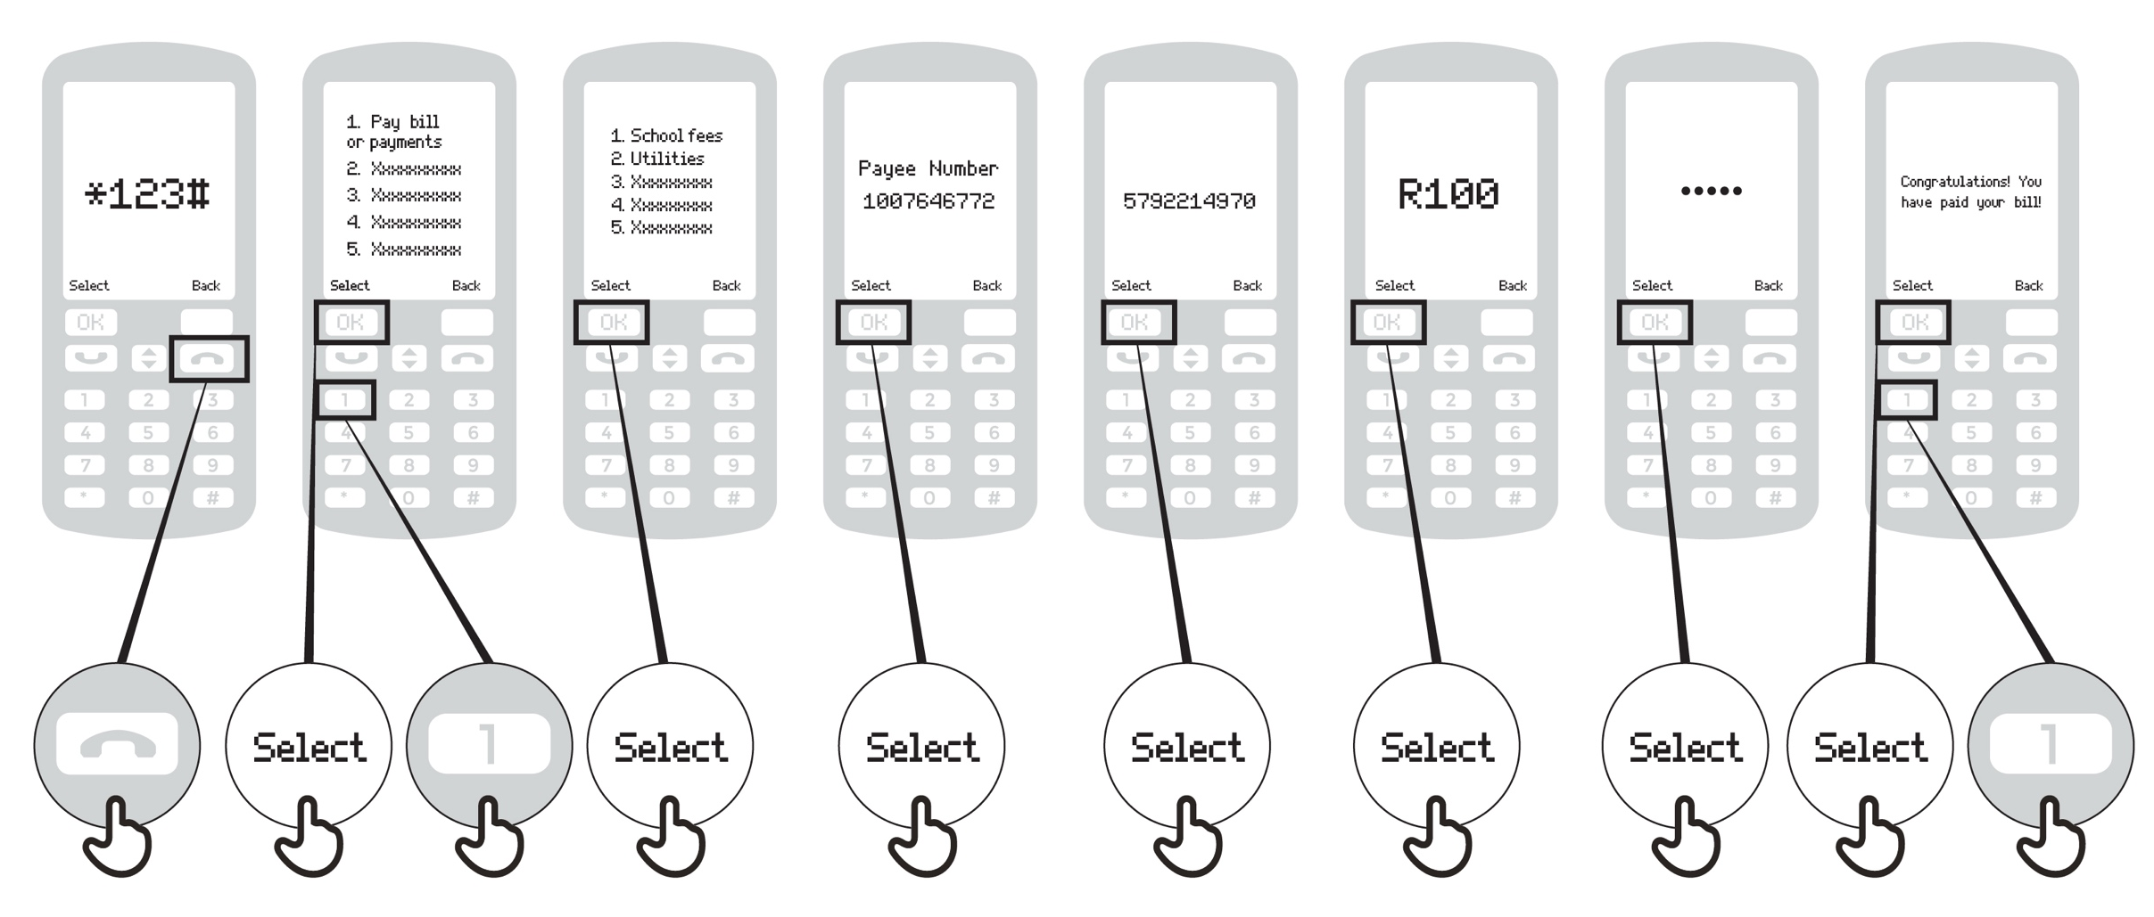
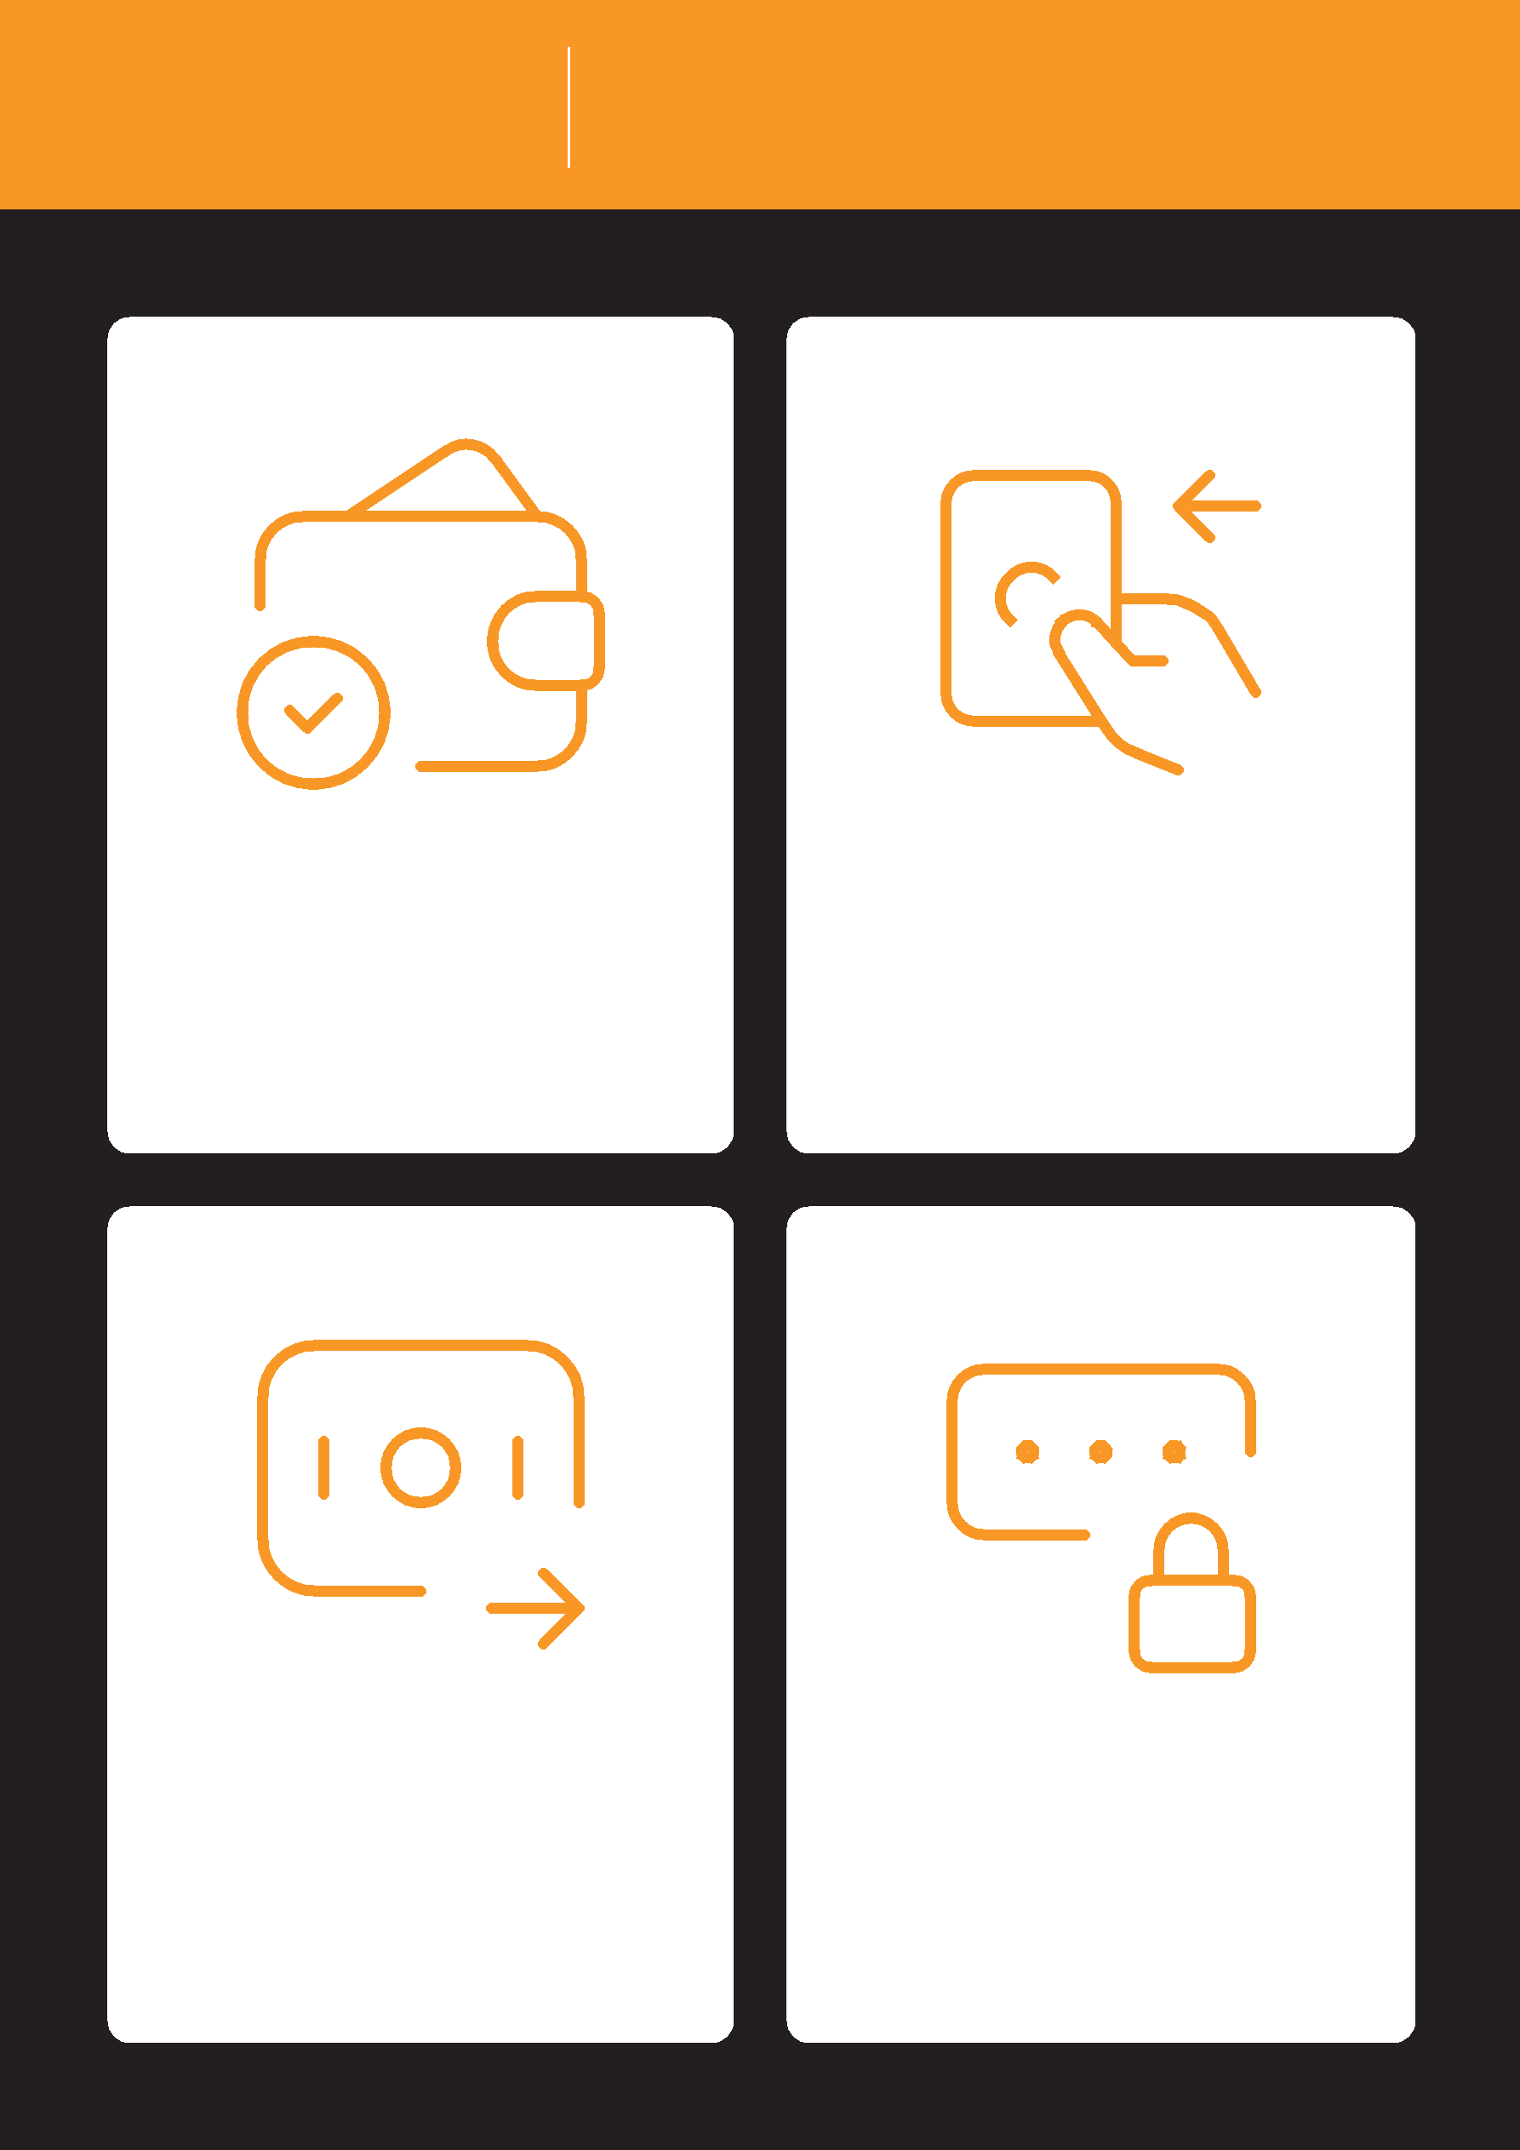
Mobile Money What is mobile money?

It’s like having a wallet on | Cash can be deposited
your phone. | and withdrawn from your
 | mobile money account
 | with your agent.

You can send money to | Your PIN number is the
other people, pay bills, | way you can use your
pay for goods. | account.

Registering for mobile
money account

Mobile Money

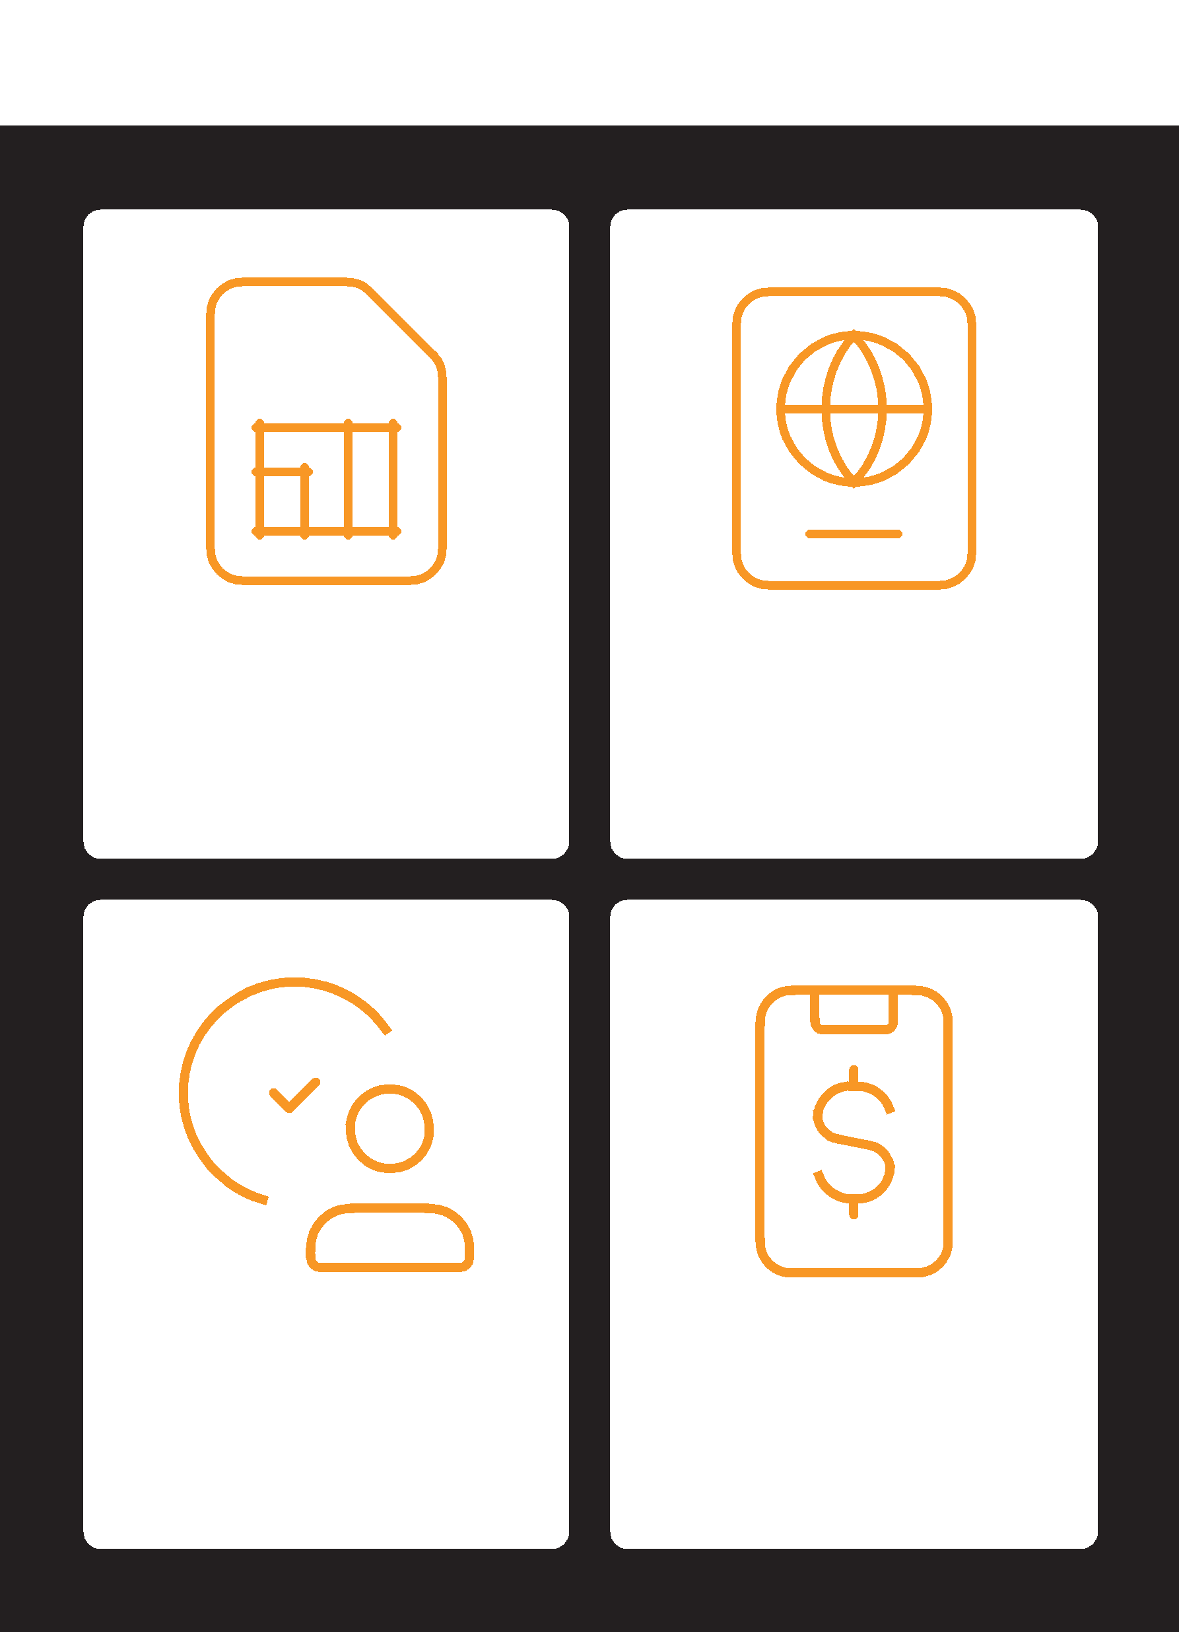

You need a SIM card from | To register for mobile
your mobile operator. | money, you need proof of
Your mobile money agent | identity.
will register you for
mobile money.

Go to your agent every | Once these steps have
time you need to deposit | been completed you can
or withdraw money from | start using your mobile
your account. | money account!

What you can do with
mobile money

Mobile Money

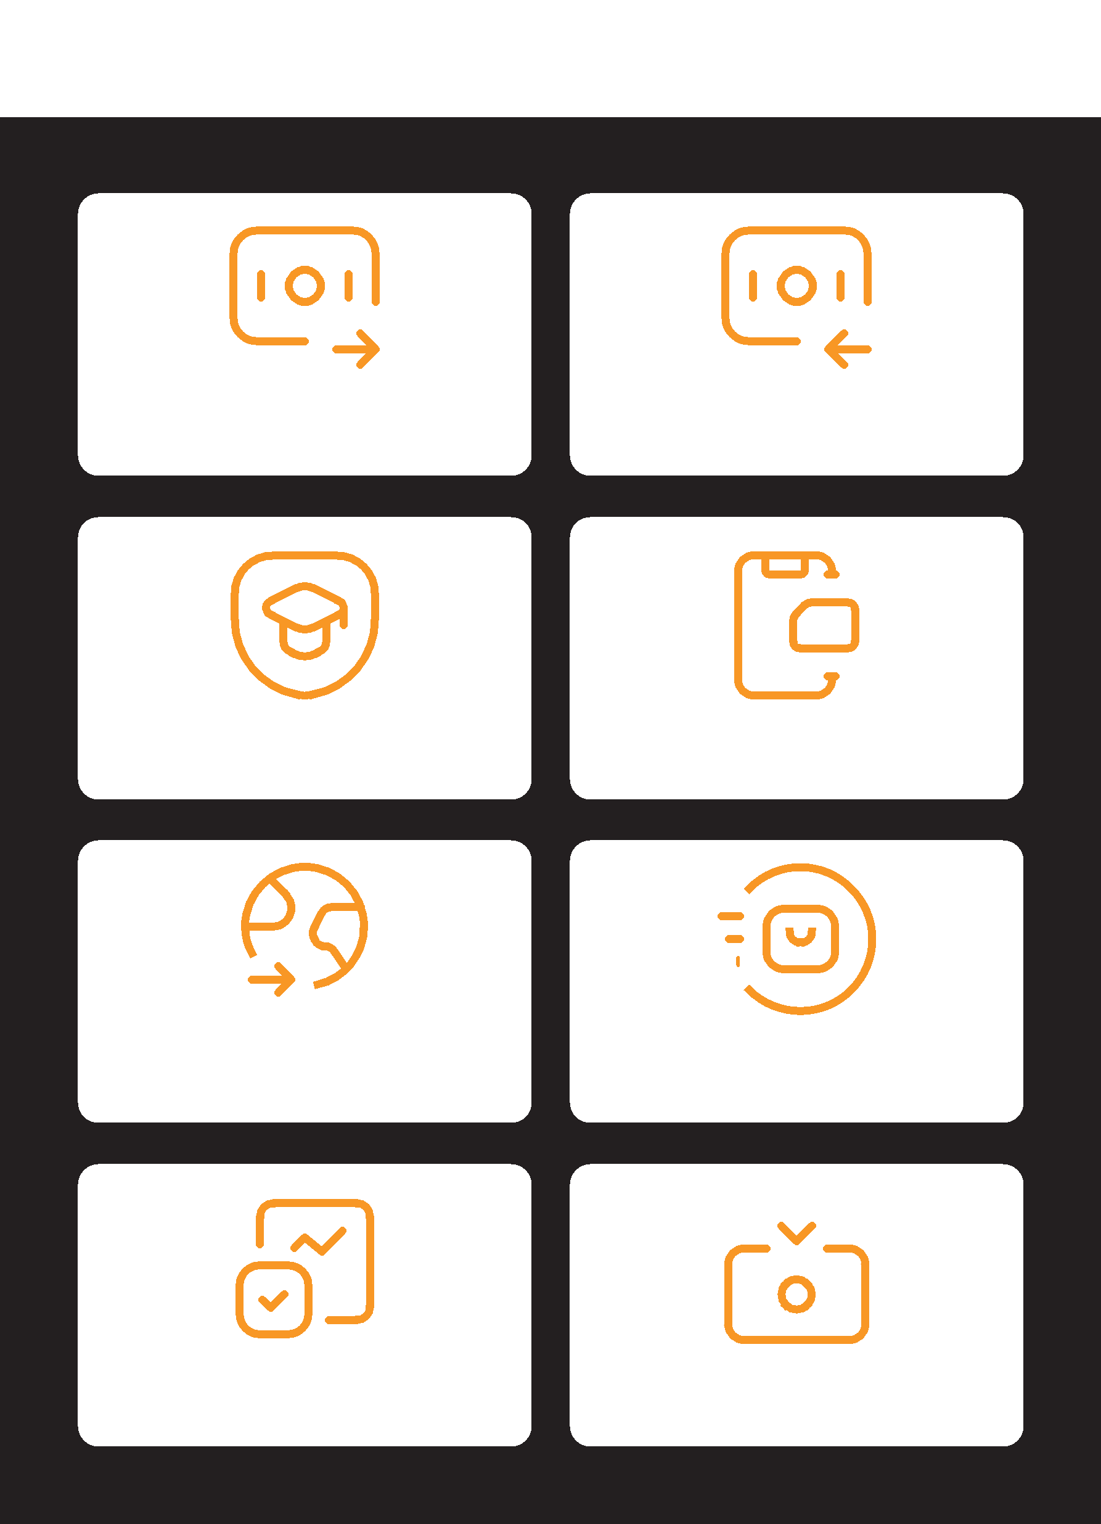

Send money to Receive money from
friends or family friends or family

Pay bills or school fees Buy airtime for you or
other people

Send / receive money to
and from friends and family |  |  | Pay for goods and
in other countries |  |  | services

Earn interest on Get a loan
your savings

Staying safe using
mobile money

Mobile Money
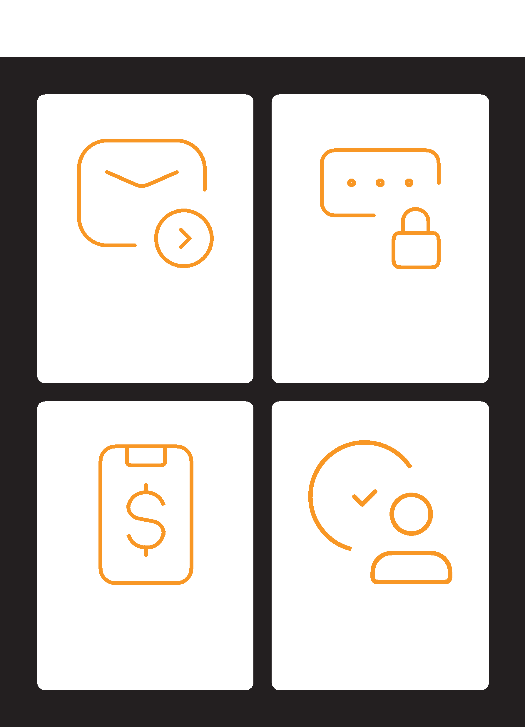

Message PIN

Phone Agents

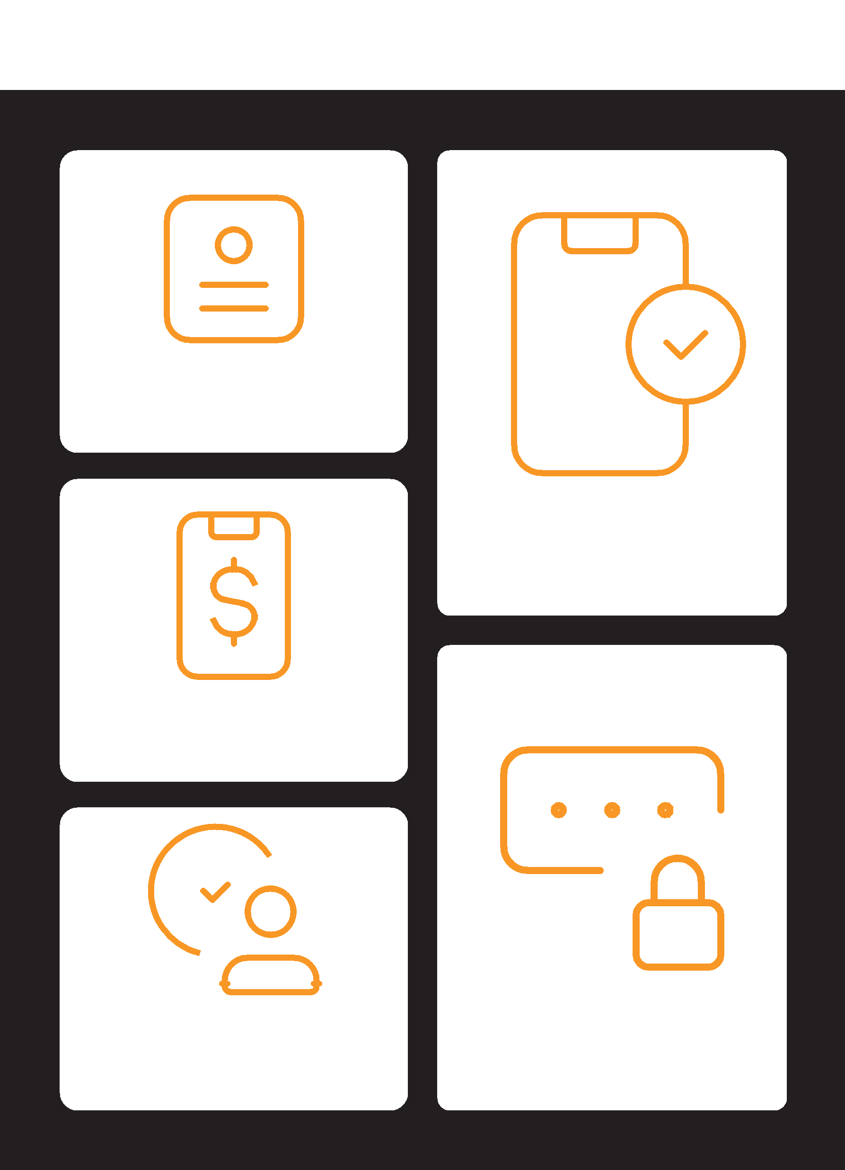
Mobile Money
5 key things to know
about mobile money

Account
registration

Mobile number

Mobile money
Mobile money | PIN number
agent | PIN number

