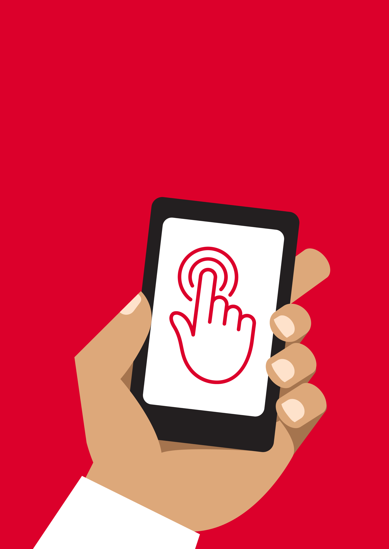


Mobile Internet
Skills Training
Toolkit
A guide for training people in
basic mobile internet skills
Copyright © 2024 GSM Association
Copyright © 2024 GSM Association
In-Depth Training
Mobile Money

Mobile Internet
Skills Training

Toolkit

A guide for training people

in basic mobile internet skills

Module 12:

Mobile Money
Learning objectives
- Trainees understand what mobile money is.

- They feel excited and motivated about mobile money and understand that there are a number of ways it can be used to improve their lives.

- Trainees are able to understand the registration process for mobile money, how to send money to a friend or family member, pay a bill and understand basic safety implications.
Time duration
45-60
minutes

Materials you will need:
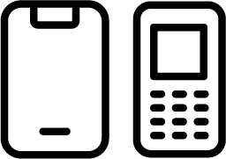  Mobile phone | 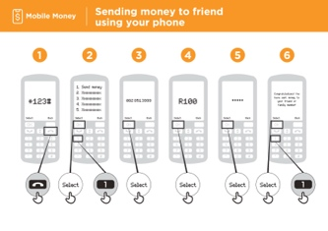  Mobile Money posters

Introduce mobile money
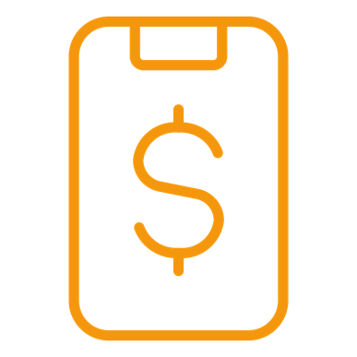
Give a short explanation of mobile money

Explain:

- “A mobile money account is like having a wallet on your phone. With mobile money you can send and receive money from people, and make payments just using your phone - without having a bank account. You can also do lots of other things like pay your bills, and save or borrow money.”

- “Unlike with cash you do not have to carry money around if you want to pay for things. This means that it is safer and easier.”
Bring these benefits to life!

Tell your own story of how mobile money is useful for you (the trainer), your friends and family or your community. Consider examples that will be relevant for these trainees:
Older person: Receive or send money to family that lives far away or pay for bills like electricity from your home so you don’t have to travel; reduce safety risk of saving or carrying large amounts of cash.

Mother or homemaker: Pay for school fees remotely; save money more securely for future family needs or activities; gain access to loans for your family needs; receive money conveniently from someone far away; reduce safety risk of carrying large amounts of cash.
Business owner: Pay suppliers or employees and receive payments from customers conveniently without carrying cash; gain access to loans for your business.

Farmer or rural person: Pay for farming inputs or receive payments for produce remotely; reduce safety risk of carrying large amounts of cash to meetings with buyers.
Young person: Pay university fees or purchase products or services remotely; earn interest on your savings.

Introduce mobile money
Make mobile money relevant for your trainees

Discuss with the trainees how mobile money can be beneficial in their own lives.

Ask:

- “What would you like to use mobile money for in your own life?” Give them some suggestions if they are unsure.

- “What are you most interested in and excited to learn about doing with mobile money?”
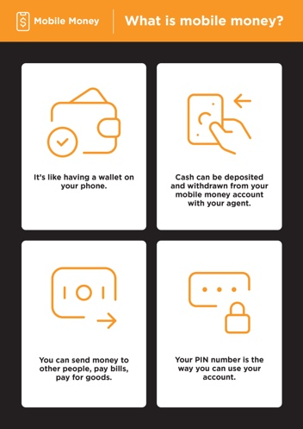
Show the ‘What is mobile money?’ poster

- A mobile money account is like having a wallet on your phone.

- You can give cash to a mobile money agent and it will be deposited in your mobile money account. You can also withdraw cash from your mobile money account at this agent.

- You can send money to other people, pay bills and pay for goods.

- Your PIN is your special number and is the way you can use your account.

Registration
Explain: “In order to make use of mobile money, you will need to have a mobile money account with your mobile operator. Every adult with a SIM card can register for a mobile money account. It is similar to how you open an account to make calls or send SMS. To register for a mobile money account, you will need to visit a mobile money agent.”

Explain: “Your mobile money agent is a very important person. They help you deposit cash into your account, as well as withdraw cash from your account when you need it. You can buy airtime and data from them and you can also set up your mobile money account with them. They will also be able to help you if you have questions.”
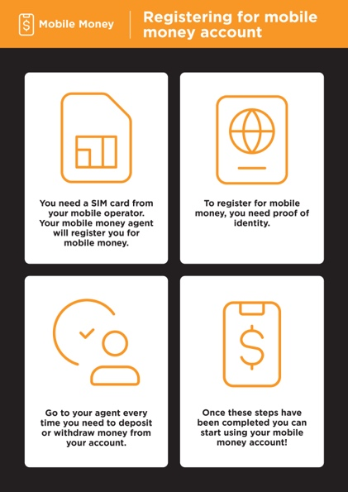
Show the ‘Registering for mobile money account’ poster

- If you don’t already have one, you will need a SIM card from your mobile operator. Once you have a SIM card, your mobile money agent will be able to help you register for mobile money. You may need to complete a form with some personal information.

- To register for mobile money, you will need to have an ID document (like a passport, driving licence or voters card).

- To start using/paying with mobile money, you will need to deposit money in your account at your operator agent (or at some ATMs - depending on your country). You will go to your agent every time you need to deposit or withdraw money from your account.
- Once you have completed these steps, you will have a mobile money account and you can start using mobile money.

Activity: Sending a transfer or remittance using mobile money
Trainer: At the beginning of the training session, check who has a mobile money account and who has not. If there are trainees without a mobile money account, take them through the registration process.

Explain: “You are now going to learn how to send some money to a friend or family member using mobile money.”

Ask: “If you want to send money using your account for real, we can do this. If you don’t have money in your mobile money account or don’t want to send it, I can demonstrate how it is done so that you know for the future.”
Tip: If the trainee does not want to send any money, then show them how they can without sending the money for real.

Tip: You can reinforce trainees’ knowledge of the icons by playing the ‘TikTok icon game’.
Bring the tips to life by using examples that are relevant for your trainees based on your experience. For example, parents may be more concerned about how to help their children avoid incorrect information.

Activity: Sending a transfer or remittance using mobile money
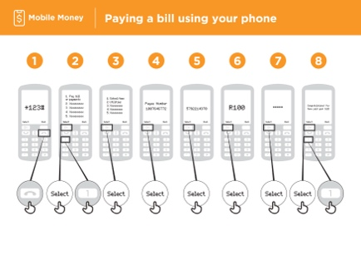
Show the ‘Sending money to friend using your phone’ poster

Demonstrate how the trainee can send money to a friend or family member using the steps on the poster.

Explain: “We will now see how to send money to friend using your phone.”

- Your mobile operator will have a short number to use their mobile money service. It will look something like *123#. Type it in and press the call button.

- You will get a list of options on screen (e.g. 1,2,3,4,5). You need to choose transfer/send money. This is normally number 1 (at the top). Press 1 on your phone keypad and then select/OK.

- Type in the phone number of your friend or family member that you want to send the money to. Press select/OK.

- Now type in the amount of money you want to send to your friend or family member (e.g. 100). Press select/OK.

- Type in your personal PIN. This is a special number that

you choose and only you will know. This helps protect your account. Choose a hard to guess PIN. Press select/OK.

- Finally, you need to press 1 to confirm that you want send this money. Press select/OK. Congratulations. You have sent money to your friend or family member.

Explain: “If you realise that you have sent the money to the wrong person, your mobile operator might be able to help. Call your mobile operator customer service as soon as possible, or ask your mobile money agent for help.”
Tip: “Remember that your PIN is your own personal number. It is important that you keep this safe as it is how you access your account. Be careful about sharing this number with anyone, even mobile money agents or customer care staff, whether in person, via SMS or on the internet.”

Activity: Paying a bill
Explain: “With mobile money, you can do far more than just send money to other people. For example, other people can send money to you, you can pay bills, or you can save or borrow money.”

Explain: “Your mobile money agent is a very important person. You can buy airtime and data from them but you can also set up your mobile money account with them. They also help you deposit cash into your account, as well as withdraw cash from your account when you need it. They will also be able to help you if you have questions.”
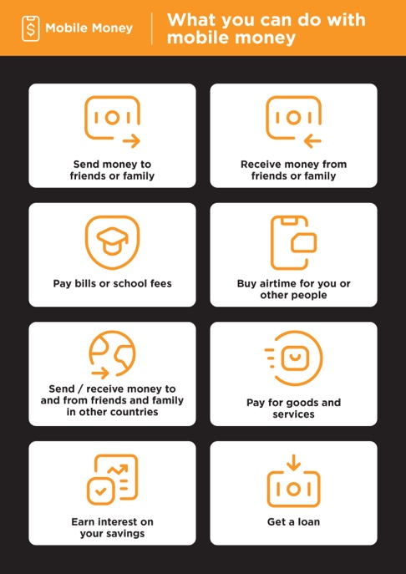
Show the ‘What you can do with mobile money’ poster

- Send money to friends or family.

  - Receive money from friends or family.

  - Pay bills or school fees.

  - Buy airtime for you or someone else.

  - Send/receive money to and from friends and family in other countries.

    - Pay for goods and services.

- Earn interest on your savings.

    - Get a loan.

Activity: Paying a bill
Explain: “Once you know how to send a payment to someone using mobile money on your phone, you can also learn how to do other things, e.g. you could pay a bill.”

Demonstrate how the trainee can send money to a friend or family member using the steps on the poster.
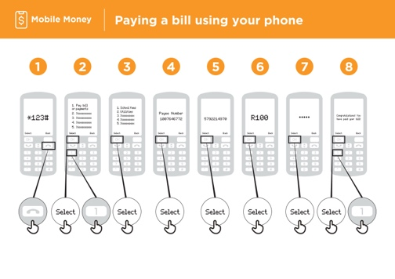
Show the ‘Paying a bill using your phone’ poster

- Your mobile operator will have a short number to call for using their mobile money service. It will look something like *123#. Type it in and press the call button.
- You will get a list of options (1,2,3,4,5). You need to choose the option for pay a bill or payments. Press select/OK.
- Then you need to find the type of bill you would like to pay and/or enter your payee’s number. For example, this could be school fees or utilities. Press select/OK.
- Enter your account number for this service. Press select/OK.
- Now type in the amount of money you want to pay (e.g. 100). Press select/OK.
- Type in your personal PIN. This is so that your mobile operator knows that it is you. Press select/OK.

- Finally, you need press 1 to confirm that you want send this money. Press select/OK. Congratulations. You have paid your bill.
Ask: “Now that you have paid a bill using mobile money, what else would you like to do?”

Trainer: Allow the trainee to run through the menu to find the other use cases for mobile money (e.g. buying airtime). Explain that the menu works in the same way as for bill payment or sending money to someone. If they need help at any stage, then assist them.
Tip: “You can also use mobile money on a smartphone. This will let you do many of the same things but is also easier to use and lets you do other things such as find out where mobile money agents are on a map. You will need mobile data to use mobile money via a smartphone app.”

Safety
Explain: “Mobile money is safer than carrying cash with you. But you need to remember that it is important that you stay safe.”

Ask your trainees to imagine they are in a typical public place, e.g. like the market.

Ask them to discuss what they would do to keep their money safe in this place.

If necessary, prompt them with the following questions and answers:
Prompts | Potential answers
What do you do if someone you don’t  know bothers you for money? | You avoid or ignore them. Remember  that people are not always who they  say they are.
What do you do if you feel unsure  or uncomfortable about something  someone asks you? | Tell someone you know and trust  about what happened and ask their  advice.
What do you do if someone you  don’t know or trust asks you for your  personal information (including via  SMS or WhatsApp)? | You don’t give out personal  information to someone you don’t  know or trust because they may  misuse it.
Explain: “You can stay safe using mobile money by acting like you do in a public place. If someone sends you an SMS saying that they need your PIN or asks you for money, they may not be who they say they are.”

Safety
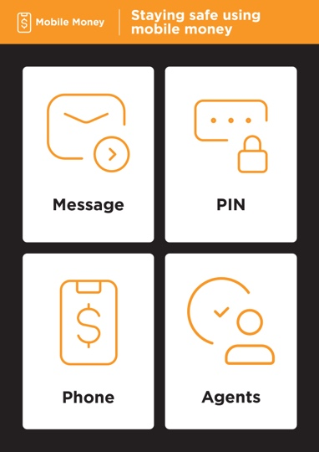
Show the ‘Staying safe using mobile’ poster

- Message: If someone sends you an SMS or message on the internet asking for money or your PIN, they might not be who they say they are.

- PIN: Your PIN is a personal number for you. You need to keep this safe and be careful about sharing this number with anyone, even mobile money agents or customer care staff, whether in person, via SMS or on the internet. It is better to hide your screen and keep your fingers covered when entering your PIN. If you think somebody else might have discovered your PIN, contact your mobile money agent to learn how to change it.

- Phone: If you lose your phone, it doesn’t mean that people can steal money from your mobile money account. If the thieves don’t know your mobile money PIN, they will not be able to use your money. If your phone gets stolen, visit your mobile money agent.

- Agents: Remember that you can only withdraw cash from and deposit cash in your mobile money account at authorised agents of your mobile operator or at certain ATMs. Make sure you know if the person you are talking to about your mobile money account is an agent.
Explain: “It is very important to remember your PIN. If you forget it, your mobile operator will be able to help you. Ask your mobile money agent how to get a new PIN but remember to keep it a secret. If you input the wrong PIN a number of times, your account might be locked. Visit your mobile money agent to get a new PIN and unlock your account.”

Discuss with your trainees what these tips mean for using mobile money.

Bring the tips to life by using examples from your life that are relevant for your trainees.

Safety
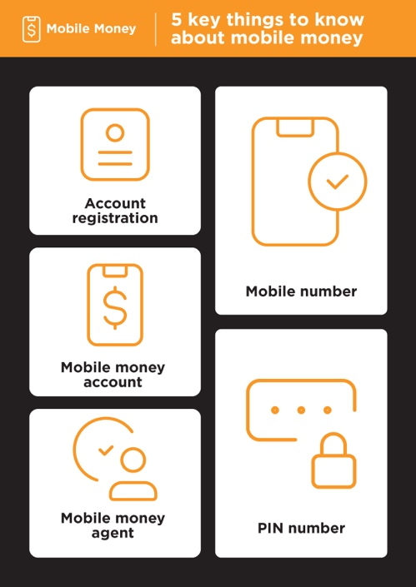
Show the ‘Five key things to know about mobile money’ poster

- Account registration: To use mobile money, you will need to register with a mobile money agent who will help you create an account. To do this, you will need a SIM card and some ID documents (like a passport, driving licence or voters card).

- Mobile money account: A mobile money account is like having a wallet on your phone. With mobile money, you can send and receive money from people, and make payments just using your phone – all without having a bank account.

- Mobile money agent: A mobile money agent is who you go to when you need to deposit or withdraw money from your account. They can help you if you have a problem with your account.

- Mobile number: A mobile phone number – the one you use to call and SMS people - is important for mobile money. When you want to send money to someone using mobile money, you use their mobile number. This is the same if they want to send money to you.

- PIN: This is your personal number which helps you protect your mobile money account. You will need to type this into your phone when using mobile money. Keep it safe and don’t share it with anyone.

In-Depth Training
Mobile Money

Mobile Internet
Skills Training

Toolkit

A guide for training people

in basic mobile internet skills

Posters and Cut-Outs
Session Ground Rules

This space is:

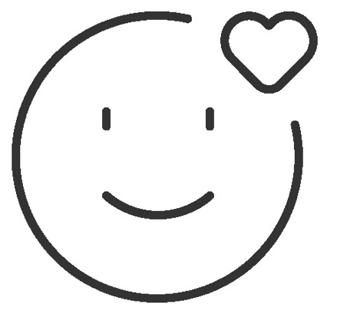

Safe

Keep all information in this training confidential. We suggest you don’t share personal numbers with the other members of group.

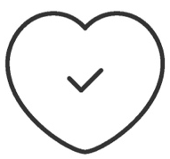

Positive & open

Please be respectful and
positive in your opinions and discussions. There are no right or wrong answers and we are not here to test you.

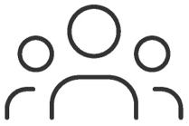

- shared
community

There are people with different backgrounds, knowledge and opinions. This is our shared space, so respect and support everyone.

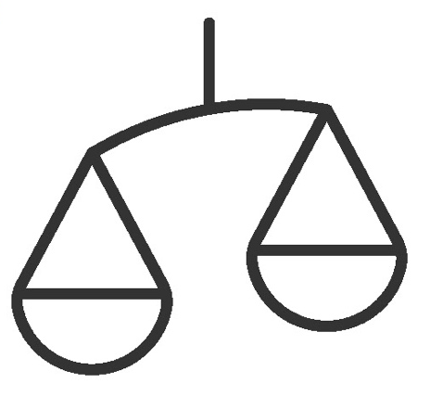

Fair

We will work in small groups and we will provide you with shared phones. We would like to give everyone an equal chance to be heard and to take turns using a phone.

Definitions

Trainers can add to this section to include local relevant information on mobile internet
3G / 4G / 5G | The internet can run at different speeds when you use it. 3G internet is the slowest, 4G internet is faster and 5G internet is the fastest.
App | An app gives you a shortcut to a service on your phone. For internet services e.g. WhatsApp, Facebook, Google, apps provide a quick and easy way to get onto the internet to use that service.
Address bar | The address bar shows you what website you are on.  In the address bar there will always be the address of the website e.g. www.google.com
Advert  or Ad | An ad is a piece of information that is trying to sell you something. It is good practice to avoid clicking on ads.  - Ads can be videos or images that pop up on your screen.  - Ads can also be the links at the top of Google results and on the right side of the screen.
Browser |   A web browser, or simply “browser,” is an application used to access and view websites. Common web browsers include:
Data | Whenever you use the internet on your phone, you are using data. You can buy data from your mobile network provider, just like you do with phone credit.
Feature  Phone | A mobile phone that has the ability to access the internet and store and play music but lacks the advanced functionality of a smartphone.
 | Google is an internet service that makes it easy to find any information that you want to find on the internet.

Definitions

Internet | The Internet is a network of millions of computers around the world connected to each other with phone lines, satellites and cables. It gives you access to a huge range of information and services and it is growing all the time. The internet is for everybody. There are no restrictions on who can use it. You just need a computer, mobile phone or tablet and a data connection.
Link | A link connects you from one website to another. To go to the other website, you can touch the link and this will connect you and take you to that other website
Megabytes & Gigabytes | Megabytes (MB) and Gigabytes (GB) are units of data that you use when using the mobile internet. GB are 1000 times bigger than MB. If you download or stream a song, that will use approximately 5MB (1MB per minute).
Search | The search function helps you find what you are looking for. You type the words to what you are looking for into a search box and then you will see a list of links to potential answers.
Smartphone | A mobile phone that has the ability to access the internet, store and play music and videos, and run ‘apps’. These phones typically also have a touchscreen.
Website | Information on the internet is kept on different websites. There are lots of separate and different websites on the internet e.g. Google is a website, YouTube is a website.
 | WhatsApp is an internet service that makes it easy to connect and communicate with people that you know; family, friends and colleagues.
WiFi | A WiFi zone is an area where you do not have to use your own data to access the internet on your phone; you can connect to the internet for free. WiFi zones are available in some public places such as coffee shops and cafes.
 | YouTube is an internet service that makes it easy to find, watch and listen to videos on the internet (and only videos).

Trainers can add to this section to include local relevant information on mobile internet

Top tips to stay safe online

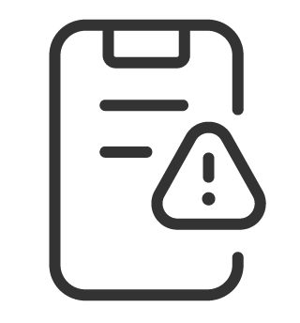 | Remember that not everything you see online is real  Anyone can post anything online, so don’t believe everything you see. Even if it’s from someone you trust, it might not be true. Be careful before sharing information with others
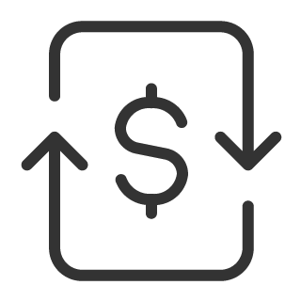 | Think twice before sending money to someone you meet online  Be careful with emails, messages or pop-ups you didn’t ask for, especially if they ask for money or contain strange links.
 | Keep your personal information private, including passwords  Avoid sharing personal details like your full name, home address or phone number unless absolutely necessary.
 | Don’t cause harm to others online  Be kind and respectful. Don’t bully, spread false information or harass anyone. Your actions online can affect people in real life.
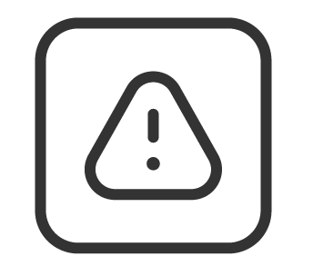 | Be aware of scams and fraudsters  Just like in real life, thieves and criminals are on the internet too.  Some people online pretend to be someone else.
 | Take action by blocking or ignoring someone who is bothering you  If someone is bothering or harassing you online, ask for help and tell someone or report it.

Remember that the internet is open to everyone around the world and so it is essential to treat it like a real-life public place (e.g. a marketplace) and stay safe by protecting yourself and being responsible with what you do online.

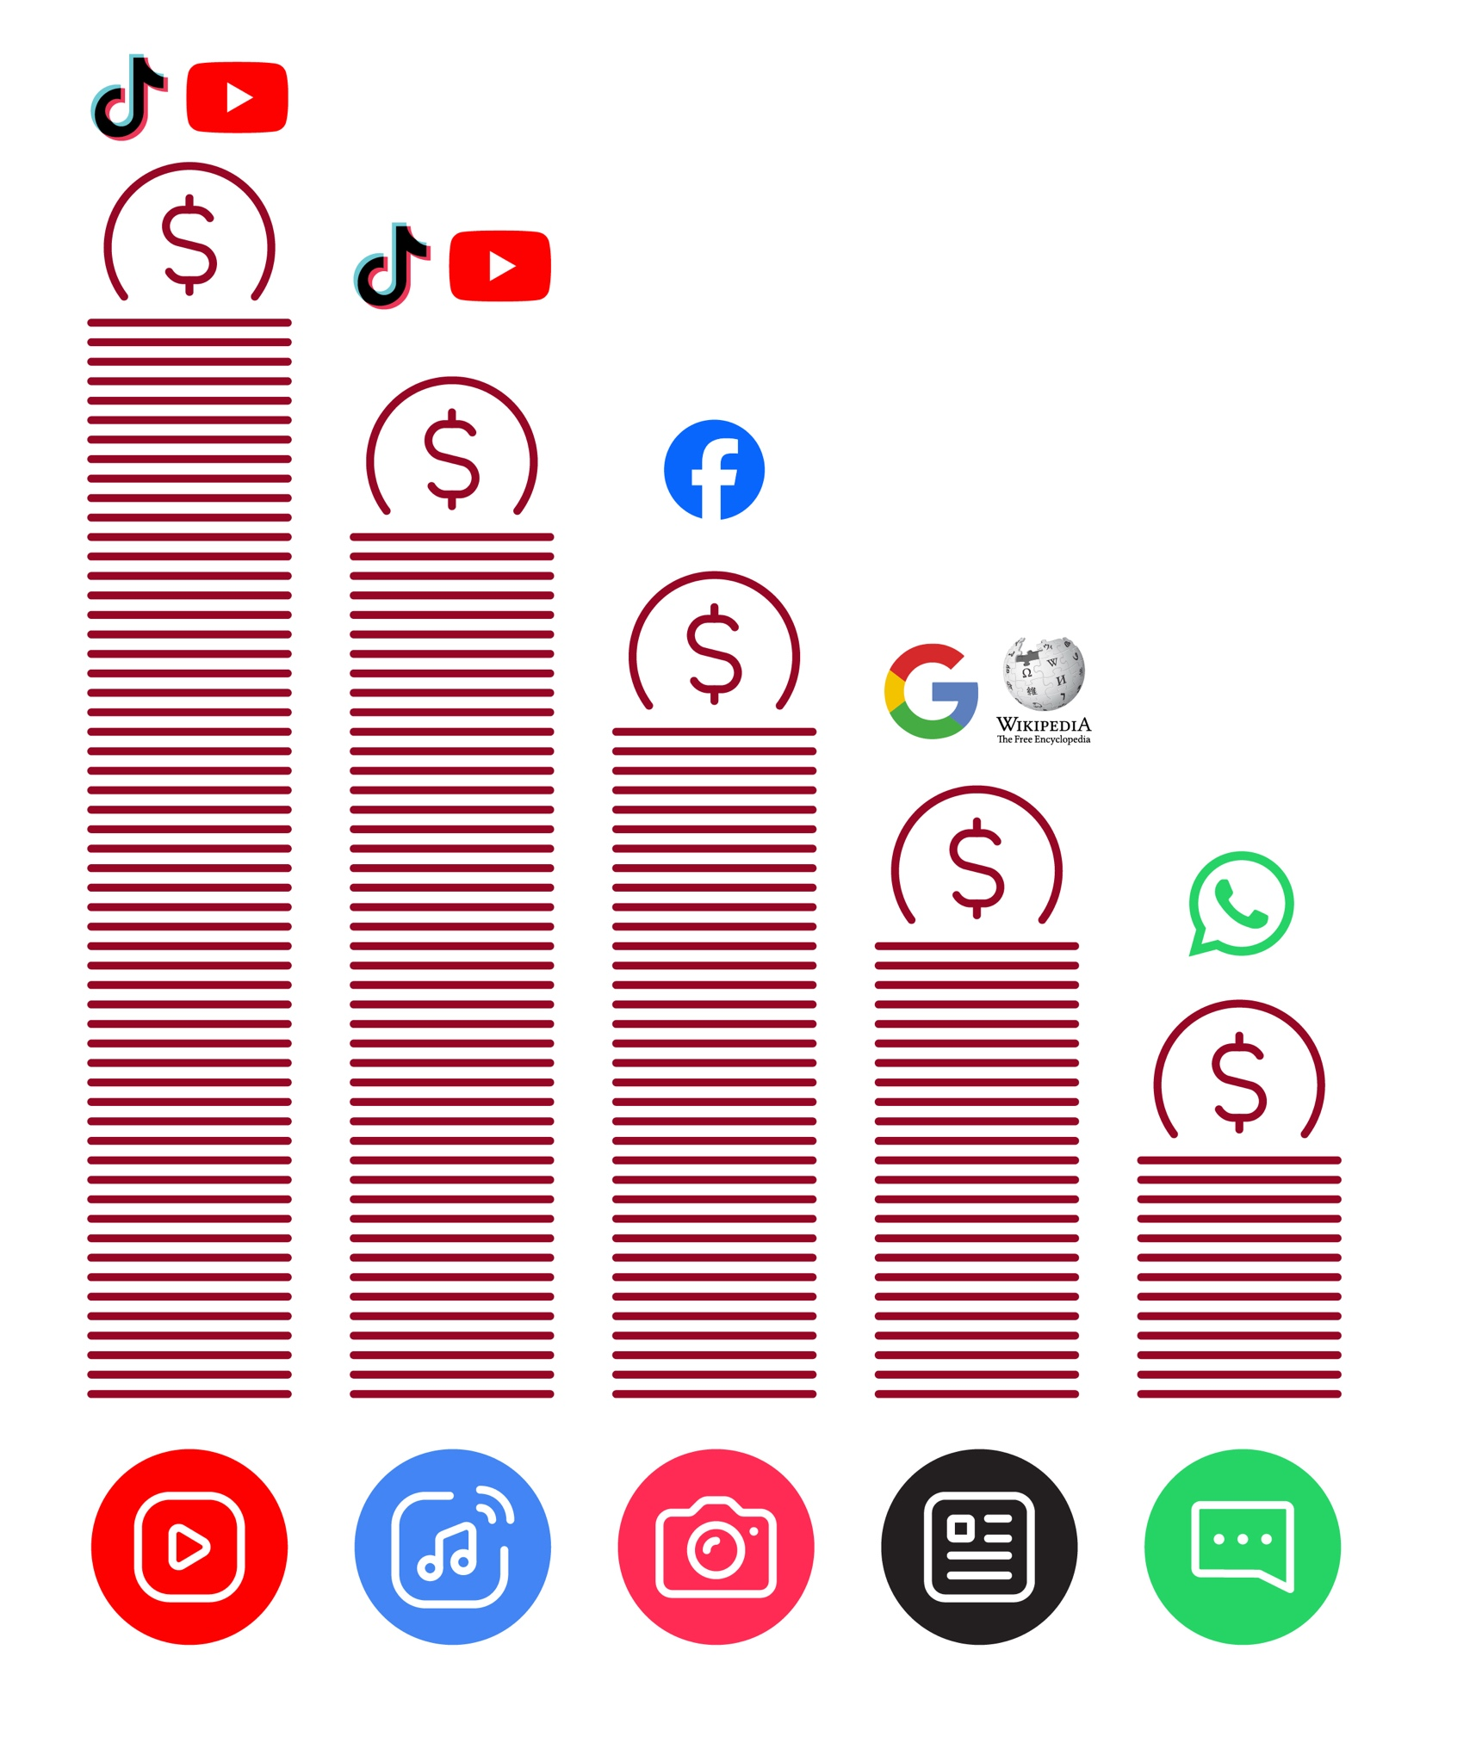
Data Cost

Healthy Internet Use

 | Set time limits  Think about how much time you are spending using the internet – it should not get in the way of your other responsibilities. If it does, set limits!
 | Watch your mood  If the internet or your phone is making you sad or angry, take a break!
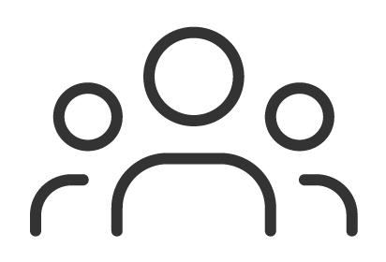 | Maintain healthy relationships online  Make time to socialise with friends and family in real life, not just on the internet! Don’t spend all your time on the internet.
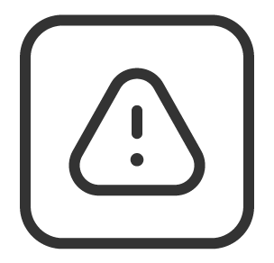 | Be careful  The internet can be dangerous with scams, harassment and things you don’t want to see. Be careful!
 | Stay positive  Stay positive and avoid upsetting or harming others. Be responsible and keep a positive attitude!
 | Get enough sleep and rest  Sleep and rest are important - make sure the internet or your phone doesn’t stop you doing this! Don’t use the internet when you need to rest or sleep.

Sending money to friend
using your phone



Mobile Money



1 2 3 4 5 6

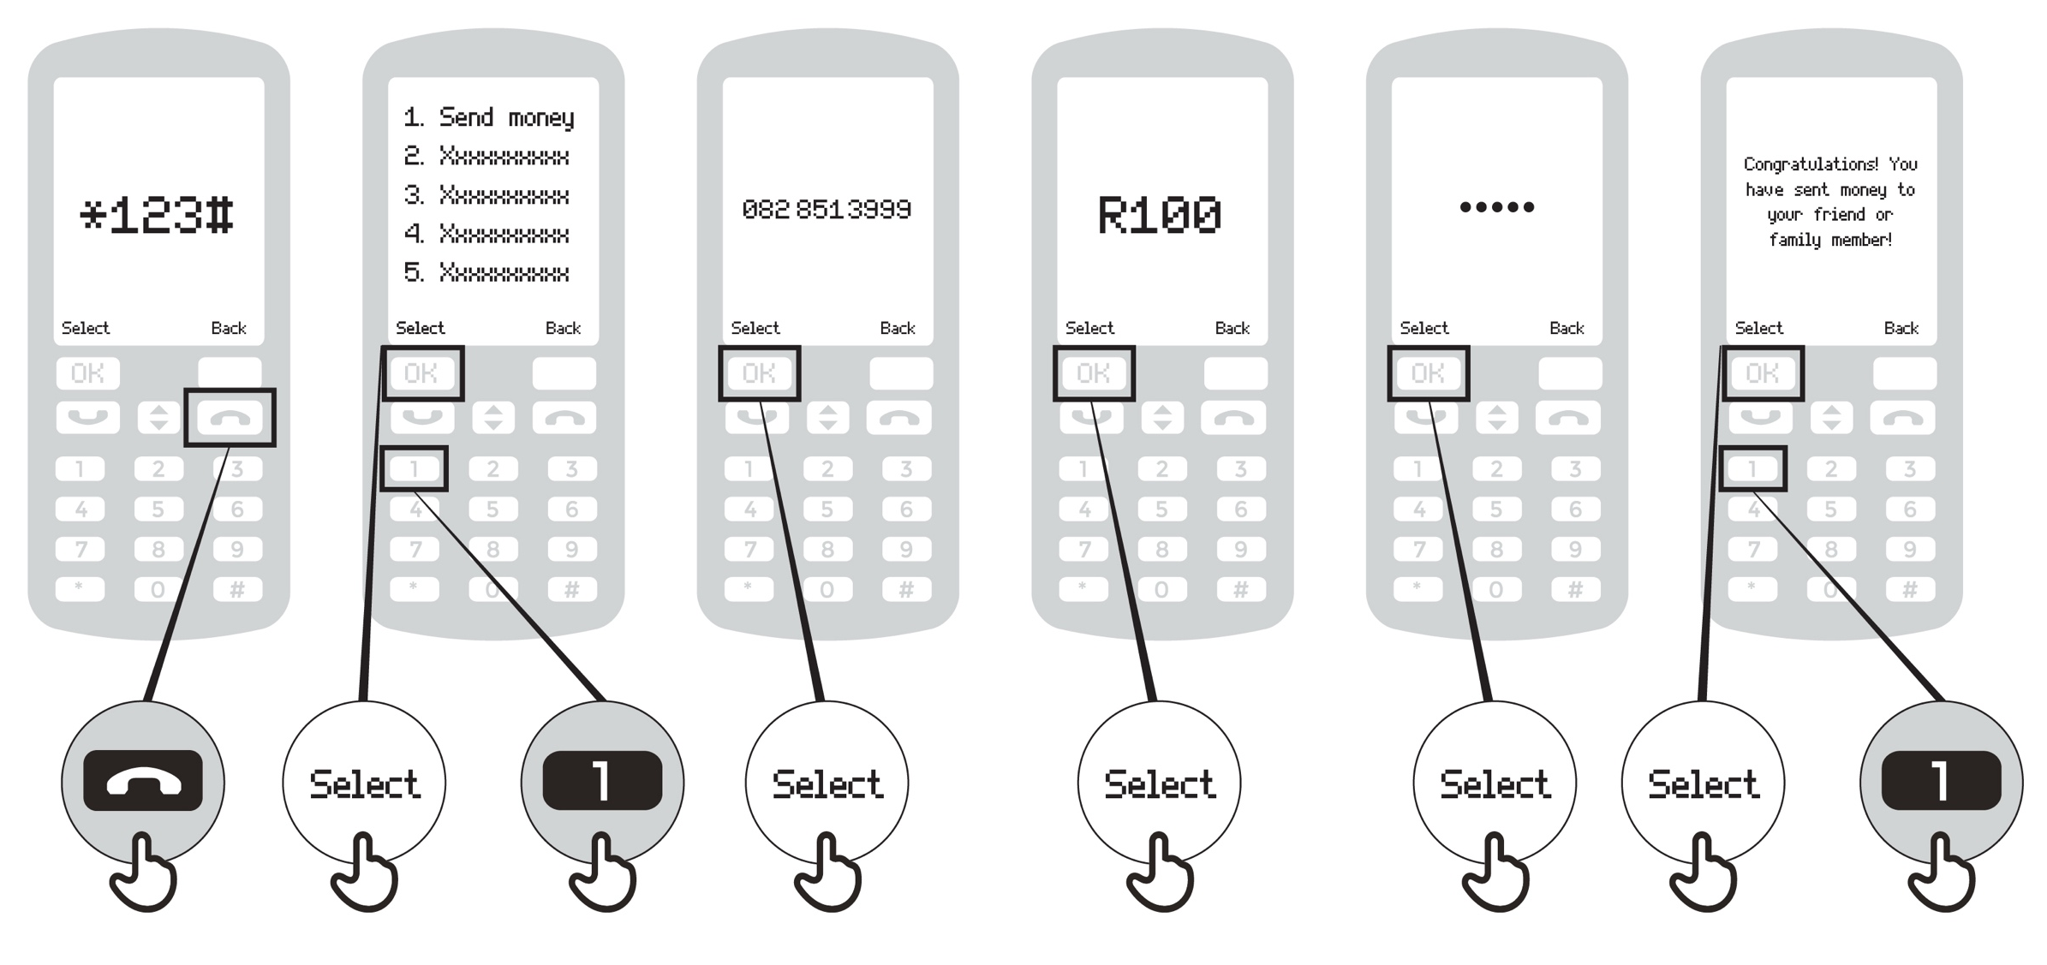

Paying a bill using your phone
Mobile Money

1 2 3 4 5 6 7 8

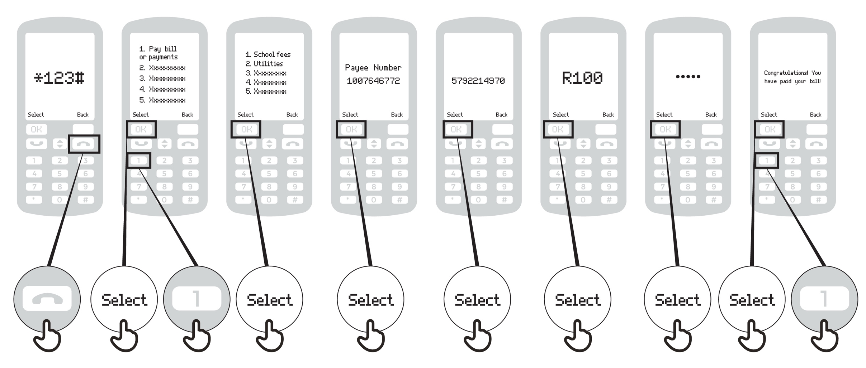
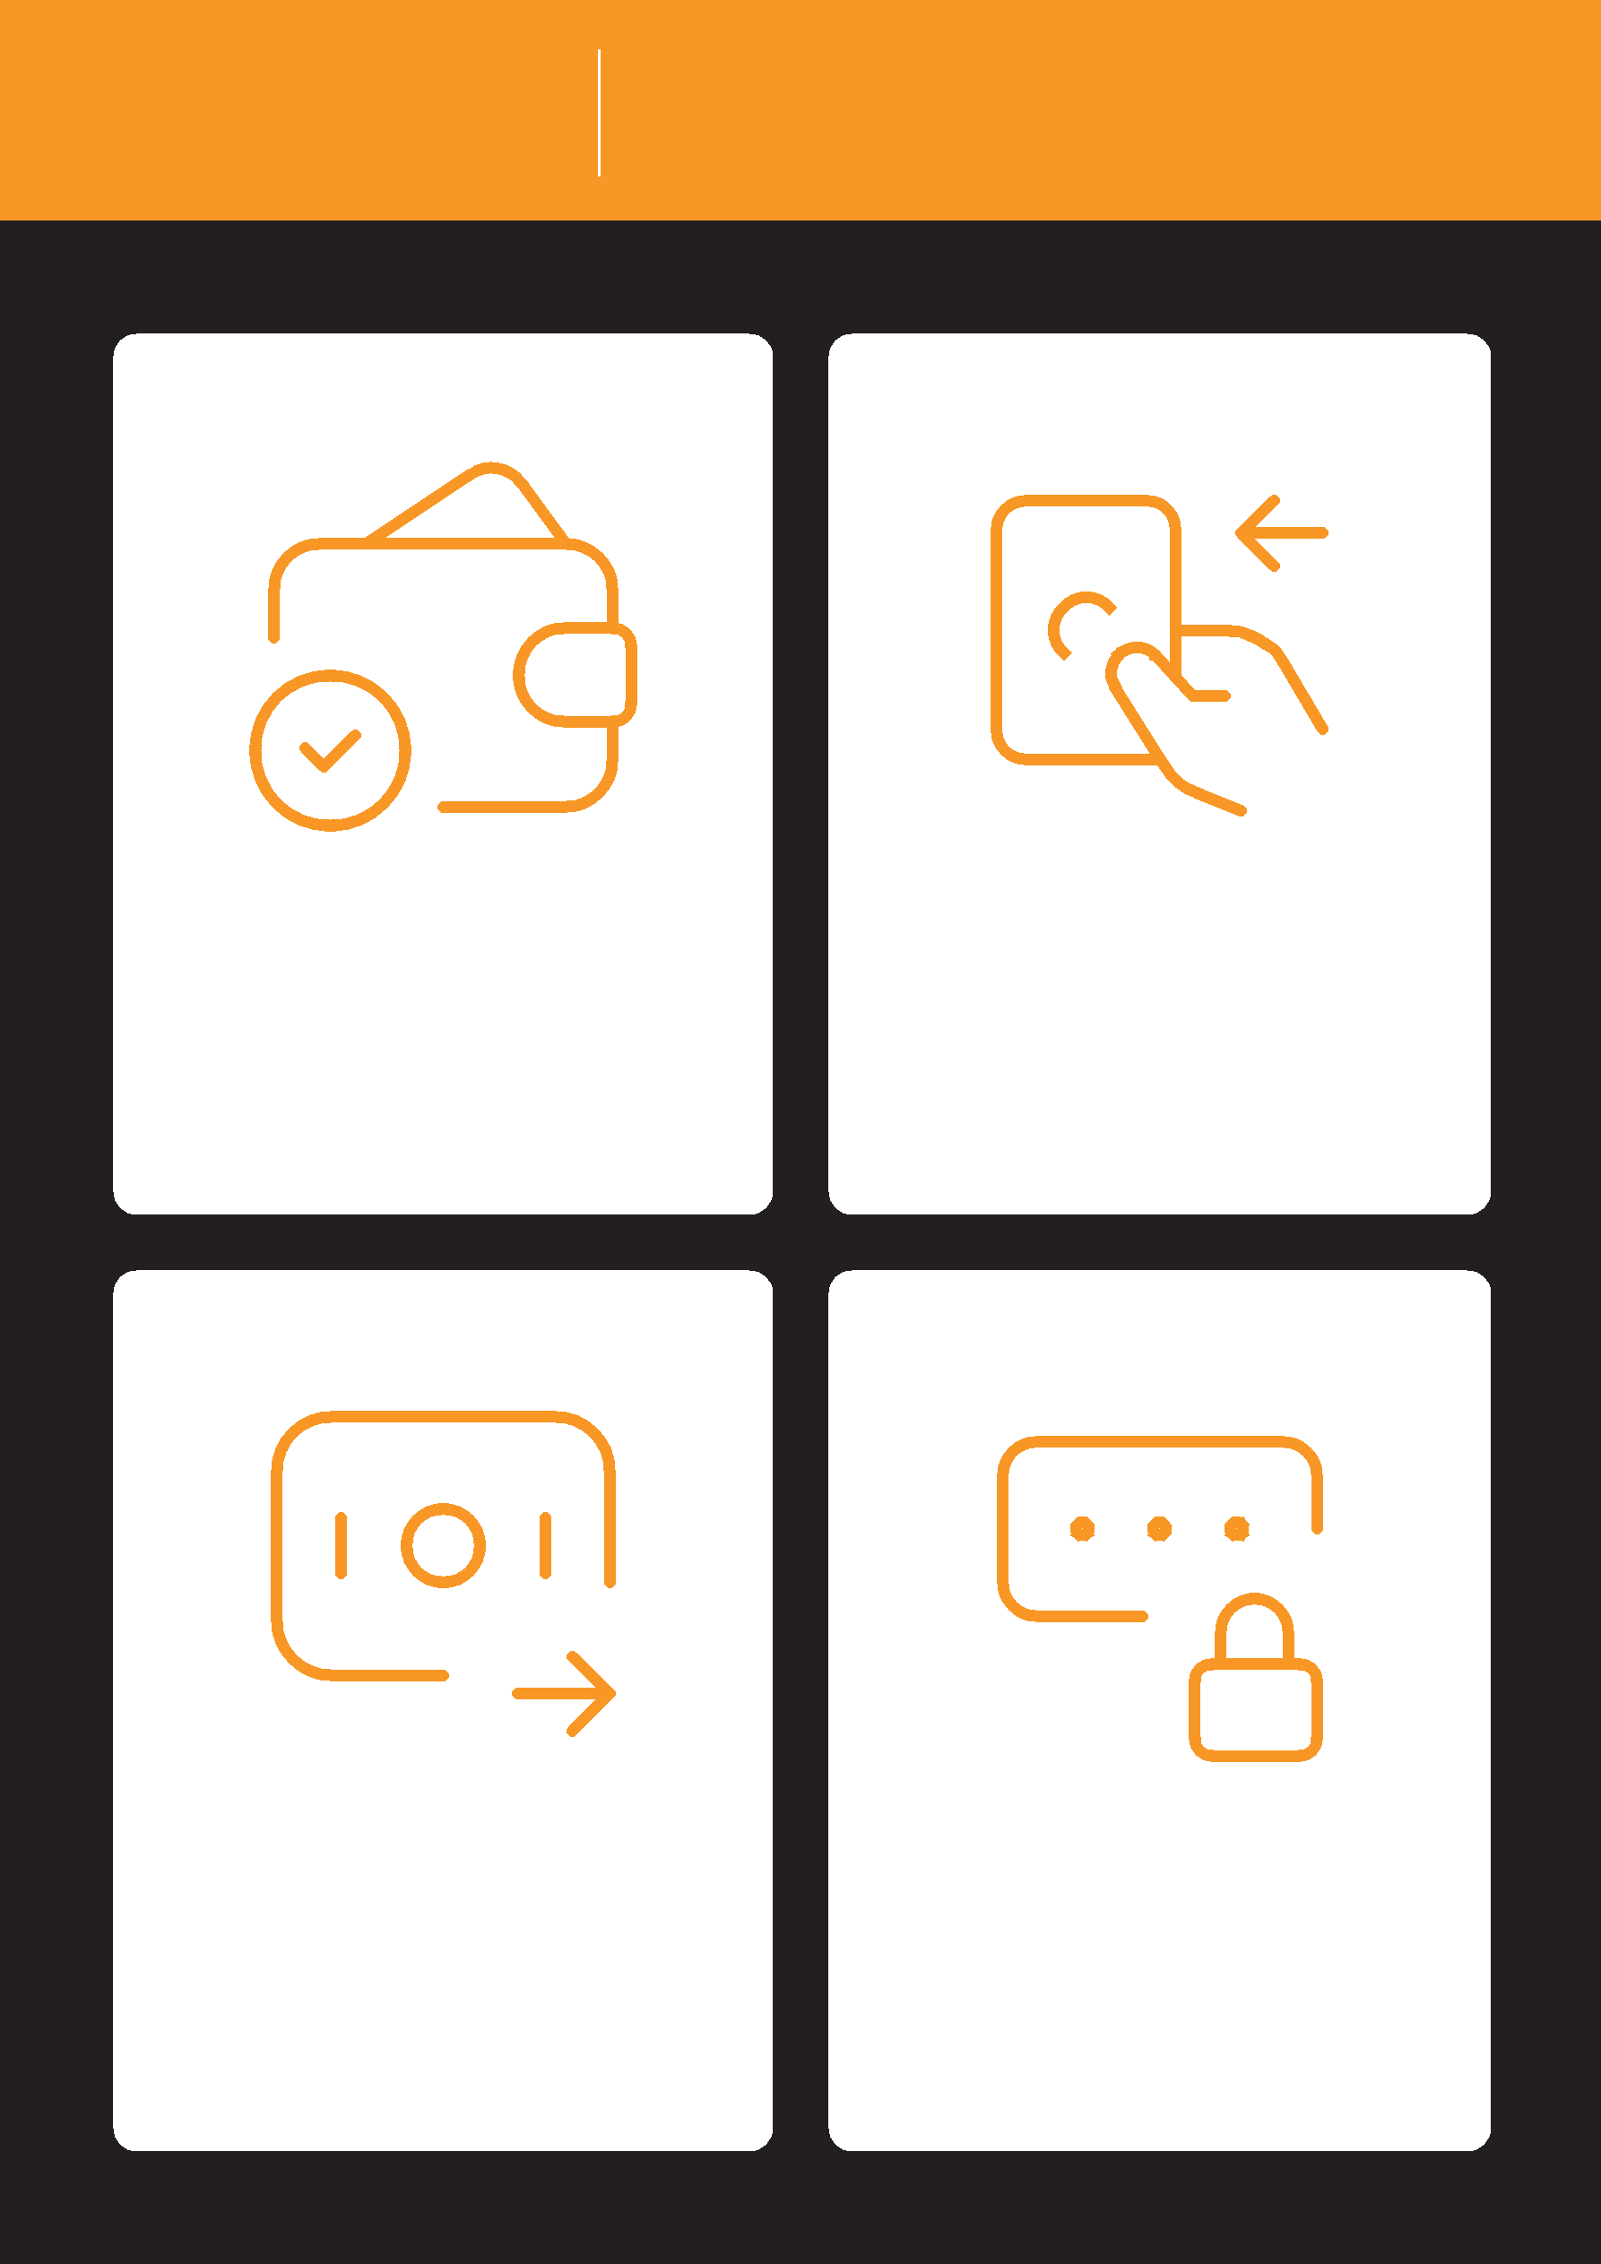
Mobile Money What is mobile money?

It’s like having a wallet on | Cash can be deposited
your phone. | and withdrawn from your
 | mobile money account
 | with your agent.

You can send money to | Your PIN number is the
other people, pay bills, | way you can use your
pay for goods. | account.

Registering for mobile
money account

Mobile Money

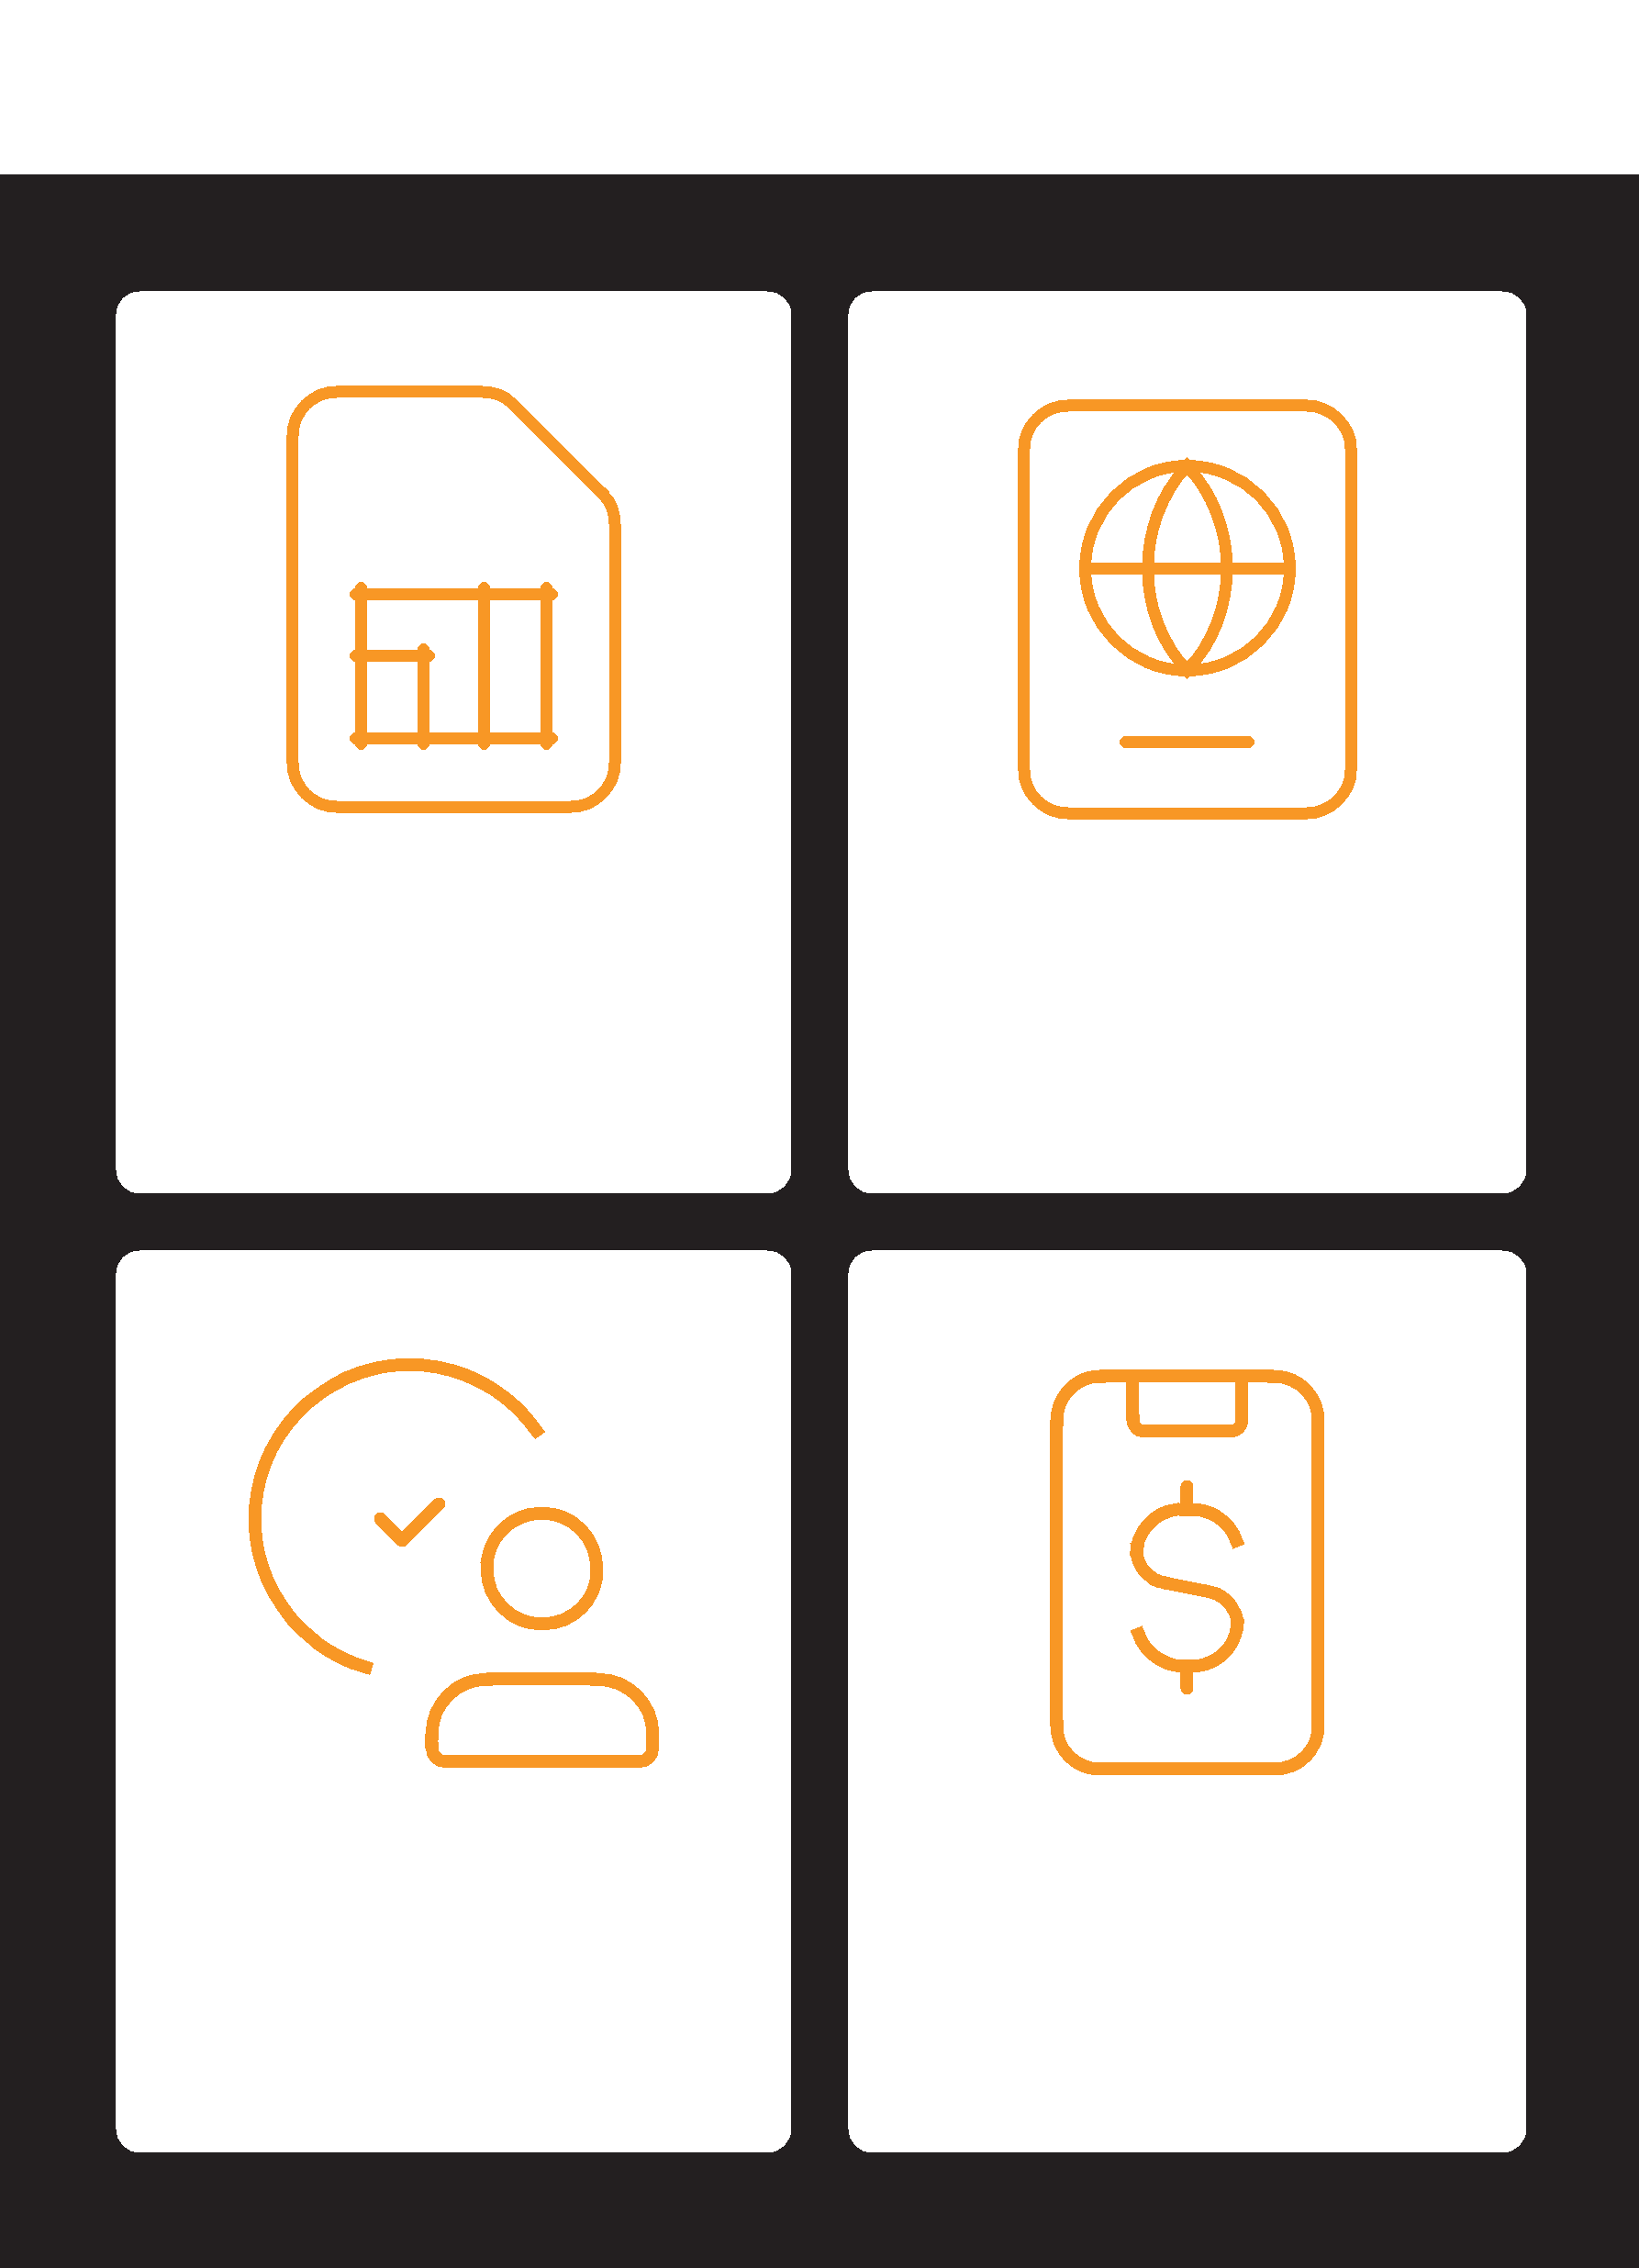

You need a SIM card from | To register for mobile
your mobile operator. | money, you need proof of
Your mobile money agent | identity.
will register you for
mobile money.

Go to your agent every | Once these steps have
time you need to deposit | been completed you can
or withdraw money from | start using your mobile
your account. | money account!

What you can do with
mobile money

Mobile Money

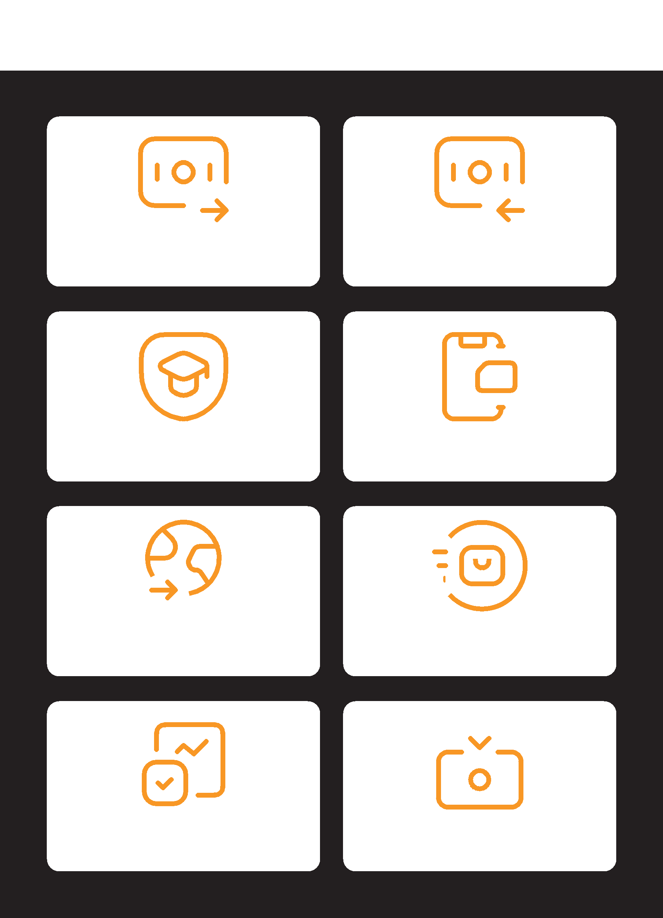

Send money to Receive money from
friends or family friends or family

Pay bills or school fees Buy airtime for you or
other people

Send / receive money to
and from friends and family |  |  | Pay for goods and
in other countries |  |  | services

Earn interest on Get a loan
your savings

Staying safe using
mobile money

Mobile Money
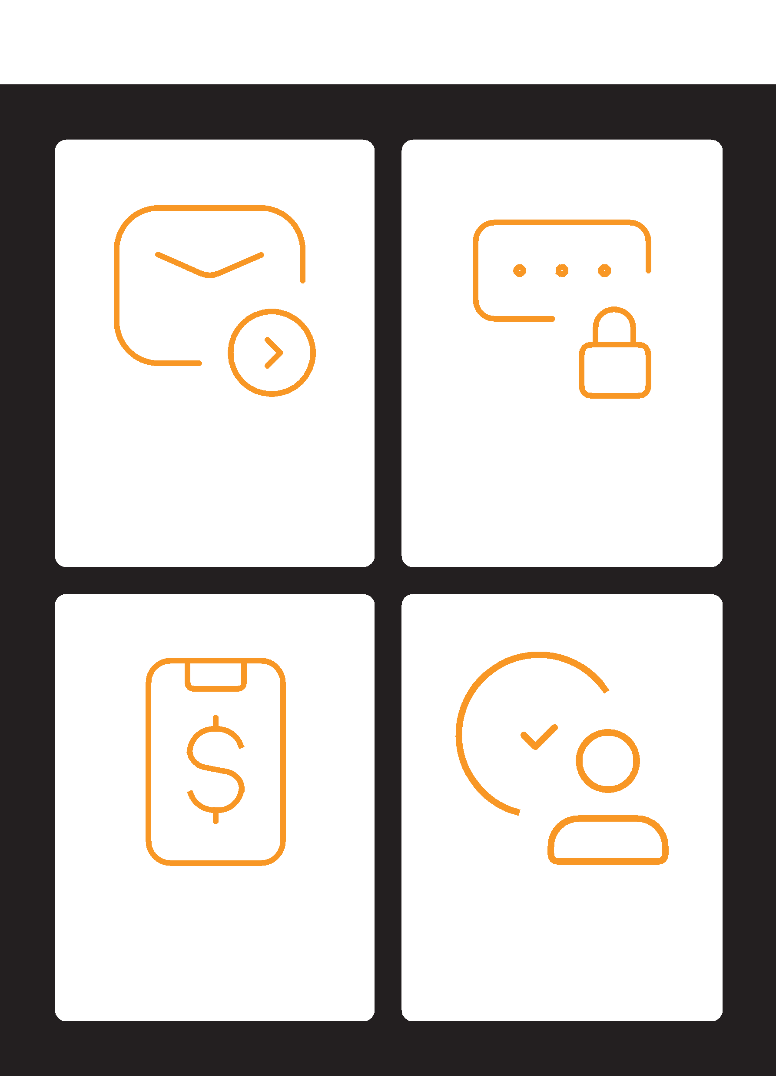

Message PIN

Phone Agents

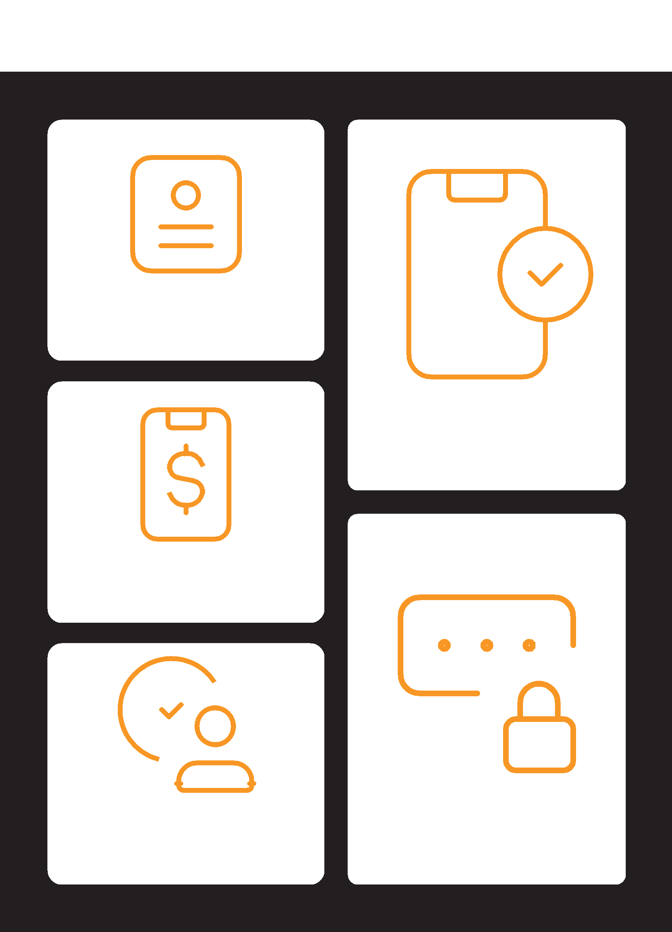
5 key things to know
about mobile money

Mobile Money

Account Registration
Mobile money | PIN number
agent | PIN number
Mobile Money
Mobile Number


Mobile Internet Skills Training Toolkit

‘Thank you’ and close training

After you have completed the training, congratulate your trainees and hand out certificates as a reward.

Thank the trainees

Give out the handouts

- Give your trainees the handouts for the training if you haven’t already done so.

- These include the ‘Definitions’, ‘Top tips to stay safe online’, ‘Data costs’, ‘Healthy internet use’ and relevant module posters.

- Ask: “Do you feel confident to use these accessibility features?” or “Do you feel confident to use your mobile phone?”

- Thank your trainees for their time, input and participation in the training.

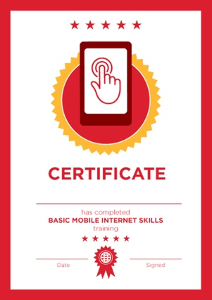

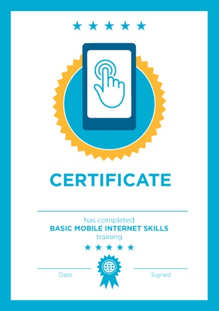

Conduct a closing ceremony

- Give each trainee a signed certificate (certificate templates are included in the toolkit).

- You can also provide the trainers with certificates for having completed the training ‘as trainers’.

Tip: You can make this more of a ceremony for trainees, by asking them to come up to the front of the room one person at a time to receive their certificate and shake the trainer’s hand.

here
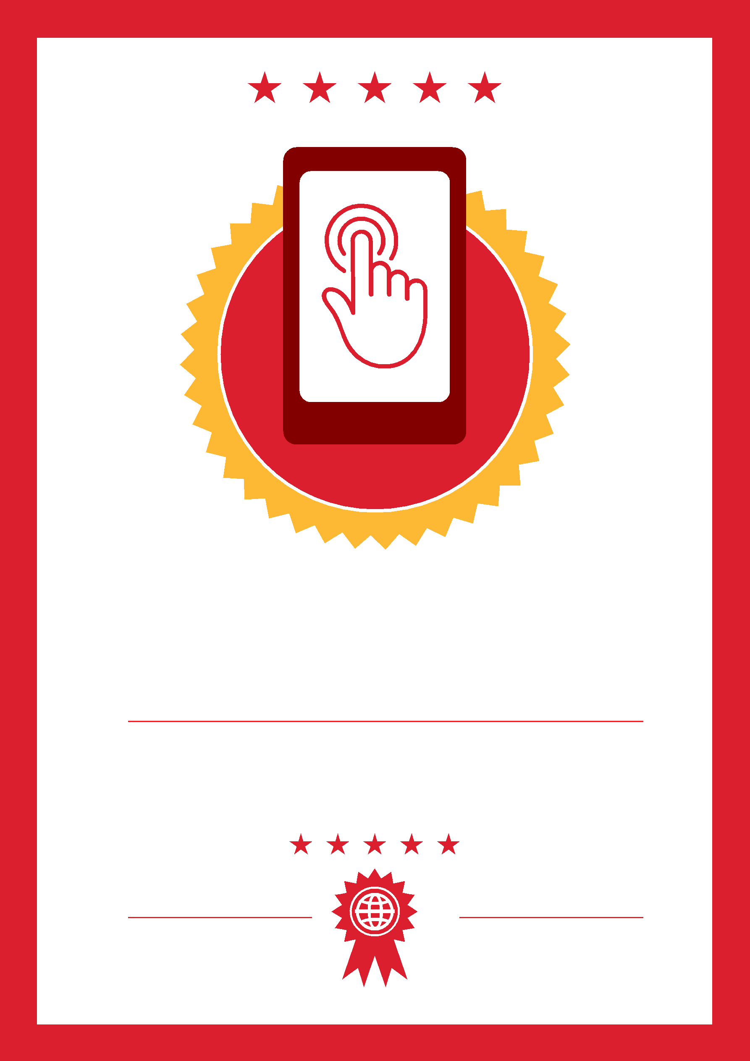

CERTIFICATE

has completed

BASIC MOBILE INTERNET SKILLS

training

Date Signed

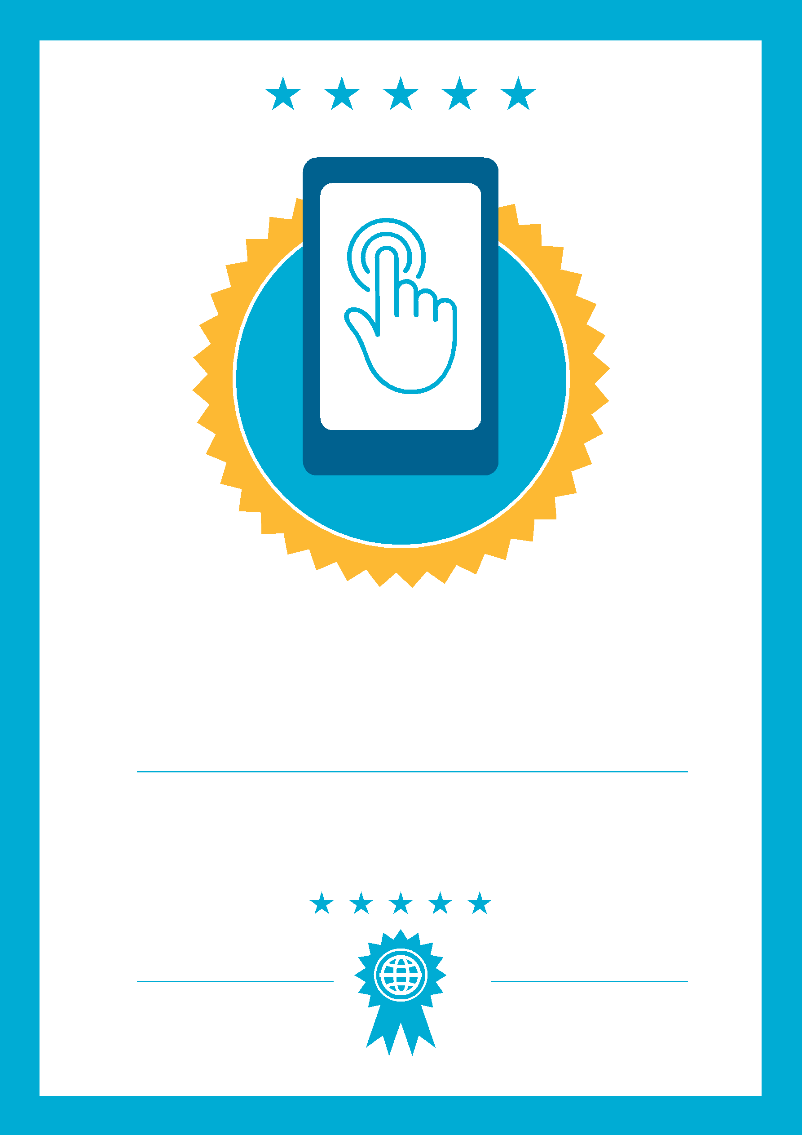

CERTIFICATE

has completed

BASIC MOBILE INTERNET SKILLS
training

Date
Signed

