


Mobile Internet
Skills Training
Toolkit
A guide for training people in
basic mobile internet skills
Copyright © 2024 GSM Association
Copyright © 2024 GSM Association
Bitesize Training
Online Safety

Mobile Internet
Skills Training

Toolkit

A guide for training people

in basic mobile internet skills

Module 10:

Online Safety

What is it?
 | Explain: “There are many great things that you can use the internet for, but it is important to remember that anyone can use the internet around the world. It is important to treat it like a real-life public place (e.g. a marketplace) and stay safe.”  “Don’t share personal information on the internet that you would not share with a stranger in real-life.”
What can you use it for?
Give out the ‘Top tips to stay safe online’ poster.

“Just like in a public space, you should:

- Block or ignore people you don’t know or who are bothering you.

- Keep your personal information private (e.g. who you are, where you live, passwords).

- Tell someone you know and trust if you feel uncomfortable about anything you see or experience on the internet.

- Be polite and respectful to people and do not bother them.”

If time allows, share your own examples with the trainees for each safety tip.
Materials you will need:

- Smartphone handsets
- Safety posters

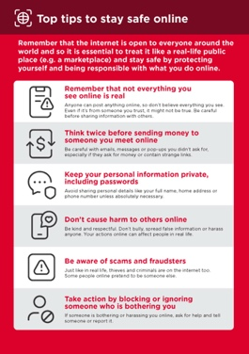

How do you stay safe?
Ask trainee which service they want to learn to stay safe on (WhatsApp, YouTube, Wikipedia, Facebook, KaiOS, Android or mobile money).

Demonstrate:
 | WhatsApp: “If someone you do not know messages you or bothers you on WhatsApp and you do not want them to, you can block them so that they cannot contact you again.”  Demonstrate this on WhatsApp: Show the ‘How To Block’ poster and demonstrate the steps.
 | YouTube: “If you are looking at videos on YouTube and you see one that you think is bad or offensive, you can go back to the previous page, refine your search and continue looking at other videos.”  Demonstrate this on YouTube: Press the back button, delete the keywords in your search box and change your search by using different keywords.
 | Wikipedia: “If you are on Wikipedia, the information is from people all over the world. Remember that you should check the source to make sure it is correct.”  Demonstrate this on Wikipedia: Show trainees the list of sources and references at the bottom of a Wikipedia page.
 | Facebook: “If you are on Facebook, you can change who sees your profile and who can contact you.”  Demonstrate this on Facebook: Show them privacy shortcuts where they can adjust who can see their profile and who can contact them with friend requests.

How do you stay safe?
Ask trainee which service they want to learn to stay safe on (WhatsApp, YouTube, Wikipedia, Facebook, KaiOS, Android or mobile money).

Demonstrate:
 | KaiOS: “If you are using a KaiOS phone, there are a number of ways you can change your phone settings so that you stay safe. You can find them in privacy and security on your phone.”  Demonstrate this on KaiOS: Show trainee how to find privacy and security via the main KaiOS menu.
 | Android: “If you don’t use your Android phone for some time, it will turn the screen off to save the battery. It is important to create a password so that other people can’t use your phone if they find it.”  Demonstrate this on Android: Show trainee how they can set up a PIN/passcode on their device to keep it secure.
 | Mobile money: “Remember that your PIN is your own personal number. It is important that you keep this safe as it is how you access your account. Be careful about sharing this number with anyone, even mobile money agents or customer care staff, whether in person, via SMS or the mobile internet.”  Demonstrate this on mobile money service: Show trainee when a PIN is needed in a normal mobile money transaction (e.g. when sending money to a friend or family member).
 | TikTok: “If you see a video on TikTok that you do not like, you can always move to another video by swiping up on the screen. If you are really concerned about what you see, take a break from the app or follow the instructions on how to report a video on the app.”  Demonstrate this on TikTok: Swipe up on a video to show how trainees can move past the video on screen.

Bitesize Training
Online Safety

Mobile Internet
Skills Training

Toolkit

A guide for training people

in basic mobile internet skills

Posters and Cut-Outs
 | Remember that not everything you see online is real  Anyone can post anything online, so don’t believe everything you see. Even if it’s from someone you trust, it might not be true. Be careful before sharing information with others
 | Think twice before sending money to someone you meet online  Be careful with emails, messages or pop-ups you didn’t ask for, especially if they ask for money or contain strange links.
 | Keep your personal information private, including passwords  Avoid sharing personal details like your full name, home address or phone number unless absolutely necessary.
 | Don’t cause harm to others online  Be kind and respectful. Don’t bully, spread false information or harass anyone. Your actions online can affect people in real life.
 | Be aware of scams and fraudsters  Just like in real life, thieves and criminals are on the internet too.  Some people online pretend to be someone else.
 | Take action by blocking or ignoring someone who is bothering you  If someone is bothering or harassing you online, ask for help and tell someone or report it.
Remember that the internet is open to everyone around the world and so it is essential to treat it like a real-life public place (e.g. a marketplace) and stay safe by protecting yourself and being responsible with what you do online.

Top tips to stay safe online

Data Costs

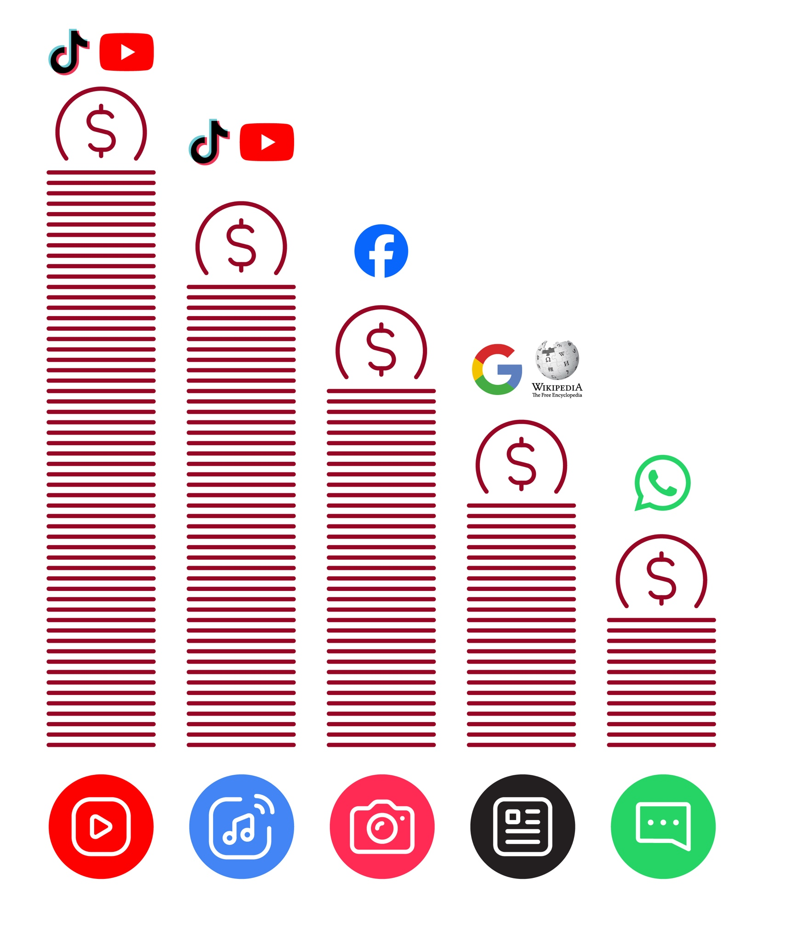



Online Safety
How to ‘block’ on Facebook

1 2 3 4 5
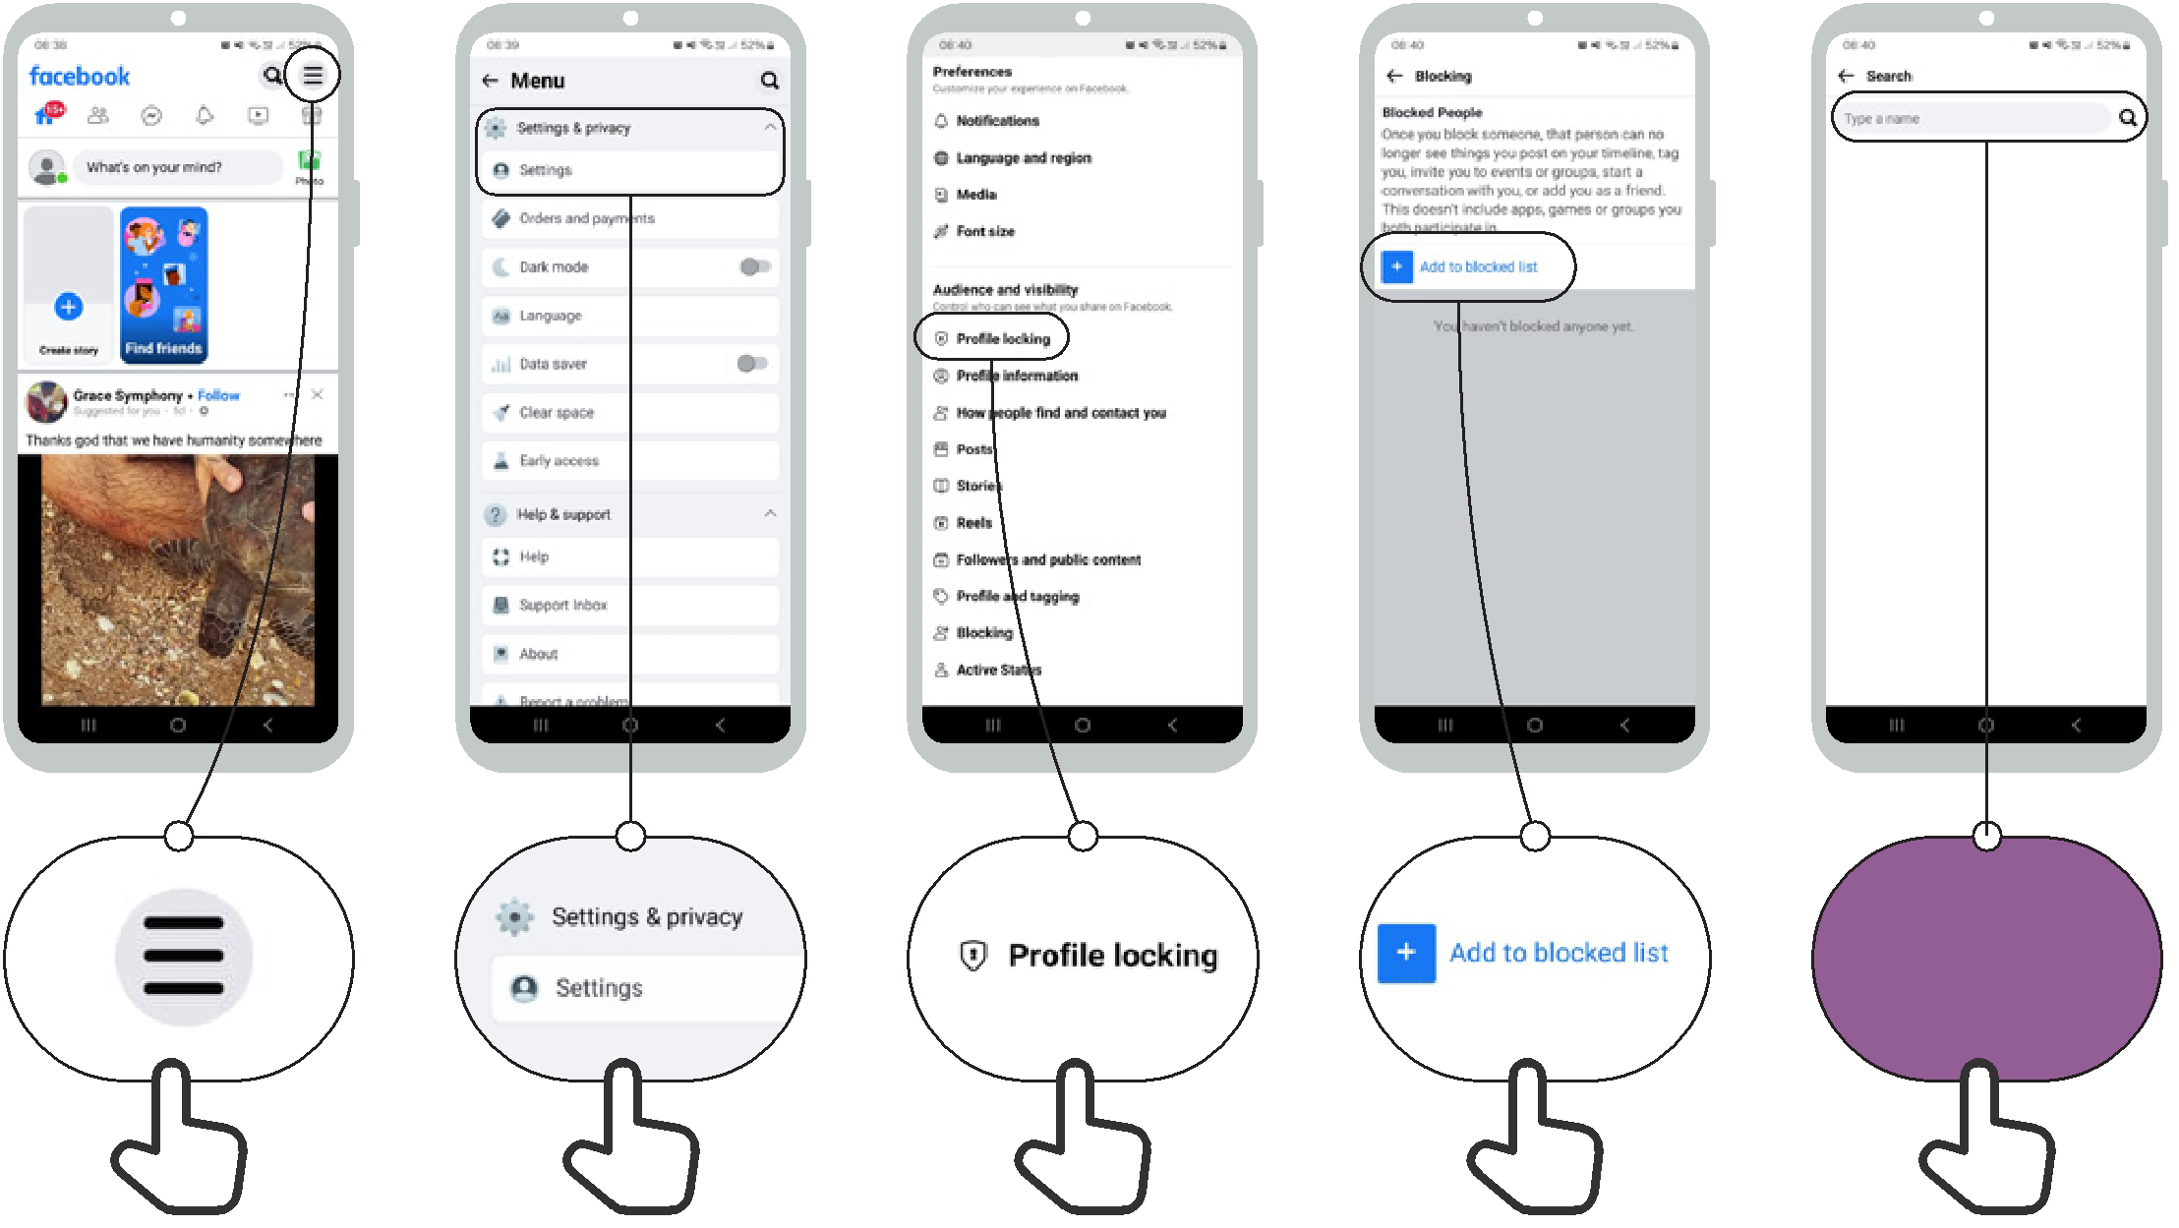

Type a name

Online Safety How to ‘block’ on Gmail


1 2 3
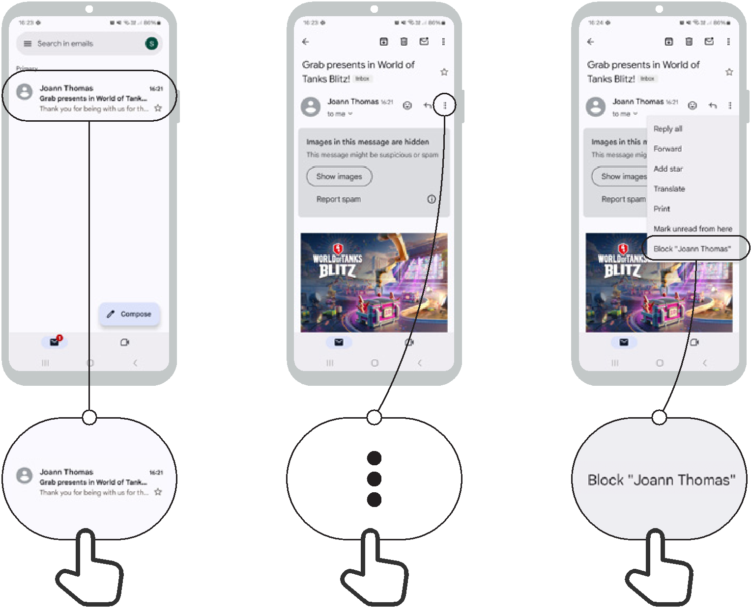
3
2
1

Online Safety Accessing 'search history' in Chrome
1
2
3

1 2 3
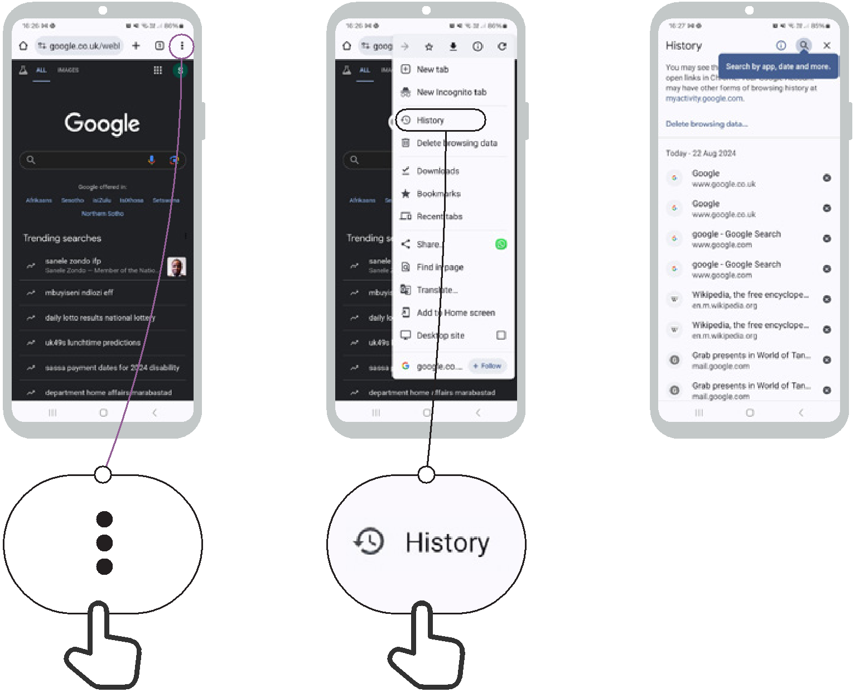

Setting up parental controls
on Play Store

Online Safety

1 2 3 4 5
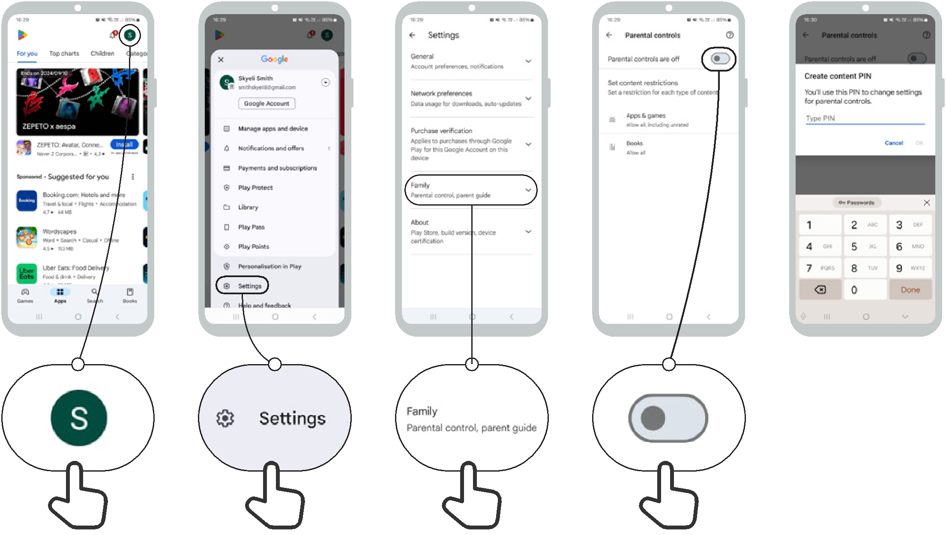

Online Safety Reporting a page on Facebook
1
2
3

1 2 3
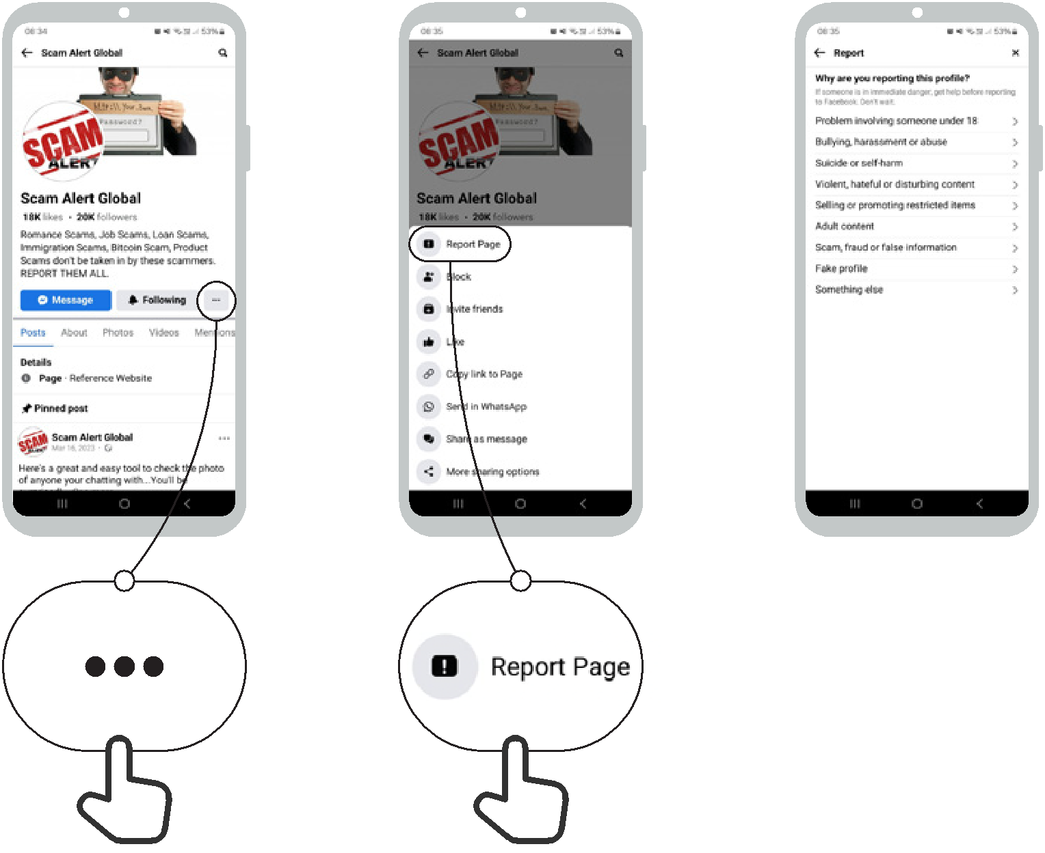

Online Safety Reporting a video on YouTube


1
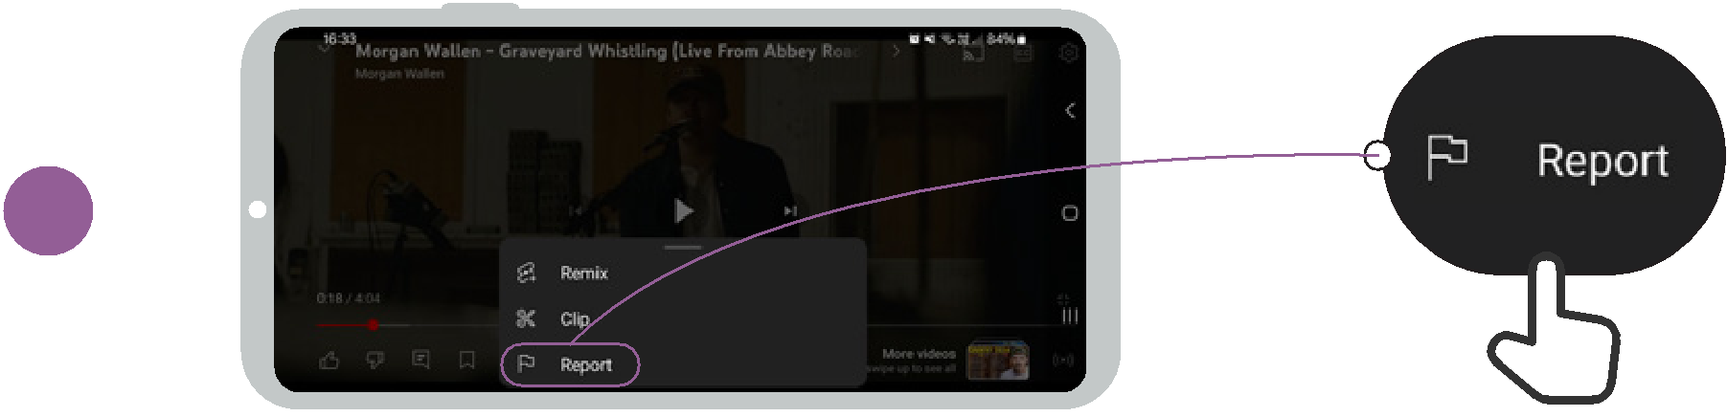

2
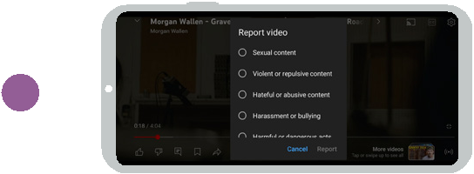

1
2
3

Be careful!

If you are unsure, ask
someone you trust!

Don’t share something with other people without thinking first!

Check other sites

Report it

False information
Online Safety
Not everything on the internet is what it says it is.

People can make fake versions of a website or an app to make it look like a good company (e.g. your phone company) or organisation (e.g. your government).

People sometimes put false information on the internet (e.g. WhatsApp or Facebook).

If you hear some news on from the internet, you might want to check this by checking on other sites (e.g. trusted news sites like BBC).

If you think something you see is dangerous or bad, you can ‘report’ it so the company (e.g. YouTube) knows there is a problem.

