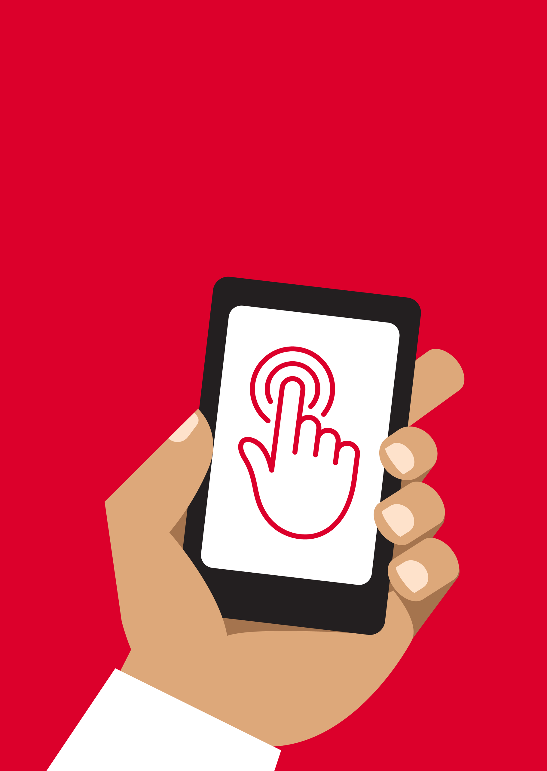


Mobile Internet
Skills Training
Toolkit
A guide for training people in
basic mobile internet skills
Copyright © 2024 GSM Association
Copyright © 2024 GSM Association
In-Depth Training
Online Safety

Mobile Internet
Skills Training

Toolkit

A guide for training people

in basic mobile internet skills

Module 10:

Online Safety
Learning objectives
- Trainees have a basic understanding of online safety.

- Trainees understand that online safety has important implications for children.
Time duration
45-60
minutes

Materials you will need:
  Smartphone or  KaiOS phone |   Active airtime access  (mobile SIM or Wi-Fi) |  | 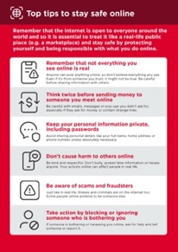  Safety tips
  Small rewards |  | 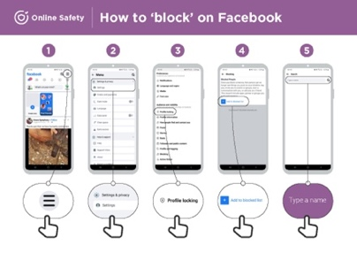  Safety posters

Introduce safety

Give a short explanation of what safety is and why it matters

Explain: “There are many great things that you can use the internet for, but it is important to remember that anyone can use the internet around the world. It is important to treat it like a real-life public place (e.g. a marketplace) and stay safe.”

“There are lots of ways that you can stay safe when using the internet. All phones and apps have settings which you can change to make sure that you are safe.”
Bring these benefits to life!

Tell your own story of how you (the trainer) have stayed safe when using the internet. This could also include examples from your friends and family. Some examples might include:

- Blocking unknown numbers on WhatsApp if they seem dangerous or malicious.

- Using the ‘back’ button when finding an unsuitable video on YouTube or swipe up on TikTok.

- Changing the privacy settings in Facebook so that your profile is only accessible by ‘Friends’.

- Setting up a PIN / passcode on your device so that people cannot access your phone if it is stolen. Changing the privacy settings in the phone operating system (e.g. Android or KaiOS).

- Keeping your mobile money PIN safe to prevent fraud.

Make safety relevant

Discuss with the trainees why staying safe when using the internet is important.

Ask:

- “What are the main things you like (or want) to do on the internet?” Give them some suggestions based on their interests.

- “Are there things that worry you when you are using the internet?” Trainer to help the trainee understand how they can be safe in these areas.

Tip: You can help trainees to change privacy settings on Facebook by looking at the Facebook module.

Dealing with unsolicited contact
- Explain: “The internet helps you to send messages to your friends and family. You can even send messages to people on the other side of the world that you haven’t met before. However, this means sometimes that people may send you messages that you don’t want to receive.”

- “It is important to teach children how to keep themselves safe when using messaging services (e.g. WhatsApp). If children are using the internet, then people can send them bad messages. You can help to protect them by teaching them how to keep their information private and block unwanted contact.”

- “On your phone or on the internet, you are able to stop any unwanted messages you receive.”

Ask the trainee what is the main way they send messages to other people when using the internet.

Demonstrate how to block unwanted messages in the following apps on their phone using the steps on the poster: WhatsApp, Gmail and Facebook.
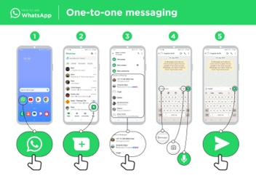
Show posters for blocking on WhatsApp, Gmail and Facebook

- Explain: “You can also take steps to manage who sees your posts on social media. If you only want your close friends or family to see something, you can limit other people seeing what you have put there.”
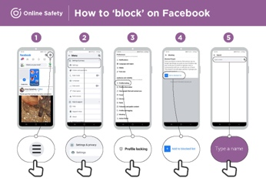
- “Remember that the internet is a public place and you cannot always control what happens to content once you have shared it. You should only post things that you are happy for other people to see.”

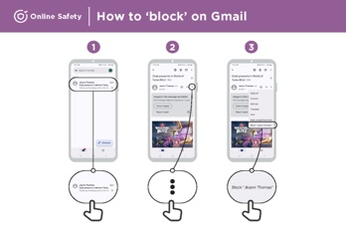
- “Remind your children that if they wouldn’t want their headteacher or grandmother to see something, they should not risk posting it.”

Inappropriate content
Explain: “The internet is very useful and interesting and can help you in many ways. You must be careful, because anyone can write anything or add pictures or videos, which means that sometimes bad things are on the internet.”

“There are ways to help keep you and your family safe when you are using the internet. You can control what you see on your phone and make sure other people who use your phone – including any children – are safe.”

Explain: “We are now going to learn how you can see the different websites that you have looked at in the past on Google Chrome.”

“Every time you visit a website, Google Chrome will keep a record of it – it is like the phone is writing everything down in a big book. If anyone uses your phone – e.g. your children – it will record which webpages they look at as well.”
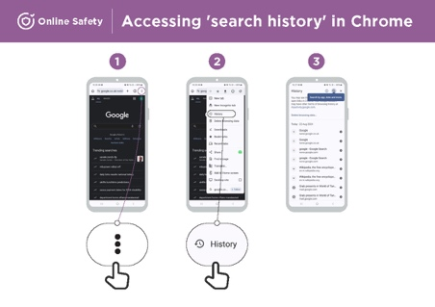
Show the ‘Accessing ‘search history’ on Chrome’ poster
Demonstrate how trainees can look at their browsing history of all the websites that have been visited on their phone on Chrome using the poster/the trainees’ phone(s). Show them how they can search the history if they want to or clear browsing history.

Explain: “If you are sharing a phone with your family, you might want to turn on SafeSearch. This means that Google Chrome will show you websites that are suitable for the whole family.”

Parental controls on Play
Explain:

- “The internet has things that are not suitable for children. Like in normal life, some things are not good for children on the internet.”

- “If there are children that use your phone, you can do some simple things so that they see good things.”

Demonstrate how to turn on parental controls in the Google Play Store.
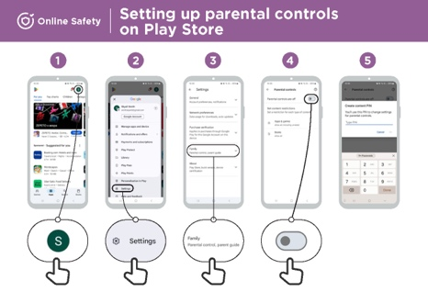
Show the ‘Setting up parental controls in Play Store’ poster

Explain that parental controls means that children will not be able to download apps or games that are for adults. They will also only find videos and music in the Play Store that are good for children.
Tip: It is possible to set up Android so that parents are able to control what is on their children’s phone. Explain to trainees that this is possible if they are interested.

Tip: You can reinforce trainees’ knowledge of the icons by playing the ‘TikTok icon game’.
Reliable information
Explain: “The internet has so many news articles, photos, videos and music - you will never run out. However, it is important to remember that not everything on the internet can be trusted.”

“The internet is a public place – like a market - and it is important to act in the same way. You cannot trust everything that people tell you or that you see.”

“If you have children, remember that they will need your help to understand what is good or bad. You can help them understand.
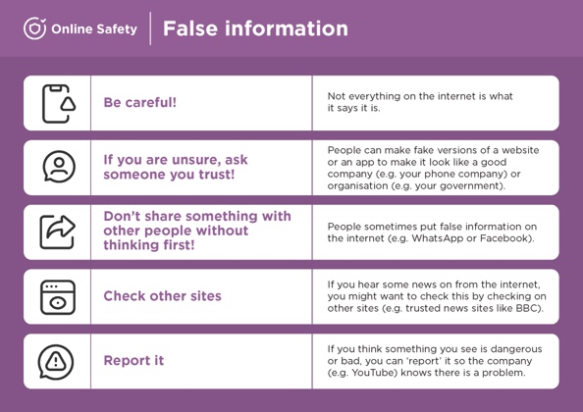
Give your trainees the ‘False information’ poster

- “Not everything on the internet is what it says it is. Be careful.”

- “People can make fake versions of a website or an app to make it look like a good company (e.g. your phone company) or organisation (e.g. your government). If you are unsure, ask someone you trust.”

- “People sometimes put false information on the internet (e.g. WhatsApp or Facebook). Don’t share something with other people without thinking first.”

- “If you hear some news from the internet, you might want confirm this by checking on other sites (e.g. trusted news sites like BBC).”

- “If you think something you see is dangerous or bad, you can report it so the company (e.g. YouTube) knows there is a problem.”

Discuss with your trainees what these tips mean for using the internet.
Bring the tips to life by using examples that are relevant for your trainees based on your experience. For example, parents may be more concerned about how to help their children avoid incorrect information.

Reporting content on YouTube, Facebook and TikTok
Explain: “If you think that something on the internet is dangerous to you or your family, you can report it to Facebook, YouTube, TikTok or other internet services. This means that you are telling them something is bad and they need to look at it.”

Explain: “You might want to report something because it is violent, it involves terrorism, it might put someone in danger – especially children – or because it is too sexual.”
Ask if they want to learn how to report something on YouTube, Facebook or TikTok.

Demonstrate how to report content on YouTube, Facebook or TikTok using the steps on the posters.
Show posters for reporting content on YouTube, Facebook and TikTok

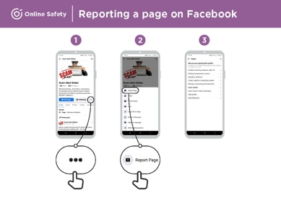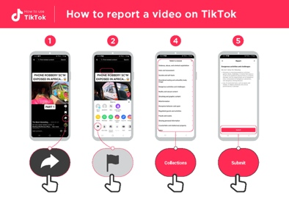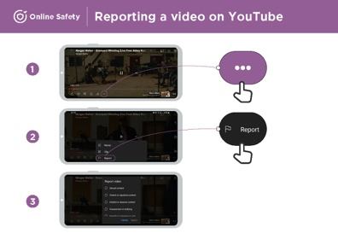

Recap
Discuss with your trainees what they have learned about safety during this session.

- “What have you learned about safety when using the internet?”

- Prompt if required: Blocking people on the messaging platform, dealing with inappropriate content and knowing what to trust on the internet.

- “What do you want to use Google Search for in your own life? What are you most interested in and excited about using it for?”

Key lessons are recapped:

- Ask: “Do you still have any concerns about staying safe when using the internet?” More advanced ideas are suggested for those that are particularly interested.
Tip: If appropriate, run the recap as a quiz and give rewards (e.g. sweets) to trainees for playing.

Going to the next level
If you reach the end of the session and have extra time:

Ask: “Do you have any further questions about safety?”

Ask: “What else would you like to know about staying safe on the mobile internet?”

Potential areas to discuss, depending on what you or the trainee are interested in, include:

- Common financial scams in your local area.

- Learning to understand if a website is trustworthy (e.g. the padlock icon).

- Why downloading apps, music or videos from a computer or memory stick can be dangerous.

- How to delete your Google account from a computer or another phone if it is stolen.

- What is a virus? Using antivirus software to remove a virus from your phone or computer.

In-Depth Training
Online Safety

Mobile Internet
Skills Training

Toolkit

A guide for training people

in basic mobile internet skills

Posters and Cut-Outs
Session Ground Rules

This space is:

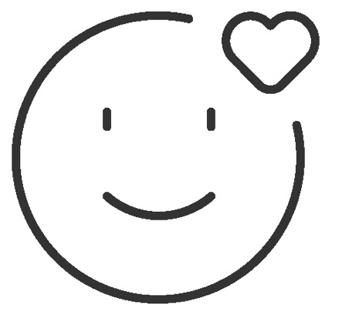

Safe

Keep all information in this training confidential. We suggest you don’t share personal numbers with the other members of group.

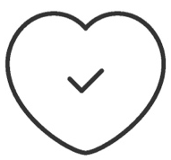

Positive & open

Please be respectful and
positive in your opinions and discussions. There are no right or wrong answers and we are not here to test you.

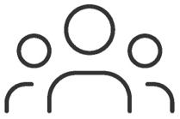

- shared
community

There are people with different backgrounds, knowledge and opinions. This is our shared space, so respect and support everyone.

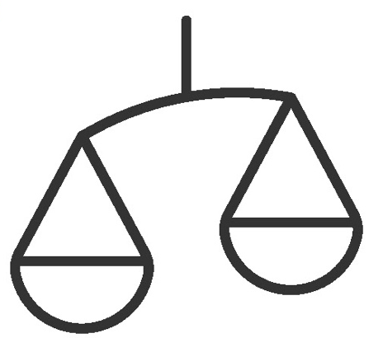

Fair

We will work in small groups and we will provide you with shared phones. We would like to give everyone an equal chance to be heard and to take turns using a phone.

Definitions

Trainers can add to this section to include local relevant information on mobile internet
3G / 4G / 5G | The internet can run at different speeds when you use it. 3G internet is the slowest, 4G internet is faster and 5G internet is the fastest.
App | An app gives you a shortcut to a service on your phone. For internet services e.g. WhatsApp, Facebook, Google, apps provide a quick and easy way to get onto the internet to use that service.
Address bar | The address bar shows you what website you are on.  In the address bar there will always be the address of the website e.g. www.google.com
Advert  or Ad | An ad is a piece of information that is trying to sell you something. It is good practice to avoid clicking on ads.  - Ads can be videos or images that pop up on your screen.  - Ads can also be the links at the top of Google results and on the right side of the screen.
Browser |   A web browser, or simply “browser,” is an application used to access and view websites. Common web browsers include:
Data | Whenever you use the internet on your phone, you are using data. You can buy data from your mobile network provider, just like you do with phone credit.
Feature  Phone | A mobile phone that has the ability to access the internet and store and play music but lacks the advanced functionality of a smartphone.
 | Google is an internet service that makes it easy to find any information that you want to find on the internet.

Definitions

Internet | The Internet is a network of millions of computers around the world connected to each other with phone lines, satellites and cables. It gives you access to a huge range of information and services and it is growing all the time. The internet is for everybody. There are no restrictions on who can use it. You just need a computer, mobile phone or tablet and a data connection.
Link | A link connects you from one website to another. To go to the other website, you can touch the link and this will connect you and take you to that other website
Megabytes & Gigabytes | Megabytes (MB) and Gigabytes (GB) are units of data that you use when using the mobile internet. GB are 1000 times bigger than MB. If you download or stream a song, that will use approximately 5MB (1MB per minute).
Search | The search function helps you find what you are looking for. You type the words to what you are looking for into a search box and then you will see a list of links to potential answers.
Smartphone | A mobile phone that has the ability to access the internet, store and play music and videos, and run ‘apps’. These phones typically also have a touchscreen.
Website | Information on the internet is kept on different websites. There are lots of separate and different websites on the internet e.g. Google is a website, YouTube is a website.
 | WhatsApp is an internet service that makes it easy to connect and communicate with people that you know; family, friends and colleagues.
WiFi | A WiFi zone is an area where you do not have to use your own  data to access the internet on your phone; you can connect to the internet for free. WiFi zones are available in some public places such as coffee shops and cafes.
 | YouTube is an internet service that makes it easy to find, watch and listen to videos on the internet (and only videos).

Trainers can add to this section to include local relevant information on mobile internet

Top tips to stay safe online

 | Remember that not everything you see online is real  Anyone can post anything online, so don’t believe everything you see. Even if it’s from someone you trust, it might not be true. Be careful before sharing information with others
 | Think twice before sending money to someone you meet online  Be careful with emails, messages or pop-ups you didn’t ask for, especially if they ask for money or contain strange links.
 | Keep your personal information private, including passwords  Avoid sharing personal details like your full name, home address or phone number unless absolutely necessary.
 | Don’t cause harm to others online  Be kind and respectful. Don’t bully, spread false information or harass anyone. Your actions online can affect people in real life.
 | Be aware of scams and fraudsters  Just like in real life, thieves and criminals are on the internet too.  Some people online pretend to be someone else.
 | Take action by blocking or ignoring someone who is bothering you  If someone is bothering or harassing you online, ask for help and tell someone or report it.

Remember that the internet is open to everyone around the world and so it is essential to treat it like a real-life public place (e.g. a marketplace) and stay safe by protecting yourself and being responsible with what you do online.

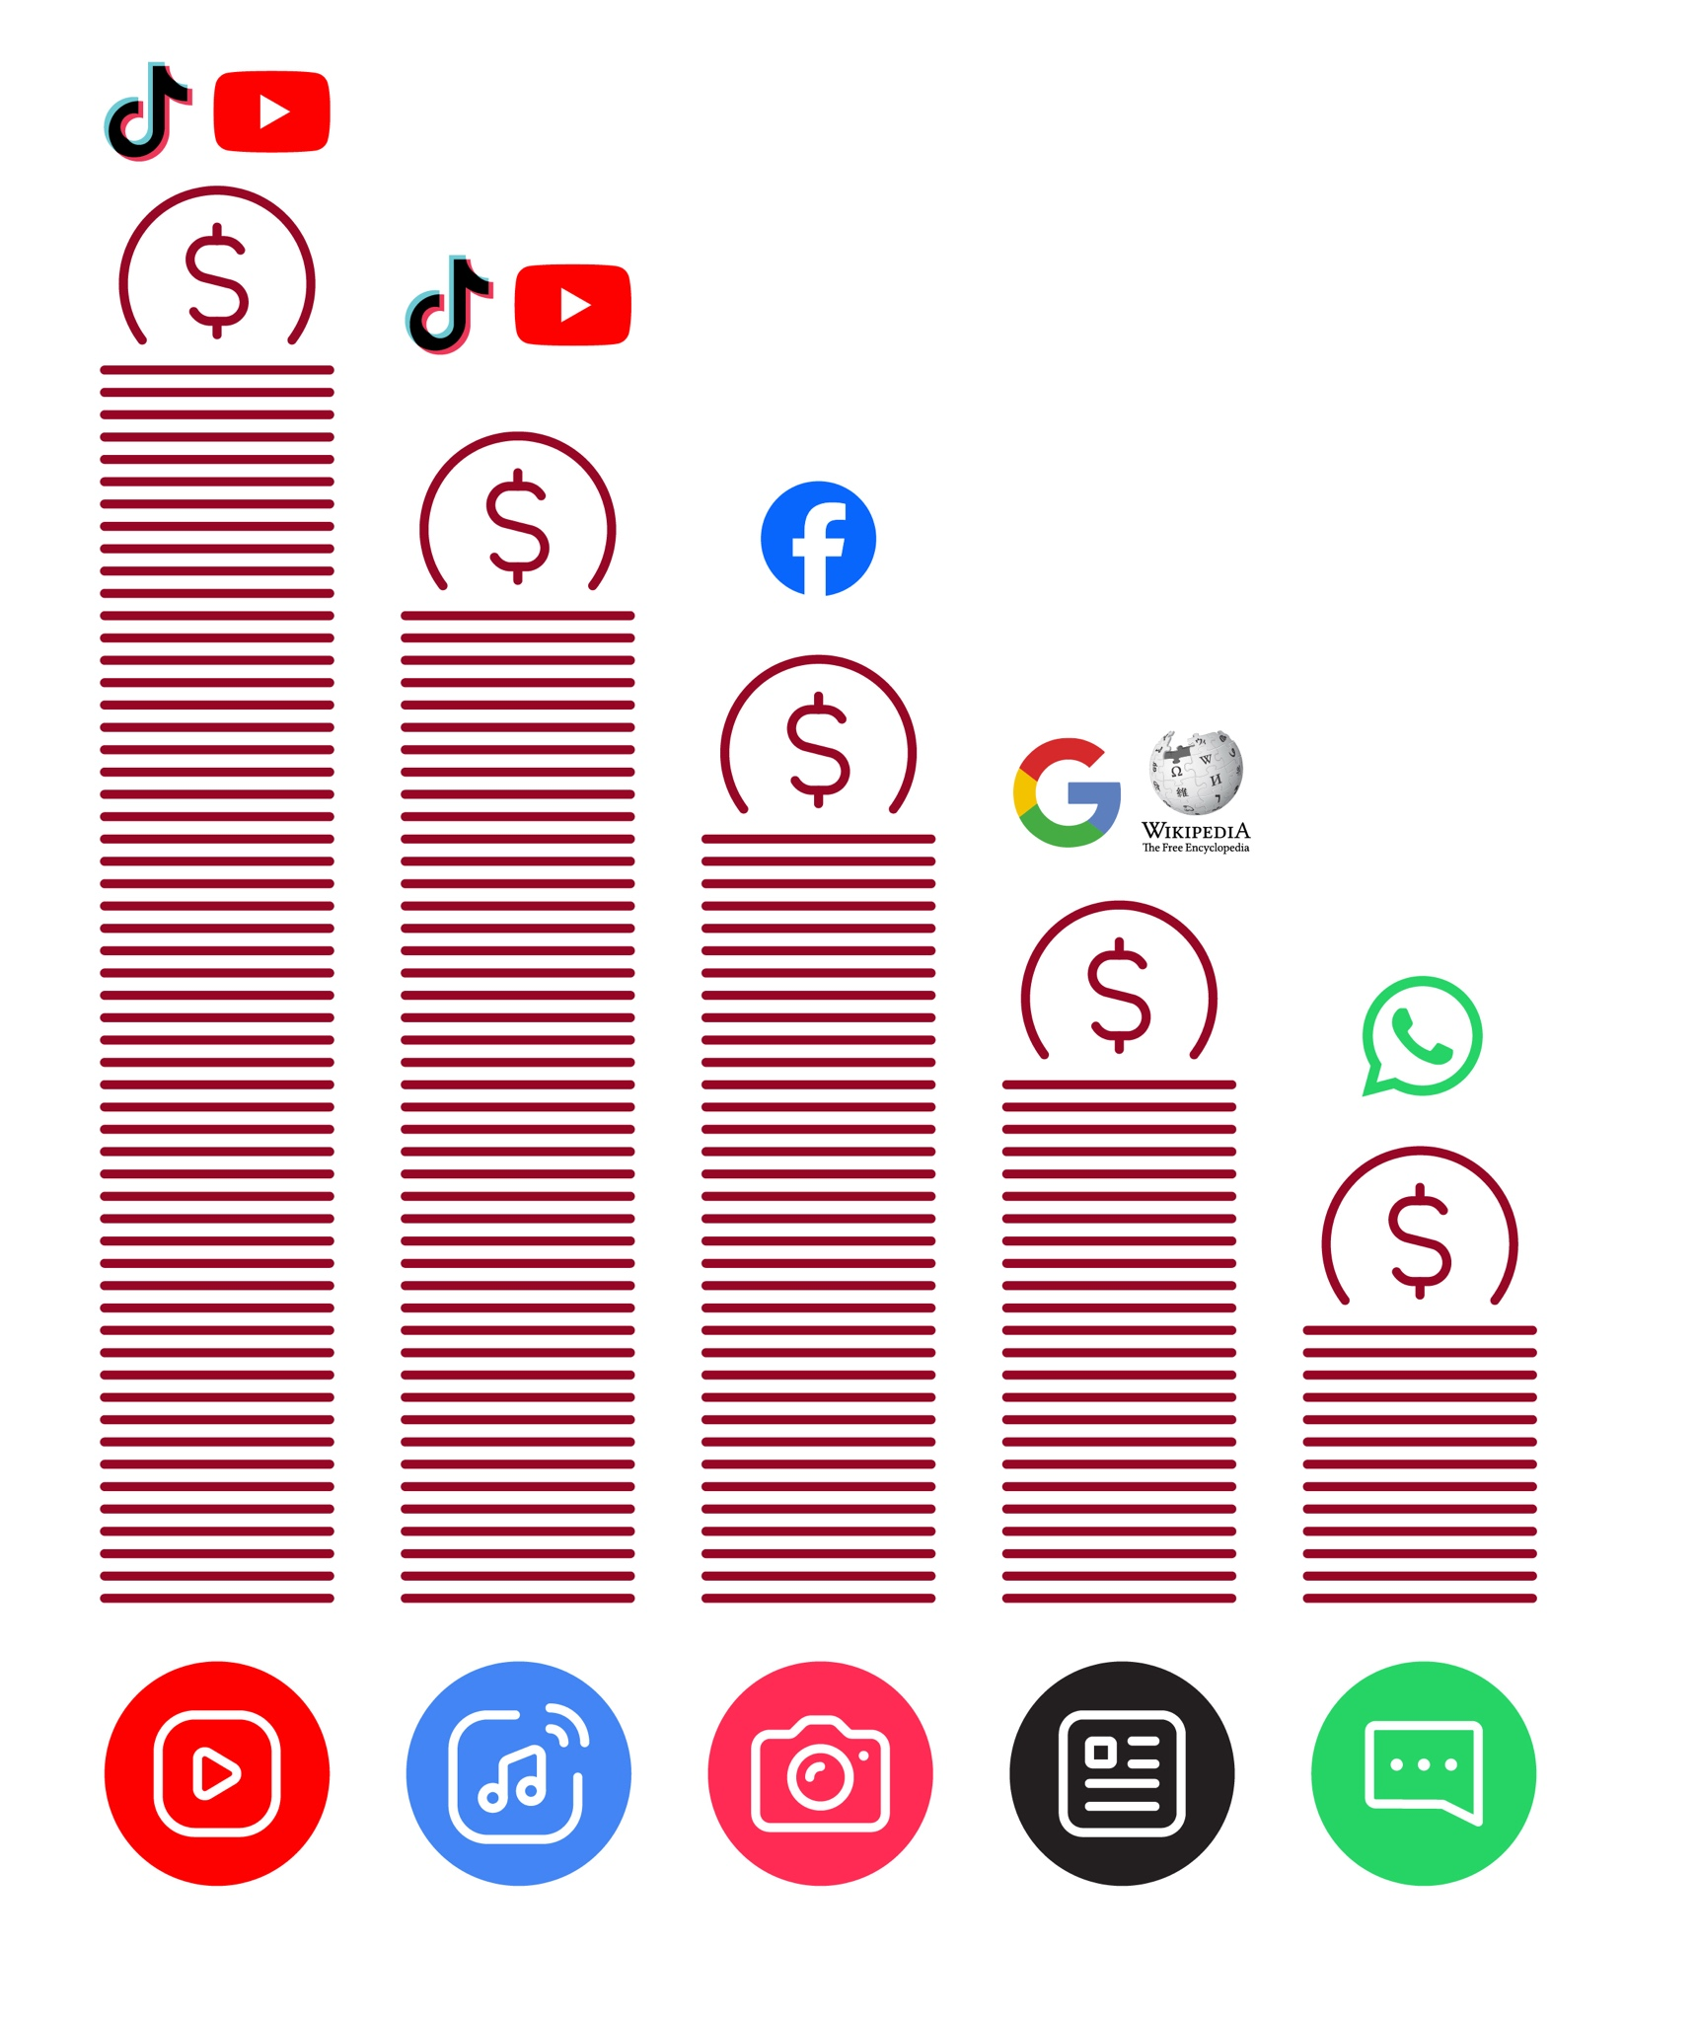
Data Costs
Healthy Internet Use

 | Set time limits  Think about how much time you are spending using the internet – it should not get in the way of your other responsibilities. If it does, set limits!
 | Watch your mood  If the internet or your phone is making you sad or angry, take a break!
 | Maintain healthy relationships online  Make time to socialise with friends and family in real life, not just on the internet! Don’t spend all your time on the internet.
 | Be careful  The internet can be dangerous with scams, harassment and things you don’t want to see. Be careful!
 | Stay positive  Stay positive and avoid upsetting or harming others. Be responsible and keep a positive attitude!
 | Get enough sleep and rest  Sleep and rest are important - make sure the internet or your phone doesn’t stop you doing this! Don’t use the internet when you need to rest or sleep.



Online Safety
How to ‘block’ on Facebook

1 2 3 4 5
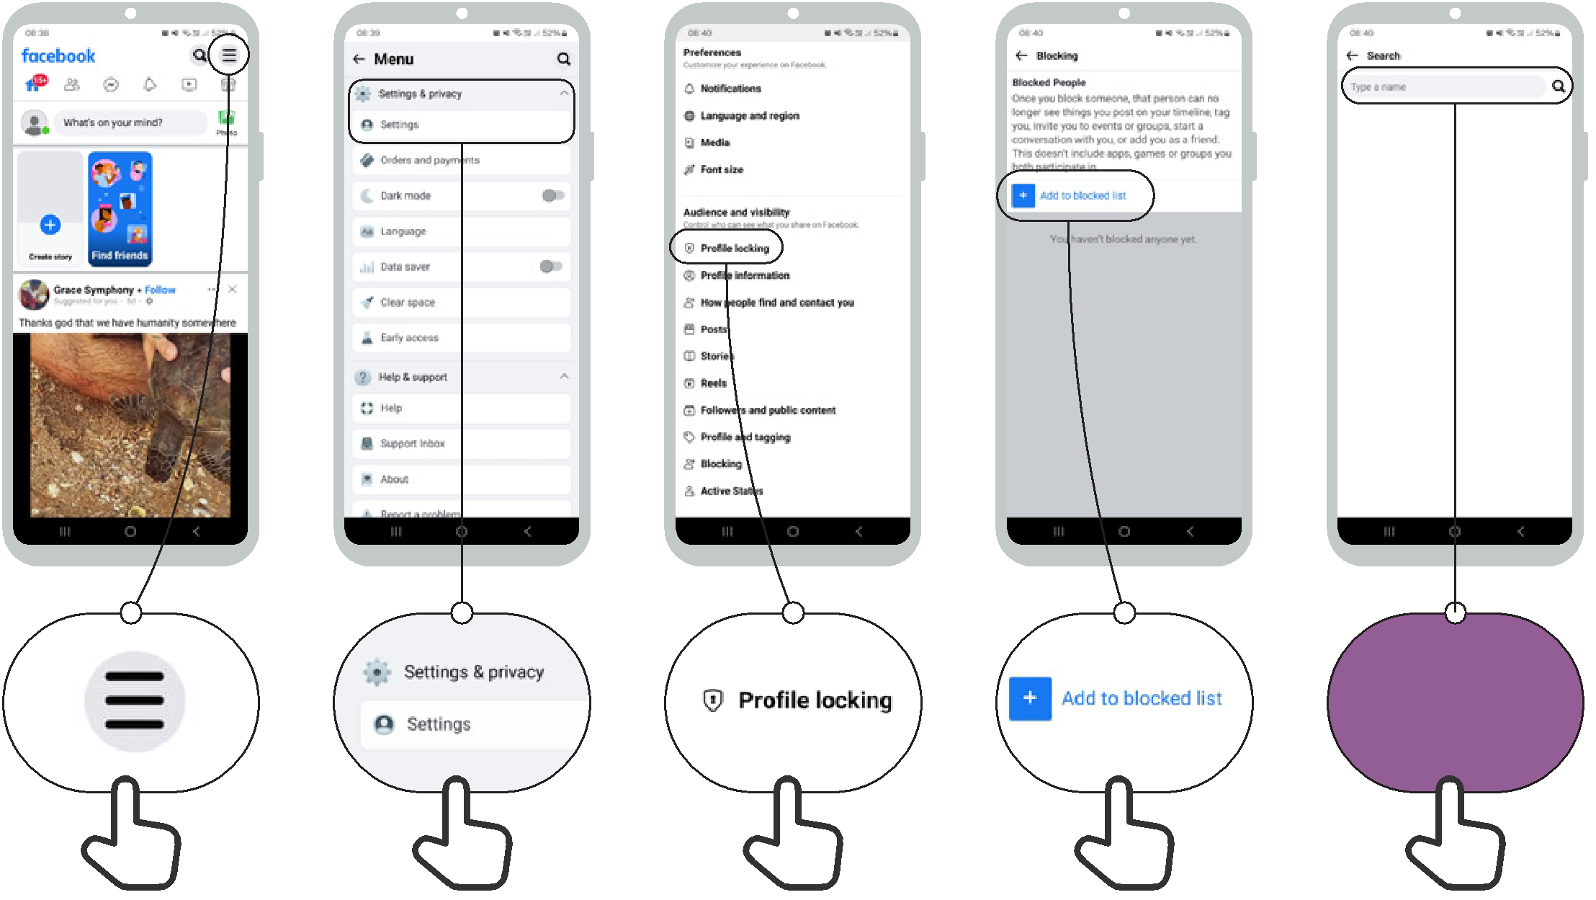

Type a name

Online Safety How to ‘block’ on Gmail


1 2 3
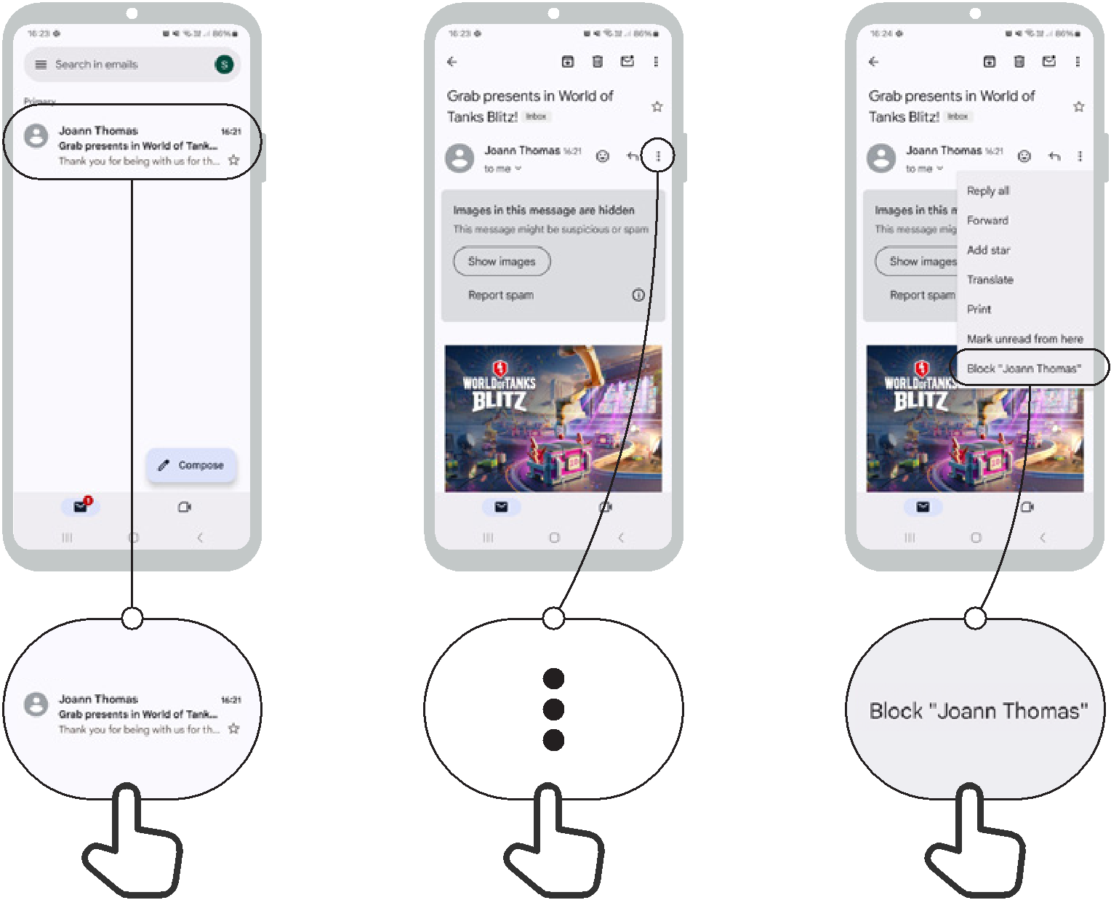
3
2
1

Online Safety Accessing 'search history' in Chrome
1
2
3

1 2 3
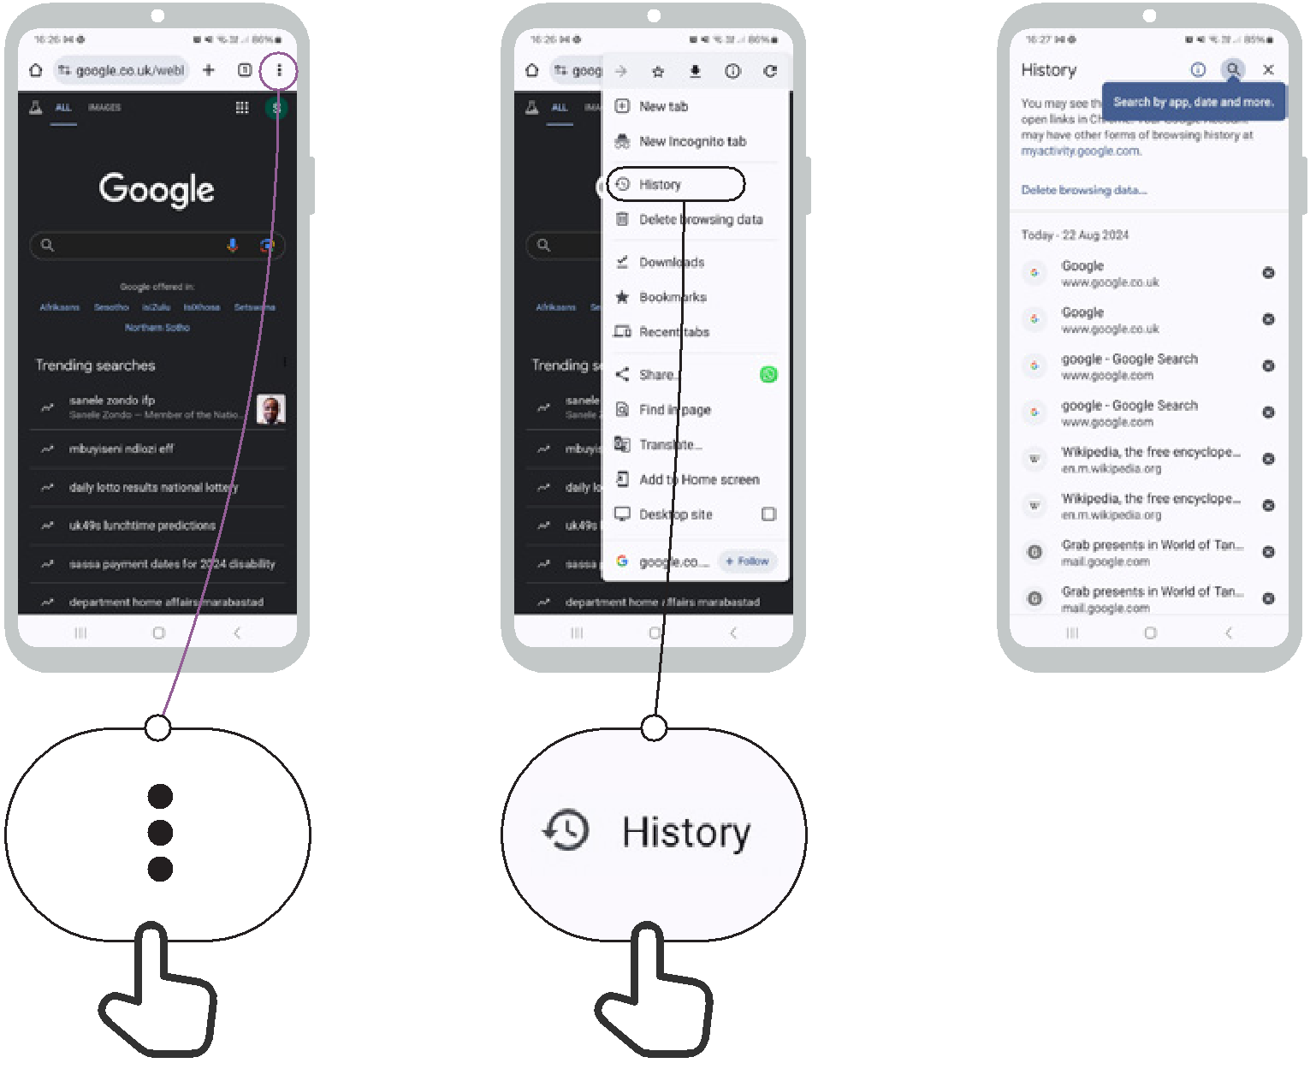

Setting up parental controls
on Play Store

Online Safety

1 2 3 4 5
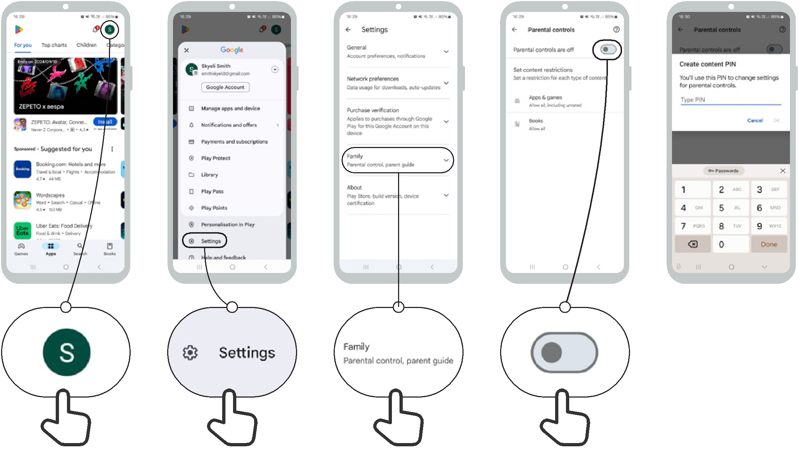

Online Safety Reporting a page on Facebook
1
2
3

1 2 3
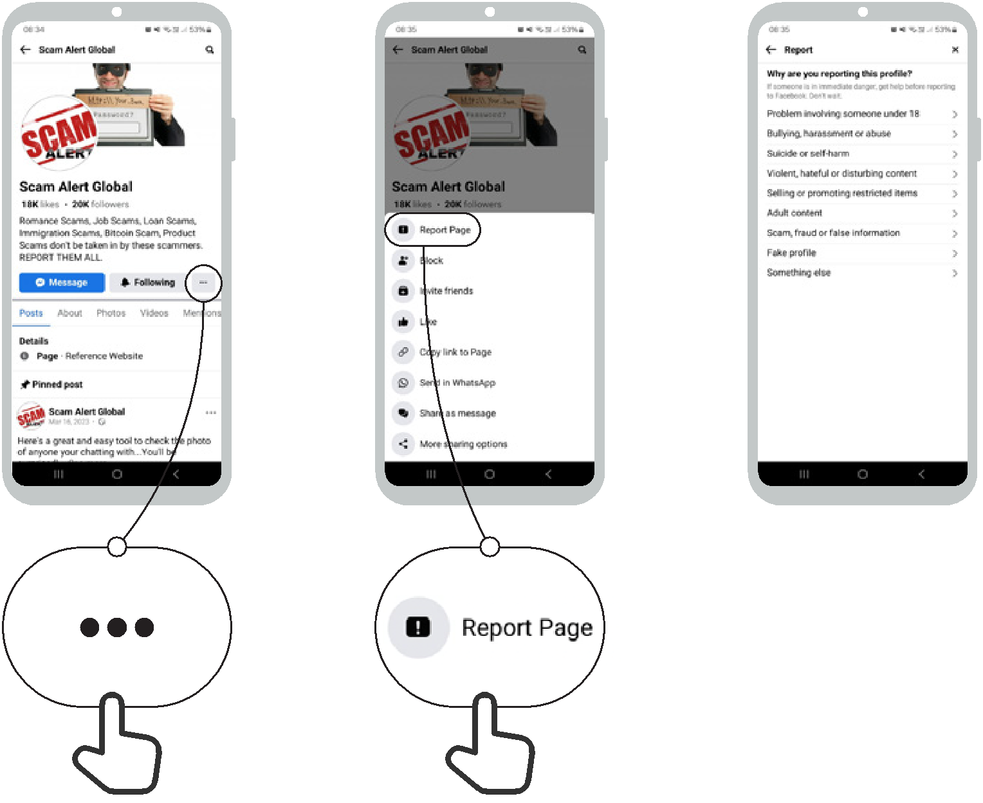

Online Safety Reporting a video on YouTube
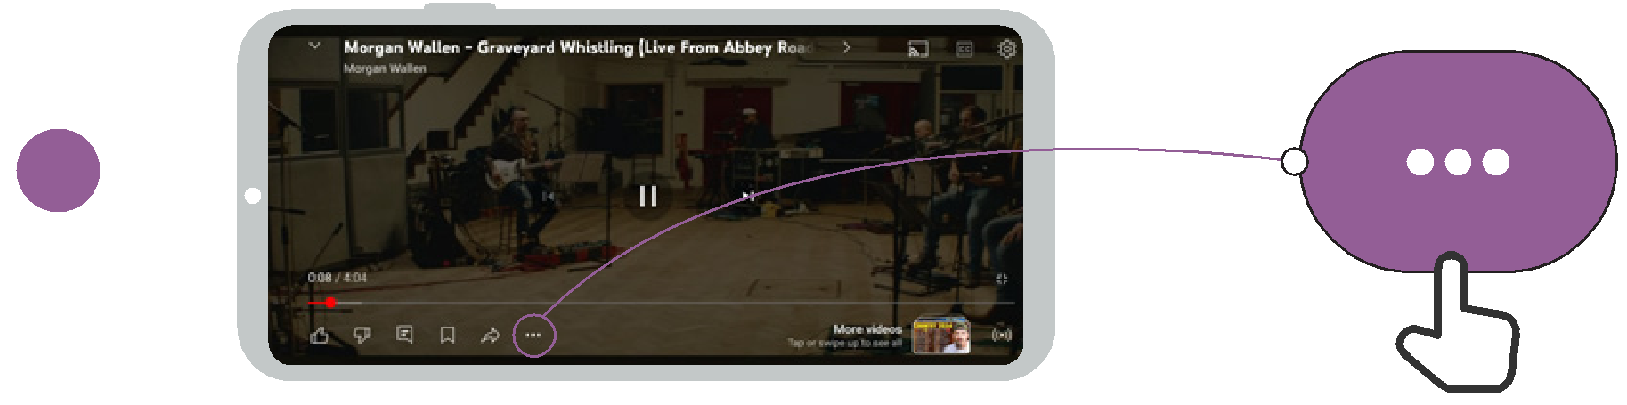

1
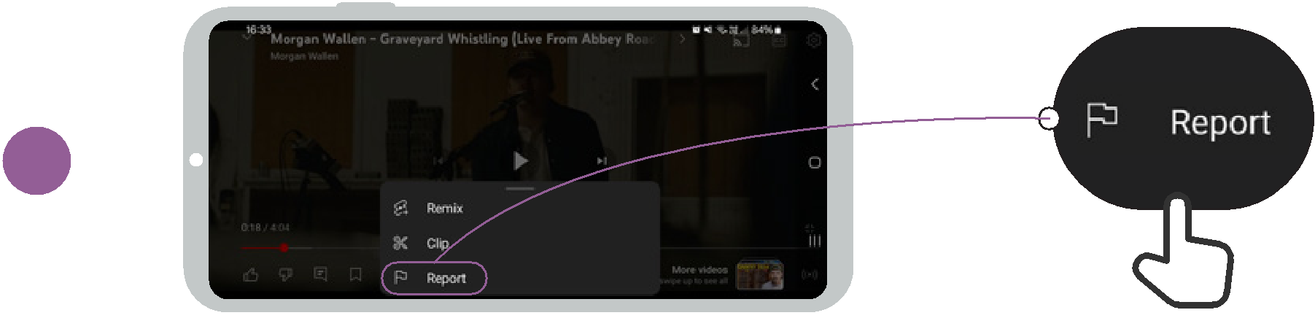

2
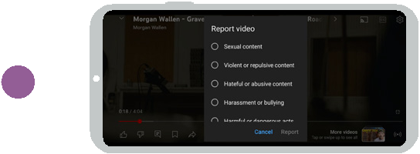

1
2
3
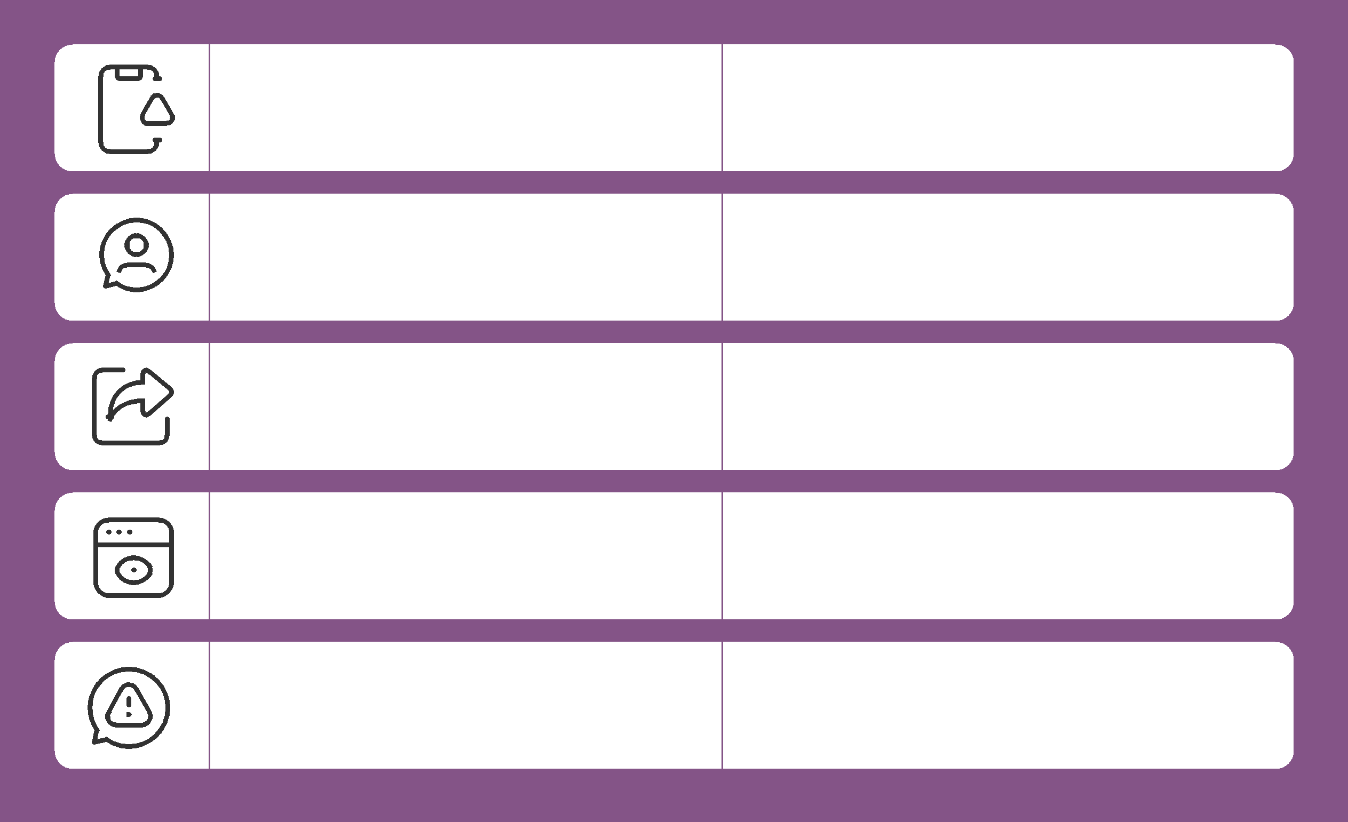
Be careful!

If you are unsure, ask
someone you trust!

Don’t share something with other people without thinking first!

Check other sites

Report it

False information
Online Safety
Not everything on the internet is what it says it is.

People can make fake versions of a website or an app to make it look like a good company (e.g. your phone company) or organisation (e.g. your government).

People sometimes put false information on the internet (e.g. WhatsApp or Facebook).

If you hear some news on from the internet, you might want to check this by checking on other sites (e.g. trusted news sites like BBC).

If you think something you see is dangerous or bad, you can ‘report’ it so the company (e.g. YouTube) knows there is a problem.


Mobile Internet Skills Training Toolkit

‘Thank you’ and close training

After you have completed the training, congratulate your trainees and hand out certificates as a reward.

Thank the trainees

Give out the handouts

- Give your trainees the handouts for the training if you haven’t already done so.

- These include the ‘Definitions’, ‘Top tips to stay safe online’, ‘Data costs’, ‘Healthy internet use’ and relevant module posters.

- Ask: “Do you feel confident to use these accessibility features?” or “Do you feel confident to use your mobile phone?”

- Thank your trainees for their time, input and participation in the training.

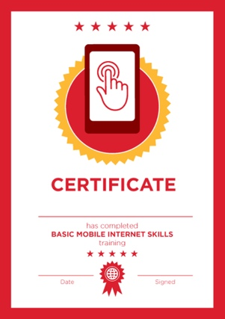

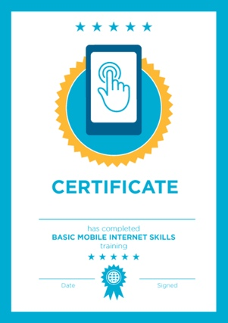

Conduct a closing ceremony

- Give each trainee a signed certificate (certificate templates are included in the toolkit).

- You can also provide the trainers with certificates for having completed the training ‘as trainers’.

Tip: You can make this more of a ceremony for trainees, by asking them to come up to the front of the room one person at a time to receive their certificate and shake the trainer’s hand.

here


CERTIFICATE

has completed

BASIC MOBILE INTERNET SKILLS

training

Date Signed

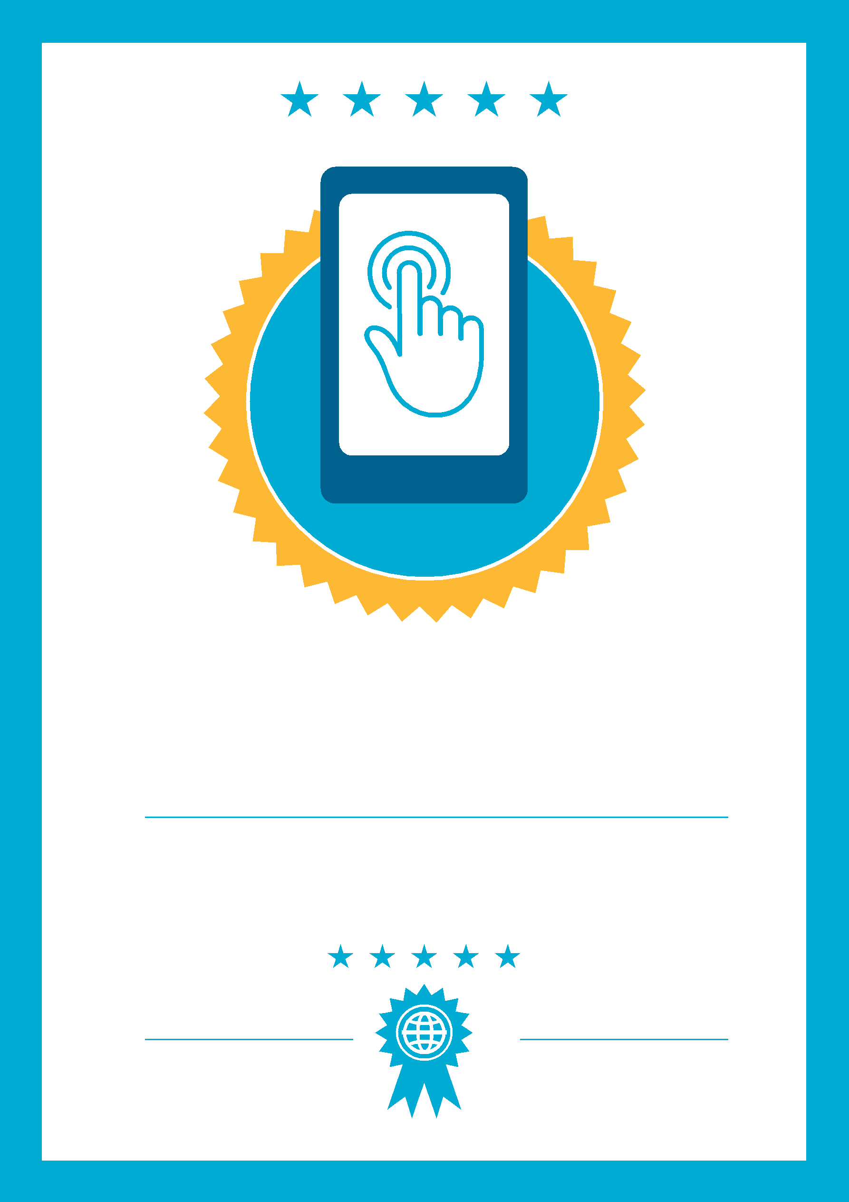

CERTIFICATE

has completed

BASIC MOBILE INTERNET SKILLS
training

Signed
Date

